Multiple site occupancy induced novel broadband Ca₈(Al₁₂O₂₄)(WO₄)₂: Eu²⁺ blue phosphors towards full-spectrum WLEDs
Ningning Feng,^{1,2,3,4,5} Jiangshan Han,³ Hua Jiao,^{1,2} Lin Yuan,^{3,4,5} Rui Huang,³ Guoqing Zhang,^{3,4,5} Boyu Wang,^{3,4,5,*} Kang Zhao^{1,2,*}
¹Department of Materials Science and Engineering, Xi’an University of Technology, Xi’an, Shaanxi, 710048, PR China
²Department of Materials Science and Engineering, Shaanxi Province Key Laboratory of Corrosion and Protection, Xi’an University of Technology, Xi’an 710048, PR China
³School of Science, Xi’an Polytechnic University, Xi’an, Shaanxi, 710048, PR China
⁴Flexible Radiation Protection Technology of Engineering Research Center, Xi’an Polytechnic University, Xi’an, Shaanxi, 710048, PR China
⁵Xi’an Key Laboratory of Nuclear Protection Textile Equipment Technology, Xi’an Polytechnic University, Xi’an, Shaanxi, 710048, PR China
*Email: kzhao@xaut.edu.cn; wangby2008@foxmail.com

S1 Supplementary Figure
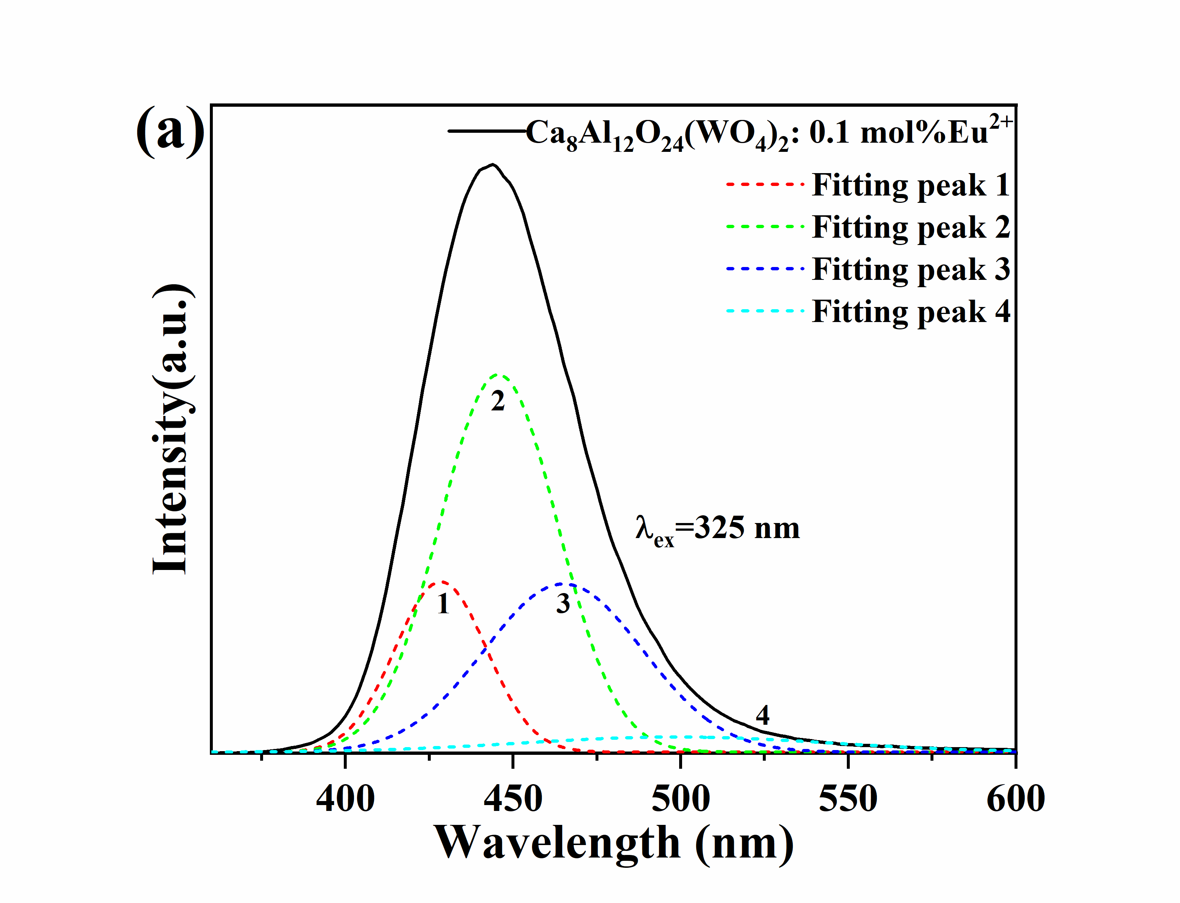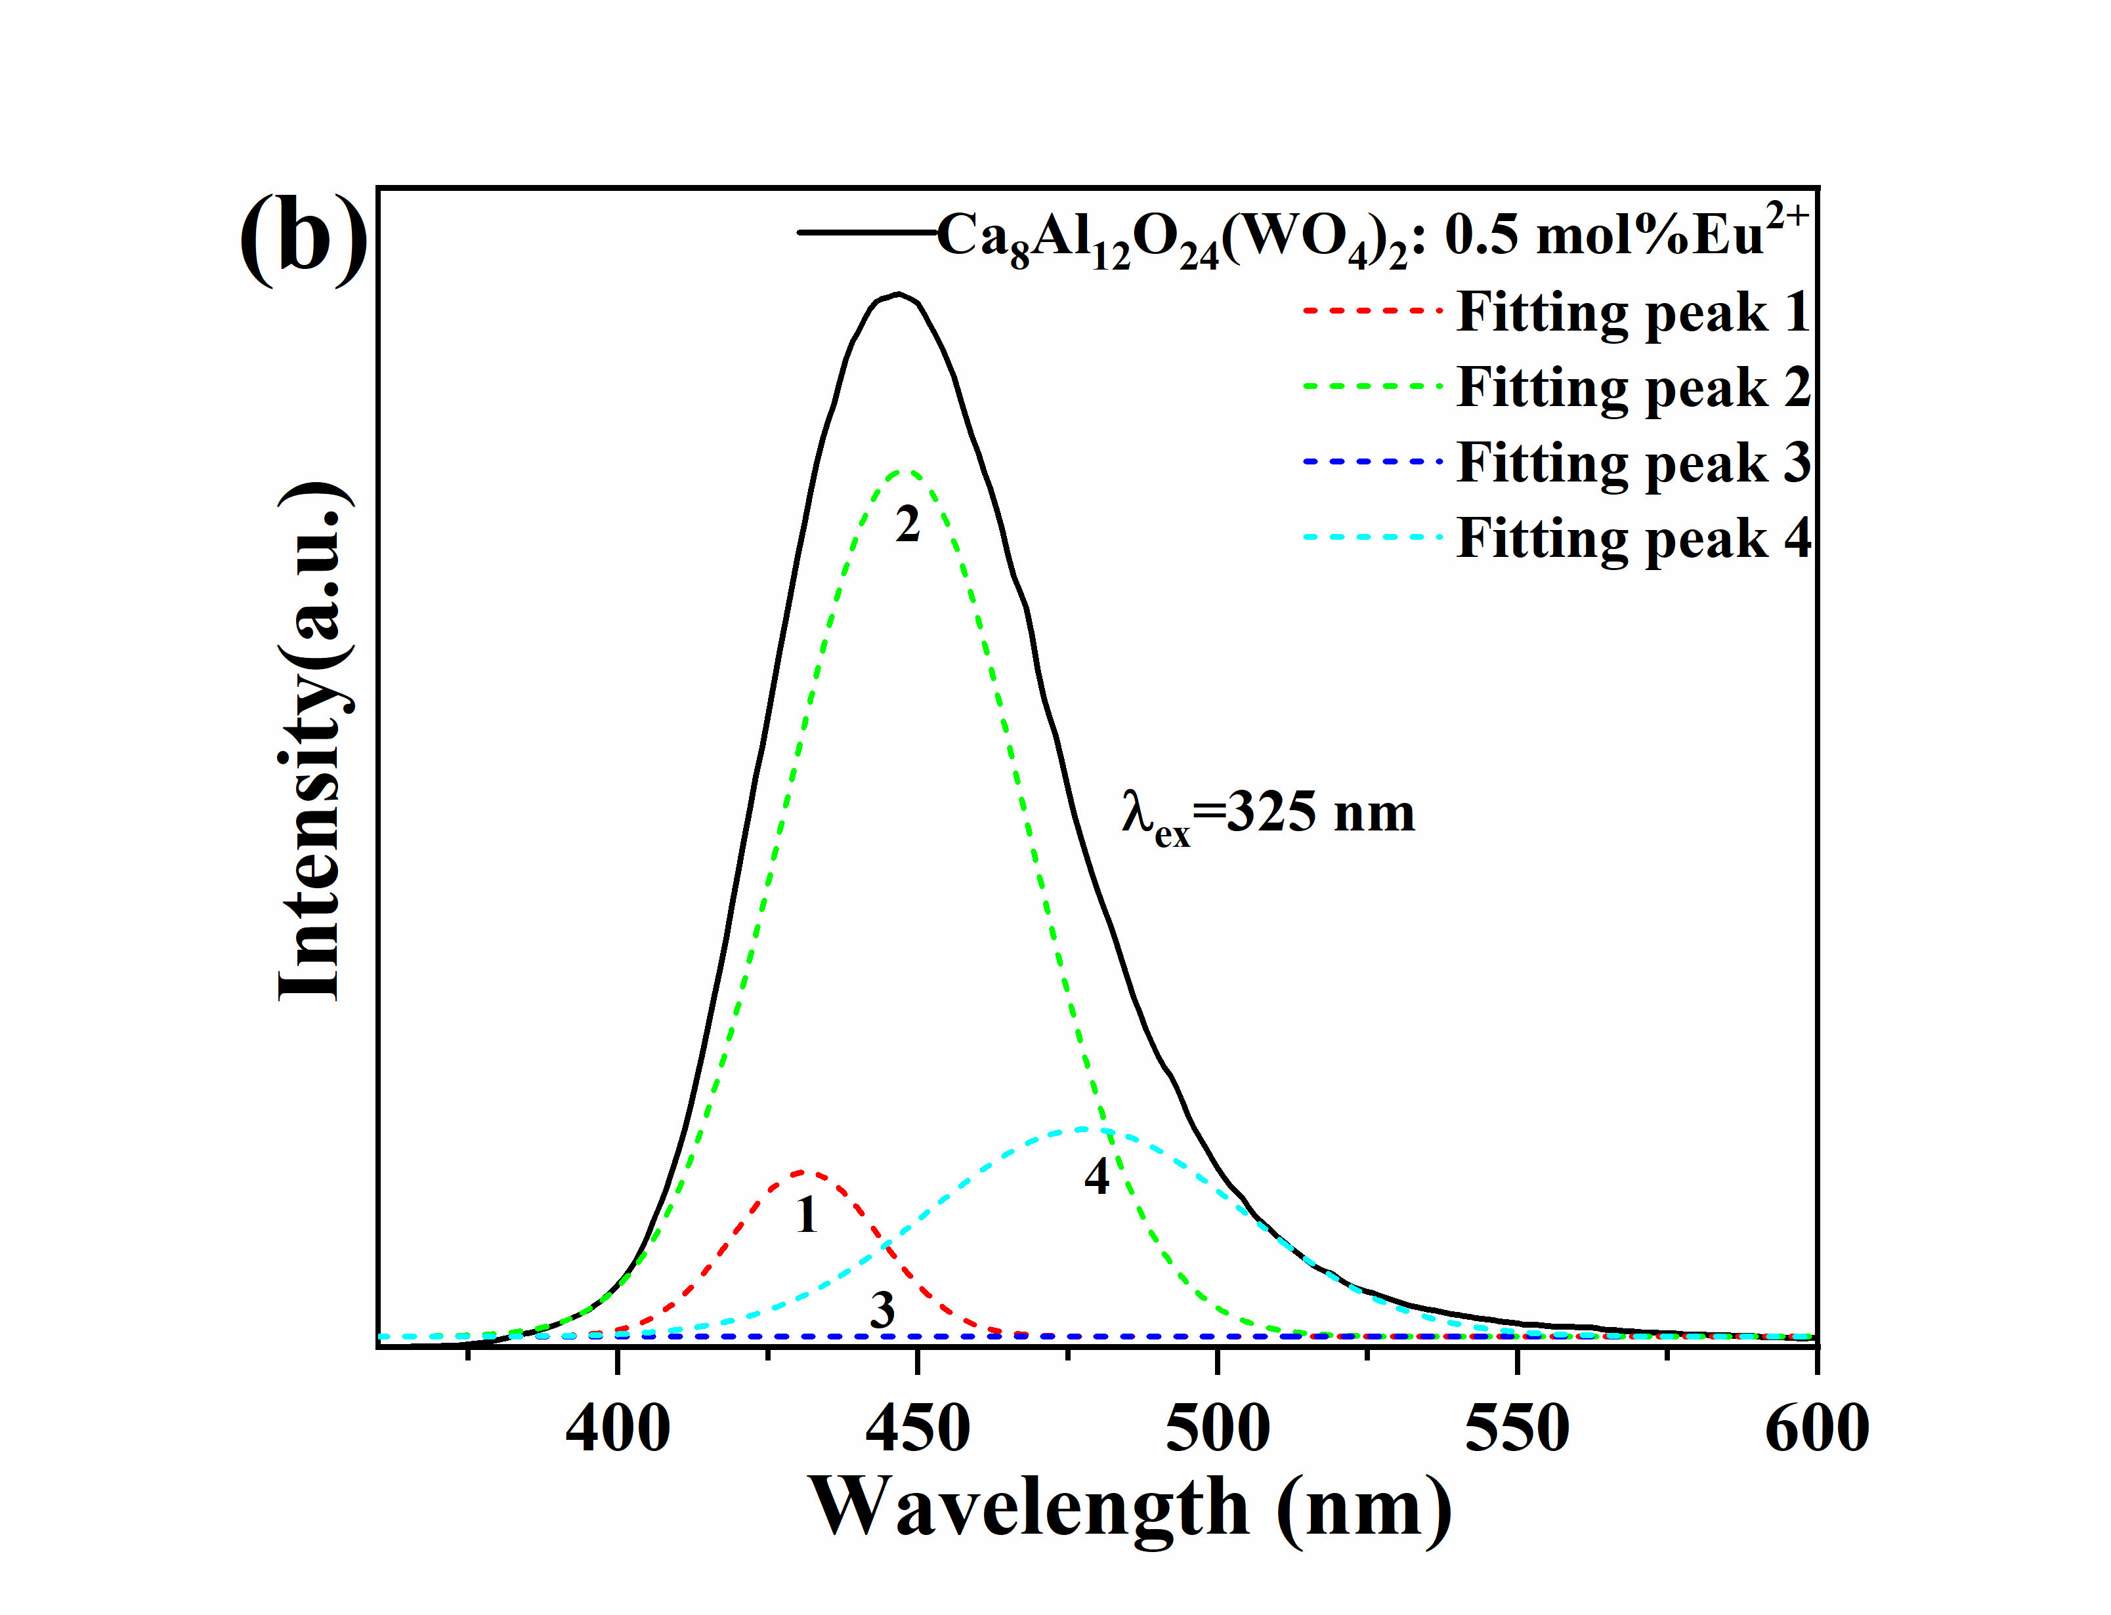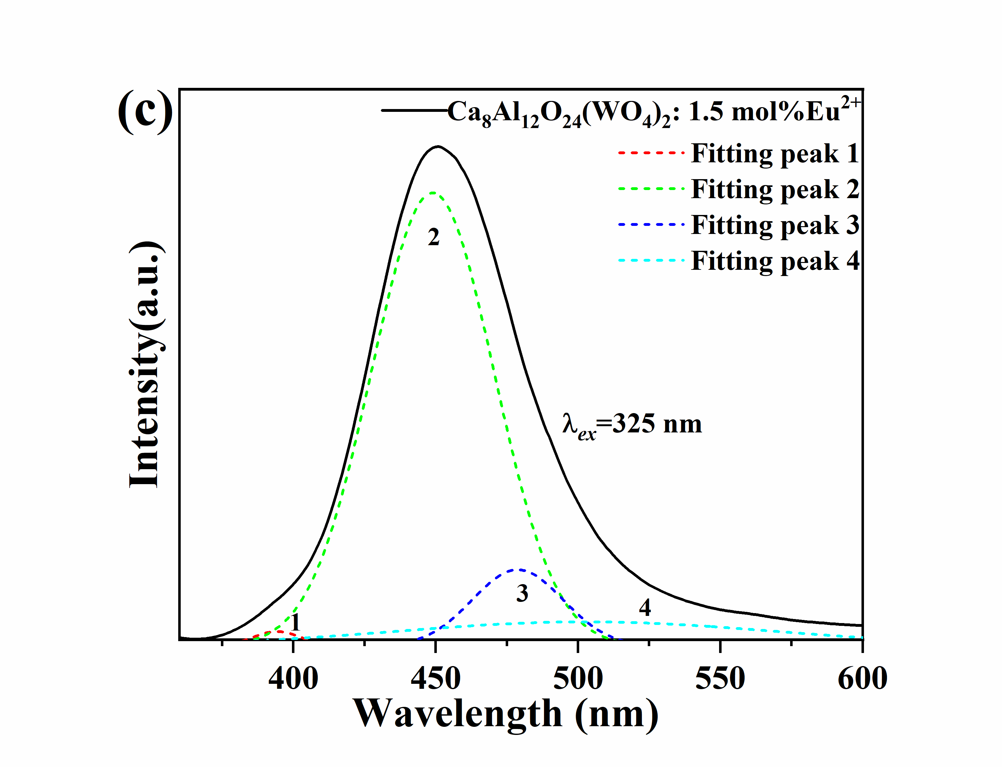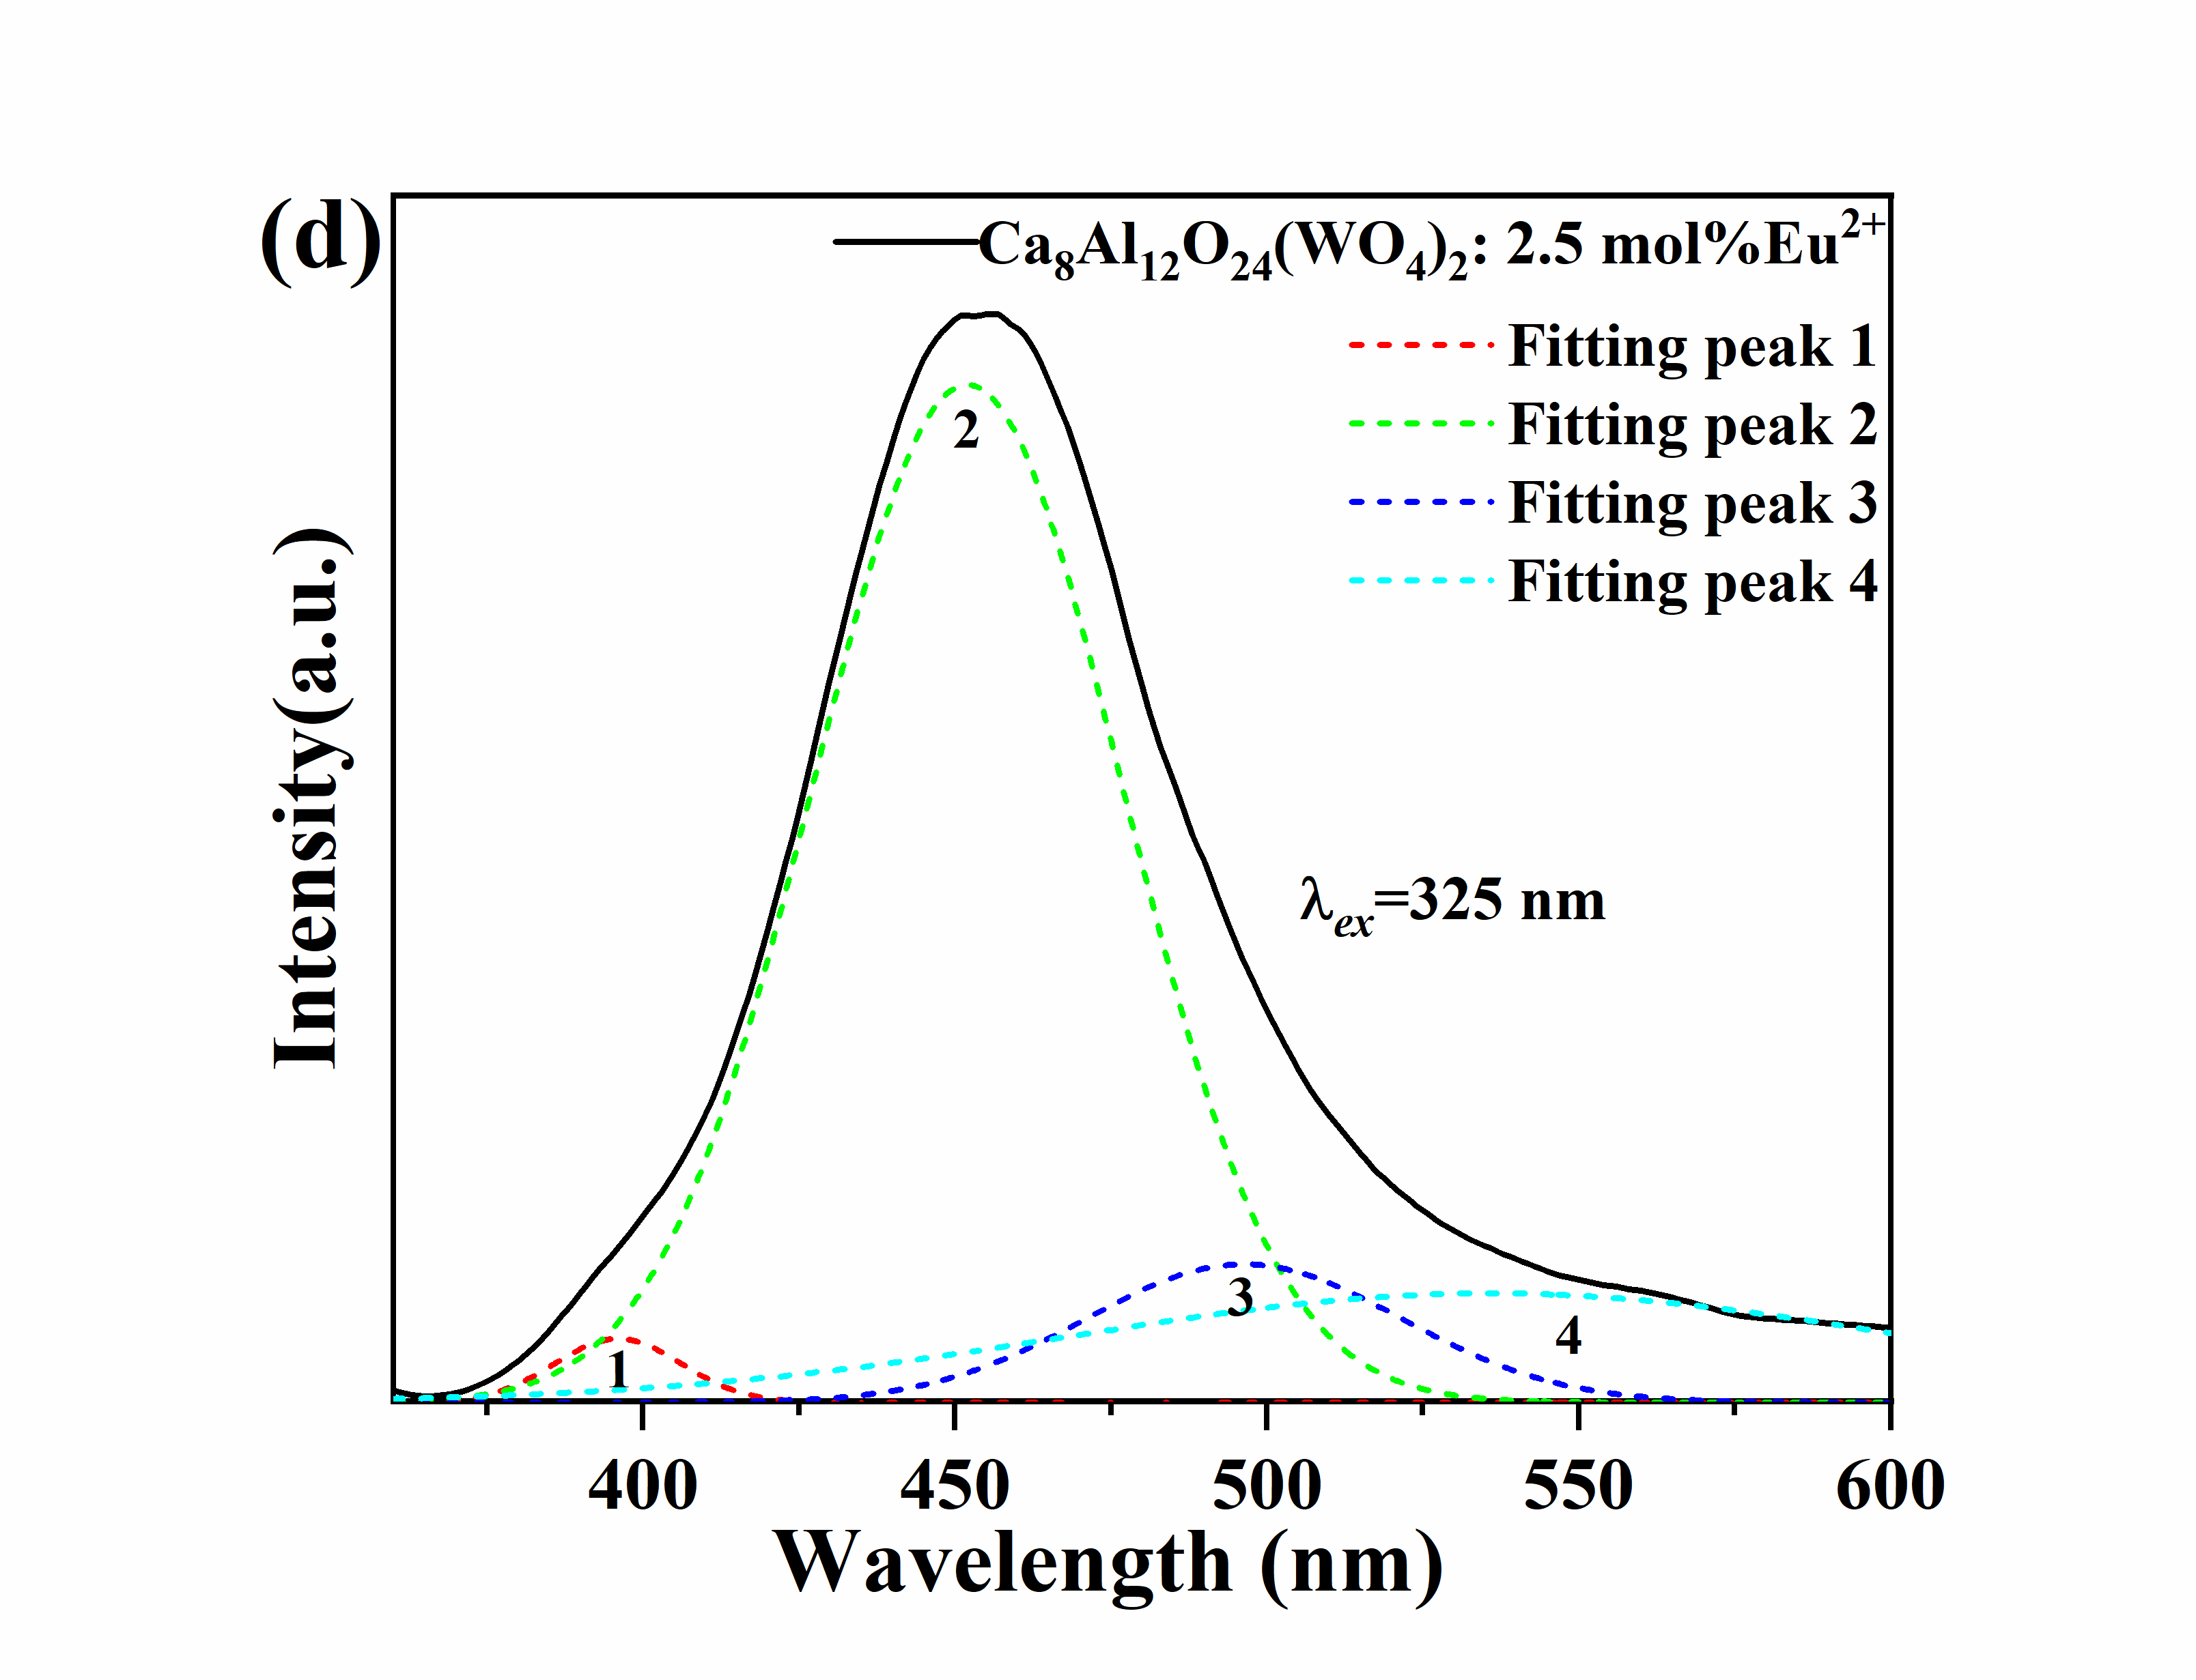

Figure S1. Gaussian fitting for the PL spectrum of CAWO: x mol%Eu²⁺ (x=0.1, 0.5, 1.5, and 2.5) phosphors

