Supplementary Table S1. Basic parameters for targeted yield equations of maize under NPK alone and NPK+FYM approach.
Parameters | NPK alone |  |  | NPK + FYM
Parameters | N | P | K | N | P | K
NR (kg q⁻¹) | 1.20 | 0.48 | 1.68 | 1.28 | 0.52 | 1.77
CS% | 9.36 | 19.49 | 29.66 | 9.36 | 19.49 | 29.66
CF% | 39.98 | 61.95 | 189.49 | 52.49 | 72.50 | 204.25
CNF% | 3595.63 | 4842.09 | - | 3596.36 | 4842.45 | -
COM% | - | - | - | 0.73 | 0.36 | 1.41

Supplementary Table S2. Influence of different approaches of nutrient application on kernel yield and stover yield of maize.
Treatment details |  | LFS |  | MFS |  | HFS
 |  | Kernel  yield  (q ha^{–1}) | Stover  yield  (q ha^{–1}) | Kernel  yield  (q ha^{–1}) | Stover  yield  (q ha^{–1}) | Kernel  yield  (q ha^{–1}) | Stover  yield  (q ha^{–1})
T₁ | STCR NPK Targeted Yield  100 q ha^{–1} | 94.91 | 134.77 | 95.87 | 138.24 | 96.80 | 141.33
T₂ | STCR NPK + FYM Targeted  Yield 100 q ha^{–1} | 97.09 | 137.87 | 98.05 | 141.38 | 98.98 | 144.51
T₃ | STCR NPK Targeted Yield  90 q ha^{–1} | 85.31 | 121.14 | 86.27 | 124.40 | 87.20 | 127.32
T₄ | STCR NPK + FYM Targeted  Yield 90 q ha^{–1} | 90.00 | 127.80 | 90.96 | 131.16 | 91.89 | 134.16
T₅ | General Recommended dose | 82.32 | 116.90 | 83.30 | 120.12 | 84.24 | 122.99
T₆ | Soil Fertility Rating Approach | 83.79 | 118.98 | 84.77 | 122.23 | 85.70 | 125.12
T₇ | Absolute control | 47.91 | 68.04 | 49.18 | 70.92 | 50.11 | 73.17
S.Em. ± |  | 4.06 | 5.77 | 4.11 | 5.92 | 4.15 | 6.06
C.D. @ 5 % |  | 11.57 | 16.43 | 11.70 | 16.87 | 11.82 | 17.26

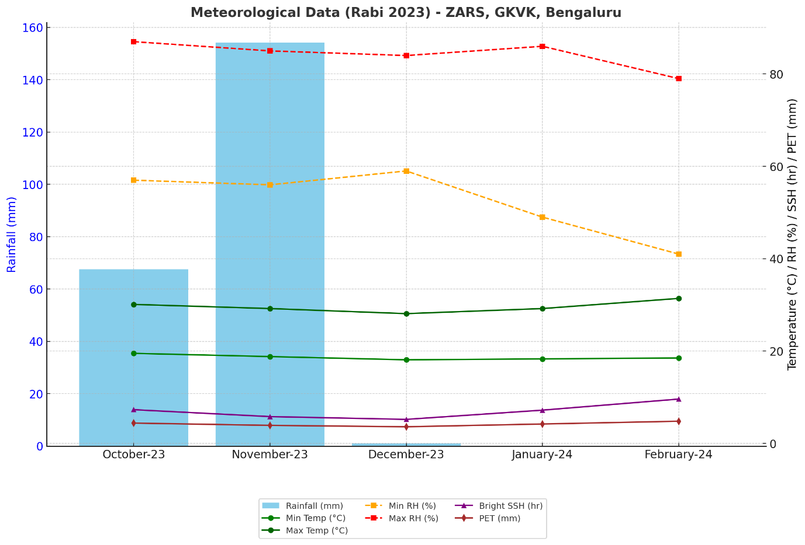
Supplementary Figure S1. Meteorological data of the main test crop experimental site during Rabi 2023 at ZARS, GKVK, Bengaluru.

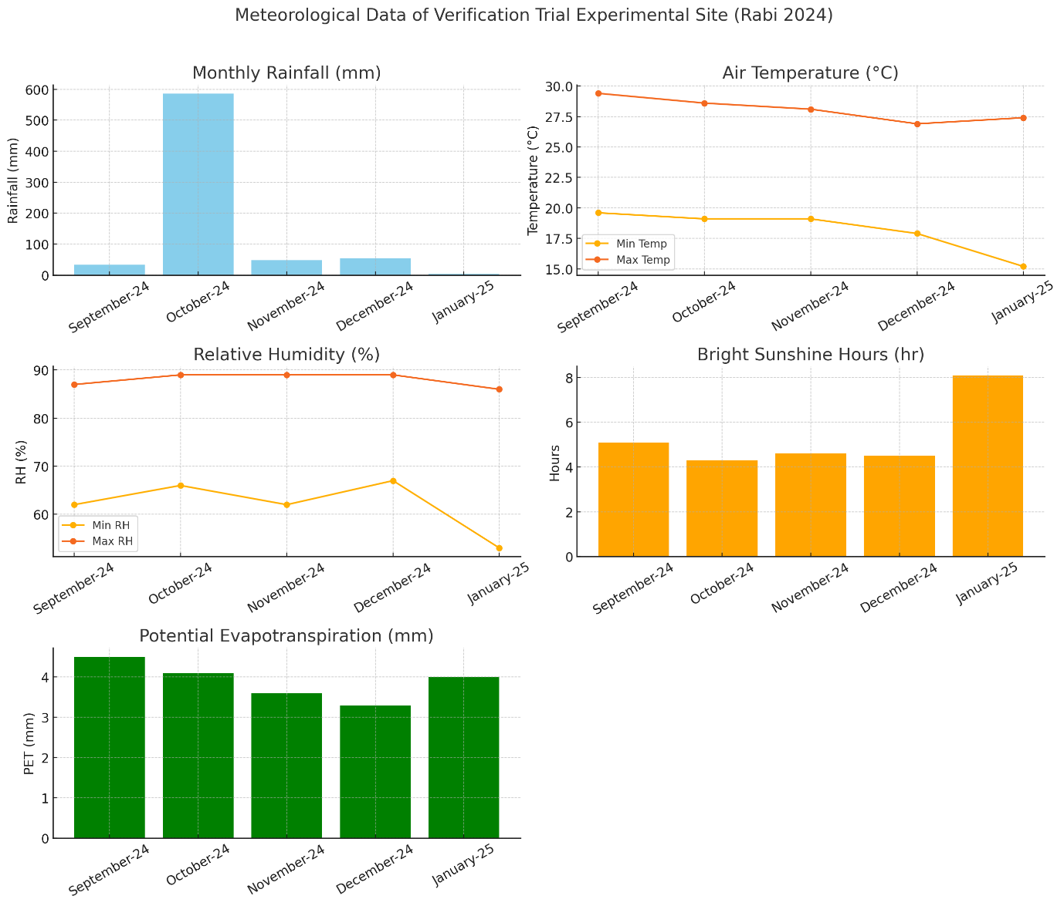

Supplementary Figure S2. Meteorological data of the verification trial experimental site during Rabi 2024 at ZARS, GKVK, Bengaluru.

R₃ R₂ R₁
 | T₄ |  | T₃ |  | T₅
 | T₇ |  | T₄ |  | T₁
 | T₃ |  | T₁ |  | T₇
 | T₁ |  | T₆ |  | T₂  Water channel (0.5mt)
 | T₅ |  | T₂ |  | T₆
 | T₆ |  | T₇ |  | T₃
 | T₂ |  | T₅ |  | T₄

Note: Same layout followed for MFS and HFS
Treatments
T₁ = STCR NPK TY 10 t ha^{–1}
T₂ = STCR NPK + FYM TY 10 t ha^{–1}
T₃ = STCR NPK TY 9 t ha^{–1}
T₄ = STCR NPK + FYM TY 9 t ha^{–1}
T₅ = General Recommended dose
T₆ = Soil Fertility Rating Approach
T₇ = Absolute Control
Bund (0.3 mt)
N
Main Bund (0.75 mt)

Supplementary Figure S3. Layout plan of the verification trial

L₃ strip L₂ strip L₁ strip
10 m
80 m
Bulk |  |  |  | Bulk |  |  |  | Bulk
Water channel (0.4 m) |  |  |  | Water channel (0.4 m) |  |  |  | Water channel (0.4 m)
 | 81 | Nano | F₀ |  | 28 | Nano | F₁ |  | 27 | Nano | F₂
 | 80 | 2-0-2 | F₀ |  | 29 | 2-2-3 | F₁ |  | 26 | 2-2-0 | F₂
 | 79 | 3-3-2 | F₀ |  | 30 | 0-0-0 | F₁ |  | 25 | 2-1-2 | F₂
 | 78 | 3-3-3 | F₀ |  | 31 | 0-2-2 | F₁ |  | 24 | 2-2-2 | F₂
 | 77 | 3-2-1 | F₀ |  | 32 | 2-1-1 | F₁ |  | 23 | 2-3-2 | F₂
 | 76 | 2-3-3 | F₀ |  | 33 | 2-2-1 | F₁ |  | 22 | 0-0-0 | F₂
 | 75 | 3-2-3 | F₀ |  | 34 | 1-2-1 | F₁ |  | 21 | 3-2-2 | F₂
 | 74 | 1-1-2 | F₀ |  | 35 | 3-1-1 | F₁ |  | 20 | 3-3-1 | F₂
 | 73 | 0-0-0 | F₀ |  | 36 | 1-1-1 | F₁ |  | 19 | 1-2-2 | F₂
Water channel (0.4 m) |  |  |  | Water channel (0.4 m) |  |  |  | Water channel (0.4 m)
 | 72 | 2-1-1 | F₂ | Water channel (0.4m) | 37 | 2-2-0 | F₀ | Water channel (0.4m) | 18 | 3-3-3 | F₁
 | 71 | 2-2-1 | F₂ | Water channel (0.4m) | 38 | 3-3-1 | F₀ | Water channel (0.4m) | 17 | 3-3-2 | F₁
 | 70 | 1-2-1 | F₂ | Water channel (0.4m) | 39 | 2-2-2 | F₀ | Water channel (0.4m) | 16 | 0-0-0 | F₁
 | 69 | 0-0-0 | F₂ | Water channel (0.4m) | 40 | 1-2-2 | F₀ | Water channel (0.4m) | 15 | 2-3-3 | F₁
 | 68 | 0-2-2 | F₂ | Water channel (0.4m) | 41 | 3-2-2 | F₀ | Water channel (0.4m) | 14 | 2-0-2 | F₁
 | 67 | 1-1-1 | F₂ | Water channel (0.4m) | 42 | 2-3-2 | F₀ | Water channel (0.4m) | 13 | 1-1-2 | F₁
 | 66 | 2-2-3 | F₂ | Water channel (0.4m) | 43 | 2-1-2 | F₀ | Water channel (0.4m) | 12 | 3-2-1 | F₁
 | 65 | 3-1-1 | F₂ | Water channel (0.4m) | 44 | 0-0-0 | F₀ | Water channel (0.4m) | 11 | 3-2-3 | F₁
 | 64 | Nano | F₂ |  | 45 | Nano | F₀ |  | 10 | Nano | F₁
Water channel (0.4 m) |  |  |  | Water channel (0.4 m) |  |  |  | Water channel (0.4 m)
 | 63 | Nano | F₁ |  | 46 | Nano | F₂ |  | 9 | Nano | F₀
 | 62 | 1-2-2 | F₁ |  | 47 | 3-3-2 | F₂ |  | 8 | 2-2-1 | F₀
 | 61 | 2-1-2 | F₁ |  | 48 | 0-0-0 | F₂ |  | 7 | 1-2-1 | F₀
 | 60 | 3-3-1 | F₁ |  | 49 | 2-3-3 | F₂ |  | 6 | 1-1-1 | F₀
 | 59 | 2-3-2 | F₁ |  | 50 | 1-1-2 | F₂ |  | 5 | 2-1-1 | F₀
 | 58 | 2-2-0 | F₁ |  | 51 | 3-3-3 | F₂ |  | 4 | 0-0-0 | F₀
 | 57 | 3-2-2 | F₁ |  | 52 | 3-2-3 | F₂ |  | 3 | 0-2-2 | F₀
 | 56 | 0-0-0 | F₁ |  | 53 | 2-0-2 | F₂ |  | 2 | 2-2-3 | F₀
 | 55 | 2-2-2 | F₁ |  | 54 | 3-2-1 | F₂ |  | 1 | 3-1-1 | F₀
Water channel (0.4m) |  |  |  | Water channel (0.4m) |  |  |  | Water channel (0.4m)
Bulk (3.0 m) |  |  |  | Bulk (3.0 m) |  |  |  | Bulk (3.0 m)
Supplementary Figure S4: Layout plan of main test crop experiment on maize.

N: P: K (Kg ha^{–1}) applied at 3 levels
After harvest of crop soil samples were collected and analyzed for available N, P and K
Fodder maize (African tall) is grown as test crop and harvested after 60 days
I strip | II strip | III strip
0-0-0  (N₁-P₁-K₁) | 150-135-200  (N₂-P₂-K₂) | 300-270-400  (N₃-P₃-K₃)

Supplementary Figure S5: Layout and details of fertility gradient experiment of fodder maize crop.

