GM-CSF Armed Oncolytic Adenovirus Enhances T-cell Infiltration and Suppresses Local and Distal Tumor Growth

Supplementary materials

Hua-Wei Xu¹, Qing-wen Wang¹, Min Zhao¹, Jie Jun¹, Ri-gan Shu¹, Yu-sen Shi¹, Xiang-Lei Peng¹, Jie-Mei Yu¹, Yan-Peng Zheng¹*, Yuan-Hui Fu¹* and Jin-Sheng He¹*

¹College of Life Sciences and Bioengineering, Beijing Jiaotong University, Beijing 100044, China

Supplementary figures
Figure S1. Construction and characteristic of OAds. (A) Schematic diagram of oncolytic adenovirus construction. OAds arming with GM-CSF, with the deletion of E1A CR2, E1B 19k and E3 6.7K/gb 19k, were under the regulation of E2F or hTERT promoter. (B) Viral replication capacity in 293 cells was determined by the Adeno-X rapid titer method. The figure represents three replicative experiments. (C) The expression of GM-CSF in 293 cells was detected by ELISA (n = 3). 293 cells were infected with adenovirus at different MOIs, and the supernatants were collected 12 h after virus infection. P values comparisons with H14 group were shown for all panels. Data were shown as mean ± SD. (* P < .05; ** P < .01; *** P < .001; ns: not significant.)

Figure S2. OAds induced immunogenic cell death and apoptosis in vivo.
(A&B) Representative figures for related antigens expression in treated or untreated tumor tissues harvested from C57BL/6 10 d after the initiation of treatment were presented by IHC ((A) HMGB1) or IF ((B) CRT) and quantification analysis (n = 3). (C&D) Representative figures for related antigens expression in treated or untreated tumor tissues harvested from C57BL/6 10 d after the initiation of treatment were presented by IF ((C) c-PARP) or IHC ((D) PARP) and quantification analysis (n = 3). Relative mRNA expression (tested by RT-qPCR) in treated (E) and untreated (F) tumor tissues harvested from C57BL/6 or 10 d after the initiation of treatment (n = 8). Data were shown as mean ± SD. (* P < .05; ** P < .01; *** P < .001.)

Figure S3. The safety of OAds treatment in vivo. (A) The relative weight of C57BL/6 mice treated with PBS or OAds was monitored until day 10. Statistical analysis on day 10 was performed (n = 8). (B&C) Representative figures for H&E stanning of livers (B) or hexon protein expression in livers (C) harvested from C57BL/6 mice 10 d after the initiation of treatment were presented by H&E staining (B) or IHC (C). (D) Virus titers in liver, lung and kidney tissues detected by qPCR (n = 8). Data were shown as mean ± SD. ns: not significant.

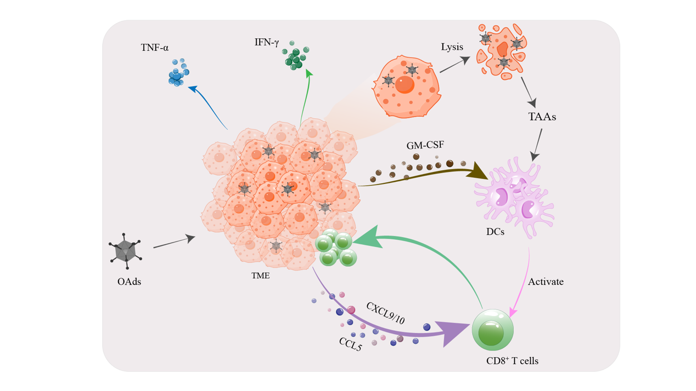
Figure S4. The mechanisms of the OAds-induced tumor inhibition involve multiple steps. OAds infect tumor cells, followed by lysing tumor cells and releasing tumor-associated antigens (TAAs), expressing GM-CSF, and upregulating the expression of immune-stimulating factors. GM-CSF promotes the maturation of dendritic cells (DCs), which will capture TAAs and present to T cells, resulting in the activation of tumor-specific T cells. These chemokines, especially CCL5, CXCL9 and CXCL10, recruit T cells and other immune cells into TME. The cytokines, such as TNF-α and IFN-γ, enhance the functions of immune cells. In summary, OAds treatment makes tumor microenvironment (TME) immunologically active, rendering cancer cells more vulnerable to immunotherapies.

Antibodies
The antibodies used for IHC and IF included anti-Ki-67 (bs-23013R, Bioss, CN), anti-Hexon (NB600-1386, Novus, USA), anti-CD4 (AF6393, Beyotime, CN), anti-CD8 (bs-0648R; Bioss, CN), anti-CD103 (BE0026, CST, USA), anti-CD11c (bs-2508R, Bioss, CN), anti-PARP (BD-PT6210, Biodragon, CN), anti-cleaved-PARP (BD-PC0101, Biodragon, CN), anti-CXCL10 (abs135937, Absin, CN), anti-CCL3 (AF-450-SP, R&D System, USA), anti-IFN-γ (abs135565, Absin, CN), anti-CCL5 (bs-1324R, Bioss, CN), anti-CXCL9 (bs-2551R, Bioss, CN),anti-TNF-α (AF8208, Beyotime, CN), anti-granzyme B (bs-1351R, Bioss, CN), anti-HMGB1 (10829-1-AP, Proteintech, USA), anti-Calreticulin (27298-1-AP, Bioss, CN),anti-STING (, Proteintech, USA), anti-pIRF3 (29528-1-AP, Proteintech, USA), anti-IRF7 (22392-1-AP, Proteintech, USA), anti-IFIT1 (23247-1-AP, Proteintech, USA) and anti-IFIT3 (15201-1-AP, Proteintech, USA). The secondary antibodies used in IHC and IF were purchased from ZSGB-Bio (PV-6001, CN) and Beyotime (P0193 and P0186), respectively.
The antibodies used for FC included FITC anti-human CD8 Antibody (344704, BioLegend, USA) and Brilliant Violet 605™ anti-human CD69 Antibody (310938, BioLegend, USA).

Gating strategy
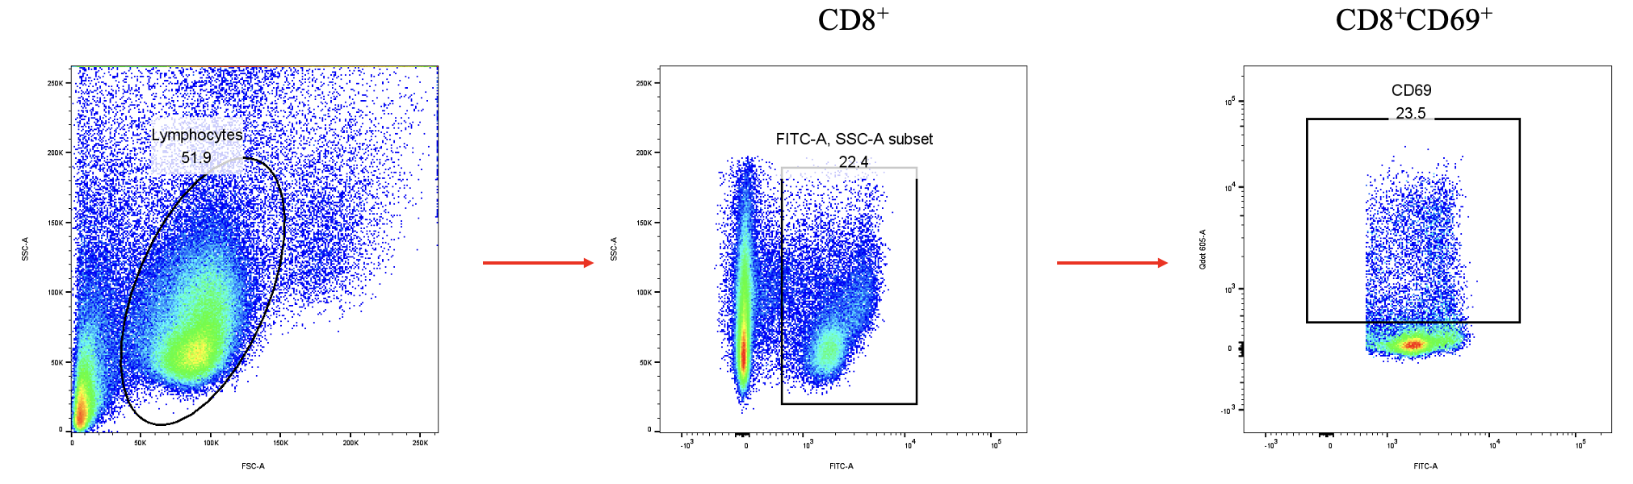
Gates are shown sequentially from left to right.

ELISA and LDH kit
GM-CSF kit (PG355, Beyotime, CN), PARP kit (JL45693, Jianglaibio, CN), CCL2 kit (PC130, Beyotime, CN), CCL3 kit (PC145, Beyotime, CN), CCL5 kit (PC160, Beyotime, CN), CXCL10 kit (PC208, Beyotime, CN), TNF-α kit (PT518, Beyotime, CN), IFN-γ kit (PI505, Beyotime, CN), LDH kit (C0016, Beyotime, CN). All ELISA experiments were proceeded according to the manufacturers’ protocols.

* Corresponding author. E-mail address: ypzheng@bjtu.edu.cn yhfu@bjtu.edu.cn and jshhe@bjtu.edu.cn

