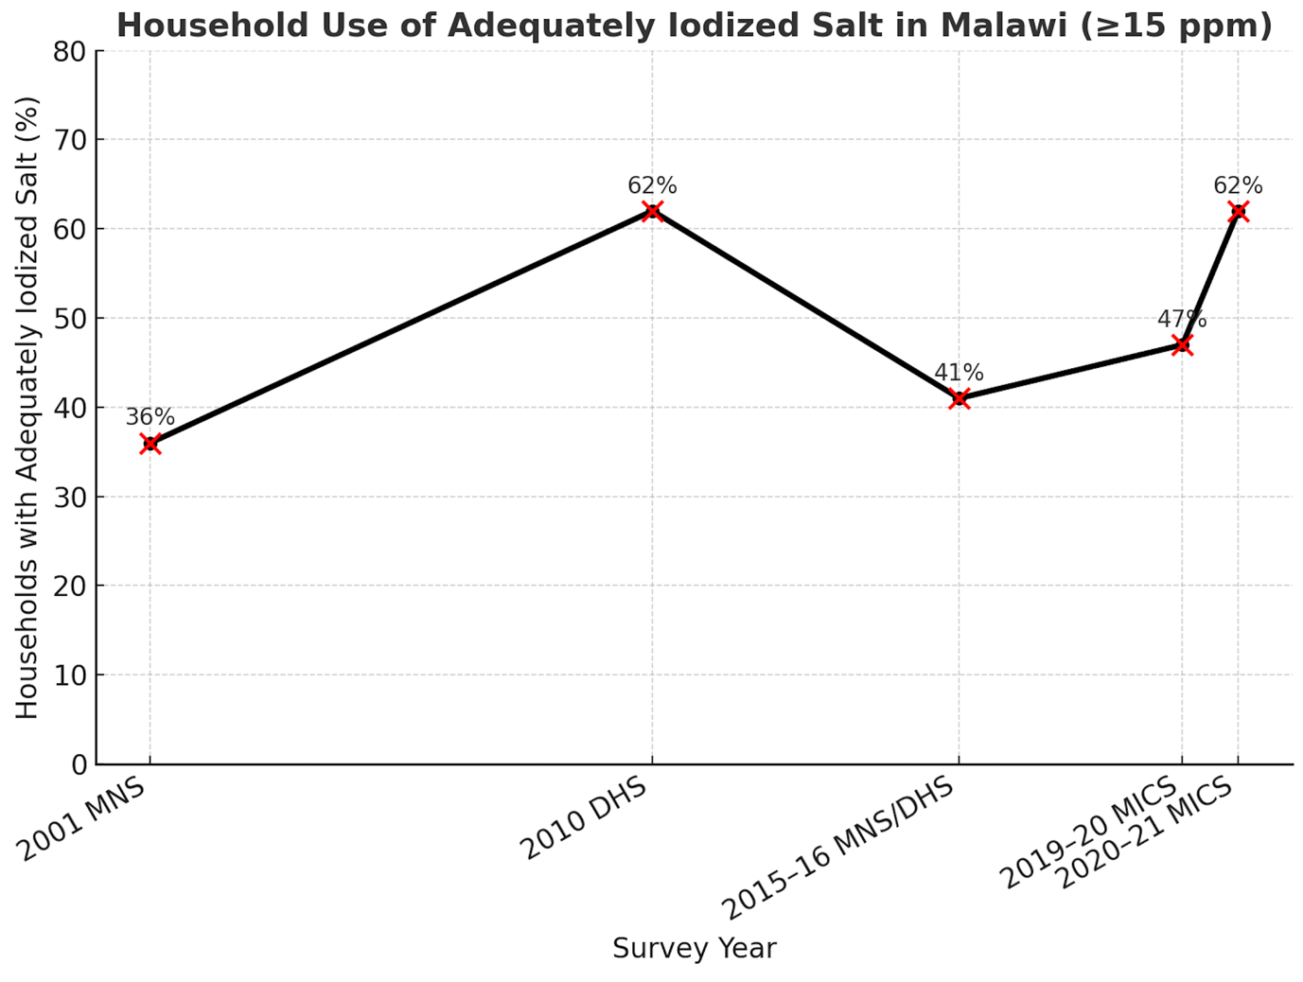

Supplementary figure S1. Trend in the level of utilization of adequately iodized salt in Malawi

