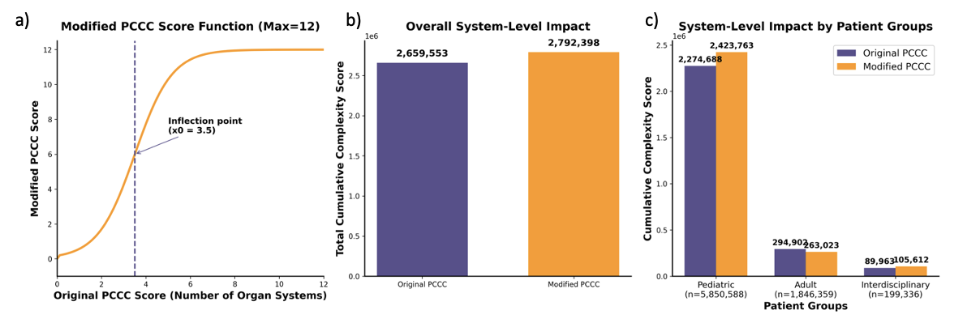
Supplementary Figure 1: Modification of the pediatric complex chronic conditions (PCCC) score
a) Modifcation of the PCCC score using the S-shaped curve to correct for increasing complexity in multiple conditions
b) System level impact of the PCCC score modification on the cumulative complexity of all cases
c) System level impact of the PCCC score modification on the cumulative complexity by department

Supplementary Table 1: Cumulative complexity and inflation factors of the modified compared to the original PCCC score
 | Number of cases | Cumulative complexity |  | Inflation factor | Normalized complexity /1000 cases (95 % CI)
 |  | Original PCCC | Modified PCCC |  | Original PCCC | Modified PCCC
Overall | 7,896,283 | 2,659,553 | 2,792,398 | 1.050
Pediatric | 5,850,588 | 2,274,688 | 2,423,763 | 1.066 | 388.8 (388.1 – 389.5) | 414.3 (413.2 – 415.4)
Adult | 1,846,359 | 294,902 | 263,023 | 0.892 | 159.7 (159.0 - 160.5) | 142.5 (141.5 - 143.4)
Interdisciplinary | 119,336 | 89,963 | 105,612 | 1.174 | 451.3 (446.9 – 455.7) | 529.8 (522.7 – 536.9)

