ROBOTIC ADVANCED TRAINING IN

LAPAROSCOPIC SUTURING

(R-ATLAS)

OVERVIEW

This module is designed to teach advanced knot-tying and suturing skills in a robotic platform. This curriculum consists of 6 needle handling, knot-tying and suturing exercises that are designed to teach advanced skills to individuals who have already mastered basic laparoscopic and robotic suturing. This curriculum is suitable for residents, fellows and practicing surgeons in surgical fields. The ATLAS curriculum was originally developed and implemented for training in laparoscopic suturing. The current curriculum is in continuity of the above-mentioned curriculum and is modified for robotic platform.

- OBJECTIVES

By the end of this training curriculum participants should be able to:
- Demonstrate proficiency in a variety of advanced robotic needle handling skills
- Demonstrate proficiency in a variety of advanced robotic suturing techniques, including suturing with an off-set camera view, using interrupted and continuous suturing, and suturing with spatial constraints
- Demonstrate proficiency in a variety of advanced robotic suturing and knot-tying techniques, including tying with an off-set camera view and tying under tension using a slip knot.

- ASSUMPTIONS

It is assumed that participants will have already mastered basic laparoscopic and robotic suturing and knot-tying either through prior simulation-based training and skill verification, clinical experience, or a combination thereof. At a minimum, individuals should generally be at the level of a resident in a surgical specialty. This curriculum is suitable for residents, fellows and practicing surgeons in surgical fields. This curriculum is generally not recommended for individuals at early stages of technical skill development, such as medical students or junior residents.

- SUGGESTED READINGS

- Nepomnayshy D, Whitledge J, Birkett R, Delmonico T, Ruthazer R, Sillin L, Seymour NE. Evaluation of advanced laparoscopic skills tasks for validity evidence. Surg Endosc. 2015 Feb;29(2):349-54.

- Nepomnayshy D, Alseidi AA, Fitzgibbons SC, Stefanidis D. Identifying the need for and content of an advanced laparoscopic skills curriculum: results of a national survey. Am J Surg. 2016 Feb;211(2):421-5.

- Bilgic E, Watanabe Y, Nepomnayshy D, Gardner A, Fitzgibbons S, Ghaderi I, Alseidi A, Stefanidis D, Paige J, Seymour N, McKendy KM, Birkett R, Whitledge J, Kane E, Anton NE, Vassiliou MC. Simulation Committee of the Association for Surgical Education. Multicenter proficiency benchmarks for advanced laparoscopic suturing tasks. Am J Surg. 2017 Feb 213(2):217-221.

- McKendy KM, Watanabe Y, Bilgic E, Enani G, Munshi A, Lee L, Feldman LS, Fried GM, Vassiliou MC. Establishing meaningful benchmarks: the development of a formative feedback tool for advanced laparoscopic suturing. Surg Endosc. 2017 Dec 24(Suppl 4), 1–9.

- Enani G, Watanabe Y, McKendy KM, Bilgic E, Feldman LS, Fried GM, Vassiliou MC. What are the Training Gaps for Acquiring Laparoscopic Suturing Skills? J Surg Educ. 2017 July, 74(4), 656-662.

- Watanabe Y, McKendy KM, Bilgic E, Enani G, Madani A, Munshi A, Feldman LS, Fried GM, Vassiliou MC. New models for advanced laparoscopic suturing: taking it to the next level. Surg Endosc, 2016 Feb 30:581–587.

- Nepomnayshy D, Fitzgibbons SC, Nijjar B, Gardner A, Stefanidis D, Alseidi AA, Birkett R, Whitledge J. Advanced Laparoscopic Skills: Understanding the relationship between simulation-based practice and clinical performance. Am J Surg, 2019 218(3) 527–532.

- Gabrysz-Forget F, Bonds M, Lovett M, Alseidi AA, Ghaderi I, Nepomnayshy D. Practicing on the Advanced Training in Laparoscopic Suturing Curriculum (ATLAS): Is Mastery Learning In Residency Feasible to Achieve Expert Level Performance in Laparoscopic Suturing? J Surg Educ. 2020 March, S1931-7204(20)30060-X.

- Mathis R, Watanabe Y, Ghaderi I, Nepomnayshy D. What are the skills that represent expert-level laparoscopic suturing? A Delphi Study. Surgical endoscopy. 2020 Mar;34(3):1318-23.

- Ericsson KA. Deliberate practice and the acquisition and maintenance of expert performance in medicine and related domains. Acad Med. 2004 Oct;79(10 Suppl):S70-81.

- DESCRIPTION OF LABORATORY MODULE

This curriculum consists of 3 standardized components: (1) orientation and pre-test (baseline performance), (2) training (self-practice to expert-derived previously established proficiency levels), and (3) post-test (final performance). Optionally, retention testing may be performed. A specific time allotment for curriculum completion is desirable; we recommend that trainees are allotted at least 20 hours of total practice time to complete the curriculum.

The online website provides video tutorials and explanations for each task. For orientation, trainees are expected to review each task video prior to pre-testing. Pre-testing consists of 1 repetition of each task with no-warm up, in consecutive order (task 1, task 2, task 3, task 4, task 5, task 6) with direct observation. The user or administrator will perform data entry with observer attestation.

The orientation and pre-test is followed by a self-training period. During this interval, trainees will document each repetition performed for each of the 6 tasks with a maximum allotted 80 repetitions per task. The goal is to reach the proficiency level of performance for each task on 2 consecutive repetitions. The user or administrator will be responsible for data entry. Once proficiency is reached on each task, trainees will schedule a post-test session with observer attestation, which consists of performing 1 repetition of each task with no-warm up, in consecutive order (task 1, task 2, task 3, task 4, task 5, task 6) with direct observation. Trainees are expected to reach proficiency on the post-test to document successful curriculum completion. Otherwise, remediation and additional training may be required. A video recording, along with performance scores, must be uploaded to the online R-ATLAS database for proficiency verification.

The 6 tasks include:
- Needle Handling
- Off-set Camera Forehand Suture
- Off-set Camera Backhand Suture
- Confined Space Suturing
- Suturing Under Tension
- Continuous Suturing

- TASK SETUP
General information
- da Vinci Abdominal box trainer:

    - Platform: Connect an 8 mm 0 Degree Xi Camera (endoscope) to the Vision cart.
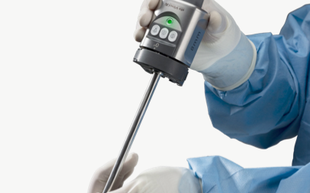

    - Docking: Deploy and dock the Xi robotic system (patient cart) for “UPPER ABDOMINAL”, “PATIENT LEFT”.

    - Trocars – Trocar naming for the task details is as shown below. use 8 mm robotic ports.

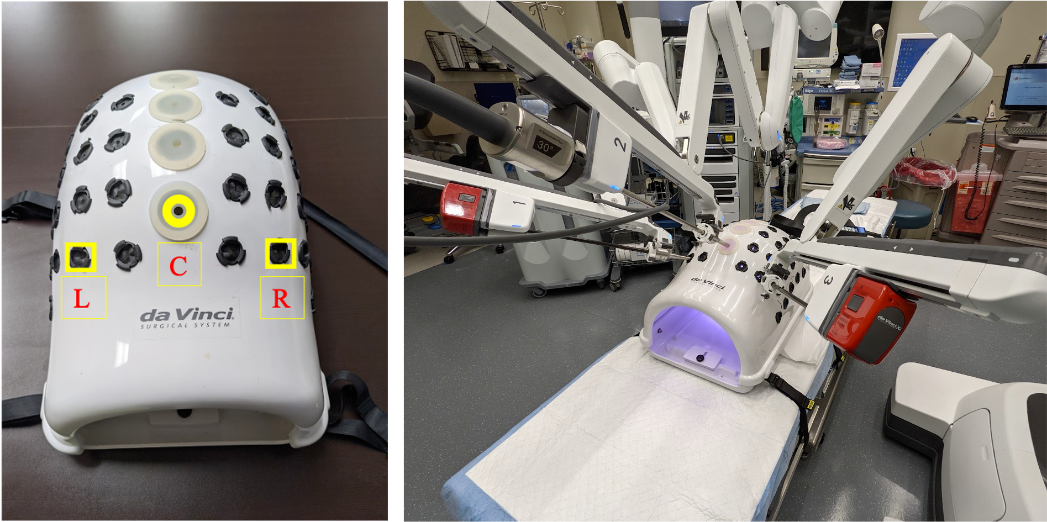

Port placement for center camera placement
L: Left Arm, R: Right Arm, C: Camera

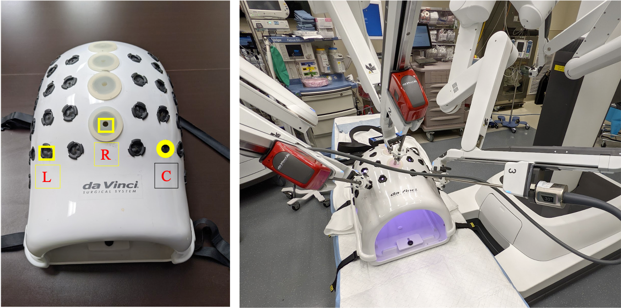

Port placement for Offset placement of camera
L: Left Arm, R: Right Arm, C: Camera

Port placement for center camera placement and Off set ports (
L: Left Arm, R: Right Arm, C: Camera

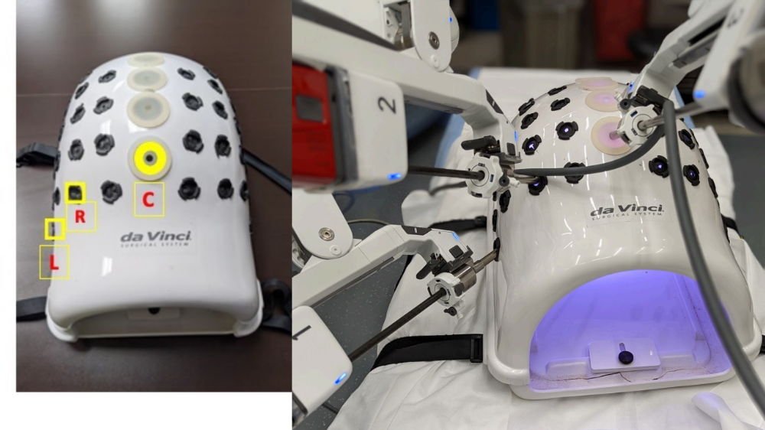

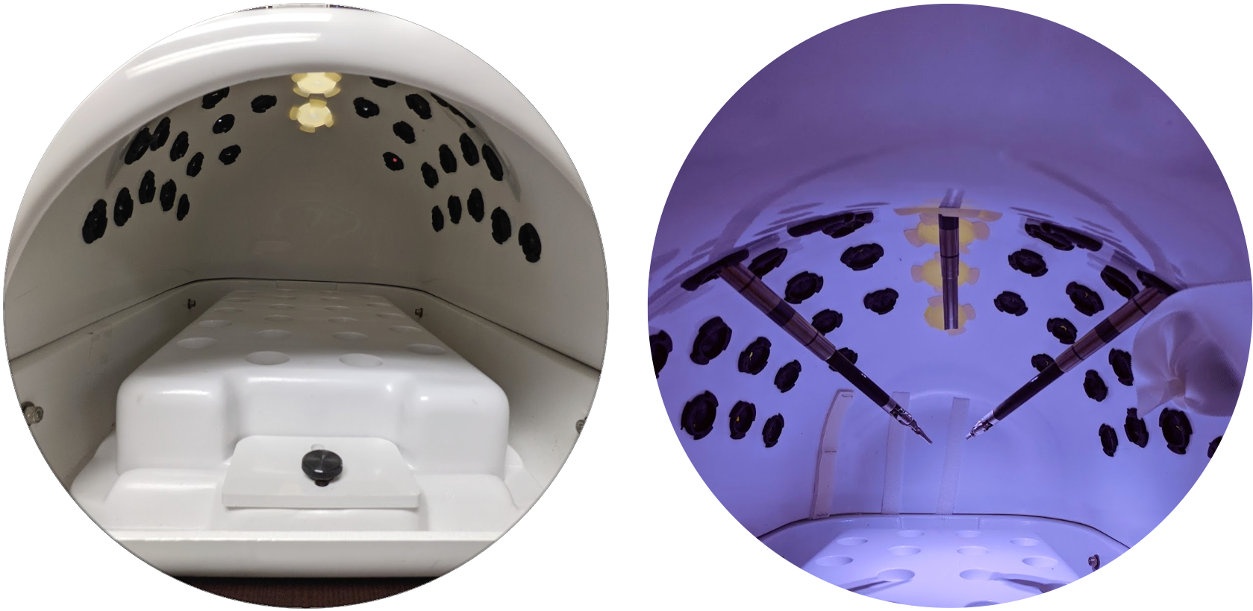

View from inside the Robotic box trainer with mounting block (left), The mounting block should be removed for the experiment (Right)

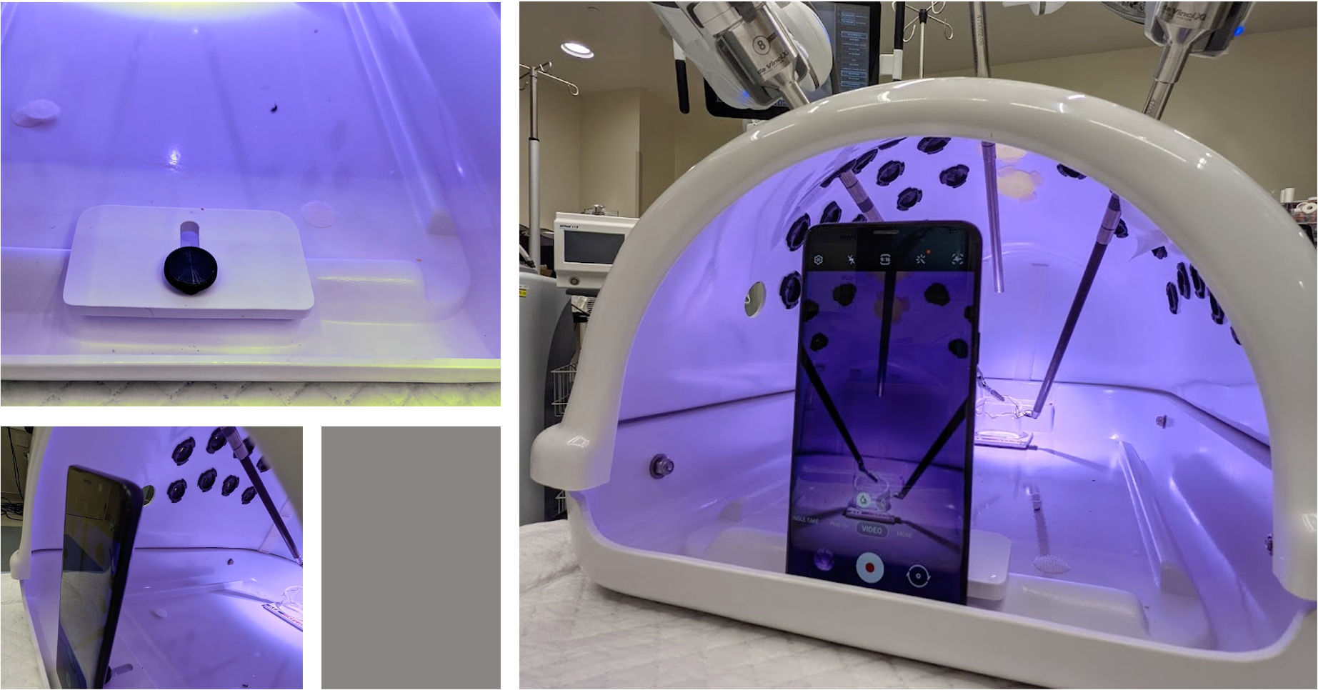

Set up for recording with the Smartphone

    - Suture Length – All tasks use either 15cm or 25cm suture length. 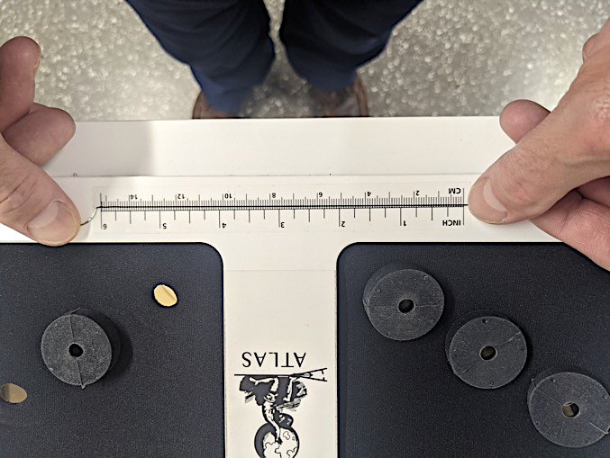

    - Left-handed trainees - This curriculum is currently built for right-handed trainees with photographs representing this set-up. For left-handed trainees, please feel free to mirror image the set-up in order to train. For example, for off-set tasks with the camera to the right and trocars L1 and L3, flip and instead place camera to front left of the box and use ports R1 and R3.
    - Suturing techniques to note
      - Load your needle correctly for each task to facilitate completion
      - Do not grab the needle tip
      - Do not hold the needle while making your loops
      - Alternate hands for square knots
      - Always wrap the same way around the shaft, either over or under. Remain consistent.

- Needle Handling
Camera and Trocar Location | Centered | 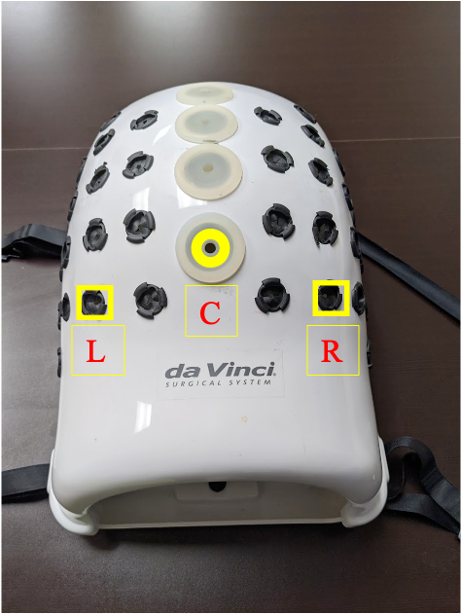
Model Location | Model centered at the end of the box on a Velcro square
Suture Length | 15cm

Steps to switch robotic arms for offset camera forehand a backhand suturing

- Off-set Camera Forehand Suture
Camera and Trocar Location | Off-center | 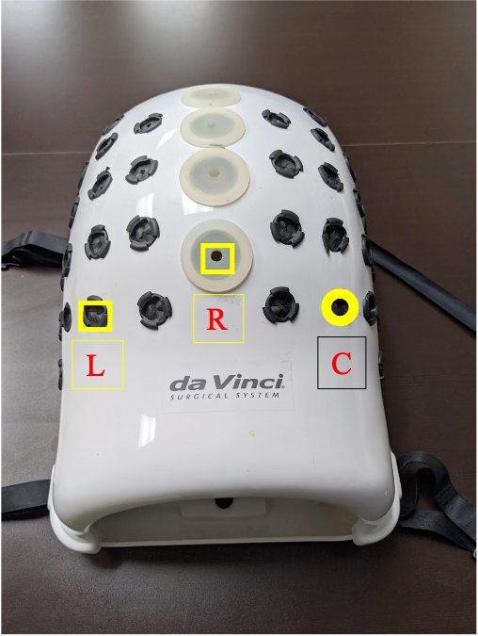
Model Location | Model centered at the end of the box on a Velcro square | 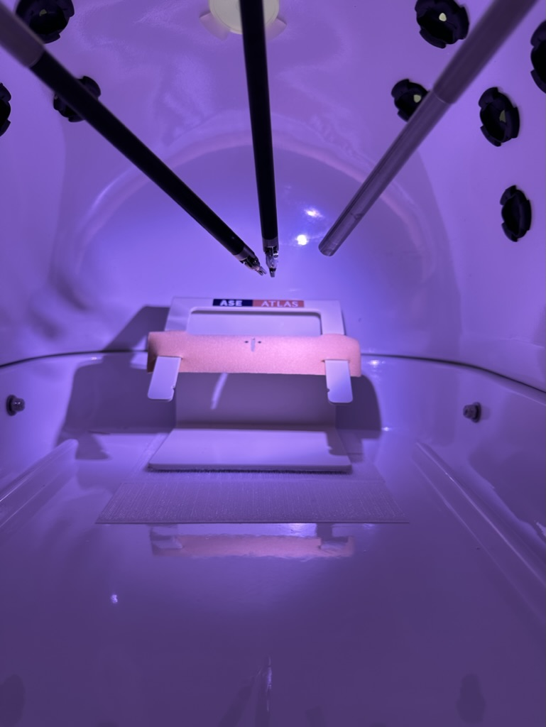
Suture Length | 15cm

- Off-set Camera Backhand Suture
Camera and Trocar Location | Off-center
Model Location | Model centered at the end of the box on a Velcro square
Suture Length | 15cm

- Confined Space Suturing
Camera and trocar Location | Center | 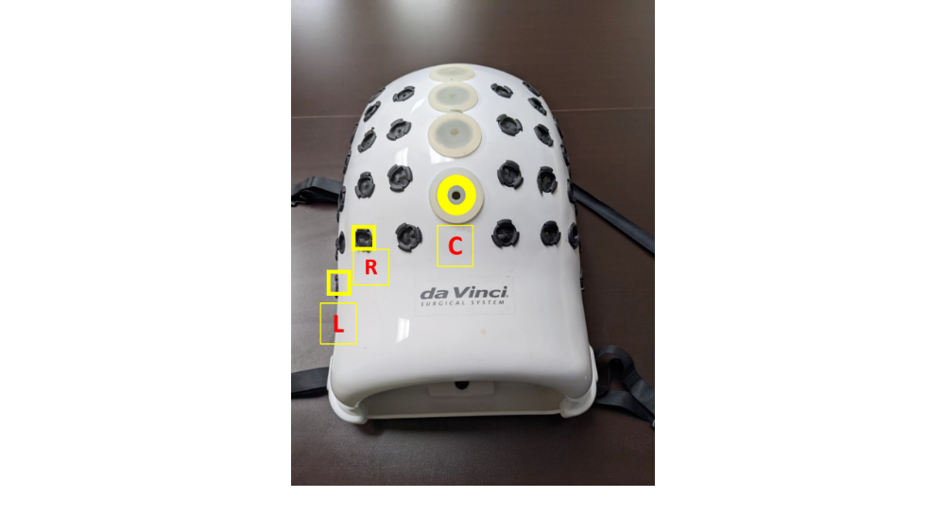
Model Location | Model centered at the end of the box on a Velcro square. Skin pad on the lower two sets of prongs with prongs in front in the center Space constrainer centered (side-to-side) and set immediately in front abutting model. | 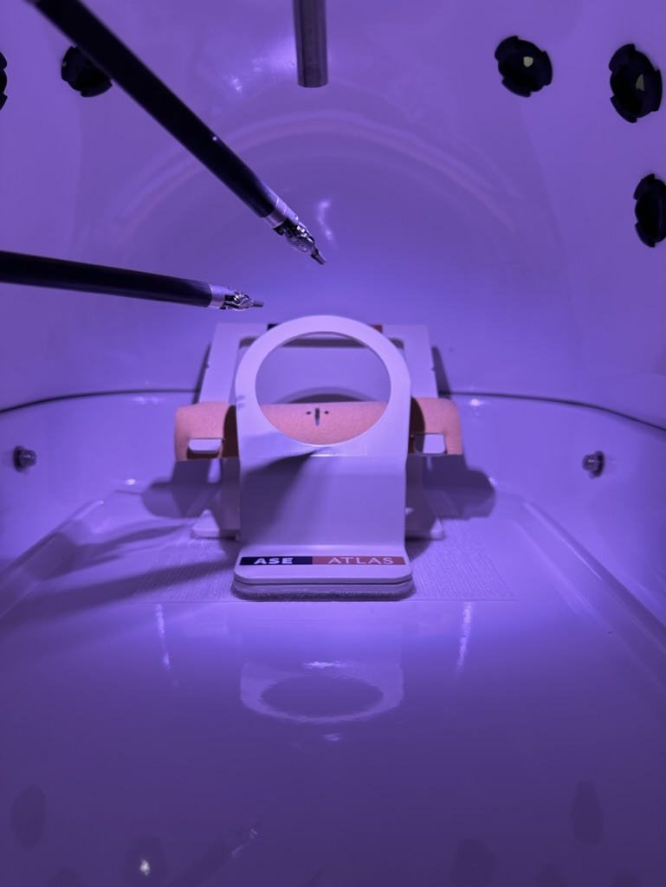
Suture Length | 15cm

- Suturing Under Tension
Camera and trocar Location | Centered
Model Location | Model centered at the end of the box on a Velcro square. Pad location on top and lowest prong sets with prongs in front in the center. | 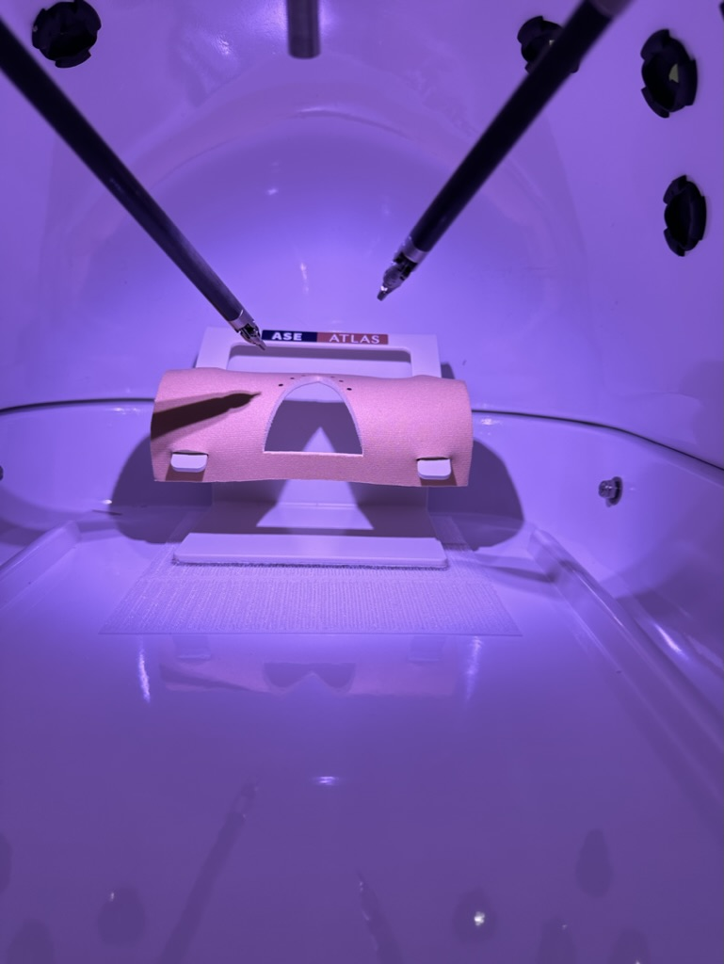
Suture Length | 25cm

- Continuous Suturing
Camera and trocar Location | Centered
Model Location | Model centered at the end of the box on a Velcro square. Skin pad on upper two sets of prongs with prongs in front in the center | 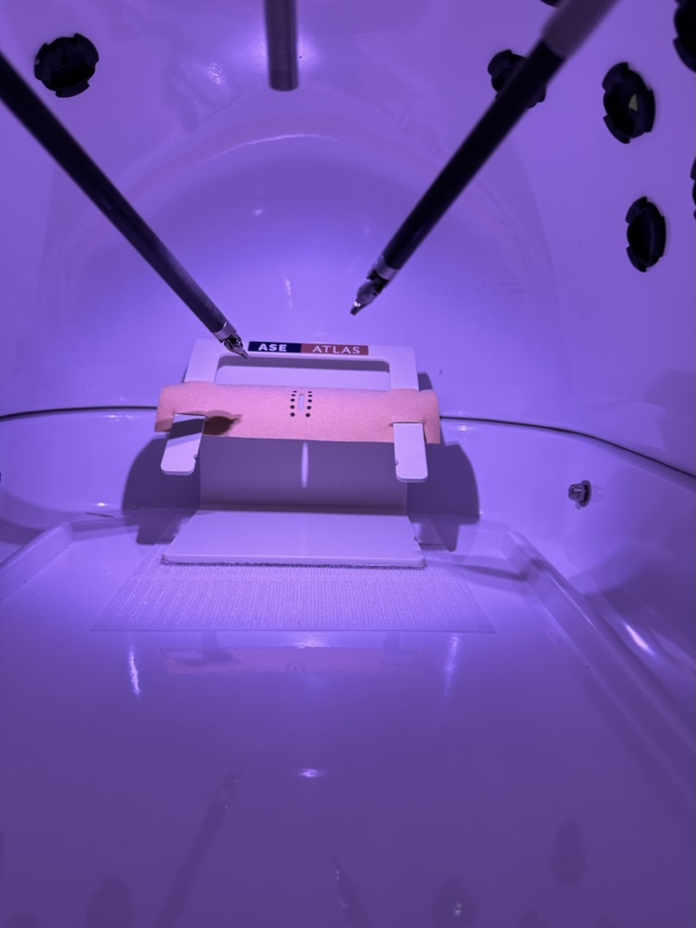
Suture Length | 25cm

- DETAILED TASK DESCRIPTIONS

Task 1 - NEEDLE HANDLING
Summary: This task requires passing a needle through 6 standardized holes oriented at different angles on a circular task platform.
Equipment: 2 needle drivers or 1 needle driver (large needle driver or Mega suture cut) and 1 Cadiere forceps, an 8 mm 30 Degree Xi Camera(endoscope), 3 robotic 8 mm ports, one 15 cm 2-0 Silk suture on an SH needle. Task 1 model with six holes.
Rules: The holes should be penetrated from outside to inside in a sequential, counter-clockwise fashion starting from the top right hole. When the last hole is reached, the string should be removed completely as this will mark the end of the timing period. If the needle is dropped within access of your instrument, pick it up and continue. The time delay will count. If the needle is dropped outside of the instrument’s access, then the task will end. You are not allowed to bend or straighten the needle.
Timing: The timing will start when any instrument is seen on the monitor and will stop when the suture strand is removed from the last hole.
Cutoff time: Maximum time for task completion is 5 minutes (300 seconds). If the task is not completed within the allotted time, you will be asked to stop.
Errors:
Needle Drop Outside of Instrument Access = 30 points
Bending/Straightening Needle = 10 points if needle curve is altered by more than 10%
Scoring Formula: Score = 300 – time – 10 (sum of errors)
Proficiency Score: To be determined
Expert Score: To be determined
Proficiency Training Protocol: Achieve proficiency score on 2 consecutive repetitions (max 80 repetitions)
Proficiency Testing (Pre- and Post-test): 1 repetition
Set up:
- The model is centered at the end of the training box.
- The 30-degree robotic camera is inserted through the C (most caudal centered port site).
- Trocars are inserted through the L and R (most caudal row- second ports from the left and the right)
- Deploy and dock the Xi robotic system in “UPPER ABDOMINAL”, “PATIENT LEFT” position.

Task Completion:
- Grasp the suture strand 2 cm from the needle using a needle driver (either hand) and insert the driver through the corresponding trocar until the suture is visible on the field (Time starts)
- Load your needle into either needle driver in a backhand or forehand configuration
- Start at the top right hole (#1) and introduce the needle from outside to inside
- Regrasp the needle within the model and reload as needed
- Proceed in a counter-clockwise manner, and introduce the needle at the adjacent hole (#2) outside to inside
- Regrasp your need and continue counter-clockwise through the remaining holes in a sequential fashion (#3-6)
- At the final hole at the bottom right (#6) introduce the needle from outside to inside
- Regrasp the needle on the inside and pull the needle and suture strand all the way through the hole (Time stops)
- Note you may alternate hands, load forehand, load backhand, as needed

Tips and Tricks:
- Avoid dropping the needle as additional time will be needed to reload your needle
- One method is to keep the needle loaded backhand or forehand in the right driver the whole time as this angle can work for all holes
- Keep the needle loaded at the tip of the driver; if it is loaded in the middle, the driver can block access to the holes, especially on hole #3
- Load immediately upon tip retrieval at each location to enhance efficiency.
Kick suture tail out completely between holes #3&4 to avoid being tethered later
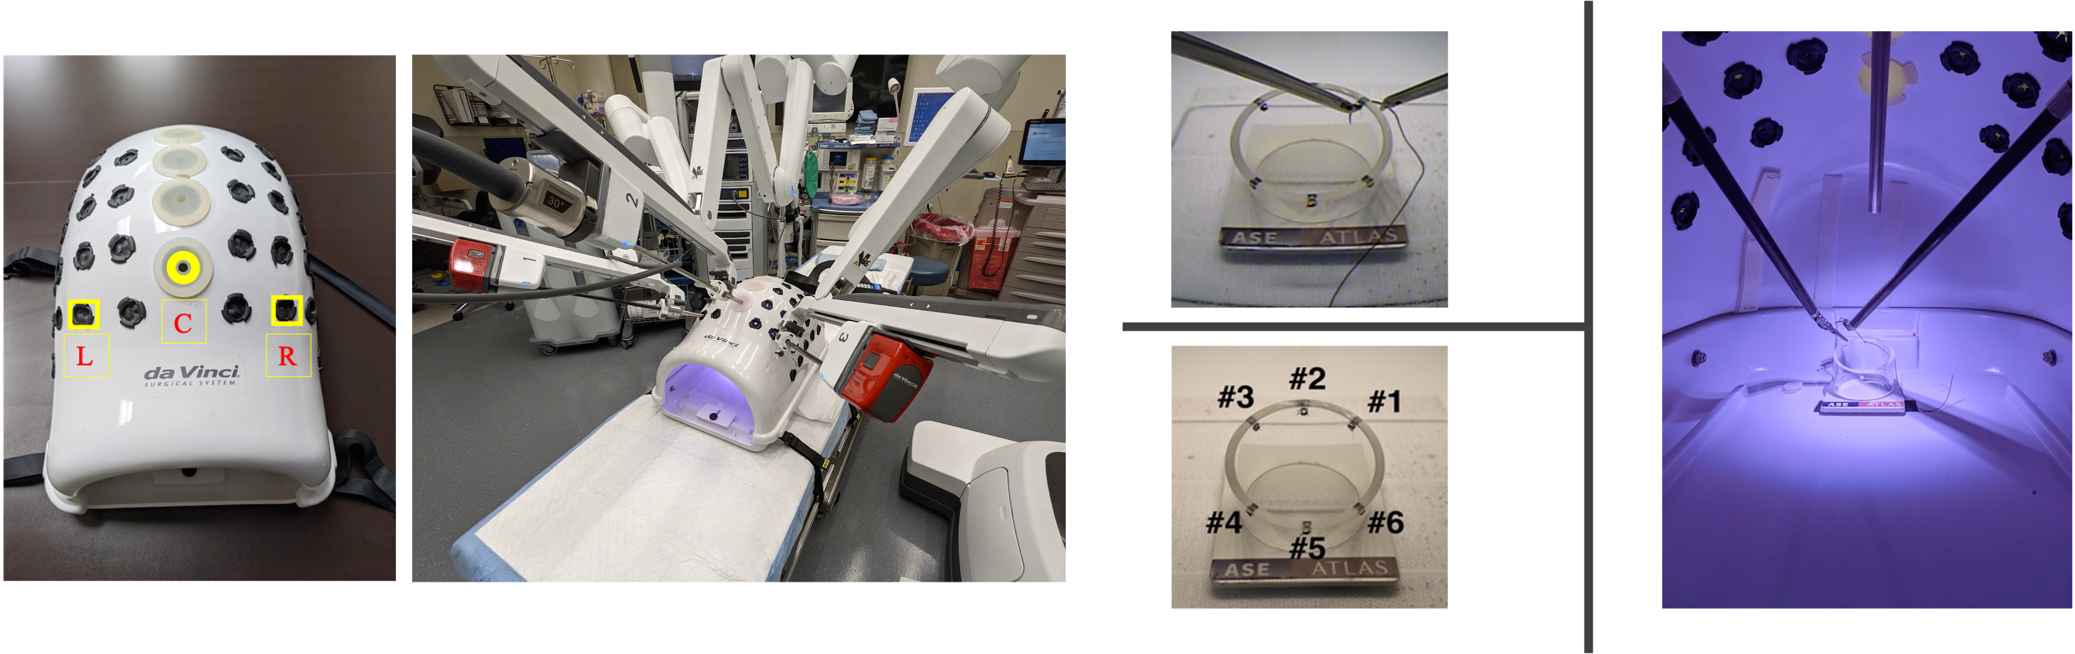

TASK 2 – OFF-SET CAMERA FOREHAND SUTURING
Summary: This task requires throwing a forehand stitch through the two marked dots on the suturing model and then tying a knot intracorporeally.
Equipment: One large needle driver or Mega suture cut and 1 Cadiere forceps, an 8 mm 30 Degree Xi Camera(endoscope), 3 robotic 8 mm ports, and one 15 cm 2-0 Silk suture on an SH needle. Interrupted suture pad with one pair of black dots.
Rules: Use a right-handed forehand suturing technique taking full thickness bites of both sides. The first throw must be a surgeon’s knot, followed by two square knots alternating hands. You will then cut both ends of your suture.
Timing: The timing will start when any instrument is seen on the monitor and will stop when both ends of the suture are cut.
Cutoff time: Maximum time for task completion is 10 minutes (cutoff = 600sec). If the task is not completed within the allotted time, you will be asked to stop.
Errors:
Accuracy = Distance in (mm) suture is outside of the target black dots
Gap (Air knot) = Distance in (mm) between knot and tissue
Slippage = 0 points for secure knot, 10 points for slippage > 3mm, 20 points for disruption
Breakage = 20 points if ligature is broken during any portion of exercise
Not a full thickness bite – 10 points
Bunny ear (tail caught in knot) – 10 points
Holding the needle while tying knots – 10pts
Scoring Formula: Score = 600 – time – 10 (sum of errors)
Proficiency Score: To be determined
Expert Score: To be determined
Proficiency Training Protocol: Achieve proficiency score on 2 consecutive repetitions (max 80 repetitions)
Proficiency Testing (Pre- and Post-test): 1 repetition

Set up:
- Interrupted suture pad placed on model with prongs anterior in the middle of the pad and situated on two upper sets of notches
- The plastic model is centered at the end of the training box in the Velcro square
- The 30-degree robotic camera is off-center inserted through the C (most caudal row, the second port from the right).
- Trocars are inserted through L (the second port from the left) and R (center) through most caudal row.
- Deploy and dock the Xi robotic system in “UPPER ABDOMINAL”, “PATIENT LEFT” position.

Task Completion:
- Grasp the suture strand 2 cm from the needle using a needle driver (either hand) and insert the driver through the corresponding trocar until the suture is visible on the field (Time starts)
- Load your needle forehand in the right needle driver
- Perform a right-handed forehand throw taking a bite on the right side and then on the left side of the suture pad
- Ensure that the needle tip enters and exits through the black dots for accuracy
- Pull the suture out until the tail is short enough to tie (~2-3cm)
- Perform a surgeon’s knot
- Perform an additional two square knots alternating hands
- Remove a needle driver and introduce the laparoscopic scissors
- Cut both tails of your suture 5-10mm (Time stops)

Tips and Tricks:
- Avoid dropping the needle as additional time will be needed to reload your needle
- Load the needle with more of an acute angle (toward from the shaft of the needle driver) to help penetrate and exit during bites
- Grab the tissue at the top of the wound to help manipulate
- Make sure to swap tails
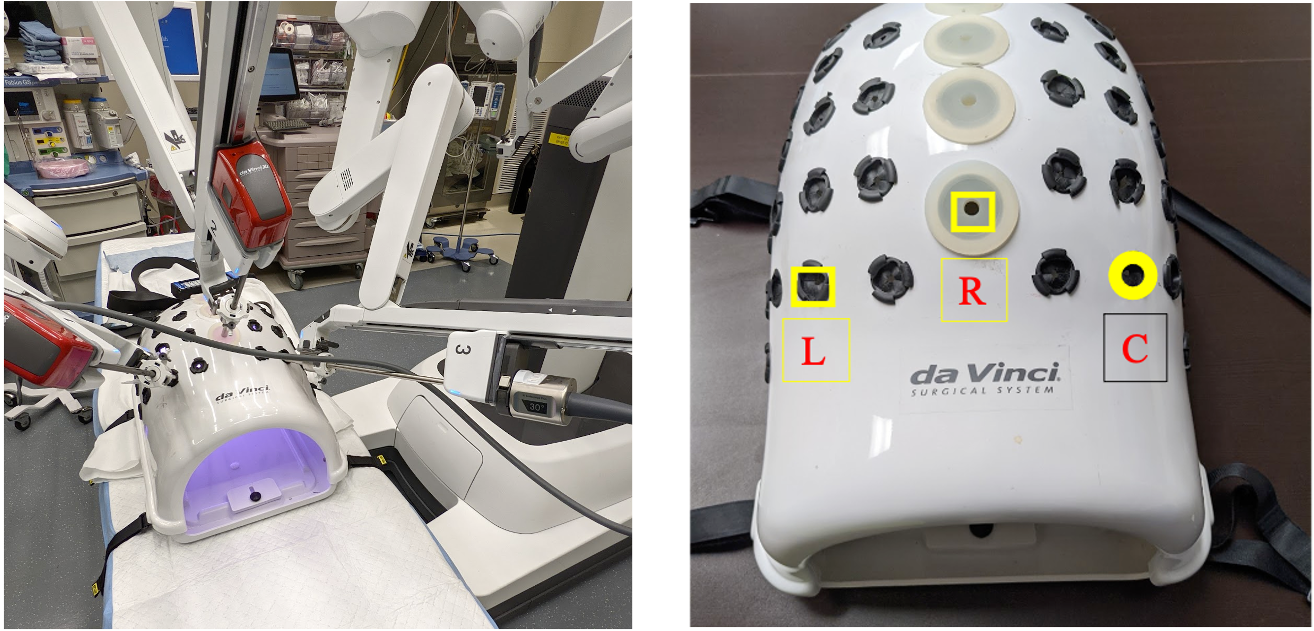

TASK 3- OFF-SET CAMERA BACKHAND SUTURING
Summary: This task requires throwing a backhand stitch through the two marked dots on the tissue model and then tying a knot intracorporeally.
Equipment: One large needle driver or Mega suture cut and 1 Cadiere forceps, an 8 mm 30 Degree Xi Camera(endoscope), 3 robotic 8 mm ports, and one 15cm 2-0 Silk suture on an SH needle. Interrupted suture pad with one pair of black dots.
Rules: Use a right-handed backhand suturing technique taking full thickness bites of tissue. The first throw must be a surgeon’s knot, followed by two square knots. You will then cut both ends of your suture.
Timing: The timing will start when any instrument is seen on the monitor and will stop when both ends of the suture are cut.
Cutoff time: Maximum time for task completion is 10 minutes (cutoff = 600sec). If the task is not completed within the allotted time, you will be asked to stop.
Errors:
Accuracy = Distance in (mm) suture is outside of the target black dots
Gap (Air knot) = Distance in (mm) between knot and tissue
Slippage = 0 points for secure knot, 10 points for slippage > 3mm, 20 points for disruption
Breakage = 20 points if ligature is broken during any portion of exercise
Not a full thickness bite – 10 points
Bunny ear (tail caught in knot) – 10 points
Holding the needle while tying knots – 10pts
Scoring Formula: Score = 600 – time – 10 (sum of errors)
Proficiency Score: To be determined
Expert Score: To be determined
Proficiency Training Protocol: Achieve proficiency score on 2 consecutive repetitions (max 80 repetitions)
Proficiency Testing (Pre- and Post-test): 1 repetition
Set up:
- Interrupted suture pad placed on model with prongs anterior in the middle of the pad and situated on two upper sets of notches
- The plastic model is centered at the end of the training box in the Velcro square
- The 30-degree robotic camera is off-center inserted through the C (the most caudal row, the second port from the right).
- Trocars are inserted through L (the second port from the left) and R (center) through the most caudal row.
- Deploy and dock the Xi robotic system in “UPPER ABDOMINAL”, “PATIENT LEFT” position.

Task Completion:
- Grasp the suture strand 2 cm from the needle using a needle driver (either hand) and insert the driver through the corresponding trocar until the suture is visible on the field (Time starts)
- Load your needle backhand in the right needle driver
- Perform a right-handed backhand throw taking a bite on the left side and then on the right side of the suture pad
- Ensure that the needle tip enters and exits through the black dots for accuracy
- Pull the suture strand out until the tail is short enough to tie to (~2-3cm)
- Perform a surgeon’s knot
- Perform an additional two square knots alternating hands
- Remove a needle driver and introduce the laparoscopic scissors
- Cut both tails of your suture 5-10mm (Time Stops)

Tips and Tricks:
- Avoid dropping the needle as additional time will be needed to reload your needle
- Load the needle with more of an obtuse angle than normal (away from the shaft of the needle driver) to help penetrate and exit during bites
- Grab a the base of tissue to help manipulate
- Go underneath to make your wraps
- Make sure to swap tails

Task 4- CONFINED SPACE SUTURING
Summary: This task requires inserting the needle through the two marked dots on the tissue and then tying a knot intracorporeally inside a space constrainer.
Equipment: One large needle driver or Mega suture cut and 1 Cadiere forceps, an 8 mm 30 Degree Xi Camera (endoscope), 3 robotic 8 mm ports. Interrupted Suture pad with one pair of black dots and space constrainer.
Rules: Use a right-handed forehand suturing technique. The first throw must be a surgeon’s knot, followed by two square knots. It is allowable for instruments to touch the edge of the space constrainer. However, you should avoid using excessive force causing the model to move.
Timing: The timing will start when any instrument is seen on the monitor and will stop when both ends of the suture are cut.
Cutoff time: Maximum time for task completion is 10 minutes (cutoff = 600sec). If the task is not completed within the allotted, you will be asked to stop.
Errors:
Accuracy = Distance in (mm) suture is outside of the target black dots
Gap (Air knot) = Distance in (mm) between knot and tissue
Slippage = 0 points for secure knot, 10 points for slippage > 3mm, 20 points for disruption
Breakage = 20 points if ligature is broken during any portion of exercise
Not a full thickness bite – 10 points
Bunny ear (tail caught in knot) – 10 points
Holding the needle while tying knots – 10pts
Dislodging space constrainer – 30pts
Scoring Formula: Score = 600 – time – 10 (sum of errors)
Proficiency Score: To be determined
Expert Score: To be determined
Proficiency Training Protocol: Achieve proficiency score on 2 consecutive repetitions (max 80 repetitions)
Proficiency Testing (Pre- and Post-test): 1 repetition

Set up:
- Interrupted suture pad placed on model with prongs anterior in the middle of the pad and situated on two lower sets of notches
- The plastic model is centered at the end of the training box in the Velcro square
- The space constrainer is placed immediately in-front with its back edge touching the model front edge and situated centered side-to-side
- The 30-degree robotic camera is off-center inserted through the C ((most caudal centered port site).
- Trocars are inserted through L (the most lateral port from the left) and R (the second port from the left) through most caudal row.
- Deploy and dock the Xi robotic system in “UPPER ABDOMINAL”, “PATIENT LEFT” position.

Task Completion:
- Grasp the suture strand 2 cm from the needle using a needle driver (either hand) and insert the driver through the corresponding trocar until the suture is visible on the field (Time starts)
- Load your needle into the right needle driver in a forehand configuration
- Perform a right-handed forehand throw taking a bite on the right side and then on the left side of the suture pad
- Ensure that the needle tip enters and exits through the black dots for accuracy
- Pull the suture strand out until the tail is short enough to tie to (~2-3 cm)
- Perform a surgeon’s knot
- Perform an additional two square knots alternating hands
- Remove needle driver and introduce the laparoscopic scissors
- Cut both tails of your suture 5-10mm (Time Stops)

Tips and Tricks:
- Avoid dropping the needle as additional time will be needed to reload your needle
- Load the needle slight obtuse (away from shaft of needle driver)
- Grab at the base of the pad to manipulate the tissue
- Wrap closer to the suture pad, and over with tips facing each other to help with the wrap
- The suture tail will alternate left to right, the left hand will not be able to grasp the tail on the left, so alternate hands when throwing knots.
- Bring work closer to camera to increase your space
- Cut your tails on the right-hand side
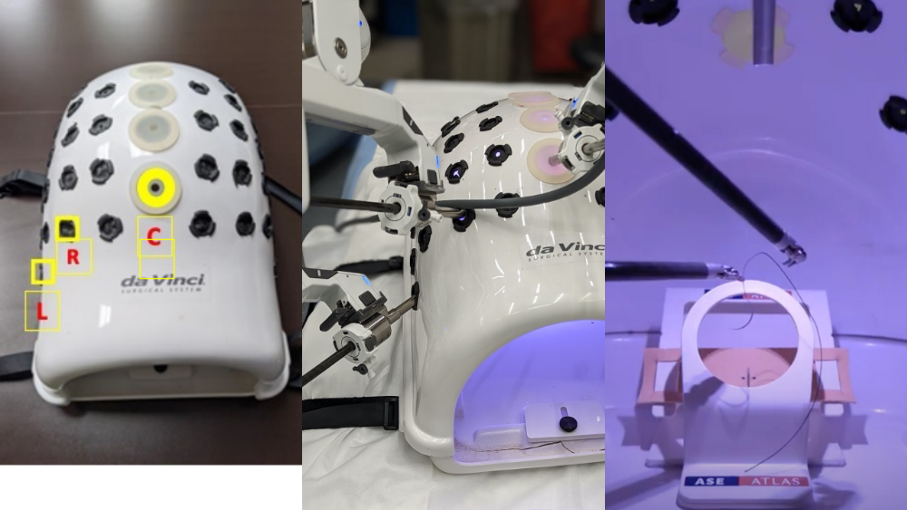

TASK 5 – TENSION SUTURING
Summary: This task requires closure of a gap under tension using one interrupted suture with a slip knot technique.
Equipment: One large needle driver or Mega suture cut and 1 Cadiere forceps, an 8 mm 30 Degree Xi Camera (endoscope), 3 robotic 8 mm ports and three 25 cm 2-0 Silk sutures on SH needle. Tension suture pad with three pairs of black dots.
Rules: Use a right-handed forehand suturing technique to close the last pair of dots at the widest part of the triangular opening. The first throw must be a slip knot, followed two square knots. You will then cut both ends of your suture.
Timing: The timing will start when any instrument is seen on the monitor and will stop when the tails are cut.
Cutoff time: Maximum time for task completion is 5 minutes (cutoff = 300sec). If the task is not completed within the allotted time, you will be asked to stop.
Errors:
Accuracy = Distance in (mm) suture is outside of the target black dots
Gap (Air knot) = Distance in (mm) between knot and tissue
Slippage = 0 points for secure knot, 10 points for slippage > 3mm, 20 points for disruption
Breakage = 20 points if ligature is broken during any portion of exercise
Not a full thickness bite – 10 points
Bunny ear (tail caught in knot) – 10 points
Holding the needle while tying knots – 10pts
Scoring Formula: Score = 300 – time – 10 (sum of errors)
Proficiency Score: To be determined
Expert Score: To be determined
Proficiency Training Protocol: Achieve proficiency score on 2 consecutive repetitions (max 80 repetitions)
Proficiency Testing (Pre- and Post-test): 1 repetition

Set up:
- Tension suture pad placed on model with prongs anterior in the middle of the pad and situated on top-most and bottom-most sets of notches
- The model is centered (front-to-back and side-to-side) at the end of the training box.
- The 30-degree robotic camera is inserted through the C (the most caudal centered port site).
- Trocars are inserted through the L and R (the most caudal row- the second port from the left and the right)
- Deploy and dock the Xi robotic system in “UPPER ABDOMINAL”, “PATIENT LEFT” position.

Task Completion:
- Grasp the suture strand 2 cm from the needle using a needle driver (either hand) and insert the driver through the corresponding trocar until the suture is visible on the field (Time starts)
- Load your needle forehand in the right needle driver
- Perform a right-handed forehand throw taking a bite on the right side and then on the left side of the tension suture pad at the third pair of dots (widest part of the triangle)
- Ensure that the needle tip enters and exits through the black dots for accuracy
- Perform a slip knot by following steps #7-12
- Perform a single throw with one hand leaving the tail adequately long (~4-5cm) followed by another single throw in the opposite direction with the opposite hand
- Snug this down but without tightening them completely
- Pull on the suture (needle side) and allow the knot to slip, if this works skip to step #12, if not proceed with steps #10-11
- Hold the suture strand connected to the needle taut in one needle driver and grasp the same strand below the knot in the other
- Pull the needle drivers in opposite directions until “give” is felt when the knot flips directions and converts to a slip knot configuration
- Continue to hold the suture strand connected to the needle in the driver taut, straddle the strand just above the knot with the opposite needle driver, and push the knot down with the left needle driver until it is tight against the foam
- Continue to hold the suture strand connected to the needle taut and use the free hand to grasp the tail of the suture with and pull in the opposite direction from your other needle driver to secure (lock) the knot
- Perform an additional two square knots alternating hands
- Remove a needle driver and introduce the laparoscopic scissors
- Cut both tails of your suture 5-10mm (Time stops)

Tips and Tricks:
- Avoid dropping the needle as additional time will be needed to reload your needle
- Load the needle with more of an obtuse angle than normal (needle away from the shaft of the needle driver) to help penetrate and exit during bites
- Stabilize the material with the left driver grasping at just above the dot on the right side. On the left side, grab the foam with the needle to help lift and readjust grab.

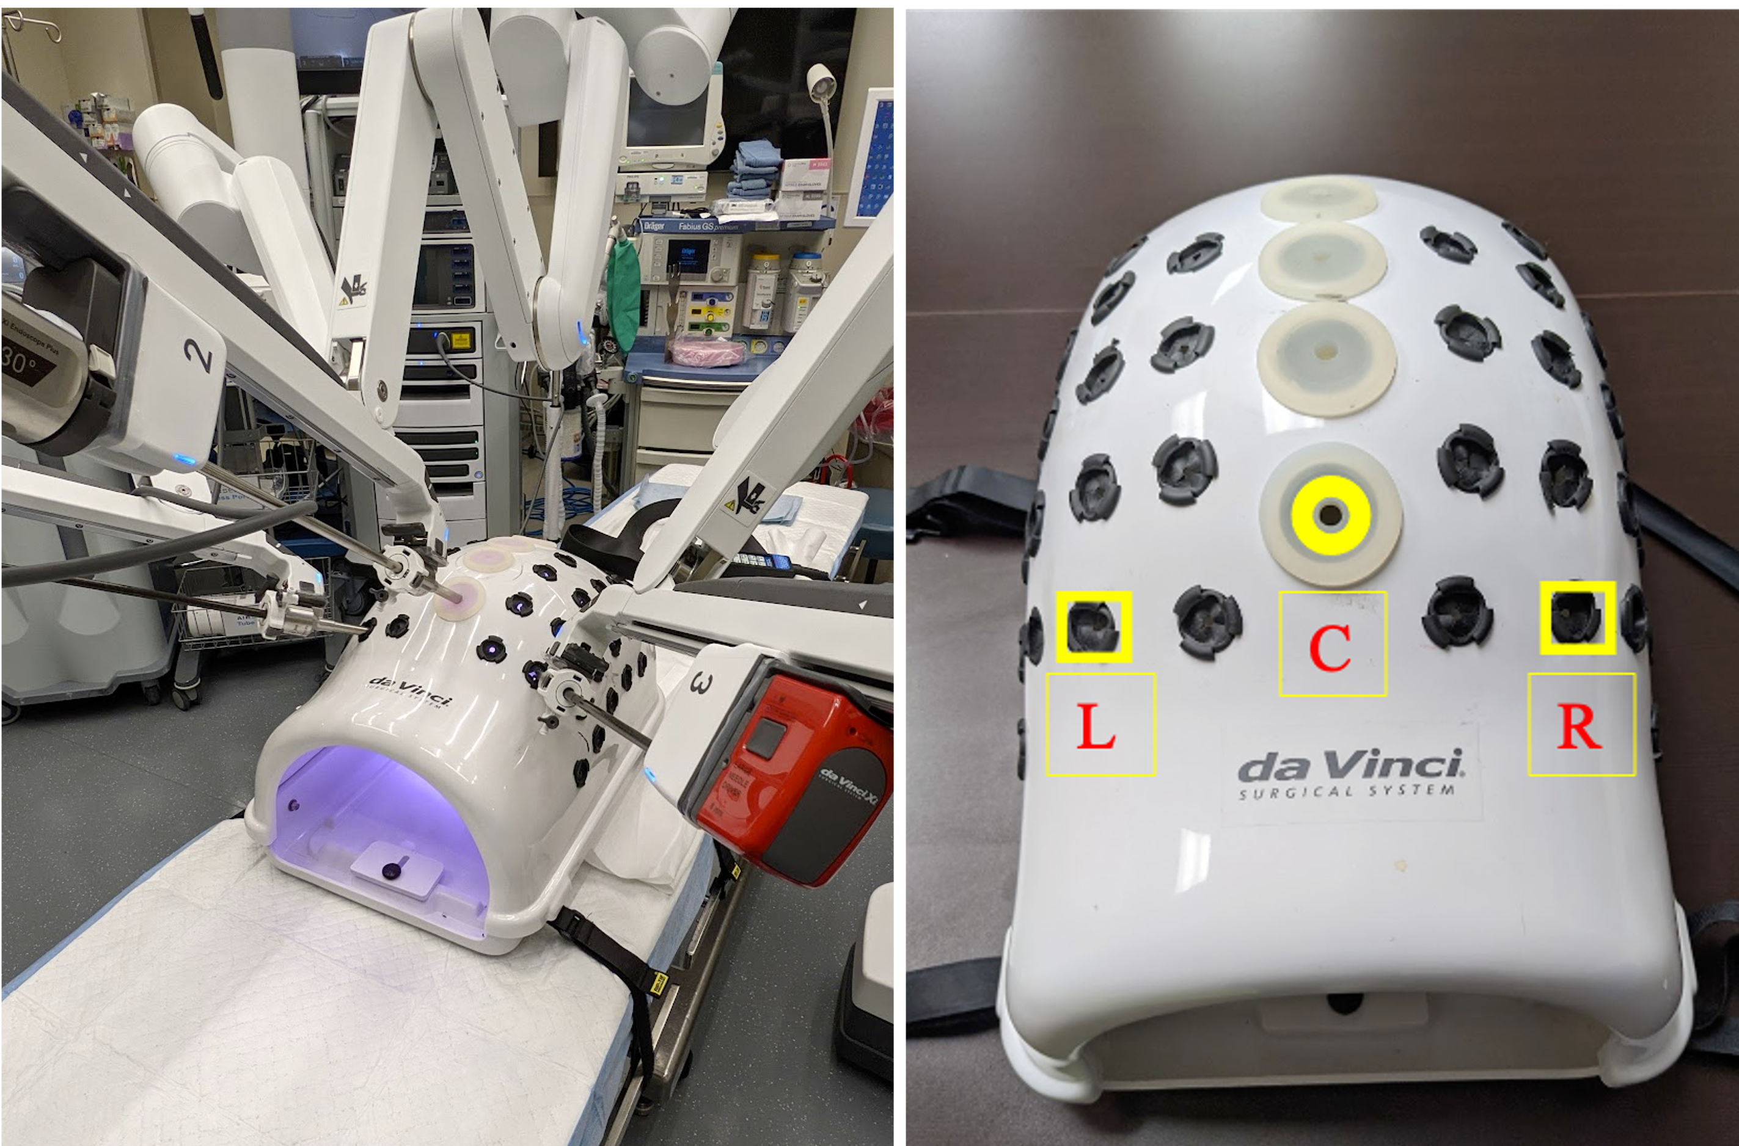

TASK 6 – RUNNING SUTURE
Summary: This task requires closure of a defect using continuous suturing and two intracorporeal knots.
Equipment: One large needle driver or Mega suture cut and 1 Cadiere forceps, an 8 mm 30 Degree Xi Camera(endoscope), 3 robotic 8 mm ports and one 25 cm 2-0 Silk suture on an SH needle. Continuous suture pad with five pairs of black dots.
Rules: Use a right-handed forehand suturing technique. First throw must be a surgeon’s knot, followed by two square knots. Continue with 4 running tissue bites. End with a surgeon’s knot to the loop, followed by two square knots. You will then cut both ends of your suture. You must take full thickness bites of tissue
Timing: The timing will start when any instrument is seen on the monitor and will stop when the suture is cut after closing the defect.
Cutoff time: Maximum time for task completion is 15 minutes (cutoff = 900sec). If the task is not completed within the allotted time, you will be asked to stop.
Errors:
Accuracy = Distance in (mm) suture is outside of the target black dots
Gap (Air knot) = Distance in (mm) between knot and tissue
Slippage = 0 points for secure knot, 10 points for slippage > 3mm, 20 points for disruption
Breakage = 20 points if ligature is broken during any portion of exercise
Not full thickness bites – 10 points each
Bunny ear (tail caught in knot) – 10 points
Holding the needle while tying knots – 10pts
Scoring Formula: Score = 900 – time – 10 (sum of errors).
Proficiency Score: To be determined
Expert Score: To be determined
Proficiency Training Protocol: Achieve proficiency score on 2 consecutive repetitions (max 80 repetitions)
Proficiency Testing (Pre- and Post-test): 1 repetition

Set up:
- Continuous suture pad placed on model with prongs anterior in the middle of the pad and situated on two upper sets of notches
- The model is centered (front-to-back and side-to-side) at the end of the training box.
- The 30-degree robotic camera is inserted through the C (the most caudal centered port site).
- Trocars are inserted through the L and R (the most caudal row- the second port from the left and the right)
- Deploy and dock the Xi robotic system in “UPPER ABDOMINAL”, “PATIENT LEFT” position.

Task Completion:
- Grasp the suture strand 2 cm from the needle using a needle driver (either hand) and insert the driver through the corresponding trocar until the suture is visible on the field (Time starts)
- Load your needle forehand in the right needle driver.
- Perform a throw at the top most pair of black dots (#1)
- Perform a right-handed forehand throw taking a bite on the right side and then on the left side of the suture pad
- Ensure that the needle tip enters and exits through the black dots for accuracy
- Pull the suture strand out until the tail is short enough to tie to (~2-3 cm)
- Perform a surgeon’s knot
- Perform an additional two square knots alternating hands
- Reload your needle
- Perform a right-handed forehand throw taking a bite on the right side and then on the left side of the suture pad at the subsequent pair of black dots (#2)
- Repeat step 10 sequentially with positions #3 and #4. Pull the suture tight between passes.
- Perform a right-handed forehand throw taking a bite on the right side and then on the left side of the suture pad at the last pair of black dots (#5)
- Do not pull the suture tight, rather leave a loop to tie to
- Perform a surgeon’s knot to the loop ensuring to make both sides of the loop equal. Do this by either leaving the jaw of the needle drive open while seating the knot or putting one jaw in and lifting up to make both sides equal prior to closing the jaws on the suture
- Perform two additional throws alternating hands
- Remove your needle driver and introduce the laparoscopic scissors
- Cut both suture tails 5-10mm (Time stops)

Tips and Tricks:
- Avoid dropping the needle as additional time will be needed to reload your needle
- Keep the tail short on the first anchoring knot. This will save you time in not having to cut it later and ensure adequate length for the remaining suture. Furthermore, it will not get caught in the following throws
- Use the tail as a handle to manipulate the tissue
- Cut both tails at the end if you need to save time on swapping instruments
- Grab the loop at the apex or adjust with the jaw open to make sure the sides are even before securing the final knot

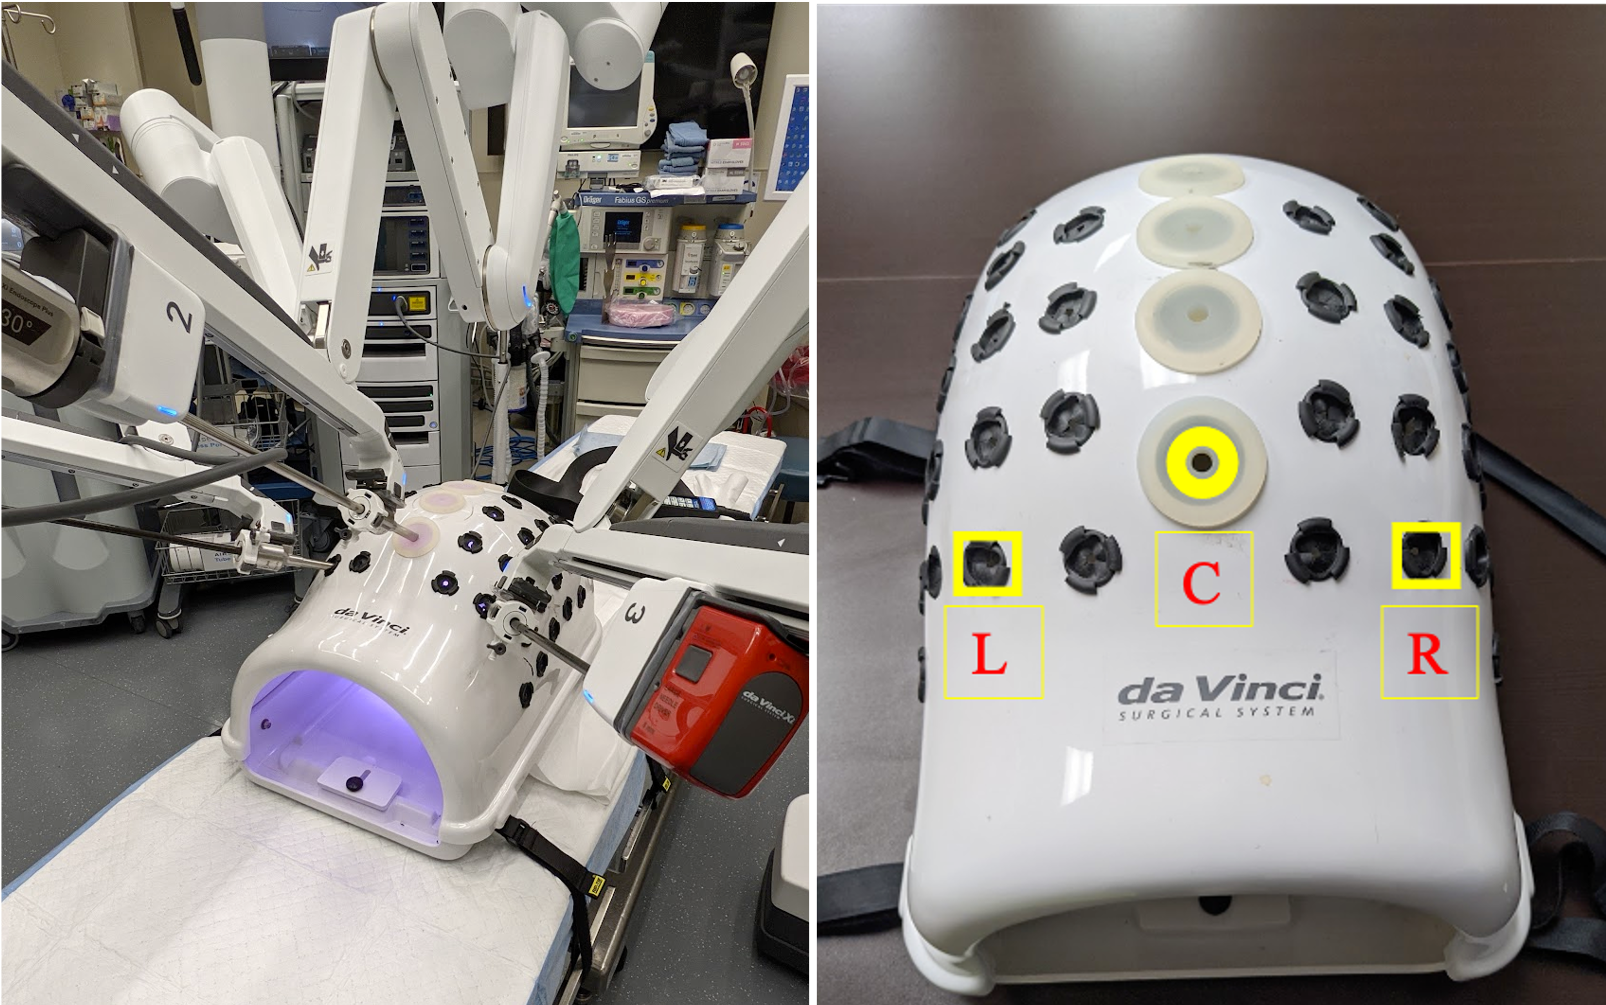

- EXPERT PERFORMANCE

Performance goals and proficiency levels for each of the 6 tasks will be derived from mean performance by expert surgeons. Participants were eligible to participate if they performed 25+ robotic suturing cases per year.

Tasks | Proficiency Score | Proficiency Time | Scoring Formula
1 | TBD | TBD | 300 - time – 10 (sum of errors)
2 | TBD | TBD | 600 - time – 10 (sum of errors)
3 | TBD | TBD | 600 - time – 10 (sum of errors)
4 | TBD | TBD | 600 - time – 10 (sum of errors)
5 | TBD | TBD | 300 - time – 10 (sum of errors)
6 | TBD | TBD | 900 - time – 10 (sum of errors)

- RECOMMENDATIONS FOR PRACTICE

  - Distributed Practice

For optimal benefits, self-training and practice should be conducted in a distributed fashion, in which individual training sessions are limited to relatively small durations in length. We recommend a maximum duration of up to 2 hours per training session (not to exceed 2 sessions in 1 day) so as to ensure that mental and physical fatigue is minimized and maximum retention and acquisition of technical skills is achieved. Practice sessions may be conducted (based on the trainee’s discretion and time availability) multiple times per week.

  - Structured Practice

This curriculum should be administered in a structured fashion with specific timelines designated for all components (orientation, pre-test, training, and post-test). Progress should be monitored so that completion is ensured.

  - Practice Order

The 6 tasks for this curriculum must be practiced in order. Trainees should begin at Task 1 and move to the following task once expert level proficiency (or the maximum number of 80 repetitions) has been achieved or documented, respectively.

  - Track Performance

The score from each repetition should be recorded in the database so that the trainee and mentors can readily track their own progress. By monitoring trainee performance, mentoring and feedback can be provided to individuals who are having difficulty acquiring skills.

  - Deliberate Practice

As defined by Dr. K Anders Ericsson, deliberate practice consists of three components: (1) improving particular aspects of performance for a discrete task with (2) immediate and detailed feedback and the (3) opportunity for repeated practice. Thus we recommend for trainees to set aside time to practice in dedicated intervals towards with observation for directed feedback. Furthermore, we have provided both proficiency levels and expert levels as we hope trainees will train to proficiency with deliberate practice and even surpass it to better enhance their performance.

- SUPPLIES & STATION SETUP

  - Needle Handling
    - One large needle driver or Mega suture cut and 1 Cadiere forceps, an 8 mm 30 Degree Xi Camera(endoscope), 3 robotic 8 mm ports
    - 2-0 silk suture, 15cm on an SH needle (x1).
    - Model with 6 holes (x1)
  - Off-set Camera Forehand Suturing
    - One large needle driver or Mega suture cut and 1 Cadiere forceps, an 8 mm 30 Degree Xi Camera(endoscope), 3 robotic 8 mm ports
    - 2-0 silk suture, 15cm on an SH needle (x1)
    - Interrupted suture pad with 1 pair of black dots (x1)
  - Off-set Camera Backhand Suturing
    - One large needle driver or Mega suture cut and 1 Cadiere forceps, an 8 mm 30 Degree Xi Camera(endoscope), 3 robotic 8 mm ports
    - 2-0 silk suture, 15cm on an SH needle (x1)
    - Interrupted suture pad with 1 pair of black dots (x1)
  - Confined Space Suturing
    - One large needle driver or Mega suture cut and 1 Cadiere forceps, an 8 mm 30 Degree Xi Camera(endoscope), 3 robotic 8 mm ports
    - 2-0 silk suture, 15cm on an SH needle (x1)
    - Interrupted suture pad with 1 pair of black dots (x1)
    - Space constrainer (x1)
  - Suturing Under Tension
    - One large needle driver or Mega suture cut and 1 Cadiere forceps, an 8 mm 30 Degree Xi Camera(endoscope), 3 robotic 8 mm ports
    - 2-0 silk suture, 25cm on an SH needle (x3)
    - Tension suture pad with 3 pairs of black dots (x1)
  - Continuous Suturing
    - One large needle driver or Mega suture cut and 1 Cadiere forceps, an 8 mm 30 Degree Xi Camera(endoscope), 3 robotic 8 mm ports
    - 2-0 silk suture, 25cm on an SH needle (x1)
    - Continuous suture pad with 5 pairs of black dots (x1)

- TIME LENGTH FOR MODULES

  - Orientation

The video tutorial and website review consists of dedicated content for each task with some information and video demonstrations for correct performance as well as separate videos for common pitfalls and tips to avoid them. Reviewing this information takes approximately 2 hours.

  - Pre-Test

A monitored pre-test is conducted for all trainees participating in this curriculum. This requires a time allotment of approximately 1 hour.

  - Average training (Self-Practice) Duration

The goal is to achieve proficiency through deliberate practice. Average times to achieving proficiency will be determined.

Task | Task 1 | Task 2 | Task 3 | Task 4 | Task 5 | Task 6
Average time to Proficiency (hr) | TBD | TBD | TBD | TBD | TBD | TBD

  - Post-Test

A monitored post-test is administered upon documenting proficiency for all tasks during the training period. This requires a maximum time allotment of approximately 25-45 minutes (without set-up time included).

