Supplementary Materials

Giant Spin-Orbit Magnetic State Readout Enhanced by a Magnetic Tunnel Junction

Yan Huang^{1,2,†}, Kun Zhang^{1,2,†,}*, Guo Liu^{1,†}, Xiaobai Ning^{1,†}, Shiyang Lu^{1,2}, Wenlong Cai^{1,2}, Yuxuan Yao¹, Yu He¹, Jinkai Wang¹, Qing Yang¹, Bo Li¹, Haozhe Yang¹, Kewen Shi¹, Kaihua Cao^{1,2}, Chao Zhao¹, Yue Zhang^{1,2,}*, and Weisheng Zhao^{1,2,}*

¹Fert Beijing Research Institute, MIIT Key Laboratory of Spintronics, School of Integrated Circuit Science and Engineering, Beihang University, Beijing 100191, P. R. China.
²Integrated Circuit and Intelligent Instruments Innovation Center, Qingdao Research Institute, Beihang University, Qingdao 266101, P. R. China.
†These authors contribute equally to this work.
*E-mail: zhang_kun@buaa.edu.cn; yz@buaa.edu.cn; weisheng.zhao@buaa.edu.cn

Table of Contents
S1. Evaluation of various Hall effects
S2. Derivation process of MTJ-modulation effect
S3. Characterization of spin Hall angle of W
S4. Detailed description of the numerical model
S5. Processing logic using “MTJ+MESO” unit

S1. Evaluation of various Hall effects
Our multiterminal device facilitates the comprehensive evaluation of various Hall effect signals. We recall this sketch in Supplementary Fig. 1a, and inset shows the top view of the cross W-channel. At first, the conventional direct Hall effect (DHE) voltage arises in the W layer influenced by the out-of-plane (OOP) stray field arising from free layer CoFeB. When free layer magnetization switches, the OOP stray field is inversed, inducing DHE voltage to reverse. We assess DHE by applying a current from lead 1 to 3 with voltage measured between lead 2 and¹. The DHE result (V₂₄ in Supplementary Fig. 1b, red curve) shows no distinct steps during the magnetization switching of CoFeB free layer with magnetic field, indicating a negligible DHE signal. Meanwhile, planar Hall effect (PHE) components are observed in V₂₄ as peaks in Supplementary Fig. 1b. The PHE affects the evaluation of the spin-to-charge conversion (SCC) signal when we focus on field region of -20 Oe ~ +20 Oe, but are deemed non-impactful when the field exceeds H_{c} and thus can be ignored². The bottom electrode resistance R_{BE} fluctuates near the average value 2275 Ω and 2260 Ω for R₁₃ (black curve) and R₂₄ (blue curve), respectively.
Moreover, anomalous Hall effect (AHE), due to the symmetry between OOP injection current and in-plane magnetizations, which can be evaluated by numerical model or finite element simulation². We measured its resistivity ρ_{AHE} at first, from the Hall signal by sweeping OOP field between ±2.5T, using a full-film cross device. The result is shown in Supplementary Fig. 1c. We evaluated the upper boundary of ρ_{AHE} by attributing the AHE resistance difference ($\text{2∆}{\text{R}}_{\text{AHE}}$=2 Ω) totally to the bottom 1.9-nm-thick CoFeB and derived a value of ${\text{ρ}}_{\text{AHE}}\text{=∆}{\text{R}}_{\text{AHE}}\text{∙}{\text{t}}_{\text{CoFeB}}$= 0.19 μΩ·cm, comparable with previous study². Considering ${\text{ρ}}_{\text{CoFeB}}$ is about 70 μΩ·cm in our study, the anomalous Hall angle is less than 1%. These parameters would give a negligible influence (less than 70 mΩ) compared with the total output resistance signal presented in the main text.

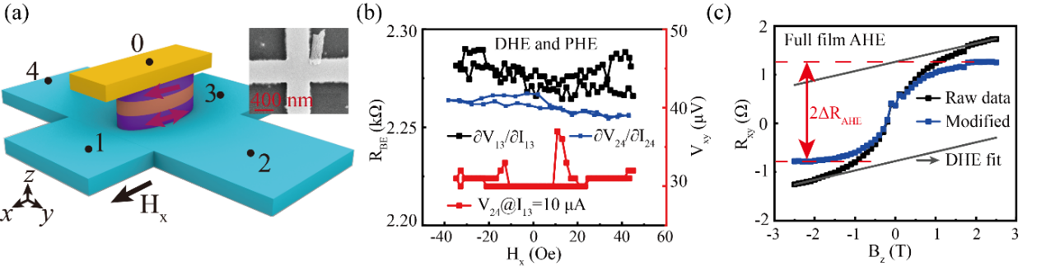
Supplementary Fig. 1. Evaluation of various Hall effects. (a) Device sketch. Inset: top view of the cross-W channel. (b) DHE and PHE signal (red curve), as well as bottom electrode resistance (black and blue curve). (c) AHE signal of full film.

S2. Derivation process of MTJ-modulation effect
Under a constant voltage source $V_{supply}$, the injection current under antiparallel (AP) and parallel (P) state of magnetic tunnel junction (MTJ) can be calculated as following:
$I_{AP}=\frac{V_{supply}}{R_{MTJ}^{AP}}$, $I_{P}=\frac{V_{supply}}{R_{MTJ}^{P}}$
where $R_{MTJ}^{AP}$ and $R_{MTJ}^{P}$ are the resistance of MTJ under AP and P states.
Moreover, the transverse resistance output voltage $∆V_{xy}$ can be calculated by the following equation,
$∆V_{xy}=V_{xy}^{P}-V_{xy}^{AP}=I_{P}R_{xy}^{P}-I_{AP}R_{xy}^{AP}$ (1)
Here, $R_{xy}^{AP}$ and $R_{xy}^{P}$ represents the transverse resistance under AP and P states, respectively. Then, equation 1 can be transformed to the following,
$$\text{=}\frac{{\text{V}}_{\text{supply}}}{{\text{R}}_{\text{MTJ}}^{\text{P}}}{\text{R}}_{\text{xy}}^{\text{P}}\text{-}\frac{{\text{V}}_{\text{supply}}}{{\text{R}}_{\text{MTJ}}^{\text{AP}}}{\text{R}}_{\text{xy}}^{\text{AP}}$$
$$\text{=}{\text{V}}_{\text{supply}}\left(\frac{{\text{R}}_{\text{xy}}^{\text{P}}}{{\text{R}}_{\text{MTJ}}^{\text{P}}}\text{-}\frac{{\text{R}}_{\text{xy}}^{\text{AP}}}{{\text{R}}_{\text{MTJ}}^{\text{AP}}}\right)$$
$$\text{=}{\text{V}}_{\text{supply}}\frac{{\text{R}}_{\text{xy}}^{\text{P}}{\text{R}}_{\text{MTJ}}^{\text{AP}}\text{-}{\text{R}}_{\text{xy}}^{\text{AP}}{\text{R}}_{\text{MTJ}}^{\text{P}}}{{\text{R}}_{\text{MTJ}}^{\text{P}}{\text{R}}_{\text{MTJ}}^{\text{AP}}}$$
$$\text{=}\frac{{\text{R}}_{\text{xy}}^{\text{P}}{\text{R}}_{\text{MTJ}}^{\text{P}}\text{+}{\text{R}}_{\text{xy}}^{\text{P}}\left({\text{R}}_{\text{MTJ}}^{\text{AP}}\text{-}{\text{R}}_{\text{MTJ}}^{\text{P}}\right)\text{-}{\text{R}}_{\text{xy}}^{\text{AP}}{\text{R}}_{\text{MTJ}}^{\text{P}}}{{\text{R}}_{\text{MTJ}}^{\text{P}}{\text{R}}_{\text{MTJ}}^{\text{AP}}}{\text{V}}_{\text{supply}}$$
$$\text{=}\frac{{\text{R}}_{\text{MTJ}}^{\text{P}}\left({\text{R}}_{\text{xy}}^{\text{P}}\text{-}{\text{R}}_{\text{xy}}^{\text{AP}}\right)\text{+}{\text{R}}_{\text{xy}}^{\text{P}}\left({\text{R}}_{\text{MTJ}}^{\text{AP}}\text{-}{\text{R}}_{\text{MTJ}}^{\text{P}}\right)}{{\text{R}}_{\text{MTJ}}^{\text{P}}{\text{R}}_{\text{MTJ}}^{\text{AP}}}{\text{V}}_{\text{supply}}$$
$$\text{=(}\frac{{\text{R}}_{\text{xy}}^{\text{P}}\text{-}{\text{R}}_{\text{xy}}^{\text{AP}}}{{\text{R}}_{\text{MTJ}}^{\text{AP}}}\text{+}\frac{{\text{R}}_{\text{xy}}^{\text{P}}\left({\text{R}}_{\text{MTJ}}^{\text{AP}}\text{-}{\text{R}}_{\text{MTJ}}^{\text{P}}\right)}{{\text{R}}_{\text{MTJ}}^{\text{P}}{\text{R}}_{\text{MTJ}}^{\text{AP}}}\text{)}{\text{V}}_{\text{supply}}$$
（Considering that $TMR=\frac{{\text{R}}_{\text{xy}}^{\text{P}}\left({\text{R}}_{\text{MTJ}}^{\text{AP}}\text{-}{\text{R}}_{\text{MTJ}}^{\text{P}}\right)}{{\text{R}}_{\text{MTJ}}^{\text{P}}}$）
$$=(\frac{R_{xy}^{P}-R_{xy}^{AP}}{R_{MTJ}^{AP}}+\frac{R_{xy}^{P}TMR}{R_{MTJ}^{AP}})V_{supply}$$
$$=\frac{(1+TMR{)R}_{xy}^{P}-R_{xy}^{AP}}{R_{MTJ}^{AP}}V_{supply}$$
At last, we figure out the expression of $∆V_{xy}=[(1+TMR{)R}_{xy}^{P}-R_{xy}^{AP}]\frac{V_{supply}}{R_{MTJ}^{AP}}$
S3. Characterization of spin Hall angle of W
We determined the SCC efficiency of channel W, i.e. effective spin Hall angle $θ_{SH}^{eff}$, utilizing spin-torque ferromagnetic resonance (ST-FMR) measurement on W (t)/CoFeB (5) heterojunction (with various thickness t in nm)³. Supplementary Fig. 2a outlines the principle of ST-FMR, i.e., a microwave frequency (RF) charge current I_{RF} exerts an oscillating spin torque on CoFeB to induce magnetization precession, leading to the oscillation of the bilayer resistance due to the anisotropic magnetoresistance (AMR). When the applied in-plane field H_{ext} and the microwave Oersted field H_{RF} satisfy the ferromagnetic resonance condition, sharp peaks emerge in the measured DC voltage V_{mix}. Supplementary Fig. 2b illustrates the top view of a 20 μm ST-FMR device and measurement set-up. The external filed H_{ext} is applied at 45 degrees to the RF current. By separating the symmetric and antisymmetric term from the DC voltage as shown in Supplementary Fig. 2c, one can identify the current-induced damping-like torque (in-plane, T//) and field-like torque (out-of-plane, T⊥), respectively. By performing ST-FMR measurements and fitting V_{mix} versus H_{ext} across different frequency as shown in Supplementary Fig. 2d, $θ_{SH}^{eff}$ can be generally determined. The inset in Supplementary Fig. 2d gives $θ_{SH}^{eff}$ dependence on frequency, giving a value about -0.26, matching with previous reports for several-nanometer-thick W. Furthermore, Supplementary Fig. 2e illustrates W resistivity $ρ$ and $θ_{SH}^{eff}$ as a function of thickness t. For t < 4, $ρ$ and $θ_{SH}^{eff}$ indicate that it is in $β$ phase, and for t > 5, it is $α$ phase^{4,5}.
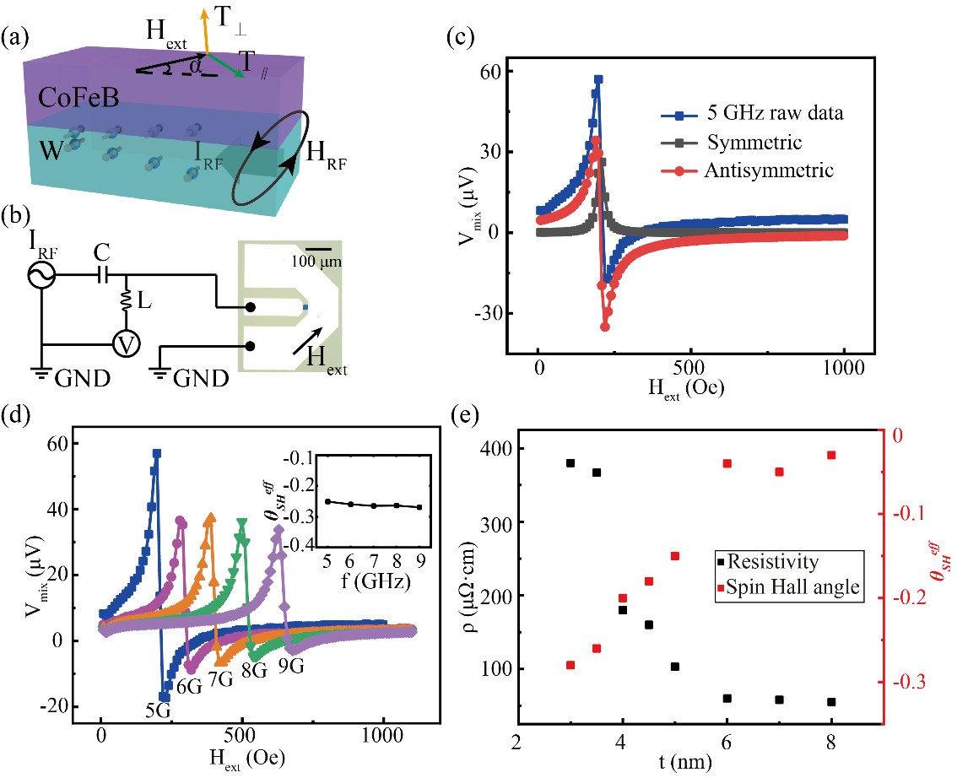
Supplementary Fig. 2. Evaluation of spin Hall angle of W channel. (a) Illustration of the ST-FMR mechanism. (b) Measurement set-up of ST-FMR. (c) ST-FMR result at 5 GHz excitation current and extractions of current-induced damping-like torque (symmetric term) and field-like torque (antisymmetric term). (d) ST-FMR results at different frequency. Inset: the deduced effective spin Hall angle. (e) Resistivity and effective spin Hall angle of W as a function of thickness.
S4. Detailed description of the numerical model
Following the existing one-dimensional spin diffusion numerical model⁶ as formula (2), and concerning the physical measurements in our experiments, we give the definition of parameters and their typical values in Supplementary Table 1. Here, SOC and FM is short for spin-orbit coupling layer and ferromagnetic layer, respectively. These values would yield about 400 times difference between W/CFB-bilayer device and MTJ-enhanced device as shown in the main text Fig 5b.
$ΔR_{SCC}=\frac{Pθ_{SH}λ_{SOC}}{(\frac{t_{FM}}{ρ_{FM}}+\frac{t_{SOC}}{ρ_{SOC}})w_{SOC}}×\frac{1-\frac{1}{\cosh{(}\frac{t_{SOC}}{λ_{SOC}})}}{\tanh{(}\frac{t_{SOC}}{λ_{SOC}})+\frac{λ_{SOC}ρ_{SOC}}{λ_{FM}{ρ^{*}}_{FM}}\tanh{(}\frac{t_{FM}}{λ_{FM}})}$ (2)

Supplementary Table 1| Typical values used in numerical calculations
Parameter | Definition | Value | Ref.
P | Spin polarization rate | P_{CoFe} = 0.2  P_{MTJ} = 0.92 | ab-initio calculation of this work
θ_{SH} | Spin Hall angle | θ_{SH_αW} = -0.04  θ_{SH_βW} = -0.26 | Experiment of this work
λ_{SOC} (λ_{FM}) | Spin diffusion length of SOC (FM) material | λ_{W} = 2.1 nm  λ_{CoFe} = 2 nm | 7
t_{SOC} (t_{FM}) | Thickness of SOC (FM) material | t_{αW} = 6 nm  t_{βW} = 3.5 nm  t_{CoFe_bilayer} = 5 nm  t_{CoFe_MTJ} = 1.9 nm | Experiment of this work
ρ_{SOC} (ρ_{FM}) | Resistivity of SOC (FM) material | ρ_{αW} = 60 μΩ·cm  ρ_{βW} = 367 μΩ·cm  ρ_{CoFe} = 75 μΩ·cm | Experiment of this work
ρ*_{FM} | Effective resistivity of FM material | ρ_{CoFe}/(1-P²) | 6

S5. Processing logic using “MTJ+MESO” unit
To investigate the prospective application of our “MTJ+MESO” unit, we designed a processing logic as shown in Supplementary Fig. 3a. The underlayer is composed of MESO array for low-power logic operation and the top layer is an MTJ array for memory operation. The MESO array and MTJ array is intrinsically-integrated using our proposed device and thus there is no bandwidth mismatch during computing. We show a detailed part of this design in Supplementary Fig. 3b, where the bottom MESO logic array forms one-bit full adder. The logic array and memory array share the same transistor for selector and power supply. Word lines (WL) and bit lines (BL) are connected to peripheral column decoder and row decoder. Here, the top MTJ array serves as magnetic random-access memory (MRAM). Through this MRAM, the data can be easily transferred to the computation logic of MESO array while the calculation results can be read out to external units. Moreover, the naturally integrated MTJ and MESO enables instantaneous and nonvolatile data exchange between computing module and external memory. In addition, this architecture allows for the extraction of any intermediate process results when required, which significantly diminishes the reliance on registers in specific computational programs. Moreover, the memory array can be utilized as error correction by monitoring its resistance state during computing. On this basis, more novel operation modes and architectures can be explored.
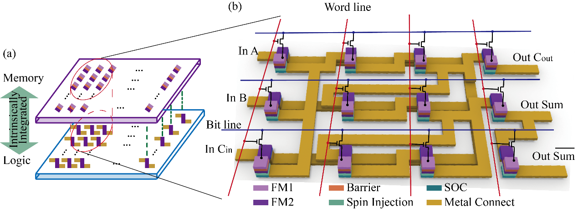
Supplementary Fig. 3. Processing unit using MTJ-enhanced MESO logic. (a) Intrinsically-integrated logic array and memory array with vertical distribution. (b) Detailed view of a one-bit full adder logic and memory unit. FM1 in light purple and FM2 in deep purple represent two ferromagnetic layers. A and B are two one-bit operands, C_{in} is input carry bit, Sum is sum for A, B and C_{in}, and C_{out} is output carry bit.
References

1. Choi, W. Y., Arango, I. C., van Pham, T., Vaz, D. C., Yang, H., Groen, I., Lin, C.-C., Kabir, E. S., Oguz, K., Debashis, P., Plombon, J. J., Li, H., Nikonov, D. E., Chuvilin, A., Hueso, L. E., Young, I. A. & Casanova, F. All-electrical spin-to-charge conversion in sputtered Bi_{x}Se_{1-x}. Nano. Lett. 22, 7992–7999 (2022).
2. Groen, I., van Pham, T., Leo, N., Marty, A., Hueso, L. E. & Casanova, F. Disentangling spin, anomalous, and planar Hall effects in ferromagnet–heavy-metal nanostructures. Phys. Rev. Appl. 15, 044010 (2021).
3. Liu, L., Moriyama, T., Ralph, D. C. & Buhrman, R. A. Spin-torque ferromagnetic resonance induced by the spin Hall effect. Phys. Rev. Lett. 106, 36601 (2011).
4. Sriram, K., Mondal, R., Pradhan, J., Haldar, A. & Murapaka, C. Structural phase engineering of (α+β)-W for a large spin Hall angle and spin diffusion length. J. Phys. Chem. C 127, 22704–22712 (2023).
5. Demasius, K.-U., Phung, T., Zhang, W., Hughes, B. P., Yang, S.-H., Kellock, A., Han, W., Pushp, A. & Parkin, S. S. P. Enhanced spin-orbit torques by oxygen incorporation in tungsten films. Nat. Commun. 7, 10644 (2016).
6. van Pham, T., Groen, I., Manipatruni, S., Choi, W. Y., Nikonov, D. E., Sagasta, E., Lin, C.-C., Gosavi, T. A., Marty, A., Hueso, L. E., Young, I. A. & Casanova, F. Spin–orbit magnetic state readout in scaled ferromagnetic/heavy metal nanostructures. Nat. Electron. 3, 309–315 (2020).
7. Wang, H. L., Du, C. H., Pu, Y., Adur, R., Hammel, P. C. & Yang, F. Y. Scaling of spin Hall angle in 3d, 4d, and 5d metals from Y₃Fe₅O₁₂/metal spin pumping. Phys. Rev. Lett. 112, 197201 (2014).

