Supplementary Materials
This supplementary document provides additional methodological details and definitions of outcome variables, as well as supporting tables and figures for interpreting the results of the main manuscript. It includes definitions of key electrophysiological and echocardiographic outcomes, risk of bias assessment, leave-one-out sensitivity analysis, and a comprehensive summary of the criteria used across studies to classify pacing as targeting the left bundle branch trunk or fascicles.

Supplementary Table 1. Outcomes and their definitions.
OUTCOME | DEFINITION
QRS duration | The QRS complex duration in the Electrocardiogram (ECG) measured in milliseconds (ms). It is a widely used measurement to assess cardiac ventricular depolarization. Longer durations are generally related to worst ventricular synchrony.
V6 R Wave Peak Time (V6-RWPT) | It is defined as the time between the pace stimulus and the peak of the R wave in V6. It is related to the time to fully activate the lateral wall of the left ventricle.
Left Ventricular Activation Time (LVAT) | Often used interchangeably with the V6-RWPT, it is the time taken between the pace stimulus and the R wave peak of either V5 or V6. Some studies used the V6-RWPT, some used the LVAT.
Left Ventricular Ejection Fraction (LVEF) | LVEF is a quantitative metric of cardiac systolic function, mathematically defined as the ratio of the left ventricular end-systolic to the end-diastolic volume, expressed as a percentage. It was measured using Echocardiogram.
Left Ventricular End-Diastolic Diameter (LVEDD) | It is defined as the left ventricular linear dimension at the end of the diastole. LVEDD serves as a primary and highly reproducible surrogate for left ventricular size and preload, measured using Echocardiogram. A decrease after left pace implantation is usually expected, translating to reverse remodeling and better long term survival.
Pacing Threshold | The necessary energy to initiate a depolarization in the ventricular muscle wall, measured in volts (V) during pace implantation. It is expected to be lower in left pacing compared to right.
Table S1. Provides standardized definitions for all primary and secondary outcomes assessed in the meta-analysis, including QRS duration, RWPT, LVAT, LVEF, LVEDD, and pacing threshold.

Supplementary Figure 1. Risk of bias assessment table.
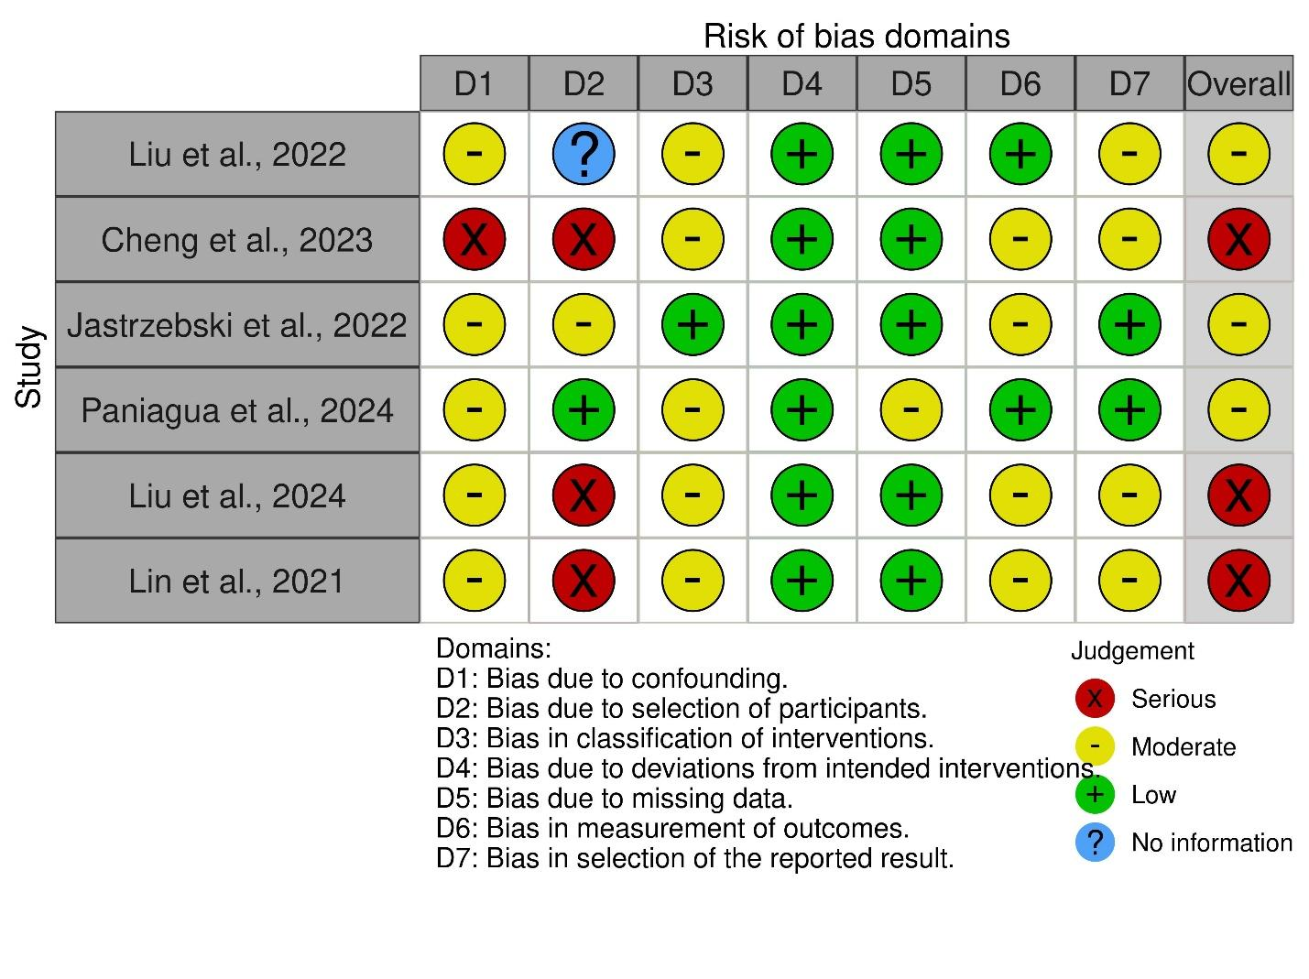
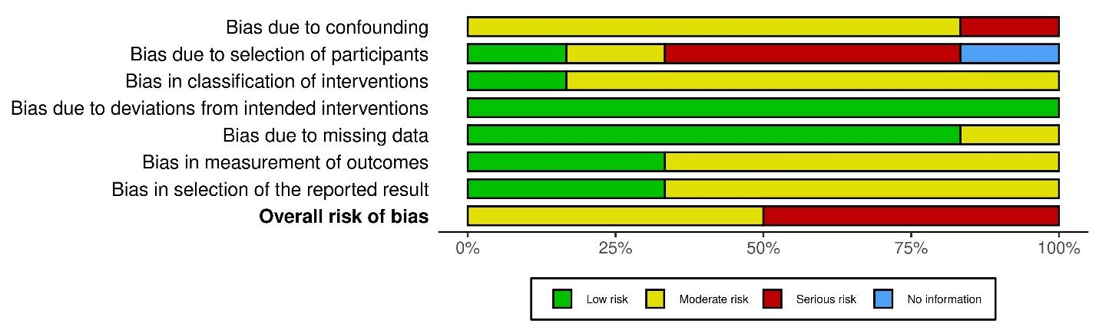
Fig S1. Summarizes the risk of bias across included studies using standard methodological domains, supporting the internal validity of the pooled analyses.

Supplementary Figure 2. Leave-One-Out Sensitivity Analysis for QRS Duration (Excluding MELOS 2022).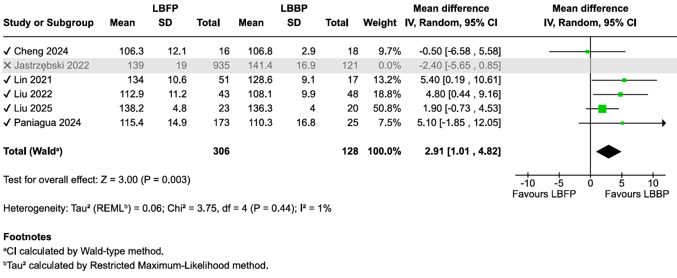
Fig S2. Displays the effect of sequentially omitting each study from the pooled analysis for QRS duration. Exclusion of MELOS (2022) resulted in a statistically significant mean difference favoring LBFP.

Supplementary Table 2. Criteria for defining left bundle branch or left bundle fascicular pacing.
Study | QRS criteria | LBB-V Interval (ms) | Frontal Axis Considered? | LBB Potential Required? | Predominant Selective Capture?
Cheng (2024) | (1) LBBP: inferior or intermediate QRS axis; (2) LPFP: superior QRS axis (leads II and III predominantly negative); (3) LAFP: inferior QRS axis (leads II and III positive); (4) LSFP: intermediate QRS axis (lead II predominantly positive, and lead III with negative component). | Longer in LBTP; shorter in LBFP | Yes | Yes | Partially (selectivity assessed but not quantified)
Lin (2021) | (1) LBBP: RBBD; QRS morphology similar to that of sinus rhythm; (2) LPFP group: RBBD; left-superior axis; dominant R wave in leads I, aVL; dominant S wave in inferior leads; (3) LAFP: RBBD; right-axis deviation; dominant R wave in inferior leads; dominant S wave in leads I, aVL | No fixed threshold defined | Yes | No, but could be used as a criteria for LBBP | Rare (10%)
Liu (2022) | (1) LBBP: RBBB pattern; paced QRS morphology similar to sinus rhythm; (2) LPFP: RBBB pattern; dominant R wave in leads I and aVL; dominant S wave in leads II, III, and aVF; left-axis deviation; (3) LAFP: RBBB pattern; dominant S wave in leads I and aVL; dominant R wave in leads II, III, and aVF; right-axis deviation | 25 ms cutoff | Yes (secondary) | Yes  (when present) | Not reported (likely non-selective)
Liu (2025) | (1) LBBP: RBBD or complete normalization of LBB block; (2) LPFP: RBBD and an LAF block pattern, left superior axis, dominant R wave in leads I and aVL, and dominant S wave in the inferior leads; (3) LAFP: RBBD and an LPF block pattern, right axis deviation, dominant R wave in the inferior leads, and dominant S wave in leads I and aVL | 25 ms cutoff | Yes (secondary) | Yes  (when present) | Not reported (likely non-selective)
MELOS (2022) | (1) LBBP: inferior or intermediate QRS axis; (2) LPFP: superior QRS axis (leads II and III predominantly negative); (3) LAFP: inferior QRS axis (leads II and III positive); (4) LSFP: intermediate QRS axis (lead II predominantly positive, and lead III with negative component). | LBTP:  25–35 ms  LBFP: <25 ms | Yes | Yes | No (mostly non-selective)
Paniagua (2024) | (1) LBBP: QRS axis similar to sinus rhythm; (2) LPFP: dominant R wave in leads I and aVL, dominant S wave in inferior leads, left-axis deviation; (3) LAFP:dominant S wave in leads I and aVL, dominant R wave in inferior leads, right-axis deviation; (4) LSFP: QRS axis like sinus rhythm or inferior axis with negative component in lead III. | LBTP:  25–35 ms  LBFP: <25 ms or no potential | Yes | Yes  (for LBTP) | No  (21–40%, more common in LBTP)
Table S2. Describes the electrophysiological and anatomical criteria used by each included study to differentiate LBTP from LBFP. It includes QRS axis definitions, the use of LBB potential and intervals, and capture selectivity.

