SUPPLEMENTARY MATERIALS

Secondary Metabolites from Piper crocatum as Natural Inhibitors of Oral Pathogens: In Vitro and In Silico Insights into Streptococcus mutans and Candida albicans
Dikdik Kurnia^{1*}, Hendra Dian Adhita Dharsono², Denny Nurdin², Norma Aura Tristyaningrum¹, Eti Apriyanti¹, Syifa Zahara Kultsum Azmi¹

¹Department of Chemistry, Faculty of Mathematics and Natural Sciences, Universitas Padjadjaran, Sumedang 45363, Indonesia;
²Department of Conservative Dentistry, Faculty of Dentistry, Universitas Padjadjaran, Sumedang 45363, Indonesia.

Correspondence should be addressed to Dikdik Kurnia; dikdik.kurnia@unpad.ac.id

General
NMR spectra were recorded on Bruker Avance Neo 700MHz NMR spectrometers (1H: 700 MHz, 13C: 175 MHz). ESI-TQD-MS were calculated on Acquity TQD, Waters Corporation, MA, USA. IR spectra were recorded on Shimidzu 4800. TLC was carried out on pre-coated silica-gel F₂₅₄ aluminum sheets (0.25 mm thickness, E. Merck). The spots were visualized by heating after spraying with 10% H₂SO₄ in methanol.
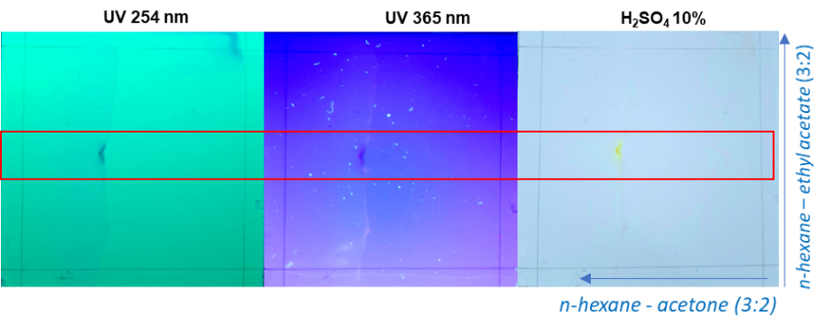
Figure S-1. Two-dimensional thin layer chromatographic of compound 1.

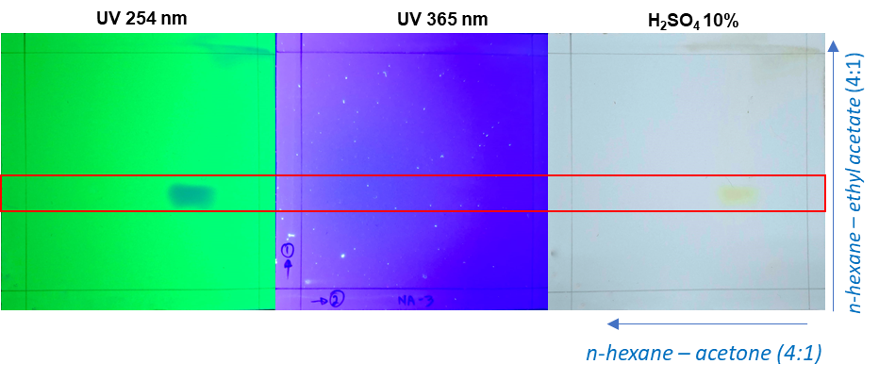
Figure S-2. Two-dimensional thin layer chromatographic analysis of compound 2.
- Structural Characterization of Compound 1
- IR Spectrum
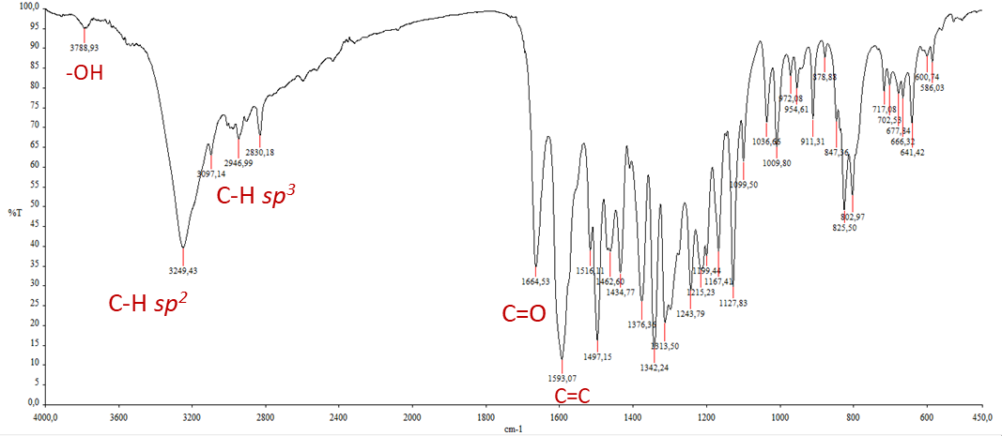
Figure S-3. IR spectrum of compound 1 (KBr)
- ¹³C-NMR and DEPT Spectra of Pachypodol (1)
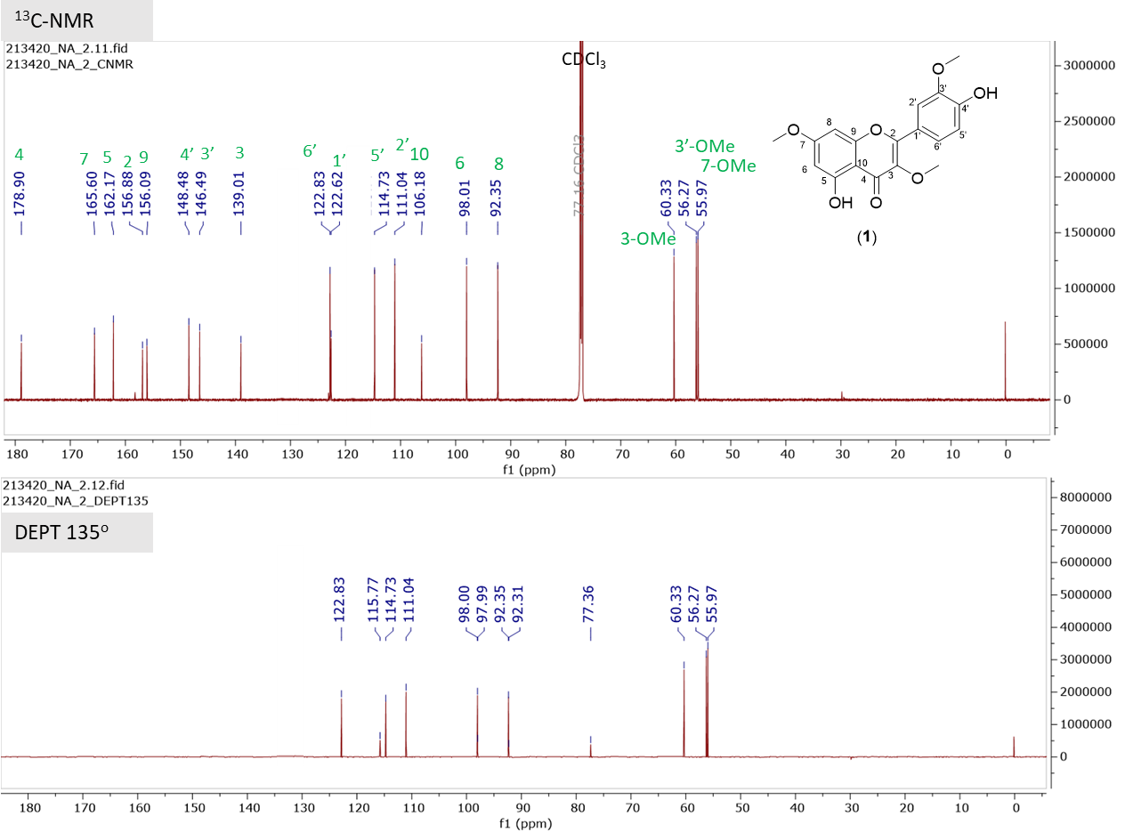
Figure S-4. ¹³C-NMR (175 MHz, CDCl₃) and DEPT 135º spectrum of 1 in CDCl₃

¹H-NMR Spectrum of Pachypodol (1)
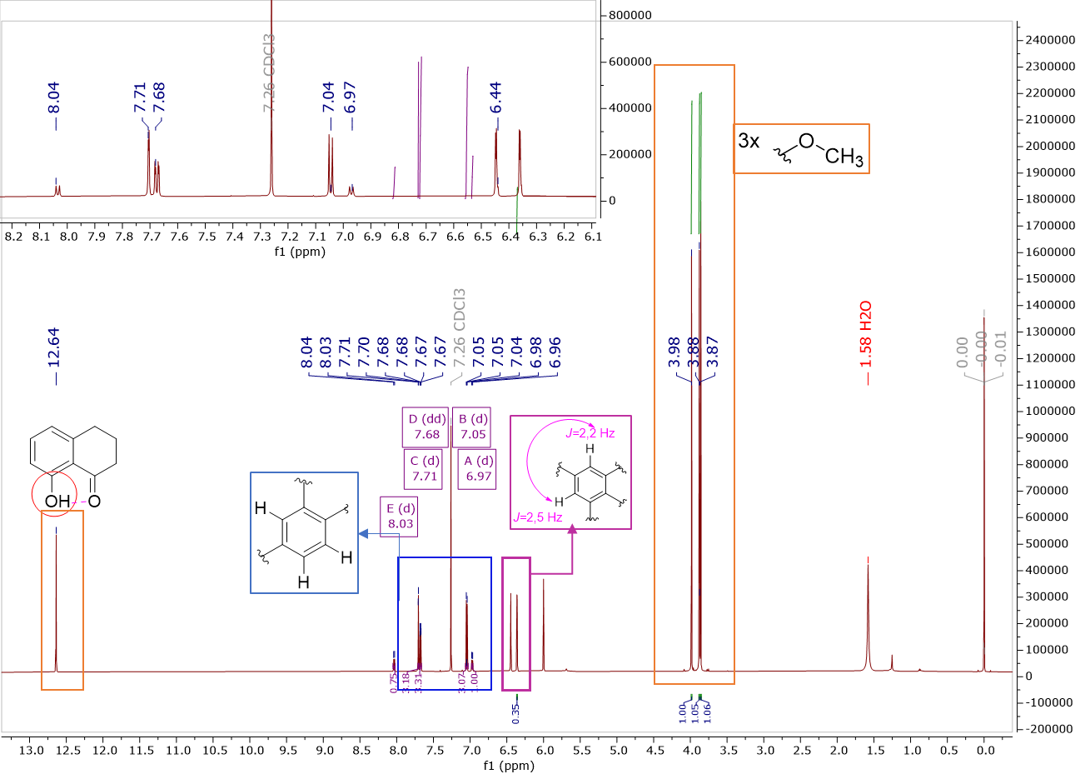
Figure S-5. ¹H-NMR (700 MHz, CDCl₃) spectrum of 1 in CDCl₃.
Table S-1. ¹H and ¹³C-NMR spectrum data of compound 1
No. | Compound 1 (CDCl₃; ¹H-NMR 700 MHz; ¹³C-NMR 175 MHz)
No. | $δ_{C}$ | $δ_{H}$ ($\sum{H}$, mult, J=Hz)
2 | 156.9 | -
3 | 139.0 | -
4 | 178.9 | -
5 | 162.2 | -
6 | 98.0 | 6.37 (1H; d; J=2.5)
7 | 165.6 | -
8 | 92.3 | 6.46 (1H; d: J=2.2)
9 | 156.1 | -
10 | 106.2 | -
1' | 122.6 | -
2' | 111.0 | 7.71 (1H; dd: J=1.98)
3' | 146.5 | -
4' | 148.5 | -
5' | 114.7 | -
6' | 122.8 | 7.68 (1H. dd; J= 2.02; 8.4)
3-OMe | 60.3 | 3.86 (3H, s)
7-OMe | 56.0 | 3.88 (3H, s)
3'-OMe | 56.3 | 3.98 (3H, s)
5-OH | - | 12.64 (1H, s)

- HSQC Spectrum of Pachypodol (1)
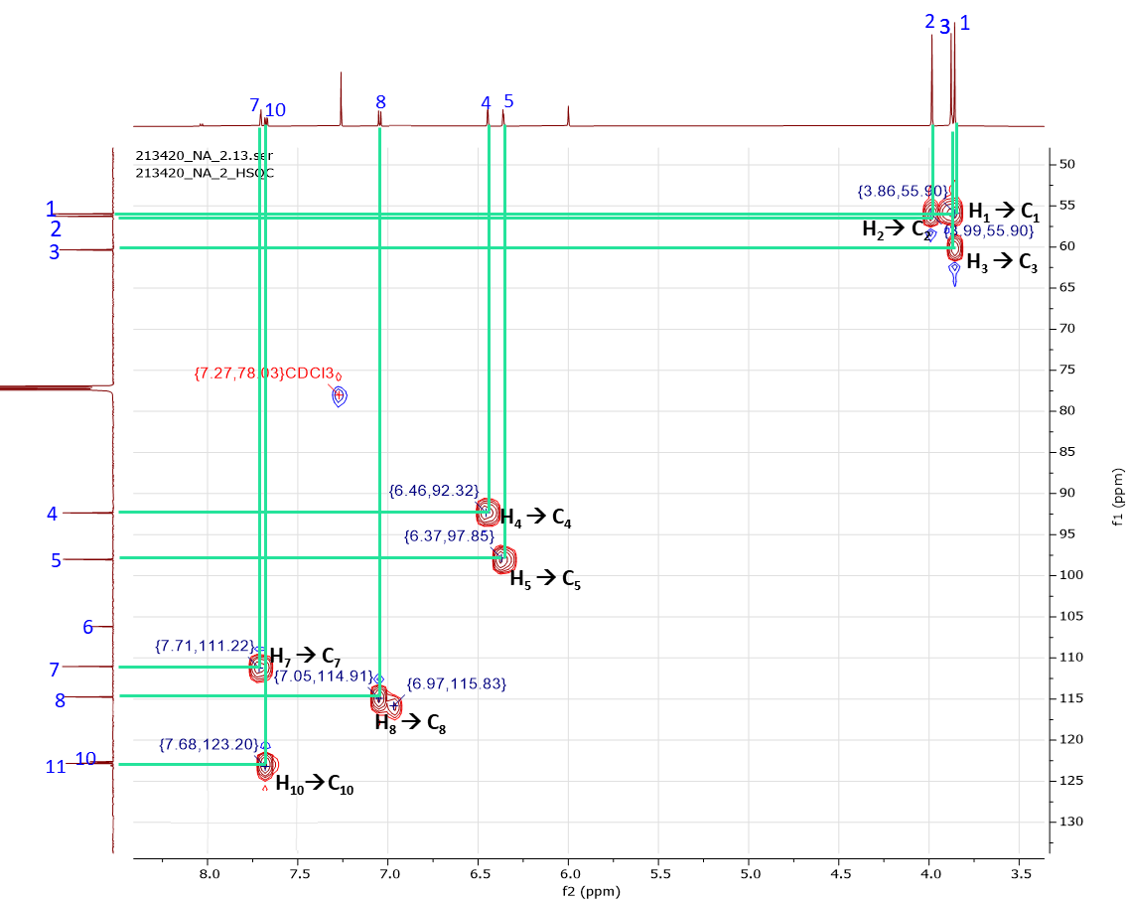
Figure S-6. HSQC spectrum of compound 1 in CDCl₃

¹H-¹H COSY Spectrum of Pachypodol (1)
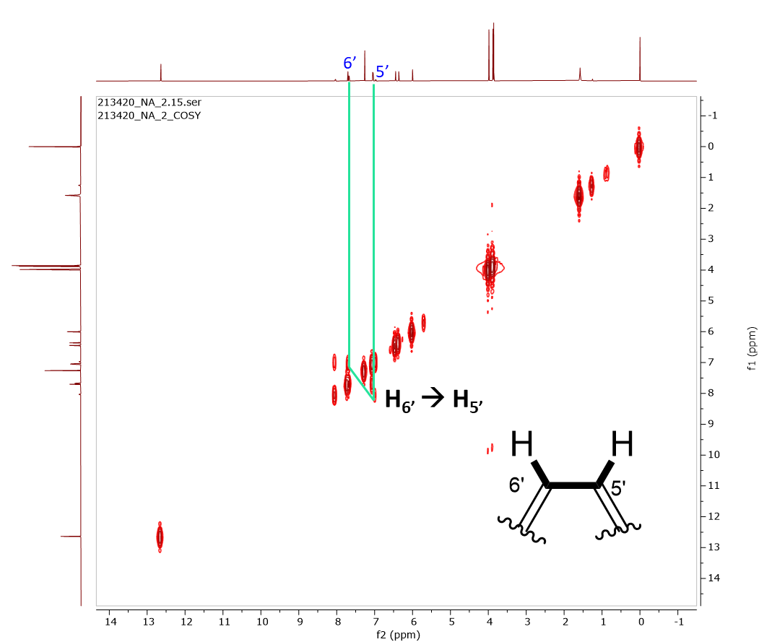
Figure S-7. ¹H-¹H COSY spectrum of compound 1 in CDCl₃

HMBC Spectrum of Pachypodol (1)
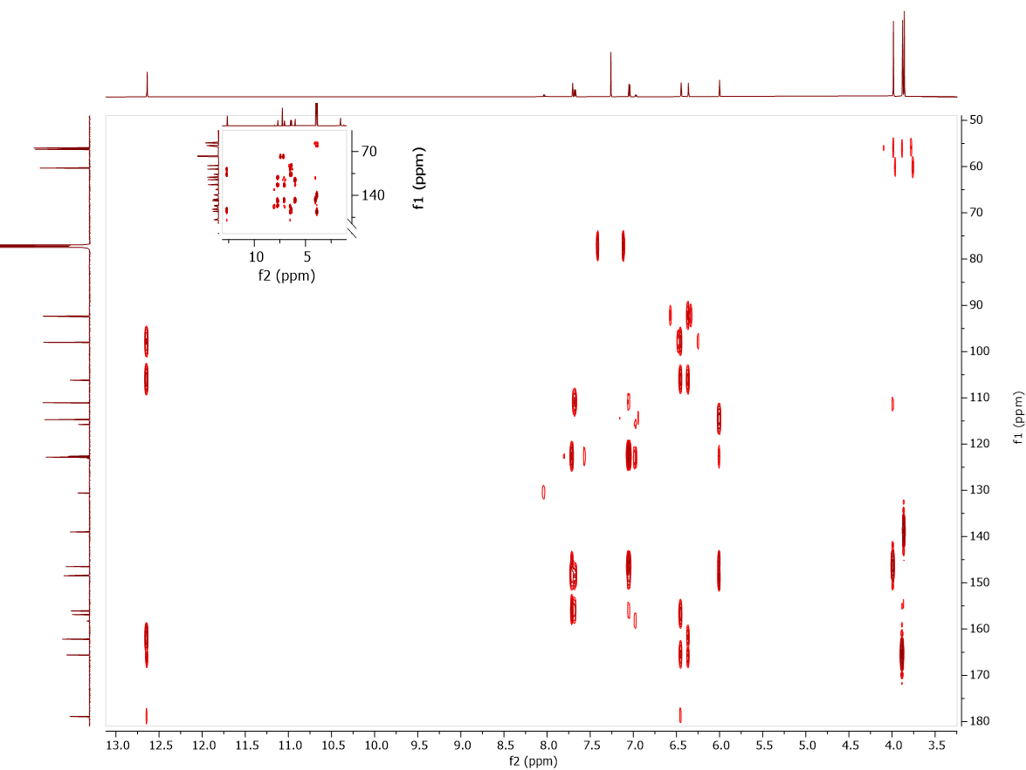
Figure S-8. HMBC Spectrum of compound 1 in CDCl₃
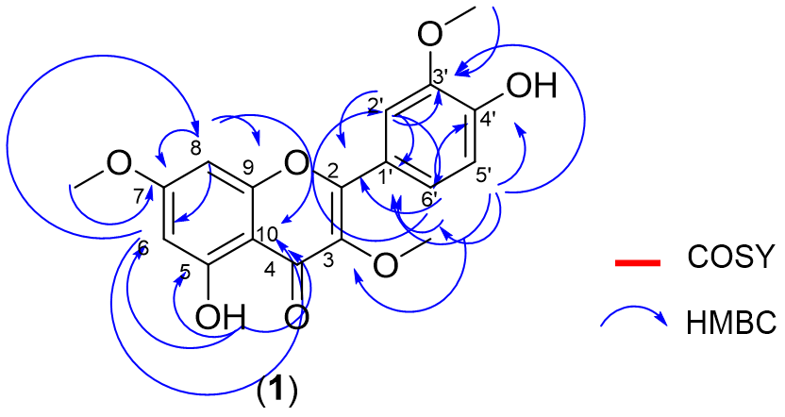
Figure S-9. H-H COSY and selected HMBC (H$→$C) correlations of compound 1

- Mass Spectrum of Compound 1
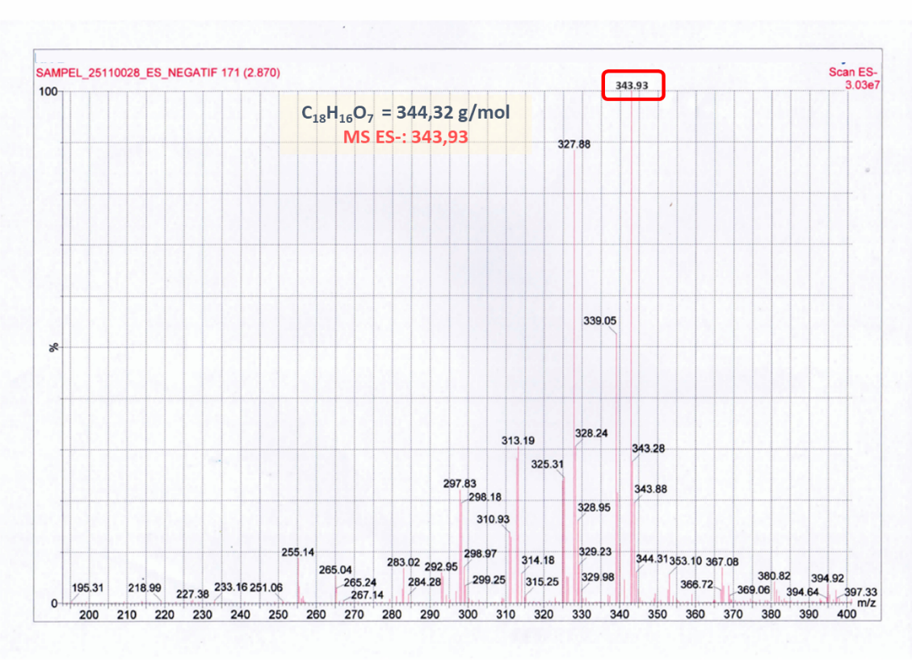
Figure S-10. MS spectrum of compound 1.
- Structural Characterization of Compound 2
- IR Spectrum
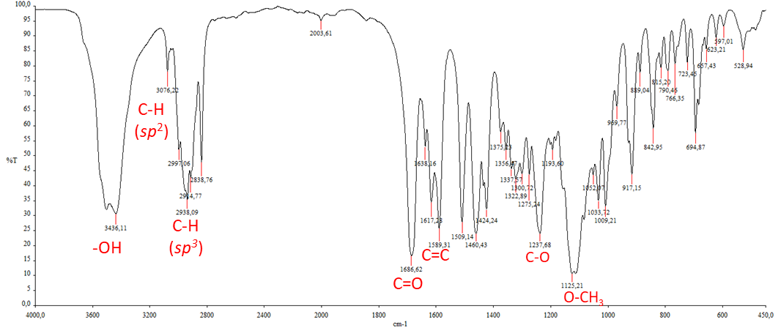
Figure S-11. IR spectrum of compound 2 (KBr)

- ¹³C-NMR and DEPT Spectra of Nectamazin B (2)

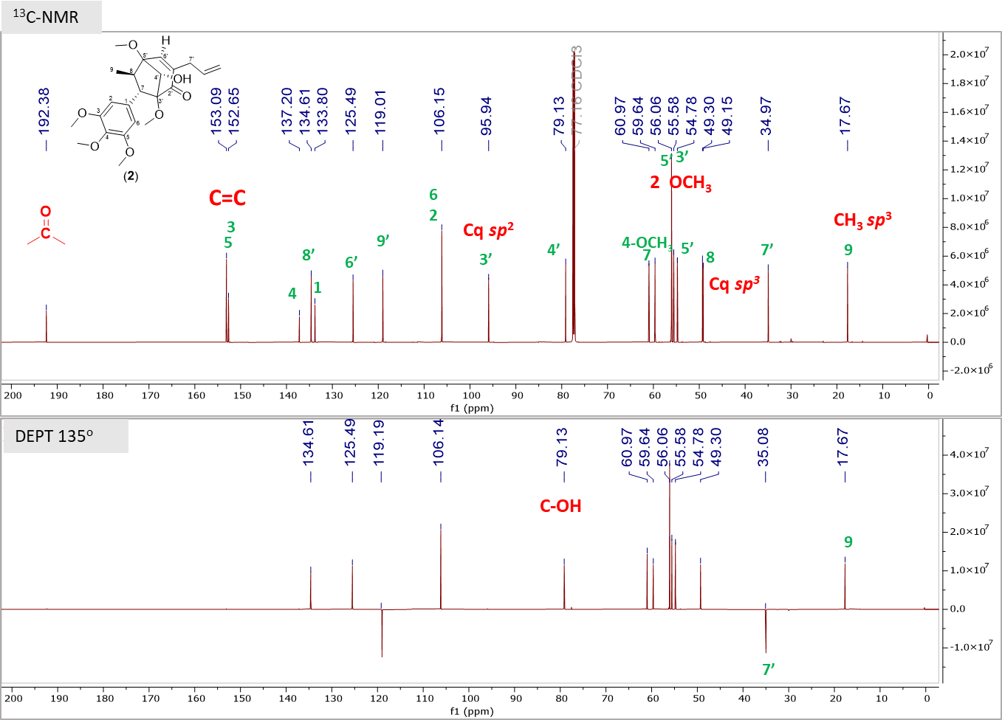
Figure S-12. ¹³C-NMR (175 MHz, CDCl₃) and DEPT 135º spectrum of 2 in CDCl₃

¹H-NMR Spectrum of Nectamazin B (2)
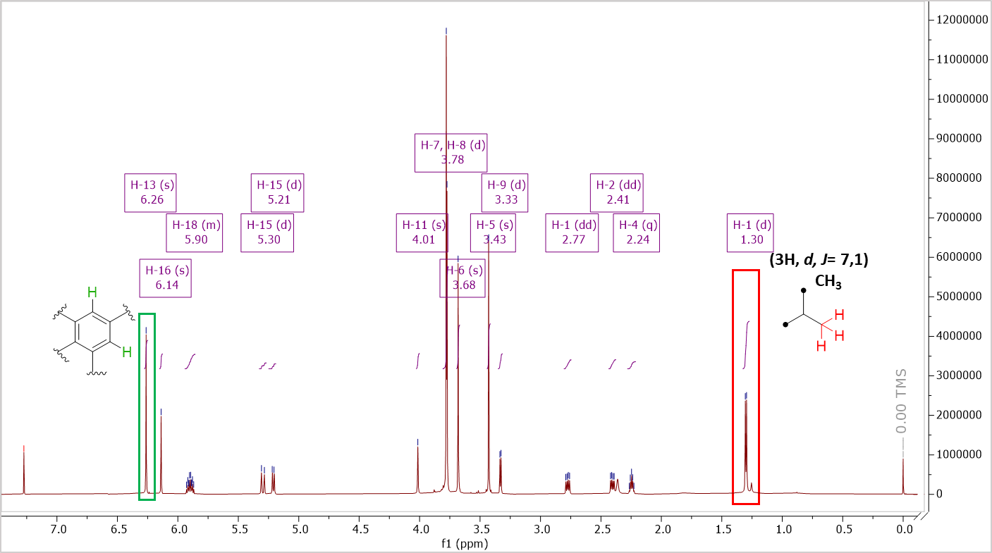
Figure S-13. ¹H-NMR (700 MHz, CDCl₃) spectrum of 2 in CDCl₃.

Table S-2. ¹H and ¹³C-NMR spectrum data of compound 2
No. | Compound 2 (CDCl₃; ¹H-NMR 700 MHz; ¹³C-NMR 175 MHz)
No. | $δ_{C}$ (ppm) | $δ_{H}$ ($\sum{H}$, mult, J=Hz)
1 | 133.8 | -
2 | 106.2 | 6.28 (1H. s)
3 | 153.1 | -
4 | 137.2 | -
5 | 153.1 | -
6 | 106.2 | 6.26 (1H. s)
7 | 59.6 | 3.33 (1H. d. J=6.5)
8 | 49.3 | (1H. m)
9 | 17.7 | 1.30 (3H. d. J=7.1)
1' | 137.2 | -
2' | 192.4 | -
3' | 95.9 | -
4' | 79.1 | 4.01 (1H. s)
5' | 95.9 | -
6' | 125.2 | 6.14 (1H. s)
7' | 35.0 | 2.77 (2H. d. J=7.0)
8' | 134.6 | 5.90 (1H. ddt. J=10.2; 17.0)
9' | 119.0 | 5.21-5.30 (2H. m)
3-OMe | 55.6 | 3.68 (3H. s)
5-OMe | 56.1 | 3.78 (3H. s)
4-OMe | 61.0 | 3.77 (3H. s)
3'OMe | 56.1 | 3.78 (3H. s)
5՛-OMe | 54.8 | 3.43 (3H. s)

- HSQC Spectrum of Nectamazin B (2)
Figure S-14. HSQC spectrum of compound 2 in CDCl₃

¹H-¹H COSY Spectrum of Nectamazin B (2)
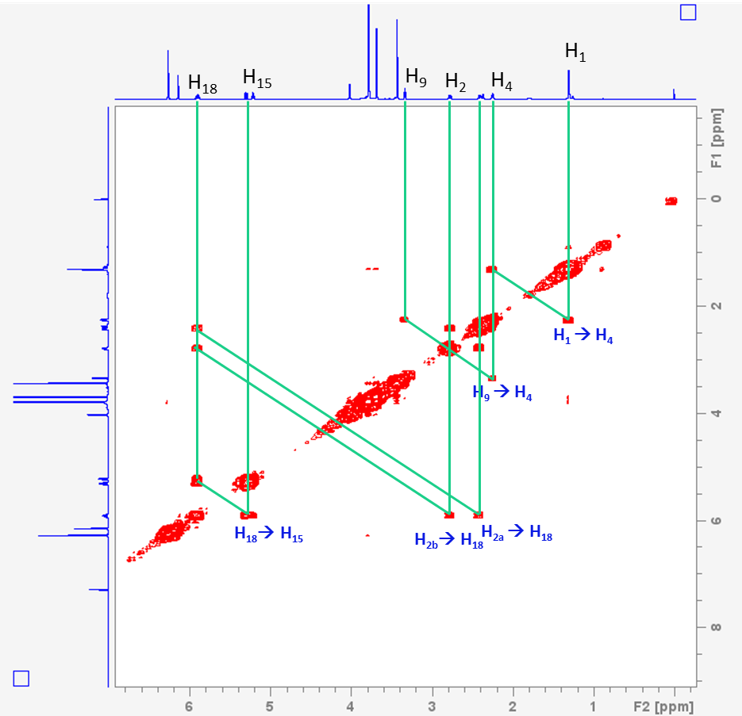
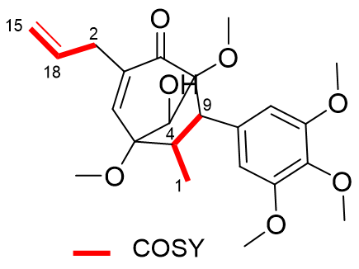
Figure S-15. ¹H-¹H COSY spectrum of compound 2 in CDCl₃

HMBC Spectrum of Nectamazin B (2)
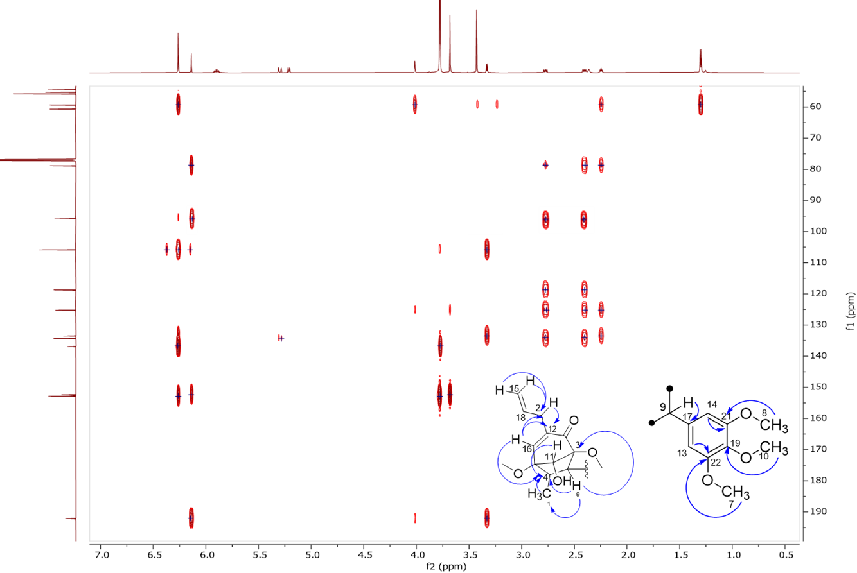
Figure S-16. HMBC Spectrum and correlation of compound 2 in CDCl₃

- NOESY Spectrum of Nectamazin B (2)
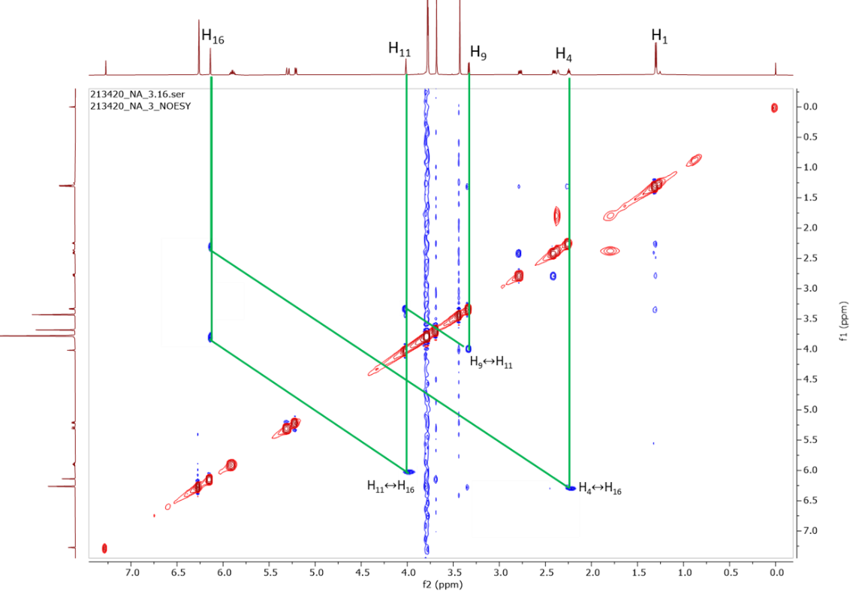
Figure S-17. NOESY Spectrum and correlation of compound 2
- Mass Spectrum of Compound 2
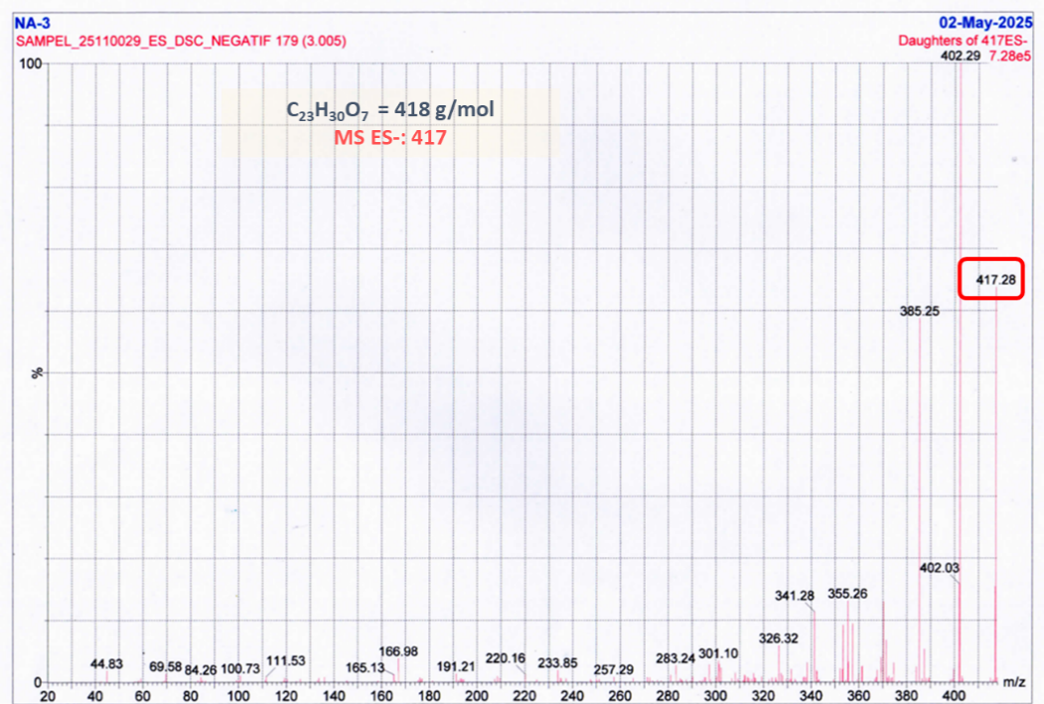
Figure S-10. MS spectrum of compound 2

