Supplementary Table 1 Four-fold table of disproportionality analysis
Item | Number of target AEs | Number of other AEs | Total
Target drug | a | b | a + b
Other drugs | c | d | c + d
Total | a + c | b + d | N = a + b + c + d

Supplementary Table 2 Summary of major algorithms used for signal detection
Algorithms | Indicator | Equation | Criteria
ROR | ROR | ROR = ad/c/b | ROR05 > 1, N ≥ 2
 |  | 95CI = eln(ROR)±1.96(1/a+1/b+1/c+1/d)^0.5
PRR | PRR | PRR = [a/(a+b)]/[c/(c + d)] | PRR≥2
 | χ² | χ² = [(ad-bc)² (a+b + c + d)]/[(a+b)(c + d)(a+c)(b + d)] | χ² ≥ 4, N ≥ 3
BCPNN | IC | IC = log2 [a (a+b + c + d)]/[(a+c)(a+b)] | IC025 > 0
 |  | 95CI = eln(IC)±1.96(1/a+1/b+1/c+1/d)^0.5
MGPS | EBGM | EBGM = a (a+b + c + d)/(a+c)/(a+b) | EBGM05 > 2, N ≥ 0
 |  | 95CI = eln(EBGM)±1.96(1/a+1/b+1/c+1/d)^0.5

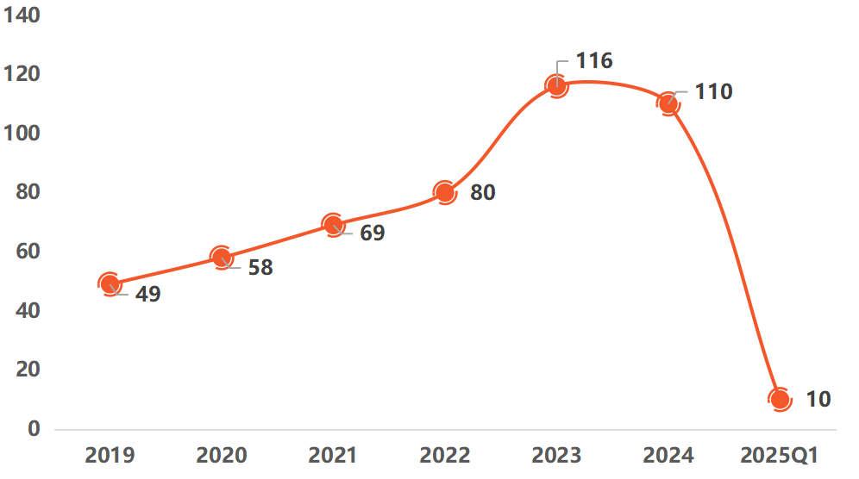
Supplementary Figure 1 Number of reported AEs of tagraxofusp from 2019 to 2025Q1

