Supplementary Material
Supplementary Note 1. Definition of pre-existing symptoms attributable to other diseases rather than COVID-19.
The Health and well-being online questionnaire assessed the length of each symptom by asking people for how long they have been suffering the a specific symptom. The answer could be either (1) less than two weeks, (2) two to four weeks, (3) four to twelve weeks, (4) more than twelve weeks, (5) do not know, or (6) prefer not to answer. If participants reported options (1), (2), (5), (6), we assumed that the patient did not have pre-existing symptoms. If participants reported option (3) we assumed that the symptoms started four weeks before answering the questionnaire (28 days). If participants reported option (4), we directly assumed that the participants had pre-existing symptoms, as the date when the symptoms started could not be determined. Afterwards, we excluded those participants who reported option (4) or those whose date of answering the questionnaire minus the number of days they have been suffering the symptoms was before the date of the infection.
For those WHO symptoms that were mapped to more than one UK Biobank symptom, the duration was determined by the symptom with longest duration.
Supplementary Note 2. Long COVID subtype cohort differences with the discovery cohort
Participants who did not answer symptom-related questions were not excluded. Additionally, the length of the subtype symptom was determined by the symptom with shortest duration.

Supplementary Table 1. UK Biobank symptoms mapped to the World Health Organisation (WHO) Delphi consensus.
WHO symptom | UK Biobank symptom
Abdominal pain | Abdominal pain / tummy ache
Menstrual and period problems | -
Altered smell/taste | Loss or change in sense of smell  Loss or change in sense of taste
Anxiety | Problems relating to mood anxiety and emotions
Blurred vision | Vision problems
Chest pain | Chest pain  Pain on breathing
Cognitive dysfunction / brain fog | Problems communicating  Problems thinking
Cough | Persistent cough
Depression | -
Dizziness | Dizziness / light headedness
Fatigue | Mild fatigue  Severe fatigue
Intermitted fever | Fever
Gastrointestinal issues | Gastrointestinal issues
Headache | Headache
Memory issues | -
Joint pain | Joint pain or swelling of joint
Muscle pain / spasms | Muscle pain / achy muscles
Neuralgias | -
New onset allergies | New allergy or intolerance
Pins and needles sensations | Numbness or tigling somewhere in the body
Post-exertional malaise | Post-exertional symptom exacerbation
Shortness of breath | Shortness of breath or trouble breathing
Sleep disorders | Difficulty sleeping  Unrestful sleep
Tachycardia / palpitations | Postural tachycardia
Tinnitus and other hearing issues | Tinnitus  Hearing loss  Hearing issues

Supplementary Table 2. Post-acute COVID-19 sequelae (PACS-CVD) diagnoses used to phenotype the condition
Organ system | Sequela | ICD10 code
Cardiovascular | Acute coronary disease | I24, I240, I241, I248, I249
Cardiovascular | Angina | I20, I200, I201, I208, I209
Cardiovascular | Atrial fibrillation | I480, I481, I482
Cardiovascular | Atrial flutter | I483, I484
Cardiovascular | Bradycardia | R001
Cardiovascular | Cardiac arrest | I46, I460, I461, I469
Cardiovascular | Cariogenic shock | R570
Cardiovascular | Heart failure | I50, I500, I501, I509
Cardiovascular | Ischemic cardiomyopathy | I255
Cardiovascular | Myocardial infarction | I21, I210, I211, I212, I213, I214, I219  I21X, I22, I220, I221, I228, I229
Cardiovascular | Myocarditis | I514
Cardiovascular | Non ischemic cardiomyopathy | I42, I420, I421, I422, I423, I424, I425, I426, I427, I428, I429, I43, I430, I431, I432, I438 B332
Cardiovascular | Pericarditis | I30, I300, I301, I308, I309, I311, I312, I313, I318, I319, I32, I320, I321, I328
Cardiovascular | Tachycardia | R000
Cardiovascular | Ventricular arrhythmias | I490, I470, I471, I472
Coagulation | Anaemia | D60, D600, D601, D608, D609, D61, D610, D611, D612, D613, D618, D619, D63, D630, D631, D638, D64, D640, D641, D642, D643, D644, D648, D649
Coagulation | Coagulation defect | D689
Coagulation | Deep vein thrombosis | I801, I802, I803, I81, I81X
Coagulation | Pulmonary embolism | I26, I260, I269
Coagulation | Venous thrombotic embolism | I82, I820, I822, I823, I828, I829

Chromosome | Base pair start | Base pair end
1 | 48227412 | 52227412
2 | 86146488 | 101133568
2 | 89563673 | 89564169
2 | 98080299 | 98080324
2 | 183291754 | 190291755
3 | 47524995 | 50024996
3 | 83417309 | 86917310
5 | 44464242 | 50464243
5 | 128972100 | 131972101
6 | 25392020 | 33392022
6 | 56892040 | 63942041
6 | 139958306 | 142458307
7 | 55032505 | 66362565
8 | 7962589 | 11962591
8 | 42880842 | 49837447
8 | 111930823 | 114930824
10 | 36959993 | 43679994
11 | 87860351 | 90860352
12 | 33108732 | 41713733
20 | 32536338 | 35066586
Supplementary Table 3. Regions with extended linkage disequilibrium excluded from the analysis.

Supplementary Table 4. Long COVID, respiratory and chest symptoms results. Note: CHR = Chromosome; BP = Base Pair; SNP = Single Nucleotide Polymorphism; EA = Effect Allele; OA = Other allele; EAF = Effect Allele Frequency; OR = Odds Ratio; SE = Standard Error.
CHR | BP | SNP | EA | OA | EAF | OR | SE | P-Value | Function | Gene
4 | 74,611,451 | rs188246983 | C | T | 0.03 | 0.27 | 0.28 | 4.2e-06 | intergenic | IL8 - RP11-447E20.1
4 | 77,176,524 | rs7655112 | C | T | 0.63 | 1.40 | 0.07 | 2.4e-06 | intronic | FAM47E-STBD1 - FAM47E - FAM47E-STBD1
5 | 56,329,225 | rs78735734 | T | C | 0.06 | 1.79 | 0.12 | 1.2e-06 | intergenic | AC114973.1 - RP11-101B14.4
5 | 177,603,653 | rs28806942 | T | C | 0.04 | 2.02 | 0.14 | 1.1e-06 | intergenic | RP11-889L3.4 - GMCL1P1
8 | 35,055,872 | rs62503875 | A | G | 0.01 | 2.75 | 0.22 | 4.2e-06 | intergenic | AC098612.1 - UNC5D
10 | 123,882,450 | rs11200414 | G | A | 0.80 | 1.55 | 0.09 | 9.6e-07 | intronic | TACC2
14 | 22,443,483 | rs79276774 | T | G | 0.21 | 0.66 | 0.09 | 4.0e-06 | intergenic | TRAV12-3 - TRAV8-6
14 | 41,935,005 | rs116950676 | A | G | 0.02 | 2.61 | 0.21 | 3.6e-06 | intergenic | AL390335.1 - CTD-2298J14.1
19 | 5,693,616 | rs35804229 | T | C | 0.02 | 2.45 | 0.19 | 3.4e-06 | exonic | LONP1
20 | 13,163,234 | rs7273138 | G | A | 0.34 | 1.38 | 0.07 | 2.0e-06 | intergenic | SPTLC3 - ISM1

Supplementary Table 5. Long COVID, ENT symptoms subtype results. Note: CHR = Chromosome; BP = Base Pair; SNP = Single Nucleotide Polymorphism; EA = Effect Allele; OA = Other allele; EAF = Effect Allele Frequency; OR = Odds Ratio; SE = Standard Error.
CHR | BP | SNP | EA | OA | EAF | OR | SE | PVAL | Function | Gene
4 | 113,686,340 | rs116512169 | T | C | 0.03 | 2.06 | 0.15 | 1.2e-06 | intergenic | Y_RNA - RPL7AP30
5 | 108,310,017 | rs13358819 | G | A | 0.04 | 0.40 | 0.18 | 3.3e-07 | intronic | FER
6 | 15,702,683 | rs4623247 | G | A | 0.11 | 1.49 | 0.09 | 4.8e-06 | intergenic | DTNBP1 - ARPC3P5
6 | 104,084,384 | rs9377551 | A | G | 0.58 | 0.76 | 0.06 | 1.8e-06 | intergenic | SNORA33 - R3HDM2P2
8 | 9,992,235 | rs73530926 | G | C | 0.02 | 2.40 | 0.19 | 4.0e-06 | intronic | MSRA
9 | 81,420,360 | rs139094115 | T | G | 0.02 | 2.36 | 0.18 | 1.3e-06 | intergenic | MTND2P8 - KRT18P24
10 | 32,303,249 | rs74333406 | A | G | 0.21 | 1.38 | 0.07 | 3.5e-06 | intronic | KIF5B
11 | 128,974,045 | rs7118778 | G | C | 0.09 | 0.58 | 0.12 | 3.1e-06 | intronic | ARHGAP32
12 | 2,751,121 | rs75808668 | A | C | 0.03 | 2.05 | 0.15 | 2.6e-06 | intronic | CACNA1C
14 | 62,068,188 | rs55668906 | T | C | 0.10 | 1.51 | 0.09 | 5.0e-06 | intronic | RP11-47I22.3 - RP11-47I22.4
14 | 80,934,122 | rs11159463 | G | A | 0.90 | 1.69 | 0.11 | 2.5e-06 | intergenic | DIO2-AS1 - CEP128
16 | 25,646,165 | rs79824211 | T | A | 0.04 | 1.89 | 0.13 | 1.4e-06 | intergenic | CYCSP39 - HS3ST4

Supplementary Table 6. Long COVID, neurological symptoms subtype results. Note: CHR = Chromosome; BP = Base Pair; SNP = Single Nucleotide Polymorphism; EA = Effect Allele; OA = Other allele; EAF = Effect Allele Frequency; OR = Odds Ratio; SE = Standard Error.
CHR | BP | SNP | EA | OA | EAF | OR | SE | PVAL | Function | Gene
1 | 81,681,594 | rs6699229 | C | T | 0.51 | 0.80 | 0.05 | 7.2e-07 | intergenic | RP3-445O10.1 - RN7SKP247
2 | 12,139,015 | rs147149354 | G | C | 0.01 | 0.19 | 0.36 | 3.3e-06 | ncRNA_intronic | AC096559.1
5 | 117,125,098 | rs115868163 | G | A | 0.01 | 2.17 | 0.16 | 1.6e-06 | intergenic | RPL7L1P4 - CTD-3179P9.1
7 | 23,754,383 | rs78009084 | A | G | 0.02 | 0.42 | 0.19 | 4.6e-06 | intronic | STK31
9 | 2,570,796 | rs75958613 | G | A | 0.01 | 2.17 | 0.16 | 9.2e-07 | ncRNA_intronic | RP11-125B21.2
17 | 8,851,379 | rs12943587 | G | A | 0.01 | 2.42 | 0.18 | 7.0e-07 | intronic | PIK3R5
17 | 79,147,409 | rs117076160 | T | C | 0.02 | 0.37 | 0.21 | 2.8e-06 | ncRNA_intronic | AATK-AS1
18 | 21,845,650 | rs117614877 | T | C | 0.01 | 2.15 | 0.15 | 5.6e-07 | intronic | OSBPL1A
19 | 3,274,527 | rs79049673 | T | C | 0.02 | 2.04 | 0.15 | 1.2e-06 | intronic | CELF5
19 | 9,019,605 | rs12981679 | G | C | 0.76 | 0.79 | 0.05 | 4.2e-06 | exonic | MUC16

Supplementary Table 7. Long COVID, fatigue symptoms subtype results. Note: CHR = Chromosome; BP = Base Pair; SNP = Single Nucleotide Polymorphism; EA = Effect Allele; OA = Other allele; EAF = Effect Allele Frequency; OR = Odds Ratio; SE = Standard Error.
CHR | BP | SNP | EA | OA | EAF | OR | SE | PVAL | Function | Gene
6 | 92,548,874 | rs2501653 | G | T | 0.17 | 1.19 | 0.04 | 3.5e-06 | intergenic | RP11-40G16.1 - RPL5P19
7 | 39,433,817 | rs79409011 | C | G | 0.07 | 0.76 | 0.06 | 4.6e-06 | intronic | POU6F2
10 | 114,839,337 | rs113267365 | A | T | 0.01 | 1.76 | 0.12 | 2.1e-06 | intronic | TCF7L2
10 | 121,167,278 | rs79290746 | A | G | 0.01 | 0.50 | 0.15 | 4.6e-06 | intronic | GRK5
11 | 25,734,129 | rs112660897 | C | T | 0.03 | 0.58 | 0.10 | 2.9e-07 | intergenic | RP11-46P12.1 - RP11-405K6.1
11 | 125,921,356 | rs112343863 | C | T | 0.02 | 0.57 | 0.12 | 4.1e-06 | intronic | CDON
12 | 54,126,061 | rs17102257 | C | T | 0.01 | 1.67 | 0.11 | 2.1e-06 | intergenic | CALCOCO1 - RP11-686F15.3
14 | 73,425,315 | rs7144193 | T | C | 0.19 | 0.84 | 0.04 | 4.3e-06 | intronic | DCAF4
15 | 84,092,255 | rs117581501 | A | G | 0.01 | 1.85 | 0.13 | 1.3e-06 | ncRNA_intronic | RP11-382A20.4
17 | 32,497,214 | rs17784068 | C | T | 0.06 | 1.33 | 0.06 | 1.9e-06 | ncRNA_intronic | RP11-215E13.1
19 | 11,037,104 | rs142129027 | A | G | 0.03 | 1.45 | 0.08 | 1.0e-06 | intronic | YIPF2

Supplementary Figure 1. Long COVID discovery cohort attrition
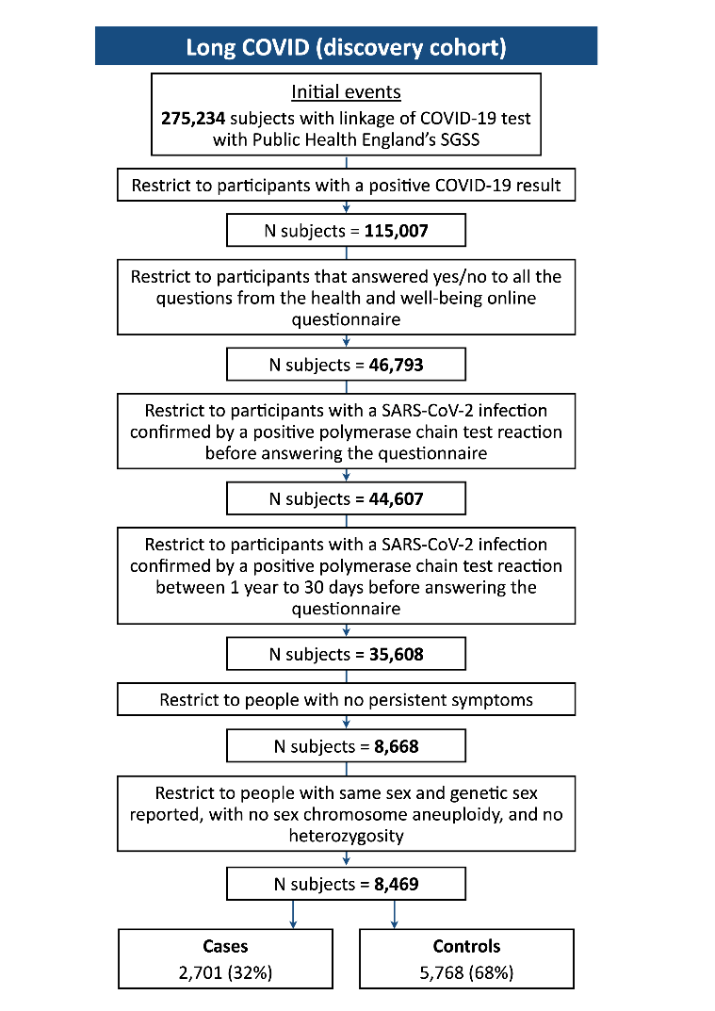
Supplementary Figure 2. PACS-CVD cohort attrition
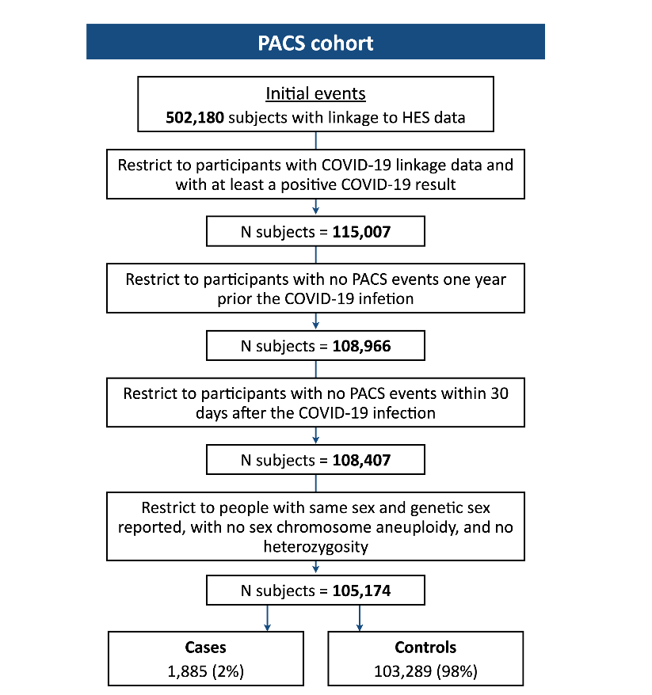
Supplementary Figure 3. Long COVID subtypes GWAS findings. Manhattan plots for (A) respiratory and chest symptoms subtype.
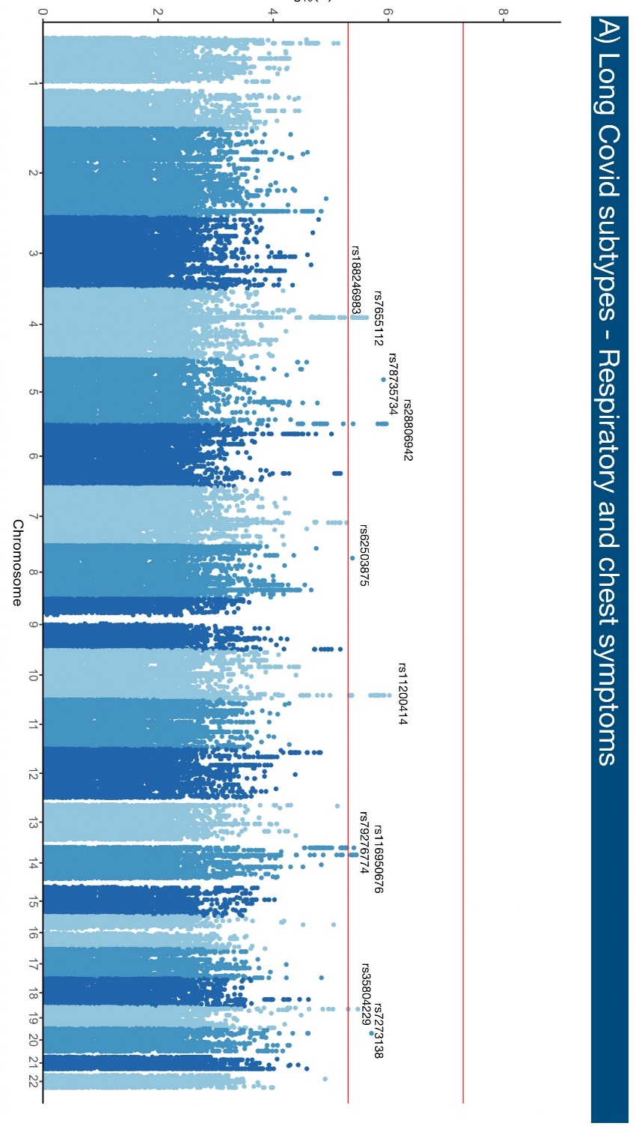
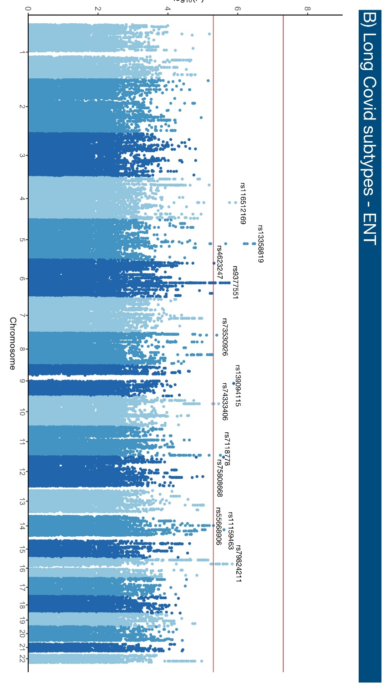

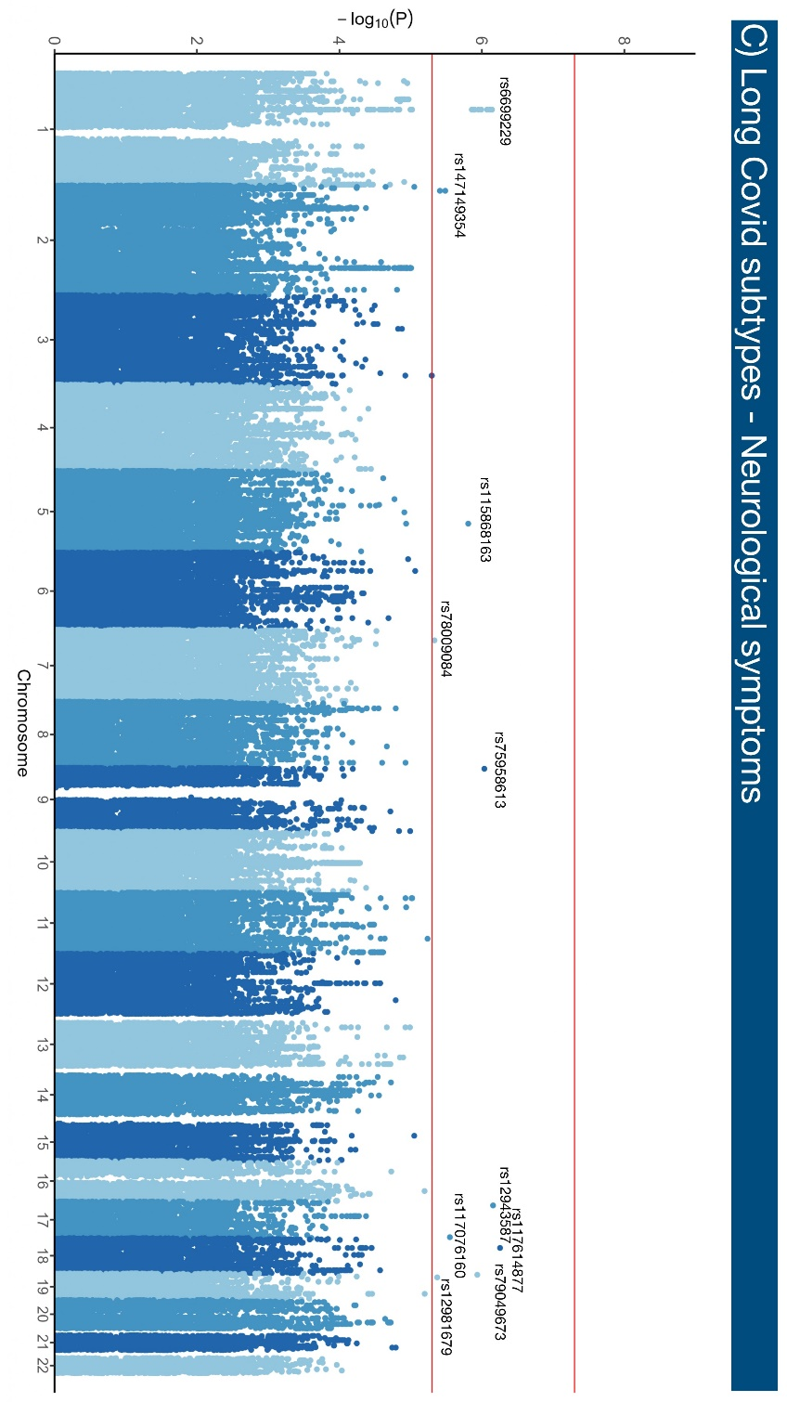
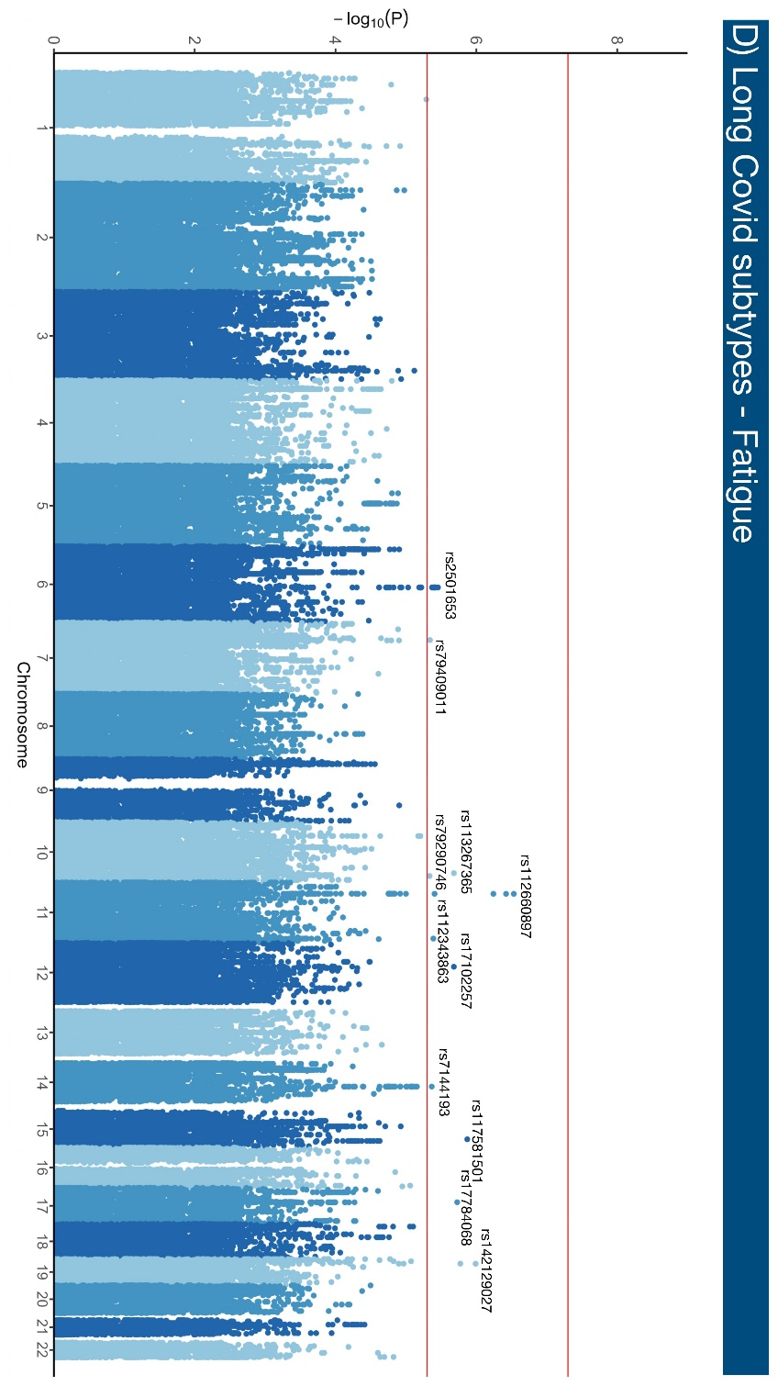

Supplementary Figure 4. Study design graphic.
