Supplemental Online Content
Dr. Firneisz Gábor, Nemes A. Botond, Dr. Németh László, Dr. Nádasdi Ákos, Prof. Dr. Benyó Zoltán, Association of Mode of Delivery and Birth Order with Neonatal Cord Blood Hyperinsulinemia

Table of Contents
Stepwise Variable Selection 2
eTable 1. Stepwise Variable Selection: Result of the First Iteration (n = 3,385) 2
eTable 2. Stepwise Variable Selection: Result of the Second Iteration (n = 3,492) 3
Maternal and Neonatal Charactheristics 4
eTable 3. Maternal and Neonatal Charactheristics grouped by Mode of Delivery 4
Sensitivity analysis 6
eFigure 1. Complete case analyses using plasma glucose (PG) levels and Maternal C-peptide (CP) instead of GDM and HOMA2 IR. 6
eFigure 2. Complete case analyses without birth order (4008 observations) 7
Final models in ethnicity specific subgroups 8
eFigure 3. Complete case analyses, European ancestry (1355 observations): 8
eFigure 4. Complete case analyses, Afro-Caribbean ancestry (719 observations): 9
eFigure 5. Complete case analyses, Thai ancestry. 618 observations 10
eFigure 6. Complete case analyses, Hispanic ancestry, 800 observations 11
Interpretation of interaction between Cesarean delivery and birth order 12
eFigure 7. Complete case analyses, final model using Cesarean delivery and birth order combined as a single, multilevel variable 12
Details of the Bayesian Joint Modeling and Imputation 13

Stepwise Variable Selection

We used an iterative Akaike Information Criteria (AIC) -based variable selection restricted to complete cases, redefining the dataset at each step to include only the retained variables. This approach preserved or increased sample size across iterations and converged once the selected variables stabilized. Convergence was reached after three iterations in our analysis.

eTable 1. Stepwise Variable Selection: Result of the First Iteration (n = 3,385)

Variable | Estimate | Std.Error | z.value | p.value | CI.Lower | CI.Upper
(Intercept) | -3,635 | 0,195 | -18,648 | 1.315e-77 | -4,026 | -3,262
EthnicityBlack | 0,686 | 0,203 | 3,376 | 7.362e-04 | 0,286 | 1,083
EthnicityAsian | -0,22 | 0,245 | -0,898 | 3.692e-01 | -0,709 | 0,253
EthnicityHispanic | 0,065 | 0,193 | 0,338 | 7.354e-01 | -0,315 | 0,442
`1st time pregnant`TRUE | -0,426 | 0,158 | -2,697 | 6.993e-03 | -0,737 | -0,118
`Cesarean Delivery1 | 1,142 | 0,158 | 7,237 | 4.572e-13 | 0,832 | 1,451
`Maternal GDM` | 0,127 | 0,065 | 1,949 | 5.130e-02 | -0,002 | 0,253
`Age of gestation at delivery (weeks)` | -0,173 | 0,076 | -2,292 | 2.193e-02 | -0,322 | -0,025
m_HbA1c_percent | 0,17 | 0,078 | 2,186 | 2.882e-02 | 0,018 | 0,323
`Birthweight (g)` | 0,819 | 0,111 | 7,395 | 1.417e-13 | 0,603 | 1,038
b_N_HCMn | -0,134 | 0,096 | -1,399 | 1.618e-01 | -0,324 | 0,049
b_N_LNGMn | -0,139 | 0,094 | -1,469 | 1.419e-01 | -0,323 | 0,047
`Neonatal sex (female)`2 | 0,89 | 0,144 | 6,197 | 5.752e-10 | 0,611 | 1,174
m_SBPM_OGTT | -0,102 | 0,07 | -1,449 | 1.473e-01 | -0,24 | 0,035
`Maternal age at OGTT (yrs)` | 0,116 | 0,078 | 1,499 | 1.339e-01 | -0,036 | 0,269
`Maternal BMI at OGTT (kg/m2)` | 0,061 | 0,076 | 0,799 | 4.242e-01 | -0,09 | 0,21
HOMA2_IR | 0,316 | 0,068 | 4,615 | 3.932e-06 | 0,181 | 0,45
WtMgain.till.OGTT | 0,19 | 0,067 | 2,841 | 4.496e-03 | 0,059 | 0,321
b_CordPGC_mmol.L | 0,756 | 0,066 | 11,542 | 8.055e-31 | 0,629 | 0,886

Abbreviations:
b_N_HCMn: Baby's mean head circumference, b_N_LNGMn:
Baby's mean length, m_SBPM_OGTT: Mother's mean OGTT systolic blood pressure, WtMgain.till.OGTT: Mother’s weight gain calculated as weight at OGTT - pre-pregnancy weight, b_CordPGC_mmol.L: Baby's cord Glucose

eTable 2. Stepwise Variable Selection: Result of the Second Iteration (n = 3,492)
Variable | Estimate | Std.Error | z.value | p.value | CI.Lower | CI.Upper
(Intercept) | -3,674 | 0,19 | -19,317 | 3.842e-83 | -4,055 | -3,309
`Maternal age at OGTT (yrs)` | 0,098 | 0,077 | 1,284 | 1.993e-01 | -0,052 | 0,249
`Maternal BMI at OGTT (kg/m2)` | 0,034 | 0,074 | 0,46 | 6.452e-01 | -0,112 | 0,178
EthnicityBlack | 0,747 | 0,194 | 3,845 | 1.208e-04 | 0,365 | 1,127
EthnicityAsian | -0,141 | 0,242 | -0,585 | 5.588e-01 | -0,625 | 0,325
EthnicityHispanic | 0,126 | 0,186 | 0,679 | 4.969e-01 | -0,24 | 0,49
`1st time pregnant`TRUE | -0,423 | 0,156 | -2,711 | 6.699e-03 | -0,731 | -0,119
`Cesarean Delivery`1 | 1,087 | 0,155 | 7,003 | 2.506e-12 | 0,783 | 1,392
`Maternal GDM` | 0,111 | 0,064 | 1,728 | 8.391e-02 | -0,016 | 0,236
`Age of gestation at delivery (weeks)` | -0,175 | 0,075 | -2,344 | 1.910e-02 | -0,321 | -0,029
`Birthweight (g)` | 0,767 | 0,096 | 7,975 | 1.524e-15 | 0,579 | 0,956
`Neonatal sex (female)`2 | 0,905 | 0,14 | 6,46 | 1.048e-10 | 0,633 | 1,182
m_HbA1c_percent | 0,172 | 0,077 | 2,24 | 2.512e-02 | 0,022 | 0,322
b_N_LNGMn | -0,152 | 0,092 | -1,659 | 9.715e-02 | -0,331 | 0,029
HOMA2_IR | 0,307 | 0,067 | 4,576 | 4.731e-06 | 0,174 | 0,438
WtMgain.till.OGTT | 0,172 | 0,066 | 2,611 | 9.021e-03 | 0,043 | 0,301
b_CordPGC_mmol.L | 0,744 | 0,065 | 11,539 | 8.430e-31 | 0,619 | 0,873

Results of the second iteration step.

Abbreviations:
b_N_LNGMn: Baby's mean length, WtMgain.till.OGTT: Mother’s weight gain calculated as weight at OGTT - pre-pregnancy weight, b_CordPGC_mmol.L: Baby's cord Glucose

Maternal and Neonatal Charactheristics

eTable 3. Maternal and Neonatal Charactheristics grouped by Mode of Delivery

Maternal Characteristics | Mode of Delivery |  | P-value
Maternal Characteristics | Cesarean delivery (n=831) | Vaginal (n=2661)
Age, median (IQR), y | 31.64 (28.07-35.09) | 28.87 (24.18-32.83) | <0.0001
Pre-pregnancy weight, median (IQR), kg | 63.50 (55.00-73.97) | 61.29 (53.57-70.82) | 0.0001
Height, median (IQR), cm | 160.00 (154.97-165.10) | 162.00 (156.60-166.50) | <0.0001
Body mass index, median (IQR)ª | 24.82 (21.77-28.50) | 23.32 (20.76-26.82) | <0.0001
Ancestry, No. (%)
European | 398 (47.9) | 957 (36.0) | <0.0001
Afro - Caribbean | 84 (10.1) | 635 (23.9) | <0.0001
Thai | 163 (19.6) | 455 (17.1) | <0.0001
Hispanic | 186 (22.4) | 614 (23.1) | <0.0001
Plasma glucose at OGTT, median (IQR), mmol/L, [mg/dL]
Fasting | 4.60 (4.30-4.90), [82,8 (77,4-88,2)] | 4.50 (4.20-4.80), [81 (75,6-86,4)] | <0.0001
1 - hour | 7.80 (6.65-9.10), [140,4 (119,7-163,8)] | 7.20 (6.20-8.40), [129,6 (111,6-151,2)] | <0.0001
2 - hour | 6.30 (5.50-7.20), [113,4 (99-129,6)] | 6.00 (5.30-6.80), [108 (95,4-122,4)] | <0.0001
HbA1c, median (IQR), % | 4.80 (4.60-5.10) | 4.70 (4.50-5.00) | <0.0001
Fasting CP levels at OGTT, median, (IQR), ug/L | 2.00 (1.50-2.60) | 1.70 (1.30-2.30) | <0.0001
GDM, No. (%) | 210 (25.3) | 408 (15.3) | <0.0001
HOMA2-IR, median (IQR) | 1.38 (1.05-1.88) | 1.21 (0.91-1.66) | <0.0001
Weight gain until OGTT, median (IQR), kg | 9.53 (6.62-12.84) | 8.80 (5.90-11.91) | <0.0001
Hypertension (any type), No. (%) | 140 (16.8) | 281 (10.6) | <0.0001
Systolic blood pressure at OGTT, median (IQR), mm Hg | 107.50 (101.00-114.00) | 105.50 (99.50-112.50) | <0.0001
1st delivery, No. (%) | 370 (44.5) | 1110 (41.7) |  | 0.1641
Drinker, No. (%) | 79 (9.5) | 233 (8.8) |  | 0.5536
Smoker, No. (%) | 46 (5.5) | 145 (5.4) |  | 0.9934
Neonatal Characteristics | Mode of Delivery |  | P-value
Neonatal Characteristics | Cesarean delivery (n=831) | Vaginal (n=2661)
Gestational age, median (IQR), weeks | 39.29 (38.57-40.43) | 39.86 (39.00-40.71) | <0.0001
Birth weight, median (IQR), g | 3352.50 (3025.00-3680.00) | 3277.00 (3007.50-3624.00) | 0.0057
Flank skinfold, median (IQR), mm | 4.20 (3.60-5.00) | 3.90 (3.30-4.60) | <0.0001
Head circumference, median (IQR), cm | 34.60 (33.95-35.50) | 34.10 (33.35-35.00) | <0.0001
Length, median (IQR), cm | 50.00 (49.00-51.48) | 50.00 (48.95-51.45) | 0.2892
Subscapular skinfold, median (IQR), mm | 4.60 (3.90-5.45) | 4.20 (3.60-5.00) | <0.0001
Sex, Male No. (%) | 409 (49.2) | 1359 (51.1) | 0.3718
Venous cord blood glucose, median (IQR), mmol/L [mg/dL] | 3,8 (3,3-4,4), [68.40 (59.40-79.20)] | 4,6 (4-5,2), [82.80 (72.00-93.60)] | <0.0001
Venous cord C-peptide, median (IQR), ug/L | 1.00 (0.70-1.40) | 0.90 (0.60-1.20) | <0.0001
Hyperinsulinemia, No. (%) | 113 (13.6) | 186 (7.0) | <0.0001

Sensitivity analysis

eFigure 1. Complete case analyses using plasma glucose (PG) levels and Maternal C-peptide (CP) instead of GDM and HOMA2 IR.

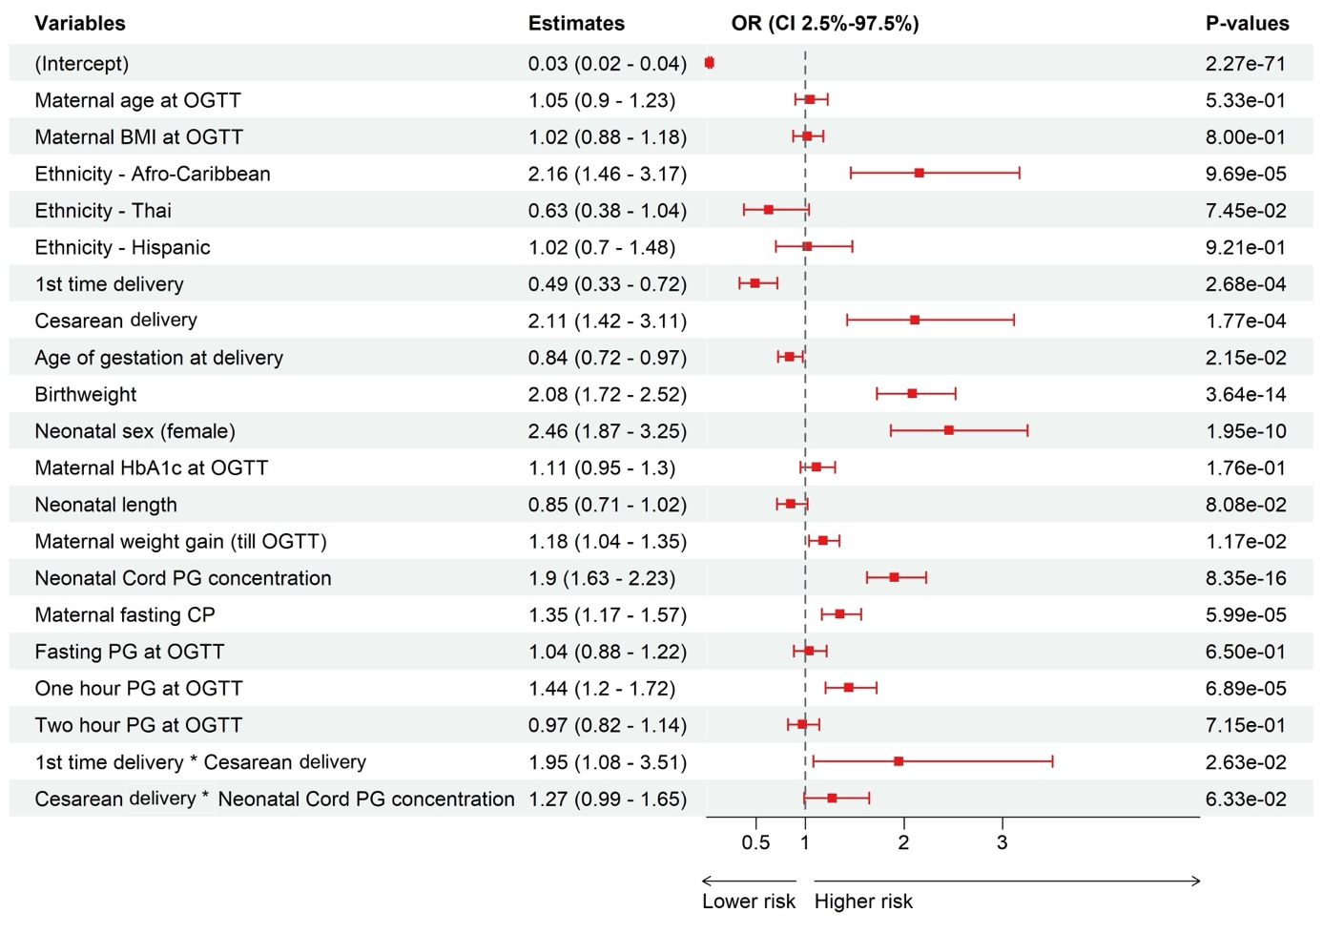
All continuous variables were standardized
PG: Plasma Glucose

eFigure 2. Complete case analyses without birth order (4008 observations)

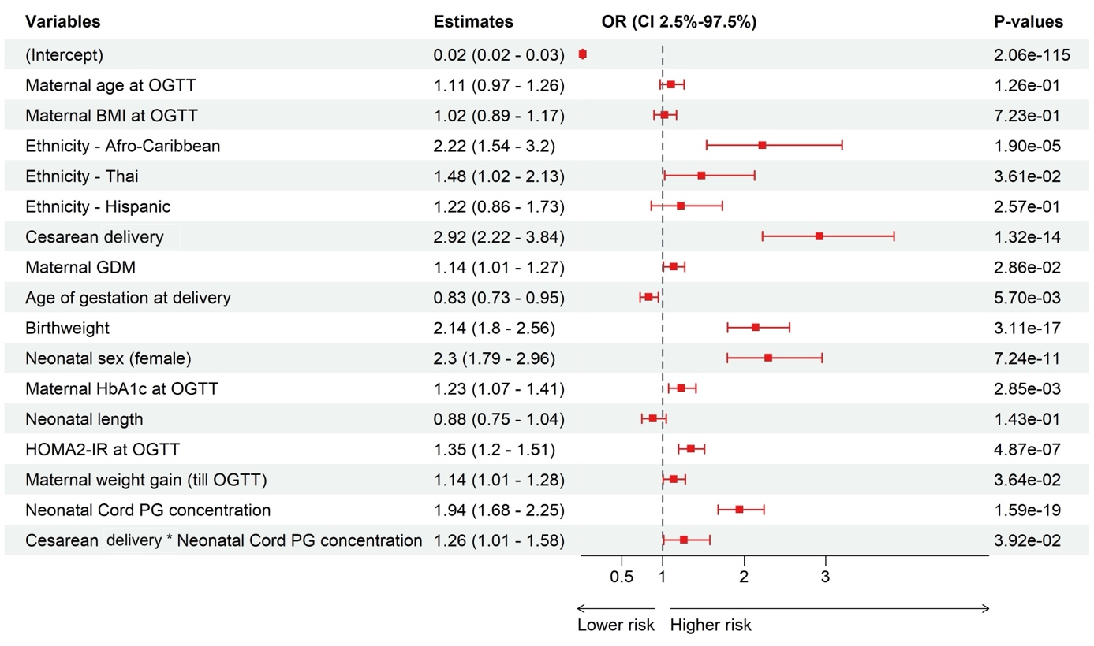
All continuous variables were standardized
PG: Plasma Glucose

Final models in ethnicity specific subgroups

eFigure 3. Complete case analyses, European ancestry (1355 observations):

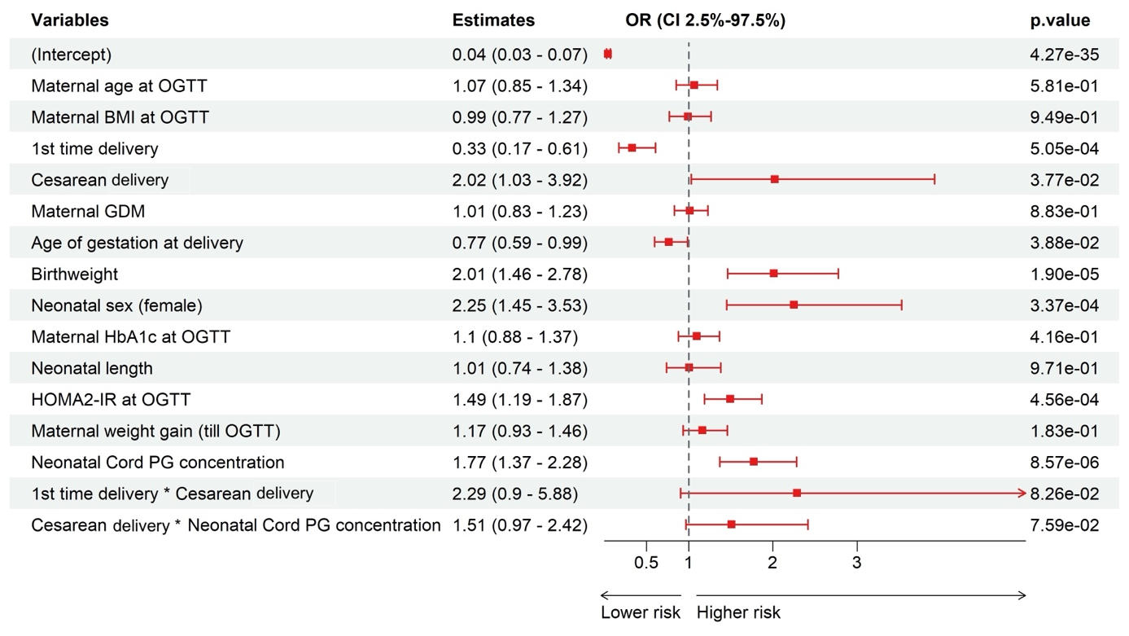
All continuous variables were standardized
PG: Plasma Glucose

eFigure 4. Complete case analyses, Afro-Caribbean ancestry (719 observations):

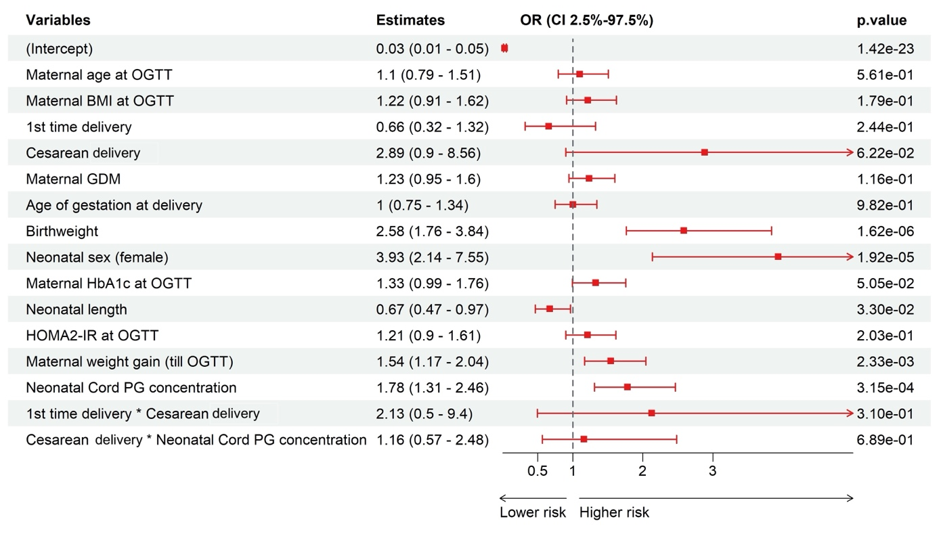
All continuous variables were standardized
PG: Plasma Glucose

eFigure 5. Complete case analyses, Thai ancestry. 618 observations

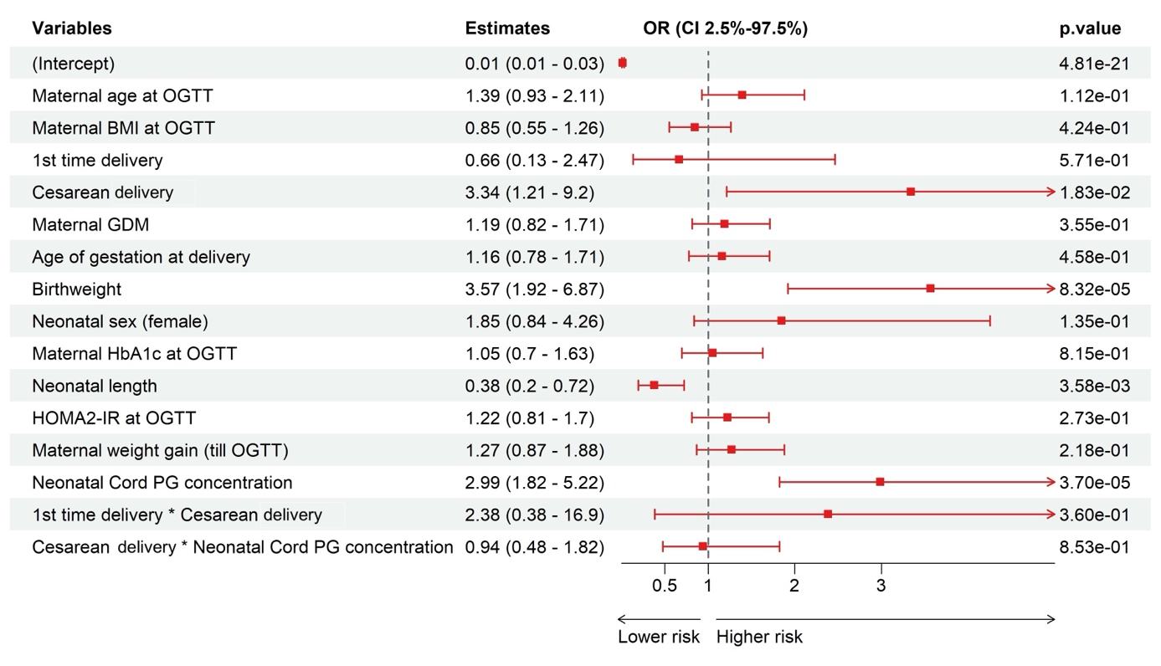
All continuous variables were standardized
PG: Plasma Glucose

eFigure 6. Complete case analyses, Hispanic ancestry, 800 observations

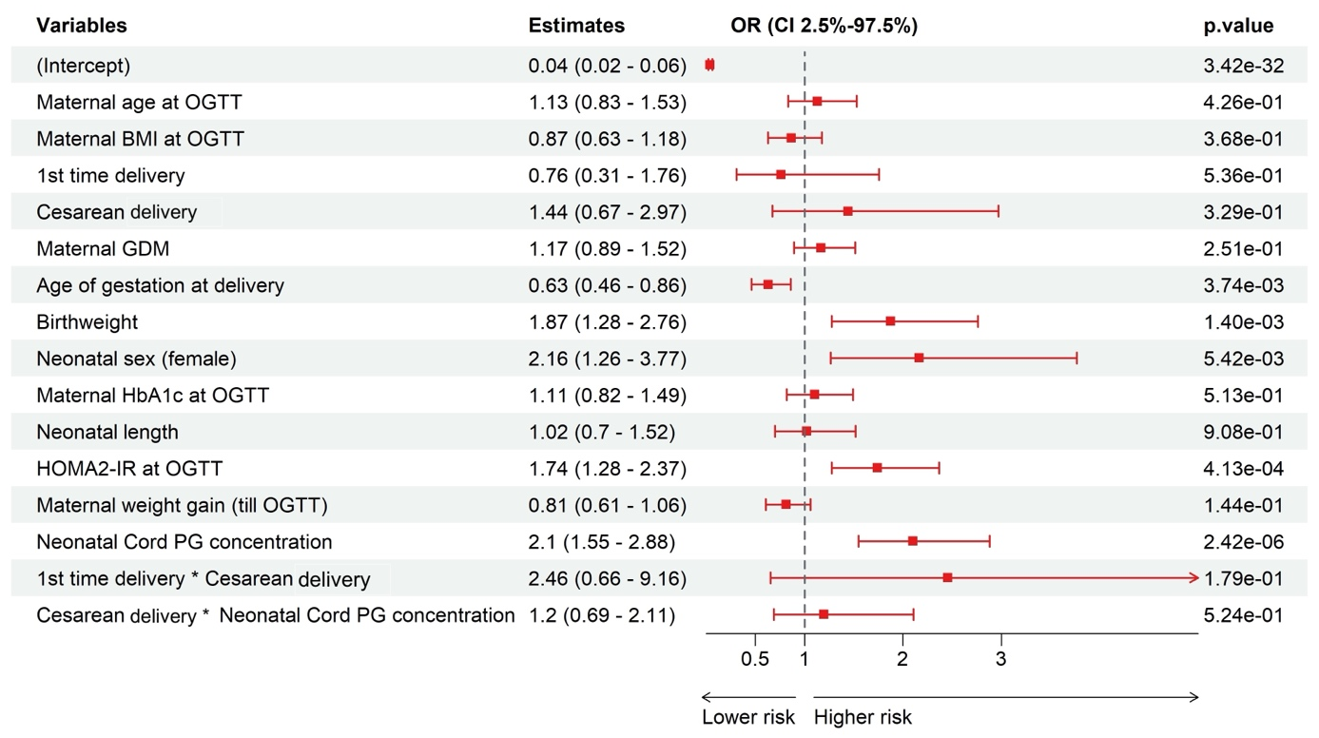
All continuous variables were standardized
PG: Plasma Glucose

Interpretation of interaction between Cesarean delivery and birth order

eFigure 7. Complete case analyses, final model using Cesarean delivery and birth order combined as a single, multilevel variable

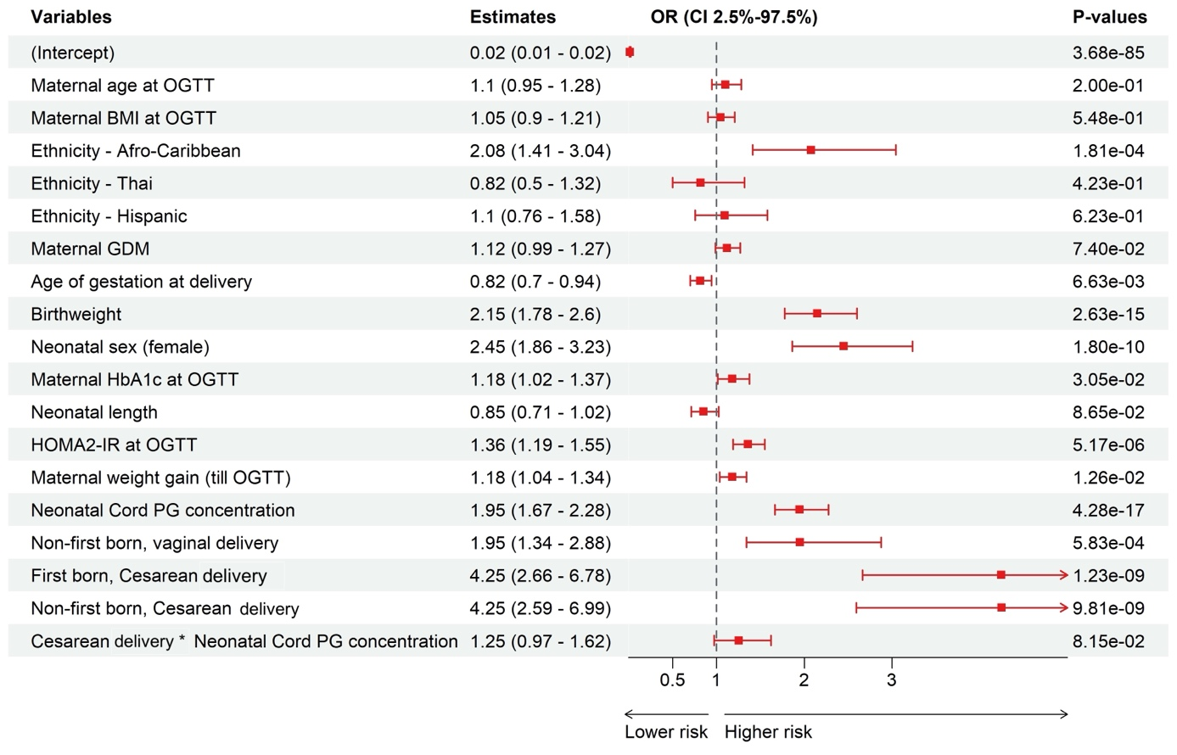
All continuous variables were standardized
PG: Plasma Glucose

Details of the Bayesian Joint Modeling and Imputation
The previously fitted complete-case logistic regression model was used to identify covariates for the Bayesian joint modeling. This model was included only observations with no missing values in the variables of interest. The final covariate set in this analysis were then selected for inclusion in a Bayesian joint modeling framework, implemented using the JointAI R package (v1.0.5).
The model was estimated using the glm_imp() function, which fits a generalized linear model with imputation under a fully Bayesian framework. This function conducts joint modeling by specifying a conditional distribution for each variable with missing values, while simultaneously estimating the main regression model. The model was fitted using a binomial family, which is appropriate for our binary outcomes.
The Bayesian model accounted for missing data through integrated multiple imputation, jointly estimating the outcome model and the imputation model under the assumption that data were missing at random (MAR). In our dataset, however, this assumption may not fully hold: for example, BMI values were most frequently missing among individuals of Afro-Caribbean ethnicity, and birth order was most often missing among those of Thai ethnicity.. Nevertheless, as the results are consistent with the complete case analysis, the missingness in BMI and birth order may not have large influence on the findings.
The Bayesian model was fitted using 300 adaptation iterations and 5,300 sampling iterations in 3 Markov Chain Monte Carlo (MCMC) chains, with a thinning interval of 5 to reduce autocorrelation. This resulted in 1060 samples per chains. A fixed seed (seed = 2020) ensured reproducibility. Posterior distributions were generated for all model parameters, including regression coefficients and auxiliary parameters related to the missing data mechanism. Summary statistics for each parameter—such as the posterior mean, standard deviation, 95% credible interval, and Monte Carlo error—were extracted. In addition, we reported tail probabilities, representing the proportion of posterior samples that fall on the less probable side of zero—serving as Bayesian analogues to two-sided p-values.

