Supplemental data

Home-based hybrid assistive limb lumbar type telerehabilitation in spinocerebellar ataxias: a nonrandomized open-label trial

Yoshiyuki Kishimoto, MD, PhD, Shinichiro Yamada, MD, PhD, Atsushi Hashizume, MD, PhD, Daisuke Ito, MD, PhD, Shota Komori, MD, Takahiro Kawase, MD, Ayano Kondo, MD, Yu Mori, MD, Kazuki Obara, MD, Munetaka Yamamoto, MD, Yachiyo Kuwatsuka, MD, PhD, Masahiko Ando, MD, PhD, Tomokazu Abe, Yoshihiro Yasunaga, Masahisa Katsuno, MD, PhD

Contents:
Supplemental Methods
Three Supplemental Figures (supplementary figure 1-3)
Five Supplemental Tables (supplementary table 1–5)
Supplemental Methods

Study Protocol
I. Background of the Study
Spinocerebellar degeneration is a collective term for a group of neurological disorders primarily characterized by ataxia. These conditions significantly impair patients’ daily lives over extended periods, with onset ranging widely from 10 to 60 years of age. The causes of secondary cerebellar ataxia include infection, exposure to toxins, tumors, nutritional deficiencies, vascular disorders, and autoimmune diseases. Spinocerebellar degeneration is also classified as hereditary or non-hereditary, with hereditary spinocerebellar degeneration following both autosomal dominant and recessive inheritance patterns. In Japan, the autosomal dominant inheritance pattern is overwhelmingly more common than the recessive pattern. Autosomal dominant spinocerebellar degeneration encompasses a group of disorders that include spinocerebellar ataxia types 1 to 49 (as of 2023) and dentatorubral-pallidoluysian atrophy. Non-hereditary spinocerebellar degeneration includes multiple system atrophy and other disorders (cortical cerebellar atrophy). This study focuses on hereditary spinocerebellar degeneration.
While all forms of hereditary spinocerebellar degeneration are progressive and lack disease-modifying or curative therapies, a recent study demonstrated the effectiveness of physical therapy¹, suggesting that patients’ functional capabilities could be maintained or improved through rehabilitation.
The wearable cyborg Hybrid Assistive Limb (HAL®) is a device worn on the body that assists the wearer’s physical movements. It determines assistive actions using information from weak bioelectric signals (BES) generated when the wearer attempts to move their muscles, thereby providing assistance for each joint movement. While this device is indicated for patients with slowly progressive neuromuscular diseases who have diminished walking function, it is not yet indicated for those with spinocerebellar degeneration. The effectiveness of HAL® in exercise therapy has been reported for a small number of patients with spinocerebellar degeneration²; however, this primarily involved hospital-based exercise therapy with limited patient accessibility. Furthermore, whether short-term hospital-based exercise therapy can lead to maintenance of long-term effects currently remains unclear.
Therefore, we designed an exploratory clinical study to examine the efficacy and safety of exercise therapy in spinocerebellar ataxia types 3, 6, and 31, using the HAL® Lumbar Type, which can be fitted by patients themselves or by their caregivers and performed regularly at home. Spinocerebellar ataxia types 3, 6, and 31 were specifically selected because their natural history has been well-established, and they allow for easier comparison with control individuals not undergoing exercise therapy. Further, limiting the genetic types enables the targeting of a relatively homogeneous population.

1. Prevalence of the Target Disease in Japan and Overseas
The spinocerebellar degeneration patient population in Japan encompasses approximately 30,000 individuals, of whom approximately 10,000 have hereditary disease. Among patients with hereditary spinocerebellar degeneration in Japan, spinocerebellar ataxia types 3, 6, and 31 are the most common.

2. Development and Description of the Standard of Care
Currently, no effective disease-modifying therapies for patients with spinocerebellar degeneration are available. Thyrotropin-releasing hormone derivatives — protirelin (Hirtonin®) and taltirelin (Ceredist®) — are the standard of care for the symptomatic treatment of ataxia. Regarding non-pharmacological therapy, intensive rehabilitation has been reported to improve ataxic gait and activities of daily living³.

3. Current Standard of Care and Therapeutic Outcomes
Approximately 60% of patients with spinocerebellar degeneration show improvement with taltirelin (Ceredist®) treatment⁴. With 4 weeks of short-term intensive inpatient rehabilitation, the Scale for the Assessment and Rating of Ataxia (SARA) score and walking speed both improve³. However, at 24 weeks post-treatment, SARA scores typically return to pre-treatment levels, and only half of all patients maintain slight improvements in walking speed.

4. Current Challenges and Uncertainties in the Standard of Care, Leading to the Need for this Research
Currently no disease-modifying therapies that function to inhibit disease progression in spinocerebellar degeneration are available. In addition, symptomatic pharmacological treatment is effective in only a subset of patients. While rehabilitation could be expected to yield benefits, these benefits are short-term, and the optimal frequency of therapeutic intervention for maintaining long-term benefits is currently unknown. Furthermore, frequent inpatient rehabilitation has its limits from the perspective of patient burden.

5. Information on the Medical Device Used in this Study
i) Name of the Medical Device (Generic and Brand Names)
Hybrid Assistive Limb Lumbar Type (HAL® Lumbar Type for Care Support)

ii) Method, Amount, and Duration of Use
Rehabilitation exercise program using the HAL® Lumbar Type performed at home:
20 min once daily
Three times per week for 4 weeks

iii) Target Population (Age Range, Sex, Disease, etc.)
Age: 20 to <85 years
Both male and female
Patients with genetically confirmed spinocerebellar ataxia types 3, 6, or 31

iv) Clinically Important Findings on Efficacy and Safety of the Medical Device fromNonclinical Trials and Other Clinical Research
Efficacy of the HAL® Lumbar Type for Frailty
In a study of 16 frail individuals who underwent exercise therapy using HAL® Lumbar Type for 20–30 min once daily over a total of five sessions, improvements were observed in the 10 m walking speed, stride length, Timed Up and Go Test (TUG test) score, and 30 s chair stand test score. Improvements were maintained at 1-month follow-up, and all improvements except the TUG test score were maintained at 3-month follow-up⁵.

Efficacy of HAL® Lumbar Type in Healthy Individuals
In one study of 18 healthy individuals comparing performance with and without HAL® Lumbar Type, individuals using HAL® showed significant improvements in both visual analogue scale (VAS) fatigue scores and lifting time during heavy object lifting tasks⁶.

Safety of HAL® Lumbar Type
In one study of 16 frail individuals who underwent exercise therapy using the HAL® Lumbar Type for 20–30 min once daily for five sessions, all patients completed the exercise therapy, with no adverse events reported⁵.

v) Advantages and Disadvantages of Using the Medical Device (Known and Potential)
Advantages
For patients with spinocerebellar degeneration, improvements are expected in stability during sit-to-stand movements and walking speed.

Disadvantages
There is a potential risk of injury from falls during the rehabilitation exercise program. While patients with spinocerebellar degeneration require particular attention to the risk of falls due to truncal ataxia, risks can be minimized through the use of handrails and other fall prevention equipment during the exercise program, along with caregiver supervision. Further, as there is a risk of fatigue-induced falls after HAL® Lumbar Type exercise therapy or falls caused by immediate effects on muscle tension and movement, patients will be informed of this possibility beforehand and instructed to move carefully immediately after exercise therapy.
Other potential risks include muscle and joint pain from the exercise load, back pain from contact with the device, contact dermatitis, erythema, or skin abrasion from contact with the electrodes. Patients will be informed of these risks beforehand and advised to avoid any excessive exercise loading and to monitor their skin condition.

II. Study Objectives
The purpose of this study is to evaluate the efficacy and safety of exercise therapy using HAL® Lumbar Type in patients with hereditary spinocerebellar degeneration.
Prior research has shown that 4 weeks of exercise therapy in patients with hereditary spinocerebellar degeneration improves the SARA scores, balance ability, and walking speed, with effects lasting approximately 12 weeks. However, frequent inpatient exercise therapy is not practical due to factors such as patient burden and the limited number of facilities.
This study therefore aims to evaluate the effectiveness, safety, and feasibility of implementing a rehabilitation exercise program using HAL® Lumbar Type at home.

Ⅲ. Study Information
1. Primary and Secondary Endpoints
Primary Endpoint
Changes in the Timed Up and Go Test score from week 0 to week 4
Secondary Endpoints
  - Changes in Timed Up and Go Test scores from week 0 to weeks 8 and 16
  - Changes in Timed Up and Go Test scores from week 4 to weeks 8 and 16
  - SARA score
  - 10 m walking test score
  - Berg Balance Scale (BBS) score
  - Cerebellar cognitive affective syndrome (CCAS) scale score
  - VAS score for lumbar pain
  - VAS score for limb pain
  - Clinical global impressions (CGI) score
  - Analysis of the motion data acquired from HAL® Lumbar Type’s proprietary data (information from angle sensors built into HAL® Lumbar Type, BES information obtained through electrodes attached to the skin surface during wear, and output intensity information from HAL® Lumbar Type)
Other Endpoints
  - Serum and plasma will be stored for exploratory biomarker measurements pending separate ethics committee approval.
Relationships between changes in endpoints from baseline to week 4 and background information obtained at screening (age, disease duration, genetic type, SARA, Mini-Mental State Examination (MMSE), and the presence of rehabilitation as concurrent therapy presence of clinical symptoms other than cerebellar symptoms, including pyramidal signs, spasticity, muscle weakness, involuntary movements, and sensory disturbances)

2. Type and Method of Clinical Study and Study Procedures
Non-blinded, uncontrolled, single-arm study

3. Methods for Randomization and Blinding to Minimize or Avoid Bias in the Clinical Study
Randomization
None
Blinding
None

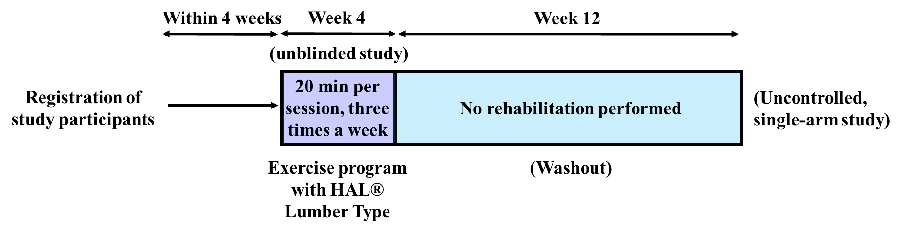
4. Information on the Use of the Medical Device
Nonproprietary name: Hybrid Assistive Limb Lumbar Type
Brand name: HAL® Lumbar Type for Care Support
Amount of use: 20 min once daily, three times per week

The HAL® Lumbar Type exercise program consists of 20-min sessions once daily. After fitting the HAL® Lumbar Type device, patients will perform trunk flexion and extension exercises in a seated position, followed by maintenance of trunk flexion. Depending on their condition, patients will progressively advance to sit-to-stand and squat exercises using handrails. The assist level of HAL® Lumbar Type can be self-adjusted according to the patient’s condition. Rest periods should be taken when fatigue is experienced. For those at risk of falling, family members or caregivers will provide supervision during the exercise program.

5. Study Timeline, Including Planned Participation Period and Observation Period
After obtaining consent and confirming eligibility, patients will be provided with HAL® Lumbar Type for use in a home exercise program. Patients will visit the outpatient clinic at weeks 0 (start), 4, 8, and 16 to perform the specified tests and observations. Efficacy and safety will be evaluated for patients who complete the 4-week rehabilitation exercise program.
Planned Study Participation Period: from the Japan Registry of Clinical Trials (jRCT) publication date to January 31, 2024
Study Observation Period: from the jRCT publication date to May 31, 2024
Entire Study Period: from the jRCT publication date to November 30, 2025

6. Criteria for Partial or Complete Discontinuation of the Clinical Study
The Principal Investigator will consider discontinuing the study if any of the following criteria are met:
1) Recruitment of participants is difficult, and achieving the planned sample size is deemed infeasible.
2) Changes to the protocol requested by the authorized Clinical Study Review Committee are deemed infeasible to implement.
3) Critical information regarding the quality, safety, or efficacy of the medical device is obtained.

7. Management Procedures for Study Medications, Including Placebos and Control Drugs
The medical device and other equipment will be borrowed from CYBERDYNE Inc., and managed by the Nagoya University Hospital Department of Neurology Clinical Study Group. The medical device manager will appropriately manage the device according to the procedures specified by the Principal Investigator. These procedures will include the necessary instructions for appropriate and reliable handling, storage, and management of the medical device. After study completion, the device and other equipment will be returned to CYBERDYNE Inc.

8. Randomization Procedure
None

9. Specification of Information to be Regarded as Source Data When Directly Recorded in Case Report Forms
Observations will generally be recorded in the medical records (including electronic medical records) and transcribed to case report forms. For the following information not typically recorded in medical records, the case report form itself will serve as the source document, unless documentation exists in the medical records.
・Severity, seriousness, causality, and findings of adverse events
・Details of reasons for discontinuation

Ⅳ. Inclusion and Exclusion Criteria, and Criteria for Study Discontinuation
Ⅳ-1. Study Population
1. Subject Inclusion Criteria
- Age 20 to <85 years at time of consent
- Genetically confirmed as having spinocerebellar ataxia type 3, 6, or 31
- Meets the following criteria at screening:
SARA gait score ≥2 and ≤6
MMSE score ≥24 points
- Able to attend outpatient visits
- Able to provide written informed consent to participate

2. Exclusion Criteria
- Difficulty wearing HAL® Lumbar Type
- Symptomatic orthostatic hypotension
- History of skin reactions to adhesive patches
- Serious cardiac conditions (myocardial infarction, angina, etc.)
- History of psychiatric disorders, including depression
- Evidence of dementia or other neurological disorders at screening
- Deemed inappropriate for study participation by the Principal Investigator or Investigator
- Currently participating in other clinical trials at time of consent

Ⅳ-2. Criteria for Study Discontinuation
The Principal Investigator or Investigator will discontinue the use of the device and conduct discontinuation assessments where possible, if any of the following circumstances arise during the study period. In cases where the study is discontinued due to safety concerns such as the occurrence of disease or worsening of complications, the Principal Investigator or Investigator will promptly implement the appropriate measures.
- Unable to continue the exercise program due to adverse events, making protocol compliance impossible
- A deviation from the protocol is identified
1) A participant is found to be ineligible after study initiation (based on the efficacy and safety evaluation, or safety assurance considerations)
2) A significant deviation from the protocol is identified
- A participant is lost to follow-up; for example, when clinic visits cannot be arranged
- A participant withdraws consent or discontinues participation (situations including relocation, transfer to a different hospital, time constraints)
- The entire study is discontinued
- The Principal Investigator or Investigator determines discontinuation is necessary

V. Treatment for Study Participants
1. Schedule Details Including All Medical Devices to be Used, Method and Amount of Use, Route of Use, Duration of Use, and Requirements for Hospitalization, Outpatient Visits, and Dietary Restrictions, etc.
HAL® Lumbar Type Rehabilitation Exercise Program
Method and amount of use
Amount of use: 20 min once daily, three times per week
Implementation period: 4 weeks at home
If participants cannot complete 20 min of exercise due to fatigue, they should record the achievable time and reason for non-completion in their diary and continue with the study.

Study Schedule
Visit Day (Reference) |  | Screening | Registration*1 | Week 0 | Week 4 | Week 8 | Week 16 | Discontinuation
Allowable time window (days)  Procedure |  |  | -28 | 0 | ＋7 | ＋7 | ＋7
Written consent |  | ◯
Participant background screening*2 |  | ◯
Implementation of the exercise program |  |  | Week 0 (baseline) to 28 days
Functional assessments | TUG test |  |  | ◯ | ◯ | ◯ | ◯ | ◯
Functional assessments | SARA | ◯ |  | ◯ | ◯ | ◯ | ◯ | ◯
Functional assessments | 10 m walking test score |  |  | ◯ | ◯ | ◯ | ◯ | ◯
Functional assessments | BBS |  |  | ◯ | ◯ | ◯ | ◯ | ◯
Functional assessments | CCAS scale |  |  | ◯ | ◯ |  |  | ◯
Functional assessments | MMSE | ◯
Questionnaires | Lumbar pain VAS |  |  | ◯ | ◯ | ◯ | ◯ | ◯
Questionnaires | Limb pain VAS |  |  | ◯ | ◯ | ◯ | ◯ | ◯
Questionnaires | CGI |  |  | ◯ | ◯ | ◯ | ◯ | ◯
Signs and symptoms (adverse events) *3 |  |  |  | ◯ | ◯ | ◯ | ◯ | ◯
Concomitant medications and therapies |  | ◯ |  | ◯ | ◯ | ◯ | ◯ | ◯
Blood pressure, pulse rate |  | ◯ |  | ◯ | ◯ | ◯ | ◯ | ◯
Height, weight |  |  |  | ◯
Blood tests, biochemistry*4 |  |  |  | 〇 | 〇 |  | 〇 | 〇
Exploratory biomarkers*5 |  |  |  | 〇 | 〇 |  | 〇 | 〇
*1: Registration to occur within 28 days of screening. The allowable time window between registration and week 0 is 28 days.
*2: Confirm the eligibility criteria (inclusion/exclusion), date of birth, clinical symptoms (ocular symptoms such as diplopia and nystagmus, dysarthria, dysphagia, gait disturbance, pyramidal signs, spasticity, muscle weakness, involuntary movements, sensory disturbance, urinary dysfunction, and orthostatic hypotension), time of ataxia onset, genetic type, concurrent diseases, medical history, and concurrent medications and therapies.
*3: After consent is obtained, assess new or worsening symptoms via examination or interview.
*4: There are generally no dietary restrictions, but as exploratory biomarker analyses may be conducted, including serum or plasma proteomics and metabolomics, participants should fast in the morning and skip their post-breakfast medications on blood collection visit days, only to minimize the metabolic effects of medications and food.

To confirm safety, including to ascertain whether excessive muscle strain or muscle damage has occurred from HAL® Lumbar Type exercise therapy, the following measurements from among the routine blood tests performed in regular medical care will be used as the existing data. Approximately 5 mL of extra blood will also be collected beyond the routine blood draw for exploratory biomarker purposes.
1) Hematology
Red blood cell count, white blood cell count, platelet count, hemoglobin, hematocrit
2) Blood chemistry
Total protein, albumin, AST, ALT, γ-GTP, ALP, LDH, total bilirubin, BUN, creatinine, uric acid, Na, K, Cl, CPK, fasting blood glucose
*5: For exploratory biomarkers, 2 mL of serum and 3 mL of plasma will be stored frozen.

2. Permitted and Prohibited Treatments Before and During the Clinical Study
Treatments prohibited from the time of obtaining consent until study completion:
1) Drugs that are not approved in Japan (including investigational drugs and clinical trial drugs)
2) Starting or discontinuing taltirelin or protirelin tartrate hydrate injection after obtaining consent is prohibited in principle. However, if discontinuation is unavoidable due to side effects or other reasons, the reason and time of discontinuation must be recorded.
3) Starting, discontinuing, or changing the frequency of rehabilitation as a concurrent therapy after obtaining consent is prohibited in principle. However, if a change in frequency is unavoidable due to adverse reactions or other reasons, the reason and time of the change must be recorded.

3. Procedure for Confirming Compliance with Use of Medications and Other Requirements for Study Participants
Adherence to the rehabilitation exercise program will be confirmed through diaries. If the exercise program cannot be performed, the reason must be recorded in the case report form, that day’s exercise program should be skipped, and the program should be resumed from the following morning.
On visit days during this study, participants should fast from the morning and skip their post-breakfast medications before coming to the hospital.
VI. Efficacy Evaluations
1. Specification of Efficacy Endpoints
Primary Endpoint
Change in Timed Up and Go Test score from week 0 to week 4
Secondary Endpoints
・Changes in Timed Up and Go Test scores from week 0 to weeks 8 and 16
・Changes in Timed Up and Go Test scores from week 4 to weeks 8 and 16
・SARA score
・10 m walking test score
・BBS score
・CCAS scale score
・Lumbar pain VAS score
・Limb pain VAS score
・CGI score
・Analysis of movement data acquired from the HAL® Lumbar Type’s proprietary data (information from angle sensors built into HAL® Lumbar Type, BES information obtained through electrodes attached to the skin surface during wear, and output intensity information from HAL® Lumbar Type)
2. Methods and Timing for Evaluation, Recording, and Analysis of Efficacy Indicators
1) Full analysis set (FAS)
All participants registered in the clinical study, excluding those who never performed the exercise program and those with no efficacy data
2) Per protocol set (PPS)
FAS participants without major protocol violations who meet the minimum protocol requirements and have evaluable primary endpoint data
The Timed Up and Go Test will be performed at week 0 (start of the exercise program), week 4 (completion of the exercise program), week 8, and week 16, or at program discontinuation. The main analysis will be performed at week 4. The FAS will be the primary analysis population. Similar analyses will be performed for the PPS.

Analysis for the Primary Endpoint
The primary analysis will involve a t-test to assess the change in Timed Up and Go Test score from baseline to week 4, with statistical significance recognized if the resulting p-value falls below the level of significance. The level of significance will be 5%, two-sided.
The following analyses will be performed for the secondary endpoints.
Analyses for Secondary Endpoints:
・Changes in Timed Up and Go Test scores from week 0 to weeks 8 and 16
・Changes in Timed Up and Go Test scores from week 4 to weeks 8 and 16
・Change in the SARA score.
・10 m walking test score
・BBS score
・CCAS scale score
・Lumbar pain VAS score
・Limb pain VAS score
・CGI score
・Analysis of motion data acquired from HAL® Lumbar Type’s proprietary data (information from angle sensors built into HAL® Lumbar Type, BES information obtained through electrodes attached to the skin surface during wear, and output intensity information from HAL® Lumbar Type)
For each of these indicators, a linear mixed model will be used, with the evaluation timepoint as a fixed effect, to calculate the adjusted means and 95% confidence intervals at each evaluation timepoint. A linear mixed model analysis will be performed with baseline value and evaluation timepoint as fixed effects, using the change in indicator as the outcome variable.
Parametric tests are planned; however, the distribution will be checked before analysis to determine whether non-parametric tests are strictly necessary. Analyses will be performed using the Friedman or Wilcoxon signed-rank tests, according to the data characteristics.

Analysis of Factors Affecting Endpoints
Analyses will be performed using correlation coefficients and group comparisons to examine potential relationships between changes in each indicator from baseline to week 4 and background information obtained at screening (age; disease duration; genetic type; SARA; MMSE; presence of rehabilitation as concurrent therapy; and presence of non-cerebellar clinical symptoms such as pyramidal signs, spasticity, muscle weakness, involuntary movements, and sensory disturbances). Parametric tests are planned; however, the distribution will be checked before analysis to determine whether non-parametric tests are necessary. Non-parametric tests will be performed as appropriate, according to the characteristics of the data.

VII. Safety Evaluation
1. Specification of Safety Evaluation Indicators
Subjective and objective findings, blood pressure and pulse measurements, blood tests (including assessment of muscle breakdown enzymes, such as LDH, CPK).

2. Methods and Timing for Safety Evaluation, Recording, and Analysis
The Principal Investigator or Investigator must document all new adverse events (such as abnormal symptoms or signs) occurring during the study period (after obtaining consent) in the adverse event section of the case report form. This documentation must include the information (name of adverse event), date of onset, date of resolution (or ongoing at study end), severity, and actions taken regarding the exercise program (discontinued, no change in amount of use, reduction in use, unknown, and not applicable (if occurred after exercise program completion or subject death)). They must also document other interventions (drug therapy, treatments (such as symptomatic therapy)), outcomes (recovered, improved, not recovered, recovered with sequelae, death, and unknown), and assessments of whether the event qualifies as a serious adverse event. Additionally, they must determine the causal relationship with the exercise program using the medical device. Adverse events that newly occur during the study period will be evaluated at all assessment timepoints, or at the time of exercise program discontinuation.

*Definition of Adverse Event
An adverse event is defined as any untoward medical occurrence in the study subjects who undertook the exercise program, and does not necessarily indicate only those with a causal relationship to the treatment. In other words, it refers to any untoward and unintended sign, symptom, or disease, regardless of whether there is a causal relationship with the exercise program.

*Definition of Serious Adverse Event
A serious adverse event is defined as any adverse event that falls under any of the following categories.
      - Death
      - Life-threatening
(This means that the participant was at risk of death at the time of the event, not that the event may have been fatal had it been more severe.)
      - Disability
      - Potentially resulting in disability
      - Requiring hospitalization or prolongation of existing hospitalization for treatment
      - Congenital anomaly or birth defect in later generations comparable in seriousness to categories (1) through (5)

*Evaluation of Severity
Severity will be assessed using the Japanese translation (JCOG version) of the Common Terminology Criteria for Adverse Events (CTCAE) v5.0 (CTCAEv5.0-JCOG).

*Definitions of Causality
The causal relationships between adverse events and the exercise program will be defined according to the JCTN-Common Guidelines for Adverse Event Reporting as follows:

(1) Definite
The adverse event clearly occurred or worsened due to the study protocol treatment, but the possibility of worsening of the original disease or other factors (comorbidities, other medications or treatments, or incidental conditions) is deemed minimal.

(2) Probable
The adverse event is unlikely to have occurred or worsened due to worsening of the original disease or other factors (comorbidities, other medications or treatments, or incidental conditions) and is deemed to be highly likely to be caused by the study protocol treatment.

(3) Possible
The adverse event is more plausibly considered to have occurred or worsened due to the protocol treatment, and the possibility of worsening of the original disease or other factors (comorbidities, other medications or treatments, or incidental conditions) is deemed to be low.

(4) Unlikely
The adverse event is more plausibly considered to have occurred or worsened due to worsening of the original disease or other factors (comorbidities, other medications or treatments, or incidental conditions), rather than the protocol treatment.

(5) Not related
The adverse event clearly occurred or worsened due to worsening of the original disease or other factors (comorbidities, other medications or treatments, or incidental conditions), and the possibility of it being due to the protocol treatment is deemed to be minimal.

Categories (1)–(3) above will be classified as “Causally related” and categories (4)–(5) as “Not causally related.”

3. Procedures for the Collection, Recording, and Reporting of Serious Adverse Events and Diseases (Including Malfunctions)
If the Principal Investigator becomes aware of any serious adverse events that occur during this clinical study, they must report to the Director of Nagoya University Hospital and the Nagoya University Clinical Study Review Committee within the specified deadlines. Furthermore, upon becoming aware of events classified under 1) or 2) b), they must also report the same to the Ministry of Health, Labour and Welfare within the specified deadline. This will be undertaken in accordance with independently established procedures for handling occurrences of diseases and other events.

*Definition of malfunction
A malfunction refers to any damage, operational failure, or other such events that cannot be ruled out as having a causal relationship with the medical device or product, regardless of the stage of design, manufacture, sales, distribution, or use.

*Definition of disease
Disease refers to any adverse event that cannot be ruled out as having a causal relationship with the specified clinical study, including any unintended signs, clinically significant changes in clinical laboratory values, symptoms, and worsening of complications.

1) Among the following disease occurrences, those suspected to be caused by this clinical study and are unexpected
Reporting deadline: 7 days (30 days for malfunctions)
a) Death
b) Disease or other such events that may lead to death
2) The following events during the implementation of this clinical study
Reporting deadline: 15 days (30 days for malfunctions)
a) Among the following disease or other event occurrences, those suspected to be caused by this clinical study (excluding those listed in 1 above)
(1) Death
(2) Disease or other such events that may lead to death
b) Among the following diseases or other event occurrences, those suspected to be caused by this clinical study and are unexpected (excluding those listed in 1 above)
(1) Disease or other such events requiring hospitalization or prolonged hospitalization for treatment
(2) Disability
(3) Disease or other such events that may lead to disability
(4) Disease or other such events that is as serious as events (1) through (3), death, and disease or other such events that may lead to death
(5) Congenital disease or abnormalities in later generations
3) Occurrence of disease etc., suspected to be caused by the implementation of this clinical study (excluding those listed in 1 and 2 above)
Reporting deadline: When filing regular reports with the authorized Clinical Study Review Committee.

The Principal Investigator must also report any serious adverse events attributed to HAL® Lumbar Type to CYBERDYNE Inc. by email within the reporting deadlines specified in 1) and 2) above. Additionally, upon becoming aware of potential diseases listed in 1) and 2) above that may occur due to malfunctions of HAL® Lumbar Type, they must report the malfunction to CYBERDYNE Inc. by email within the specified deadline.

4. Observation Period for Subjects After Adverse Event Occurrence
In cases of adverse events or safety concerns, the Principal Investigator or Investigator shall promptly take the appropriate measures and conduct follow-up investigations until participant safety is confirmed, along with performing the necessary tests.

Ⅷ. Statistical Analysis
1. Statistical Analysis Methods for the Interim Analysis
The primary analysis will be conducted at completion of the exercise program (week 4). No interim analysis will be performed. Other details are specified in the Statistical Analysis Plan.

2. Planned Sample Size and Rationale, Including Power Calculations and Clinical Considerations
Target enrollment: 20 participants
As there are no existing studies of exercise therapy using the HAL® Lumbar Type in hereditary spinocerebellar degeneration patients, precise estimation of the change is difficult. Therefore, based on a study in which patients with Parkinson’s disease using the HAL® Lumbar Type showed a 3.7-s improvement in the TUG test scores [5], we set the expected difference at 4 weeks after exercise program initiation at 3.2 s, with a standard deviation of 3.6 s. To detect this difference using a t-test with 5% significance level and 90% power, 16 participants are required. Considering potential dropouts, we set the target sample size at 20 participants. Given that approximately 40 patients with hereditary spinocerebellar degeneration are currently attending our hospital, we believe that enrolling 20 patients would be feasible, considering the expected rates of consent.

3. Level of Significance to be Used
5%, two-sided

4. Criteria for Study Discontinuation
As specified in Section IV-6

5. Procedures for Handling Missing and Abnormal Data
To be discussed in case review meetings.

6. Procedure for Modifying the Initial Statistical Analysis Plan
When changes to the statistical analysis plan are required, the details, timing, rationale, impact on statistical evaluations, and validity will be documented, and the statistical analysis plan will be revised accordingly.

7. Selection of Subjects for Analysis
The following populations will be defined for analysis. The main analysis population for efficacy analysis (efficacy evaluation group) will consist of participants meeting both of the criteria below:
(1) Participants who performed the exercise program at least once
(2) Participants with the TUG test scores obtained at baseline and after exercise program implementation
Analyses will also be performed for the PPS, which excludes participants with low implementation rates or violations of the inclusion or exclusion criteria. The safety analysis population (safety analysis group) will comprise participants who performed the exercise program at least once.

Ⅸ. Access to Source Documents
The Principal Investigator and implementing medical institution will make all clinical study-related records available for direct examination during monitoring, as authorized by the Clinical Study Review Committee audits, and regulatory authority inspections.

X. Quality Control and Quality Assurance
1. Monitoring Methods
Monitoring will be conducted in accordance with separately specified procedures and protocols and will seek to confirm that the study is being implemented safely and according to protocol, and that data is being collected accurately.

XI. Ethical Considerations
1. Advantages, Burdens, and Predicted Disadvantages for Subjects; Comprehensive Evaluation and Measures to Minimize Burdens and Disadvantages
The advantages and disadvantages of undertaking the HAL® Lumbar Type exercise program are described in Section II-5-v. In addition, blood tests may involve pain or bleeding. Compensation for study-related health injury to participants will be specified elsewhere. Furthermore, care will be taken to ensure that patients who do not participate in the research do not suffer any disadvantage, and it will be thoroughly explained to participants that they can receive the same care as before.

2. Handling of Study Results (Including Incidental Findings) if Important Findings Relevant to Subjects’ Health or Inherited Genetic Characteristics May Affect their Descendants
Not applicable

XII. Handling and Storage of Records (Including Data)
1. Provision of Samples or Information to Other Institutions
■ Yes
□ No
In this study, proprietary data that can be acquired from HAL® Lumbar Type (information from angle sensors built into HAL® Lumbar Type, BES information obtained through electrodes attached to the skin surface during wear, and output intensity information from HAL® Lumbar Type) will be stored on CYBERDYNE Inc.’s online server, taking maximum consideration to ensure participant anonymization (only the participant assignment number, sex, and birth date will be transmitted). CYBERDYNE Inc. will further conduct independent motion data analysis using this information and share the information with Nagoya University.

2. Storage and Disposal Methods for Samples and Information
Blood samples will be stored in freezers at the Nagoya University Graduate School of Medicine Department of Neurology. Data on clinical motor and cognitive function scores and blood test results will be appropriately kept in locked storage at the Nagoya University Graduate School of Medicine Department of Neurology for 10 years from the date the study completion is reported or 3 years from the date the final study results are reported, whichever is longer. If consent is obtained, the consent forms will continue to be stored in the same storage cabinet with the same careful attention as during the study period. If consent is similarly obtained for clinical information, the forms will be stored on password-protected HDDs and DVDs. If consent for such continued storage is not obtained, materials will be promptly shredded and electronic files will be deleted using a deletion software or physical destruction. Furthermore, if consent is withdrawn by any participant after initial consent provision, their samples and information will be disposed of immediately after the completion of analysis of the study results.

XⅢ. Study-Related Payments and Compensation
1. Insurance Coverage and Details
■ Coverage will be obtained
□ Coverage will not be obtained
Details if coverage is obtained
A quotation and coverage that follow Nagoya University Hospital regulations will be obtained. The details will be in accordance with the contract terms for clinical study insurance.

2. Compensation Other Than Insurance and Relevant Details
■ Yes
□ No
If “Yes”, details
Appropriate medical care will be provided as compensation for adverse events, regardless of the causal relationship with the medical device. The burden of compensation costs for serious adverse events will be in line with the contract terms for clinical study insurance.

XⅣ. Publication of Clinical Study Information
1. Registration and Publication in the jRCT
■ Yes
□ No

2. Existence of Arrangements with Funding Marketing Authorization Holders Regarding the Content and Timing of the Study Results
■ Yes
□ No
If “Yes”, details
As specified in a separate contract.

XV. Clinical Study Period
From the jRCT publication date to November 30, 2025

XVI. Explanation to and Consent from Study Participants
1. Informed Consent Procedure
When seeking consent from study participants, the Principal Investigator or Investigator will provide potential participants with consent documents and explanatory materials (please see below, “consent and information documents”) and provide them with a thorough explanation of the materials before their participation in the study. For explanations, only consent and information documents approved by the authorized Clinical Study Review Committee will be used.
Both the explaining Principal Investigator or Investigator and the study participant must print their names and seal or sign and date the consent form. A copy will be provided to the study participant, with the original retained by the Principal Investigator. If a research collaborator provides a supplementary explanation, the collaborator must also print their name and seal or sign and date the form. After obtaining consent, the Principal Investigator or Investigator will provide the participant with a copy of the signed and dated consent and information documents before their study participation begins. The date at which consent is obtained will also be recorded in the case report form.

2. Guideline for Identification and Selection of Proxy for Consent Purposes (if needed)
Not applicable

3. Procedure for Obtaining Informed Assent
Not applicable

4. Documentation of All Expected Advantages and Disadvantages
1) Related to the use of the medical device and other such devices.
See II-5-v.
2) Related to blood collection
While participants may experience disadvantages such as pain and physical risks, these disadvantages do not clearly exceed those experienced during routine medical care.

5. Notification of a Possibility and the Anticipated Details at the Time of Consent on the Use of Samples or Information Obtained from Participants for Future Research that is Not Specified at the Time of Consent or Provided to Other Research Institutions
If samples or information are to be used for other research in the future or potentially provided to other research institutions, application and review by the authorized Clinical Study Review Committee or bioethics review committee will be required in advance.

XVII. Requirements for Appropriate Study Implementation
1. Study Funding from Marketing Authorization Holders and others.
■ Yes
□ No
If “Yes”, details
The medical device will be provided by CYBERDYNE Inc., which will also provide partial study funding. CYBERDYNE Inc. will also conduct exploratory motion analysis (analysis using angle sensor data built into HAL® Lumbar Type, BESs obtained through skin surface electrodes, and output intensity information from HAL® Lumbar Type). The Principal Investigator will manage conflicts of interest appropriately according to the conflicts of interest plan reviewed by the authorized Clinical Study Review Committee.

Outcome measures
Secondary outcome measures included the assessment and rating of ataxia (SARA) total score, SARA axial score, and SARA limb score. The SARA total score ranges from 0 (no ataxia) to 40 (severe ataxia), and the SARA axial score consists of four items (gait, stance, sitting, and speech disturbance), within a range of 0–24; finally, the SARA limb score consists of four items (finger chase, nose-finger test, fast alternating hand movements, and heel-shin slide), within a range of 0–16⁷. In the 10-m walk test, lines were marked at 0, 2, 12, and 14 m. The participant was instructed to walk as quickly as possible from the 0 m to the 14 m line. The time started when either foot crossed the 2 m line and stopped when either foot crossed the 12 m line. This procedure was repeated three times, and the average time was taken as result⁸. Participants were allowed to use their usual assistive devices if they used them in daily life and were instructed to maintain the same conditions throughout the study period. The Berg balance scale (BBS) was used to evaluate the participants’ ability to balance. It consists of 14 items rated on a 5-point scale (from 0 to 4) and had a maximum score of 56⁹. The cerebellar cognitive affective/Schmahmann syndrome scale (CCAS-S) was developed as a screening measure for CCAS presence in individuals with known cerebellar disease and has 10 domains which probe semantic fluency, phonemic fluency, category switching, forward digit span, reverse digit span, cube draw and copy if needed, verbal recall, abstraction, go/no-go performance, and presence of neuropsychiatric symptoms¹⁰. The sum of the raw score of each domain ranges from 0 to 120. Unlike the other outcomes, for the CCAS-S evaluations were conducted only at pre- and post-intervention. The visual analogue scale (VAS) is a self-reported scale consisting of a horizontal line, 100 mm long anchored at the extremes by two verbal descriptions referring to the pain status. An introductory question asked the participant to tick the line on the point that best referred to his or her lumbar and limb pain, and the distance from the 0 mm was measured¹¹. The clinical global impressions scale (CGI) comprises three single-item subscales: clinical global impressions scale of severity of illness (CGI-S), a measure of global symptom severity at the time of evaluation; clinical global impressions scale of global improvement (CGI-I), a measure of global improvement since baseline evaluation; and clinical global impressions scale of efficacy index (CGI-E), a measure of therapeutic effect and side effect. CGI-S and CGI-I were rated on a scale of 1–7 with instructive anchor points, and CGI-E was calculated as the therapeutic score, ranging from 1 to 4 points, divided by the side effect score, also ranging from 1 to 4 points¹².

Supplemental References
- Ilg W, Synofzik M, Brötz D, Burkard S, Giese MA, Schöls L. Intensive coordinative training improves motor performance in degenerative cerebellar disease. Neurology. 2009;73(22):1823-30. doi:10.1212/WNL.0b013e3181c33adf
- Fujita S, Nakamura Y, Ueno S, et al. The effects of gait training using the robotic suit Hybrid Assistive Limb for spinocerebellar degeneration. Rigakuryohou Supplement. 2019;46S1(0):E-161_1
- Miyai I, Ito M, Hattori N, et al. Cerebellar ataxia rehabilitation trial in degenerative cerebellar diseases. Neurorehabil Neural Repair. 2012;26(5):515-22. doi:10.1177/1545968311425918
- Sobue I, Takayanagi T, Nakanishi T, et al. Controlled trial of Thyrotropin releasing hormone tartrate in ataxia of spinocerebellar degenerations. J Neurol Sci. 1983;61(2):235-248. doi:10.1016/0022-510x(83)90008-4
- Kotani N, Morishita T, Yatsugi A, et al. Biofeedback Core Exercise Using Hybrid Assistive Limb for Physical Frailty Patients With or Without Parkinson’s Disease. Front Neurol. 2020;11:215. doi:10.3389/fneur.2020.00215
- Miura K, Kadone H, Koda M, et al. The hybrid assistive limb（HAL）for Care Support successfully reduced lumber load in repetitive lifting movements. J Clin Neurosci. 2018;53:276-279. doi:10.1016/j.jocn.2018.04.057
- Schmitz-Hübsch T, Du Montcel ST, Baliko L, et al. Scale for the assessment and rating of ataxia: Development of a new clinical scale. Neurology. 2006;66(11):1717-20. doi:10.1212/01.wnl.0000219042.60538.92
- Saito Y, Nakamura S, Tanaka A, Watanabe R, Narimatsu H, Chung U Il. Evaluation of the validity and reliability of the 10-meter walk test using a smartphone application among Japanese older adults. Front Sport Act Living. 2022;4:904924. doi:10.3389/fspor.2022.904924
- Berg K, Wood-Dauphinee S, Williams JI, Gayton D. Measuring balance in the elderly: Preliminary development of an instrument. Physiother Can. 1989;41(6):304-311. doi:10.3138/ptc.41.6.304
- Hoche F, Guell X, Vangel MG, Sherman JC, Schmahmann JD. The cerebellar cognitive affective/Schmahmann syndrome scale. Brain. 2018;141(1):248-270. doi:10.1093/brain/awx317
- Euasobhon P, Atisook R, Bumrungchatudom K, Zinboonyahgoon N, Saisavoey N, Jensen MP. Reliability and responsivity of pain intensity scales in individuals with chronic pain. Pain. 2022;163(12) :e1184-e1191. doi:10.1097/j.pain.0000000000002692
- Guy W; National Institute of Mental Health (U.S.), Psychopharmacology Research Branch, Division of Extramural Research Programs. ECDEU Assessment Manual for Psychopharmacology. Rockville, MD: US Department of Health, Education, and Welfare, Public Health Service, Alcohol, Drug Abuse, and Mental Health Administration; 1976:218-222.

Supplementary Table 1. Long-Term changes of Outcome Measures After 4-week rehabilitation in patients with SCA according to per protocol set.
 | Pre-intervention | Post-intervention | 4 Weeks | 12 Weeks | Pre–post  p value | Pre–4W  p value | Pre-12W  p value
TUG (sec) | 17.6 (2.0) | 15.8 (1.9) | 15.5 (1.8) | 17.2 (2.0) | 0.079 | 0.012* | 0.902
SARA total score | 11.2 (0.8) | 10.6 (0.7) | 10.9 (0.7) | 11.2 (0.7) | 0.238 | 0.912 | 1.000
SARA axial score | 6.7 (0.5) | 6.3 (0.4) | 6.6 (0.4) | 6.6 (0.4) | 0.062 | 0.988 | 0.998
SARA limb score | 4.5 (0.5) | 4.4 (0.4) | 4.4 (0.4) | 4.6 (0.4) | 0.930 | 0.904 | 0.999
10m walking test (sec) | 9.5 (1.0) | 9.0 (0.9) | 9.0 (1.0) | 9.3 (1.0) | 0.224 | 0.151 | 0.901
Berg Balance Scale | 43.4 (1.7) | 46.4 (1.7) | 46.1 (1.7) | 45.1 (1.9) | 0.005** | 0.046* | 0.093
CCAS scale | 95.4 (2.1) | 99.1 (1.7) | N.D. | N.D. | 0.045*# | N.D. | N.D.
VAS lumber | 14.8 (4.9) | 11.1 (3.8) | 10.4 (3.8) | 11.6 (3.7) | 0.260 | 0.372 | 0.880
VAS limb | 20.2 (6.1) | 12.4 (4.7) | 13.9 (5.5) | 18.5 (5.0) | 0.481 | 0.739 | 0.992
CGI-S | 4.8 (0.2) | 4.1 (0.2) | 4.2 (0.2) | 4.2 (0.3) | 0.097 | 0.058 | 0.145
CGI-I | 4.5 (0.2) | 3.5 (0.2) | 4.2 (0.2) | 4.5 (0.2) | 0.039* | 0.888 | 0.997
CGI-E | 1.0 (0.2) | 1.9 (0.2) | 1.7 (0.2) | 1.4 (0.2) | <0.001*** | 0.001** | 0.100
Abbreviations: SCA = spinocerebellar ataxia; TUG = Timed Up and Go test; SARA = Scale for the Assessment and Rating of Ataxia; CCAS = Cerebellar Cognitive Affective Syndrome; N.D. = not determined; VAS = Visual analogue scale; CGI-S = Clinical Global Impression-Severity of illness; CGI-I = Clinical Global Impression-Improvement; CGI-E = Clinical Global Impression-Efficacy Index.
Data represent mean (standard error). *P < 0.05, **P < 0.01, ***P < 0.001.
p value was calculated using a Tukey-Kramer test. #p value was calculated using paired t test.

Supplementary Table 2. Comparison of Short-Term changes of Outcome Measures After 4-week rehabilitation among each genotype
 | SCA3 (n = 8) | SCA6 (n = 6) | SCA31 (n = 6) | p Value
TUG (sec) | -2.5 (1.1) | 0.6 (1.1) | -1.8 (1.0) | 0.127
SARA total score | -0.4 (0.4) | -1.2 (0.5) | -0.2 (0.6) | 0.310
SARA axial score | -0.4 (0.3) | -0.3 (0.2) | -0.3 (0.3) | 0.992
SARA limb score | 0.0 (0.4) | -0.8 (0.5) | 0.2 (0.4) | 0.254
10MWT (sec) | -0.9 (0.6) | 0.0 (0.2) | -0.9 (0.4) | 0.369
BBS | 2.8 (1.7) | 2.2 (1.0) | 2.7 (0.6) | 0.947
CCAS scale | 7.1 (1.5) | 4.3 (3.4) | -1.7 (2.1) | 0.044*
VAS lumber | -2.4 (1.2) | 1.7 (1.8) | -8.3 (4.5) | 0.064
VAS limb | -4.6 (6.4) | 3.8 (3.8) | -18.7 (11.3) | 0.164
CGI-S | -1.0 (0.4) | -0.2 (0.5) | -0.7 (0.4) | 0.387
CGI-I | -0.4 (0.3) | -0.7 (0.5) | -1.7 (0.6) | 0.134
CGI-E | 1.0 (0.3) | 0.5 (0.2) | 0.9 (0.1) | 0.380
Changes between pre- and post-intervention were shown. Abbreviations: SCA = spinocerebellar ataxia; TUG = Timed Up and Go Test; SARA = Scale for the Assessment and Rating of Ataxia; 10MWT = 10-m walk test; BBS = Berg Balance Scale; CCAS = Cerebellar Cognitive Affective Syndrome; VAS = Visual analogue scale; CGI-S = Clinical Global Impression-Severity of illness; CGI-I = Clinical Global Impression-Improvement; CGI-E = Clinical Global Impression-Efficacy Index.
Data represent mean ± standard error. *P < 0.05
p value was calculated using a one-way ANOVA and Bonferroni test.

Supplementary Table 3. Comparison of Short-Term changes of Outcome Measures After 4-week rehabilitation in SCA patients with and without non-ataxia symptoms
 | SCA without non-ataxia symptoms  (n = 6) | SCA with non-ataxia symptoms  (n = 14) | p Value
TUG (sec) | 0.6 (1.1) | -2.2 (0.7) | 0.045*
SARA total score | -1.2 (0.5) | -0.3 (0.3) | 0.129
SARA axial score | -0.3 (0.2) | -0.4 (0.2) | 0.944
SARA limb score | -0.8 (0.5) | 0.1 (0.3) | 0.098
10MWT (sec) | 0.0 (0.2) | -0.9 (0.4) | 0.152
BBS | 2.2 (0.9) | 2.7 (1.0) | 0.739
CCAS scale | 4.3 (3.4) | 3.4 (1.7) | 0.777
VAS lumber | 1.7 (1.8) | -4.9 (2.1) | 0.075
VAS limb | 3.8 (3.8) | -10.6 (6.1) | 0.156
CGI-S | -0.2 (0.5) | -0.9 (0.3) | 0.202
CGI-I | -0.7 (0.5) | -0.9 (0.3) | 0.674
CGI-E | 0.5 (0.2) | 1.0 (0.2) | 0.164
Changes between pre- and post-intervention were shown. Abbreviations: SCA = spinocerebellar ataxia; TUG = Timed Up and Go Test; SARA = Scale for the Assessment and Rating of Ataxia; 10MWT = 10-m walk test; BBS = Berg Balance Scale; CCAS = Cerebellar Cognitive Affective Syndrome; VAS = Visual analogue scale; CGI-S = Clinical Global Impression-Severity of illness; CGI-I = Clinical Global Impression-Improvement; CGI-E = Clinical Global Impression-Efficacy Index.
Data represent mean ± standard error. *P < 0.05.
p value was calculated using Unpaired Student t-test.

Supplementary Table 4. Comparison of Short-Term changes of Outcome Measures After 4-week rehabilitation in SCA patients with and without conventional physical therapy
 | SCA without  conventional physical therapy  (n = 15) | SCA with  conventional physical therapy  (n = 5) | p Value
TUG (sec) | -1.3 (0.8) | -1.3 (1.2) | 0.997
SARA total score | -0.5 (0.3) | -0.8 (0.5) | 0.598
SARA axial score | -0.3 (0.2) | -0.4 (0.2) | 0.853
SARA limb score | -0.1 (0.3) | -0.4 (0.4) | 0.656
10MWT (sec) | -0.5 (0.3) | -0.8 (0.8) | 0.707
BBS | 2.7 (0.9) | 2.0 (1.2) | 0.673
CCAS scale | 3.9 (1.7) | 3.0 (3.5) | 0.812
VAS lumber | -3.5 (2.2) | -1.4 (2.3) | 0.613
VAS limb | -5.3 (3.7) | -9.4 (16.1) | 0.710
CGI-S | -0.9 (0.3) | 0.2 (0.2) | 0.040*
CGI-I | -0.9 (0.3) | -0.8 (0.6) | 0.920
CGI-E | 0.8 (0.2) | 0.8 (0.2) | 0.927
Changes between pre- and post-intervention were shown. Abbreviations: SCA = spinocerebellar ataxia; TUG = Timed Up and Go Test; SARA = Scale for the Assessment and Rating of Ataxia; 10MWT = 10-m walk test; BBS = Berg Balance Scale; CCAS = Cerebellar Cognitive Affective Syndrome; VAS = Visual analogue scale; CGI-S = Clinical Global Impression-Severity of illness; CGI-I = Clinical Global Impression-Improvement; CGI-E = Clinical Global Impression-Efficacy Index.
Data represent mean ± standard error. *P < 0.05.
p value was calculated using Unpaired Student t-test.

Supplementary Table 5. Baseline characteristics of the SCA patients with and without non-ataxia symptoms
 | SCA without non-ataxia symptoms  (n = 6) | SCA with non-ataxia symptoms (n = 14) | p Value
Age at examination (years) | 60.0 ± 9.2 | 51.6 ± 11.6 | 0.133
Sex, F/M | 0/6 | 6/8 | 0.077#
Disease duration (years) | 11.1 ± 13.4 | 7.8 ± 5.2 | 0.426
Genotypes SCA3/6/31 | 0/6/0 | 8/0/6 | <0.001*#
SARA total score | 12.8 ± 4.3 | 10.6 ± 1.4 | 0.093
SARA axial score | 7.7 ± 3.0 | 6.3 ± 0.7 | 0.114
SARA limb score | 5.2 ± 1.6 | 4.3 ± 1.2 | 0.197
MMSE | 29.2 ± 1.6 | 29.1 ± 1.9 | 0.979
Abbreviations: SCA = spinocerebellar ataxia; SARA = Scale for the Assessment and Rating of Ataxia; MMSE = Mini Mental State Examination.
Data represent mean ± standard deviation (range). *P < 0.05.
p value was calculated using Unpaired Student t-test. #p value was calculated using chi-square test.

Supplementary Fig. 1 Design of the clinical trial
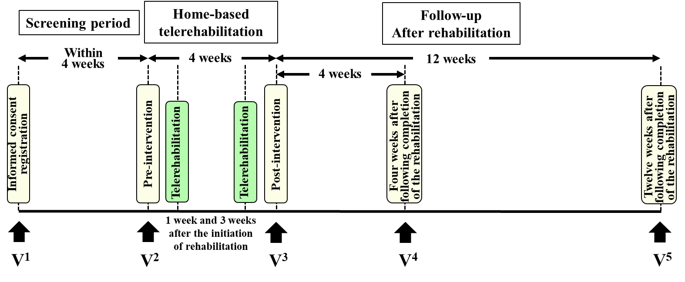

Supplementary Fig. 2 HAL assisted exercise
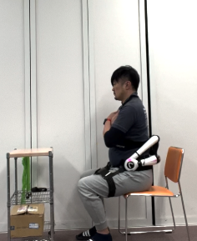
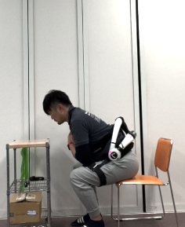
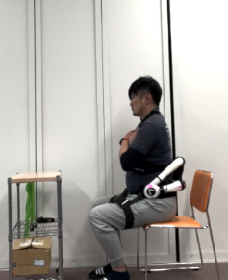
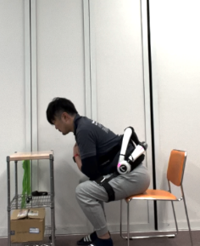
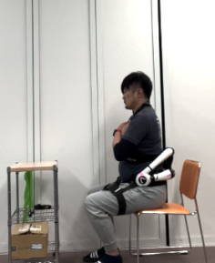
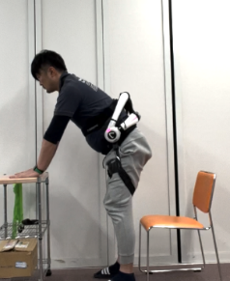
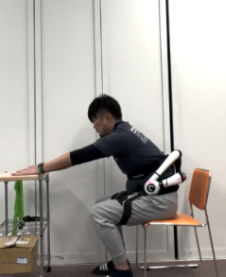
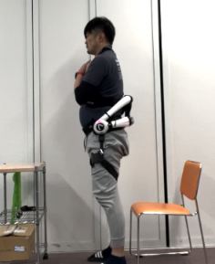
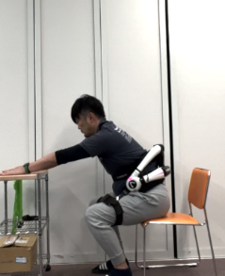
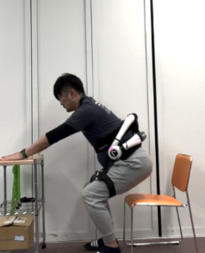

a

b

c

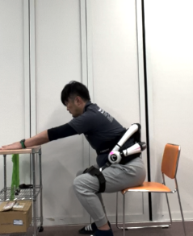
d

(a) Repetitive lumbar flexion and extension exercise in a sitting position. (b) Exercise to maintain trunk flexion posture in a sitting position. (c) Repetitive sit-to-stand exercise. (d) Exercise to maintain trunk and knee flexion posture in the process of standing up.

Supplementary Fig. 3 Correlations between short-term changes of outcome measures and baseline parameters
TUG pre-post
TUG pre-post
 | Age | Disease duration | Baseline SARA total score | MMSE
TUG | r = 0.358  p = 0.121 | r = 0.442  p = 0.051 | r = 0.480  p = 0.032* | r = -0.080  p = 0.736
SARA total score | r = 0.061  p = 0.798 | r = 0.209  p = 0.377 | r = -0.094  p = 0.693 | r = 0.118  p = 0.620
SARA axial score | r = 0.032  p = 0.892 | r = 0.048  p = 0.841 | r = -0.190  p = 0.423 | r = -0.445  p = 0.049*
SARA limb score | r = 0.045  p = 0.850 | r = 0.192  p = 0.417 | r = 0.015  p = 0.951 | r = 0.392  p = 0.087
10MWT | r = 0.391  p = 0.088 | r = 0.189  p = 0.424 | r = 0.100  p = 0.676 | r = 0.110  p = 0.646
BBS | r = -0.134  p = 0.572 | r = -0.176  p = 0.458 | r = 0.048  p = 0.842 | r = 0.263  p = 0.263
CCAS scale | r = -0.108  p = 0.651 | r = -0.162  p = 0.495 | r = 0.143  p = 0.549 | r = 0.146  p = 0.539
VAS lumber | r = -0.254  p = 0.279 | r = 0.096  p = 0.686 | r = 0.027  p = 0.909 | r = 0.106  p = 0.657
VAS limb | r = 0.003  p = 0.990 | r = 0.212  p = 0.369 | r = 0.171  p = 0.470 | r = 0.041  p = 0.866
CGI-S | r = 0.133  p = 0.577 | r = 0.074  p = 0.758 | r = 0.224  p = 0.343 | r = -0.139  p = 0.559
CGI-I | r = -0.288  p = 0.219 | r = 0.156  p = 0.512 | r = 0.011  p = 0.964 | r = -0.109  p = 0.648
CGI-E | r = -0.258  p = 0.272 | r = -0.175  p = 0.462 | r = -0.339  p = 0.144 | r = 0.312  p = 0.180
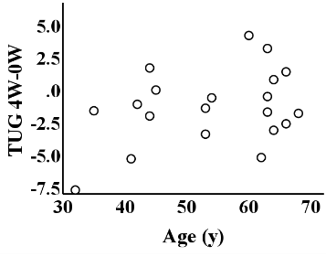
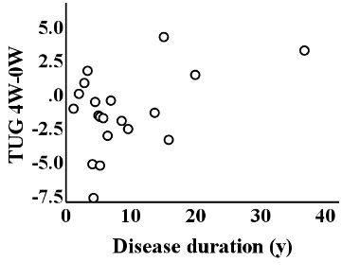
TUG pre-post
TUG pre-post
a
p = 0.736
p = 0.032
r = -0.080
r = 0.358
r = 0.442
p = 0.051
p = 0.121
c
b
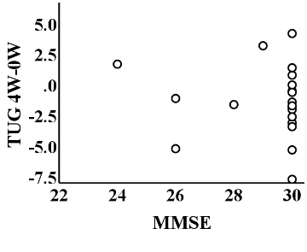
r = 0.480
e
d
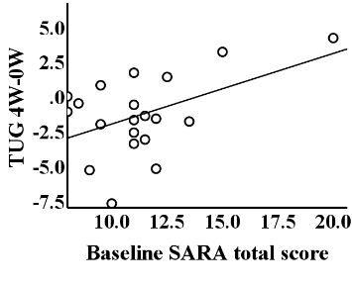

(a) Pearson’s correlation test between baseline characteristics and the changes in each outcome measure between pre- and post-intervention. Correlation coefficients and p values are shown. (b-e) Correlations between the change in TUG at post-intervention and age, disease duration, baseline SARA total score, and MMSE. SARA, Scale for the Assessment and Rating of Ataxia; MMSE, Mini Mental State Examination; TUG, Timed Up and Go Test; 10MWT, 10-m walk test; BBS, Berg Balance Scale; CCAS, Cerebellar Cognitive Affective Syndrome; VAS, Visual analogue scale; CGI-S, Clinical Global Impression-Severity of illness; CGI-I, Clinical Global Impression-Improvement; CGI-E, Clinical Global Impression-Efficacy Index.

