Supplementary Information

Modulating MoS₂ Conductivity through Nitrogen Doping: A Spray-Coating Approach to P-Type 2D Semiconductors

Thomas Vicart^{1,2}, Youssef Doubi¹, Bouchra Asbani¹, Nitul Rajput³, Ahmed Kotbi¹, Mimoun El Marssi¹, My Ali EL Khakani², Mustapha Jouiad^{1,*}
¹Laboratory of Physics of Condensed Matter, University of Picardie Jules Verne, Scientific Pole, 33 rue Saint-Leu, 80039 Amiens Cedex 1, France, France
²Institut National de la Recherche Scientifique, Centre-Energie, Matériaux et Télécommunications, 1650, Blvd, Lionel–Boulet, Varennes, QC J3X-1P7, Canada
³Advanced Materials Research Center, Technology Innovation Institute, P.O. Box 9639, Abu Dhabi, UAE

Corresponding author: mustapha.jouiad@u-picardie.fr

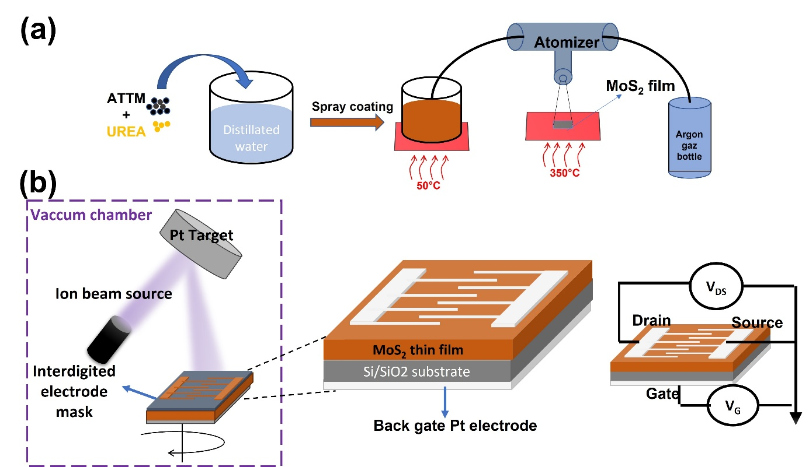

Figure S1. Experimental process for MoS₂ based device fabrication. (a) Schematic representation of the spray coating system used for the synthesis of MoS₂. (b) Device fabrication setup involving ions beam deposition (PECS II – Model 685) of Pt electrodes, followed by the assembly of the MoS₂ based Field Effect Transistor (FET).
Figure S2 Distribution of grain size in MoS₂ thin films: a) Pristine MoS₂; b) 10% nitrogen-doped MoS₂; c) 50% nitrogen-doped MoS₂.

Figure S3 XRD diagram for pristine, 10% and 50% nitrogen doped MoS₂ thin films including a zoom in on (100) peak to showcase the XRD shift-induced nitrogen doping.

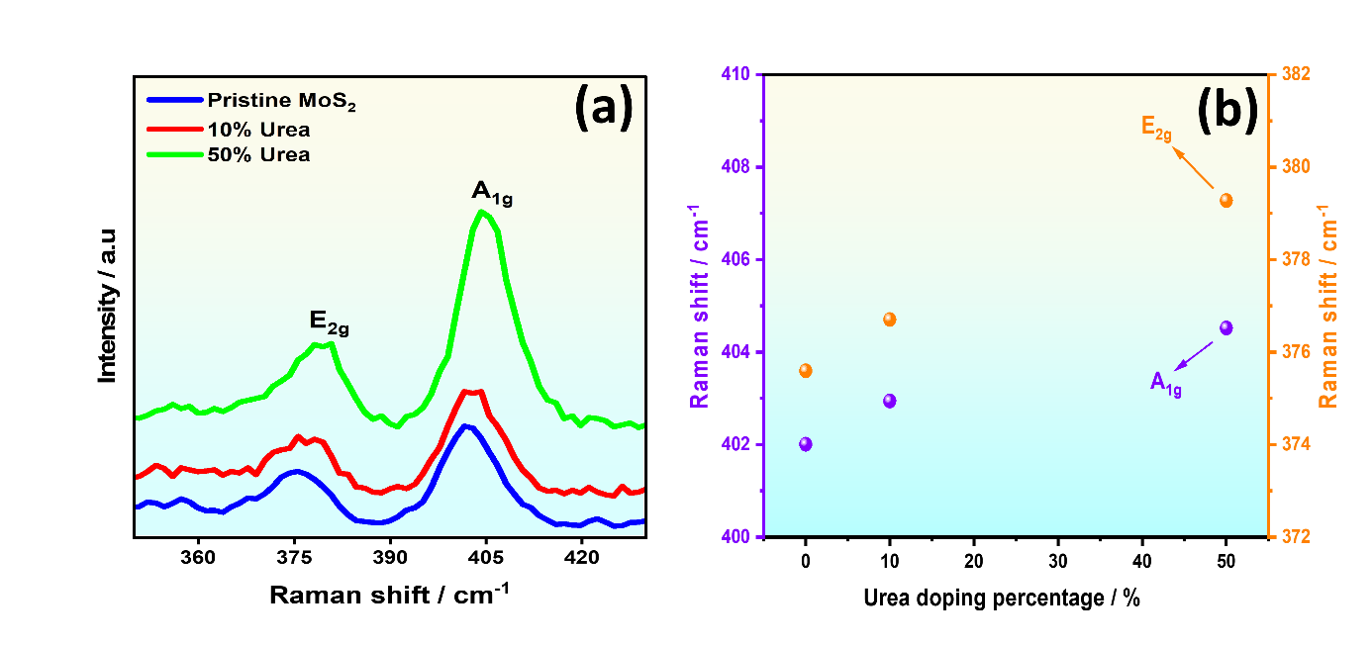
Figure S4. Raman spectroscopy analysis of MoS₂ thin films. (a) Zoomed Raman spectra showing the characteristic A₁g and E¹_{2g} modes, highlighting shifts in peak positions indicative of structural and phase modifications induced by N-doping. (b) Variation of the A₁g and E₂g Raman peak positions as a function of urea doping concentration.
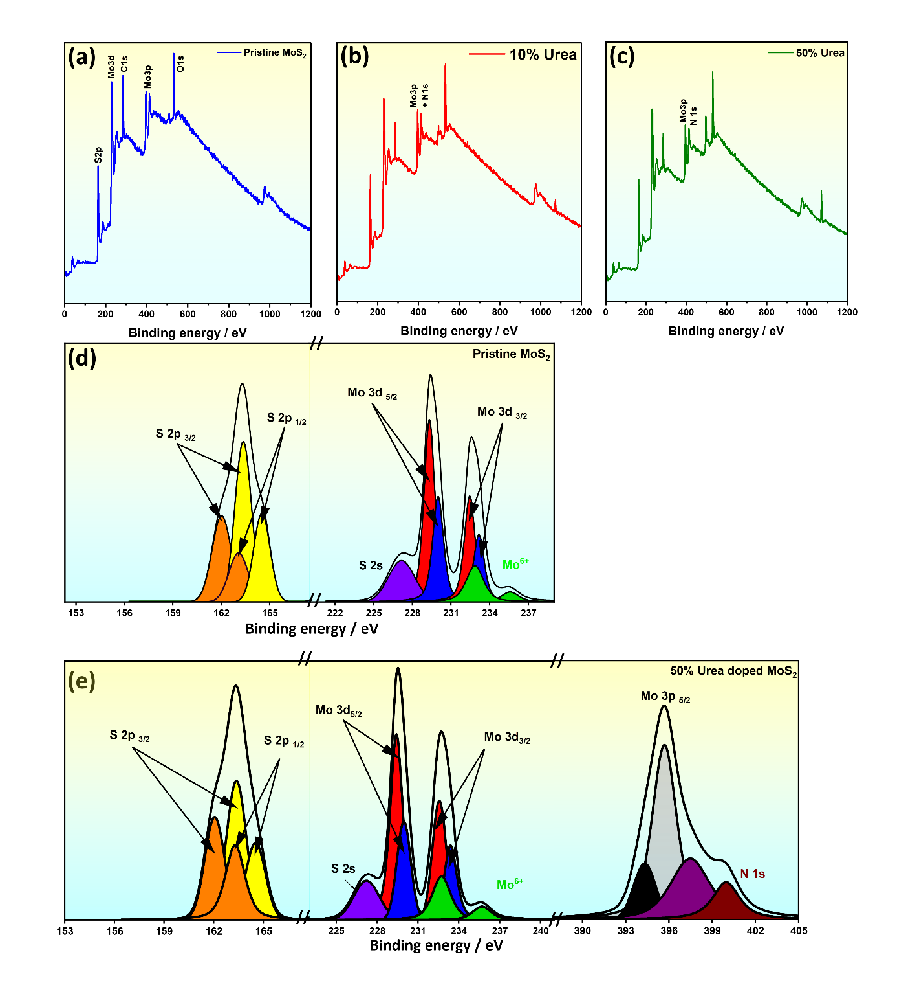
Figure S5. XPS elemental and compositional analysis of MoS₂ thin films. (a–c) General XPS survey spectra of (a) pristine MoS₂. (b) 10% urea-doped MoS₂. (c) 50% urea-doped MoS₂. High-resolution XPS spectrum of (d) pristine MoS₂. (e) 50% urea-doped MoS₂.
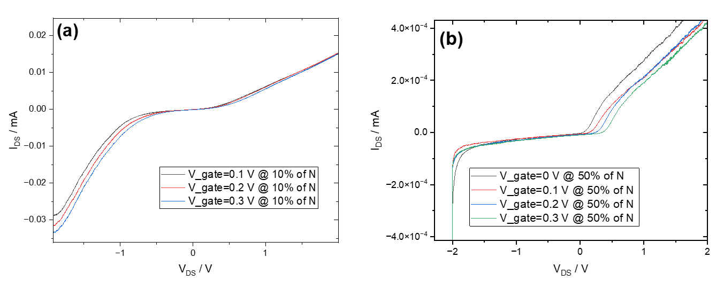
Figure S6. I_{DS}-V_{DS} plots with respect to various gate bias for sample: a) 10% N-doping; b) 50% N-doping

Table S1. XPS element contents Mo, S and N in MoS₂ thin films.
Samples | Mo / at% | S / at% | N / at%
Pristine MoS₂ | 28.79 | 71.21 | -
10% Urea doped MoS₂ | 42.75 | 54.46 | 2.79
50% Urea doped MoS₂ | 42.36 | 52.81 | 4.83

