Supplementary materials
Table S1. Sequence details of crRNAs, probes, and LAMP primers utilized in this study.
Name |  |  | Sequences（5’→3’）
PEDV-crRNA1-F |  |  | TAATACGACTCACTATAGG-AATTTCTACTAAGTGTAGAT AAAAGTTCAGCCAGCCCGCG
PEDV-crRNA1-R |  |  | CGCGGGCTGGCTGAACTTTTATCTACACTTAGTAGAAA  TTCCTATAGTGAGTCGTATTA
PEDV-crRNA2-F |  |  | TAATACGACTCACTATAGG-AATTTCTACTAAGTGTAGAT TCAGAAATTTCCGCGGGCTG
PEDV-crRNA2-R |  |  | CAGCCCGCGGAAATTTCTGAATCTACACTTAGTAGAAA  TTCCTATAGTGAGTCGTATTA
PEDV-crRNA3-F |  |  | TAATACGACTCACTATAGG-AATTTCTACTAAGTGTAGAT CGCGGGCTGGCTGAACTTTT
PEDV-crRNA3-R |  |  | AAAAGTTCAGCCAGCCCGCGATCTACACTTAGTAGAAA  TTCCTATAGTGAGTCGTATTA
TEDV-crRNA4-F |  |  | TAATACGACTCACTATAGG-AATTTCTACTAAGTGTAGAT  TAGACCGAGATCTAGATTGA
TEDV-crRNA4-R |  |  | TCAATCTAGATCTCGGTCTAATCTACACTTAGTAGAAAT  TCCTATAGTGAGTCGTATTA
TEDV-crRNA5-F |  |  | TAATACGACTCACTATAGG-AATTTCTACTAAGTGTAGAT  AGTGCGGCAAGAACAGCTTG
TEDV-crRNA5-R |  |  | CAAGCTGTTCTTGCCGCACTATCTACACTTAGTAGAAA  TTCCTATAGTGAGTCGTATTA
TEDV-crRNA6-F |  |  | TAATACGACTCACTATAGG-AATTTCTACTAAGTGTAGAT TGTGTCAACACCTAACTTTT
TEDV-crRNA6-R |  |  | AAAAGTTAGGTGTTGACACAATCTACACTTAGTAGAAA  TTCCTATAGTGAGTCGTATTA
PCoDV-crRNA7-F |  |  | TAATACGACTCACTATAGG-AATTTCTACTAAGTGTAGAT  TCTGGTGTAACGCAGCCAGT
PCoDV-crRNA7-R |  |  | ACTGGCTGCGTTACACCAG AATCTACACTTAGTAGAAA  TTCCTATAGTGAGTCGTATTA
PCoDV-crRNA8-F |  |  | TAATACGACTCACTATAGG-AATTTCTACTAAGTGTAGAT  GTGGCAATGGAGTTCCGCTT
PCoDV-crRNA8-R |  |  | AAGCGGAACTCCATTGCCACATCTACACTTAGTAGAAA  TTCCTATAGTGAGTCGTATTA
PCoDV-crRNA9-F |  |  | TAATACGACTCACTATAGG-AATTTCTACTAAGTGTAGAT  GACGGGTTTGATGGCGGAGT
PCoDV-crRNA9-R |  |  | ACTCCGCCATCAAACCCGTCATCTACACTTAGTAGAAA  TTCCTATAGTGAGTCGTATTA
PoRV-crRNA10-F |  |  | TAATACGACTCACTATAGG -AATTTCTACTAAGTGTAGAT  AGTTGATGCTTCAGTAGG
PoRV-crRNA10-R |  |  | CCTACTGAAGCATCAACTATCTACACTTAGTAGAAA  TTCCTATAGTGAGTCGTATTA
PEDV-F3 | GAGTTCCGCTTAACTCCGC
PEDV-B3 | GGTGGTTTCCAGTATGTGGT
PEDV-FIP | ACGCTTCTGCATTTTCCCGCTC-GAGCAGCACCCTGTAACG
PEDV-BIP | ATGTACACGTCATTGTGGGGCC-CCGGGTCTGCAAAATTAGCA
PEDV-LF | TTCAAAAGTTCAGCCAGCCC
PEDV-LB | ACCTGGGTGTGGTAAAAGCA
TEDV-F3 | GCCAGGCGAATTTCAACT
TEDV-B3 | TAGAACGAGAGCGTTGCT
TEDV-FIP | TGCCTCTAGATTGAGATCTGTTTCTGAAGTTAACCAGTCAAGGGA
TEDV-BIP | GCAACAATCCAATAACAAGAAGGATTTTTCTGTGTCAACACCTAAC
TEDV-LF |  | TGAGAGCGTGACCTTGAATTG
TEDV-LB |  | GACAGTGTAGAACAAGCTGTTCTTG
PDCoV-F3 |  | GAGTTCCGCTTAACTCCGC
PDCoV-B3 |  | AGTGTCAGCTCCCGAACC
PDCoV-FIP |  | ATACTGGCACAGGTCCCAGAGGGAGTGGTTGCTGGGGTATC
PDCoV-BIP |  | ATACTGGCACAGGTCCCAGAGGGAGTGGTTGCTGGGGTATC
PDCoV-LB |  | TCTTAAGTATGGTGAACTCCCTCCT
PoRV G9-F3 |  | TACTGGCTCCATGGACAC
PoRV G9-B3 |  | CACAATAAAGTTGTGGGTCA
PoRV G9-FIP |  | ATTTGAGTTGATGCTTCAGTAGGATCAAATTCGTCACAACAAGAAAC
PoRV G9-BIP |  | TATCCCAATTGTTCTTGACTAAGGGGAGAATGAAGCGATATTAGTGTA
PoRV G9-LB |  | TGGCCAACTGGATCAGTTTACT
FAM-BHQ-ssDNA |  | 5’-(FAM)CCGGAAAAAAAAAAACCGG(BHQ1)-3'
FAM-Biotin-ssDNA |  | 5’-(FAM)CCGGAAAAAAAAAAACCGG(Biotin)-3'

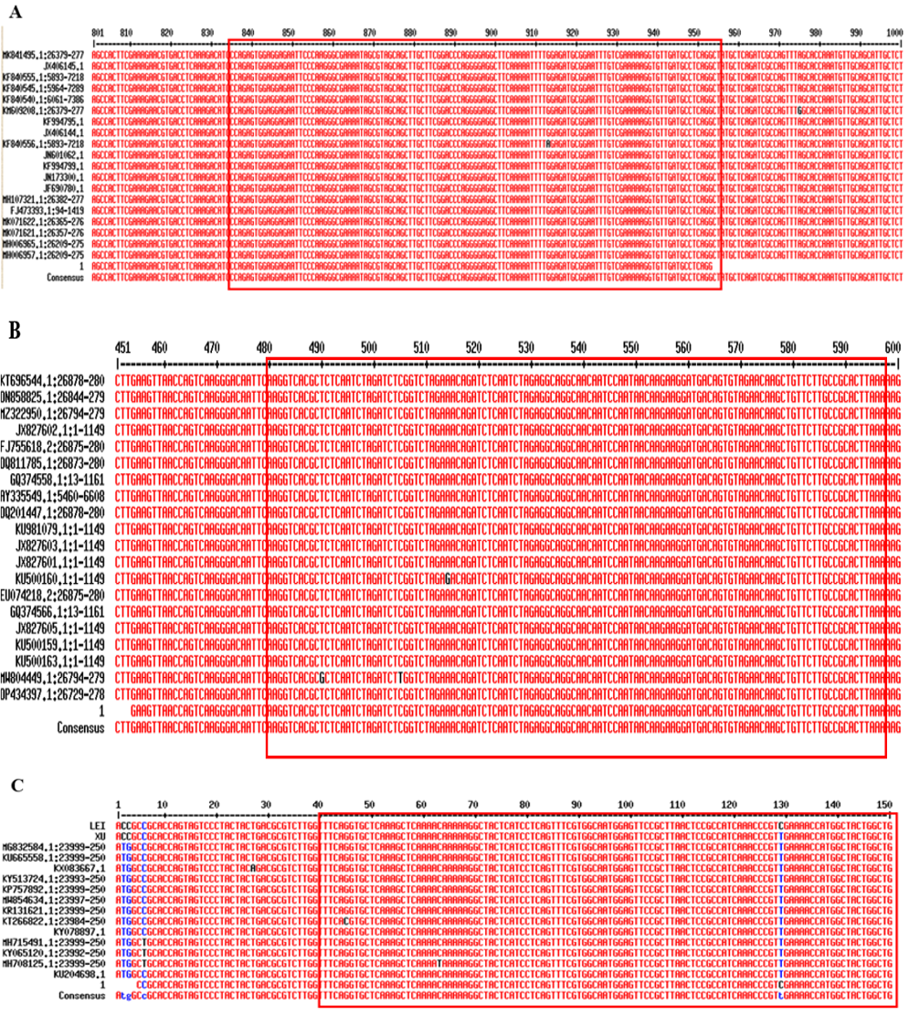
Figure S1. Nucleotide sequences alignment of different PEDV, TGEV and PDCoV strains. A, B and C display the sequence comparison results of the N gene from various PEDV, TGEV and PDCoV strains, respectively. The regions highlighted in the red boxes represent conserved sequences that were used for designing crRNA and LAMP primers.

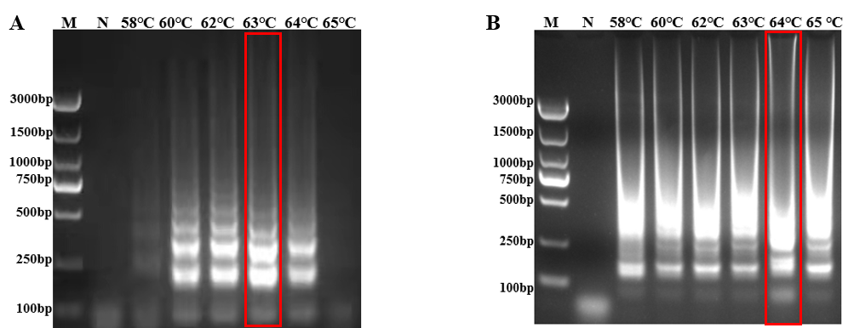
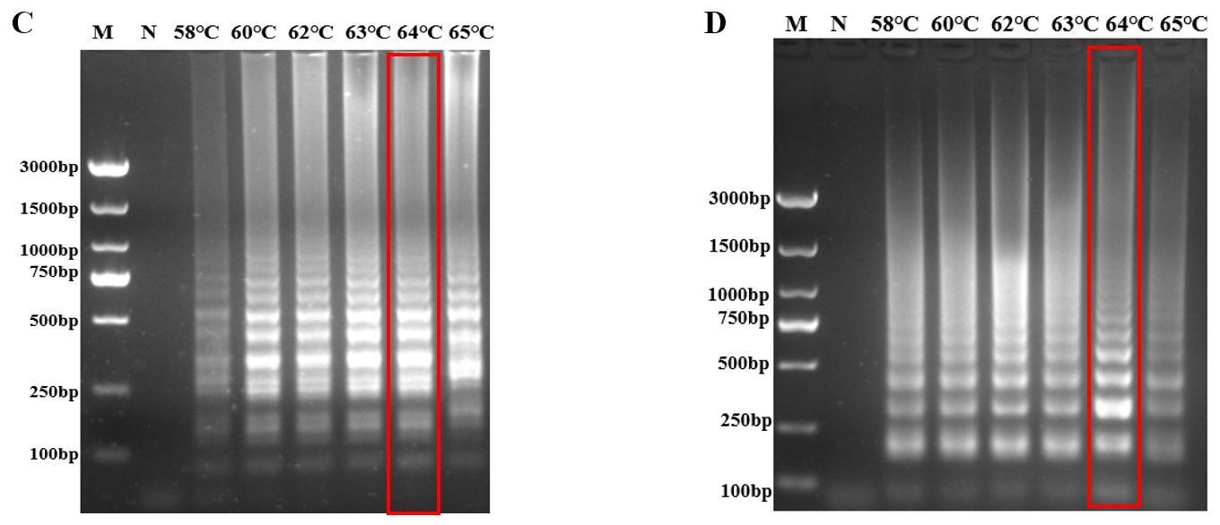
Figure S2. Electrophoretic analysis of LAMP reaction temperatures optimization. M: DL3000 DNA Marker; N: negative control group; Red boxes indicate the optimal reaction temperature for each target; A, B, C and D show the LAMP temperature optimization results for PEDV, TGEV, PDCoV and PoRV G9, respectively.

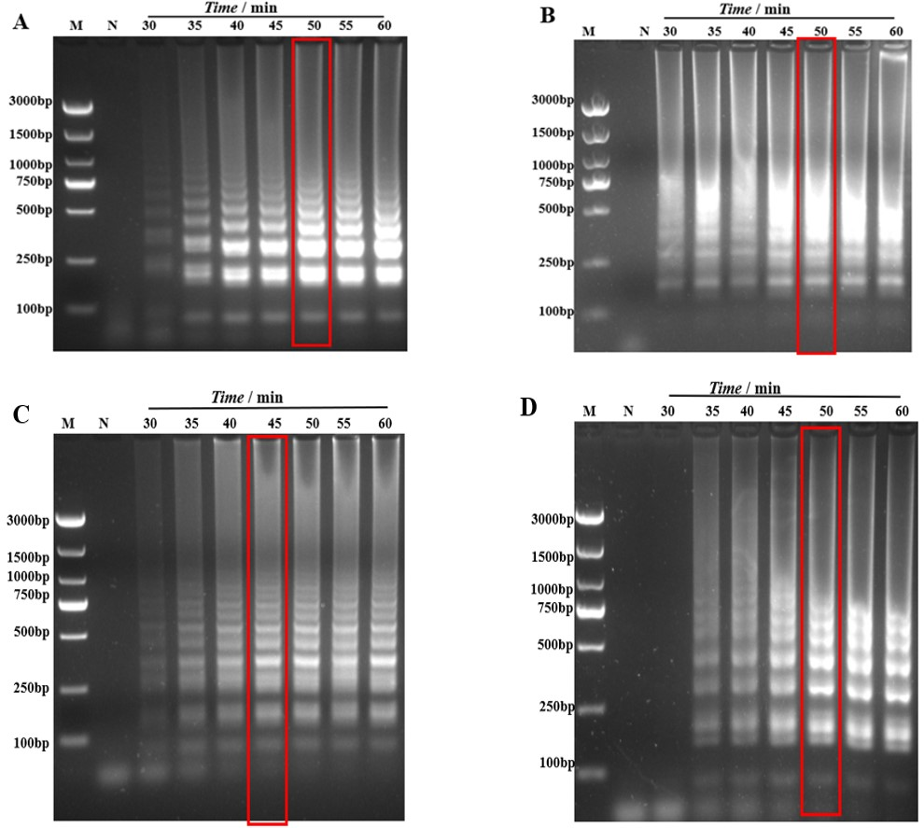
Figure S3. Electrophoretic analysis of LAMP reaction time optimization. M: DL3000 DNA Marker; N: Negative control; Red boxes indicate the optimal reaction time for each target; A, B, C and D display the time optimization results for PEDV, TGEV, PDCoV and PoRV G9, respectively.

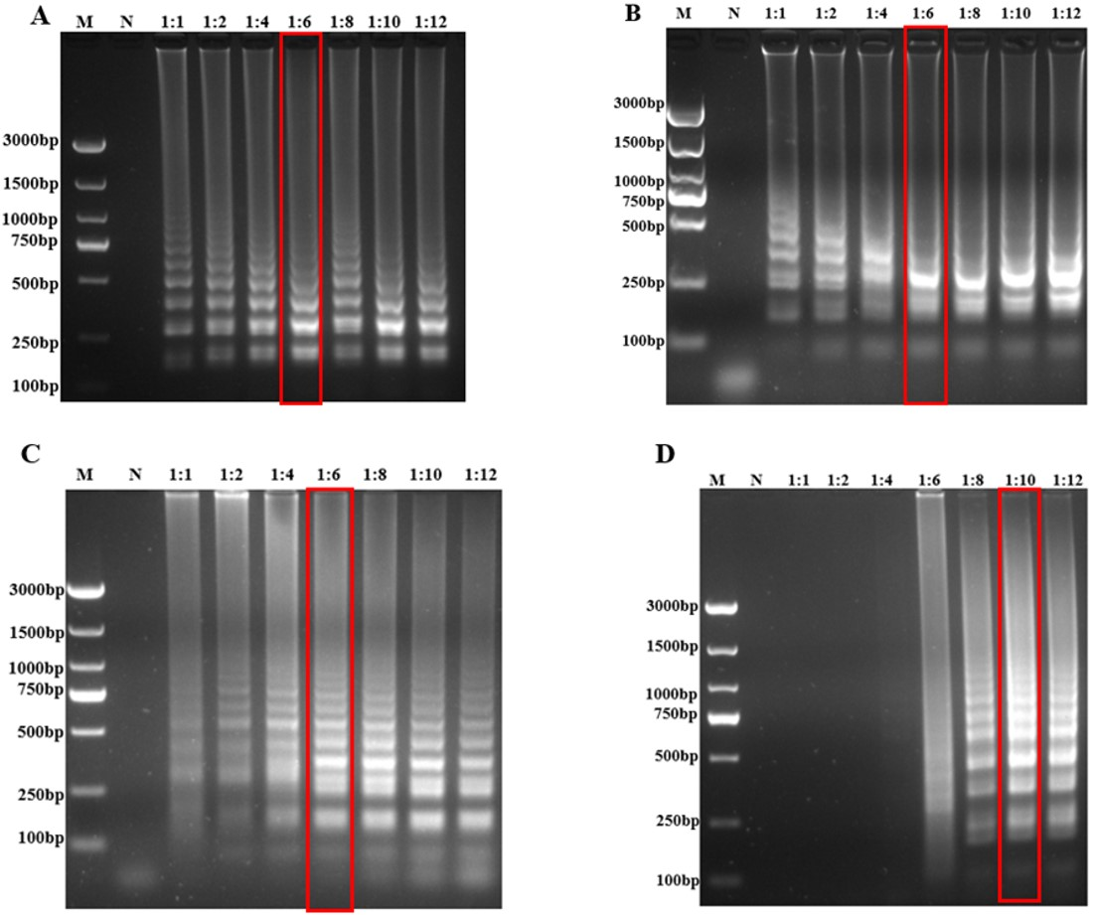
Figure S4. Electrophoretic analysis of FIP and BIP primer concentration ratio optimization. M: DL3000 DNA Marker; N: Negative control; Red boxes highlight the optimal outer-to-inner primer ratio bands; A, B, C and D shwo the optimization results for the outer-to-inner primer concentration ratios for PEDV, TGEV, PDCoV and PoRV G9 in the LAMP assays.

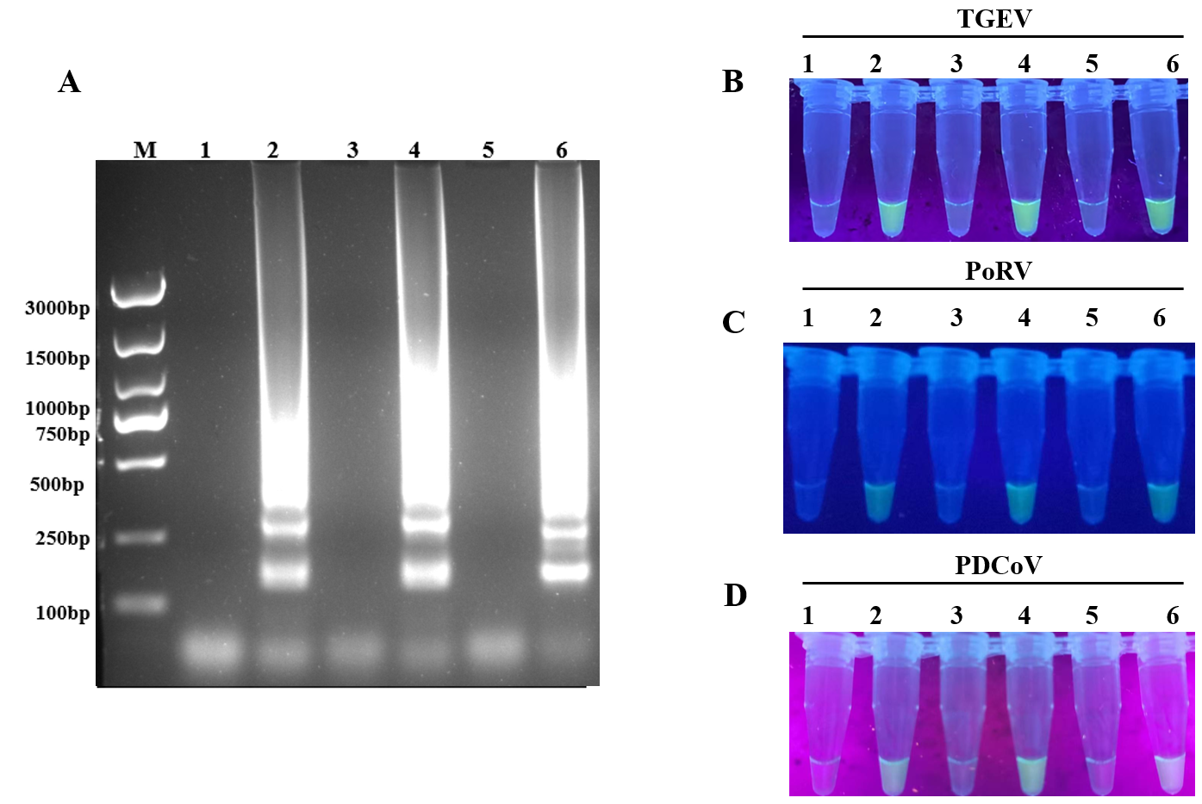
Figure S5. Results of the double LAMP-CRISPR detection system. (A) Gel electrophoresis results of the double LAMP assay. (B, C, E and F) Verification results of the double LAMP-CRISPR visual detection. Lanes 1, 3, and 5 represent negative controls; lanes 2, 4, and 6 represent template test groups with double LAMP amplification products; M: DL3000 DNA marker.

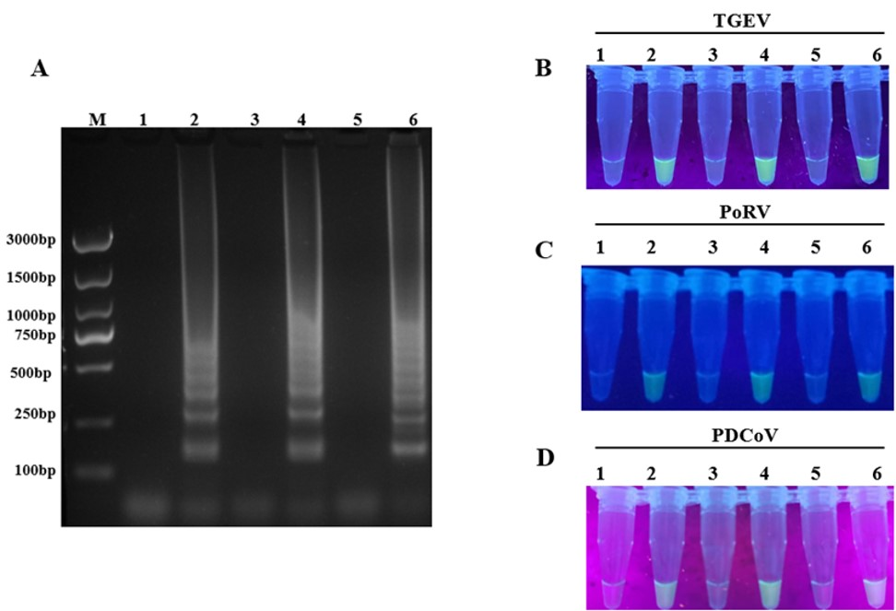

Figure S6. Results of the triple LAMP-CRISPR detection system. (A) Gel electrophoresis results of the triple LAMP assay. (B, C, E and F) Verification results of the triple LAMP-CRISPR visual detection. Lanes 1, 3, and 5 represent negative controls; lanes 2, 4, and 6 contain template test groups with triple LAMP amplification products; M: DL3000 DNA marker.

