Table-1 Covered areas
No. of Session | Content
Session 1. (Individual Play)-Receprocation | The child engages in clay play with a family member, forming basic shapes (e.g., circles, squares). For the first 20 days, the family member leads (80%), while the child follows (20%). After this, the child takes the lead (80%). Colours and vegetables are introduced to build vocabulary. Simple choices in food and clothing are offered to encourage autonomy and communication.
Session 2 (Associative Play)-interaction | Encourage respectful two-way communication—children should say "sorry" for mistakes, and parents should model politeness by saying "thank you." Avoid negative comments or comparisons with others. Address inappropriate behavior with calm verbal correction, not physical punishment.
Session 3 (Cooperative Play)-social adjust | Joining Play school
Session 4 (Family indoor games)- adjustment with family members or extended family members | Engage the child in indoor games like Ludo, Carom, or Uno with all family members to build a sense of belonging and group interaction. This helps young children, especially under 24 months, begin to understand family as a social unit.
Session 5 (Domestic Activity)-Responsibity | Give one small responsibility. For e.g. Re-filling water in water bottles.

Table -2
Prevalence Demographic details according to group division
Demographic Variables | Group A (N=63) | Group B (N= 51) | p- value
Age | 3.41±1.23 | 3.67±1.5 | 1.2
18-36 months  37-60 months | 39%  61% | 43%  57% | 1.11
Gender
Girls  Boys | 49%  51% | 44%  56% | 1.21
Residencial areas
Home  Community | 46%  54% | 51%  49% | 0.075
Family type
Nuclear  Joint | 73%  27% | 69%  31% | 1.1
Parents Both working
Yes  No | 53%  47% | 51%  49% | 1.04
Number of caregivers
Single  Multiple | 64%  36% | 69%  31% | 1.09
Relation with caregiver
Mother  Parents  Grand parents  Nany | 42%  21%  11%  26% | 43%  29%  19%  9% | 0.000*
Age of going to school
≤36 months  37-60 months | 53%  47% | 56%  44% | 1.03
Socioeconomic status (according to kuppuswamy scale)
Lower middle class  Middle class  Upper middle class | 13%  59%  28% | 12%  61%  27% | 1.31
Duration of mobile phone
≤3 hours  >3 hours | 39%  61% | 38%  62% | 1.06
Age of mobile phone use
≤36 months  37-60 months | 63.2%  36.8% | 64.6%  35.4% | 1.01
Duration of parent child interaction  <8 hours  >8 hours | 54.3%  45.7% | 34.2%  65.8% | 1.07

Table- 3 Change of social communication skills among participants across the research duration

Group-A (N=63) | Group-B (N=51)
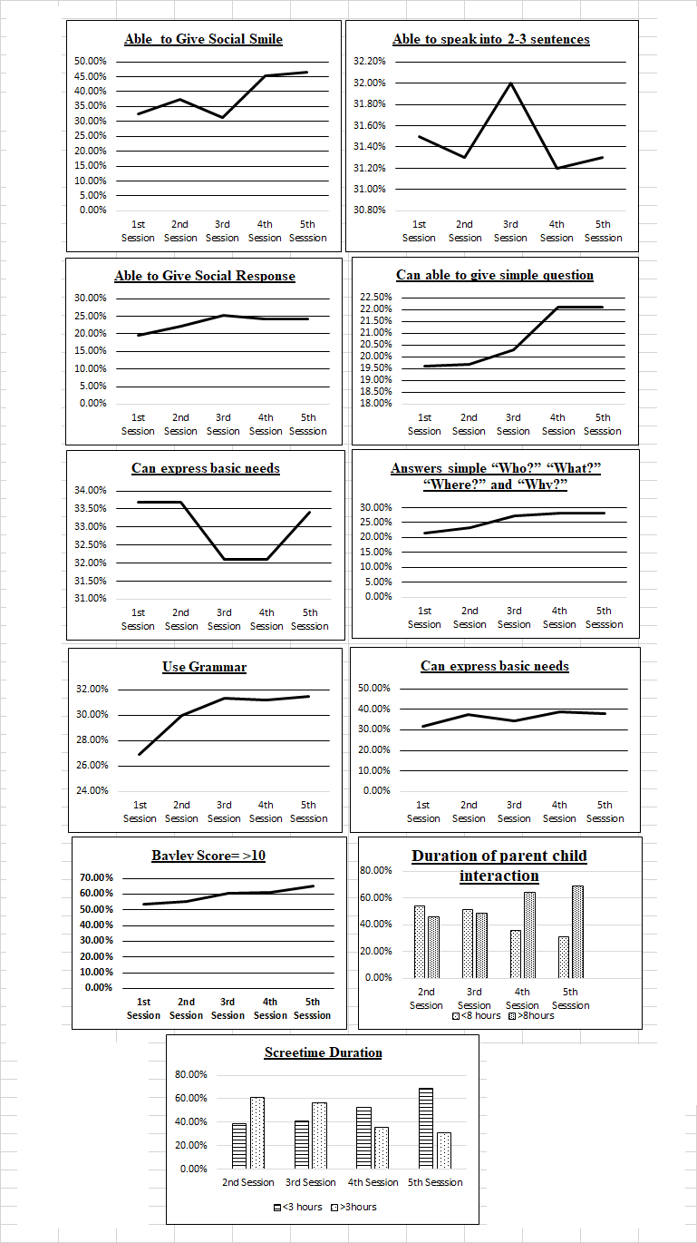 | 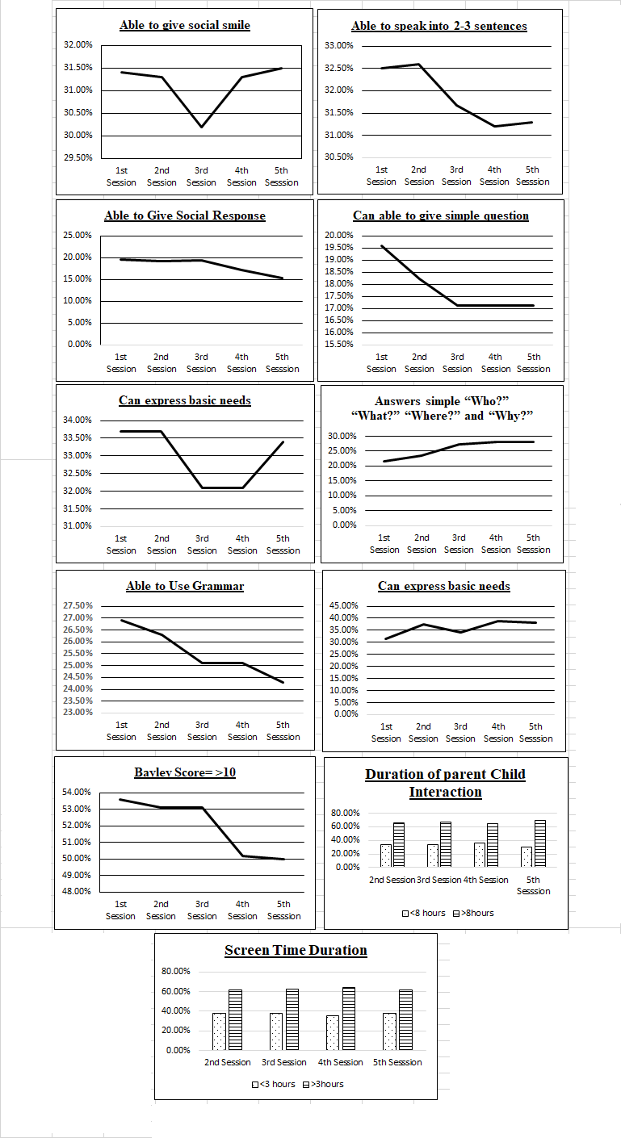

Table-4 Change of social communication skills and smartphones or other electronic devices among participants across the research duration
 | Group-A |  |  | Group-B
Session | Bayley Scale | Smartphone use or other electronic device |  | Bayley Scale | Smartphone use or another electronic device |  | p-value (95% CI)  (Bayley scale- Group-A vs Group-B
Session | Bayley Scale | Yes | No | Bayley Scale | Yes | No
1 | 23.15±1.23 | 78% | 22% | 24.01±1.44 | 77.86% | 22.94% | 0.78 (20.98±29.34)
2 | 20.07±1.45 | 73.31% | 26.69% | 25.12±1.03 | 77.1% | 22.9% | 0.000* (19.18±28.05)
3 | 18.54±1.06 | 50.2% | 49.8% | 24.89±1.29 | 76% | 24% | 0.000*(14.22±27.34)
4 | 15.23±1.54 | 41% | 59% | 24.31±1.76 | 79.2% | 20.8% | 0.000*(13.07±26.34)
5 | 13.22±1.39 | 29% | 71% | 24.57±1.3 | 79.3% | 20.7% | 0.000*(12.31±25.34)

