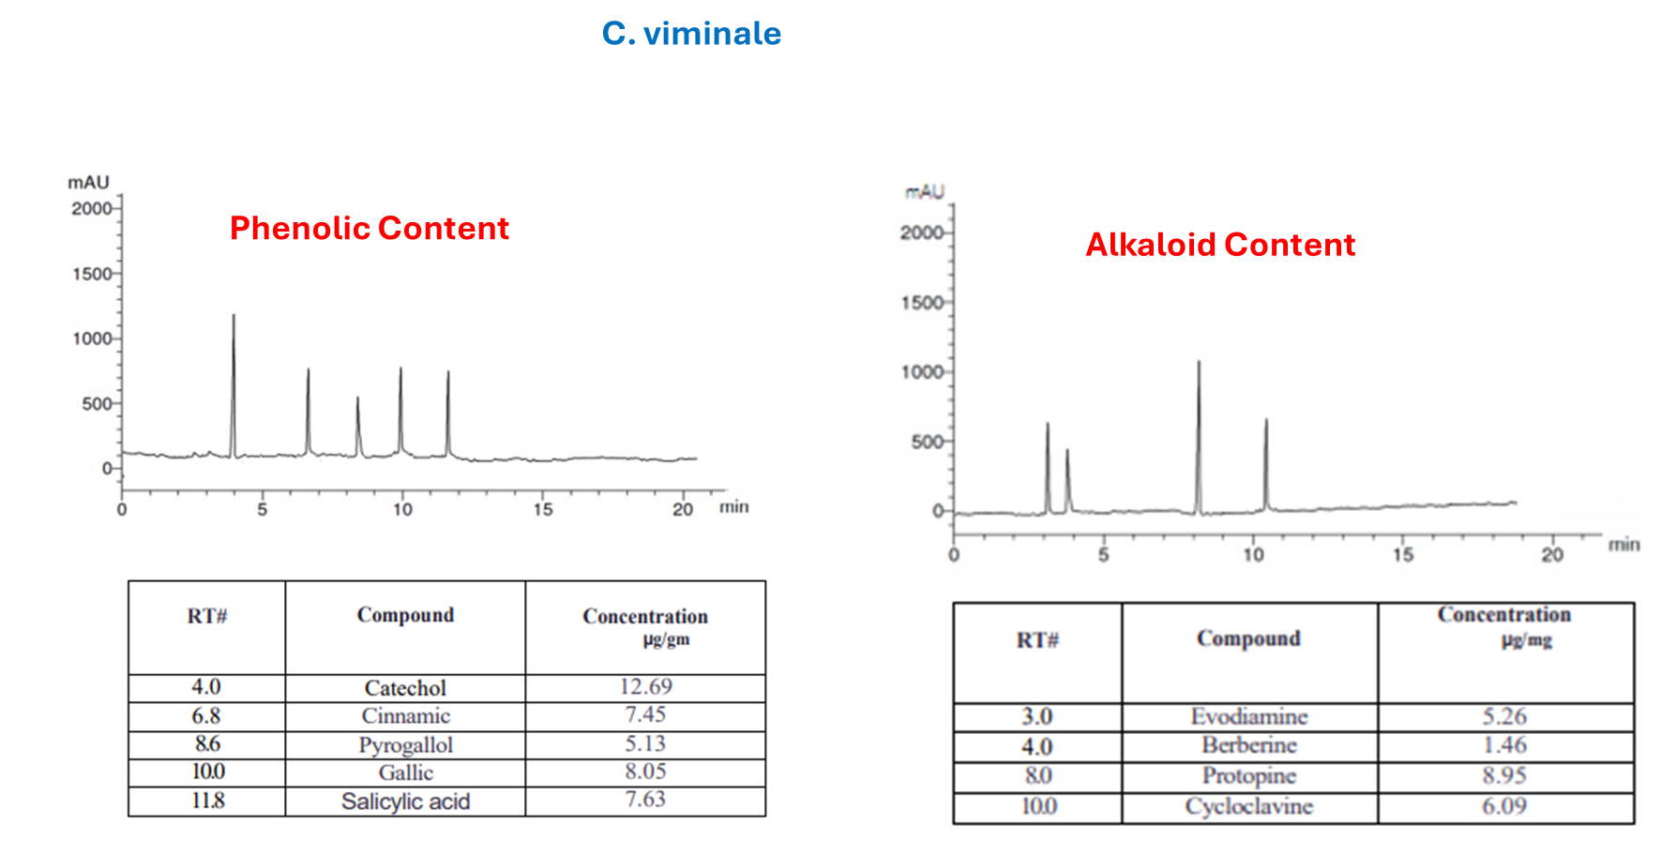

Figure S-1: HPLC Chromatogram of alkaloid and phenolic composition of C. viminale methanol extracts.
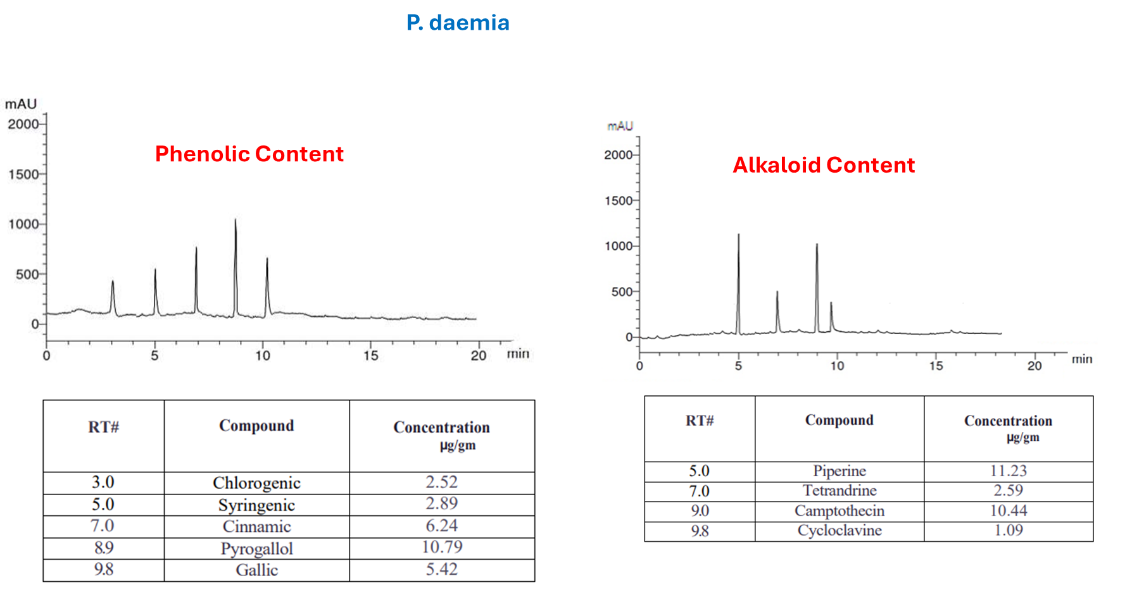
Figure S-2: HPLC Chromatogram of alkaloid and phenolic composition of P. daemia methanol extracts

Table S-1: Evaluation of antioxidant of alkaloid and phenolic composition of C. viminale and P. daemia methanol extracts
using DPPH radical scavenging
Sample  conc. (µg/ml) | C. viminale |  |  |  |  | P. daemia
Sample  conc. (µg/ml) | 3 Readings |  |  | Mean | S.D. (±) | 3 Readings |  |  | Mean | S.D. (±)
 | C. viminale |  |  |  |  | P. daemia
1000 | 95.14 | 94.73 | 94.73 | 94.87 | 0.24 | 95.60 | 96.03 | 94.96 | 95.53 | 0.54
500 | 90.13 | 90.95 | 89.02 | 90.03 | 0.97 | 93.41 | 93.41 | 92.57 | 93.13 | 0.48
250 | 87.49 | 85.14 | 85.14 | 85.92 | 1.36 | 90.58 | 89.06 | 89.06 | 89.57 | 0.88
125 | 75.21 | 73.14 | 76.09 | 74.81 | 1.51 | 84.79 | 81.75 | 80.23 | 82.26 | 2.32
62.5 | 60.08 | 62.45 | 59.17 | 60.57 | 1.69 | 66.43 | 64.90 | 67.29 | 66.21 | 1.21
31.25 | 38.94 | 41.32 | 40.26 | 40.17 | 1.19 | 43.56 | 45.12 | 40.62 | 43.10 | 2.28
15.6 | 23.85 | 20.96 | 25.13 | 23.31 | 2.14 | 27.68 | 26.84 | 24.93 | 26.48 | 1.41
7.8 | 9.37 | 9.37 | 10.41 | 9.72 | 0.60 | 13.14 | 15.09 | 13.14 | 13.79 | 1.13
3.9 | 5.16 | 4.83 | 5.72 | 5.24 | 0.45 | 9.73 | 8.62 | 8.62 | 8.99 | 0.64
2 | 3.28 | 2.41 | 2.95 | 2.88 | 0.44 | 6.44 | 5.96 | 5.40 | 5.93 | 0.52
1 | 1.73 | 1.08 | 1.39 | 1.40 | 0.33 | 3.85 | 3.04 | 2.79 | 3.23 | 0.55
0.5 | 0.92 | 0.82 | 0.64 | 0.79 | 0.14 | 1.49 | 1.25 | 0.88 | 1.21 | 0.31
0 | 0 | 0 | 0 | 0 | 0 | 0 | 0 | 0 | 0 | 0
 | IC50 |  |  |  |  | IC50
 | 47.60 | 44.09 | 47.35 | 46.34 | 1.96 | 40.05 | 38.96 | 42.24 | 40.42 | 1.67

Table S-2: Evaluation of antioxidant of alkaloid and phenolic composition of C. viminale and P. daemia methanol extracts
using ABT radical scavenging
Sample  conc. (µg/ml) | C. viminale |  |  |  |  | P. daemia
Sample  conc. (µg/ml) | 3 Readings |  |  | Mean | S.D. (±) | 3 Readings |  |  | Mean | S.D. (±)
 | C. viminale |  |  |  |  | P. daemia
1000 | 91.46 | 90.63 | 89.42 | 90.50 | 1.03 | 93.46 | 92.75 | 92.97 | 93.06 | 0.36
500 | 80.29 | 76.82 | 79.40 | 78.84 | 1.80 | 88.19 | 86.21 | 87.08 | 87.16 | 0.99
250 | 63.74 | 60.42 | 64.53 | 62.90 | 2.18 | 71.95 | 74.92 | 75.46 | 74.11 | 1.89
125 | 47.31 | 45.19 | 44.96 | 45.82 | 1.30 | 58.42 | 61.34 | 62.78 | 60.85 | 2.22
62.5 | 30.46 | 31.23 | 28.62 | 30.10 | 1.34 | 45.17 | 43.89 | 40.91 | 43.32 | 2.19
31.25 | 19.73 | 20.59 | 18.61 | 19.64 | 0.99 | 31.42 | 30.69 | 28.97 | 30.36 | 1.26
15.6 | 9.84 | 11.47 | 10.25 | 10.52 | 0.85 | 20.61 | 18.43 | 19.56 | 19.53 | 1.09
7.8 | 6.25 | 5.82 | 6.74 | 6.27 | 0.46 | 9.28 | 8.65 | 9.40 | 9.11 | 0.40
3.9 | 3.04 | 3.76 | 4.29 | 3.70 | 0.63 | 4.59 | 4.06 | 4.32 | 4.32 | 0.27
2 | 1.73 | 2.09 | 1.64 | 1.82 | 0.24 | 2.34 | 1.87 | 1.87 | 2.03 | 0.27
1 | 0.68 | 0.84 | 0.79 | 0.77 | 0.08 | 0.87 | 0.92 | 1.08 | 0.96 | 0.11
0.5 | 0.29 | 0.24 | 0.36 | 0.30 | 0.06 | 0.59 | 0.23 | 0.41 | 0.41 | 0.18
0 | 0 | 0 | 0 | 0 | 0 | 0 | 0 | 0 | 0 | 0
 | IC50 |  |  |  |  | IC50
 | 145.47 | 164.48 | 157.19 | 155.71 | 9.59 | 85.28 | 84.38 | 88.48 | 86.05 | 2.15

Table S-3: Evaluation of antioxidant of alkaloid and phenolic composition of C. viminale and P. daemia methanol extracts
using FRAP radical scavenging
Sample  conc. (µg/ml) | C. viminale |  |  |  |  | P. daemia
Sample  conc. (µg/ml) | 3 Readings |  |  | Mean | S.D. (±) | 3 Readings |  |  | Mean | S.D. (±)
 | C. viminale |  |  |  |  | P. daemia
1000 | 90.23 | 88.69 | 89.51 | 89.48 | 0.77 | 93.25 | 91.86 | 92.19 | 92.43 | 0.73
500 | 74.51 | 73.26 | 76.24 | 74.67 | 1.50 | 85.60 | 84.17 | 82.46 | 84.08 | 1.57
250 | 56.28 | 55.91 | 57.13 | 56.44 | 0.63 | 76.93 | 75.46 | 73.15 | 75.18 | 1.91
125 | 41.39 | 38.64 | 36.90 | 38.98 | 2.26 | 57.41 | 58.23 | 61.42 | 59.02 | 2.12
62.5 | 26.78 | 25.16 | 23.84 | 25.26 | 1.47 | 39.28 | 42.67 | 45.29 | 42.41 | 3.01
31.25 | 17.09 | 14.73 | 11.95 | 14.59 | 2.57 | 30.68 | 31.29 | 30.68 | 30.88 | 0.35
15.6 | 10.42 | 9.56 | 8.23 | 9.40 | 1.10 | 22.51 | 23.86 | 21.74 | 22.70 | 1.07
7.8 | 4.32 | 4.79 | 4.06 | 4.39 | 0.37 | 14.29 | 13.72 | 15.46 | 14.49 | 0.89
3.9 | 1.87 | 2.32 | 2.35 | 2.18 | 0.27 | 6.84 | 6.84 | 7.42 | 7.03 | 0.33
2 | 0.95 | 1.23 | 0.95 | 1.04 | 0.16 | 3.12 | 3.46 | 3.79 | 3.46 | 0.34
1 | 0.73 | 0.91 | 0.64 | 0.76 | 0.14 | 0.95 | 1.35 | 1.82 | 1.37 | 0.44
0.5 | 0.28 | 0.43 | 0.28 | 0.33 | 0.09 | 0.54 | 0.62 | 0.97 | 0.71 | 0.23
0 | 0 | 0 | 0 | 0 | 0 | 0 | 0 | 0 | 0 | 0
 | IC50 |  |  |  |  | IC50
 | 197.28 | 207.22 | 205.94 | 203.48 | 5.41 | 99.46 | 91.94 | 80.75 | 90.72 | 9.41

Table S-4: Evaluation of antioxidant of alkaloid and phenolic composition of C. viminale and P. daemia methanol extracts
using H₂O₂ radical scavenging
Sample  conc. (µg/ml) | C. viminale |  |  |  |  | P. daemia
Sample  conc. (µg/ml) | 3 Readings |  |  | Mean | S.D. (±) | 3 Readings |  |  | Mean | S.D. (±)
 | C. viminale |  |  |  |  | P. daemia
1000 | 92.59 | 90.78 | 92.59 | 91.99 | 1.05 | 94.21 | 93.85 | 92.98 | 93.68 | 0.63
500 | 78.14 | 74.26 | 77.08 | 76.49 | 2.01 | 88.59 | 87.04 | 85.71 | 87.11 | 1.44
250 | 56.31 | 59.24 | 61.37 | 58.97 | 2.54 | 79.24 | 74.93 | 76.48 | 76.88 | 2.18
125 | 36.62 | 45.13 | 42.39 | 41.38 | 4.34 | 64.92 | 61.88 | 63.20 | 63.33 | 1.52
62.5 | 17.45 | 20.91 | 25.32 | 21.23 | 3.94 | 49.23 | 46.70 | 48.19 | 48.04 | 1.27
31.25 | 8.93 | 12.85 | 11.47 | 11.08 | 1.99 | 37.51 | 32.14 | 34.75 | 34.80 | 2.69
15.6 | 3.76 | 6.04 | 5.21 | 5.00 | 1.15 | 24.98 | 20.63 | 21.56 | 22.39 | 2.29
7.8 | 1.58 | 2.37 | 2.37 | 2.11 | 0.46 | 13.85 | 11.47 | 11.47 | 12.26 | 1.37
3.9 | 0.72 | 0.94 | 0.89 | 0.85 | 0.12 | 6.76 | 5.29 | 5.83 | 5.96 | 0.74
2 | 0.29 | 0.35 | 0.41 | 0.35 | 0.06 | 3.82 | 3.24 | 2.19 | 3.08 | 0.83
1 | 0.13 | 0.21 | 0.17 | 0.17 | 0.04 | 1.59 | 1.16 | 0.98 | 1.24 | 0.31
0.5 | 0.05 | 0.07 | 0.04 | 0.05 | 0.02 | 0.93 | 0.54 | 0.54 | 0.67 | 0.23
0 | 0 | 0 | 0 | 0 | 0 | 0 | 0 | 0 | 0 | 0
 | IC50 |  |  |  |  | IC50
 | 209.94 | 168.14 | 175.12 | 184.40 | 22.39 | 65.57 | 76.09 | 70.04 | 70.56 | 5.28

Table S-5: Evaluation of antioxidant of alkaloid and phenolic composition of C. viminale and P. daemia methanol extracts
cytotoxicity against HepG-2 cell line
Sample  conc. (µg/ml) | C. viminale |  |  |  |  | P. daemia
Sample  conc. (µg/ml) | 3 Readings |  |  | Mean | S.D. (±) | 3 Readings |  |  | Mean | S.D. (±)
 | C. viminale |  |  |  |  | P. daemia
500 | 4.03 | 3.17 | 4.29 | 3.83 | 96.17 | 13.49 | 15.24 | 16.38 | 15.04 | 84.96
250 | 8.61 | 8.03 | 9.78 | 8.81 | 91.19 | 31.74 | 34.68 | 35.26 | 33.89 | 66.11
125 | 13.75 | 14.65 | 15.89 | 14.76 | 85.24 | 72.95 | 75.03 | 73.17 | 73.72 | 26.28
62.5 | 27.43 | 30.27 | 26.14 | 27.95 | 72.05 | 94.17 | 89.46 | 90.24 | 91.29 | 8.71
31.25 | 40.78 | 42.31 | 40.78 | 41.29 | 58.71 | 98.72 | 98.72 | 97.68 | 98.37 | 1.63
15.6 | 62.34 | 57.49 | 65.12 | 61.65 | 38.35 | 100 | 100 | 99.54 | 99.85 | 0.15
7.8 | 79.02 | 76.36 | 75.28 | 76.89 | 23.11 | 100 | 100 | 100 | 100 | 0
3.9 | 87.41 | 84.93 | 86.06 | 86.13 | 13.87 | 100 | 100 | 100 | 100 | 0
2 | 95.23 | 93.18 | 94.81 | 94.41 | 5.59 | 100 | 100 | 100 | 100 | 0
1 | 98.54 | 98.54 | 99.73 | 98.94 | 1.06 | 100 | 100 | 100 | 100 | 0
0.5 | 100 | 100 | 100 | 100 | 0 | 100 | 100 | 100 | 100 | 0
0.25 | 100 | 100 | 100 | 100 | 0 | 100 | 100 | 100 | 100 | 0
0 | 100 | 100 | 100 | 100 | 0 | 100 | 100 | 100 | 100 | 0
 | IC50 |  |  |  |  | IC50
 | 24.53 | 23.30 | 25.29 | 24.37 | 1.01 | 194.61 | 202.54 | 201.40 | 199.52 | 4.29

Table S-6: Evaluation of antioxidant of alkaloid and phenolic composition of C. viminale and P. daemia methanol extracts
cytotoxicity against MCF-7 cell line
Sample  conc. (µg/ml) | C. viminale |  |  |  |  | P. daemia
Sample  conc. (µg/ml) | 3 Readings |  |  | Mean | S.D. (±) | 3 Readings |  |  | Mean | S.D. (±)
 | C. viminale |  |  |  |  | P. daemia
500 | 15.23 | 14.59 | 12.87 | 14.23 | 85.77 | 17.08 | 18.23 | 15.41 | 16.91 | 83.09
250 | 26.15 | 30.63 | 28.94 | 28.57 | 71.43 | 29.74 | 31.7 | 30.89 | 30.78 | 69.22
125 | 44.87 | 42.76 | 41.53 | 43.05 | 56.95 | 48.16 | 49.08 | 45.27 | 47.50 | 52.50
62.5 | 75.34 | 76.08 | 72.19 | 74.54 | 25.46 | 79.51 | 85.16 | 78.27 | 80.98 | 19.02
31.25 | 91.38 | 90.54 | 90.54 | 90.82 | 9.18 | 96.2 | 96.2 | 90.68 | 94.36 | 5.64
15.6 | 96.4 | 97.63 | 98.12 | 97.38 | 2.62 | 98.79 | 99.14 | 98.79 | 98.91 | 1.09
7.8 | 99.54 | 99.54 | 100 | 99.69 | 0.31 | 100 | 100 | 100 | 100 | 0
3.9 | 100 | 100 | 100 | 100 | 0 | 100 | 100 | 100 | 100 | 0
2 | 100 | 100 | 100 | 100 | 0 | 100 | 100 | 100 | 100 | 0
1 | 100 | 100 | 100 | 100 | 0 | 100 | 100 | 100 | 100 | 0
0.5 | 100 | 100 | 100 | 100 | 0 | 100 | 100 | 100 | 100 | 0
0.25 | 100 | 100 | 100 | 100 | 0 | 100 | 100 | 100 | 100 | 0
0 | 100 | 100 | 100 | 100 | 0 | 100 | 100 | 100 | 100 | 0
 | IC50 |  |  |  |  | IC50
 | 114.48 | 111.42 | 107.73 | 111.21 | 3.38 | 121.33 | 123.41 | 116.04 | 120.26 | 3.80

Table S-7: Evaluation of antioxidant of alkaloid and phenolic composition of C. viminale and P. daemia methanol extracts
cytotoxicity against HCT-116 cell line
Sample  conc. (µg/ml) | C. viminale |  |  |  |  | P. daemia
Sample  conc. (µg/ml) | 3 Readings |  |  | Mean | S.D. (±) | 3 Readings |  |  | Mean | S.D. (±)
 | C. viminale |  |  |  |  | P. daemia
500 | 5.26 | 4.75 | 6.29 | 5.43 | 94.57 | 7.96 | 9.85 | 8.13 | 8.65 | 91.35
250 | 11.48 | 15.29 | 13.04 | 13.27 | 86.73 | 17.42 | 19.64 | 20.56 | 19.21 | 80.79
125 | 26.13 | 29.76 | 25.42 | 27.10 | 72.90 | 31.75 | 33.29 | 34.08 | 33.04 | 66.96
62.5 | 39.56 | 42.08 | 36.91 | 39.52 | 60.48 | 65.49 | 64.86 | 69.17 | 66.51 | 33.49
31.25 | 61.34 | 65.29 | 64.83 | 63.82 | 36.18 | 87.13 | 85.26 | 90.54 | 87.64 | 12.36
15.6 | 85.09 | 86.41 | 86.41 | 85.97 | 14.03 | 98.06 | 98.06 | 99.74 | 98.62 | 1.38
7.8 | 97.41 | 95.23 | 96.74 | 96.46 | 3.54 | 100 | 100 | 100 | 100 | 0
3.9 | 99.54 | 99.54 | 98.62 | 99.23 | 0.77 | 100 | 100 | 100 | 100 | 0
2 | 100 | 100 | 100 | 100 | 0 | 100 | 100 | 100 | 100 | 0
1 | 100 | 100 | 100 | 100 | 0 | 100 | 100 | 100 | 100 | 0
0.5 | 100 | 100 | 100 | 100 | 0 | 100 | 100 | 100 | 100 | 0
0.25 | 100 | 100 | 100 | 100 | 0 | 100 | 100 | 100 | 100 | 0
0 | 100 | 100 | 100 | 100 | 0 | 100 | 100 | 100 | 100 | 0
 | IC50 |  |  |  |  | IC50
 | 47.52 | 51.84 | 47.85 | 49.07 | 2.40 | 91.19 | 91.92 | 96.64 | 93.25 | 2.96

Table S-8: Evaluation of antioxidant of alkaloid and phenolic composition of C. viminale and P. daemia methanol extracts
cytotoxicity against A-549 cell line
Sample  conc. (µg/ml) | C. viminale |  |  |  |  | P. daemia
Sample  conc. (µg/ml) | 3 Readings |  |  | Mean | S.D. (±) | 3 Readings |  |  | Mean | S.D. (±)
 | C. viminale |  |  |  |  | P. daemia
500 | 5.34 | 6.08 | 4.95 | 5.46 | 94.54 | 12.08 | 14.56 | 13.24 | 13.29 | 86.71
250 | 11.27 | 12.59 | 10.34 | 11.40 | 88.60 | 24.65 | 31.42 | 29.13 | 28.40 | 71.60
125 | 19.41 | 20.73 | 18.62 | 19.59 | 80.41 | 43.76 | 40.94 | 47.38 | 44.03 | 55.97
62.5 | 32.56 | 32.56 | 30.79 | 31.97 | 68.03 | 68.49 | 65.13 | 70.88 | 68.17 | 31.83
31.25 | 46.93 | 44.81 | 42.06 | 44.60 | 55.40 | 83.15 | 80.42 | 81.79 | 81.79 | 18.21
15.6 | 67.52 | 64.23 | 60.87 | 64.21 | 35.79 | 94.08 | 90.67 | 91.85 | 92.20 | 7.80
7.8 | 81.47 | 80.95 | 82.76 | 81.73 | 18.27 | 99.27 | 98.63 | 97.94 | 98.61 | 1.39
3.9 | 90.68 | 90.68 | 92.43 | 91.26 | 8.74 | 100 | 100 | 100 | 100 | 0
2 | 98.13 | 97.46 | 98.13 | 97.91 | 2.09 | 100 | 100 | 100 | 100 | 0
1 | 100 | 100 | 100 | 100 | 0 | 100 | 100 | 100 | 100 | 0
0.5 | 100 | 100 | 100 | 100 | 0 | 100 | 100 | 100 | 100 | 0
0.25 | 100 | 100 | 100 | 100 | 0 | 100 | 100 | 100 | 100 | 0
0 | 100 | 100 | 100 | 100 | 0 | 100 | 100 | 100 | 100 | 0
 | IC50 |  |  |  |  | IC50
 | 28.87 | 27.03 | 24.61 | 26.84 | 2.14 | 109.23 | 101.59 | 118.03 | 109.62 | 8.23

Table S-8: Evaluation of antioxidant of alkaloid and phenolic composition of C. viminale and P. daemia methanol extracts
cytotoxicity against PC-3 cell line
Sample  conc. (µg/ml) | C. viminale |  |  |  |  | P. daemia
Sample  conc. (µg/ml) | 3 Readings |  |  | Mean | S.D. (±) | 3 Readings |  |  | Mean | S.D. (±)
 | C. viminale |  |  |  |  | P. daemia
500 | 6.79 | 7.34 | 5.98 | 6.70 | 93.30 | 10.83 | 12.74 | 13.81 | 12.46 | 87.54
250 | 14.58 | 16.02 | 12.73 | 14.44 | 85.56 | 26.74 | 28.65 | 27.09 | 27.49 | 72.51
125 | 30.67 | 30.67 | 29.49 | 30.28 | 69.72 | 39.57 | 42.13 | 40.64 | 40.78 | 59.22
62.5 | 46.82 | 43.17 | 44.96 | 44.98 | 55.02 | 90.63 | 87.65 | 86.21 | 88.16 | 11.84
31.25 | 69.45 | 78.94 | 72.13 | 73.51 | 26.49 | 99.46 | 98.74 | 98.74 | 98.98 | 1.02
15.6 | 81.56 | 88.07 | 88.07 | 85.90 | 14.10 | 100 | 100 | 100 | 100 | 0
7.8 | 92.73 | 96.31 | 95.28 | 94.77 | 5.23 | 100 | 100 | 100 | 100 | 0
3.9 | 98.71 | 99.25 | 98.71 | 98.89 | 1.11 | 100 | 100 | 100 | 100 | 0
2 | 100 | 100 | 100 | 100 | 0 | 100 | 100 | 100 | 100 | 0
1 | 100 | 100 | 100 | 100 | 0 | 100 | 100 | 100 | 100 | 0
0.5 | 100 | 100 | 100 | 100 | 0 | 100 | 100 | 100 | 100 | 0
0.25 | 100 | 100 | 100 | 100 | 0 | 100 | 100 | 100 | 100 | 0
0 | 100 | 100 | 100 | 100 | 0 | 100 | 100 | 100 | 100 | 0
 | IC50 |  |  |  |  | IC50
 | 58.11 | 56.53 | 56.70 | 57.11 | 0.86 | 112.23 | 114.19 | 112.16 | 112.86 | 1.15

Table S-10: Evaluation of antioxidant of alkaloid and phenolic composition of C. viminale and P. daemia methanol extracts
cytotoxicity against A-431 cell line
Sample  conc. (µg/ml) | C. viminale |  |  |  |  | P. daemia
Sample  conc. (µg/ml) | 3 Readings |  |  | Mean | S.D. (±) | 3 Readings |  |  | Mean | S.D. (±)
 | C. viminale |  |  |  |  | P. daemia
500 | 4.85 | 5.23 | 4.51 | 4.86 | 95.14 | 11.89 | 9.75 | 9.75 | 10.46 | 89.54
250 | 11.24 | 12.75 | 11.43 | 11.81 | 88.19 | 25.43 | 21.89 | 24.12 | 23.81 | 76.19
125 | 23.47 | 23.47 | 20.64 | 22.53 | 77.47 | 39.05 | 37.41 | 34.69 | 37.05 | 62.95
62.5 | 37.26 | 36.08 | 38.51 | 37.28 | 62.72 | 60.84 | 54.25 | 57.16 | 57.42 | 42.58
31.25 | 54.19 | 59.27 | 54.19 | 55.88 | 44.12 | 76.49 | 70.64 | 78.31 | 75.15 | 24.85
15.6 | 68.34 | 72.13 | 73.08 | 71.18 | 28.82 | 89.06 | 88.42 | 91.74 | 89.74 | 10.26
7.8 | 83.95 | 86.54 | 88.27 | 86.25 | 13.75 | 97.61 | 98.17 | 98.58 | 98.12 | 1.88
3.9 | 91.72 | 92.63 | 96.04 | 93.46 | 6.54 | 100 | 100 | 100 | 100 | 0
2 | 99.46 | 98.17 | 98.63 | 98.75 | 1.25 | 100 | 100 | 100 | 100 | 0
1 | 100 | 100 | 100 | 100 | 0 | 100 | 100 | 100 | 100 | 0
0.5 | 100 | 100 | 100 | 100 | 0 | 100 | 100 | 100 | 100 | 0
0.25 | 100 | 100 | 100 | 100 | 0 | 100 | 100 | 100 | 100 | 0
0 | 100 | 100 | 100 | 100 | 0 | 100 | 100 | 100 | 100 | 0
 | IC50 |  |  |  |  | IC50
 | 38.98 | 43.74 | 39.60 | 40.78 | 2.59 | 93.59 | 78.27 | 82.42 | 84.76 | 7.92

Table S-10: Evaluation of antioxidant of alkaloid and phenolic composition of C. viminale and P. daemia methanol extracts
cytotoxicity against MRC-5 cell line
Sample  conc. (µg/ml) | 3 Readings |  |  | Mean | S.D. (±) | 3 Readings |  |  | Mean | S.D. (±)
 | C. viminale |  |  |  |  | P. daemia
500 | 4.85 | 5.23 | 4.51 | 4.86 | 95.14 | 21.78 | 30.64 | 27.08 | 26.50 | 73.50
250 | 11.24 | 12.75 | 11.43 | 11.81 | 88.19 | 48.19 | 49.06 | 45.23 | 47.49 | 52.51
125 | 23.47 | 23.47 | 20.64 | 22.53 | 77.47 | 85.02 | 91.43 | 88.92 | 88.46 | 11.54
62.5 | 37.26 | 36.08 | 38.51 | 37.28 | 62.72 | 97.16 | 99.68 | 98.46 | 98.43 | 1.57
31.25 | 54.19 | 59.27 | 54.19 | 55.88 | 44.12 | 100 | 100 | 100 | 100 | 0
15.6 | 68.34 | 72.13 | 73.08 | 71.18 | 28.82 | 100 | 100 | 100 | 100 | 0
7.8 | 83.95 | 86.54 | 88.27 | 86.25 | 13.75 | 100 | 100 | 100 | 100 | 0
3.9 | 91.72 | 92.63 | 96.04 | 93.46 | 6.54 | 100 | 100 | 100 | 100 | 0
2 | 99.46 | 98.17 | 98.63 | 98.75 | 1.25 | 100 | 100 | 100 | 100 | 0
1 | 100 | 100 | 100 | 100 | 0 | 100 | 100 | 100 | 100 | 0
0.5 | 100 | 100 | 100 | 100 | 0 | 100 | 100 | 100 | 100 | 0
0.25 | 100 | 100 | 100 | 100 | 0 | 100 | 100 | 100 | 100 | 0
0 | 100 | 100 | 100 | 100 | 0 | 100 | 100 | 100 | 100 | 0
 | IC50 |  |  |  |  | IC50
 | 38.98 | 43.74 | 39.60 | 40.78 | 2.59 | 243.86 | 247.23 | 236.35 | 242.48 | 5.57

