Supplementary Materials

- Supplementary Table 1. Demographics of physician survey-takers
- Supplementary Table 2. Frequency with which physicians assessed the risk of malignancy to be less than 60%
- Supplementary Figure 1. Allocation of cases to physician survey takers
- Supplementary Figure 2. Percepta GSC risk re-stratification algorithm
- Supplementary Figure 3. Percepta GSC result report for risk re-stratification high risk to very high risk
- Supplementary Figure 4. Confidence scale

Supplementary Table 1. Demographics of survey takers.
Survey Taker Characteristics | N=101¹
Use of Percepta in medical practice
Yes | 57 (56%)
No | 44 (44%)
Medical Specialty
Interventional Pulmonology | 29 (29%)
Pulmonary Critical Care | 29 (29%)
Pulmonology | 43 (43%)
Length of time in medical practice (years) | 13 (8, 23)
Region of medical practice (within the US)
Midwest | 29 (29%)
Northeast | 29 (29%)
South | 29 (29%)
West | 14 (14%)
Medical practice setting
Academic or Teaching Hospital | 50 (50%)
Community-Based | 51 (50%)
Bronchoscopies performed for suspect lung cancer (monthly) | 15 (10, 25)
¹n (%); Median (IQR, interquartile range)

Supplementary Table 2. in a case without and with a Percepta GSC very high risk result.

<=60% ROM | Without | With
 | Percepta | Percepta
Independent | 33% | 12.50%
Pre/post | 32.80% | 8.80%

ROM = risk of malignancy

Supplementary Figure 1. Allocation of cases to physician survey takers. (Not all physicians received cases in all three formats.)

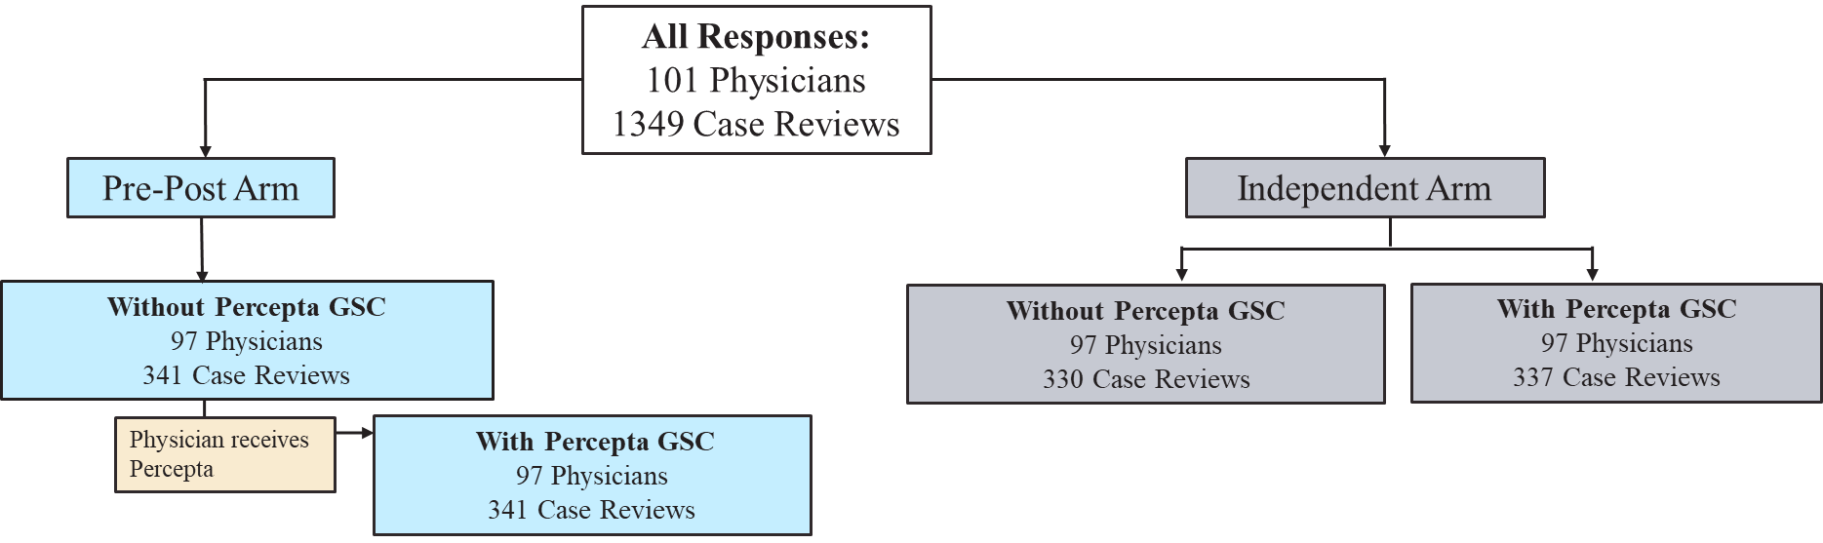

Supplementary Figure 2. Percepta GSC result report for risk re-stratification high risk to very high risk.
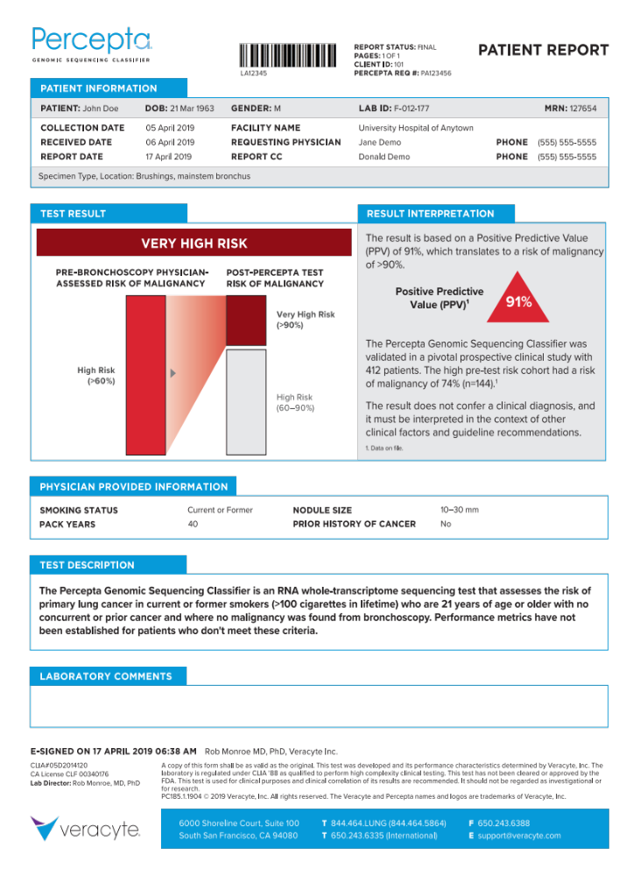
Supplementary Figure 3. Confidence scale for assessment of physician confidence.

Not at all Confident |  |  | Neutral |  |  | Extremely Confident
1 | 2 | 3 | 4 | 5 | 6 | 7

Supplementary Figure 4. Potential risk re-stratification algorithm for Percepta GSC.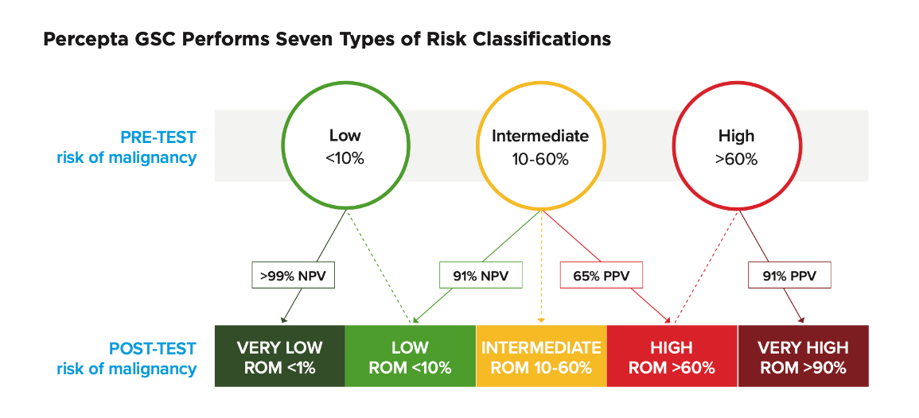
PPV=positive predictive value; NPV=negative predictive value; ROM=risk of malignancy

