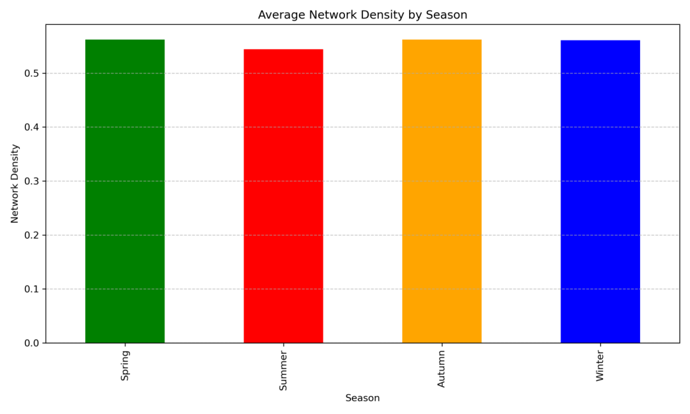
Fig. S1. Seasonal distribution of average network density
The network density remained relatively consistent in spring, autumn, and winter but decreased during summer. This seasonal decline is attributed to enhanced vertical atmospheric dispersion due to frequent convective weather in summer, which weakens intercity correlations.
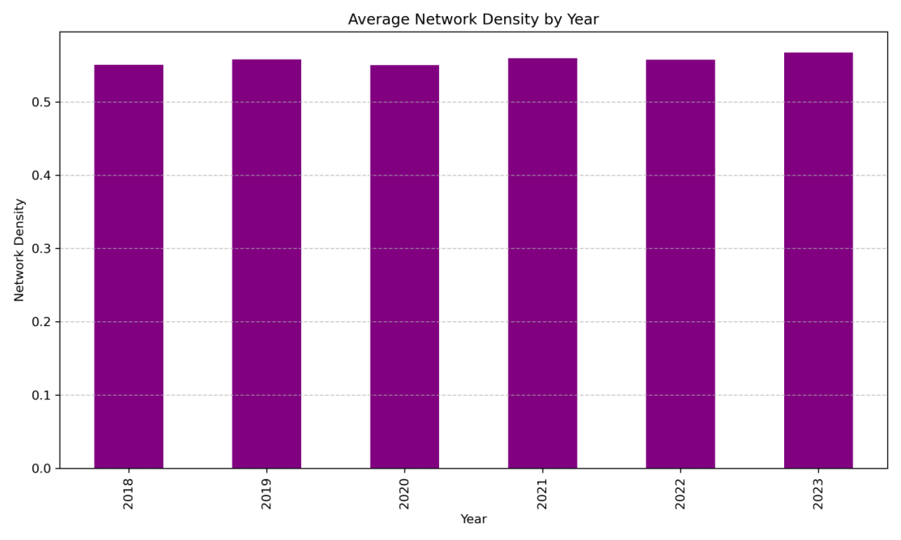
Fig. S2. Annual distribution of average network density
The network density showed a clear increasing trend over the six-year period. The accelerated increase after 2021 is likely associated with the rebound of industrial production and precursor emissions following the COVID-19 pandemic, indicating strengthened regional connectivity.
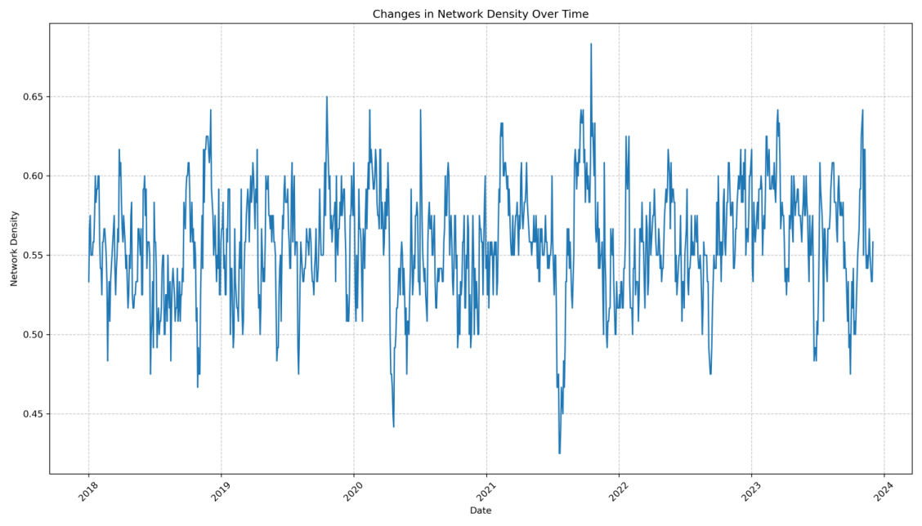
Fig. S3. Long-term fluctuations in network density (2018–2023)
The time series reveals a recurring short-term trough from June to August each year, consistent with the seasonal pattern. The period 2022–2023 is characterized by persistently elevated density with reduced dispersion, reflecting a more stable and intensified regional interaction pattern.

