Supplementary Information

Effect of repeated blocks of split-belt walking on locomotor adaptation, physiological arousal response and cortical activation

Kaya Yoshida^{1,2}, Shannon B. Lim², Lara A. Boyd^{1,4}, Janice J. Eng^{2,3}, Amy Schneeberg², Theodore J. Huppert⁵, Courtney L. Pollock^{2,3}

¹Graduate Studies in Rehabilitation Sciences, University of British Columbia, Vancouver, Canada,
²Rehabilitation Research Program of the Centre for Aging SMART and the GF Strong Rehabilitation Centre, Vancouver, Canada
³Department of Physical Therapy, University of British Columbia, Vancouver, Canada
⁴The Djavad Mowafaghian Centre for Brain Health Vancouver, Canada
⁵Department of Electrical and Computer Engineering, University of Pittsburgh, Pittsburgh, PA, USA

Corresponding author: Courtney Pollock, courtney.pollock@ubc.ca

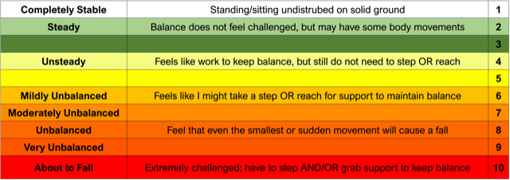
Fig. S1 Rating of Perceived Stability (RPS) scale (Espy et al., 2017).

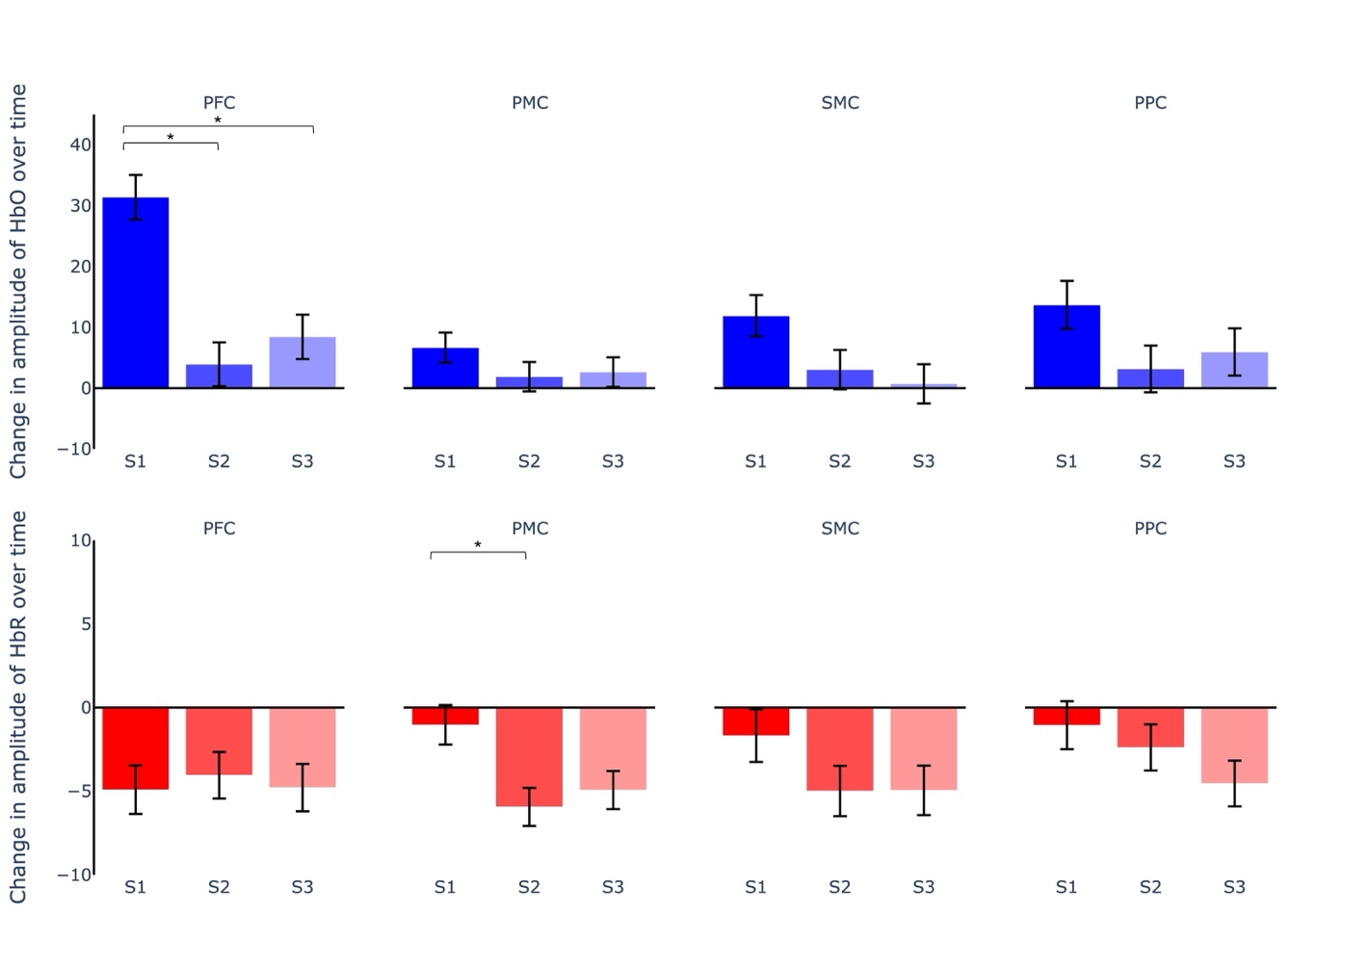
Fig. S2 Bar graphs showing the change in amplitude of response over time in oxyhemoglobin (HbO) and deoxyhemoglobin (HbR) concentration across the three, 210-second split-belt walking blocks calculated for the prefrontal cortex (PFC), premotor cortex (PMC), sensorimotor cortex (SMC) and posterior parietal cortex (PPC) during split-blocks 1-3 (S1, S2, S3). Error bars represent the standard error. Asterisk (*) indicates significance at q ≤ 0.05
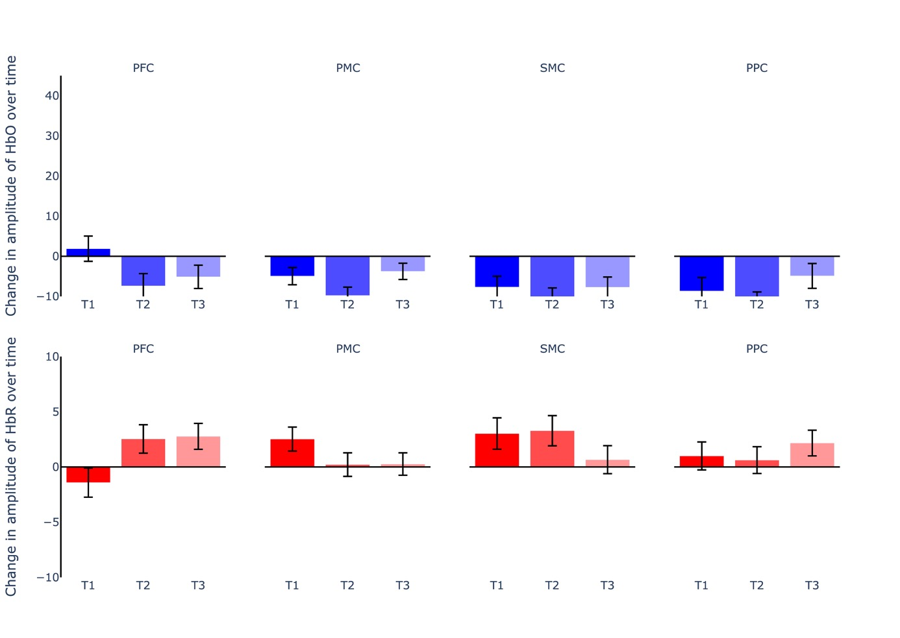
Fig. S3 Bar graphs showing the mean amplitude of response in oxyhemoglobin (HbO) and deoxyhemoglobin (HbR) concentration across the three, 210-second tied-belt walking blocks calculated for the prefrontal cortex (PFC), premotor cortex (PMC), sensorimotor cortex (SMC) and posterior parietal cortex (PPC) during tied-blocks 1-3 (T1, T2, T3). Error bars represent the standard error

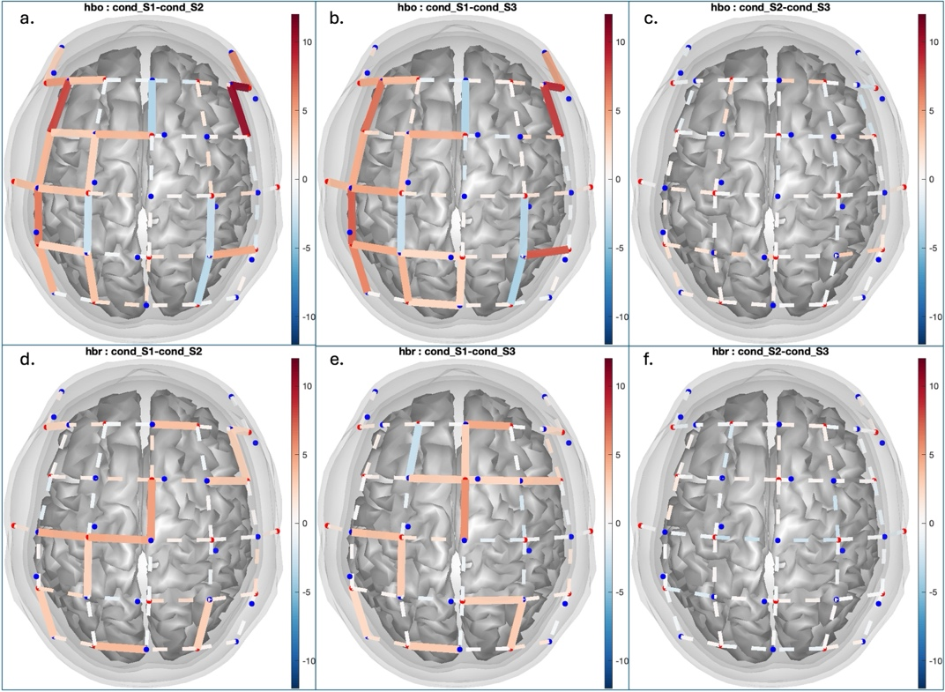
Fig. S4 Block-wise activation maps by channel for comparisons between split blocks, averaged over the group, showing oxyhemoglobin (HbO, top) and deoxyhemoglobin (HbR, bottom). Results are displayed as t scores with a corrected threshold of q < 0.05
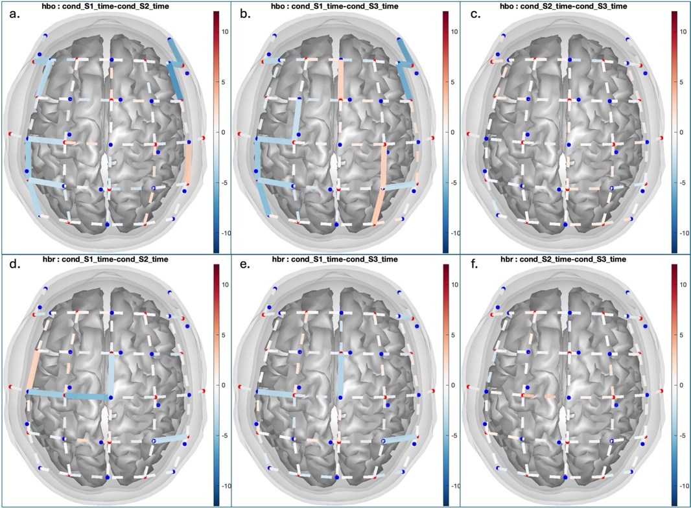
Fig. S5 Time-varying activation maps by channel for comparisons between split blocks, averaged over the group, showing oxyhemoglobin (HbO, top) and deoxyhemoglobin (HbR, bottom). Results are displayed as t scores with a corrected threshold of q < 0.05
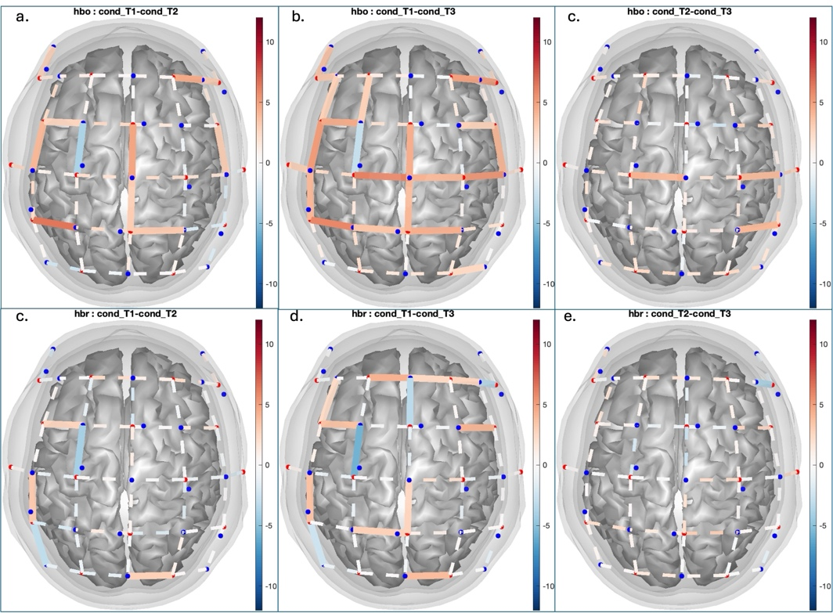
Fig. S6 Block-wise activation maps by channel for comparisons between tied blocks, averaged over the group, showing oxyhemoglobin (HbO, top) and deoxyhemoglobin (HbR, bottom). Results are displayed as t scores with a corrected threshold of q < 0.05
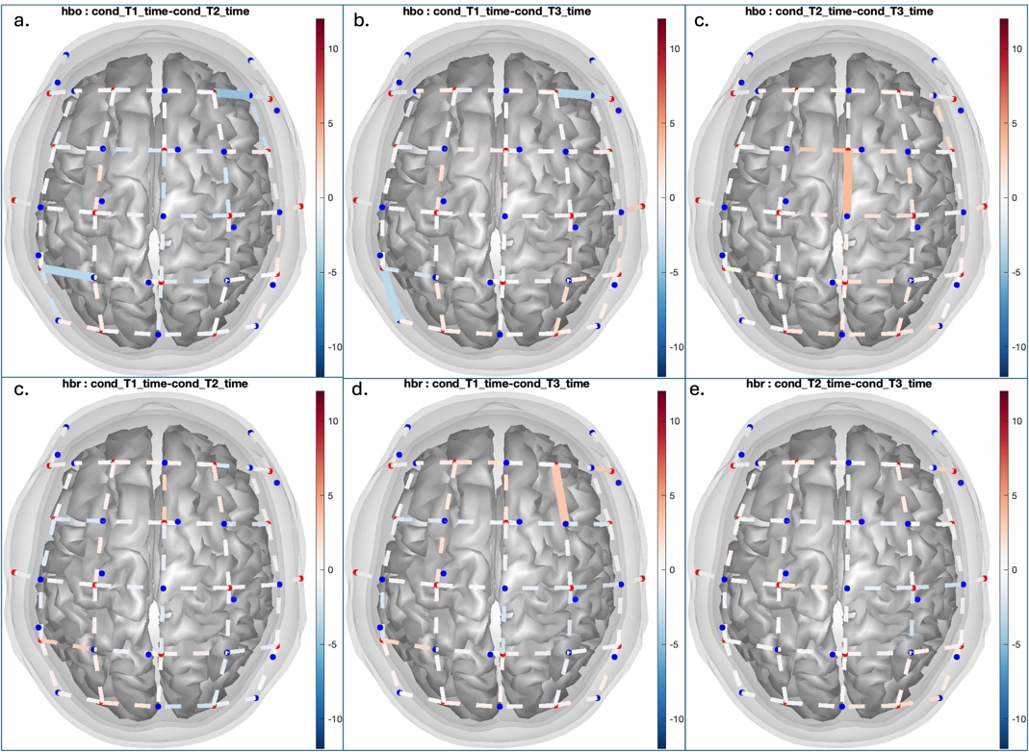
Fig. S7 Time-varying activation maps by channel for comparisons between tied blocks, averaged over the group, showing oxyhemoglobin (HbO, top) and deoxyhemoglobin (HbR, bottom). Results are displayed as t scores with a corrected threshold of q < 0.05

Table S1 Linear mixed-effects models results for all SLS and EDA
Variable | Predictors | Estimates | CI | p | σ² | τ₀₀ _{PID} | ICC | N _{PID} | Observations | Marginal R² / Conditional R²
RPS Split | Block [1] | 6.2 | 5.48 – 6.92 | <0.001 | 0.72 | 2.32 | 0.76 | 20 | 120 | 0.274 / 0.828
 | Block [2] | 4.7 | 3.98 – 5.42 | <0.001
 | Block [3] | 3.6 | 2.88 – 4.32 | <0.001
SLS Split | Phase [1] | -0.22 | -0.25 – -0.19 | <0.001 | 0 | 0 | 0.67 | 20 | 120 | 0.441/0.815
 | Phase [2] | -0.09 | -0.12 – -0.06 | <0.001
 | Block [2] | 0.12 | 0.10 – 0.14 | <0.001
 | Block [3] | 0.15 | 0.13 – 0.18 | <0.001
 | Phase [2] × Block [2] | -0.09 | -0.13 – -0.06 | <0.001
 | Phase [2] × Block [3] | -0.11 | -0.15 – -0.08 | <0.001
EDA Split | Phase [1] | 69.93 | 61.89 – 77.97 | <0.001 | 152.8 | 159.65 | 0.51 | 19 | 114 | 0.454 / 0.733
 | Phase [2] | 22.22 | 14.18 – 30.26 | <0.001
 | Block [2] | -32.95 | -40.90 – -25.00 | <0.001
 | Block [3] | -35.84 | -43.80 – -27.89 | <0.001
 | Phase [2] × Block [2] | 33.92 | 22.68 – 45.17 | <0.001
 | Phase [2] × Block [3] | 43.49 | 32.25 – 54.74 | <0.001
SLS Tied | Phase [1] | 0.12 | 0.10 – 0.14 | <0.001 | 0 | 0 | 0.6 | 20 | 120 | 0.323/0.730
 | Phase [2] | 0.03 | 0.01 – 0.05 | 0.002
 | Block [2] | -0.04 | -0.06 – -0.02 | <0.001
 | Block [3] | -0.07 | -0.09 – -0.05 | <0.001
 | Phase [2] × Block [2] | 0.04 | 0.01 – 0.06 | 0.004
 | Phase [2] × Block [3] | 0.07 | 0.05 – 0.10 | <0.001
EDA Tied | Phase [1] | 39.06 | 29.76 – 48.37 | <0.001 | 173 | 245.34 | 0.59 | 19 | 114 | 0.238/0.685
 | Phase [2] | 8.03 | -1.27 – 17.33 | 0.09
 | Block [2] | -7.83 | -16.29 – 0.63 | 0.069
 | Block [3] | -5.12 | -13.58 – 3.34 | 0.233
 | Phase [2] × Block [2] | 12.76 | 0.80 – 24.73 | 0.037
 | Phase [2] × Block [3] | 16.44 | 4.48 – 28.40 | 0.008
*uncorrected p-values and confidence intervals.
Table S2 Functional near-infrared spectroscopy channels removed for each participant, shown as source-detector pairings. Channels were excluded if the scalp coupling index was below a threshold of 0.75. PFC = Prefrontal cortex; PPC = Posterior parietal cortex; PMC = Premotor cortex; SMC = Sensorimotor cortex.
Subject | PFC | PMC | SMC | PPC
P_01 | 2-3, 2-6, 3-3 | 6-9, 10-10 | 13-9 | 16-12
P_02 | 2-6, 5-2, 7-4 | 7-10, 9-8 | 9-11, 12-11, 13-9, 14-10 | 12-13, 13-12, 15-11, 16-14
P_03 | 3-7 | 5-8, 6-9, 9-8, 9-9, 10-9, 10-10, 11-10 | 9-11, 10-12, 12-11, 13-9, 14-10, 14-12 | 13-11, 13-12, 15-11, 16-12
P_04 | All channels excluded due to technical issue
P_05 | 4-5, 7-4 | 6-9, 7-7 | 9-11, 12-11 | 14-15, 15-11
P_6 | NA | 9-8 | 14-Oct | 16-12
P_7 | 2-3, 2-6 | 5-6, 6-9, 9-9 | NA | 15-11
P_8 | NA | 6-6 | NA | NA
P_9 | NA | 6-9, 9-9, 10-9 | 13-9 | NA
P_10 | All channels excluded due to technical issue
P_11 | 3-3, 5-2 | 5-6, 5-8, 6-7 | NA | NA
P_12 | 3-3, 3-7 | 9-9 | NA | NA
P_13 | 2-3, 3-3 | NA | NA | NA
P_14 | 3-3, 4-4, 4-5 | NA | 9-11, 12-11, 14-12 | 13-11, 15-11, 15-13, 16-12
P_15 | 2-3, 2-6, 3-3 | 6-6, 9-6 | 12-11 | 12-13
P_16 | NA | 6-9, 9-6, 10-7 | 13-9 | NA
P_17 | All channels excluded due to technical issue
P_18 | 2-3, 3-3, 3-7 | 7-7, 9-6, 10-7, 10-10 | 12-11 | 13-12
P_19 | 1-1, 2-3, 2-6 | NA | 13-9 | 13-14, 15-14
P_20 | 3-7 | NA | 13-9 | NA

Table S3 Linear mixed effects model contrast results for step length symmetry (SLS), electrodermal arousal (EDA) and rating of perceived stability (RPS) during split and tied blocks for early and late phases. Estimated marginal means, standard error, corrected p-values (q-values) and Effect size (Cohen’s d)
Variable | Contrast | Estimate | Standard Error | q-value | Cohen's d
SLS Split | Early Split1 - Late Split1 | -0.144 | 0.012 | 0.000 | -2.071
SLS Split | Early Split1 - Early Split2 | -0.121 | 0.012 | 0.000 | -1.715
SLS Split | Early Split1 - Late Split2 | -0.173 | 0.012 | 0.000 | -3.006
SLS Split | Early Split1 - Early Split3 | -0.152 | 0.012 | 0.000 | -1.990
SLS Split | Early Split1 - Late Split3 | -0.182 | 0.012 | 0.000 | -2.233
SLS Split | Late Split1 - Early Split2 | 0.024 | 0.012 | 0.071 | -0.495
SLS Split | Late Split1 - Late Split2 | -0.028 | 0.012 | 0.032 | -0.841
SLS Split | Late Split1 - Early Split3 | -0.008 | 0.012 | 0.525 | 0.206
SLS Split | Late Split1 - Late Split3 | -0.038 | 0.012 | 0.005 | -0.714
SLS Split | Early Split2 - Late Split2 | -0.052 | 0.012 | 0.000 | -1.215
SLS Split | Early Split2 - Early Split3 | -0.031 | 0.012 | 0.020 | -0.831
SLS Split | Early Split2 - Late Split3 | -0.061 | 0.012 | 0.000 | -0.988
SLS Split | Late Split2 - Early Split3 | 0.020 | 0.012 | 0.113 | -0.595
SLS Split | Late Split2 - Late Split3 | -0.009 | 0.012 | 0.471 | -0.219
SLS Split | Early Split3 - Late Split3 | -0.030 | 0.012 | 0.024 | -0.754
EDA Split | Early Split1 - Late Split1 | 47.338 | 3.937 | 0.000 | 2.665
EDA Split | Early Split1 - Early Split2 | 32.948 | 3.974 | 0.000 | 1.902
EDA Split | Early Split1 - Late Split2 | 46.411 | 3.937 | 0.000 | 2.112
EDA Split | Early Split1 - Early Split3 | 35.845 | 3.974 | 0.000 | 1.790
EDA Split | Early Split1 - Late Split3 | 40.074 | 3.937 | 0.000 | 1.756
EDA Split | Late Split1 - Early Split2 | -14.390 | 3.937 | 0.001 | 0.759
EDA Split | Late Split1 - Late Split2 | -0.927 | 3.873 | 0.811 | -0.066
EDA Split | Late Split1 - Early Split3 | -11.493 | 3.937 | 0.008 | 0.590
EDA Split | Late Split1 - Late Split3 | -7.265 | 3.873 | 0.096 | -0.436
EDA Split | Early Split2 - Late Split2 | 13.463 | 3.937 | 0.002 | 0.797
EDA Split | Early Split2 - Early Split3 | 2.897 | 3.974 | 0.501 | 0.222
EDA Split | Early Split2 - Late Split3 | 7.125 | 3.937 | 0.100 | 0.367
EDA Split | Late Split2 - Early Split3 | -10.566 | 3.937 | 0.014 | 0.835
EDA Split | Late Split2 - Late Split3 | -6.338 | 3.873 | 0.131 | -0.736
EDA Split | Early Split3 - Late Split3 | 4.229 | 3.937 | 0.330 | 0.311
RPS Split | Split1 - Split2 | 0.085 | 0.009 | 0.000 | 1.308
RPS Split | Split1 - Split3 | 0.039 | 0.009 | 0.000 | 1.560
RPS Split | Split2 - Split3 | 0.086 | 0.009 | 0.000 | 0.909
SLS Tied | Early Tied1 - Late Tied1 | 0.085 | 0.009 | 0.000 | 1.416
SLS Tied | Early Tied1 - Early Tied2 | 0.039 | 0.009 | 0.000 | 0.908
SLS Tied | Early Tied1 - Late Tied2 | 0.086 | 0.009 | 0.000 | 1.804
SLS Tied | Early Tied1 - Early Tied3 | 0.069 | 0.009 | 0.000 | 1.621
SLS Tied | Early Tied1 - Late Tied3 | 0.083 | 0.009 | 0.000 | 1.473
SLS Tied | Late Tied1 - Early Tied2 | -0.046 | 0.009 | 0.000 | 1.487
SLS Tied | Late Tied1 - Late Tied2 | 0.001 | 0.009 | 0.876 | 0.034
SLS Tied | Late Tied1 - Early Tied3 | -0.016 | 0.009 | 0.114 | 0.350
SLS Tied | Late Tied1 - Late Tied3 | -0.002 | 0.009 | 0.876 | -0.043
SLS Tied | Early Tied2 - Late Tied2 | 0.047 | 0.009 | 0.000 | 1.546
SLS Tied | Early Tied2 - Early Tied3 | 0.030 | 0.009 | 0.002 | 1.048
SLS Tied | Early Tied2 - Late Tied3 | 0.044 | 0.009 | 0.000 | 1.141
SLS Tied | Late Tied2 - Early Tied3 | -0.017 | 0.009 | 0.090 | 0.643
SLS Tied | Late Tied2 - Late Tied3 | -0.003 | 0.009 | 0.820 | -0.187
SLS Tied | Early Tied3 - Late Tied3 | 0.014 | 0.009 | 0.161 | 0.443
EDA Tied | Early Tied1 - Late Tied1 | 30.506 | 4.194 | 0.000 | 1.826
EDA Tied | Early Tied1 - Early Tied2 | 7.829 | 4.232 | 0.092 | 0.552
EDA Tied | Early Tied1 - Late Tied2 | 25.819 | 4.194 | 0.000 | 1.054
EDA Tied | Early Tied1 - Early Tied3 | 5.117 | 4.232 | 0.265 | 0.250
EDA Tied | Early Tied1 - Late Tied3 | 19.750 | 4.194 | 0.000 | 0.816
EDA Tied | Late Tied1 - Early Tied2 | -22.677 | 4.194 | 0.000 | 1.810
EDA Tied | Late Tied1 - Late Tied2 | -4.687 | 4.124 | 0.277 | -0.246
EDA Tied | Late Tied1 - Early Tied3 | -25.389 | 4.194 | 0.000 | 1.338
EDA Tied | Late Tied1 - Late Tied3 | -10.756 | 4.124 | 0.016 | -0.450
EDA Tied | Early Tied2 - Late Tied2 | 17.990 | 4.194 | 0.000 | 1.171
EDA Tied | Early Tied2 - Early Tied3 | -2.712 | 4.232 | 0.523 | -0.247
EDA Tied | Early Tied2 - Late Tied3 | 11.921 | 4.194 | 0.009 | 0.715
EDA Tied | Late Tied2 - Early Tied3 | -20.702 | 4.194 | 0.000 | 1.157
EDA Tied | Late Tied2 - Late Tied3 | -6.069 | 4.124 | 0.181 | -0.313
EDA Tied | Early Tied3 - Late Tied3 | 14.633 | 4.194 | 0.001 | 1.031

Table S4 Statistical summary of hemoglobin responses (HbO and HbR) across regions of interest (ROI) during split-belt walking blocks. Table includes contrast conditions, estimated beta coefficients, standard errors, test statistics (T), p-values, false discovery rate-adjusted q-values, statistical power, and corresponding effect sizes (Cohen’s d).
ROI | Species | Contrast | Beta | Standard error | T | p-value | q-value | Power | Cohen's d
PFC | HbO | S1_time-S2_time | -20.506 | 5.405 | -3.794 | 0.000 | 0.002 | 0.018 | -0.736
PFC | HbO | S1_time-S3_time | -14.104 | 5.430 | -2.597 | 0.011 | 0.052 | 0.176 | -0.335
PFC | HbO | S2_time-S3_time | 12.759 | 5.387 | 2.369 | 0.020 | 0.032 | 0.241 | 0.361
PMC | HbO | S1_time-S2_time | -4.771 | 3.441 | -1.387 | 0.169 | 0.225 | 0.608 | -0.339
PMC | HbO | S1_time-S3_time | -4.011 | 3.472 | -1.155 | 0.251 | 0.251 | 0.693 | -0.162
PMC | HbO | S2_time-S3_time | 4.537 | 3.441 | 1.319 | 0.190 | 0.218 | 0.634 | 0.323
PPC | HbO | S1_time-S2_time | -10.503 | 5.497 | -1.911 | 0.059 | 0.126 | 0.402 | -0.634
PPC | HbO | S1_time-S3_time | -7.719 | 5.536 | -1.394 | 0.166 | 0.190 | 0.605 | -0.549
PPC | HbO | S2_time-S3_time | 9.111 | 5.470 | 1.666 | 0.099 | 0.132 | 0.498 | 0.227
SMC | HbO | S1_time-S2_time | -8.836 | 4.701 | -1.879 | 0.063 | 0.126 | 0.414 | 0.049
SMC | HbO | S1_time-S3_time | -11.165 | 4.699 | -2.376 | 0.019 | 0.052 | 0.238 | 0.107
SMC | HbO | S2_time-S3_time | 3.758 | 4.618 | 0.814 | 0.418 | 0.418 | 0.801 | 0.110
PFC | HbR | S1_time-S2_time | -0.413 | 2.178 | -0.190 | 0.850 | 0.850 | 0.928 | -0.192
PFC | HbR | S1_time-S3_time | -3.047 | 2.178 | -1.399 | 0.165 | 0.190 | 0.603 | -0.371
PFC | HbR | S2_time-S3_time | -11.468 | 2.156 | -5.320 | 0.000 | 0.000 | 0.000 | -0.228
PMC | HbR | S1_time-S2_time | -4.901 | 1.628 | -3.010 | 0.003 | 0.013 | 0.090 | -0.087
PMC | HbR | S1_time-S3_time | -3.895 | 1.631 | -2.388 | 0.019 | 0.052 | 0.235 | 0.073
PMC | HbR | S2_time-S3_time | -10.869 | 1.615 | -6.731 | 0.000 | 0.000 | 0.000 | 0.200
PPC | HbR | S1_time-S2_time | -1.329 | 1.982 | -0.671 | 0.504 | 0.576 | 0.838 | -0.186
PPC | HbR | S1_time-S3_time | -3.486 | 1.980 | -1.761 | 0.081 | 0.163 | 0.460 | -0.058
PPC | HbR | S2_time-S3_time | -6.926 | 1.949 | -3.554 | 0.001 | 0.001 | 0.031 | 0.131
SMC | HbR | S1_time-S2_time | -3.303 | 2.154 | -1.533 | 0.128 | 0.206 | 0.551 | 0.368
SMC | HbR | S1_time-S3_time | -3.263 | 2.142 | -1.524 | 0.131 | 0.190 | 0.555 | 0.287
SMC | HbR | S2_time-S3_time | -9.940 | 2.116 | -4.698 | 0.000 | 0.000 | 0.002 | 0.014
PFC | HbO | S1-S2 | 16.769 | 3.453 | 4.856 | 0.000 | 0.000 | 0.001 | 0.658
PFC | HbO | S1-S3 | 15.585 | 3.501 | 4.452 | 0.000 | 0.000 | 0.003 | 0.649
PFC | HbO | S2-S3 | 6.851 | 3.636 | 1.884 | 0.063 | 0.125 | 0.412 | 0.067
PMC | HbO | S1-S2 | 9.862 | 2.227 | 4.427 | 0.000 | 0.000 | 0.003 | 0.328
PMC | HbO | S1-S3 | 10.692 | 2.275 | 4.700 | 0.000 | 0.000 | 0.002 | 0.341
PMC | HbO | S2-S3 | 1.829 | 2.287 | 0.800 | 0.426 | 0.426 | 0.804 | 0.112
PPC | HbO | S1-S2 | 7.313 | 3.461 | 2.113 | 0.037 | 0.041 | 0.326 | 0.488
PPC | HbO | S1-S3 | 10.805 | 3.487 | 3.099 | 0.003 | 0.003 | 0.077 | 0.558
PPC | HbO | S2-S3 | 2.859 | 3.571 | 0.801 | 0.425 | 0.426 | 0.804 | 0.350
SMC | HbO | S1-S2 | 6.416 | 3.096 | 2.072 | 0.041 | 0.041 | 0.341 | -0.119
SMC | HbO | S1-S3 | 11.440 | 3.127 | 3.658 | 0.000 | 0.001 | 0.024 | 0.155
SMC | HbO | S2-S3 | 3.449 | 2.990 | 1.154 | 0.251 | 0.335 | 0.694 | 0.758
PFC | HbR | S1-S2 | 5.153 | 1.499 | 3.437 | 0.001 | 0.002 | 0.039 | 0.439
PFC | HbR | S1-S3 | 5.511 | 1.516 | 3.636 | 0.000 | 0.001 | 0.026 | 0.621
PFC | HbR | S2-S3 | 9.025 | 1.509 | 5.982 | 0.000 | 0.000 | 0.000 | 0.255
PMC | HbR | S1-S2 | 5.847 | 1.082 | 5.405 | 0.000 | 0.000 | 0.000 | 0.216
PMC | HbR | S1-S3 | 4.087 | 1.097 | 3.726 | 0.000 | 0.001 | 0.021 | 0.051
PMC | HbR | S2-S3 | 6.429 | 1.094 | 5.876 | 0.000 | 0.000 | 0.000 | -0.160
PPC | HbR | S1-S2 | 4.083 | 1.342 | 3.043 | 0.003 | 0.005 | 0.085 | 0.226
PPC | HbR | S1-S3 | 3.950 | 1.353 | 2.920 | 0.004 | 0.005 | 0.106 | 0.192
PPC | HbR | S2-S3 | 2.286 | 1.329 | 1.720 | 0.089 | 0.142 | 0.476 | -0.081
SMC | HbR | S1-S2 | 3.738 | 1.454 | 2.571 | 0.012 | 0.016 | 0.183 | -0.001
SMC | HbR | S1-S3 | 2.394 | 1.456 | 1.644 | 0.103 | 0.103 | 0.507 | -0.078
SMC | HbR | S2-S3 | 6.227 | 1.457 | 4.273 | 0.000 | 0.000 | 0.005 | -0.107

Table S5. Statistical summary of hemoglobin responses (HbO and HbR) across regions of interest (ROI) during tied-belt walking blocks. Table includes contrast conditions, estimated beta coefficients, standard errors, test statistics (T), p-values, false discovery rate-adjusted q-values, statistical power, and corresponding effect sizes (Cohen’s d)
ROI | Species | Contrast | Beta | SE | T | p-value | q-value | Power | Cohen's d
PFC | HbO | T1_time-T2_time | -9.268 | 4.280 | -2.166 | 0.033 | 0.131 | 0.308 | -0.037
PFC | HbO | T1_time-T3_time | -7.012 | 4.194 | -1.672 | 0.098 | 0.329 | 0.496 | -0.097
PFC | HbO | T2_time-T3_time | -12.508 | 4.300 | -2.909 | 0.005 | 0.007 | 0.108 | -0.072
PMC | HbO | T1_time-T2_time | -4.840 | 2.917 | -1.659 | 0.100 | 0.246 | 0.501 | 0.251
PMC | HbO | T1_time-T3_time | 1.180 | 2.887 | 0.409 | 0.684 | 0.781 | 0.893 | 0.359
PMC | HbO | T2_time-T3_time | -13.550 | 2.988 | -4.535 | 0.000 | 0.000 | 0.003 | 0.005
PPC | HbO | T1_time-T2_time | -3.518 | 4.575 | -0.769 | 0.444 | 0.592 | 0.813 | 0.051
PPC | HbO | T1_time-T3_time | 3.760 | 4.472 | 0.841 | 0.403 | 0.644 | 0.793 | -0.004
PPC | HbO | T2_time-T3_time | -17.079 | 4.625 | -3.693 | 0.000 | 0.001 | 0.023 | -0.052
SMC | HbO | T1_time-T2_time | -2.843 | 3.640 | -0.781 | 0.437 | 0.592 | 0.810 | -0.242
SMC | HbO | T1_time-T3_time | -0.039 | 3.619 | -0.011 | 0.991 | 0.991 | 0.949 | -0.391
SMC | HbO | T2_time-T3_time | -18.264 | 3.826 | -4.773 | 0.000 | 0.000 | 0.001 | -0.005
PFC | HbR | T1_time-T2_time | 3.955 | 1.775 | 2.229 | 0.028 | 0.131 | 0.286 | 0.149
PFC | HbR | T1_time-T3_time | 4.191 | 1.713 | 2.446 | 0.016 | 0.130 | 0.217 | 0.000
PFC | HbR | T2_time-T3_time | 5.311 | 1.803 | 2.945 | 0.004 | 0.007 | 0.101 | -0.135
PMC | HbR | T1_time-T2_time | -2.309 | 1.485 | -1.555 | 0.123 | 0.246 | 0.542 | 0.456
PMC | HbR | T1_time-T3_time | -2.259 | 1.454 | -1.554 | 0.123 | 0.329 | 0.543 | 0.417
PMC | HbR | T2_time-T3_time | 0.478 | 1.512 | 0.316 | 0.752 | 0.752 | 0.909 | 0.023
PPC | HbR | T1_time-T2_time | -0.377 | 1.713 | -0.220 | 0.827 | 0.895 | 0.924 | 0.046
PPC | HbR | T1_time-T3_time | 1.169 | 1.683 | 0.695 | 0.489 | 0.652 | 0.832 | 0.178
PPC | HbR | T2_time-T3_time | 2.786 | 1.727 | 1.614 | 0.110 | 0.126 | 0.519 | 0.149
SMC | HbR | T1_time-T2_time | 0.255 | 1.920 | 0.133 | 0.895 | 0.895 | 0.935 | 0.117
SMC | HbR | T1_time-T3_time | -2.369 | 1.859 | -1.274 | 0.206 | 0.412 | 0.650 | 0.166
SMC | HbR | T2_time-T3_time | 3.944 | 1.920 | 2.054 | 0.043 | 0.057 | 0.348 | 0.074
PFC | HbO | T1-T2 | 8.645 | 2.690 | 3.213 | 0.002 | 0.007 | 0.062 | 0.203
PFC | HbO | T1-T3 | 12.201 | 2.702 | 4.516 | 0.000 | 0.000 | 0.003 | 0.329
PFC | HbO | T2-T3 | -5.420 | 2.995 | -1.810 | 0.073 | 0.196 | 0.441 | 0.235
PMC | HbO | T1-T2 | 6.801 | 1.846 | 3.684 | 0.000 | 0.003 | 0.023 | 0.176
PMC | HbO | T1-T3 | 12.431 | 1.864 | 6.668 | 0.000 | 0.000 | 0.000 | 0.461
PMC | HbO | T2-T3 | 8.212 | 2.066 | 3.975 | 0.000 | 0.001 | 0.011 | 0.498
PPC | HbO | T1-T2 | 1.376 | 2.924 | 0.471 | 0.639 | 0.852 | 0.882 | 0.043
PPC | HbO | T1-T3 | 9.178 | 2.953 | 3.108 | 0.002 | 0.005 | 0.076 | 0.648
PPC | HbO | T2-T3 | -4.510 | 3.190 | -1.414 | 0.161 | 0.214 | 0.597 | 0.736
SMC | HbO | T1-T2 | 7.108 | 2.314 | 3.071 | 0.003 | 0.007 | 0.081 | 0.396
SMC | HbO | T1-T3 | 13.833 | 2.355 | 5.874 | 0.000 | 0.000 | 0.000 | 1.073
SMC | HbO | T2-T3 | 7.635 | 2.627 | 2.906 | 0.005 | 0.018 | 0.108 | 0.731
PFC | HbR | T1-T2 | -0.807 | 1.230 | -0.656 | 0.513 | 0.821 | 0.841 | 0.177
PFC | HbR | T1-T3 | -0.241 | 1.209 | -0.199 | 0.843 | 0.901 | 0.926 | 0.257
PFC | HbR | T2-T3 | -2.219 | 1.377 | -1.612 | 0.110 | 0.214 | 0.520 | 0.291
PMC | HbR | T1-T2 | -0.094 | 0.943 | -0.100 | 0.921 | 0.921 | 0.939 | -0.298
PMC | HbR | T1-T3 | 0.364 | 0.952 | 0.382 | 0.703 | 0.901 | 0.898 | -0.229
PMC | HbR | T2-T3 | -1.596 | 1.075 | -1.484 | 0.141 | 0.214 | 0.570 | 0.071
PPC | HbR | T1-T2 | -1.135 | 1.152 | -0.985 | 0.327 | 0.654 | 0.750 | -0.206
PPC | HbR | T1-T3 | 0.144 | 1.158 | 0.125 | 0.901 | 0.901 | 0.936 | -0.106
PPC | HbR | T2-T3 | -1.229 | 1.258 | -0.977 | 0.331 | 0.331 | 0.752 | 0.081
SMC | HbR | T1-T2 | -0.386 | 1.258 | -0.307 | 0.760 | 0.868 | 0.911 | -0.268
SMC | HbR | T1-T3 | 1.970 | 1.261 | 1.562 | 0.122 | 0.194 | 0.539 | -0.095
SMC | HbR | T2-T3 | -1.522 | 1.389 | -1.095 | 0.276 | 0.316 | 0.714 | 0.248

Table S6 All correlation results between variables. Including Pearson’s correlations (r) and Spearman’s rank correlations (𝜌). Bolded p- and q-values indicate significance at alpha < 0.05. SLS = step length symmetry, EDA = electrodermal activity, PFC = prefrontal cortex, PPC = posterior parietal cortex, PPC = Premotor cortex (which includes the supplementary motor area), SMC = sensorimotor cortex, RPS = Rating of perceived stability)
Comparisons | Correlation coefficient | p-value | q-value
SLS Split, EDA Split | -0.569 | 0.000 | 0.000
SLS Split, PFC HbO Split | -0.270 | 0.056 | 0.272
SLS Split, PMC HbO Split | -0.142 | 0.322 | 0.674
SLS Split, SMC HbO Split | -0.254 | 0.073 | 0.290
SLS Split, PPC HbO Split | -0.212 | 0.136 | 0.399
EDA Split, PFC HbO Split | 0.236 | 0.106 | 0.389
EDA Split, PMC HbO Split | 0.202 | 0.168 | 0.463
EDA Split, SMC HbO Split | 0.122 | 0.409 | 0.692
EDA Split, PPC HbO Split | 0.283 | 0.051 | 0.320
SLS Split, PFC HbR Split | -0.125 | 0.384 | 0.676
SLS Split, PMC HbR Split | -0.038 | 0.789 | 0.964
SLS Split, SMC HbR Split | -0.102 | 0.477 | 0.749
SLS Split, PPC HbR Split | -0.008 | 0.954 | 0.976
EDA Split, PFC HbR Split | 0.167 | 0.256 | 0.626
EDA Split, PMC HbR Split | 0.048 | 0.748 | 0.968
EDA Split, SMC HbR Split | -0.019 | 0.899 | 0.989
EDA Split, PPC HbR Split | 0.042 | 0.777 | 0.976
EDA Tied, PFC HbO Tied | -0.136 | 0.358 | 0.656
EDA Tied, PMC HbO Tied | -0.147 | 0.320 | 0.703
EDA Tied, SMC HbO Tied | -0.281 | 0.053 | 0.294
EDA Tied, PPC HbO Tied | -0.306 | 0.034* | 0.252
EDA Tied, PFC HbR Tied | -0.142 | 0.336 | 0.672
EDA Tied, PMC HbR Tied | -0.094 | 0.525 | 0.797
EDA Tied, SMC HbR Tied | -0.002 | 0.991 | 0.991
EDA Tied, PPC HbR Tied | -0.012 | 0.933 | 0.977
RPS Split, PFC HbO Split | 0.183 | 0.200 | 0.517
RPS Split, PMC HbO Split | -0.056 | 0.699 | 0.932
RPS Split, SMC HbO Split | -0.228 | 0.107 | 0.364
RPS Split, PPC HbO Split | 0.034 | 0.813 | 0.967
RPS Split, SLS Split | -0.203 | 0.119 | 0.374
RPS Split, EDA Split | 0.364 | 0.005* | 0.118
RPS Split, PFC HbR Split | 0.350 | 0.012* | 0.129
RPS Split, PMC HbR Split | 0.085 | 0.555 | 0.814
RPS Split, SMC HbR Split | 0.114 | 0.426 | 0.694
RPS Split, PPC HbR Split | 0.298 | 0.034* | 0.296
SLS Tied, EDA Tied | 0.025 | 0.852 | 0.905
SLS Tied, PFC HbO Tied | 0.101 | 0.479 | 0.814
SLS Tied, PMC HbO Tied | 0.039 | 0.787 | 1.000
SLS Tied, SMC HbO Tied | 0.139 | 0.332 | 0.805
SLS Tied, PPC HbO Tied | -0.037 | 0.796 | 0.966
SLS Tied, PFC HbR Tied | 0.041 | 0.776 | 1.000
SLS Tied, PMC HbR Tied | -0.244 | 0.085 | 0.479
SLS Tied, SMC HbR Tied | 0.174 | 0.222 | 0.755
SLS Tied, PPC HbR Tied | -0.034 | 0.813 | 0.921
Bold and * indicate significance at alpha < 0.05. Bolded correlation coefficients indicate relationships with strengths > |0.3|

