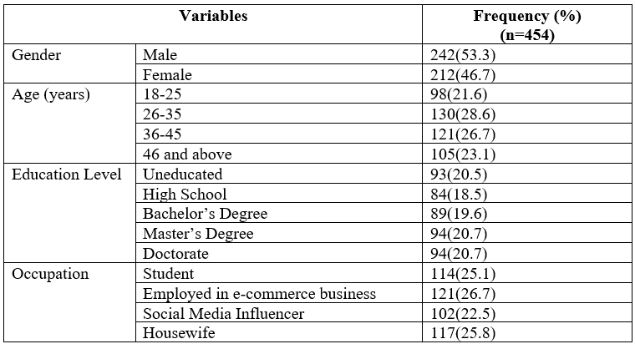
Table 1 Demographic Characteristics of Participants
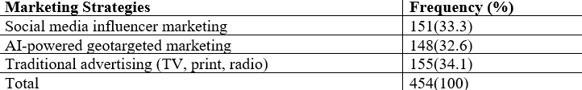
Table 2 Marketing Strategies Adopted by e-Commerce Companies
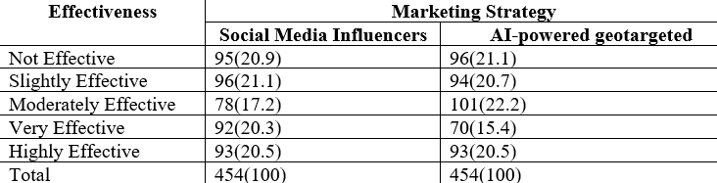
Table 3 Effectiveness of Marketing Strategies
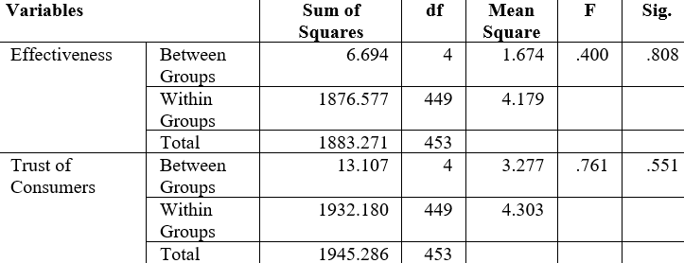
Table 4 One Way ANOVA
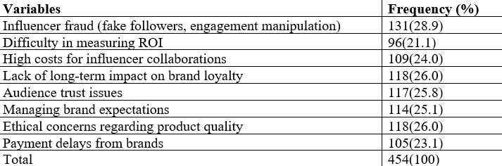
Table 5 Challenges Faced by E-Commerce Companies
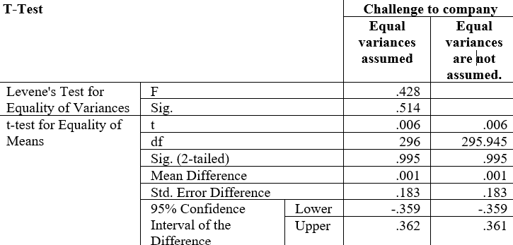
Table 6 Independent Sample T-Test
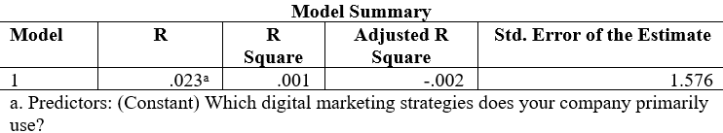
Table 7 Model Summary
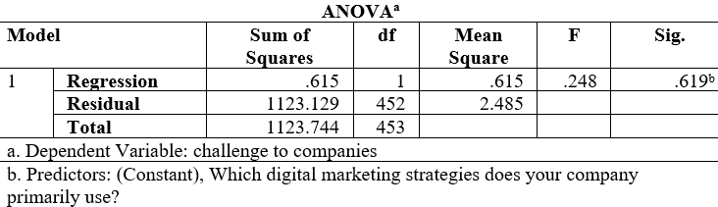
Table 8 ANOVA
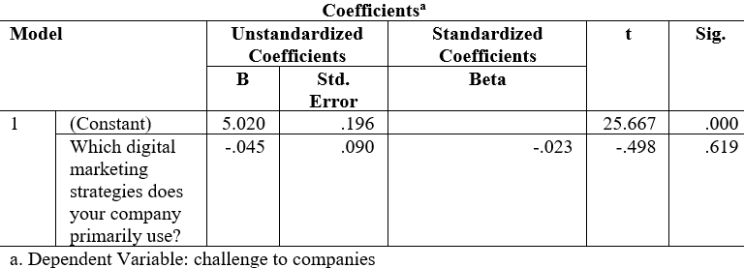
Table 9 Coefficients
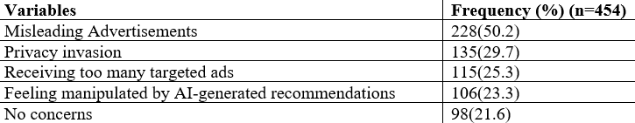
Table 10 Challenges Faced by Consumers
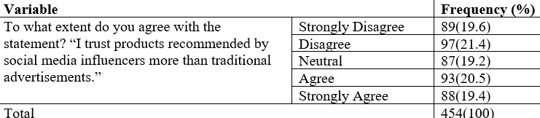
Table 11 Trust Issues Faced by Consumers
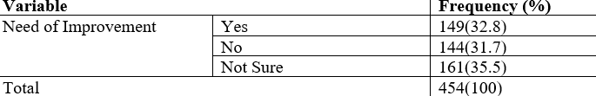
Table 12 Improvement Regarding Perceptions of Consumers
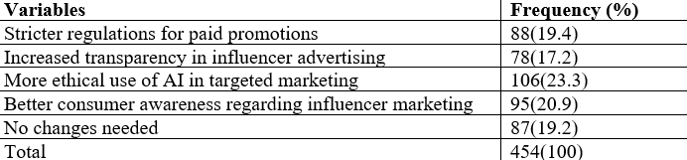
Table 13 Recommended Strategies by Customers

