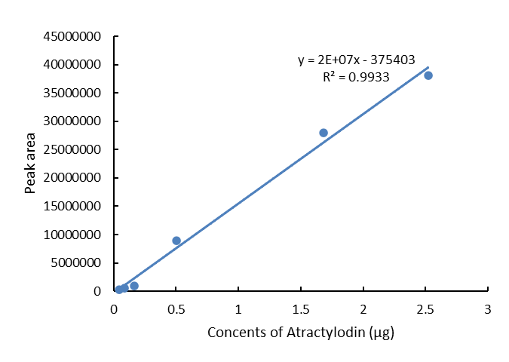
Fig. S1 The standard curve of Atractylodin.

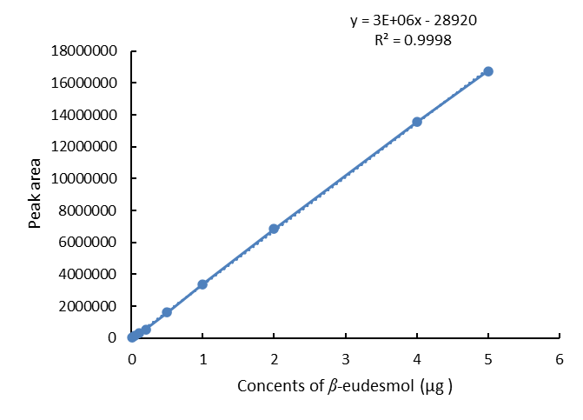
Fig. S2 The standard curve of β-eudesmol.

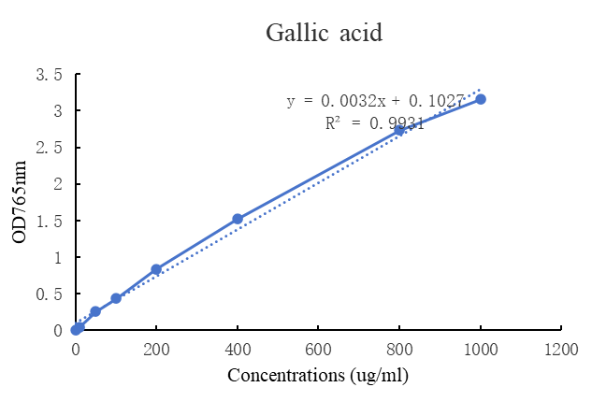
Fig. S3 The standard curve of gallic acid.

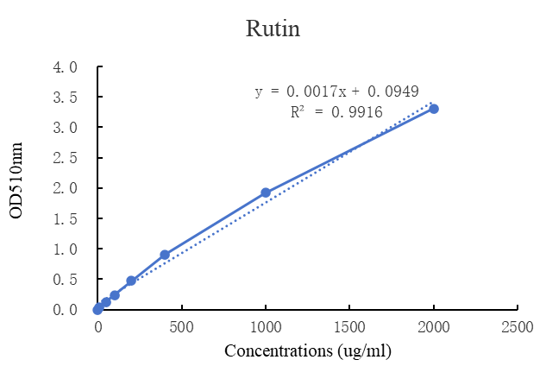
Fig. S4 The standard curve of rutin.

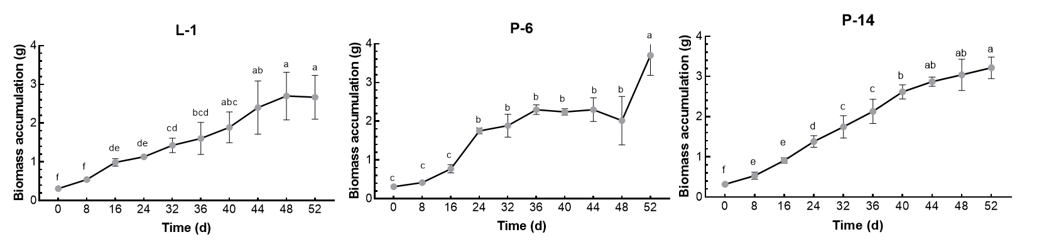
Fig. S5 The biomass accumulation of three A. chinensis hairy roots lines at different time.
Each value represents the mean ± standard deviation (n = 3). The lower-case letters indicate significant differences among different times via ANOVA followed by Duncan's post-test (P < 0.05).

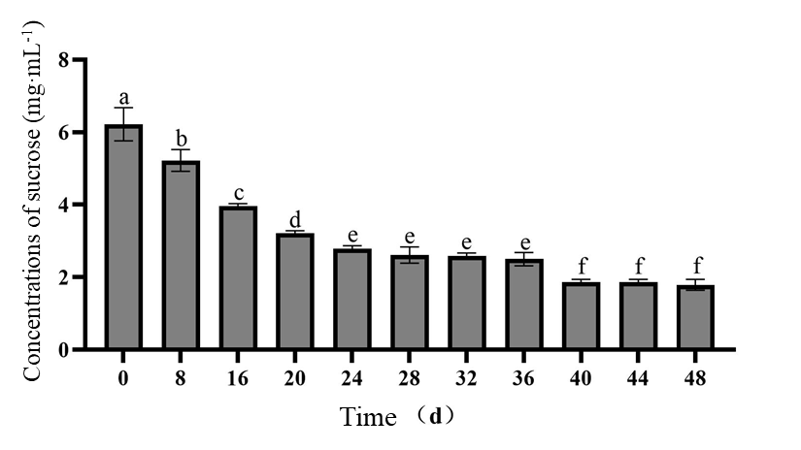
Fig. S6 Sucrose concentration in medium at different time.
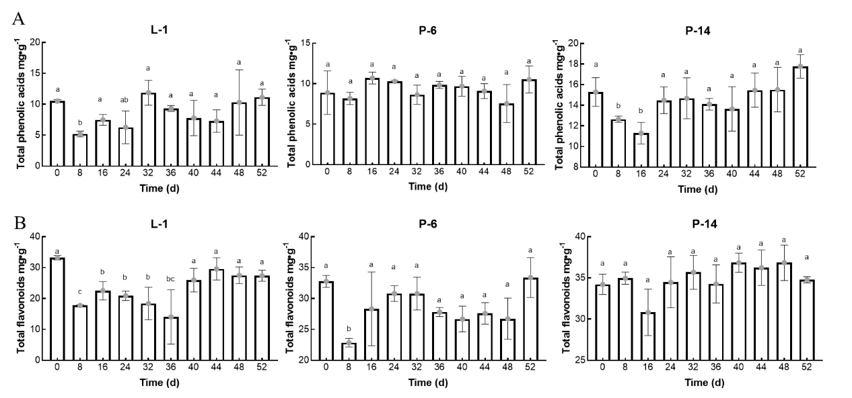
Fig. S7 The total phenolic acids (A) and total flavonoids (B) of three A. chinensis hairy roots lines at different time.
Each value represents the mean ± standard deviation (n = 3). The lower-case letters indicate significant differences among different times via ANOVA followed by Duncan's post-test (P < 0.05).

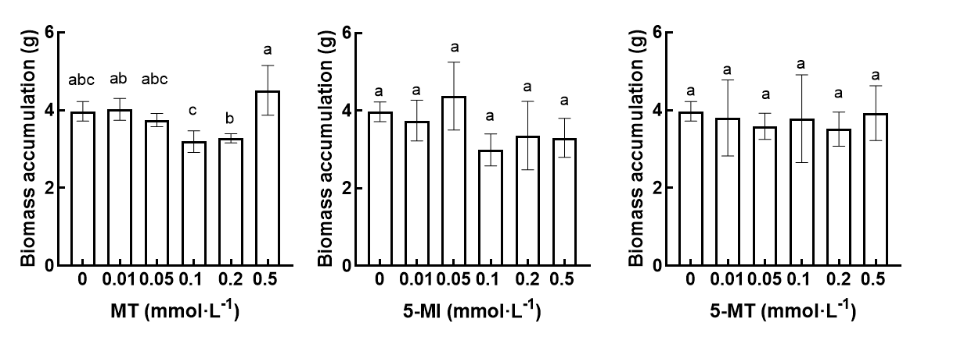
Fig. S8 Different concentrations of melatonin and its derivatives treatment on the biomass accumulation of A. chinensis hairy roots.
The lower-case letters indicate significant differences among different treatments via ANOVA followed by Duncan's post-test (P < 0.05).
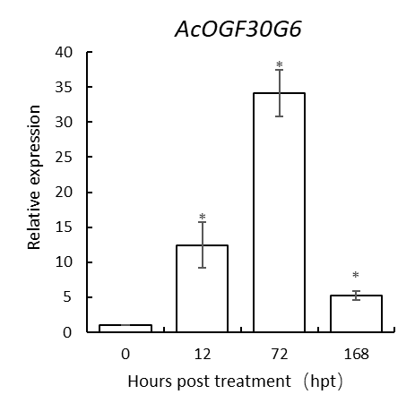
Fig. S9 The expression levels of AcOGF30G6 related to the biosynthesis of β-eudesmol of A. chinensis hairy roots.
The lower-case letters indicate significant differences among different lines via ANOVA followed by Duncan's post-test (P < 0.05).

Table S1 The primers used in this study.
Primer Name | Primer Sequence (5‘-3’)
Rolb -F | GCTCTTGCAGTGCTAGATTT
Rolb -R | GAAGGTGCAAGCTACCTCTC
Rolc -F | CTCCTGACATCAAACTCGTC
Rolc -R | TGCTTCGAGTTATGGGTACA
AcOGF3OG6-F | GAGCGGTATAAGGCGGTTGA
AcOGF3OG6-R | GTCGGCCAATTGATGCGTAC
AcZFP706-F | AAACAGAAGATCGAGGCGCA
AcZFP706-R | TGCACTTTACAGATGGGGCA
AcCTA12-F | CACTGGAAAGGAGCTGCTGA
AcCTA12-R | GAAAGCAATGCACCTGAGGC
AcPSPTA25520-F | ATGTGGCTGGGGTTGTCAAA
AcPSPTA25520-R | TTGAGTCGCCTTCTTCTCGG
AcGTF25-F | GGACGTCGCTTTAATTCCGC
AcGTF25-R | CACCTTTTGCACCTTGTCCG
β-actin-F | CGTGCTTTCCTTGTTTGC
β-actin-R | GTTGCTACTTTCTGCCAGTG

