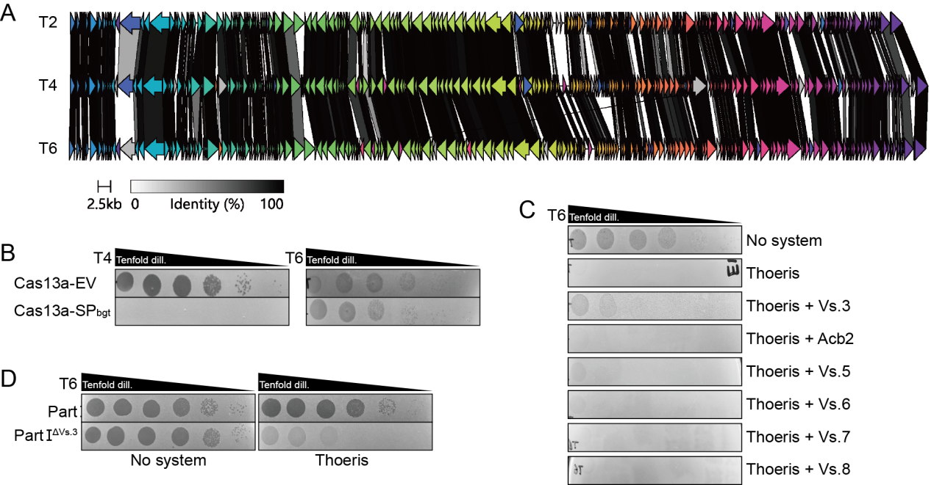
Fig. S1. Phage hybridization identified T4 TadIV-1.
(A) Genome comparison of T2, T4 and T6.
(B) Efﬁciency of plating of T2, T4 and T6 infecting E. coli containing an artifitial CRISPR-Cas13 system. SP_{bgt}, a spacer targeting the T4 beta-glucosyltransferase gene; EV, no spacer.
(C) Efﬁciency of plating of T6 infecting E. coli expressing type IV Thoeris and each gene from the Part I region.
(D) Efﬁciency of plating of T6 infecting E. coli expressing type IV Thoeris and Part I, or type IV Thoeris and Part I with a deletion of vs.3.

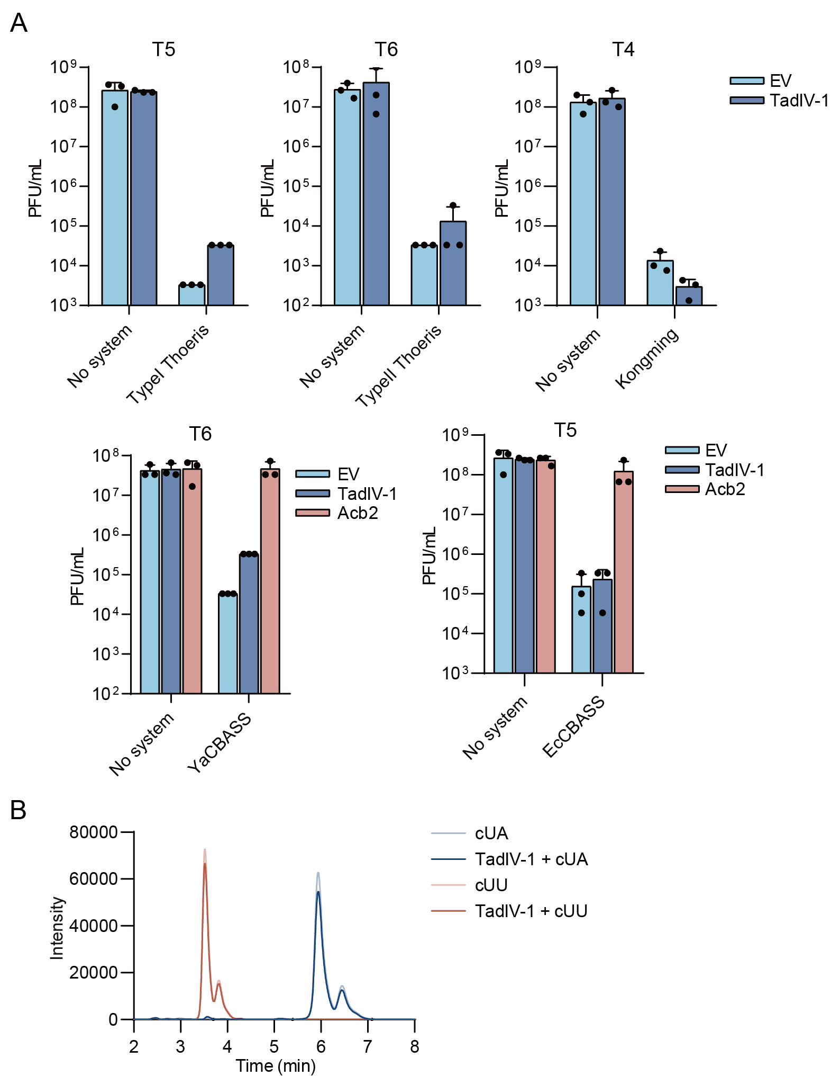
Fig. S2. Effects of TadIV-1 on other immune signaling systems.
(A) Plaque forming units of indicated phages were measured on plates expressing indicated defense systems with TadIV-1 or not. Data represent the mean ± SD of n = 3 biological replicates. The suppression of Acb2 on the CBASS systems were also analyzed as positive control.
(B) TadIV-1 does not bind to cUU or cUA in vitro. HPLC analysis of cUU and cUA post incubation with TadIV-1 or mock incubation.

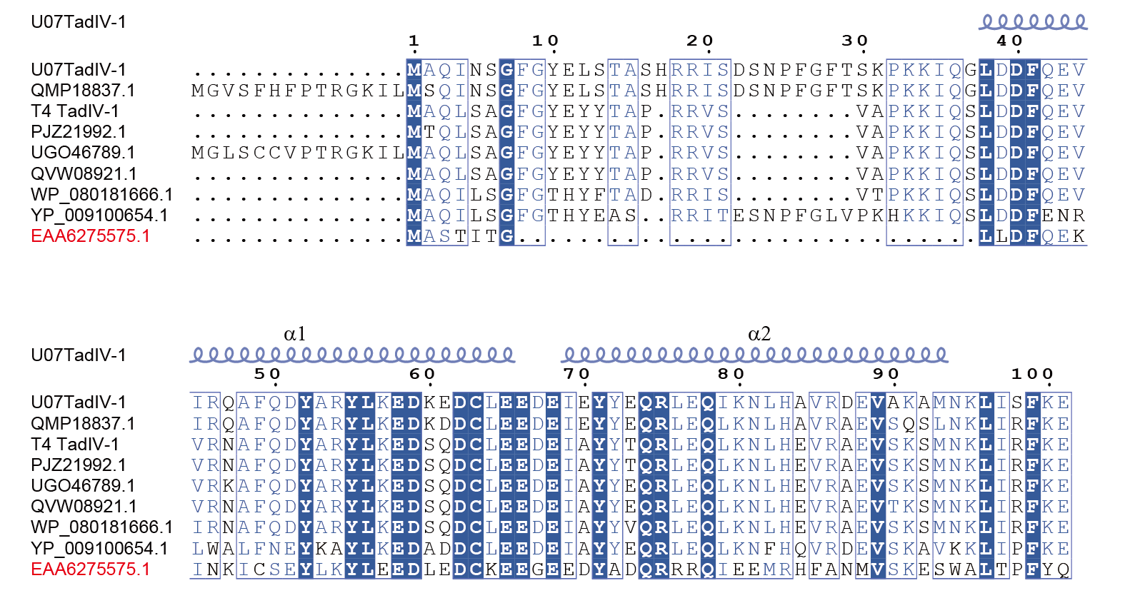
Fig. S3. Sequence alignment of T4 TadIV-1 and 8 homologs that were analyzed experimentally. The short TadIV-1 homolog is indicated in red. Secondary structure is shown above the alignment, based on the structure of U07TadIV-1.

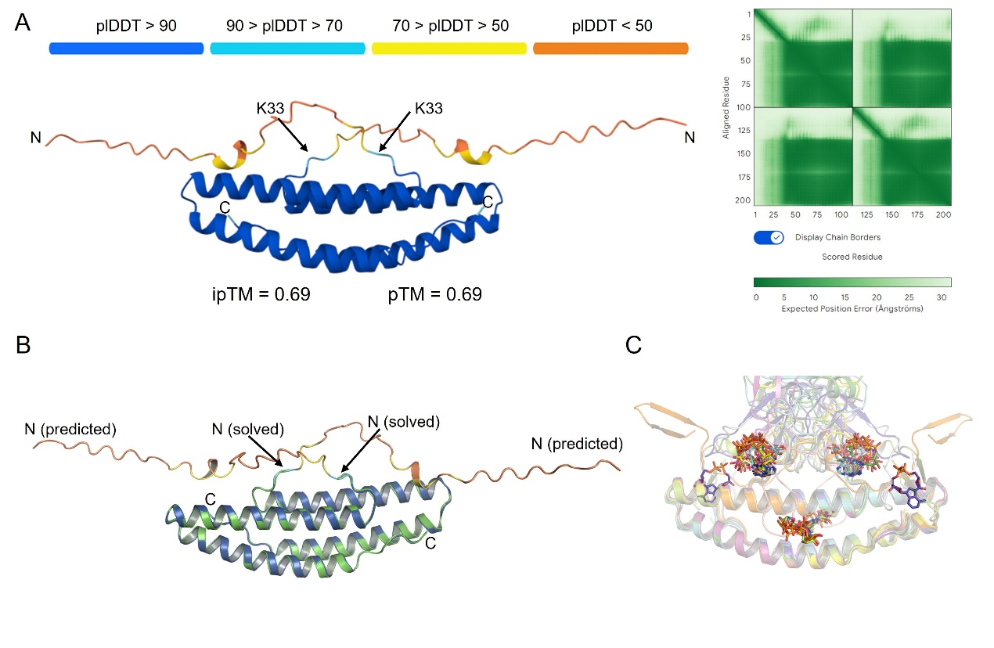
Fig. S4. Predicted structures of apo and ligand-bound TadIV-1.
(A) AlphaFold3-predicted structure of apo TadIV-1.
(B) Comparison of solved structure of apo TadIV-1 and that predicted by AlphaFold3. The solved structure of apo TadIV-1 is colored green. The predicted structure is colored as in A.
(C) Superimposition of the top 10 predicted structures of TadIV-1 bound with N7-cADPR. The ten TadIV-1- N7-cADPR structures are colored separately, in which N7-cADPR is shown as sticks in each structure.

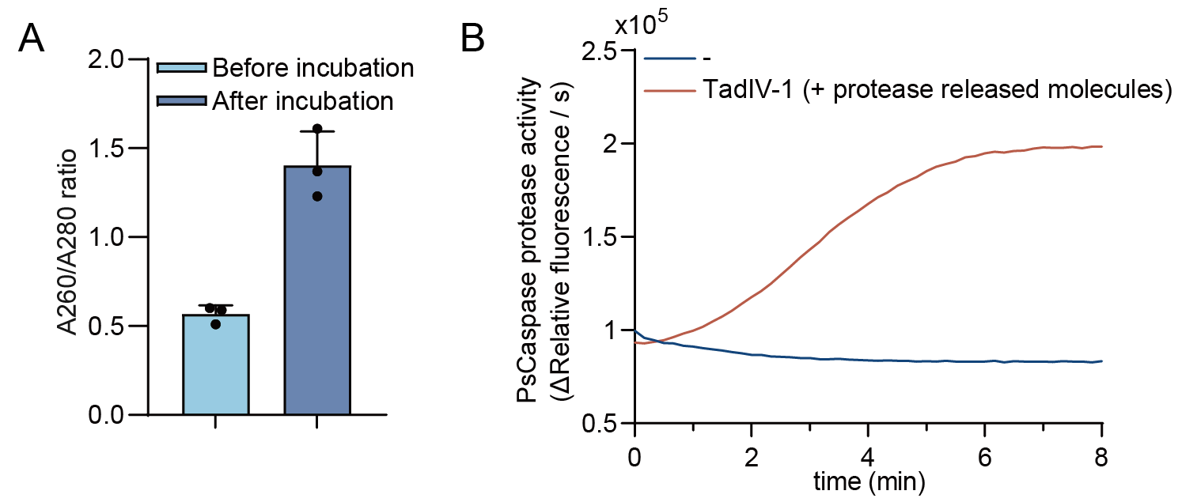
Fig. S5. U07TadIV-1 was bound by N7-cADPR post incubation with lysate of TIR-expressing cells and gel filtration purification.
(A) The ratio of absorbance at 260 nm and 280 nm of the purified U07TadIV-1 samples after or before incubation the lysate of T6-infected TIR-expressing cells. Mean ± SD is shown.
(B) Protease reporter assay showing the activity of PsCaspase in response to the molecules released by proteolysis of U07TadIV-1.

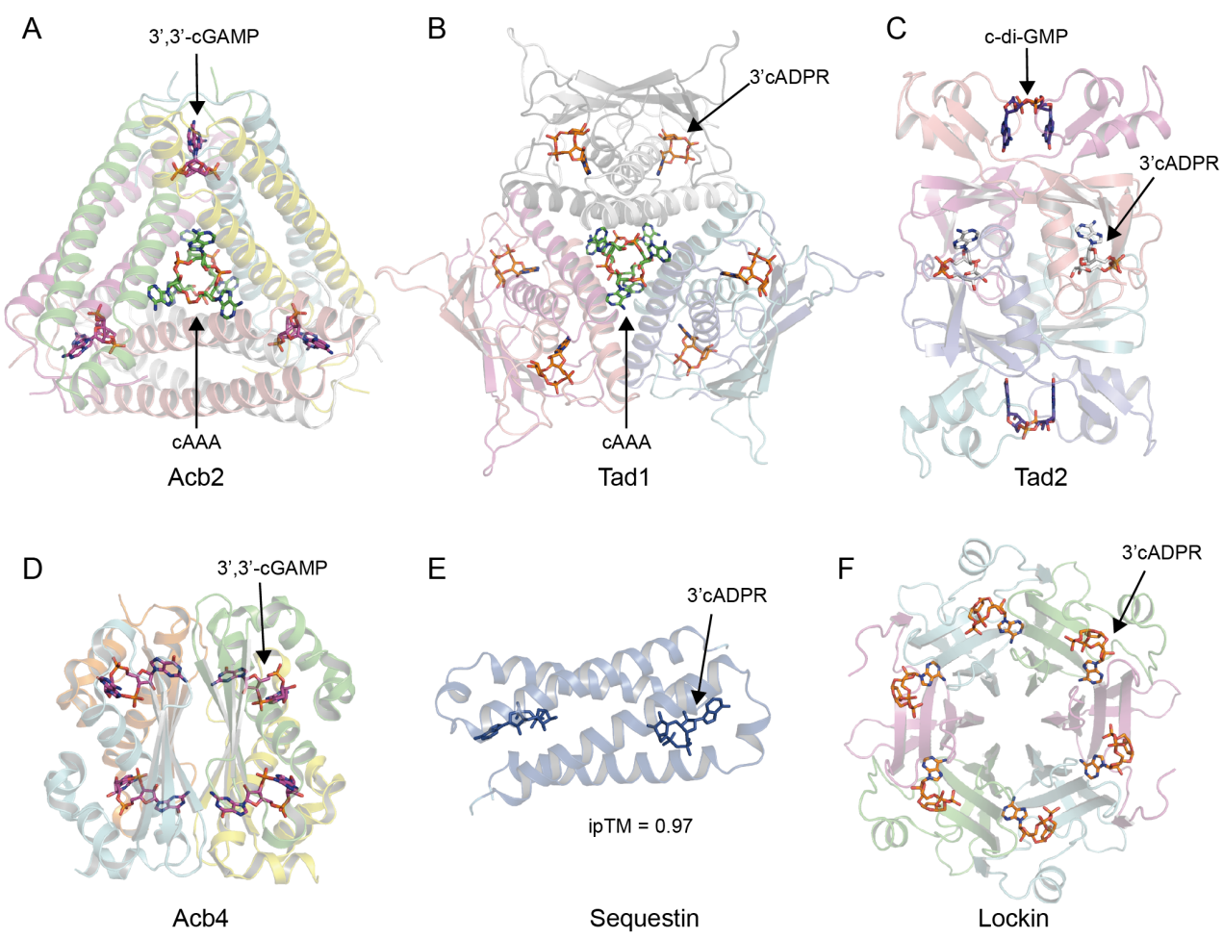
Fig. S6. Structures of known phage sponge families
(A-F) Structures of the six known phage sponge families with bound nucleotide shown as sticks. For (E), predicted model by Protenix is shown.

Supplementary Table S1 Crystallographic statistics of U07TadIV-1
Statistics | U07TadIV-1
Data collection
Space group | P 43 21 2
Cell dimensions
a, b, c (Å) | 64.471 64.471 54.539
(°) | 90 90 90
Resolution (Å) | 41.64 - 2.56 (2.94 - 2.56)^{a,b}
R_{sym} or R_{merge} (%) | 16.5 (96.2)
I/σ(I) | 29.1 (4.0)
Completeness (%) | 100 (100)
Redundancy | 44.1 (30.1)
Refinement
Resolution (Å) | 41.64 - 2.56 (2.94 - 2.56)
Unique reflection | 3979 (1288)
R_{work} / R_{free}^{c} | 0.230 /0.269
No. atoms | 607
Protein | 591
Ligand/ion | 5
Water | 11
B factors | 56.13
Protein | 55.79
Ligand/ion | 86.73
Water | 60.63
R.m.s. deviations
Bond lengths (Å) | 0.002
Bond angles (°) | 0.30
Ramachandran plot (%)
Favored | 100
Allowed | 0
Outliers | 0
ª For each structure one crystal was used.
^{b} Values in parentheses are for highest-resolution shell.
^{c} Rfree was calculated with 5% of the reflections selected

Supplementary Table S2 Proteins analyzed in the study.
Supplementary Table S3 Plasmids used in the study.
Supplementary Table S4 Primers used in the study

