Supplemental Information
A three-step relay mechanism enables the highly selective reduction of NO₃⁻ to N₂ under acidic conditions
Mingsen Xie,^{1⊥} Tianyu Zhang,^{1,2⊥} Jingkun Yu,^{1⊥} Xiaonan Yang,¹ Qi Liu,¹ Haiquan Xie,^{2*} Siyu Lu^{1*}
¹Pingyuan Laboratory, College of Chemistry, Zhengzhou University, Zhengzhou 450000, China
²College of Chemistry and Pharmaceutical Engineering, Nanyang Normal University, Nanyang 473000, China

Characterization
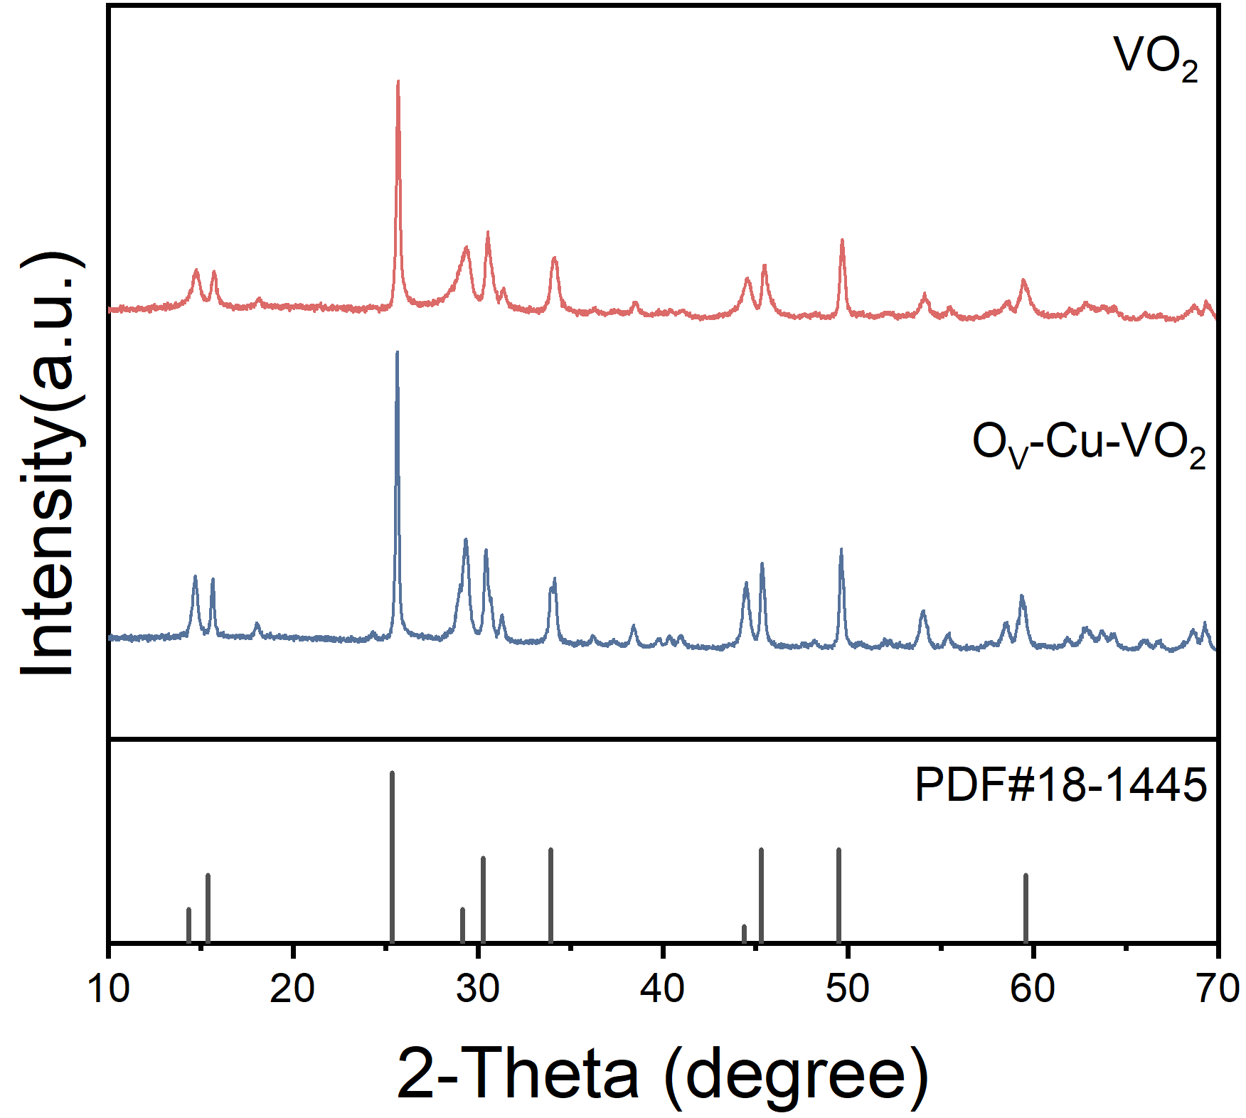
Figure S1. XRD of VO₂ and O_{V}-Cu-VO₂. After doping with Cu, no obvious Cu peak was observed, indicating that Cu might exist in a monatomic form.
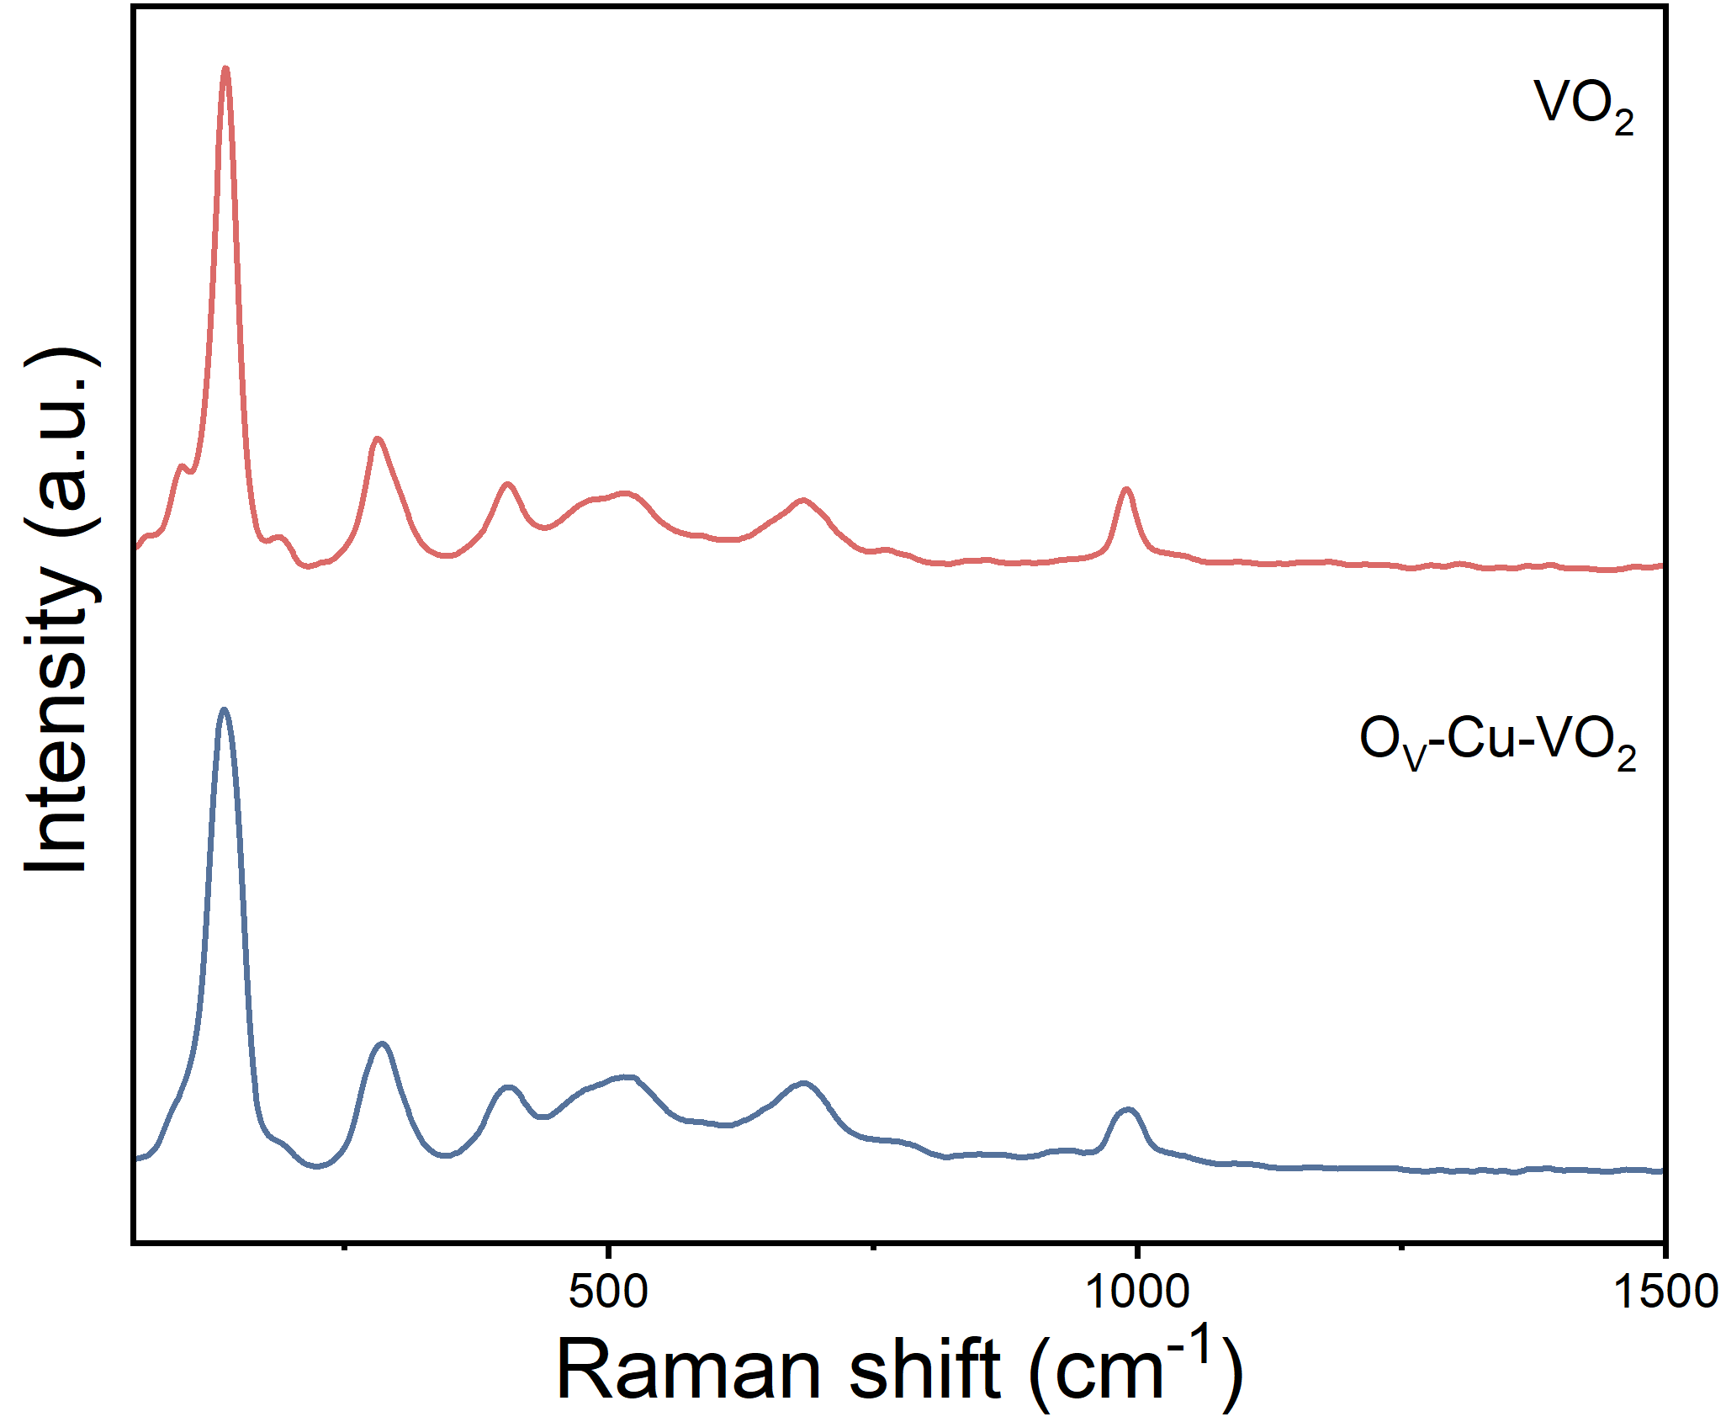
Figure S2. Raman comparison of VO₂ and O_{V}-Cu-VO₂. The crystal structure is intact, indicating that the introduction of Cu has not disrupted the crystal integrity of O_{V}-Cu-VO₂.
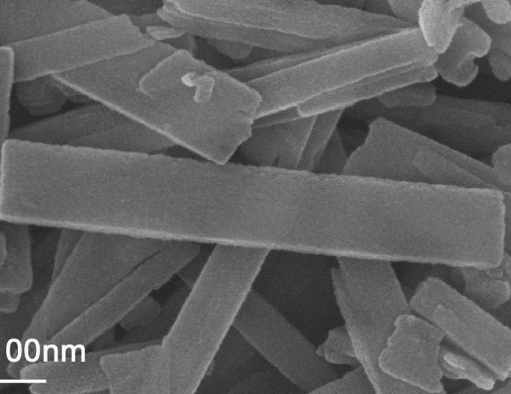
Figure S3. SEM image of O_{V}-Cu-VO₂.
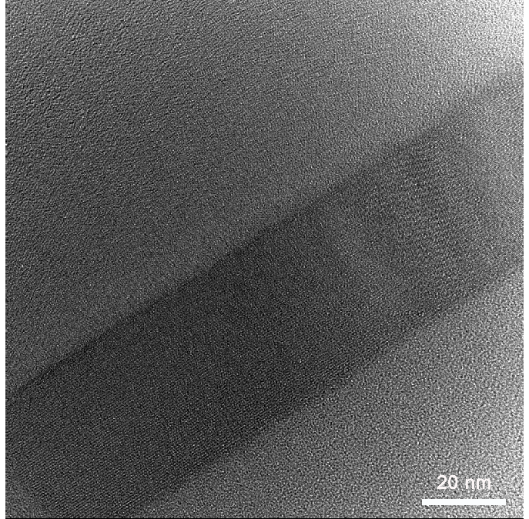
Figure S4. TEM image of O_{V}-Cu-VO₂.
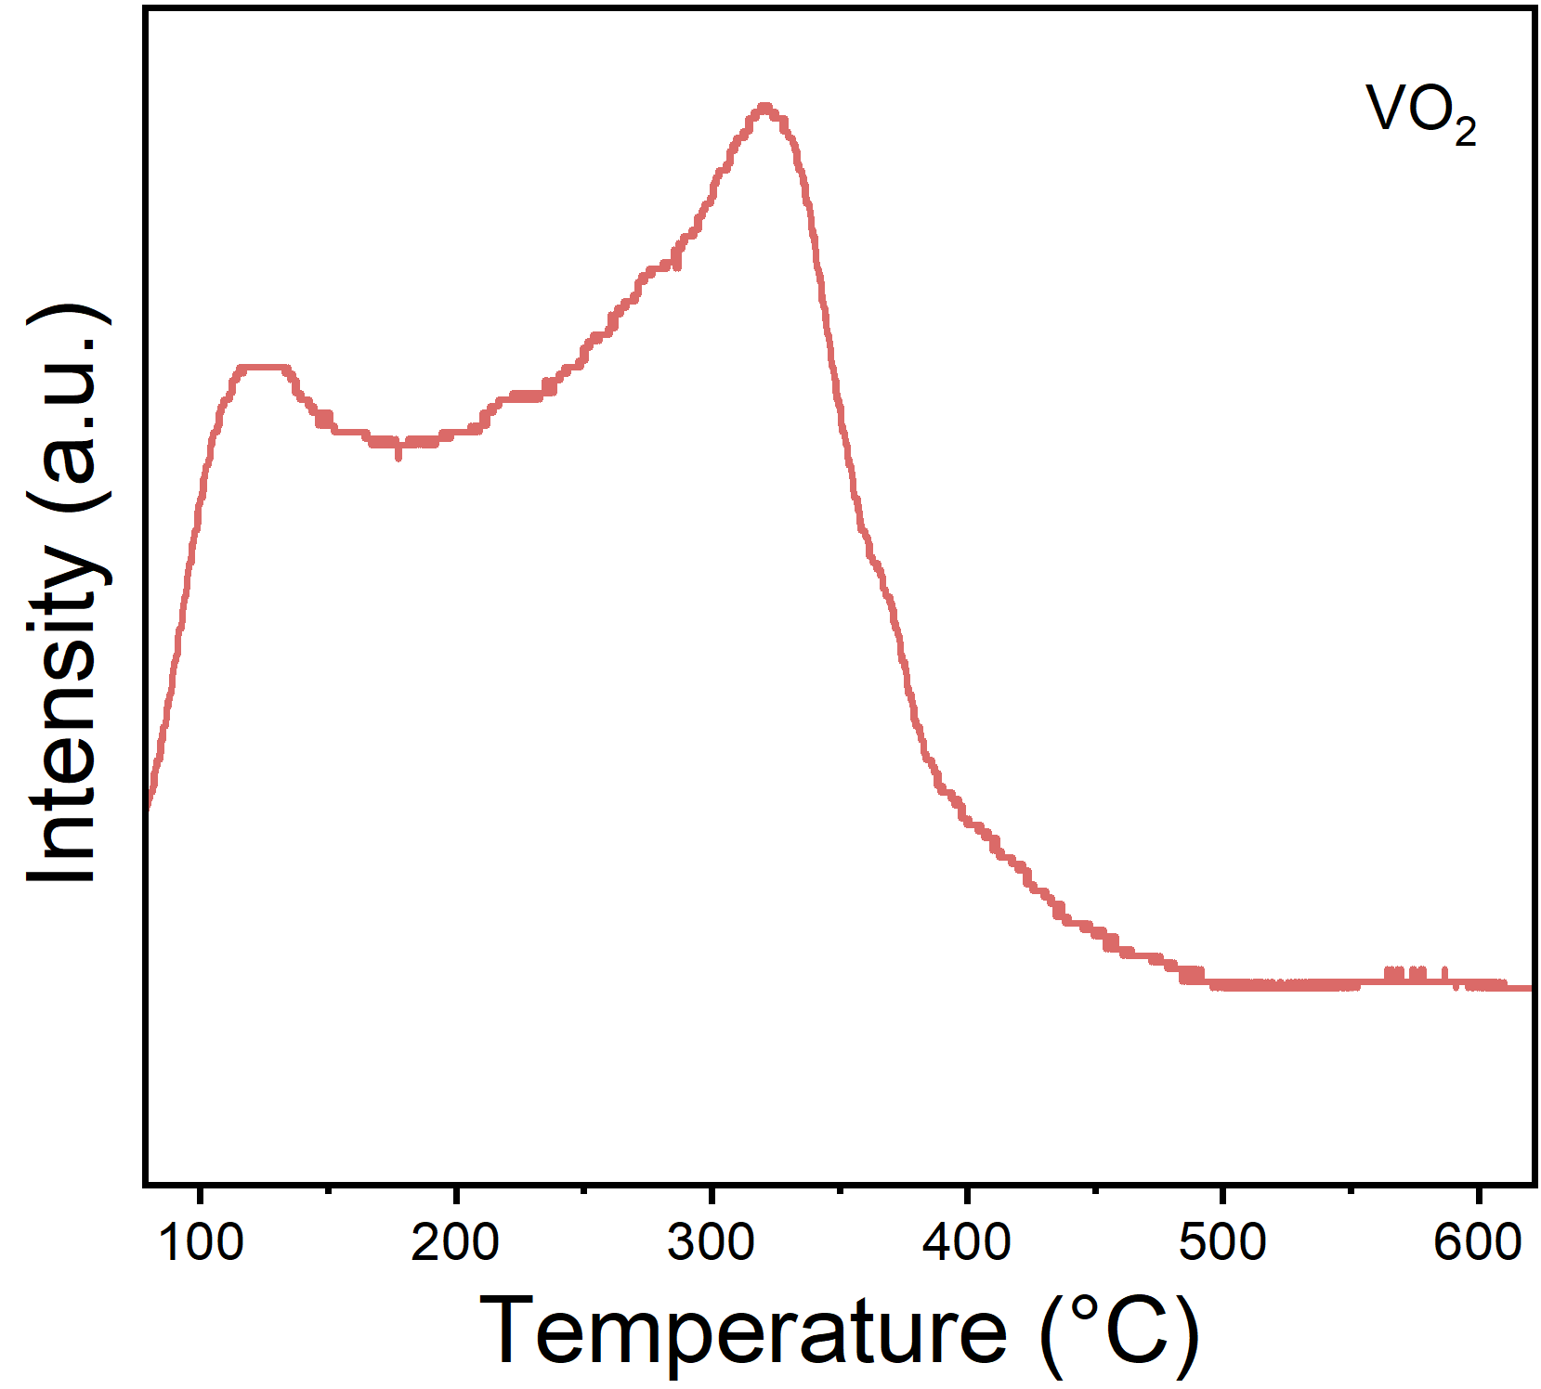
Figure S5. NH₃-TPD curves for VO₂.The content and intensity of representative Lewis acid sites of NH₃-TPD at 250-400 °C indicate that VO₂ has strong Lewis acidity. This means that there are more NO₃⁻ adsorption sites on the material surface, which is more conducive to the activation of NO₃⁻.
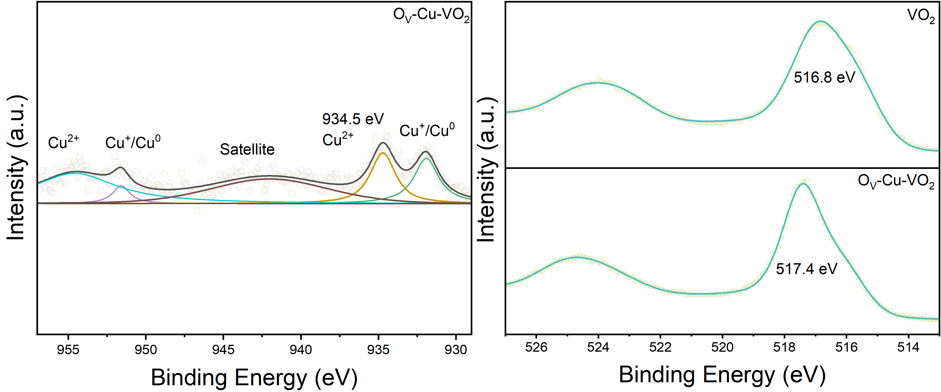
Figure S6. (a) Cu XPS of O_{V}-Cu-VO₂. (b) V XPS of O_{V}-Cu-VO₂.There is an electronic perturbation between Cu and V.
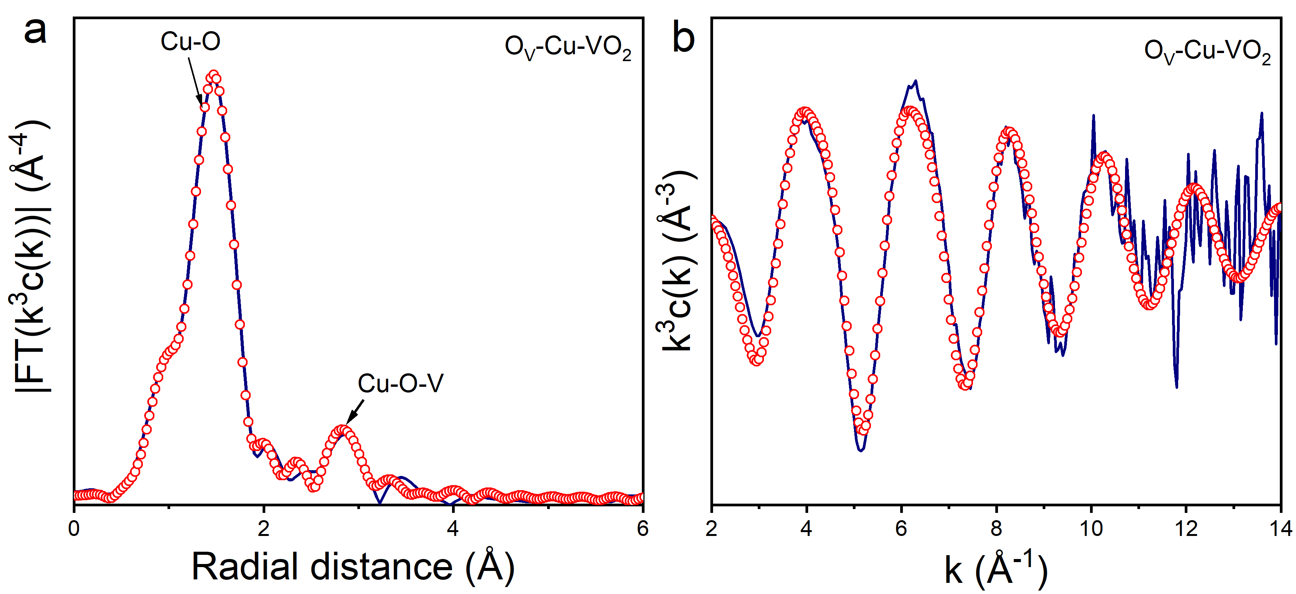
Figure S7. XAFS fitting data of R-fit and K-fit for different samples O_{V}-Cu-VO₂.
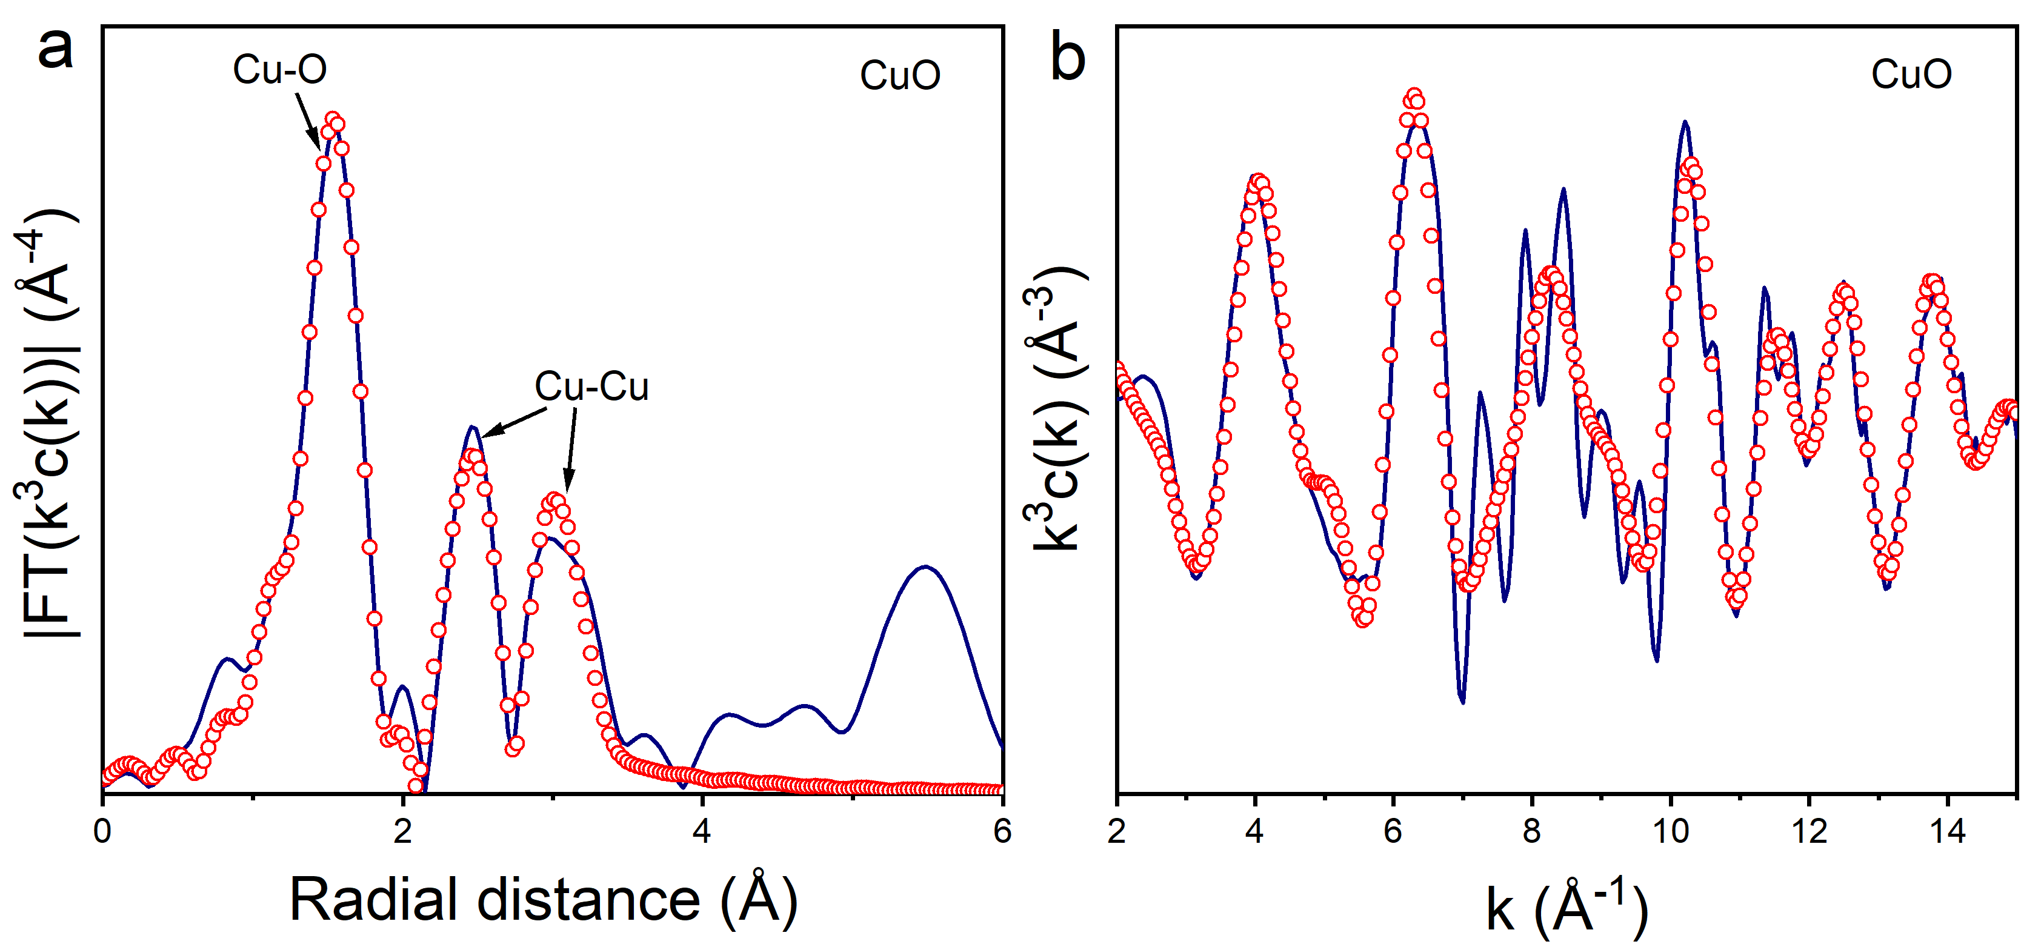
Figure S8. XAFS fitting data of R-fit and K-fit for different samples CuO.
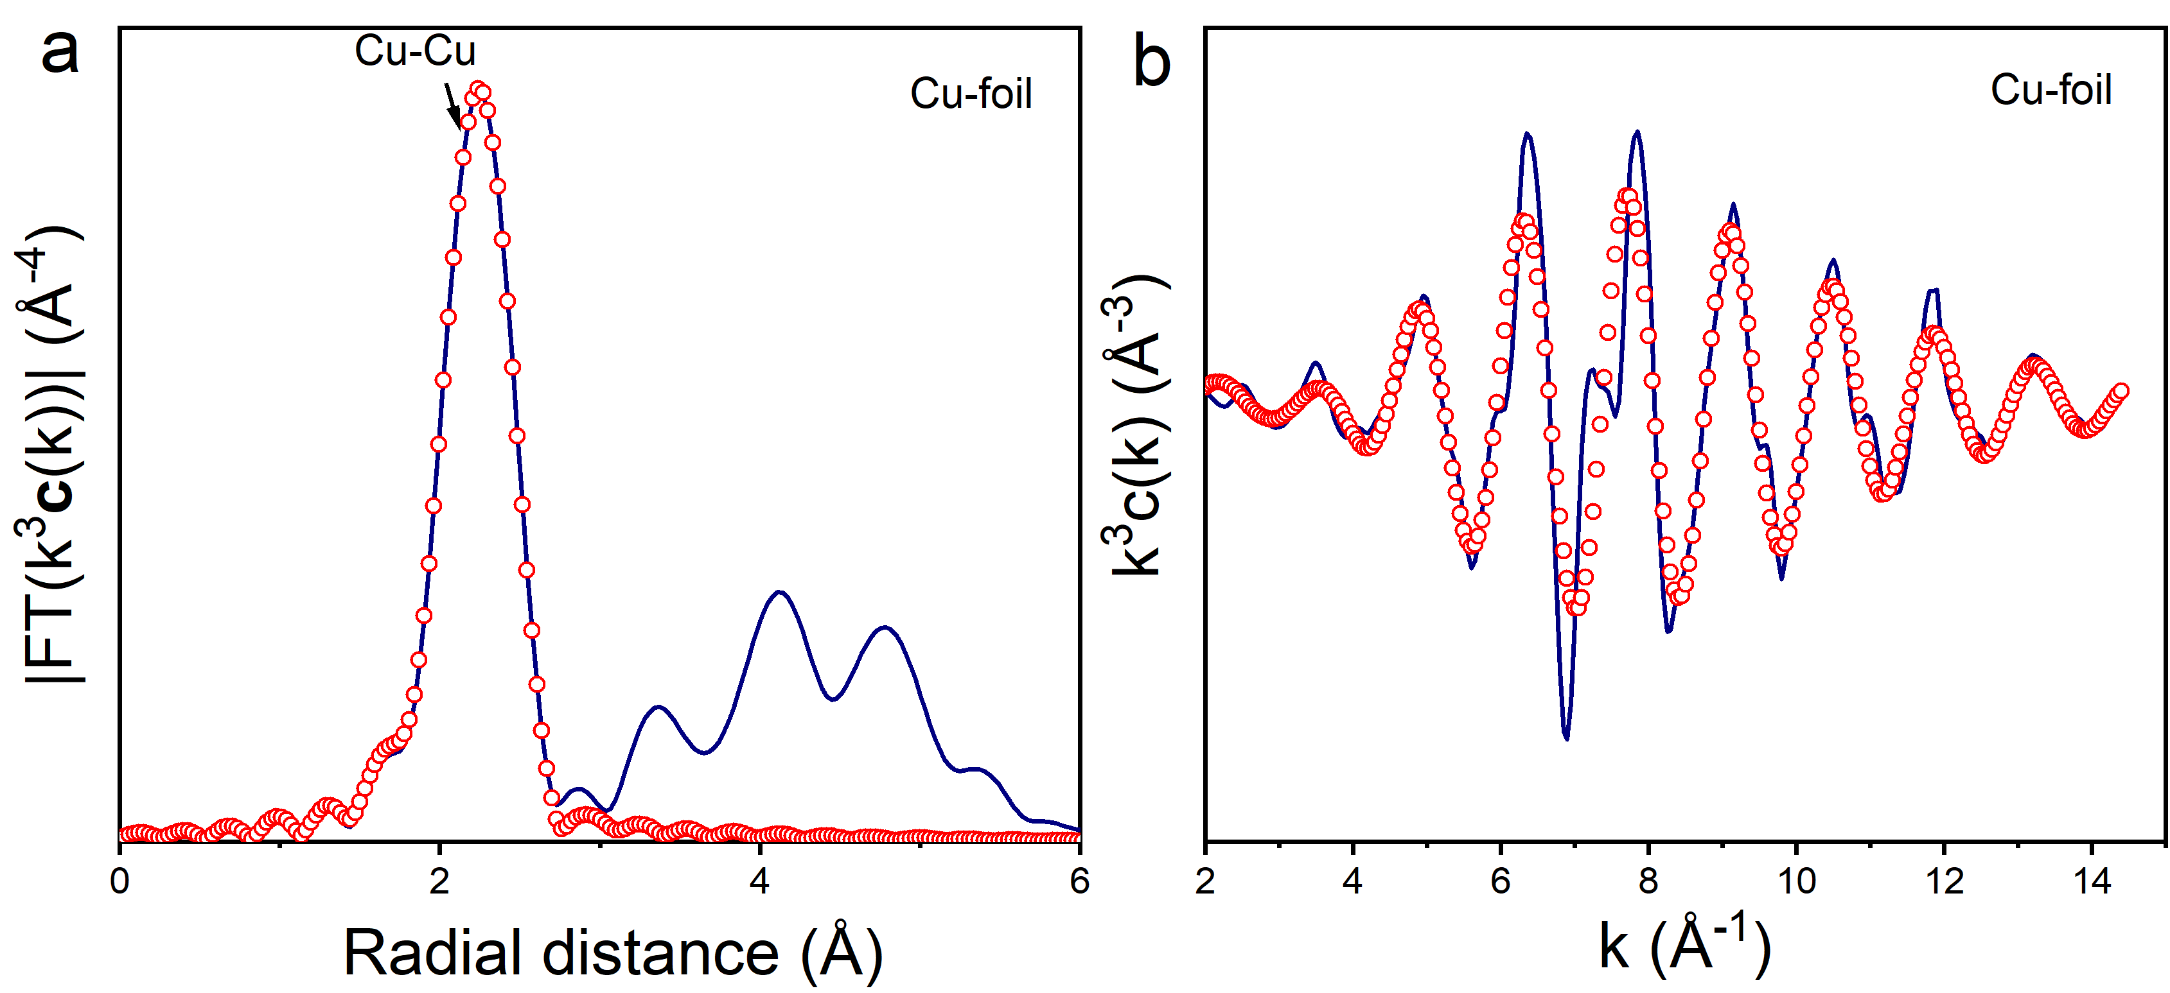
Figure S9. XAFS fitting data of R-fit and K-fit for different samples Cu-foil.
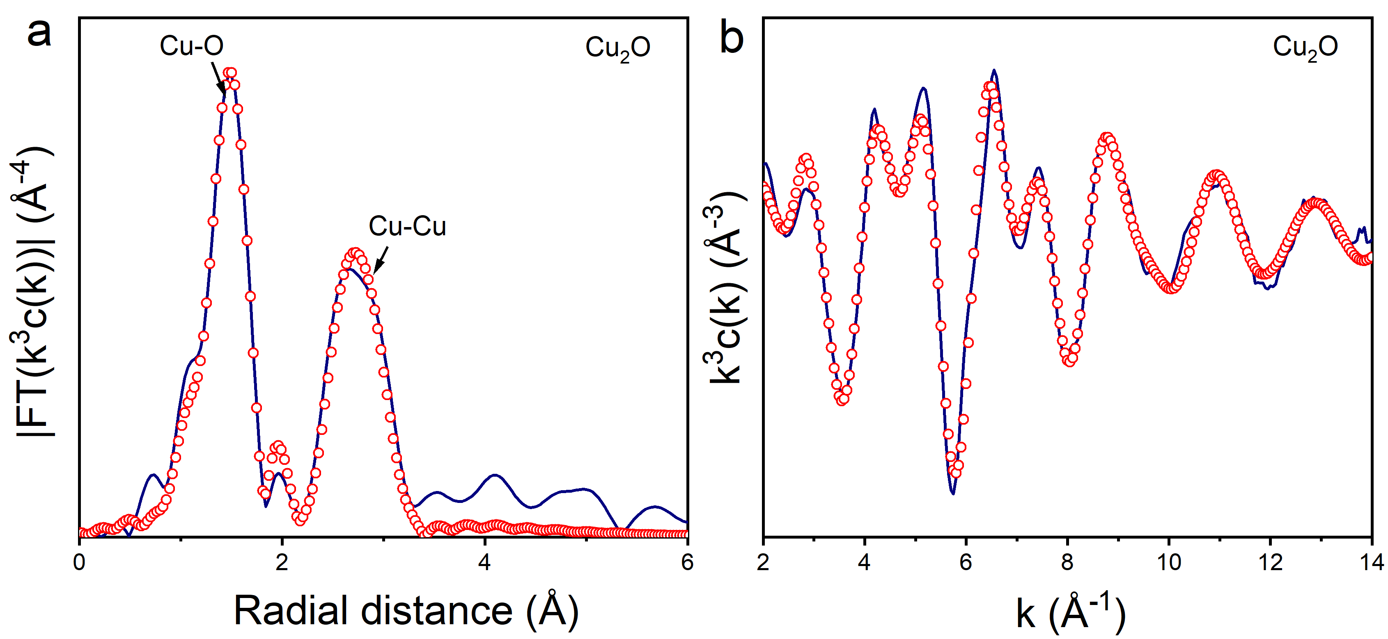
Figure S10. XAFS fitting data of R-fit and K-fit for different samples Cu₂O.
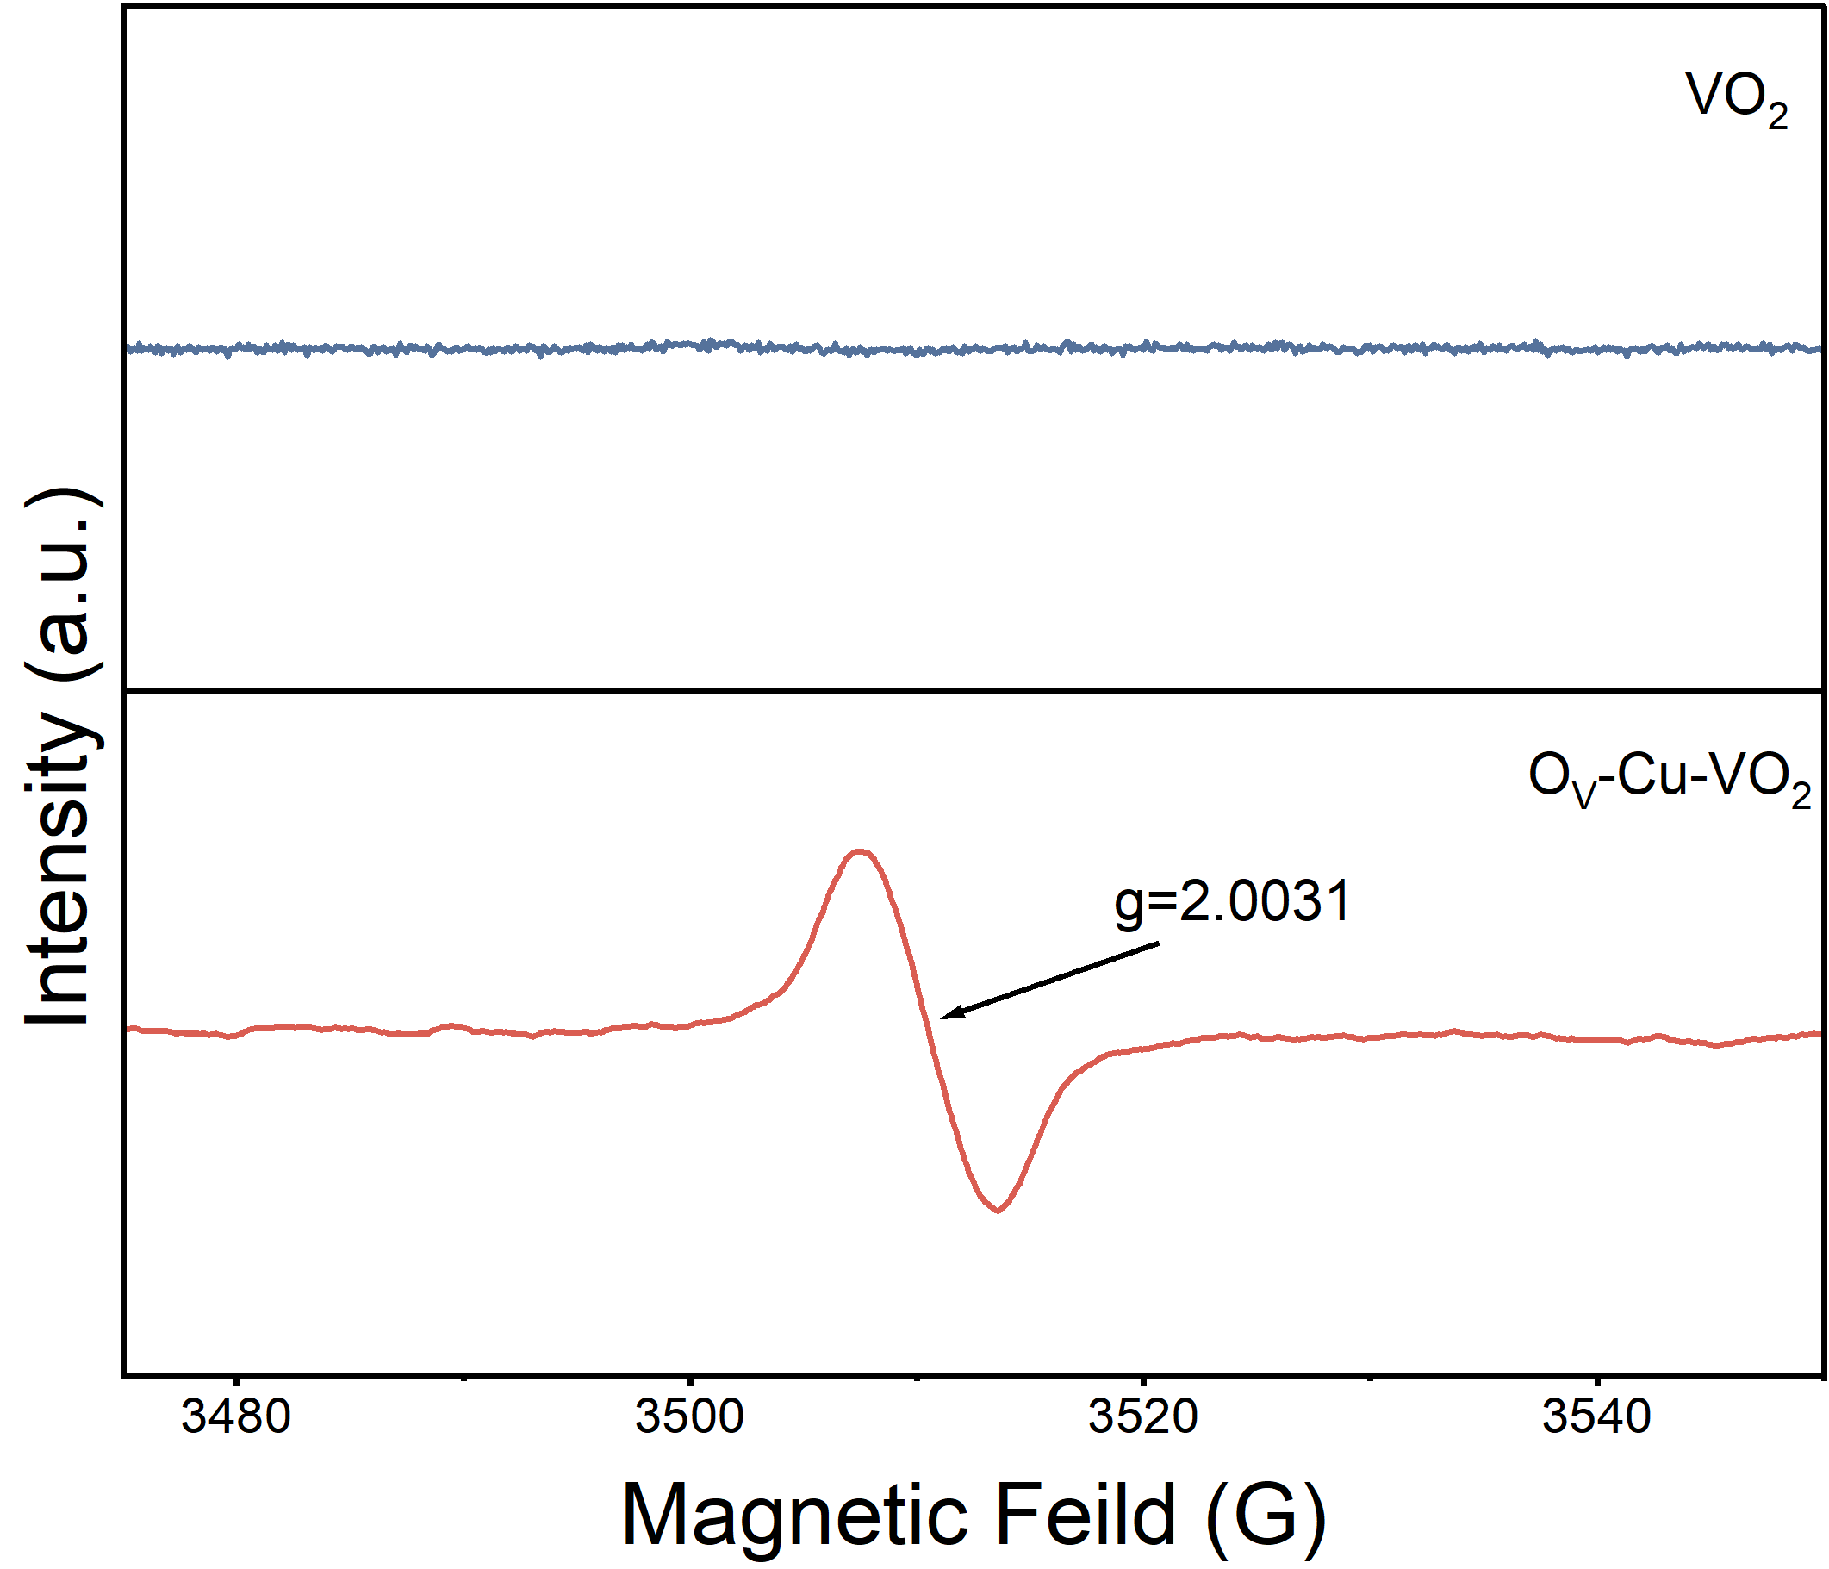
Figure S11. EPR of O_{V}-Cu-VO₂ and VO₂. After doping with Cu, the O_{V}-Cu-VO₂ sample exhibited a distinct asymmetric signal at g = 2.0031, which proved the presence of oxygen vacancies.
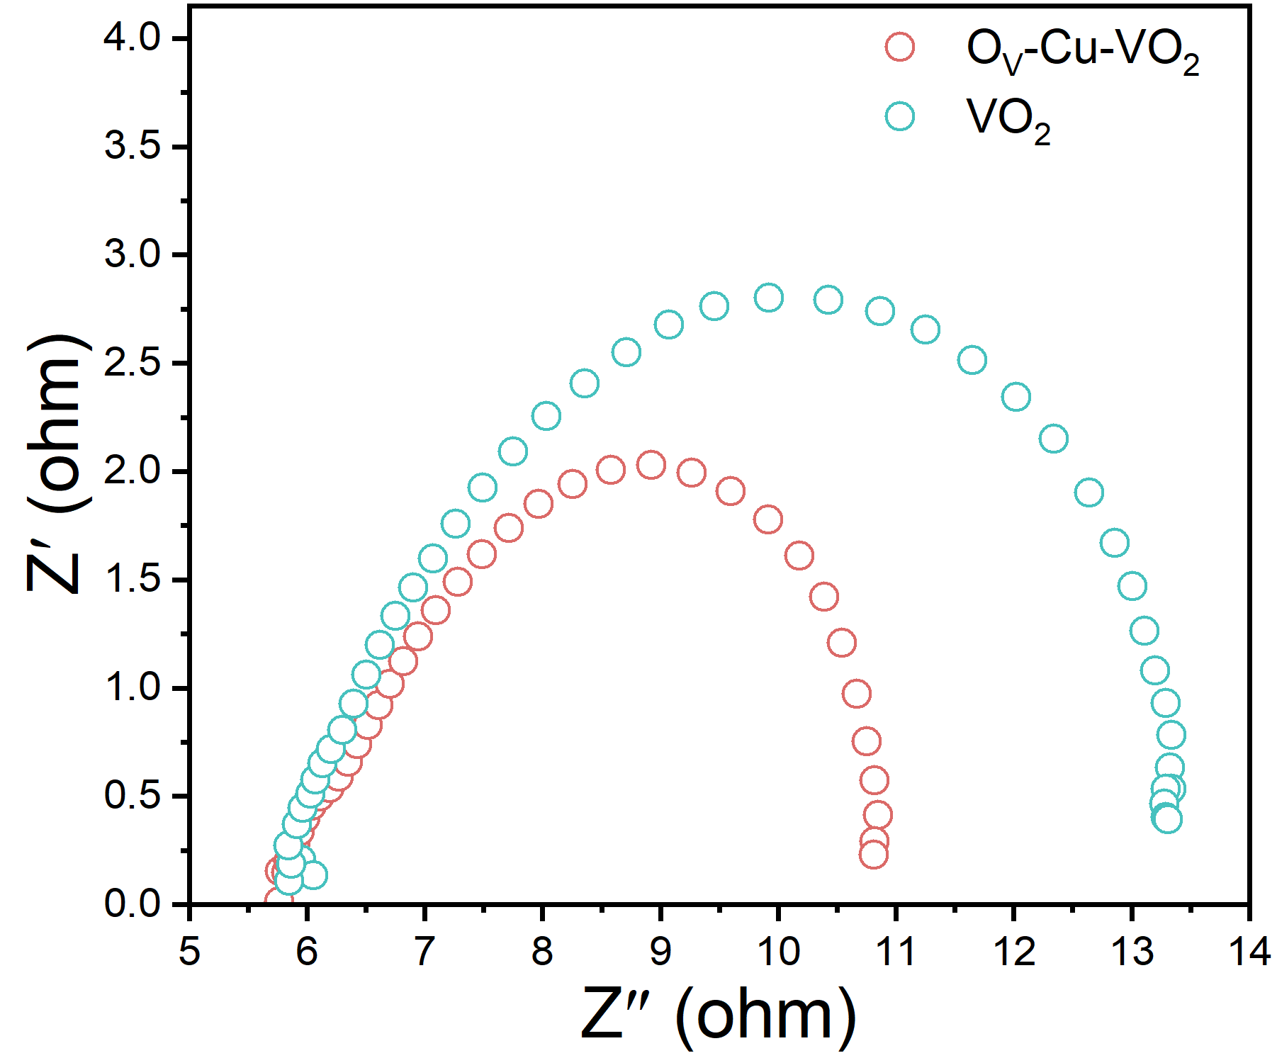
Figure S12. Impedance diagram of O_{V}-Cu-VO₂ and VO₂. The Nyquist plot shows that the semi-circular radius of O_{V}-Cu-VO₂ is significantly smaller than that of VO₂, indicating that it has the lowest charge transfer resistance (Rct), which significantly promotes the charge transfer process of NO₃⁻ on the cathode surface.
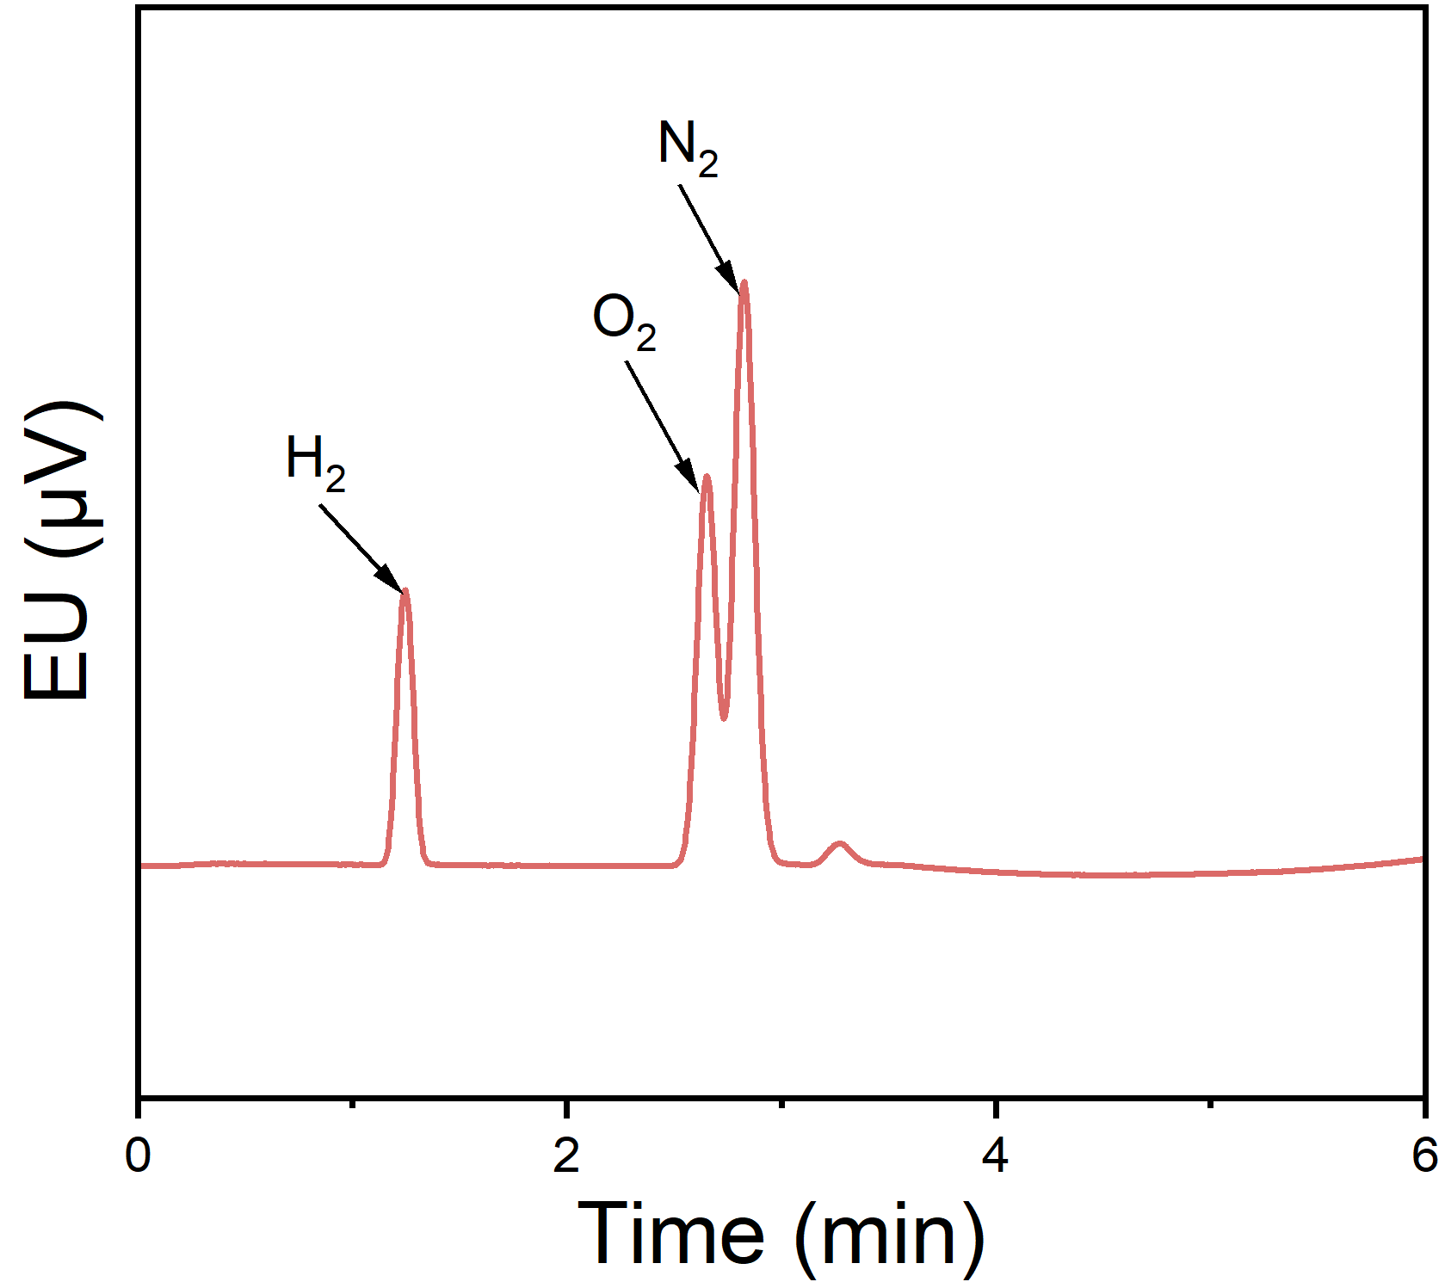
Figure S13. Gas chromatogram of reaction product. There were obvious characteristic peaks of N₂ and H₂ in the products, confirming that N₂ was the main reduction product of NO₃RR.
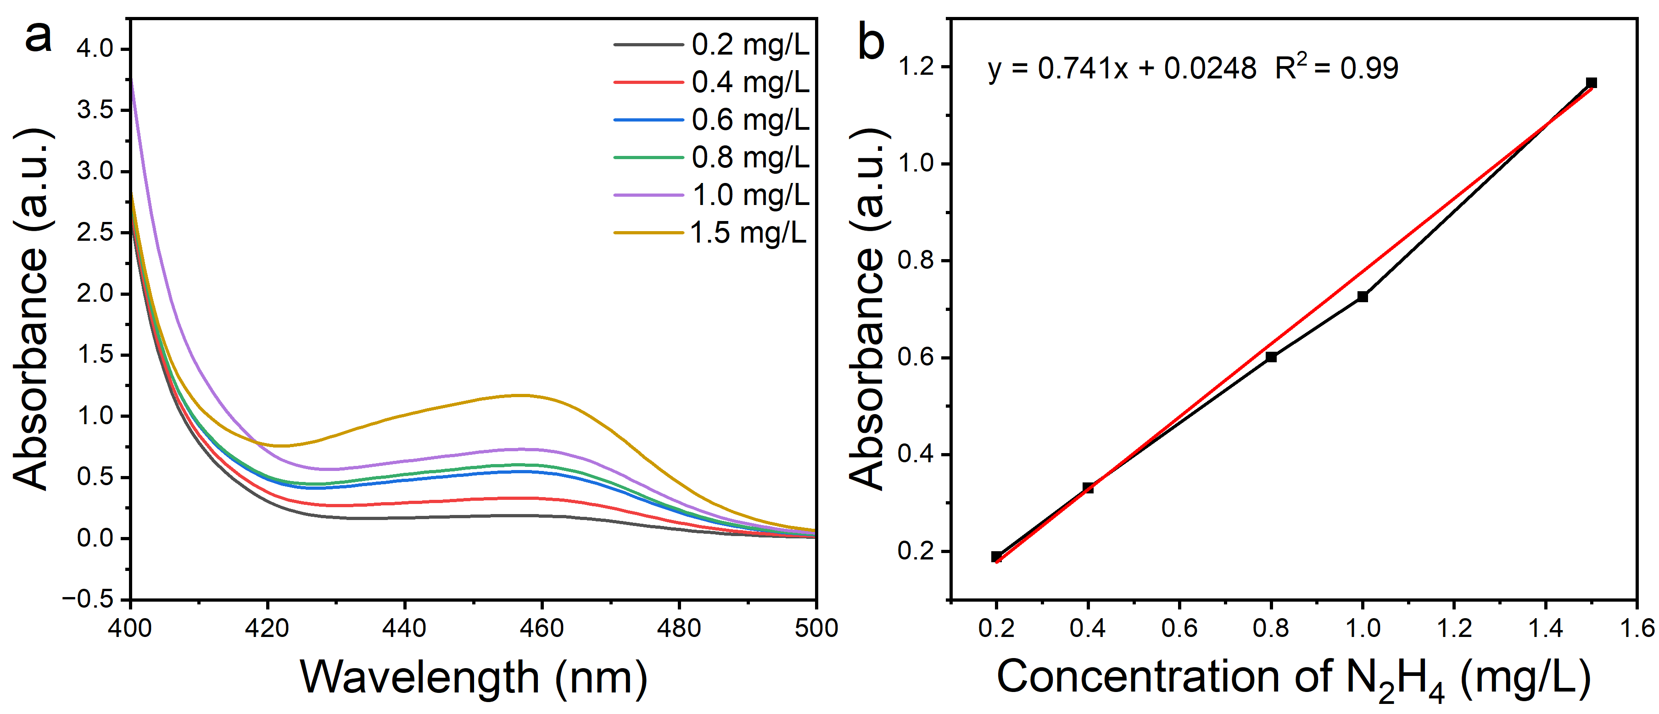
Figure S14. UV−vis absorption spectroscopy of different concentrations of N₂H₄-N (a) and the corresponding standard curves (b) A standard solution of N₂H₄ in water with a certain concentration was used as the reference substance for N₂H₄-N to draw the standard curve. Deionized water was used as the background solution. The calibration curve shows good linearity.
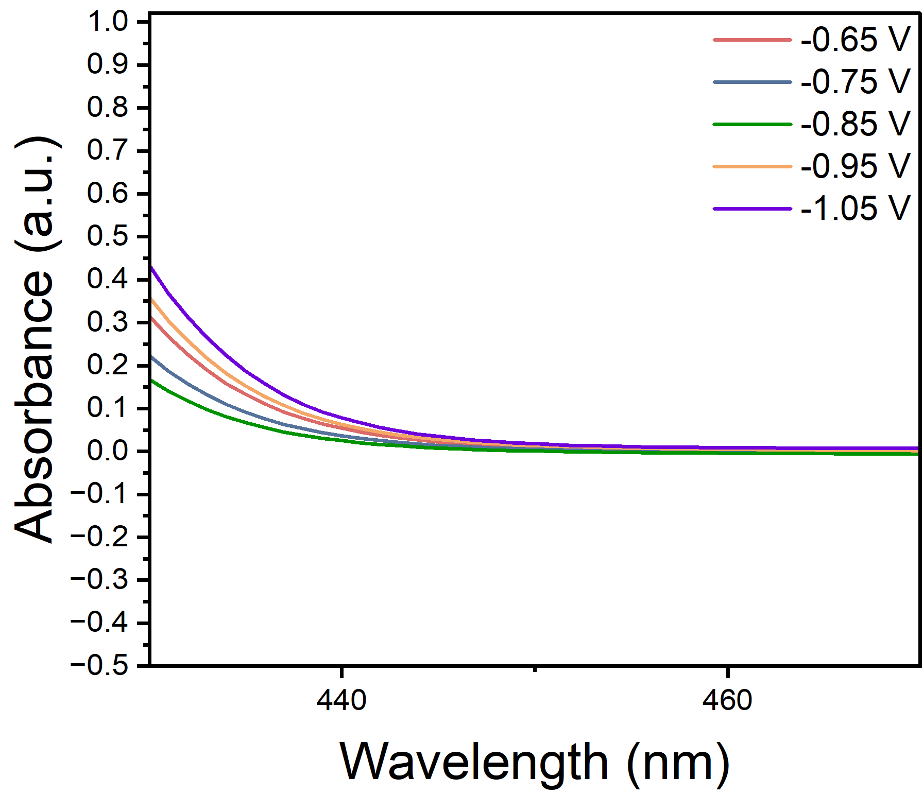
Figure S15. UV−vis absorption spectroscopy of N₂H₄ at various potentials.
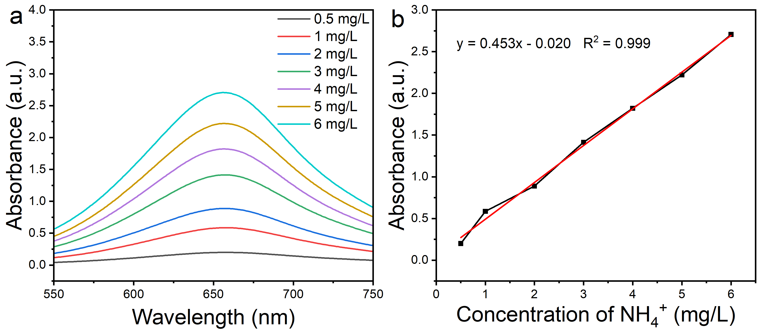
Figure S16. UV−vis absorption spectroscopy of indophenol blue spectrophotometry with different concentrations of ammonia-N (a) and the corresponding standard curve (b) A 10 mg/L standard solution of ammonia was used as ammonia-N sources for standard curve preparation. Deionized water was used as the background solution. The calibration curve shows good linearity.
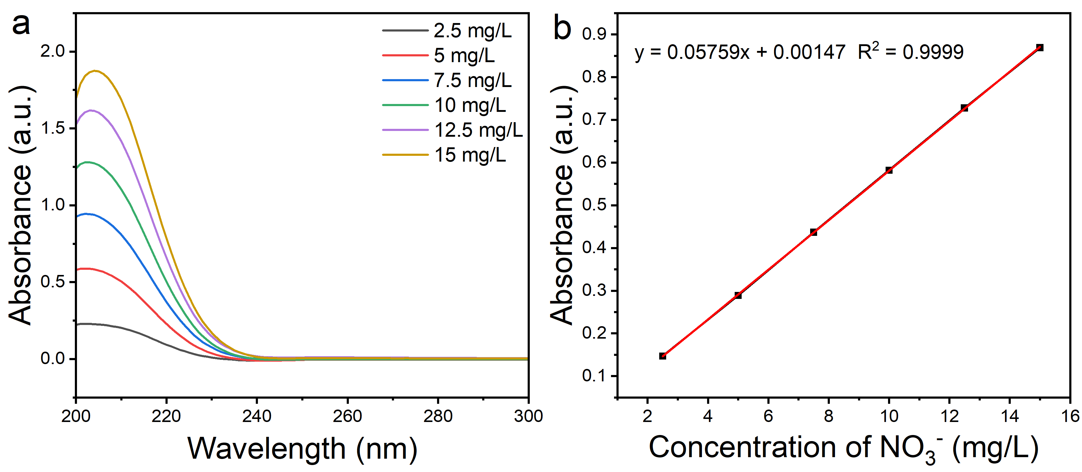
Figure S17. The UV−vis absorption spectroscopy (a) and the corresponding standard curves (b) of the diazotization spectrophotometric method for different concentrations of nitrate-N. Potassium nitrate was used as the source of nitrate-N standard substances to prepare the standard curves. Deionized water was used as the background solution. The calibration curve shows good linearity.
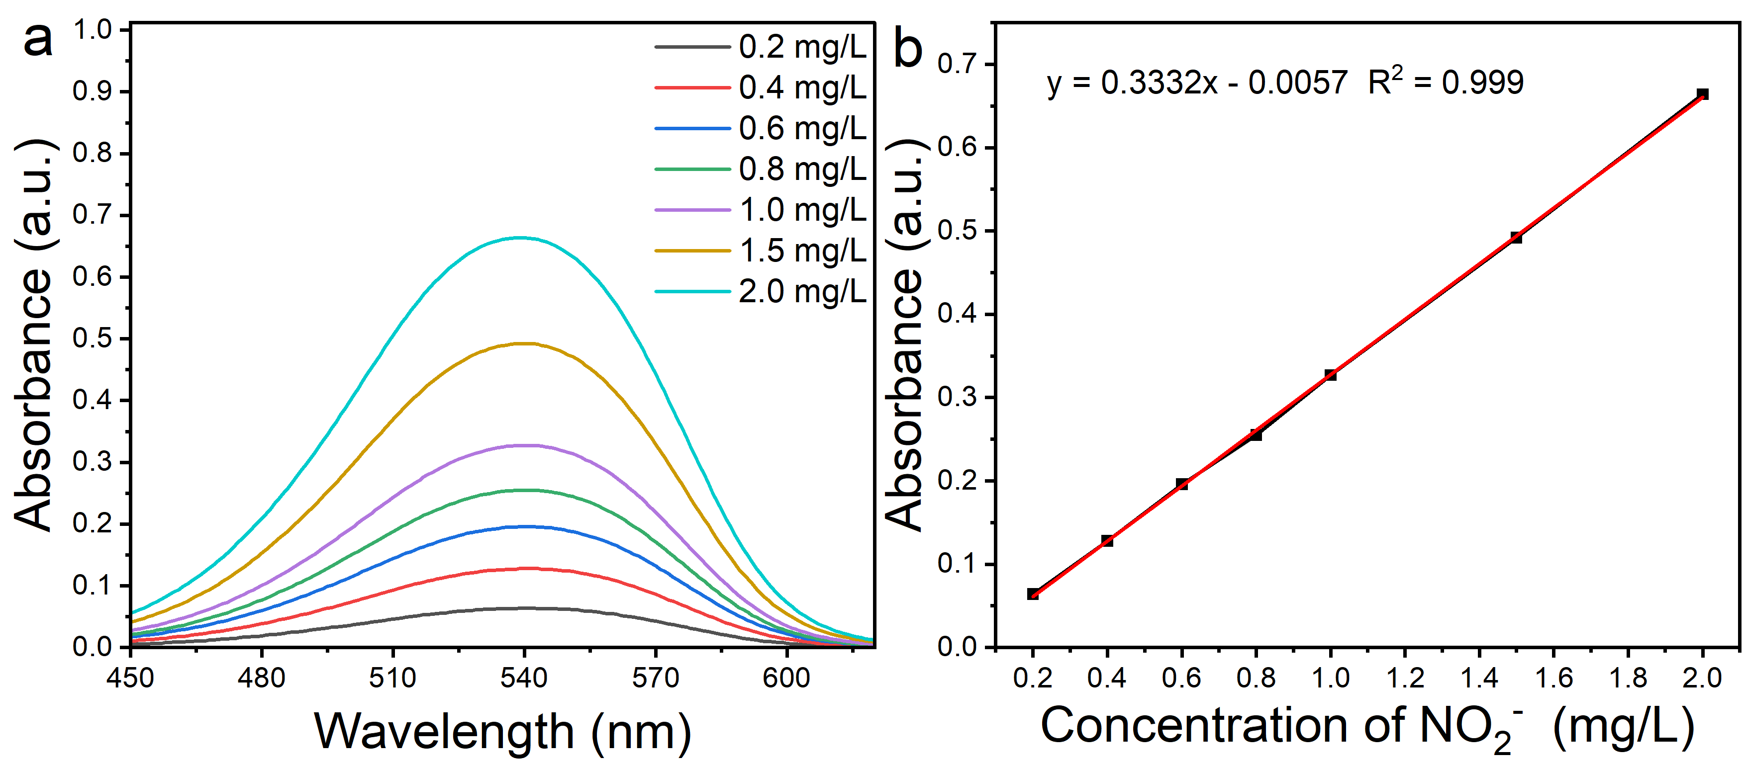
Figure S18. UV−vis absorption spectroscopy of diazotization spectrophotometry with different concentrations of nitrite-N (a) and the corresponding standard curve (b) Potassium nitrite was used as nitrite-N sources for standard curve preparation. Deionized water was used as the background solution. The calibration curve shows good linearity.
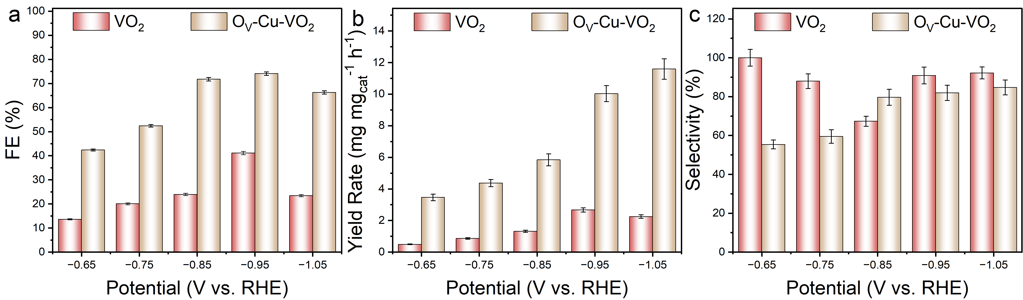
Figure S19. (a) FE (b) yield and (c) selectivity of the product N₂ in the 1 h electrolysis experiment of O_{V}-Cu-VO₂ and VO₂ in Ar/O₂ atmosphere. The electrolyte is 0.05 M H₂SO₄+0.1 M KNO₃. Overall, O_{V}-Cu-VO₂ has the best performance in reducing nitrate to N₂.
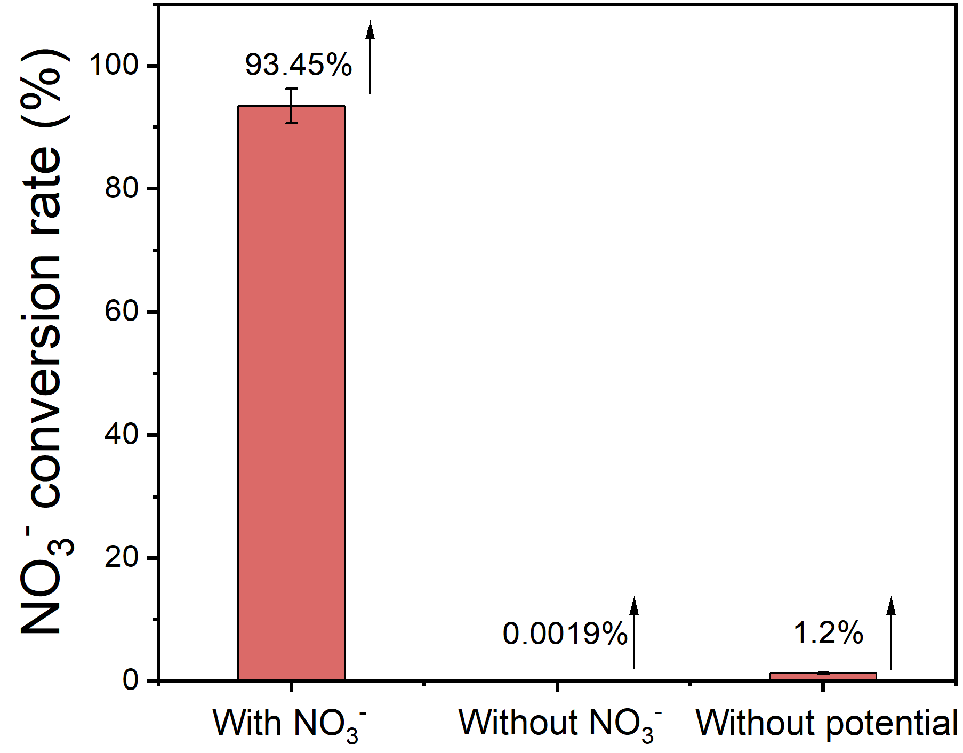
Figure S20. Performance tests of the O_{V}-Cu-VO₂ catalyst under open-circuit potential were conducted in electrolytes without KNO₃ and in electrolytes containing 100 mg/L NO₃⁻.The experimental results showed that the NO₃⁻ conversion rates measured under both conditions were negligible.
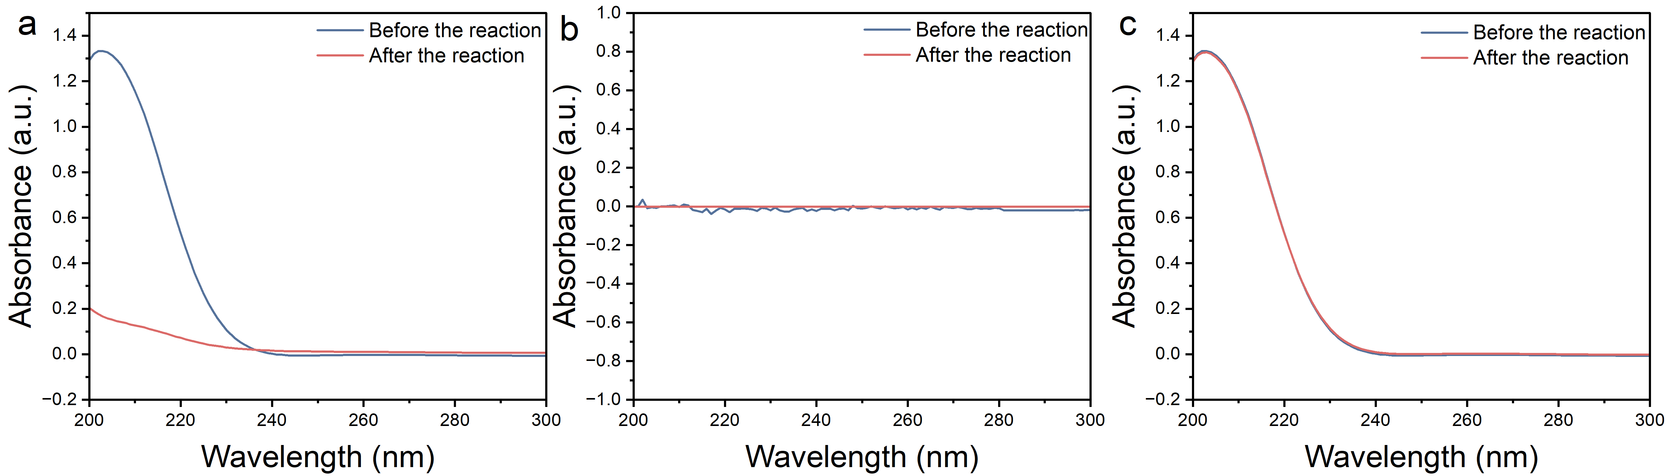
Figure S21. The UV−vis absorption spectroscopy of (a) the electrolyte containing 100 mg/L NO₃⁻ (b) the one without NO₃⁻ and (c) the one containing 100 mg/L NO₃⁻ before and after reacting for the same period of time under an electrically neutral condition.
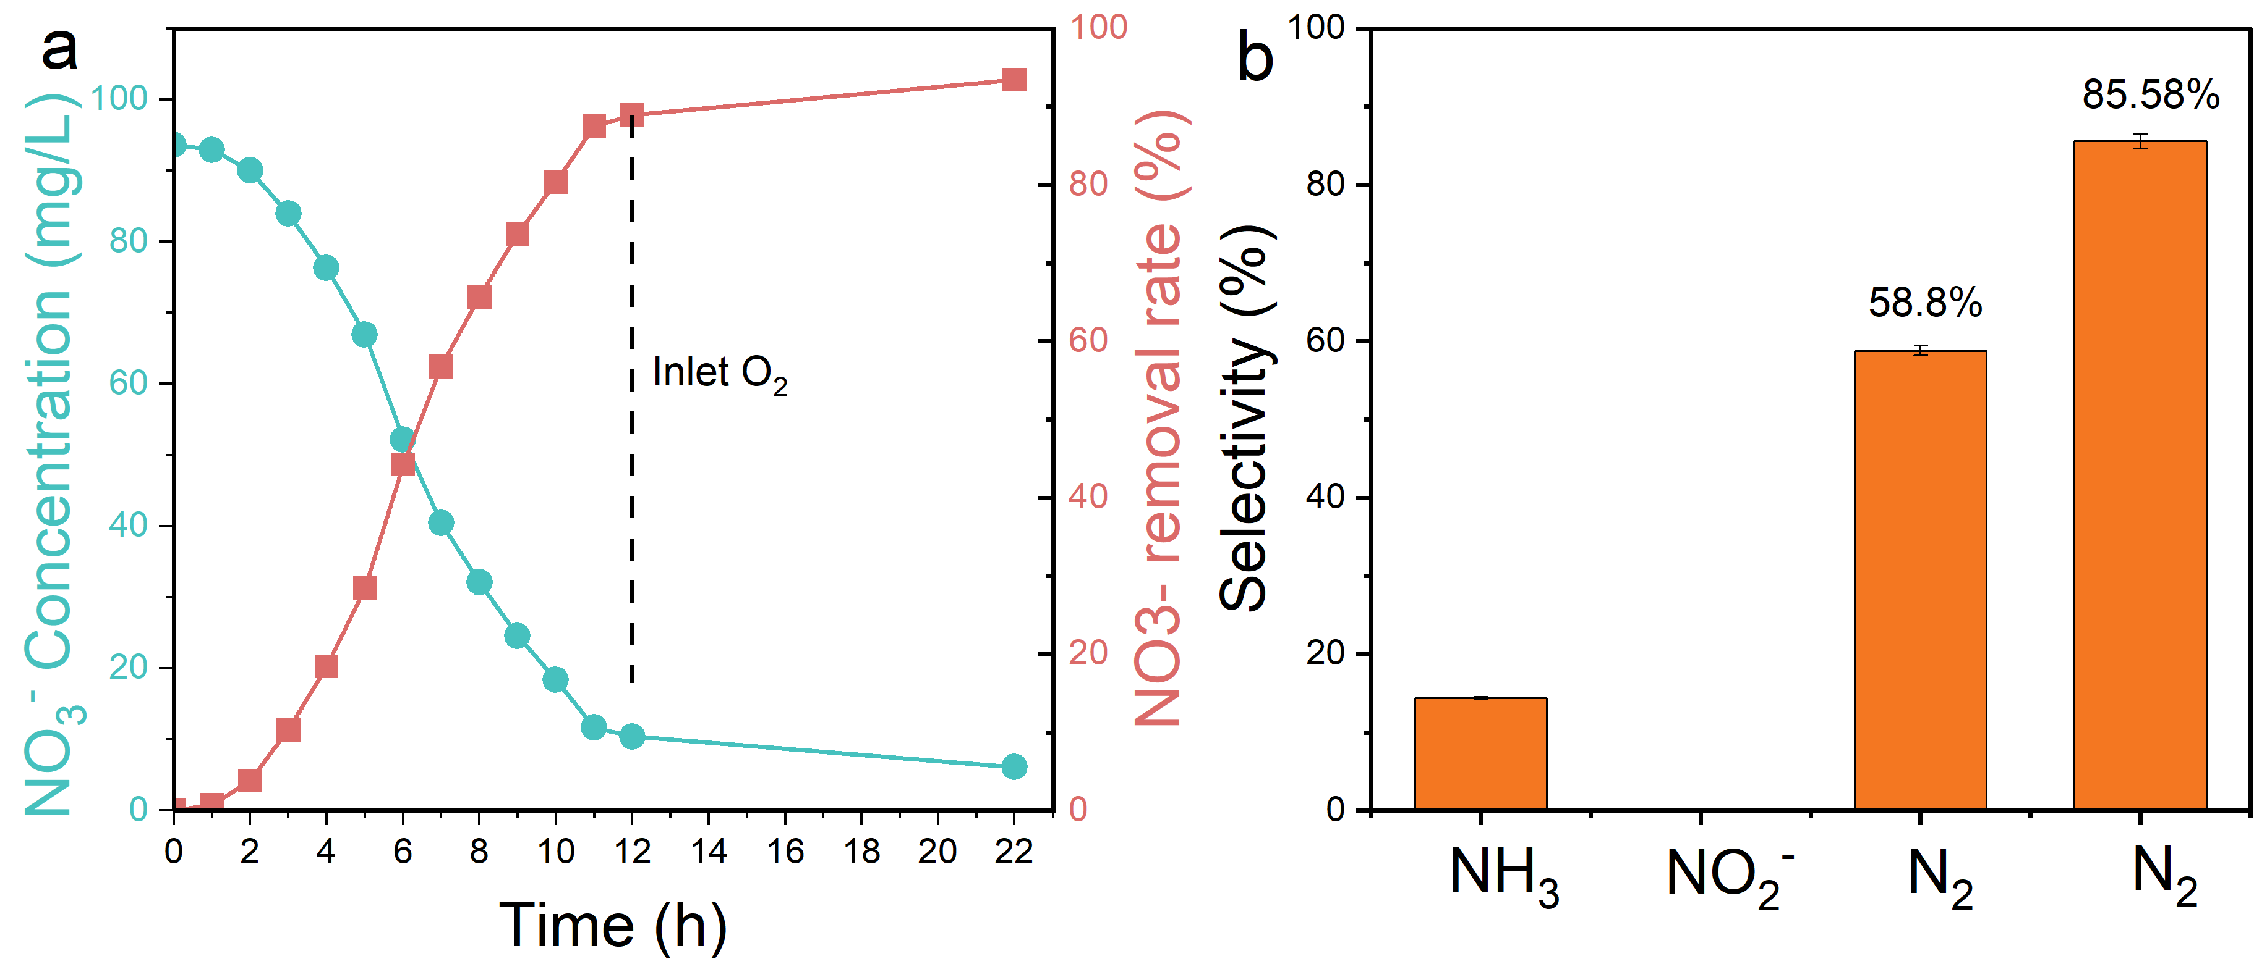
Figure S22. The removal rate of 100 mg L⁻¹ NO₃⁻ and the change of NO₃⁻ concentration (a) and the selectivity of its products (b) After 12 h of NO₃⁻ degradation, oxygen (O₂) was introduced into the solution to convert the generated NH₃ into N₂, thereby enhancing the selectivity of N₂.
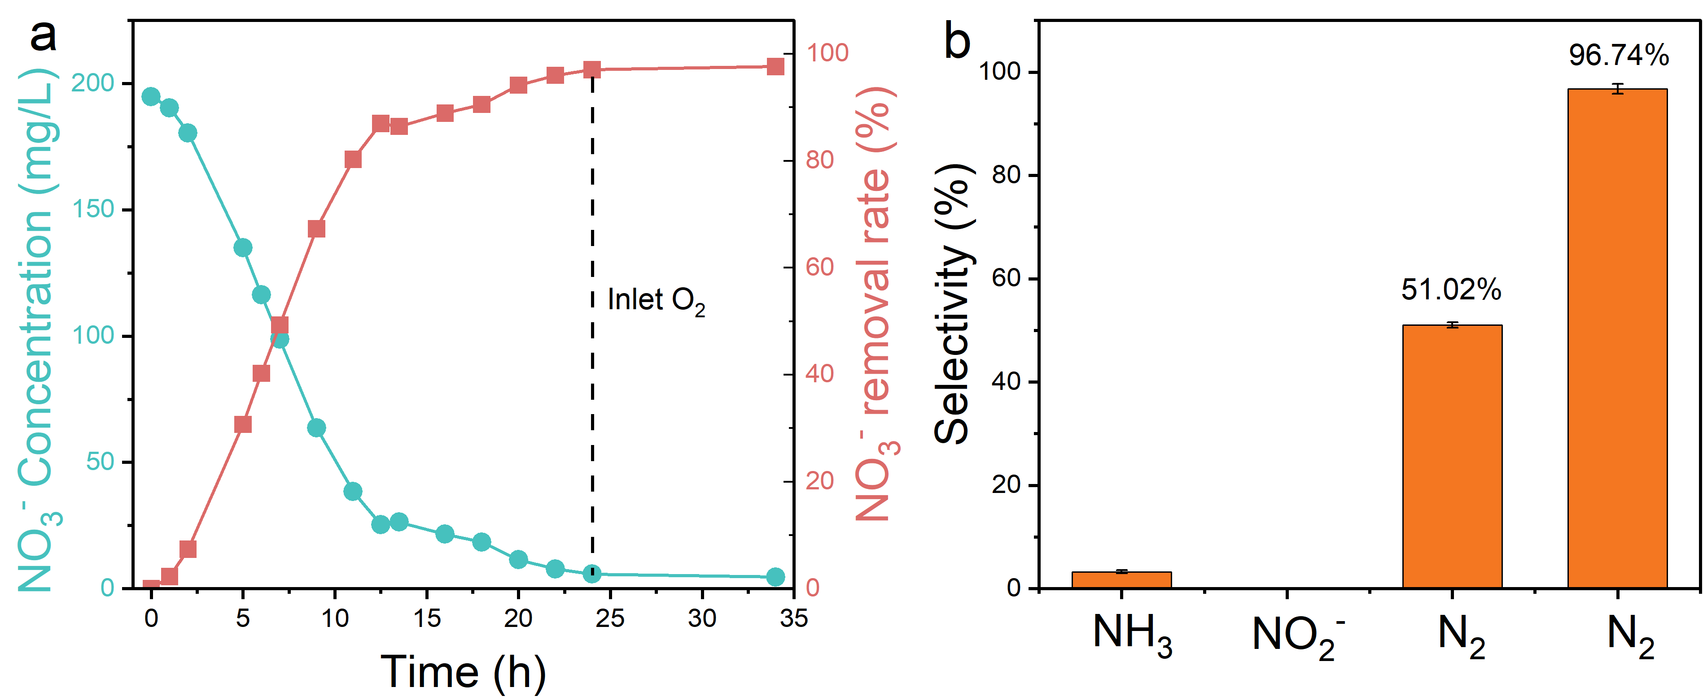
Figure S23. The removal rate of 200 mg/L NO₃⁻ and the change of NO₃⁻ concentration (a) and the selectivity of its products (b) After 24 h of NO₃⁻ degradation, O₂ was introduced into the solution to convert the generated NH₃ into N₂, thereby enhancing the selectivity of N₂.

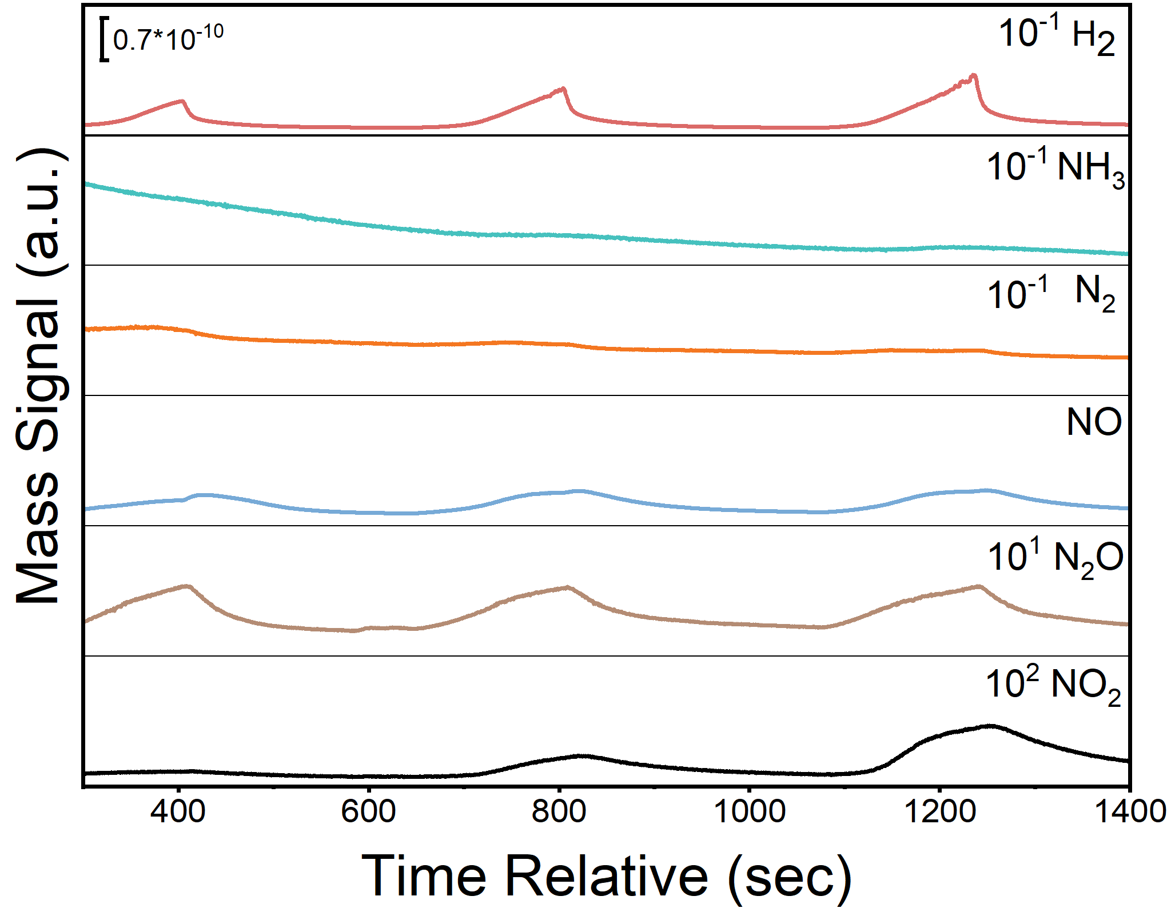
Figure S24. The DEMS test of O_{V}-Cu-VO₂ under Ar atmosphere. The test potential is -0.95 V (vs. RHE), and the testing time for each cycle is 200 seconds. The results showed no obvious N₂ peak, indicating that no N₂ was produced or only a very small amount of N₂ was produced.
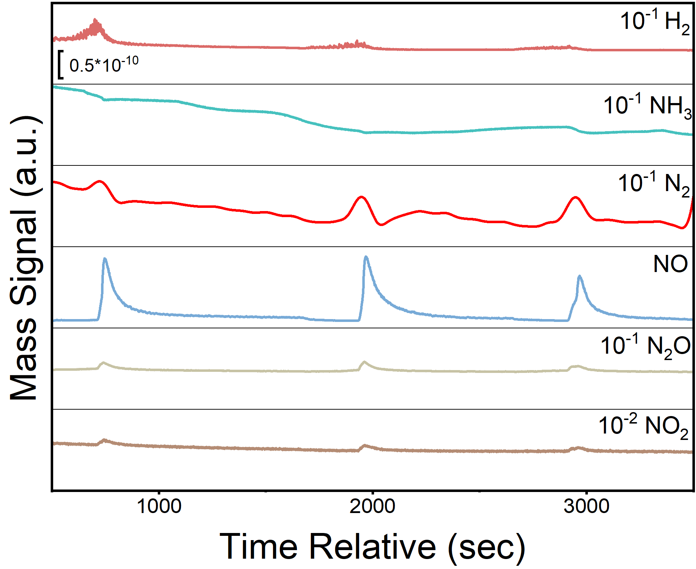
Figure S25. The DEMS test of O_{V}-Cu-VO₂ under O₂/Ar atmosphere. The test potential is -0.95 V (vs. RHE), and the testing time for each cycle is 200 s. The results show a distinct N₂ peak, indicating that N₂ was produced during the reaction.
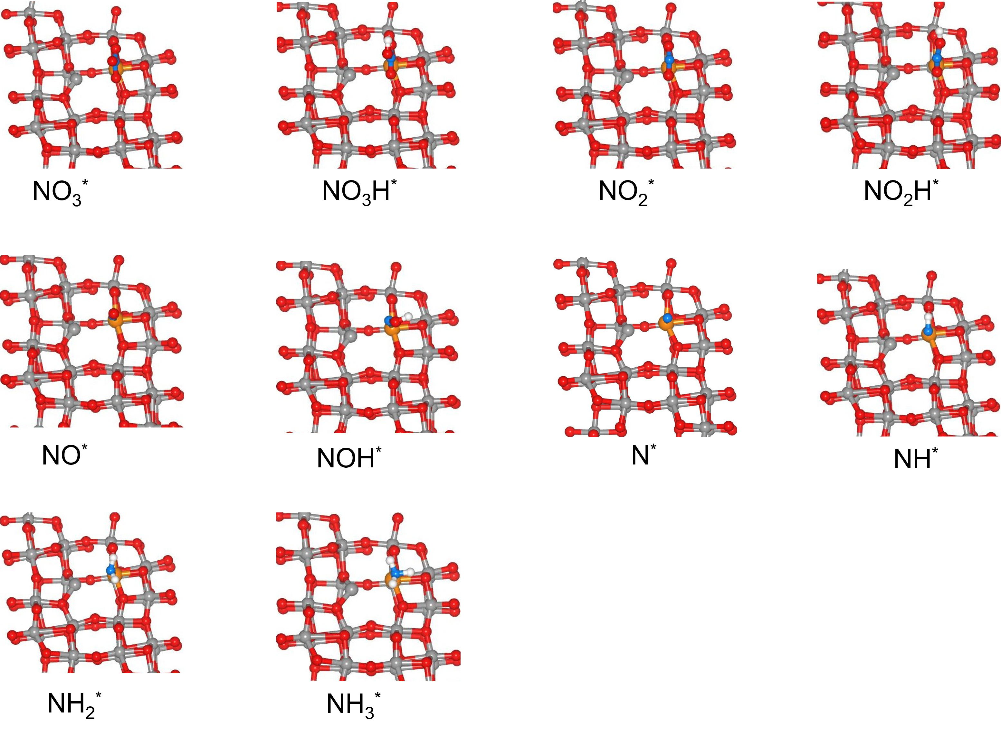
Figure S26. The intermediate model of the pathway for the reduction of NO₃⁻ to NH₃ under the condition of no O refilling. Spheres: red = O, grey = V, orange =Cu, blue = N, white = H.
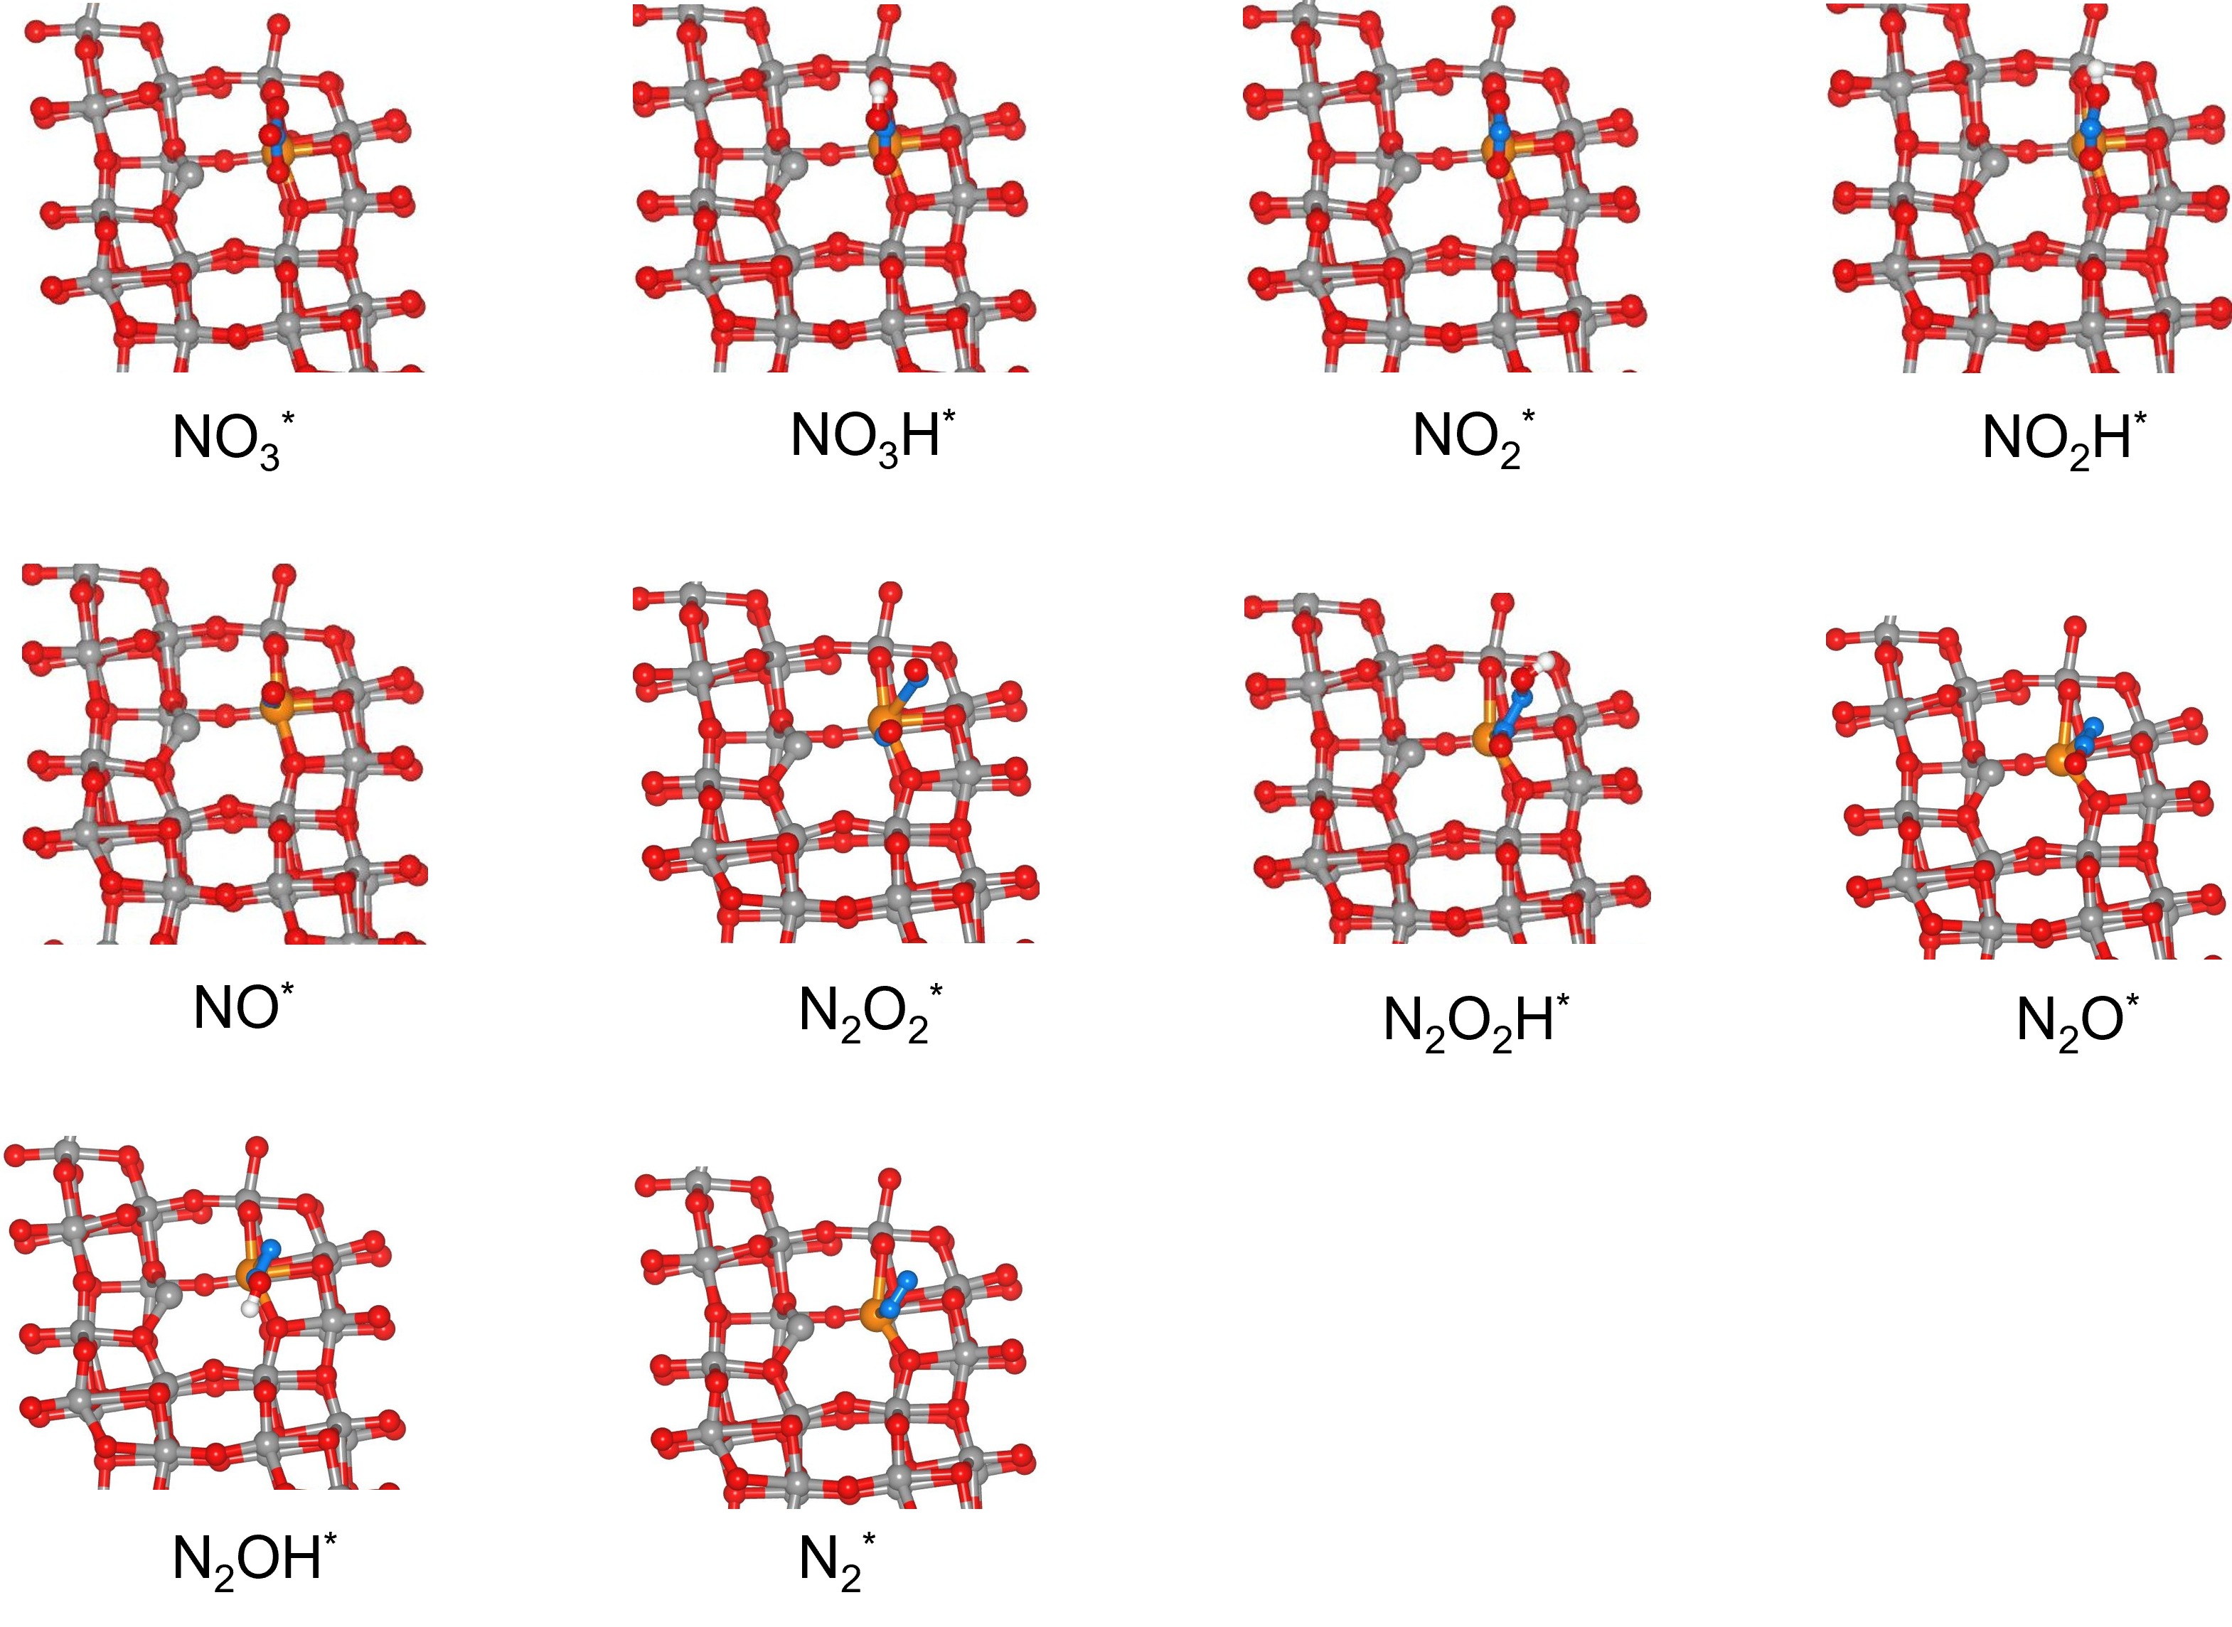
Figure S27. The intermediate model of the pathway for the reduction of NO₃⁻ to N₂ under the condition of no O refilling. Spheres: red = O, grey = V, orange =Cu, blue = N, white = H.
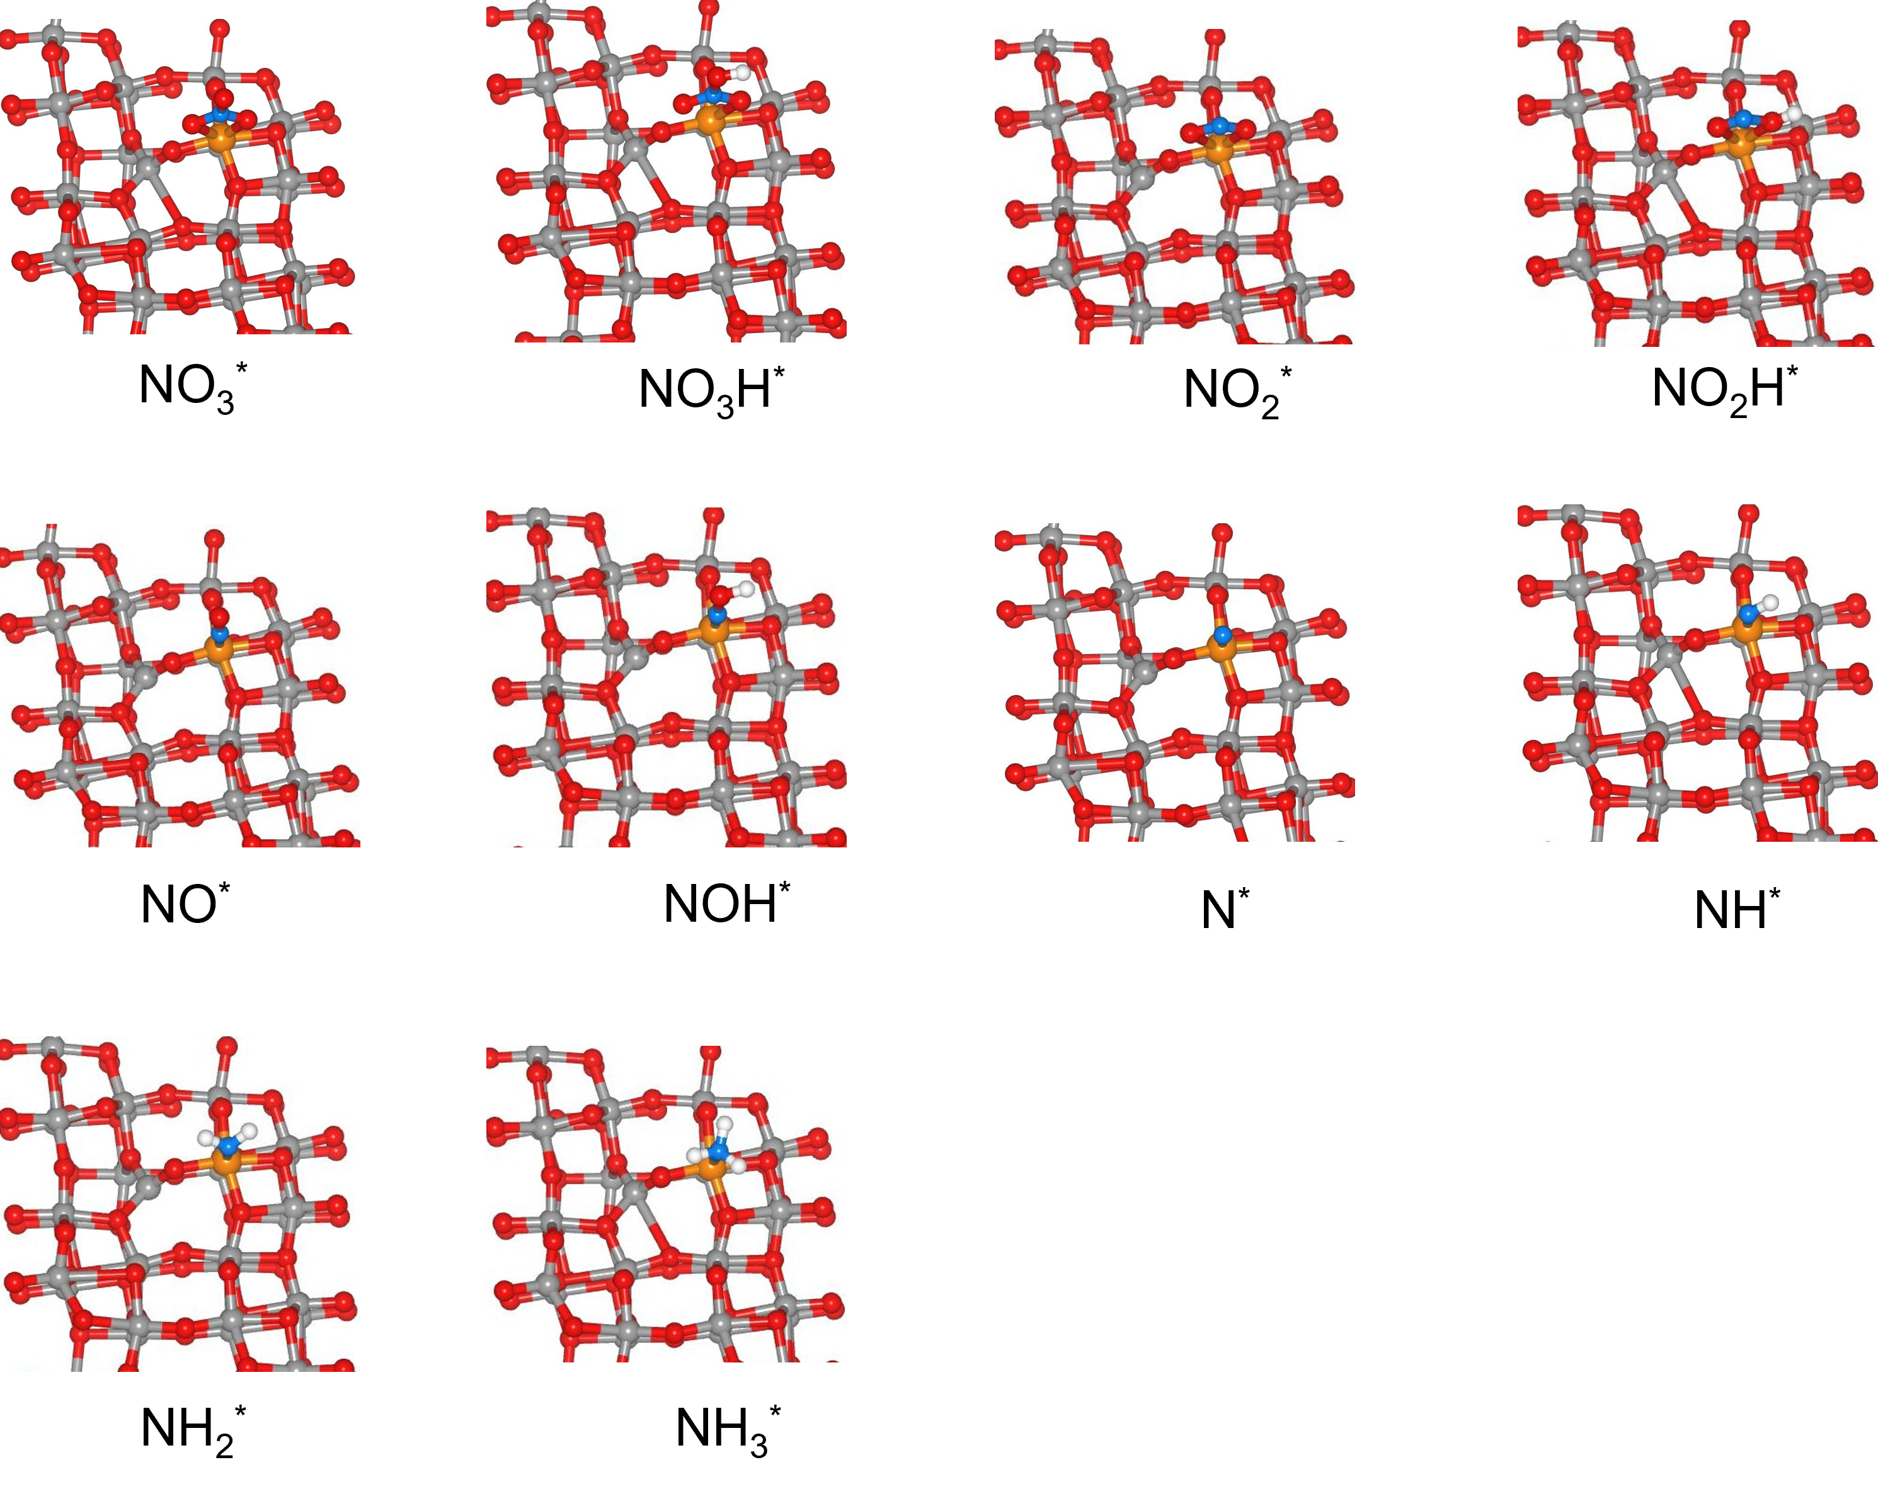
Figure S28. There is an intermediate model for the pathway of NO₃⁻ being reduced to NH₃ under the condition of O refilling. Spheres: red = O, grey = V, orange =Cu, blue = N, white = H.
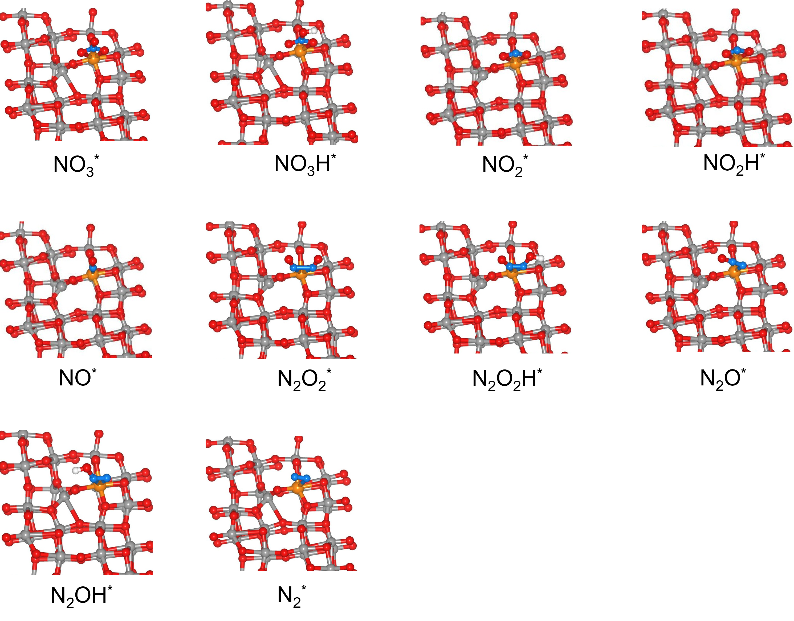
Figure S29. There is an intermediate model for the pathway of NO₃⁻ being reduced to N₂ under the condition of O refilling. Spheres: red = O, grey = V, orange =Cu, blue = N, white = H.

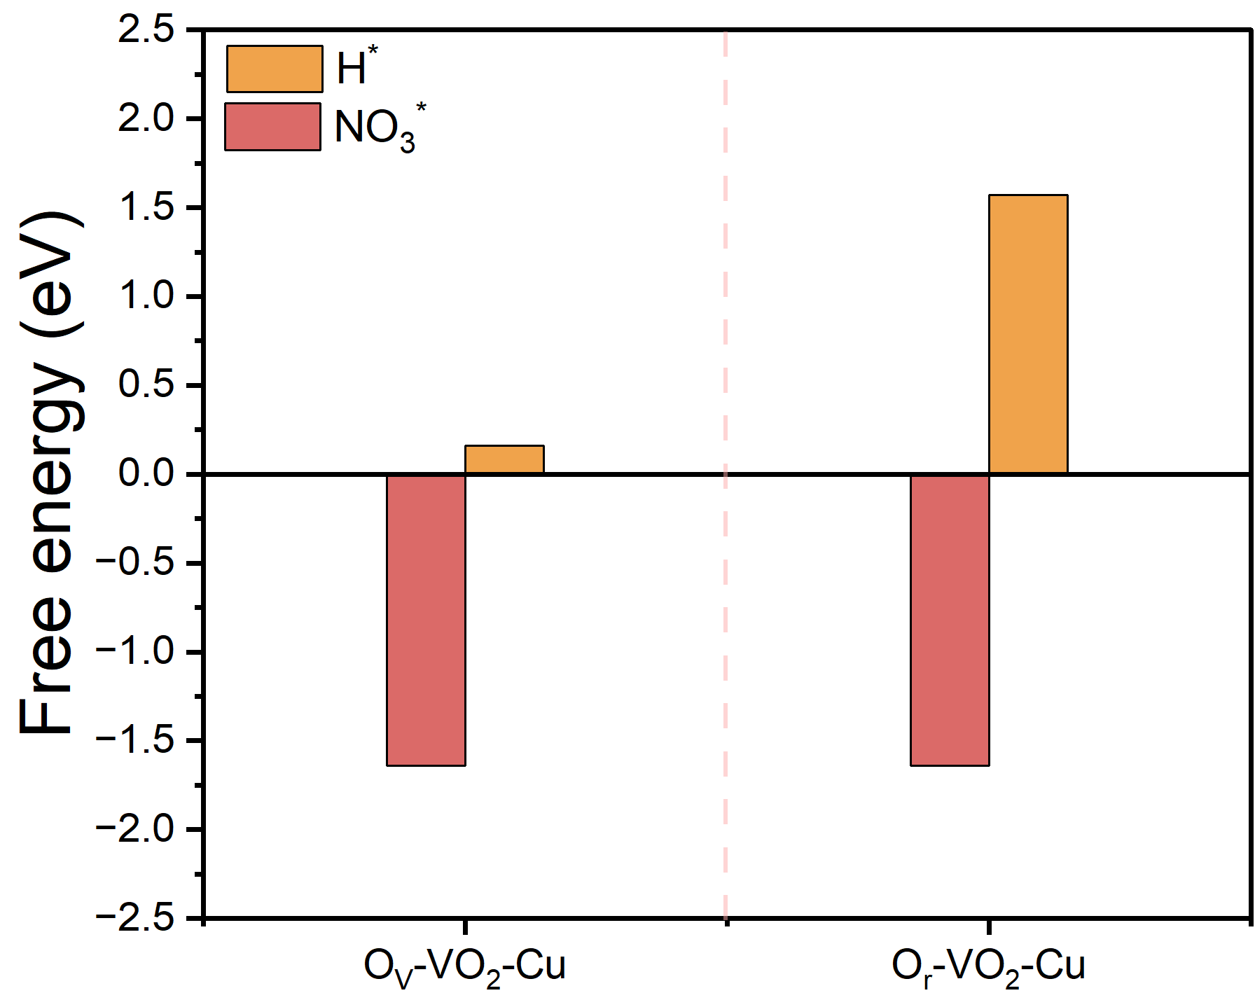
Figure S30. Comparison of adsorption energy between NO₃* and H*.
Tables
Table1. ICP results of O_{V}-Cu-VO₂.
Constant volume V₀ (mL) | Test element | Test solution element concentration C_{o} (mg/L) | Dilution ratio  f | Element concentration in the original solution of digestion solution C₁ (mg/L) | Sample element content C_{x} (mg/kg) | Sample element content C (mg/kg) | Sample element content  W (%)
25 | V | 1.0670724 | 1000 | 1067.072 | 588892.053 | 607199.573 | 60.72%
25 | V | 1.1116607 | 1000 | 1111.661 | 613499.283 | 607199.573 | 60.72%
25 | V | 1.1220037 | 1000 | 1122.004 | 619207.384 | 607199.573 | 60.72%
25 | Cu | 1.7022065 | 10 | 17.022 | 9394.076 | 9420.756 | 0.94%
25 | Cu | 1.7059609 | 10 | 17.060 | 9414.795 | 9420.756 | 0.94%
25 | Cu | 1.7129555 | 10 | 17.130 | 9453.397 | 9420.756 | 0.94%

Table2. EXAFS data fitting results of Samples.
Sample | Path | CNª | R(Å)^{b} | σ² (Å²)^{c} | ΔE₀(eV)^{d} | Range of k | Range of R | R factor
Cu K-edge (Ѕ₀²=0.905)
Cu foil | Cu-Cu | 12.0* | 2.540 | 0.0086 | 4.4 | 2.0-13.0 | 1.0-3.0 | 0.0020
Cu₂O | Cu-O | 2.0 | 1.863 | 0.0045 | 6.1 | 2.0-13.0 | 1.0-3.3 | 0.0118
Cu₂O | Cu-Cu | 12.0 | 3.018 | 0.0244
Cu₂O | Cu-O | 6.0 | 3.451 | 0.0102
CuO | Cu-O | 4.0 | 1.956 | 0.0037 | 0.1 | 2.0-13.0 | 1.0-3.2 | 0.0104
CuO | Cu-Cu | 4.0 | 2.917 | 0.0061 | 3.9 | 2.0-13.0 | 1.0-3.2 | 0.0104
CuO | Cu-Cu | 6.0 | 3.110 | 0.0087
O_{V}-Cu-VO₂ | Cu-O | 3.4 | 1.942 | 0.0050 | -4.5 | 2.0-10.3 | 1.0-3.3 | 0.0107
O_{V}-Cu-VO₂ | Cu-V | 3.6 | 3.295 | 0.0253 | 6.5 | 2.0-10.3 | 1.0-3.3 | 0.0107

Table3. Comparison with other works.
Catalyst | pH | Concentration of NO₃⁻ | NO₃⁻ removal rate | N₂  selectivity  (%) | Precious metal or not | Cl⁻ or not | Ref
O_{V}-Cu-VO₂ | 1 | 100 mg/L | 97.64% | 94.32% | No | No | This work
O_{V}-Cu-VO₂ | 1 | 0.1 M | 7.33% (1h) | 81.92% | No | No | This work
Fe_{sAs}/g-C₃N₄ | 7 | 50 mg/L | 71.6% | 97.9% | No | Yes | ¹
Fe₃Ni-N-C | 7 | 100 mg/L | 86.6% | 89.9% | No | Yes | ²
FeCo-NPCNFs | 7 | 100 mg/L | 78.25% | 85% | No | Yes | ³
Pd-Cu/GS | 6 | 100 mg/L | 88% | 97.3% | Yes | No | ⁴
CNTs@mesoC@CuPd | 7 | 100 mg/L | 95% | 98% | Yes | No | ⁵
FeOOH@CC-160 | 7 | 100 mg/L | 88.51% | 80.12% | No | Yes | ⁶
Fe/NFs | 7 | 100 mg/L | 80.4% | 97.2% | No | Yes | ⁷
RL-Fe₂N@NC | 7 | 100 mg/L | 86% | 96% | No | Yes | ⁸
FeS_{x}@FF | ≥7 | 350 mg/L | 90.75% | 98.88% | No | Yes | ⁹
Co₃O₄-TiO₂/Ti | 7 | 50 mg/L | 60% | 71% | No | Yes | ¹⁰
FeN-NC-140 | 7 | 100 mg/L | 6004 mg N/g Fe | 91% | No | Yes | ¹¹
Cu₂O/Cu NRs/CF | 7 | 30 mg/L | 91.32% | 96.81% | No | Yes | ¹²
Co/Co₃O₄-meso-C | 7 | 100 mg/L | 90.77% | 99% | No | Yes | ¹³

References
1. Song Q, et al. Anchored Fe atoms for N O bond activation to boost electrocatalytic nitrate reduction at low concentrations. Appl. Catal. B-Environ. 317, 121721 (2022).
2. Sun J, Gao W, Fei H, Zhao G. Efficient and selective electrochemical reduction of nitrate to N₂ by relay catalytic effects of Fe-Ni bimetallic sites on MOF-derived structure. Appl. Catal. B-Environ. 301, 120829 (2022).
3. Luo H, et al. Relay Catalysis of Fe and Co with Multi‐Active Sites for Specialized Division of Labor in Electrocatalytic Nitrate Reduction Reaction. Adv. Funct. Mater. 34, 2403838 (2024).
4. Al Bahri M, Calvo L, Gilarranz MA, Rodriguez JJ, Epron F. Activated carbon supported metal catalysts for reduction of nitrate in water with high selectivity towards N₂. Appl. Catal. B-Environ. 138-139, 141-148 (2013).
5. Xu H, Chen J, Zhang Z, Hung CT, Yang J, Li W. In Situ Confinement of Ultrasmall Metal Nanoparticles in Short Mesochannels for Durable Electrocatalytic Nitrate Reduction with High Efficiency and Selectivity. Adv. Mater. 35, 2207522 (2022).
6. Li R, Teng W, Shi Y, Li S, Fan J, Zhang W-x. High-performance electrocatalytic reduction of nitrate to dinitrogen (N₂) with self-supporting iron nanoarrays. Appl. Catal. B-Environ. 373, 125335 (2025).
7. Zhang F, et al. Interfacial Assembly of Nanocrystals on Nanofibers with Strong Interaction for Electrocatalytic Nitrate Reduction. Angew. Chem., Int. Ed. 62, e202310383 (2023).
8. Luo H, et al. Modulating the Active Hydrogen Adsorption on Fe─N Interface for Boosted Electrocatalytic Nitrate Reduction with Ultra‐Long Stability. Adv. Mater. 35, 202304695 (2023).
9. Wang K, Mao R, Liu R, Zhang J, Zhao X. Sulfur-dopant-promoted electrocatalytic reduction of nitrate by a self-supported iron cathode: Selectivity, stability, and underlying mechanism. Appl. Catal. B-Environ. 319, 121862 (2022).
10. Gao J, et al. Non-precious Co₃O₄-TiO₂/Ti cathode based electrocatalytic nitrate reduction: Preparation, performance and mechanism. Appl. Catal. B-Environ. 254, 391-402 (2019).
11. Wang J, Ling L, Deng Z, Zhang W-x. Nitrogen-doped iron for selective catalytic reduction of nitrate to dinitrogen. Science Bulletin 65, 926-933 (2020).
12. Zhou J, et al. Achieving efficient and stable electrochemical nitrate removal by in-situ reconstruction of Cu₂O/Cu electroactive nanocatalysts on Cu foam. Appl. Catal. B-Environ. 317, 121811 (2022).
13. Xie F, et al. Built–in Electric Field Boosted Tandem Catalysis for Rapid Electrochemical Nitrate Reduction to Nitrogen. ACS Nano 19, 26217-26228 (2025).

