Supplementary Materials for
Lobe-Switching Avulsions: Delta Geometry Could Determine Locations
Ningjie Hu¹, A. Brad Murray¹, Katherine M. Ratliff¹, Bo Wang², and Laurence Smith³
*Corresponding authors. ningjie.hu@duke.edu
¹Division of Earth and Climate Sciences, Nicholas School of the Environment, Duke University, Durham, NC, USA.
² Saint Louis University, St. Louis, USA
³ Brown University, Rhode Island, Providence, USA

This supplementary online file includes:
Text S1 to S3
Figures S1 to S5
Tables S1

Supplementary Text
Text S1. Methodology of generating floodplain lines

The river centerline was smoothed using the Polynomial Approximation with Exponential Kernel (PAEK) method in ArcGIS, based on a smoothing tolerance of 10km, to capture the general trend of the river course. For each river, we created buffers to each side of the smoothed river centerline to capture the geometry of riverbank transect. The buffer tool traverses each of the vertices of the input line and creates buffer offsets to a fixed distance. The output buffer features were generated by connecting the buffer offsets (detailed description see ArcGIS Pro tool reference). The buffer polygons were then converted to line features, and the line features are used as the riverbank transects. We visually evaluate the riverbank transect and manually correct points off the banks for an accurate depiction of the riverbank transect. The riverbank elevation was extracted along the riverbank transects from FABDEM+. To generate the floodplain lines, the buffer tool was applied to create buffer polygons to the left or right of the river centerline (in the case of the Mississippi river, 10km, 30km, 50km away from the river centerline). Multiple elevation profiles were then extracted parallel to the downstream direction of the river along the floodplain lines. The levee crest and floodplain elevation profiles were tracked at least two backwater lengths upstream.
Text S2. Brahmaputra River Delta

The Bengal basin covers ∼100,000 km² of lowland floodplain and delta plain. The Brahmaputra River has a braided planform with some vegetated and populated island bars. Because of the monsoon climate, the water and sediment discharges are strongly seasonal. The riverbanks of the Brahmaputra River comprise ~ 60% sand and ~ 40% silt (Thorne et al., 1993). The most recent avulsion of the Brahmaputra River occurred near the Tista–Brahmaputra confluence around 1830 (Pickering et al., 2014; Richards et al., 2021), diverting most of the discharge to the current course of the Brahmaputra River. Previous studies identified a slope transition in the distal floodplain profile of the Brahmaputra River (Wilson and Goodbred, 2015; Ratliff et al., 2021), making it an additional potential study site.
Like the Mississippi River, we found a high concavity zone exposed in the floodplain profiles Brahmaputra River (Figure S1) around 150 km upstream of the river mouth. Similarly, we found that $T_{b}$ of the Brahmaputra River is around 30,000 years, which is beyond the time scale since of the late Holocene (and despite uncertainties in relative SLRR, $N_{t}$ is consistently larger than 1, which is consistent with the existence of a high-curvature zone for that delta). However, avulsions in the Brahmaputra-Ganges braided river are primarily driven by tectonics (Reitz et al., 2013; Wilson and Goodbred, 2015), so the location of river avulsions follows a maximum subsidence zone instead of the high concavity zone. The parameters used for the calculation are listed in the supplementary table 1.
The scaling analysis assumes a steady subsidence and uniform basin depth. For river deltas in tectonic active regions, the discrete tectonic subsidence events tend to disturb the time scales of river avulsions (Dong et al., 2023). If the tectonic-controlled avulsion timescale is shorter than the autogenic avulsion timescales, the delta resurfacing time scale will be shorter and the signal of allogenic avulsions may overprint the signal of geometric effects.
Text S3. Sensitivity Analysis
We conducted sensitivity studies by changing the distance over which the middle 1/3 data are selected (every 11km, 20km, or 28km along the profile, where data points are spaced at intervals of 0.35 km), the size of the moving average window (79km, 99km, 133km), and the window for calculating the slopes (159km, 199km, 239km). Results of the sensitivity analysis suggest that the curvature maximum persist in all floodplain profiles and is not sensitive to the window size we used to select and smooth the data (Figure S2-5).
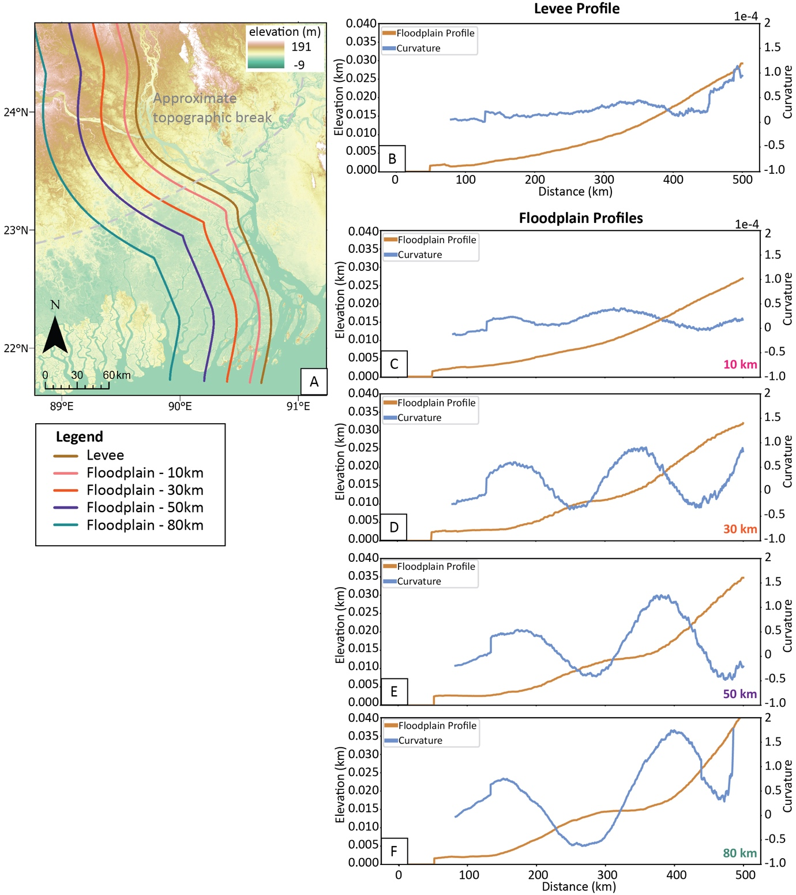
Figure S1. (A) The floodplain lines used for extracting the long profiles on the Brahmaputra Delta. The previously identified topographic break (Wilson and Goodbred, 2015) is marked in a dashed grey line. (B) Smoothed levee elevation profiles (brown lines) and their local curvatures (blue lines). (C-F) Smoothed floodplain elevation profiles (brown lines) and their local curvatures (blue lines). The floodplain line is 10km, 30km, 50km, 80km away from the river laterally. The floodplain elevation profile is smoothed using a moving average filter over a 99 km window.
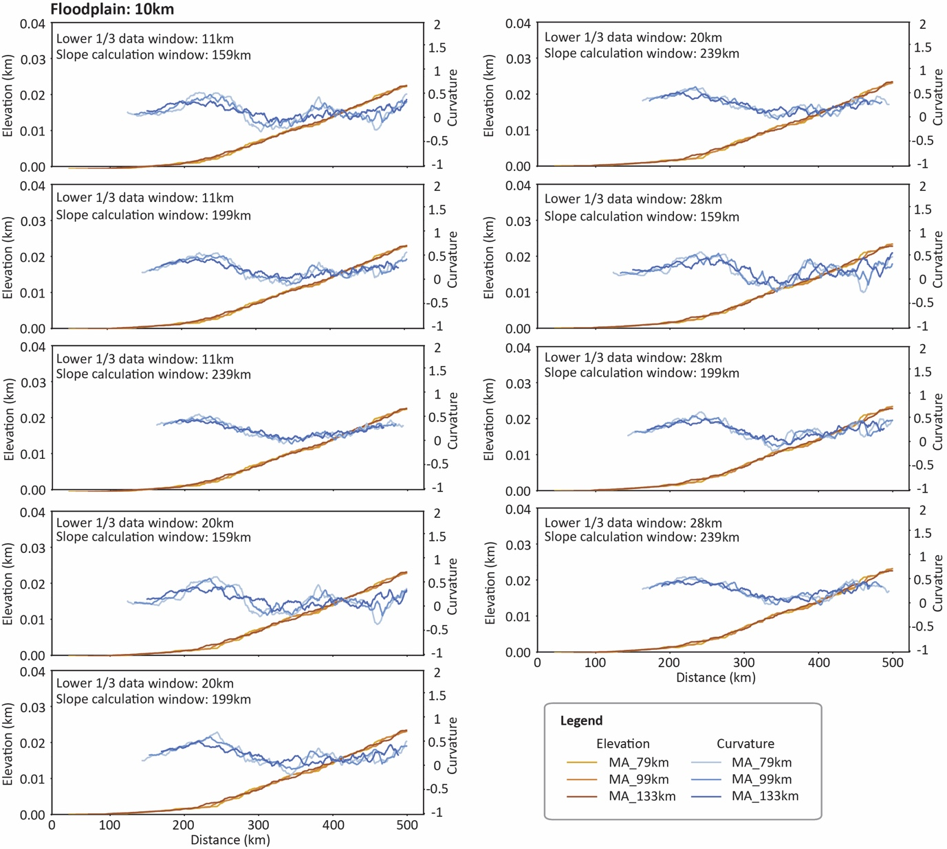
Figure S2. Smoothed floodplain elevation profiles (brown lines) and their local curvatures (blue lines) of the floodplain line 10 km away from the river laterally using varying windows for selecting data, calculating curvature, and moving average filter. Results show that the existence of the local curvature maximum is insensitive to the these parameters.
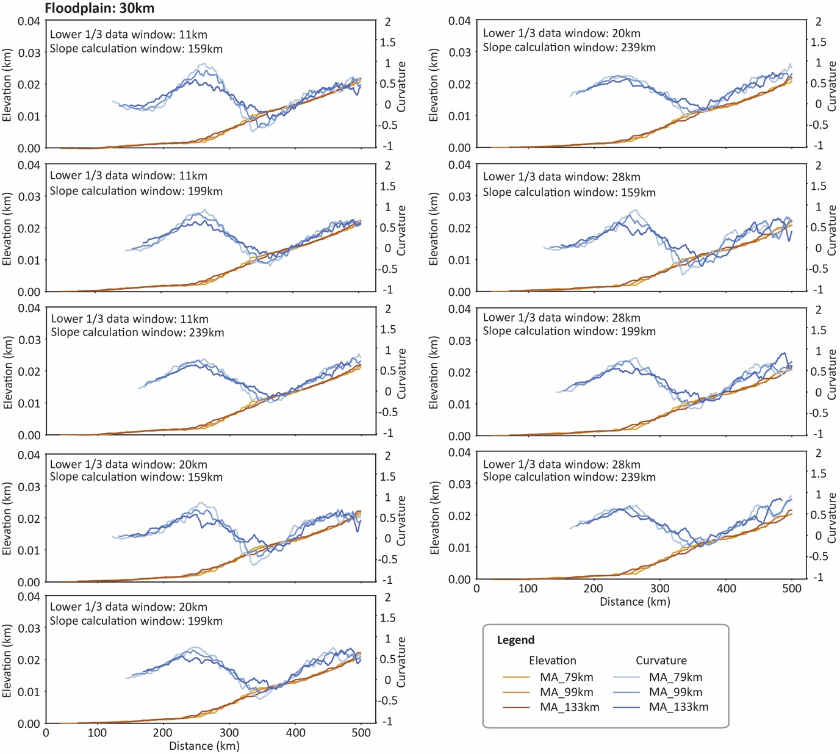
Figure S3. Smoothed floodplain elevation profiles (brown lines) and their local curvatures (blue lines) of the floodplain line 30 km away from the river laterally using varying windows for selecting data, calculating curvature, and moving average filter. Results show that the local curvature maximum is insensitive to these parameters.

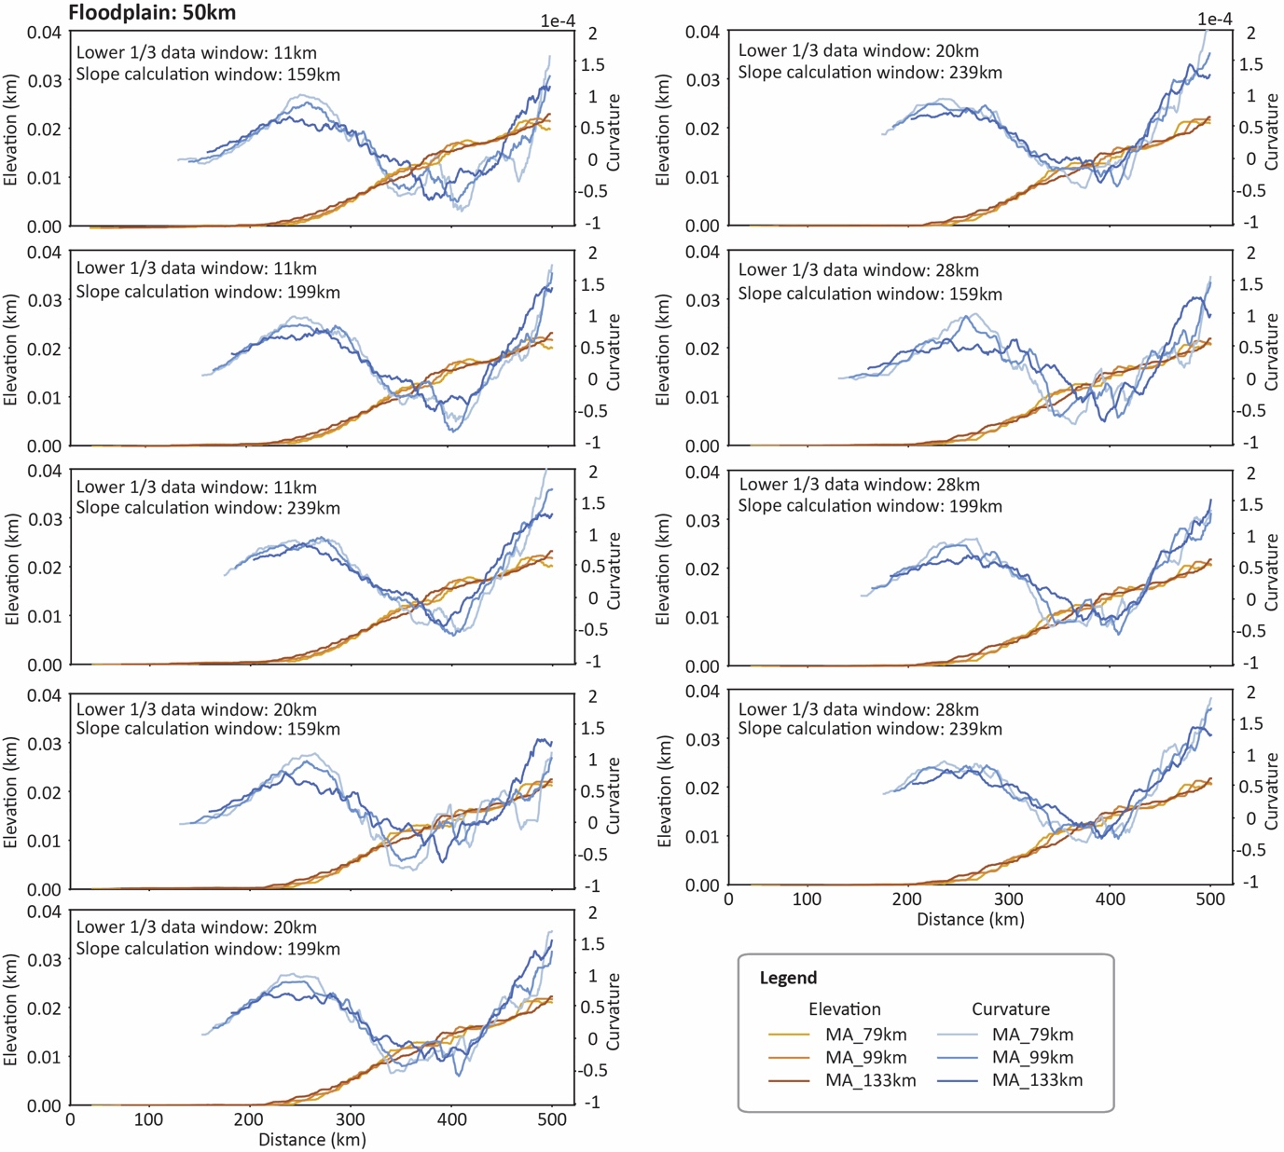
Figure S4. Smoothed floodplain elevation profiles (brown lines) and their local curvatures (blue lines) of the floodplain line 50 km away from the river laterally using varying windows for selecting data, calculating curvature, and moving average filter. Results show that the local curvature maximum is insensitive to these parameters. 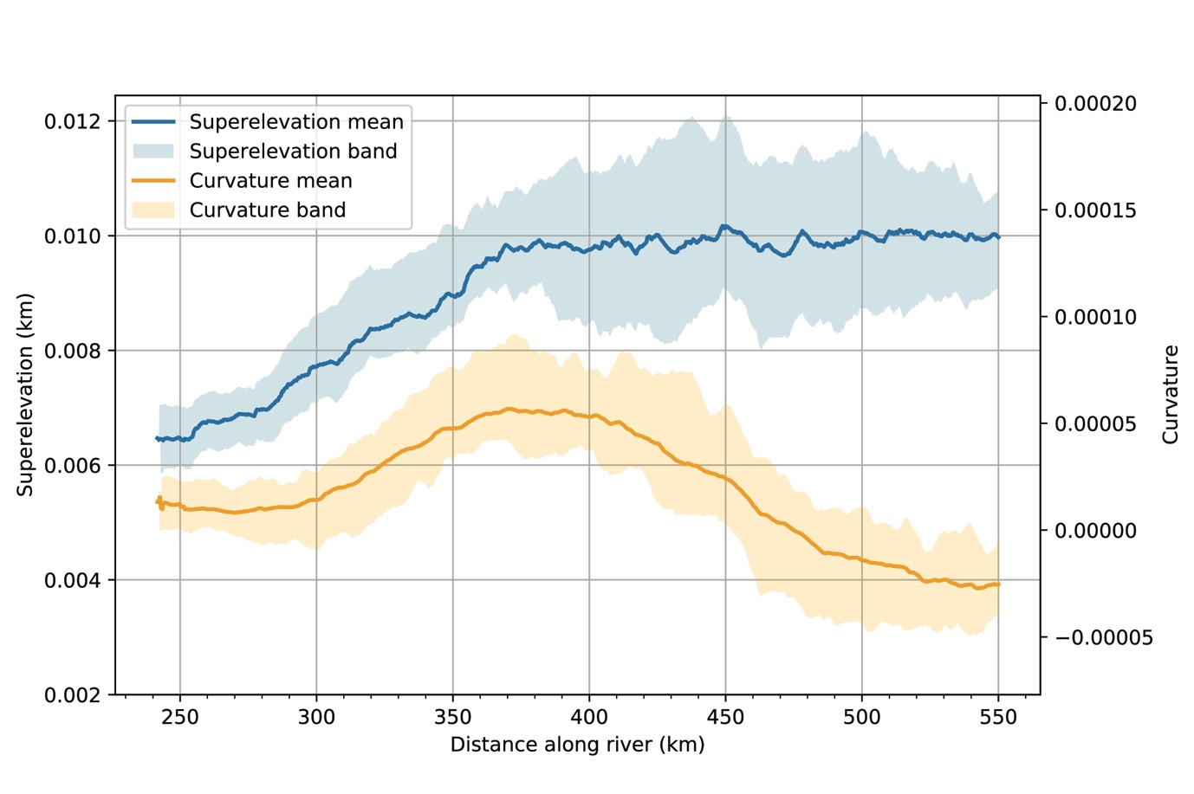Figure S5. Moving upstream, the superelevation increases up to the location of the curvature maximum.
TABLE S1. PARAMETERS FOR TIMESCALE CALCULATIONS
Name | Mississippi River | Brahmaputra River
Progradation rate (m/yr) | 55.83 |  | 15.00
PRd (m/yr) | 13.56 |  | n/a
Eustatic SLRR (mm/yr) | 2.70 |  | 1.80
Subsidence rate (mm/yr) | 9 |  | 5
Relative SLRR (m/yr) | 0.0117 |  | 0.0068
Bd (m) | 420,000 |  | 200,000
Br (m) | 7,000 |  | 10,000
D (m) | 21 |  | 15
S | 0.000043 |  | 0.0001
Lb (km) | 488 |  | 150
Tb (yr) | 524,878 |  | 200,000
Tp (yr) | 36,015 |  | n/a
Tt (yr) | 1,795 |  | 2,206
Np | 14.57 |  | n/a
Nt | 292.43 |  | 90.67
Reference | Coleman et al., 1998 |  | Wilson and Goodbred, 2015

Supplementary References
ArcGIS Pro tool reference: https://pro.arcgis.com/en/pro-app/latest/tool-reference/analysis/how-buffer-analysis-works.htm
Coleman, J. M., Roberts, H. H., & Stone, G. W. (1998). Mississippi River delta: an overview. Journal of Coastal Research, 699-716.
Dong, T. Y., Nittrouer, J. A., Carlson, B., McElroy, B., Il’icheva, E., Pavlov, M., & Ma, H. (2023). Impacts of tectonic subsidence on basin depth and delta lobe building. Journal of Geophysical Research: Earth Surface, 128(2), e2022JF006819.
Thorne, C. R., Russell, A. P., & Alam, M. K., 1993. Planform pattern and channel evolution of the Brahmaputra River, Bangladesh. Geological Society, London, Special Publications, 75(1), 257-276.
Pickering, J. L., Goodbred, S. L., Reitz, M. D., Hartzog, T. R., Mondal, D. R., & Hossain, M. S., 2014. Late Quaternary sedimentary record and Holocene channel avulsions of the Jamuna and Old Brahmaputra River valleys in the upper Bengal delta plain. Geomorphology, 227, 123-136.
Richards, K., Brammer, H., & L Saunders, P., 2021. The historical avulsion of the Tista River,
and its relationship to the Brahmaputra: Map and archive evidence from 1750 to 1835. The Geographical Journal, 187(3), 253-268.
Reitz MD, Steckler MS, Paola C, Goodbred SL, Petter A, et al. 2013. River avulsions in the presence of tectonic tilting, and the Ganges-Brahmaputra Delta. Presented at Am. Geophys.Union Annu. Conf., San Francisco, CA, Dec. 9–13
Wilson, C. A., & Goodbred, S. L. (2015). Construction and Maintenance of the Ganges-BrahmaputraMeghna Delta: Linking Process, Morphology, and Stratigraphy. Annual Review of Marine Science, 7(1), 67-88. doi:10.1146/annurev-marine-010213-135032

