Supplementary Figure 1. Funnel plots for each long COVID risk factor

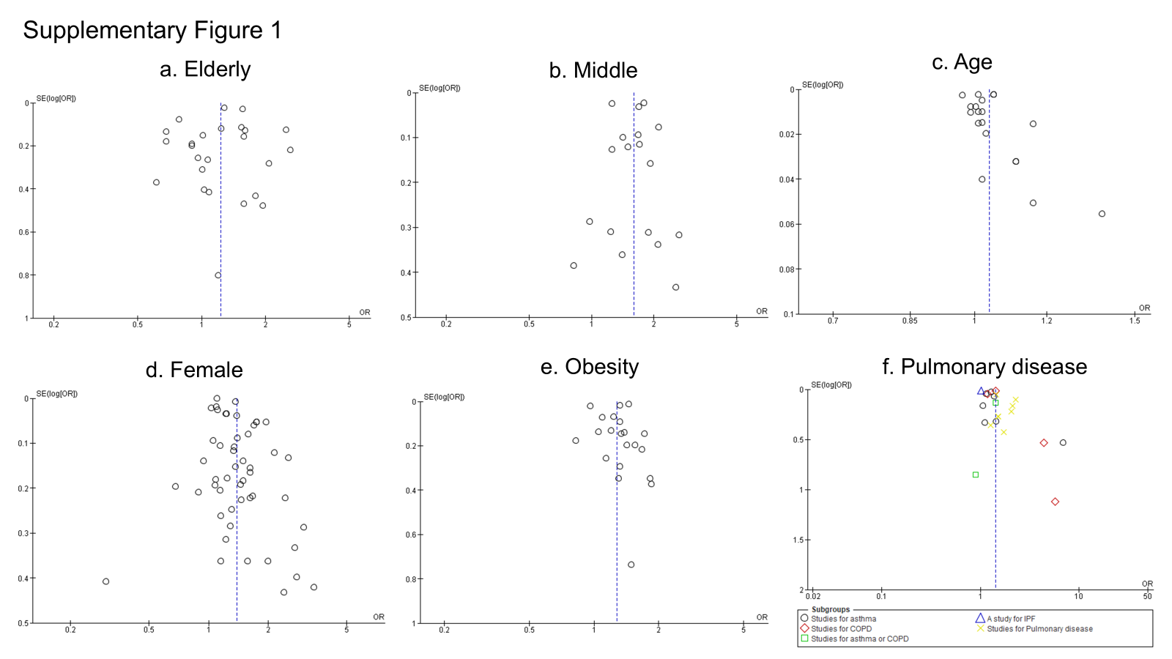
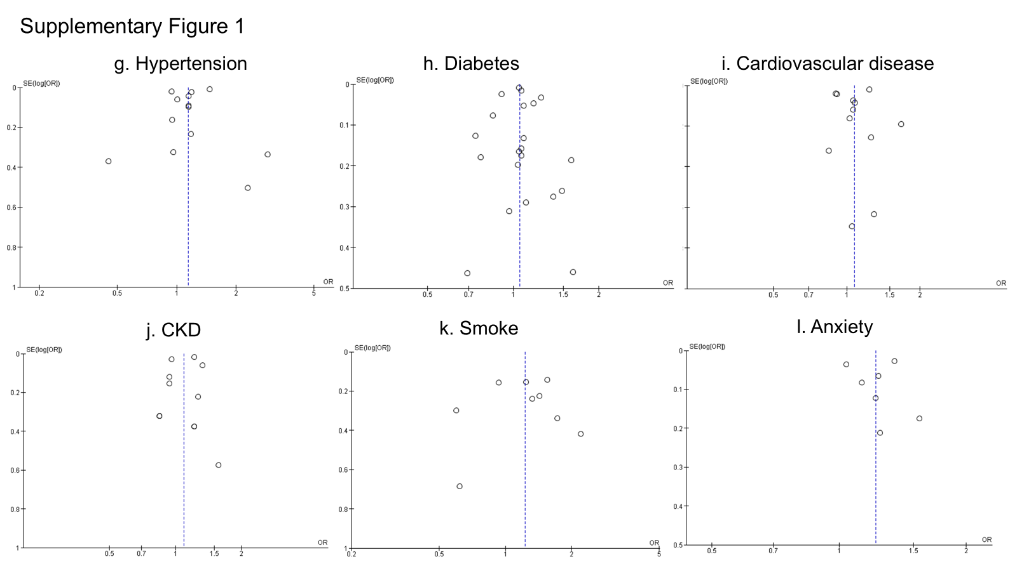
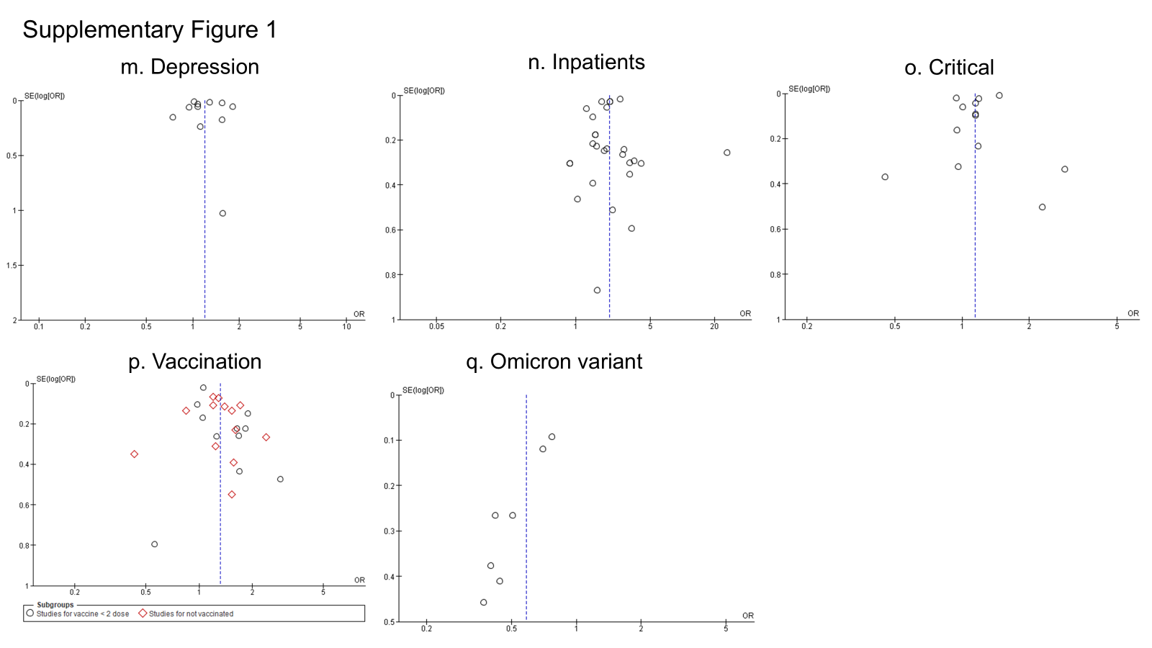

Supplementary Figure 1. Funnel plots for each long COVID risk factor
a) Funnel plots of studies evaluating the elderly as a risk factor for long COVID
b) Funnel plots of studies evaluating the middle-age as a risk factor for long COVID
c) Funnel plots of studies evaluating the age as a risk factor for long COVID
d) Funnel plots of studies evaluating the female as a risk factor for long COVID
e) Funnel plots of studies evaluating the obesity as a risk factor for long COVID
f) Funnel plots of studies evaluating the pulmonary disease as a risk factor for long COVID
g) Funnel plots of studies evaluating the hypertension as a risk factor for long COVID
h) Funnel plots of studies evaluating the diabetes as a risk factor for long COVID
i) Funnel plots of studies evaluating the cardiovascular disease as a risk factor for long COVID
j) Funnel plots of studies evaluating the CKD as a risk factor for long COVID
k) Funnel plots of studies evaluating the smoke as a risk factor for long COVID
l) Funnel plots of studies evaluating the anxiety as a risk factor for long COVID
m) Funnel plots of studies evaluating the depression as a risk factor for long COVID
n) Funnel plots of studies evaluating the inpatients as a risk factor for long COVID
o) Funnel plots of studies evaluating the critical as a risk factor for long COVID
p) Funnel plots of studies evaluating the vaccination as a risk factor for long COVID
q) Funnel plots of studies evaluating the omicron variant as a risk factor for long COVID

Supplementary Figure 2. Forrest plot showing risk of long COVID by age
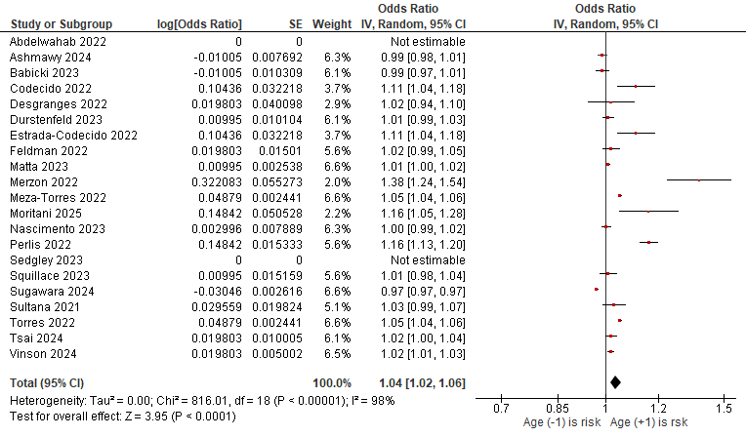

Supplementary Figure 3. Forrest plot showing risk of long COVID for comorbidity
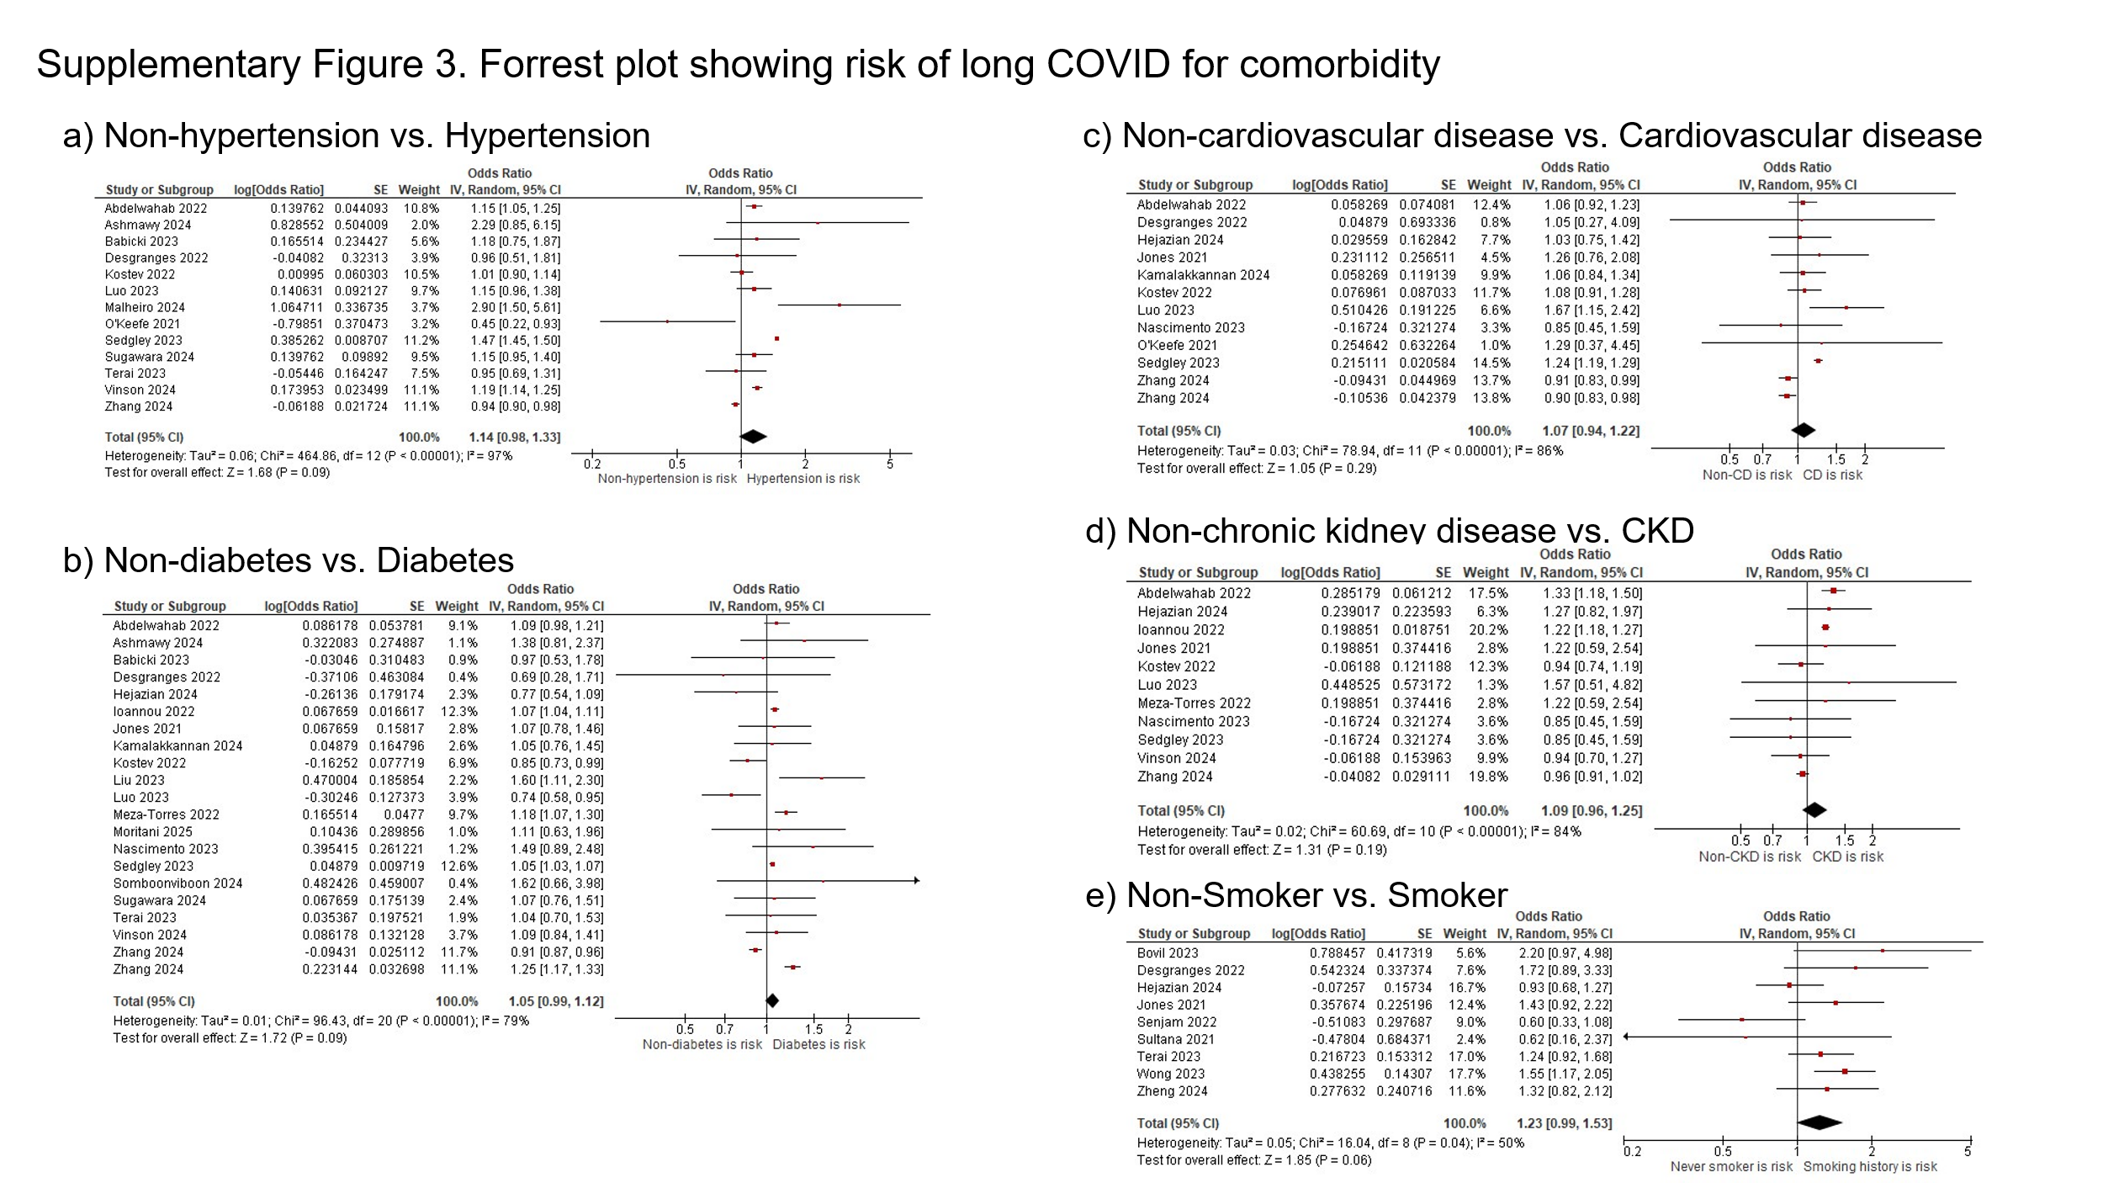
Supplementary Figure 3. Forrest plot showing risk of long COVID for comorbidity
a) Non-hypertension vs. Hypertension
b) Non-diabetes vs. Diabetes
c) Non-cardiovascular disease vs. Cardiovascular disease
d) Non-CKD vs. CKD
e) Non-Smoker vs. Smoker

Supplementary Figure 4. Forrest plot showing risk of long COVID with omicron variant
