Supplementary Materials for

Spatiotemporal Brain Transcriptomics Reveal Risk Gene Hot-Spots in Major Neuropsychiatric Disorders

Weiqing Liu^{1*} and Tomomi Shimogori^{2*}

¹Clinical Research Center for Mental Disorders, Shanghai Pudong New Area Mental Health Center, School of Medicine, Tongji University, 165 Sanlin Road, Pudong New Area, Shanghai 200124, China
²Laboratory for Molecular Mechanisms of Brain Development, Center for Brain Science, RIKEN, 2-1 Hirosawa, Wako, Saitama 351-0198, Japan

*Author for correspondence: Weiqing Liu and Tomomi Shimogori
Email: liuwq2010@tongji.edu.cn, tomomi.shimogori@riken.jp

This file includes:
Supplementary Figures S1-S14
Contents of Supplementary Tables S1-S13

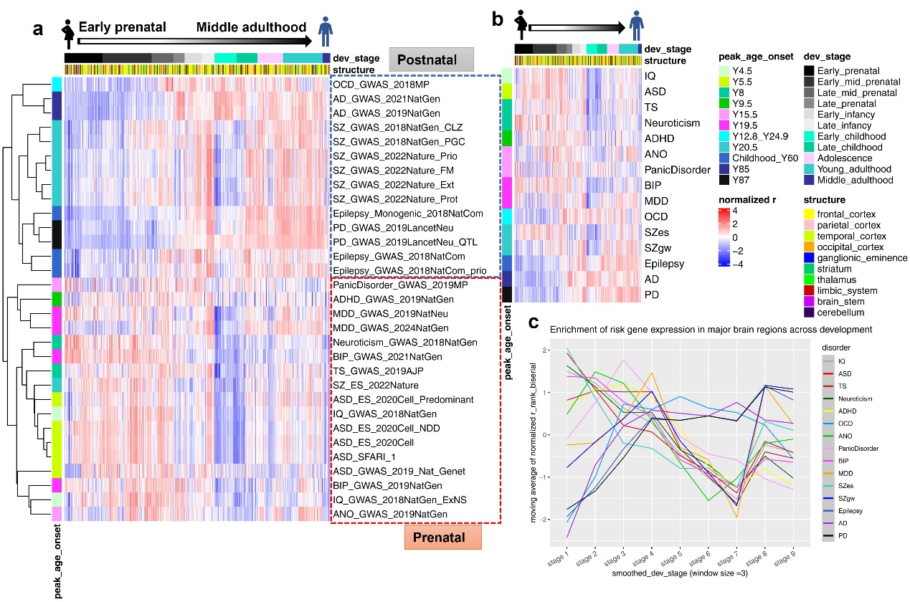
Fig.S1 Clustering of major neuropsychiatric disorders based on developmental dynamics of risk gene expression.
(a) Cluster analysis of the developmental trajectories of risk gene set expression enrichment revealed a clear separation between early-onset and late-onset neuropsychiatric disorders. Risk gene sets from the same disorder predominantly clustered in close proximity, indicating internal consistency across datasets.
(b) Clustering of the 15 merged risk gene sets—aggregated from all available neuropsychiatric risk gene datasets—recapitulated the major grouping patterns observed in panel (a), supporting the robustness of the developmental clustering framework.
(c) Line plots illustrating the temporal expression dynamics of risk gene sets further emphasized divergent developmental trajectories among neurological and psychiatric disorders, with the exception of OCD, which showed a distinct pattern. Notably, MDD and SZgw risk genes displayed two prominent periods of expression enrichment during development, suggesting multiple windows of vulnerability.

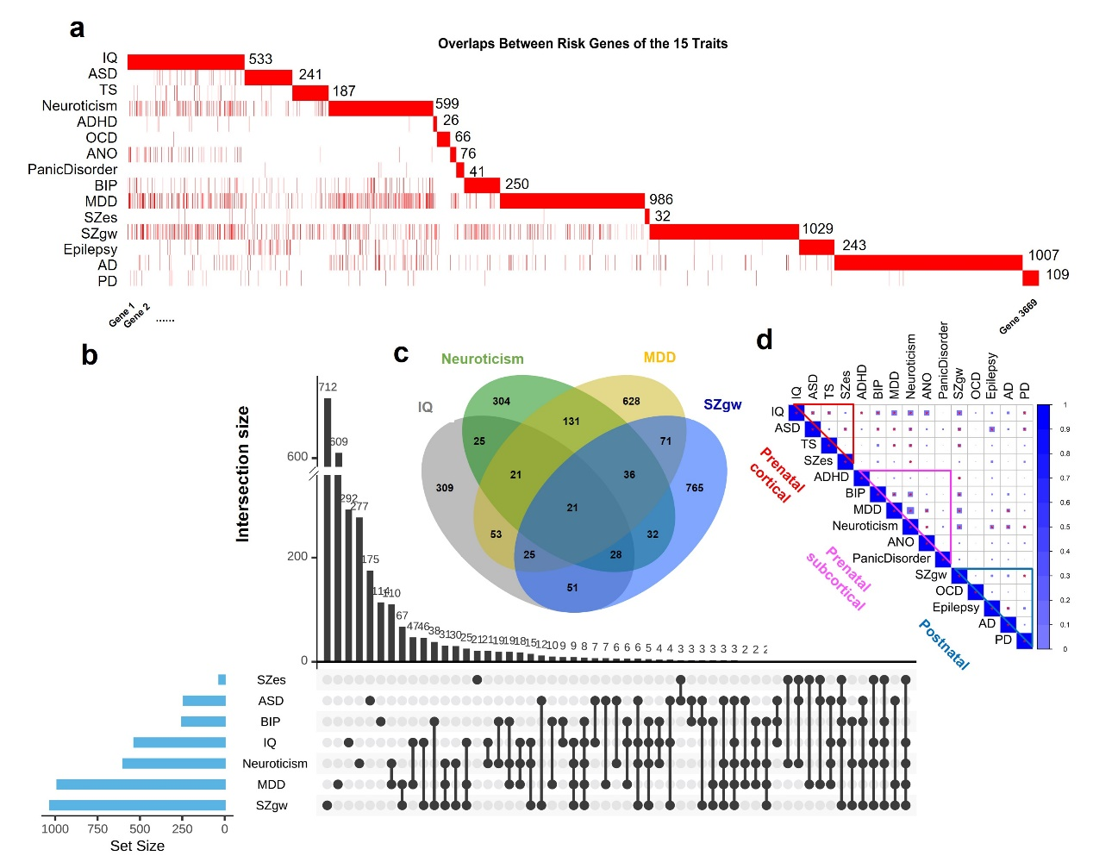
Fig. S2 Similarities between risk gene sets do not account for the spatiotemporal clustering of the 15 traits.
(a) Sizes of the 15 risk gene sets for major neuropsychiatric disorders and their gene overlaps. Each row represents a trait risk gene set, with the total number of genes indicated at the end of the row. Columns correspond to all 3,669 unique genes across the 15 sets; red cells in each row denote composition risk genes for the traits.
(b) UpSet plot illustrating gene overlaps among traits. Notably, traits assigned to the same cluster (e.g., SZes, IQ, and ASD in the “Prenatal cortical” cluster; MDD and BIP in the “Prenatal subcortical” cluster) exhibited limited gene overlap, indicating that the t-SNE-based clustering was driven by similarities in spatiotemporal expression profiles rather than gene set overlap.
(c) Overlaps among major neuropsychiatric disorder risk gene sets.
(d) Pairwise Jaccard similarity analysis among the 15 gene sets. Traits are ordered by their corresponding clusters. Intra-cluster correlations are indicated by triangles, while inter-cluster correlations are shown outside the triangles. Square sizes reflect Jaccard similarity coefficients; asterisks denote statistical significance (P<0.05/120). Overall, pairwise similarities were low, with the highest observed between MDD and neuroticism (J = 0.15). Importantly, most traits within the same cluster showed generally lower similarities with each other than that with traits from different clusters. For example, IQ, ASD, TS, and SZes in the “Prenatal cortical” cluster, and SZgw, AD, PD, and epilepsy in the “Postnatal” cluster, all exhibited lower pairwise similarities, supporting the conclusion that the observed clustering of traits reflects shared spatiotemporal expression patterns rather than overlapping gene content.
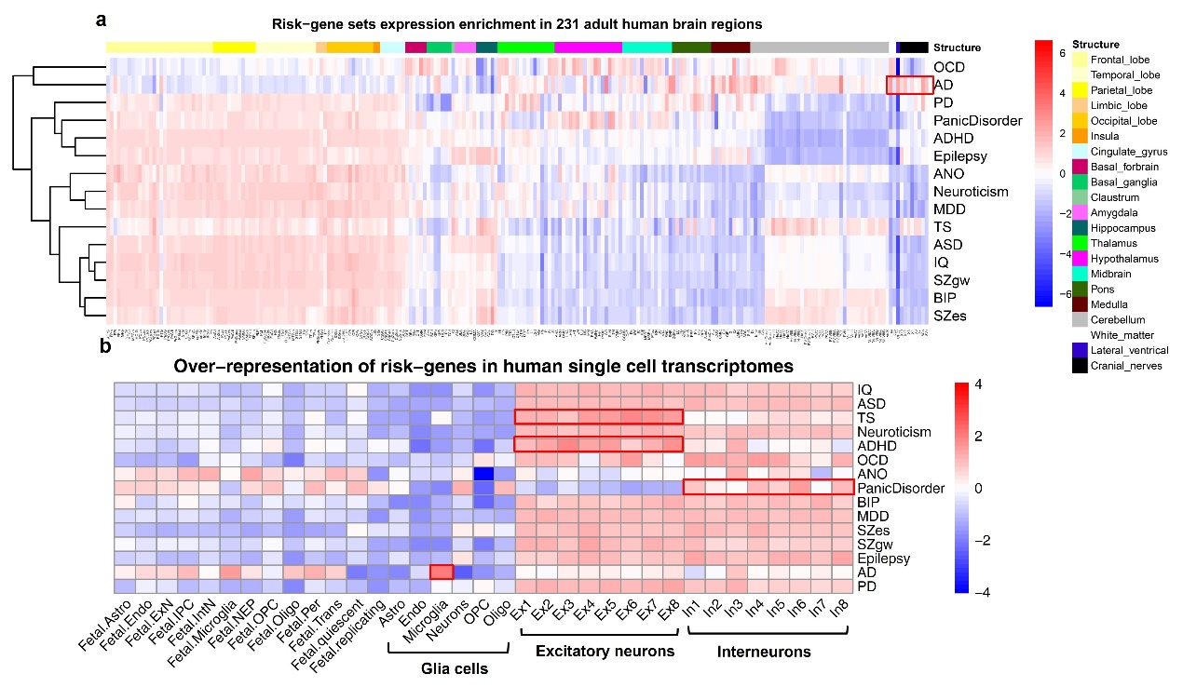
Fig. S3 Expression enrichment patterns of risk gene sets across anatomically refined brain regions and cell types.
(a) To generate a spatially refined, whole-brain map of risk gene set enrichment, we analyzed transcriptomic data from 231 anatomically defined brain regions in six adult human donors from the Allen Human Brain Atlas (AHBA) microarray dataset. Brain regions were ordered from anterior to posterior and from cortical to subcortical structures. Red and blue gradients represent Z-scored rank-biserial correlation coefficients derived from Mann–Whitney U tests. Hierarchical clustering grouped the 15 neuropsychiatric traits into distinct clusters based on spatial similarity in gene enrichment profiles. Most traits exhibited risk gene expression enrichment in the neocortex, with the notable exceptions of OCD and AD, which diverged by showing stronger enrichment in non-neocortical regions. In particular, AD risk genes were markedly enriched in the white matter, cranial nerves, and lateral ventricles—regions typically devoid of risk gene expression in other traits—supporting the widespread neuroanatomical involvement characteristic of AD pathology.
(b) To assess cell type–specific enrichment patterns, we analyzed a merged developmental single-cell RNA-seq dataset encompassing 35 annotated cell types derived from fetal (5–20 post-conception weeks) and adult neocortical tissues. Cell types were ordered from fetal to adult glial and neuronal populations. Z-scored rank-biserial correlation coefficients reflect the relative enrichment of risk gene expression across cell types. Consistent with panel (a), risk genes for most traits were preferentially enriched in adult neocortical neurons, with lower enrichment in fetal and glial populations, likely reflecting non-neocortical tissue sampling in fetal datasets. Among neuronal subtypes, panic disorder risk genes showed consistent enrichment in inhibitory neurons, whereas those for TS and ADHD were enriched in excitatory neurons. Notably, AD risk genes showed the strongest enrichment in microglia, aligning with inflammation-related mechanisms and the broad brain involvement in AD.
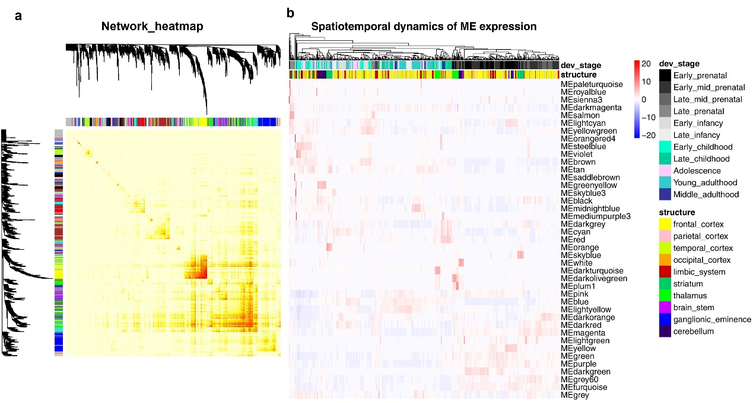
Fig. S4 WGCNA based spatiotemporal co-expression modules
Weighted Gene Co-expression Network Analysis (WGCNA) was applied on the BrainSpan transcriptomic dataset to identify modules of co-expressed genes across developmental stages and brain regions. A total of 41 co-expression modules were initially identified.
(a) Network heatmap visualizes the topological overlap matrix (TOM)-based dissimilarity among 400 randomly selected genes. The dissimilarity matrix (1 − TOM) was raised to the 7th power to enhance contrast, and hierarchical clustering was applied to organize the genes. Each gene is colored according to its assigned co-expression module, facilitating the identification of distinct module structures and network connectivity patterns.
(b) Spatiotemporal dynamics of module eigengene (ME) expression. Heatmap of the expression levels of 41 MEs across 521 BrianSpan transcriptomes, spanning 11 developmental stages and 10 major brain structures. Expression values are row-scaled for each ME, with hierarchical clustering performed on the samples. Sample annotations are color-coded by developmental stage and brain region, highlighting dynamic and region-specific co-expression module activity across human brain development. The heatmap illustrated significant enrichment of module genes expression in a spatiotemporal specific pattern.
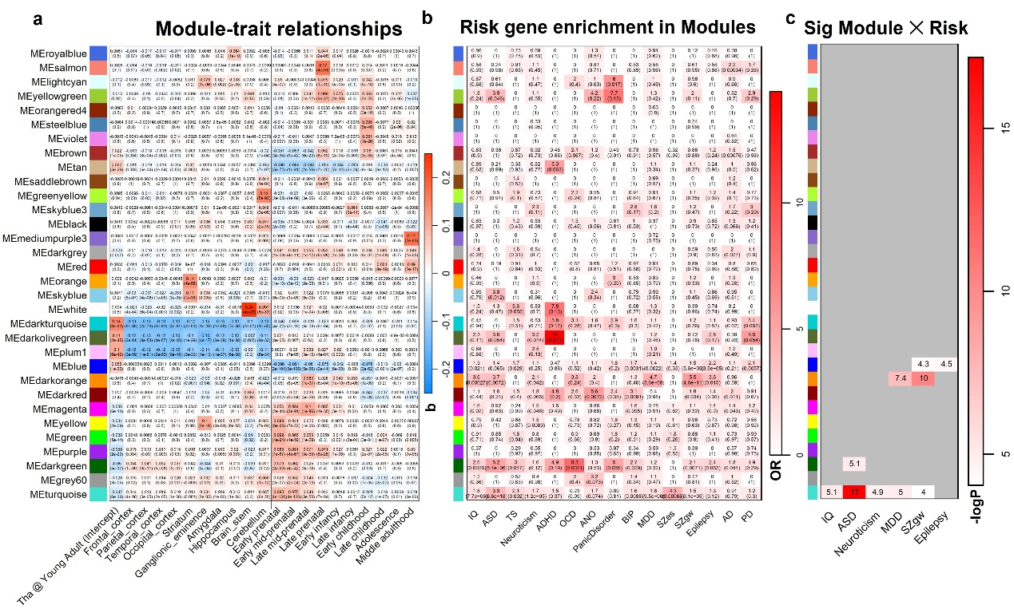
Fig. S5 Spatiotemporal regression of module eigengene (ME) expression and enrichment of neuropsychiatric risk genes.
(a) Linear regression models were used to assess the influence of brain region and developmental stage (encoded as dummy variables) on ME expression levels. The thalamus during young adulthood was set as the reference category and absorbed into the model intercept, which thus represents the baseline expression of each module. Predicted ME expression levels for other regions and developmental stages were computed by adding corresponding β coefficients to the intercept, allowing identification of spatiotemporal expression peaks ("hot-spots") for each module. Only 32 modules that showed the most significant spatial or temporal expression enrichment (with at least one β > 0.05 in the regression model) were retained for visualization in the heatmap. The β coefficients and P values are displayed in the Spatiotemporal variable × Module matrix, with red colors indicate enrichment of module gene expression and blue indicate deprivation.
(b) Enrichment of neuropsychiatric disorder risk gene sets across the 32 spatiotemporal modules. Odds ratios (ORs) and P values from chi-square tests are displayed in the Trait × Module matrix, with the color gradient indicating OR magnitude. Notably, the ADHD × MEdarkolivegreen combination showed the highest OR (14), though the P value was marginal (0.071), likely reflecting the limited size of the ADHD risk gene set. P values are uncorrected.
(c) Following Bonferroni correction for multiple testing (P < 0.05/15 traits/32 modules = 1.04 × 10⁻⁴), four modules remained significantly enriched for six disorder risk gene sets. Color gradients represent the −log₁₀-transformed raw P values, with the most significant enrichment observed in ASD × MEturquoise combination.
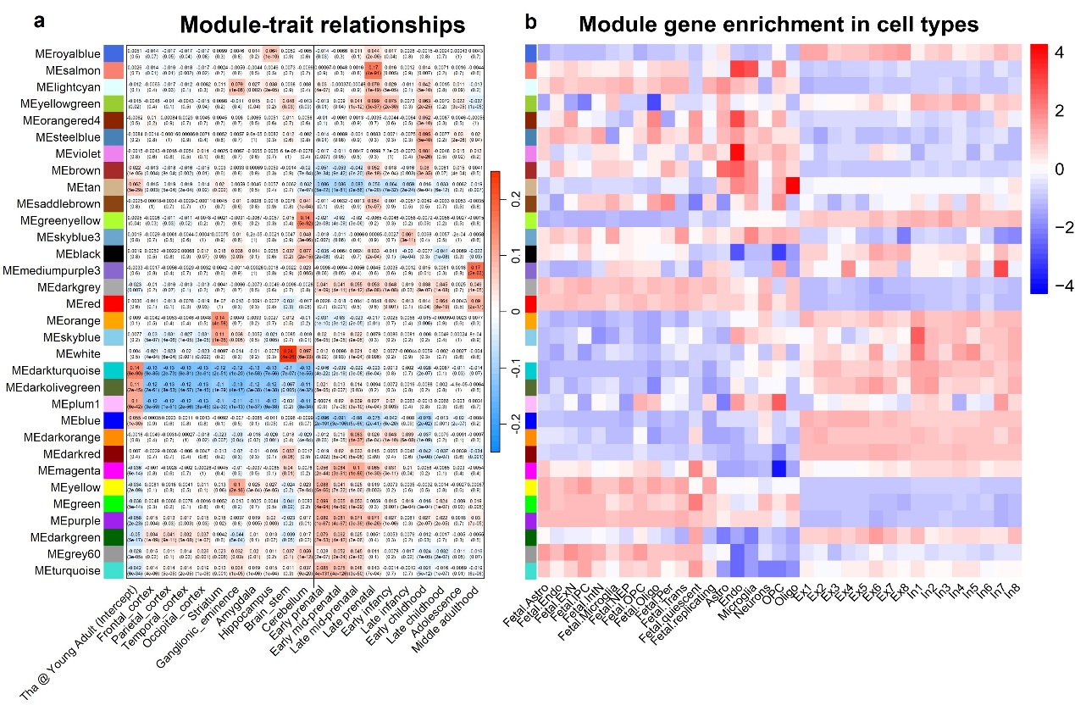
Fig. S6 Developmental cell type enrichment of spatiotemporal module genes.
(a) The same as Fig. S5a.
(b) Expression enrichment of WGCNA based co-expression module genes in the 35 developmental cell types were evaluated with Mann–Whitney U test. Red and blue color gradients indicate Z-scored rank-biserial correlation coefficients across cell types for each module. Cell types were ordered from fetal to adult glia, and to adult neurons. Note that, the modules enriched in glia cells are overrepresented during perinatal and early childhood stages, and modules enriched in fetal cell types show expression enrichment during early developmental stages.

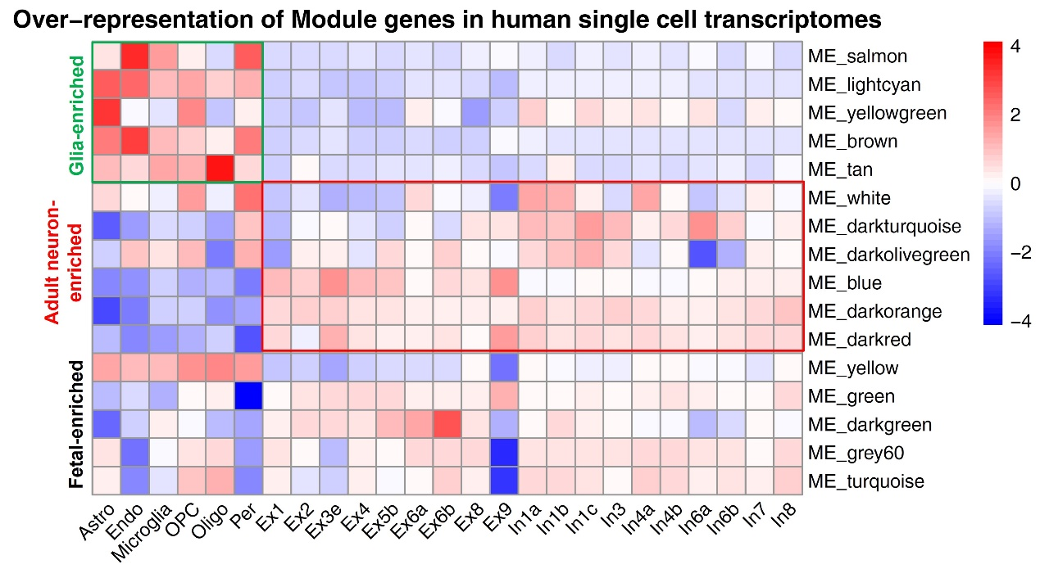
Fig. S7 Expression enrichment of the 16 significant modules in adult single cell dataset.
The enrichment of the 16 co-expression modules most strongly associated with neuropsychiatric disorders was assessed across 25 adult brain cell types using the Mann–Whitney U test. Red and blue color gradients represent Z-scored rank-biserial correlation coefficients for each module across cell types, which are ordered from glial to neuronal lineages. Notably, modules enriched in glial cell types in this adult single-cell dataset showed consistent enrichment patterns with those observed in the developmental dataset (Fig. S6), supporting the robustness of the results.

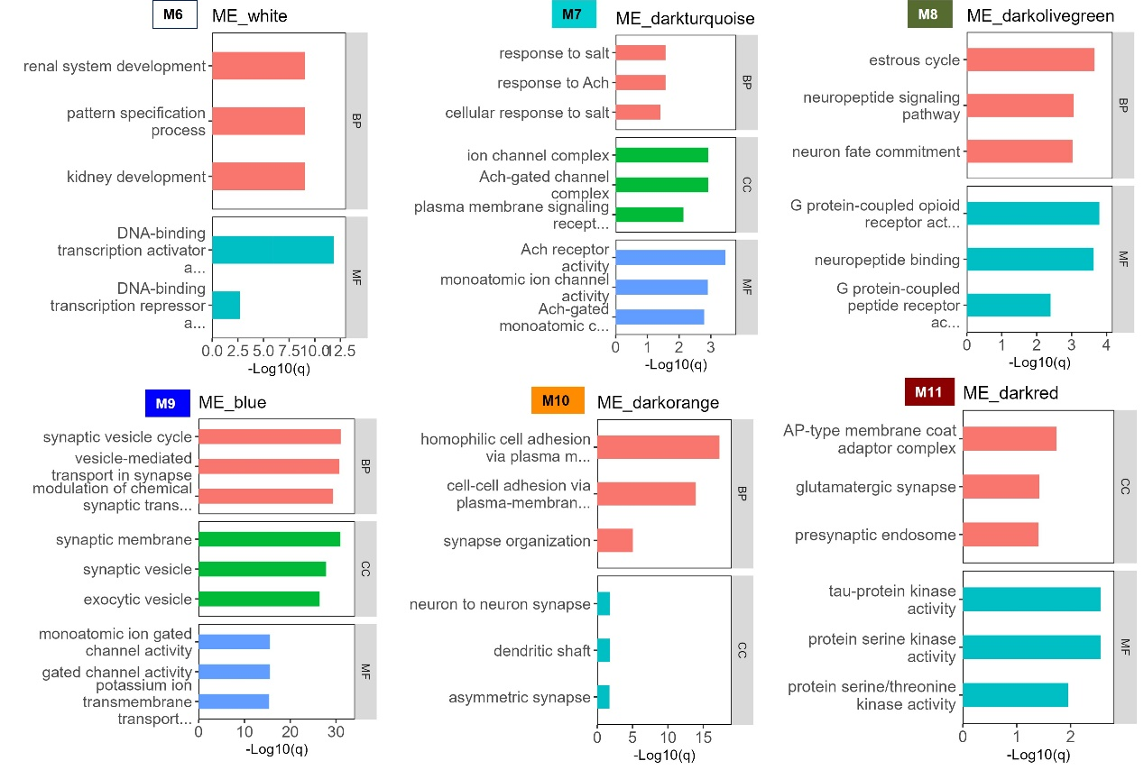
Fig. S8 Functional annotation of the Adult-neuron-enriched co-expression module genes.
Functional annotation of the Adult-neuron-enriched modules—M6-11—highlighted distinct Biological Processes (BP), Cellular Components (CC), and Molecular Functions (MF) implicated in neuropsychiatric disorders. The top three Gene Ontology (GO) terms in each category are shown; significance was determined using a q-value threshold of 0.05.

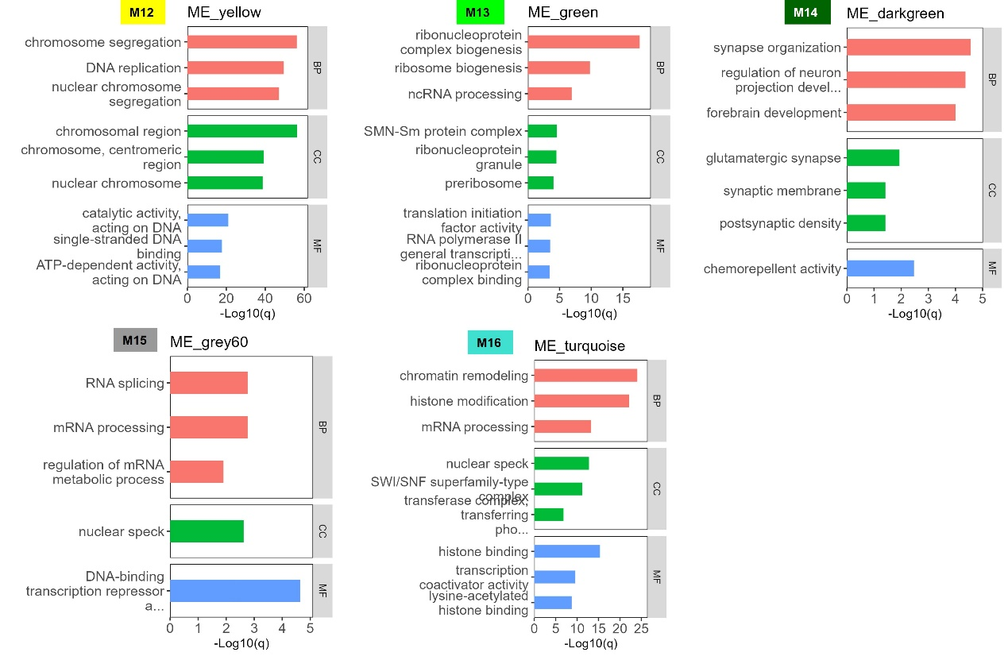
Fig. S9 Functional annotation of Fetal-enriched co-expressed module.
Functional annotation of the Fetal-enriched modules—M12-16—highlighted distinct BP, CC, and MF implicated in neuropsychiatric disorders. The top three GO terms in each category are shown; significance was determined using a q-value threshold of 0.05.

Fig. S10 KEGG pathway enrichment analysis of genes in the 16 disorder-related co-expression modules.
KEGG pathway enrichment analysis was performed for genes in each of the 16 co-expression modules most significantly associated with neuropsychiatric disorders. The results are displayed as a bubble plot, where each bubble represents a significantly enriched KEGG pathway. The x-axis corresponds to the module ID, and the y-axis indicates the pathway name. Bubble color represents the –log₁₀-transformed q-value, indicating the statistical significance of enrichment. Bubble size reflects the gene ratio. Only the top 3 significantly enriched pathways per module are shown. Enriched pathways reflect diverse biological processes in accordance with the corresponding GO items for each module, with the most significant pathway found was “cell cycle” for ME yellow (M12), which was associated with Neuroticism risks.
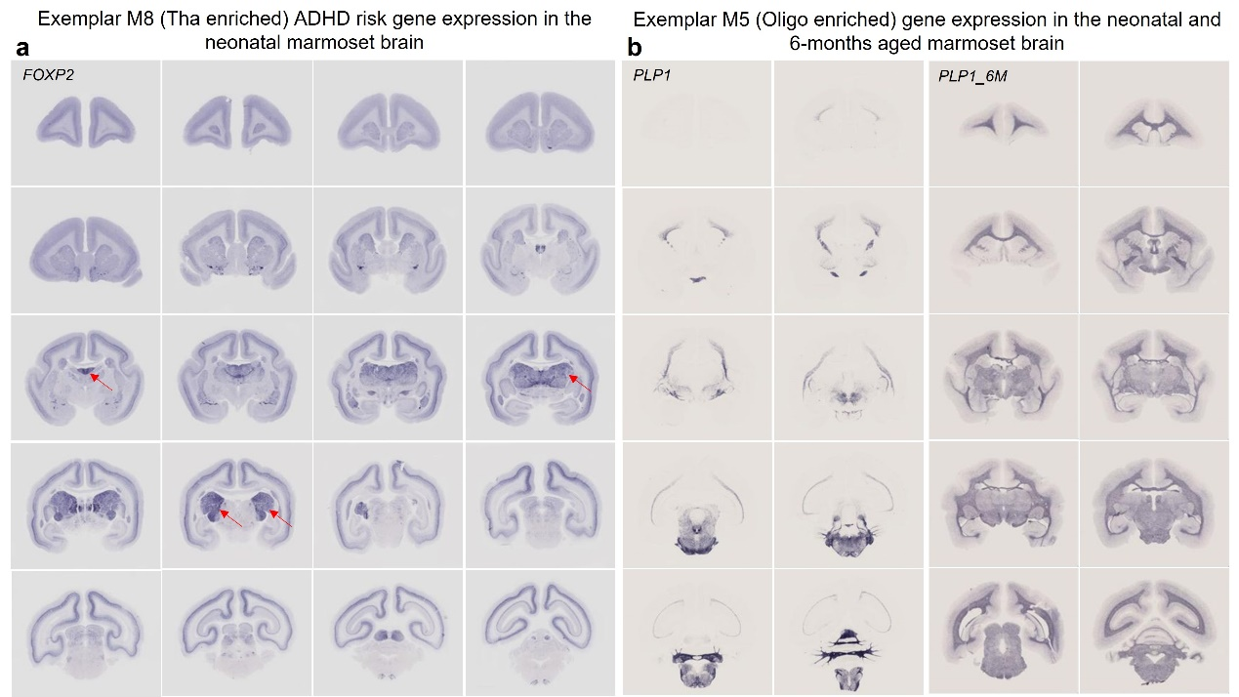
Fig. S11 Exemplar module-specific risk gene expression across the neonatal marmoset brain.
In situ hybridization (ISH) data from the neonatal marmoset brain were used to examine the whole-brain spatial expression patterns of representative risk genes from co-expression modules enriched for neuropsychiatric risk. (a) Representative M8 module gene (FOXP2), associated with ADHD and enriched in the thalamus, shows marked expression in the thalamic region of the neonatal marmoset brain. As indicated by red arrows, FOXP2 exhibits strong expression in the thalamus, consistent with the spatiotemporal expression pattern of M8 shown in Fig. 5a. (b) Representative M5 module gene (PLP1), overexpressed in the thalamus after adolescence and preferentially in the oligodendrocytes, shows distinct expression in the white matters in neonatal marmoset brain, which was upregulated at 6 months ages.

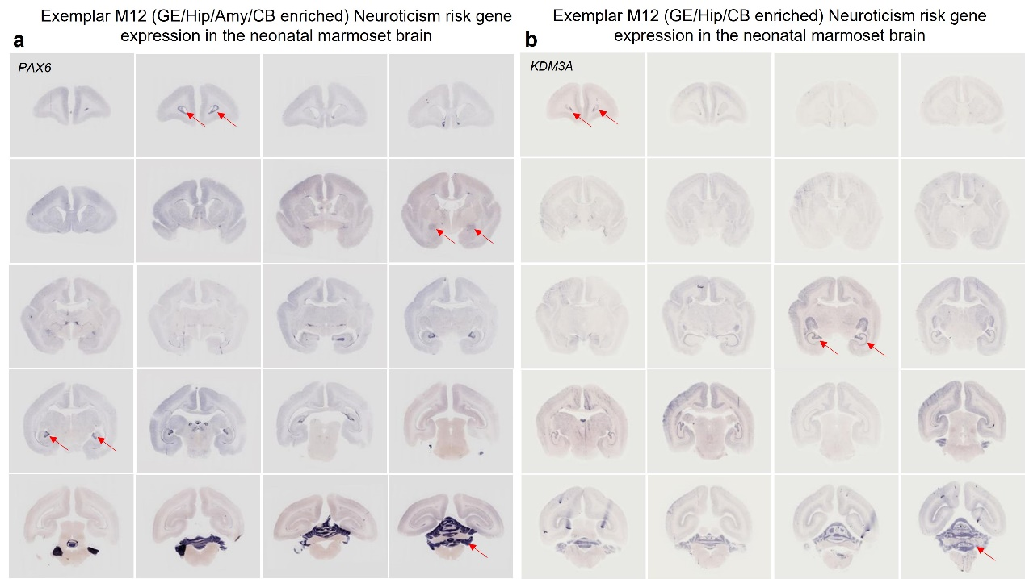
Fig. S12 Exemplar M12 Neuroticism risk gene expression across the neonatal marmoset brain.
In situ hybridization (ISH) data from the neonatal marmoset brain were used to evaluate the whole-brain spatial expression patterns of representative risk genes from co-expression module M12, which is enriched in the ganglionic eminence (GE), hippocampus (Hip), amygdala (Amy), and cerebellum (CB). (a) Representative M12 neuroticism risk gene PAX6 exhibits prominent expression in the ventricular zone, central amygdaloid nucleus, dentate gyrus, and cerebellum, as indicated by red arrows, consistent with the spatiotemporal expression pattern of M12 shown in Fig. 5. (b) Representative M12 neuroticism risk gene KDM3A shows marked expression in the ventricular zone, hippocampus, and cerebellum, also supporting the M12 module’s spatial expression pattern.

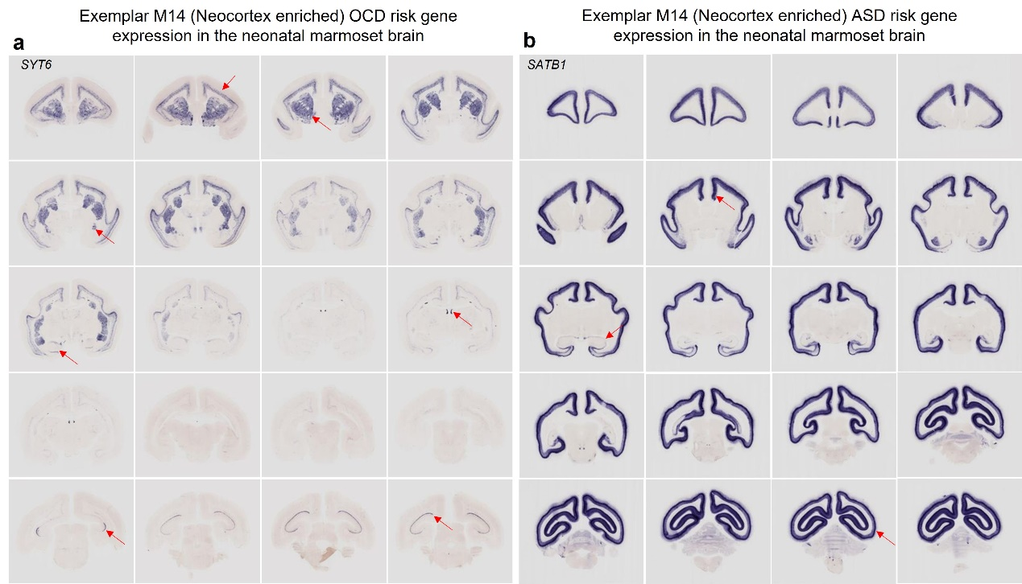
Fig. S13 Exemplar M14 OCD and ASD risk gene expression across the neonatal marmoset brain.
ISH data from the neonatal marmoset brain were used to examine the spatial expression of representative neuropsychiatric risk genes from co-expression module M14, which is enriched in the neocortex. (a) Representative M14 OCD risk gene SYT6 exhibits strong expression in the deep layers of the neocortex (specifically in V1 of the occipital cortex), as well as in the striatum, with weaker expression observed in the hippocampus and central amygdaloid nucleus. These patterns are consistent with the spatiotemporal expression profile of M14 shown in Fig. 5. (b) Representative M14 ASD risk gene SATB1 shows prominent expression in the neocortex and weaker expression in the hippocampus, in accordance with the spatial distribution pattern of M14.

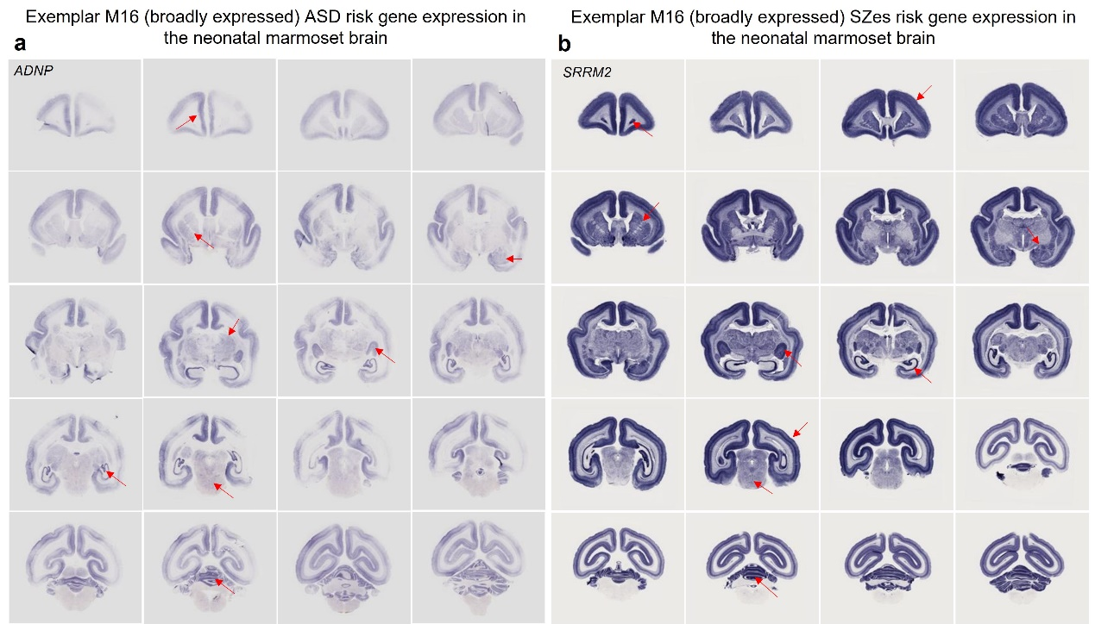
Fig. S14 Exemplar M16 ASD and SZes risk gene expression across the neonatal marmoset brain.
ISH data from the neonatal marmoset brain were used to examine the spatial expression of representative neuropsychiatric risk genes from co-expression module M16, which is broadly expressed during early neural development. (a) Representative M16 ASD risk gene ADNP exhibits widespread expression across the neonatal marmoset brain, consistent with the spatiotemporal expression profile of M16 shown in Fig. 5. (b) Representative M16 SZes risk gene SRRM2 shows prominent and widespread expression in the neonatal brain, in accordance with the spatial distribution pattern of M16.

Contents of Supplementary tables

Table S1. Data supporting Fig. 2a, Enrichment of control gene sets in Brainspan samples
Table S2. Data supporting Fig. 2b, Fig. S1a, Enrichment of 31 risk gene sets in Brainspan samples
Table S3. Data supporting Fig. 2, Fig. S1b, Enrichment of 15 traits risk gene set in Brainspan samples
Table S4. Data supporting Fig. 3b, Top 3 Hot-spots for each of the 15 traits
Table S5. Data supporting Fig. S2, Jaccard similarities between the 15 merged risk gene sets
Table S6. Data supporting Fig. S3a, Enrichment of 15 traits risk gene set in AHBA
Table S7. Data supporting Fig. S3b and Fig. S7, Enrichment of the 15 risk gene sets in single cell transcriptomes
Table S8. Structures shared between AHBA and ENIGMA
Table S9. Data supporting Fig. 4, Visualization of the spatial enrichment patterns of the 15 risk gene sets
Table S10. Data supporting Fig. S4b, The 41 WGCNA based co-expression modules
Table S11. Data supporting Fig. 5a and Fig. S5, Spatiotemporal expression and risk gene enrichment of 32 modules
Table S12. Data supporting Fig. 5b and Fig. S6b, Enrichment of module genes in single cell types
Table S13. GO terms enriched in the 16 top co-expression modules

