High-Performance, Temperature Retardant and Hydrophobic BiCoO₃:PDMS Piezoelectric Nanogenerator for Effective Energy Harvesting in Harsh Environments
Dhiraj Kumar Bharti^{1,2*}, Sandeep Kumar,^{3,4} Jitendra Pratap Singh^{1,2*}
¹Nanoscale Research Facility, Indian Institute of Technology Delhi, Hauz Khas, New Delhi 110016, India
²Department of Physics, Indian Institute of Technology Delhi, Hauz Khas, New Delhi 110016, India
³Department of Chemistry, Indian Institute of Technology Delhi, Hauz Khas, New Delhi 110016, India
⁴Department of Chemistry, Motilal Nehru College, University of Delhi, Benito Juarez Marg, New Delhi 110021, India

*Corresponding author: E-mail: jpsingh@physics.iitd.ac.in, dbharti5141@gmail.com; Telephone: 011-26591323 Fax 011-26591323

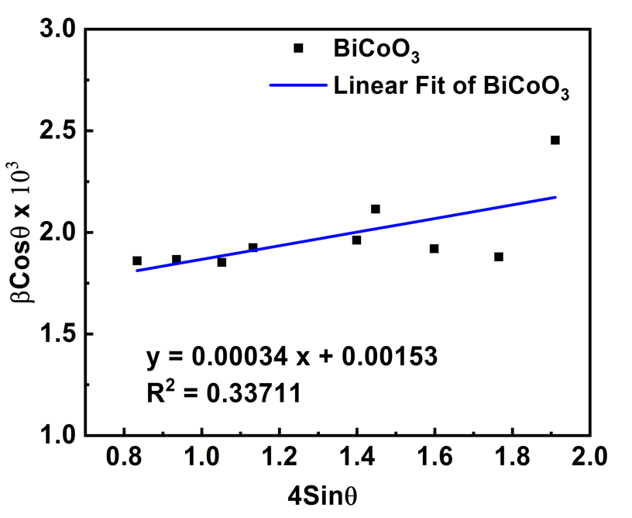

Fig. S1. Williamson-Hall of BiCoO₃ nanoparticles

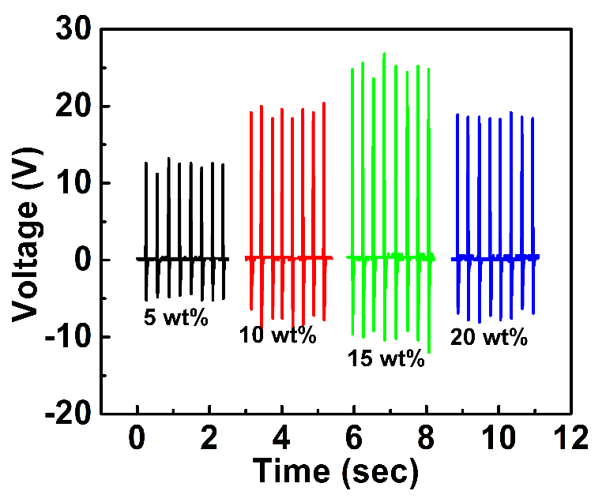
Fig. S2. Output voltage response of PENG measured at different concentrations of BiCoO₃ in PDMS matrix.

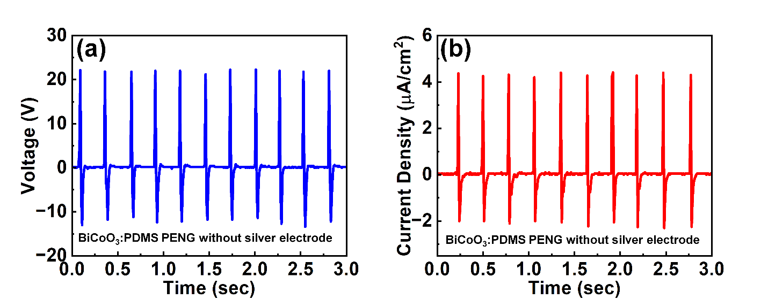
Fig. S3. a Output voltage and b current density of the PENG with ITO/PET as a counter electrode under the 0.15 kgf force.

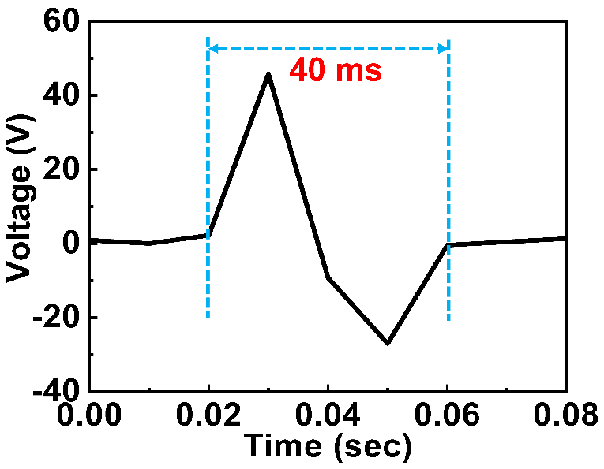
Fig. S4. Response time of PENG.

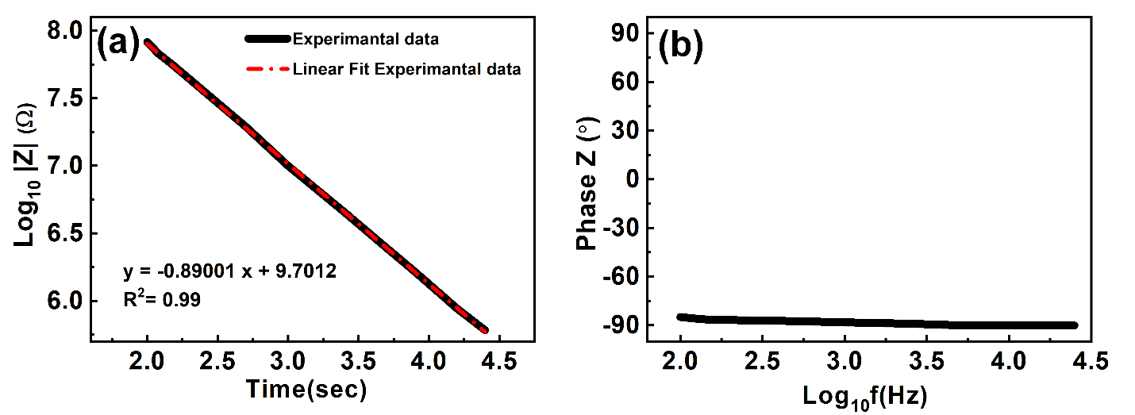
Fig. S5. a logarithm plot between the Z modulus vs applied frequency and b logarithmic graph between the Z phase vs applied frequency of BiCoO₃:PDMS nanocomposite film.

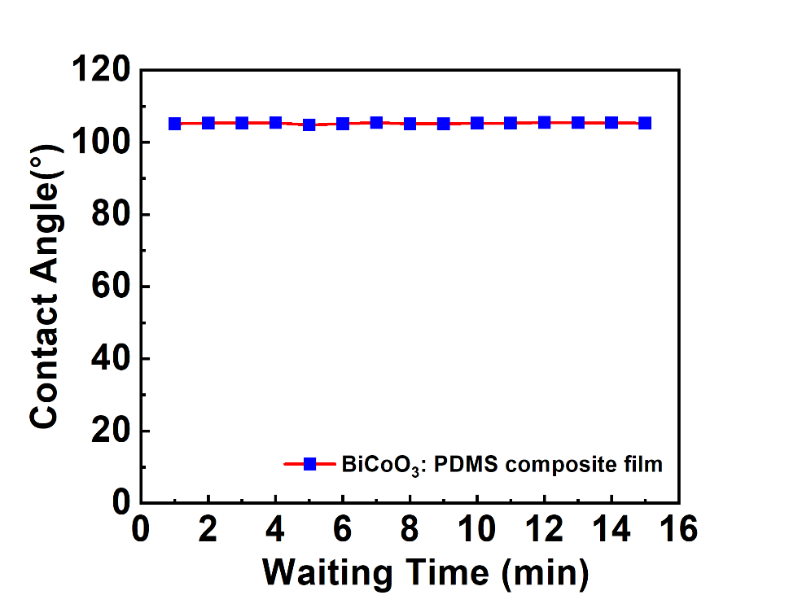
Fig. S6. The waiting time vs contact angle of water on BiCoO₃:PDMS nanocomposite film.

Parameters of Contact Angle measurements are:
- Fitting Method: Young Laplace
- DropType: Sessile drop
- Temperature: 25 °C
- Drop phase: water
- Surrounding phase: Air
- Gravitational acceleration: 9.80665 m/s²

Section S7. Calculation of cost per Piezoelectric Nanogenerator
1. Price of ITO coated PET substrate (4 cm x 2 cm) = $ 0.31
2. Cost of chemical utilized per device = $ 0.816
3. Overhead Charges (8%) = $ 0.08

Video V1: https://drive.google.com/file/d/1ra0L7k4sarICaiCg9XvYZyQRu_7WeRgo/view?usp=share_link

