Supplementary Information

Low-frequency ionic-electronic coupling for energy-efficient noise-resilient wireless bioelectronics
Ji Hong Kim¹†, Haerim Kim²†, Jaewon Rhee², Joo Sung Kim^{1‡}, Hanbin Choi¹, Won Hyuk Choi¹, Seungyoung Ahn^{2*}, and Do Hwan Kim^{1,3,4*}

¹Department of Chemical Engineering, Hanyang University, Seoul 04763, Republic of Korea.
²Cho Chun Shik Graduate School of Mobility, Korea Advanced Institute of Science and Technology, Daejeon 34051, Republic of Korea.
3Institute of Nano Science and Technology, Hanyang University, Seoul 04763, Republic of Korea.
⁴Clean-Energy Research Institute, Hanyang University, Seoul 04763, Republic of Korea.
†These authors contributed equally to this work.
‡Current address: Thin-Film Device Laboratory, RIKEN, 2-1 Hirosawa, Wako, Saitama 351-0198, Japan.

*Corresponding authors’ email: sahn@kaist.ac.kr (S.A.), dhkim76@hanyang.ac.kr (D.H.K.)

This PDF file includes:
Supplementary Figures 1 to 20
Supplementary Table 1 to 3

Supplementary Figures

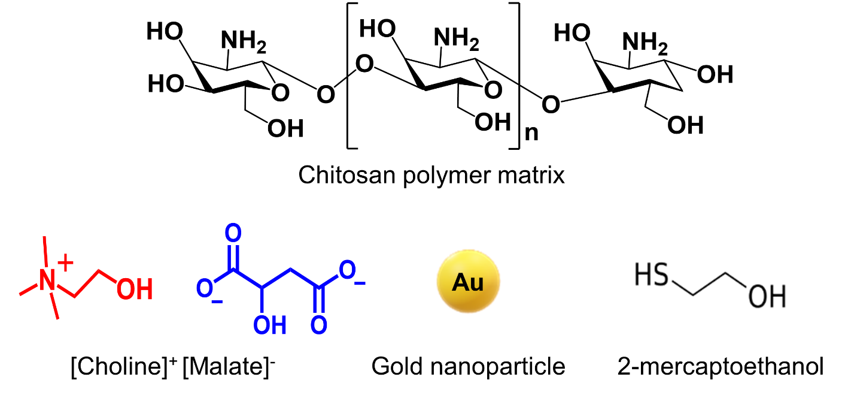
Supplementary Fig. 1 | Molecular structures of the wireless low-frequency electrochemical sensor
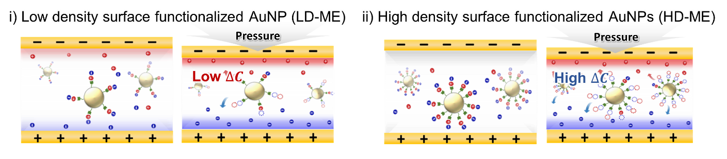
Supplementary Fig. 2 | Comparison of capacitance change induced by pressure in low(left) and high (right) functionalization surfaces of gold nanoparticles. The surface with high functionalization density shows a significantly higher capacitance change (ΔC) compared to the low functionalization surface, resulting in enhanced sensitivity.

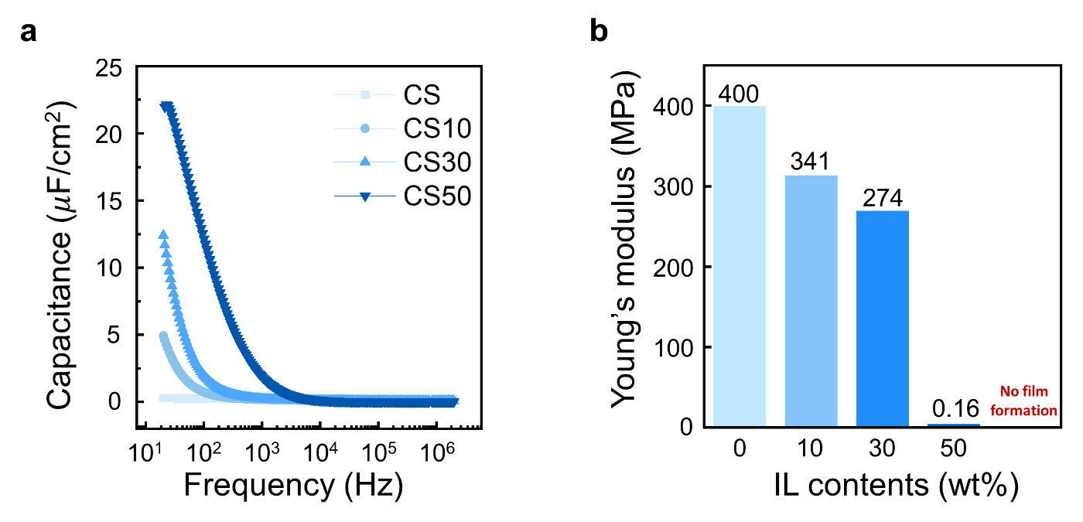
Supplementary Fig. 3 | Electrical and mechanical properties of chitosan-based ion gel a, Frequency-dependent capacitance of chitosan pristine ion gel with various ionic liquid content (0-50wt%). b, Young’s modulus of chitosan pristine ion gel with various ionic liquid content (0-50wt%).

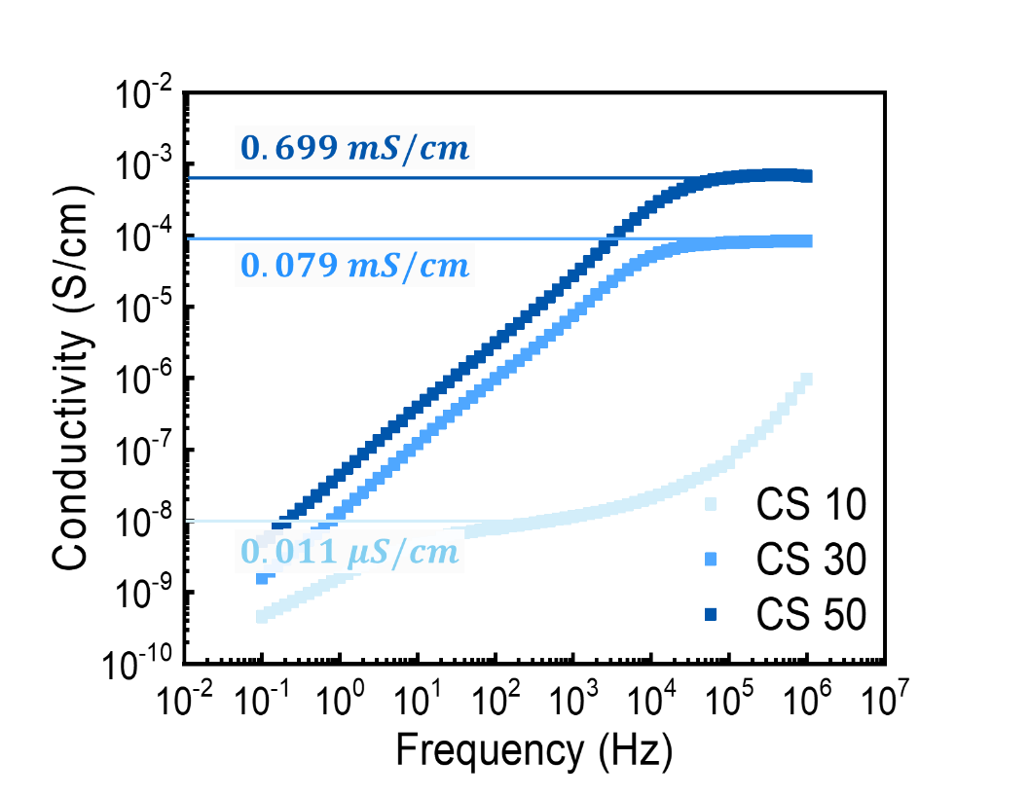
Supplementary Fig. 4 | Ionic conductivity from bode plots for pristine ion gel with various ion contents. As the ionic liquid content increases from 10 wt% to 50 wt%, the ionic conductivity increases dramatically.

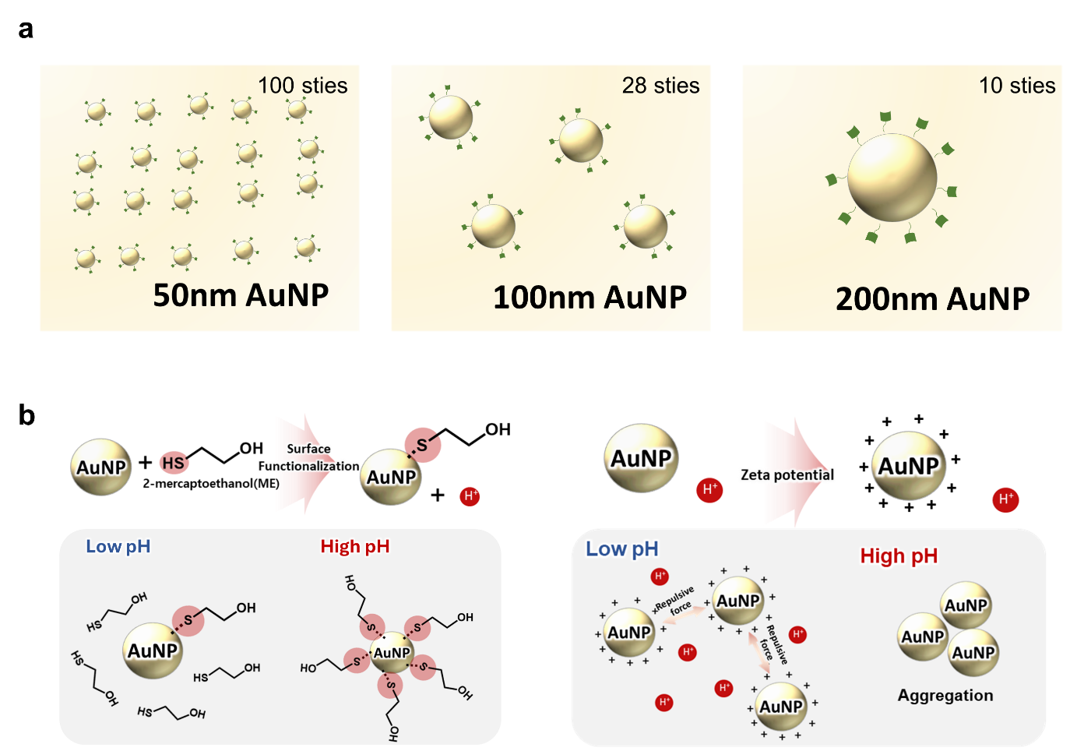
Supplementary Fig. 5 | Differences of surface functionalized density by (a) size of gold nanoparticle, and (b) synthetic pH condition.

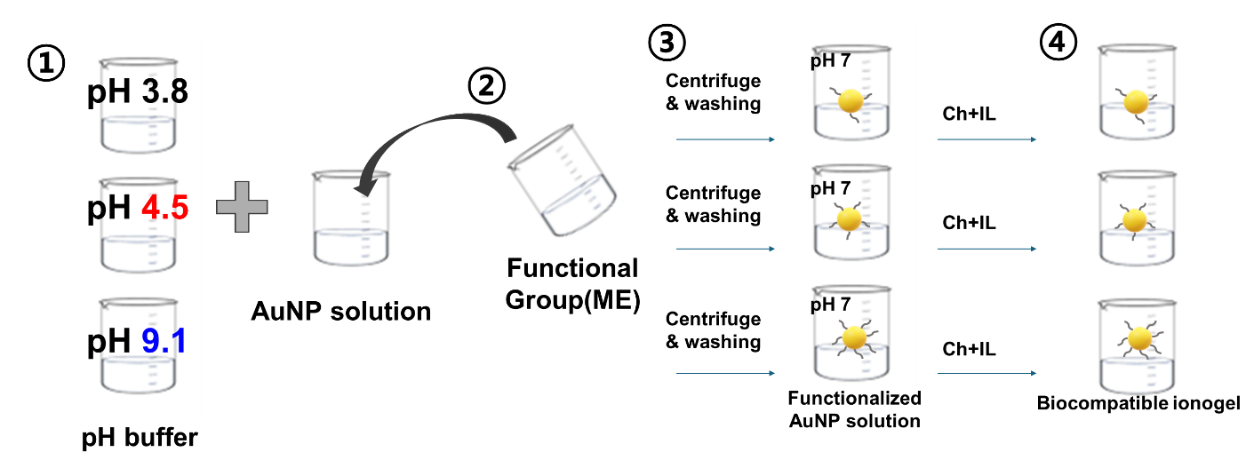
Supplementary Fig. 6 | Synthesis of functionalized gold nanoparticles. Schematics illustrates the synthesis process of functionalized gold nanoparticles.

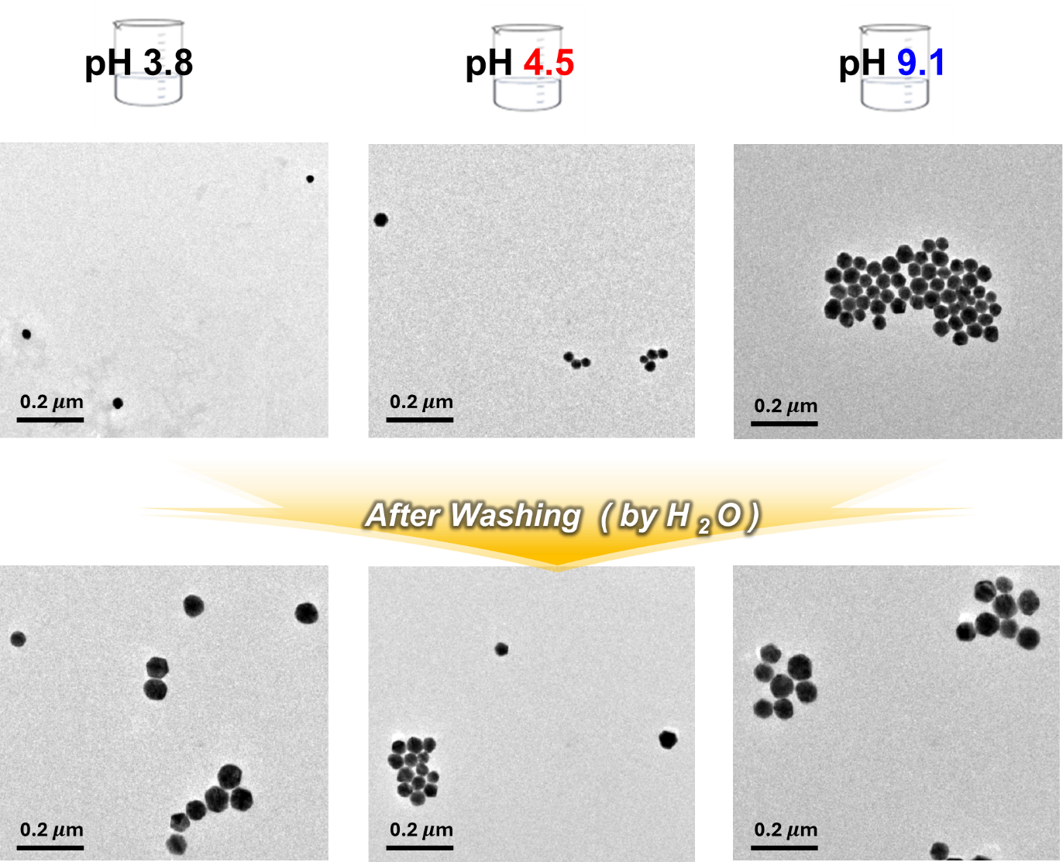
Supplementary Fig. 7 | TEM images of gold nanoparticles under different conditions displaying the aggregations of gold nanoparticles by varying pH conditions.

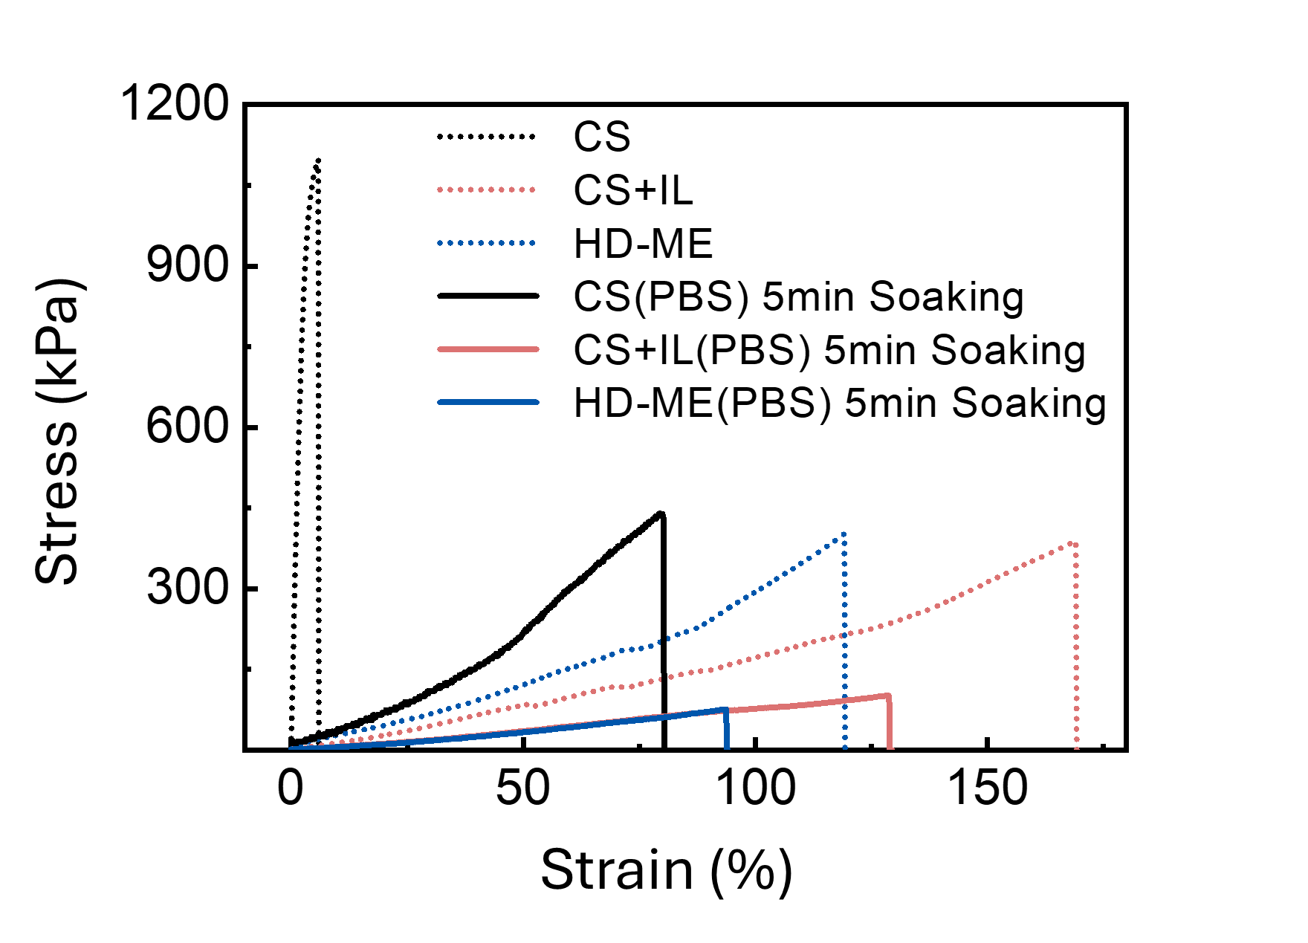
Supplementary Fig. 8 | Stress–strain curves of pristine chitosan(CS) gel, chitosan with ionic liquid(CS+IL) ion gel, and high-density surface functionalized gold nanoparticle(HD-ME) ion gel comparing before and after soaking in PBS buffer.

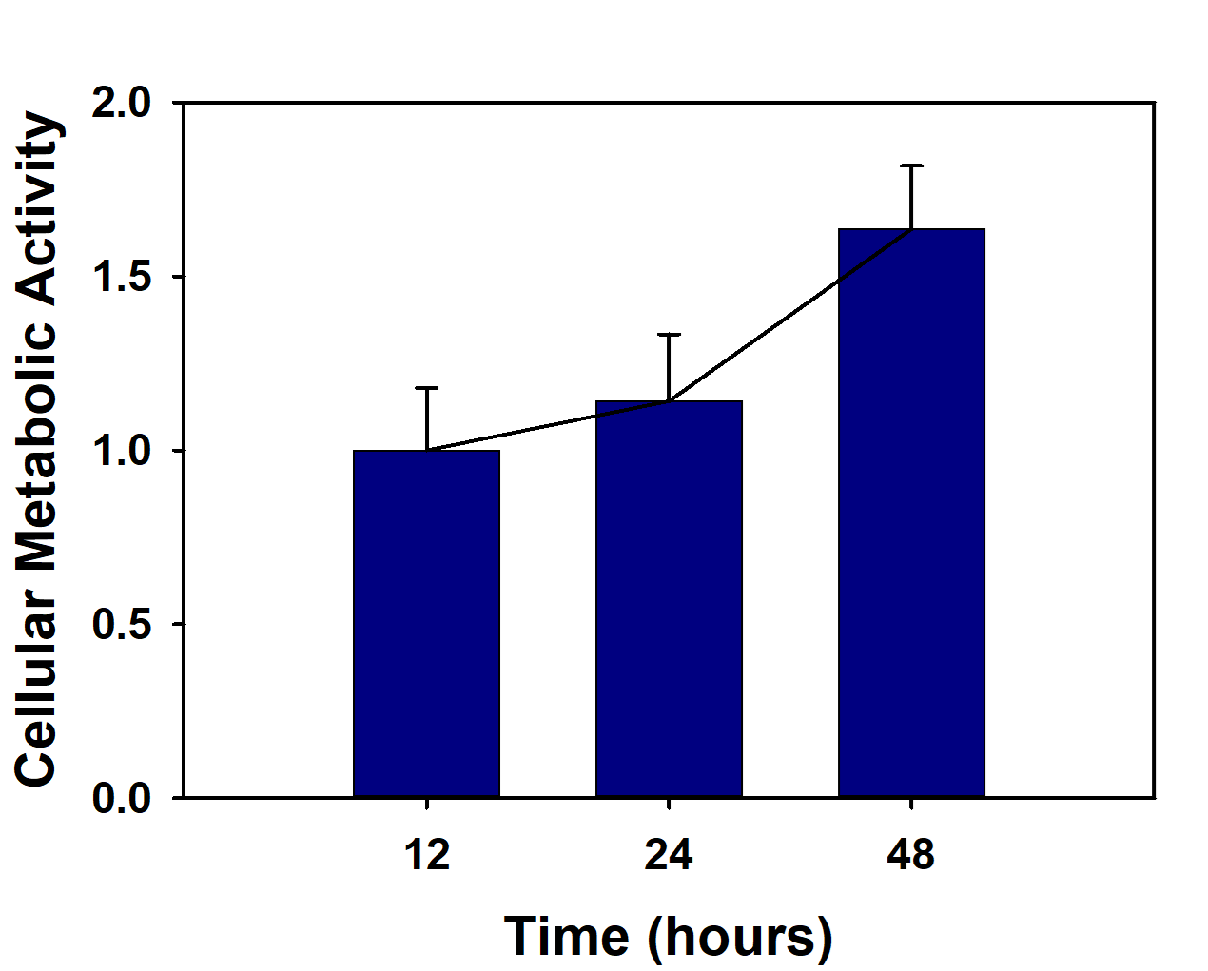
Supplementary Fig. 9 | Cellular metabolic activity of HD-ME ion gel over time (12-48 hours).

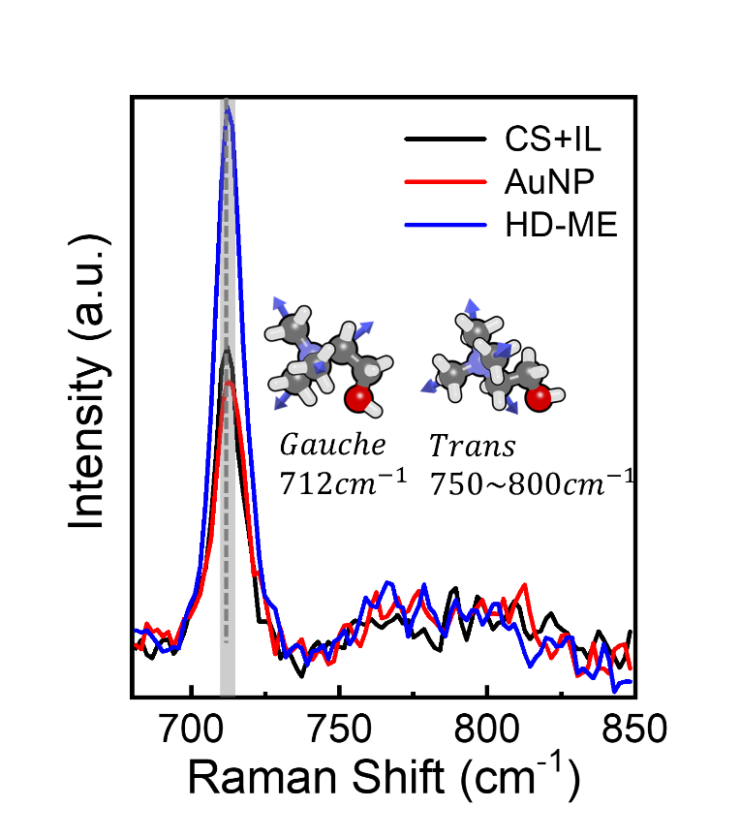
Supplementary Fig. 10 | The Raman spectra in the spectral range 680–850 cm⁻¹ corresponding to choline cation conformation in various ion gel.

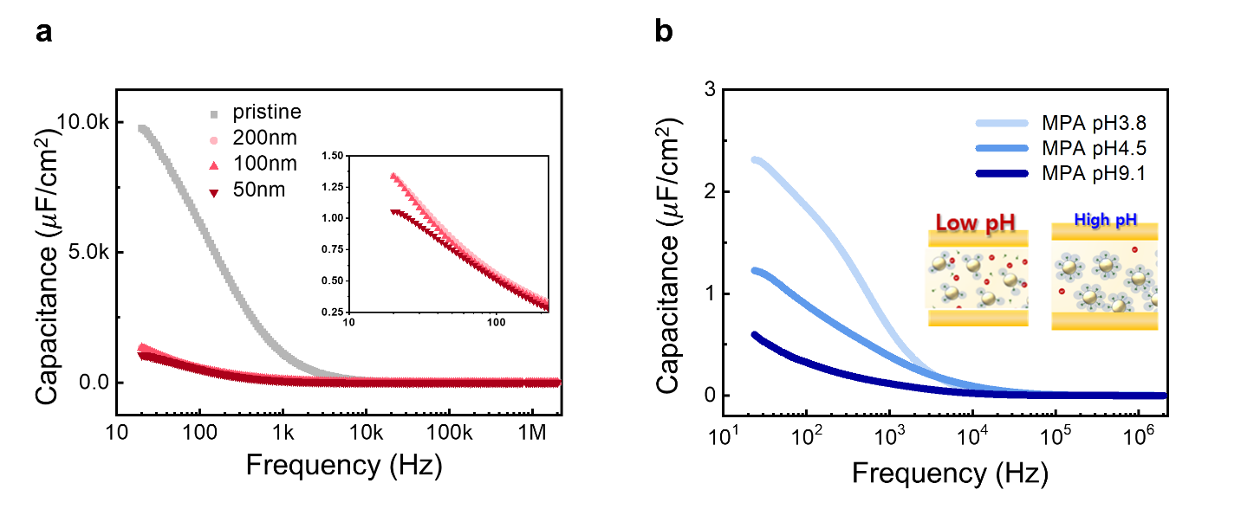
Supplementary Fig. 11 | Comparison of capacitance change as a function of frequency. The capacitance change was analyzed by different functionalized condition (a) gold nanoparticle size (50-200nm) and (b) synthesizing pH condition (pH 3.8-pH9.1) The capacitance change to frequency decrease with higher surface functionalization density.

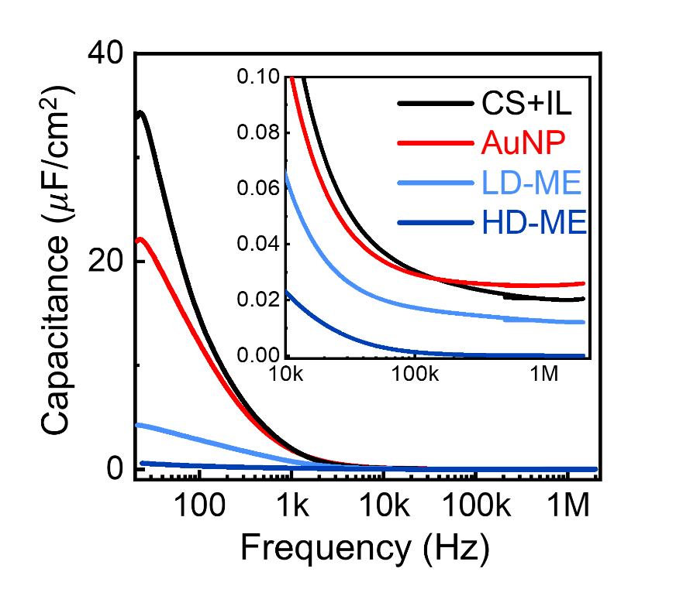
Supplementary Fig. 12 | Frequency vs. capacitance plots of various material-based ion gels. The strong ion-trapping effect of gold nanoparticles results in lower capacitance across various frequency ranges (20-2MHz).

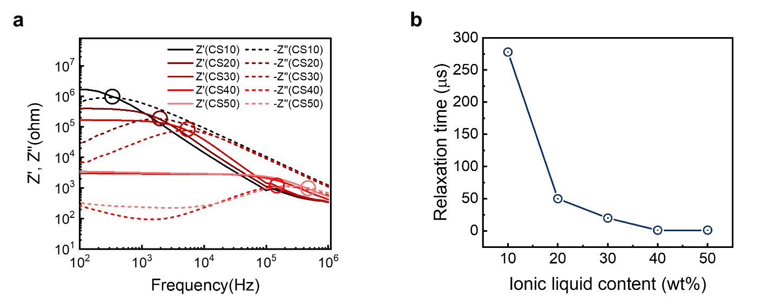
Supplementary Fig. 13 | Ion dynamics of chitosan-based ion gel. a, Frequency-dependent impedance spectra of the pristine ion gel, showing real (solid line) and imaginary (dashed line) components at varying ionic concentrations. b, Relaxation time values corresponding to different ionic liquid contents, derived from the impedance spectra.

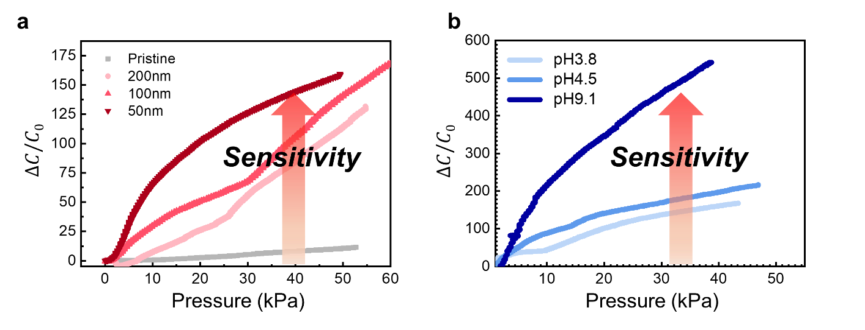
Supplementary Fig. 14 | Comparison of capacitance change as a function of applied pressure. The capacitance change was analyzed by different functionalized condition (a) gold nanoparticle size (50-200nm) and (b) synthesizing pH condition (pH 3.8-pH 9.1). The sensitivity of capacitance changes to pressure increases with higher surface functionalization density.

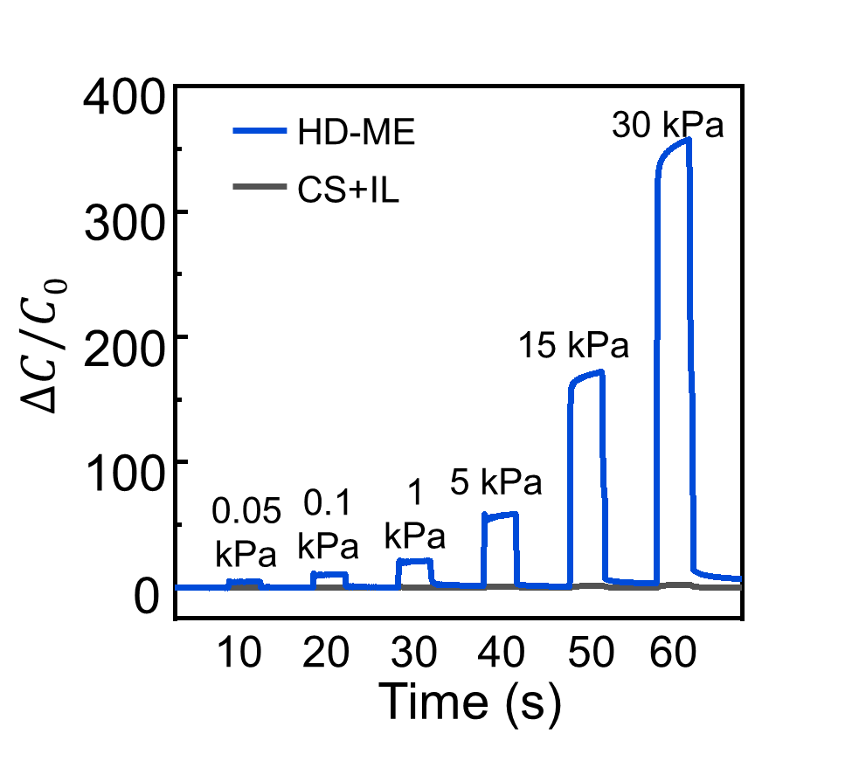
Supplementary Fig. 15 | Performance of pressure sensor based ion gels. Plots of relative change in capacitance as a function of applied pressures (0.05kPa, 0.1kPa, 1kPa, 5kPa, 15kPa, and 30kPa) comparison between HD-ME and CS+IL iongel.

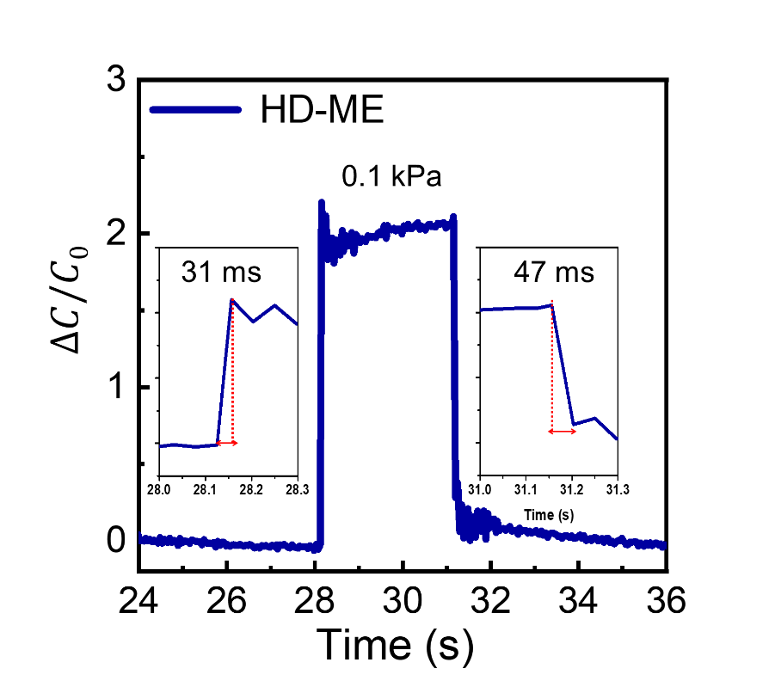
Supplementary Fig. 16 | Dynamic response of HD-ME ion gel based ionic capacitive pressure sensor. Transient response of HD-ME ion gel based ionic capacitive pressure sensor under 0.1 kPa. The inset shows a magnified curve representing a response time of 31 ms and a reset time of 47 ms, applied bias at 1V at 100 kHz.

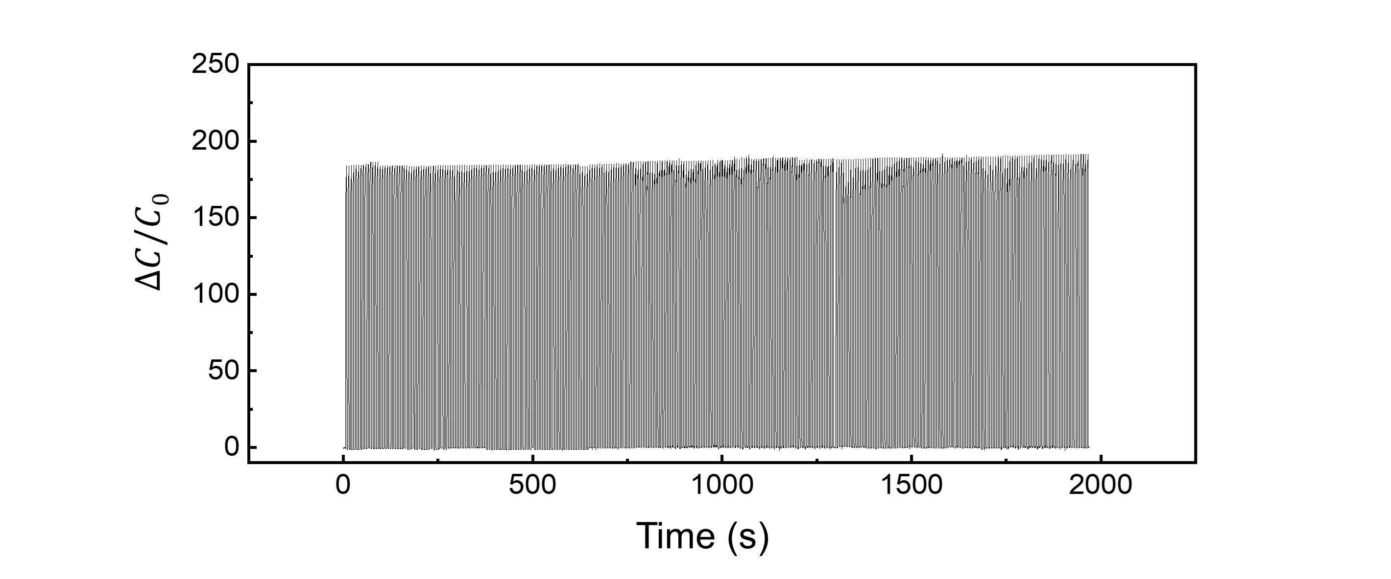
Supplementary Fig. 17 | Reliability of HD-ME ion gel based ionic capacitive pressure sensor. Mechanical durability test results of the HD-ME ion gel based sensor (700 cycles) applied bias at 1V at 100 kHz.

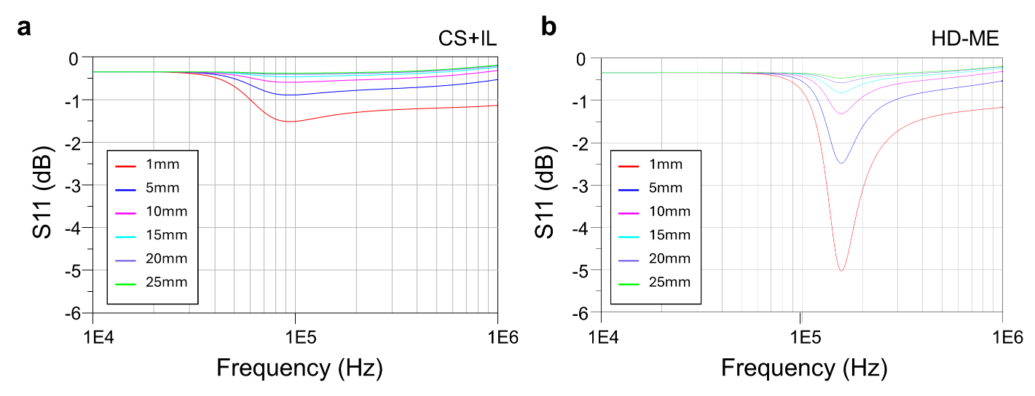
Supplementary Fig. 18 | Simulation results of sensitivity according to the air gap between the sensor coil and the reader coil (a) CS+IL ion gel, (b) HE-ME ion gel.

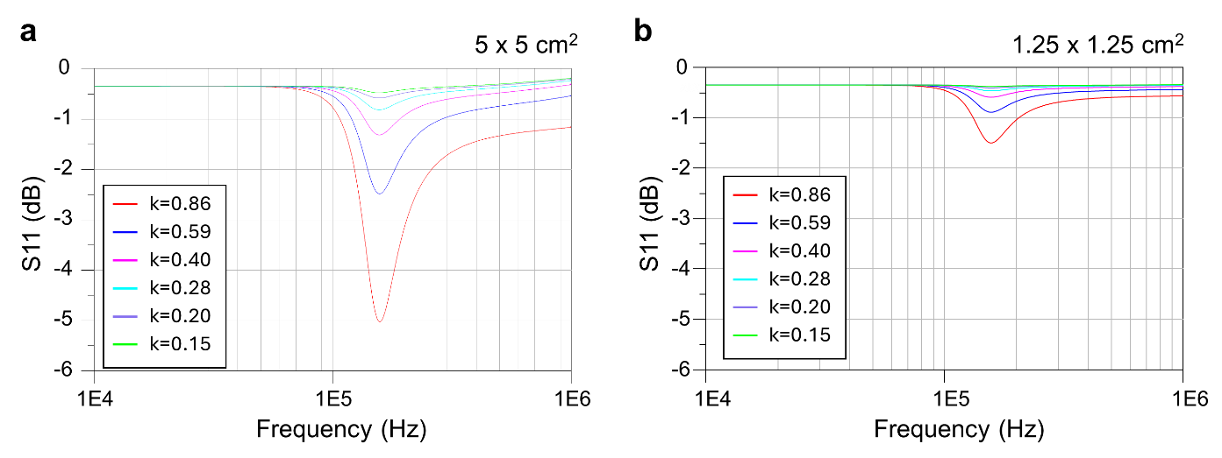
Supplementary Fig. 19 | Comparison of measurement sensitivity based on antenna size (a) 5 x 5 cm² and (b) 1.25 x 1.25 cm².

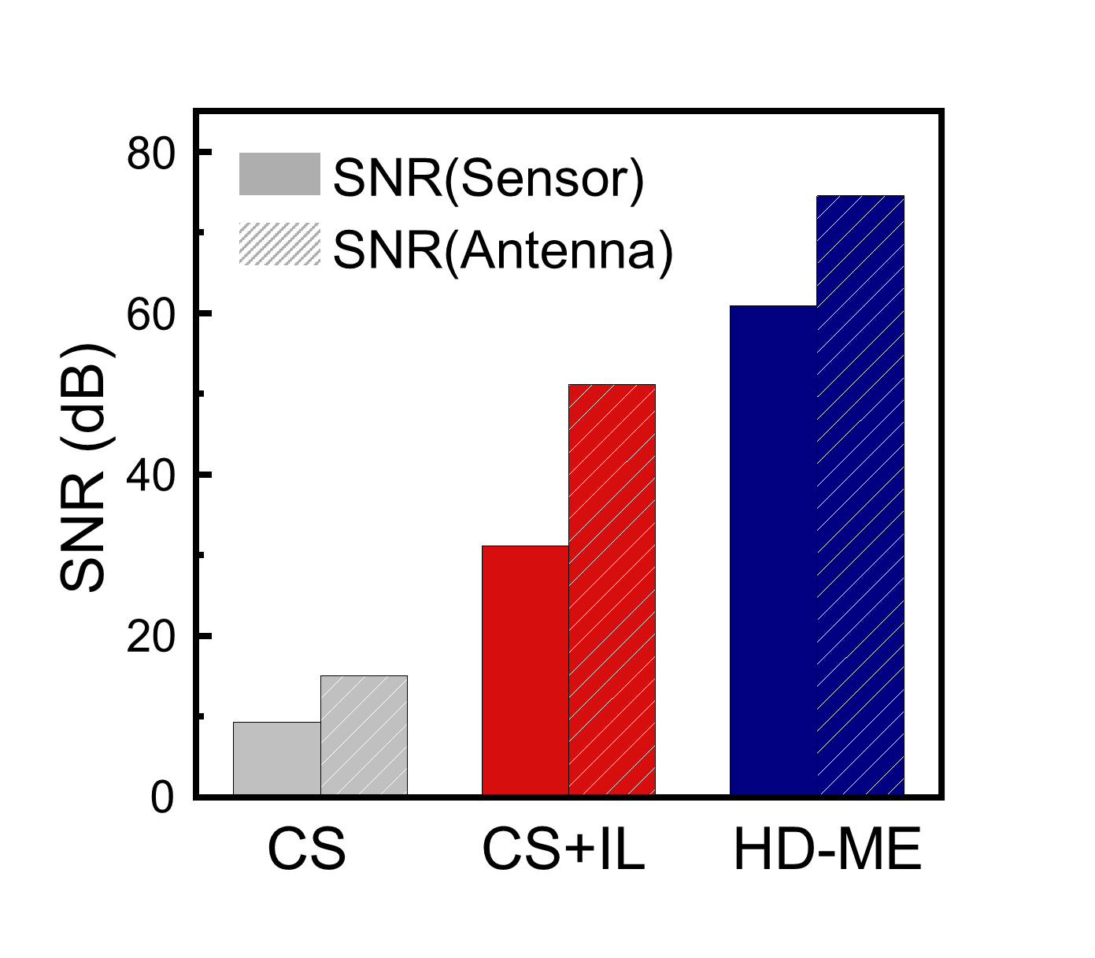
Supplementary Fig. 20 | Signal to noise ration of WiLECS platform with various materials.

Supplementary Tables

Supplementary Table. 1 | Quantitative comparison of reported wireless pressure sensors, summarizing their sensitivity and operating frequency ranges.
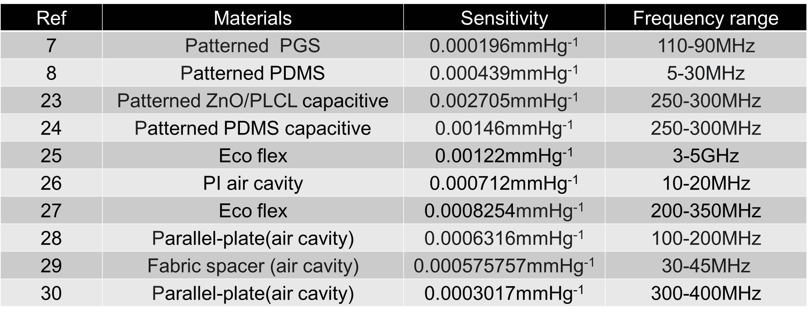
Supplementary Table. 2 | Simulation results of sensitivity according to the air gap between the sensor coil and the reader coil.
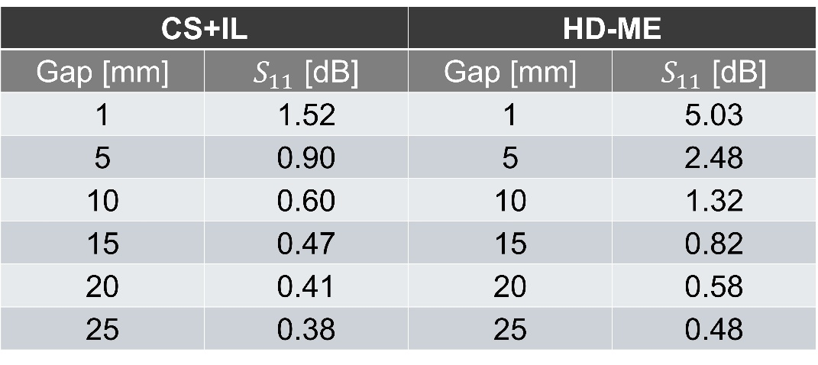

Supplementary Table. 3 | Comparison of measurement sensitivity based on antenna size.
