Supplementary Information
High-entropy driven electronic and microstructural synergy for superior capacitive energy storage in lead-free ceramics
Yunting Li¹, Peng Li^{1*}, Haihua Huang¹, Hairui Bai², Fei Xu¹, Jigong Hao¹, Peng Fu¹, Juan Du¹, Zhongbin Pan³, Wangfeng Bai⁴, Wei Li^{1*}, Jiwei Zhai^{5*}, Zhenxiang Cheng^{6*}
¹School of Materials Science and Engineering, Liaocheng University, Liaocheng 252059, China
²Shandong Laboratory of Advanced Materials and Green Manufacturing at Yantai, Yantai 264000, China
³School of Materials Science and Chemical Engineering, Ningbo University, Ningbo 315211, China
⁴College of Materials and Environmental Engineering, Hangzhou Dianzi University, Hangzhou 310018, China
⁵School of Materials Science and Engineering, Tongji University, Shanghai 201804, China
⁶Institute for Superconducting and Electronic Materials, University of Wollongong, Wollongong 2500, Australia

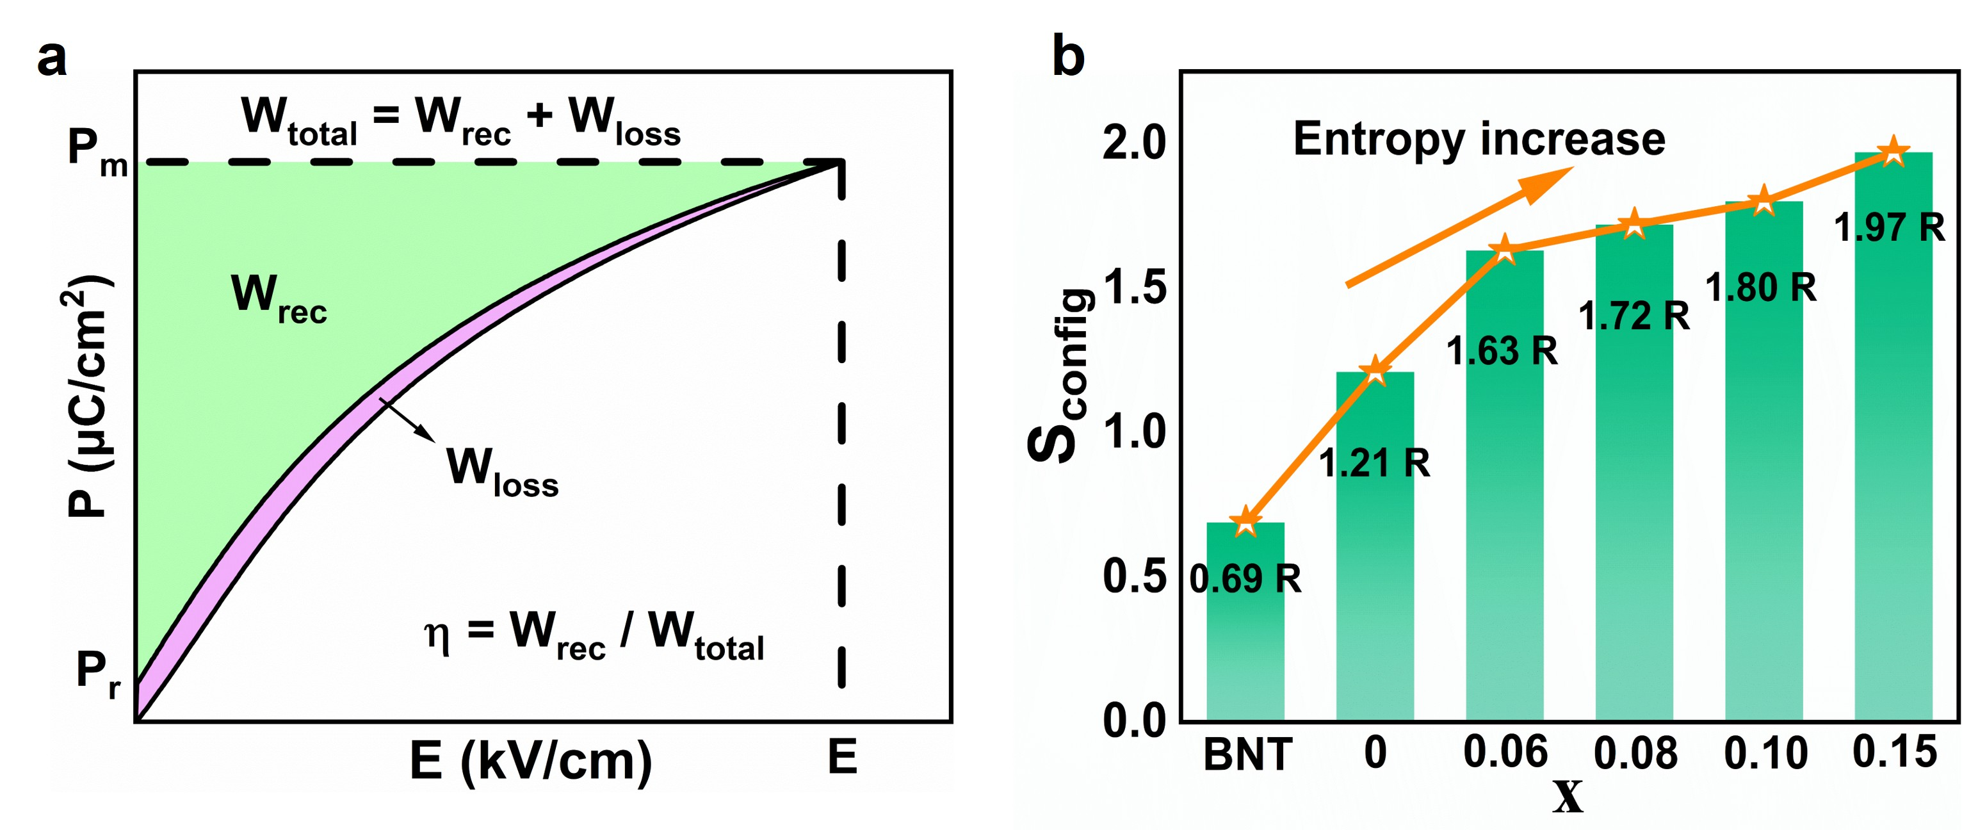
Fig. S1 a Schematic illustration of a unipolar P-E hysteresis loop, defining key parameters for energy storage performance: recoverable energy density (W_{rec}), total energy density (W_{total}), efficiency (η), maximum polarization (P_{max}), and remnant polarization (P_{r}). b Configuration entropy (S_{config}) values for BNT and BNSLT-xBMT ceramics with x = 0, 0.06, 0.08, 0.10, and 0.15.
The S_{config} values are determined to be 0.69R, 1.21R, 1.63R, 1.72R, 1.80R, and 1.97R for BNT and x = 0 - 0.15 ceramics, respectively. When S_{config} < 1R, the material is classified as low-entropy. When 1R ≤ S_{config} < 1.5R, it is considered a medium-entropy material. When S_{config} ≥ 1.5R, the material is defined as high-entropy.

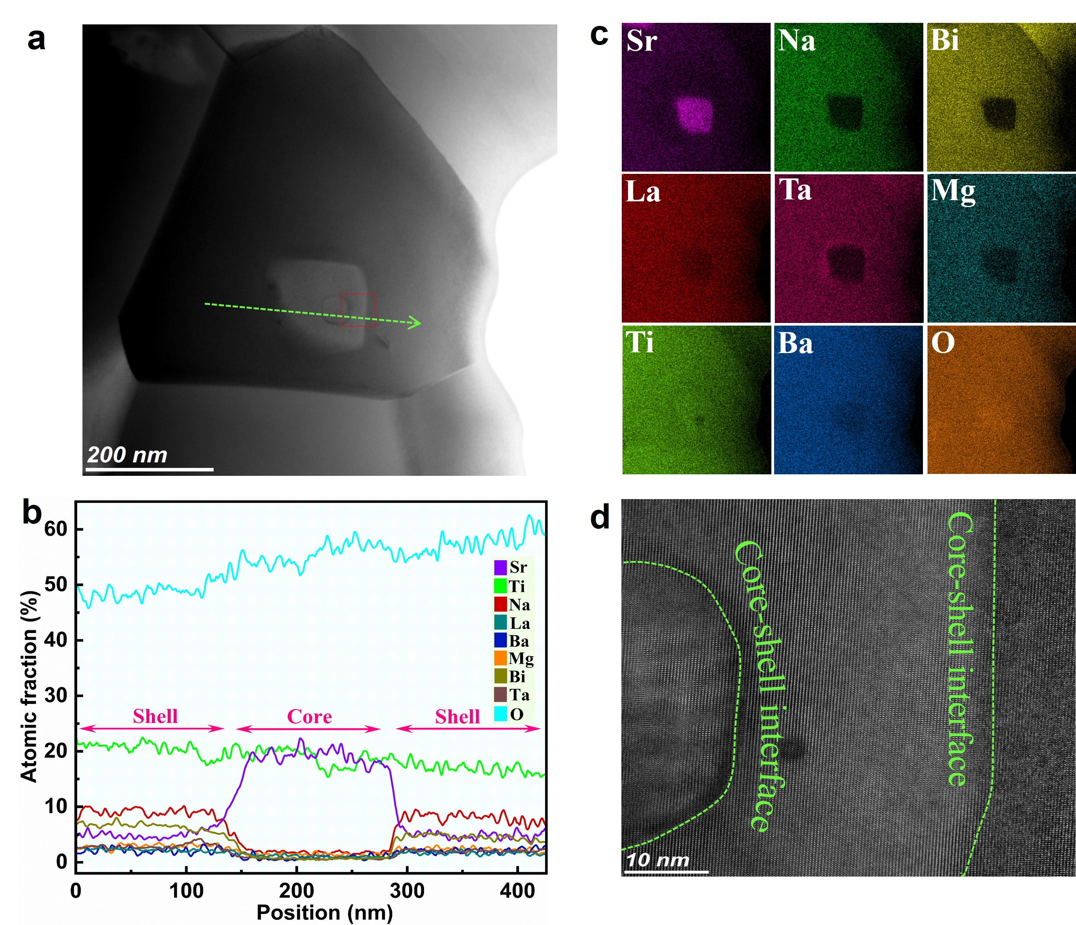
Fig. S2 Additional TEM characterization of the core-shell structure (x = 0.10). a Bright-field STEM image of a core-shell grain. b EDS line scan profile (along the green arrow in a) across a core-shell interface. c Corresponding EDS elemental mapping. d HRTEM lattice fringe image.
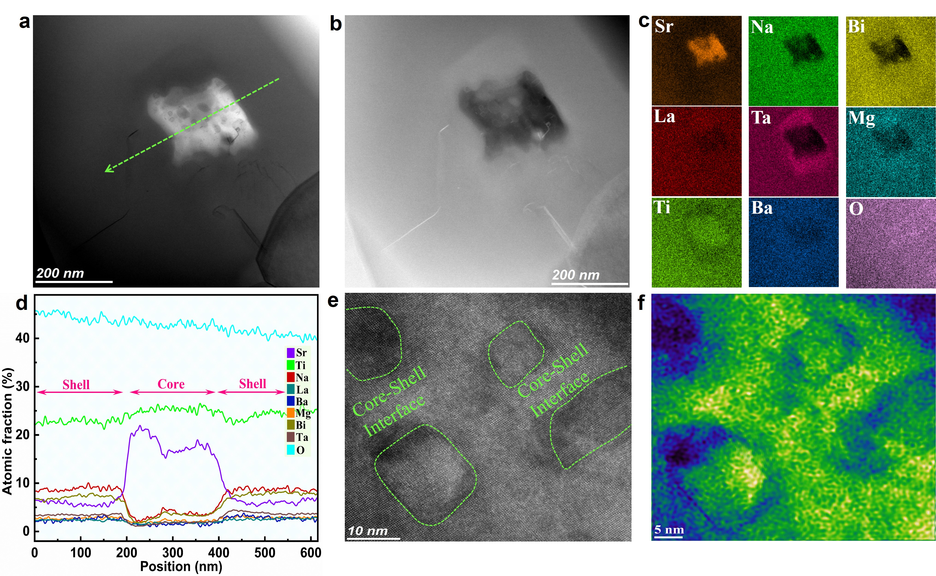
Fig. S3 Additional TEM and EDS analysis of the core-shell structure (x = 0.10). a Bright-field and b HAADF-STEM images of multinuclear-type core-shell grain. c EDS elemental mapping. d EDS line scan profile (along the green arrow in a) across the core-shell interface. e HRTEM lattice fringe image of a series of well-defined core-shell interfaces. f Corresponding IFFT image.
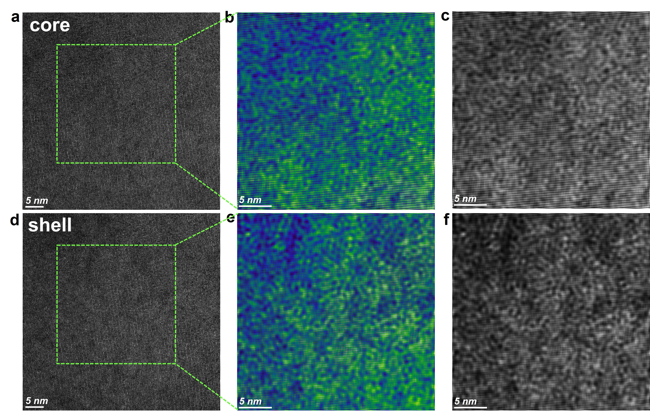
Fig. S4 HRTEM and IFFT analysis of core and shell regions (x = 0.10). HRTEM lattice fringe images of the core a and shell d regions. b, c, e, f Corresponding IFFT images for the areas marked in a and d.
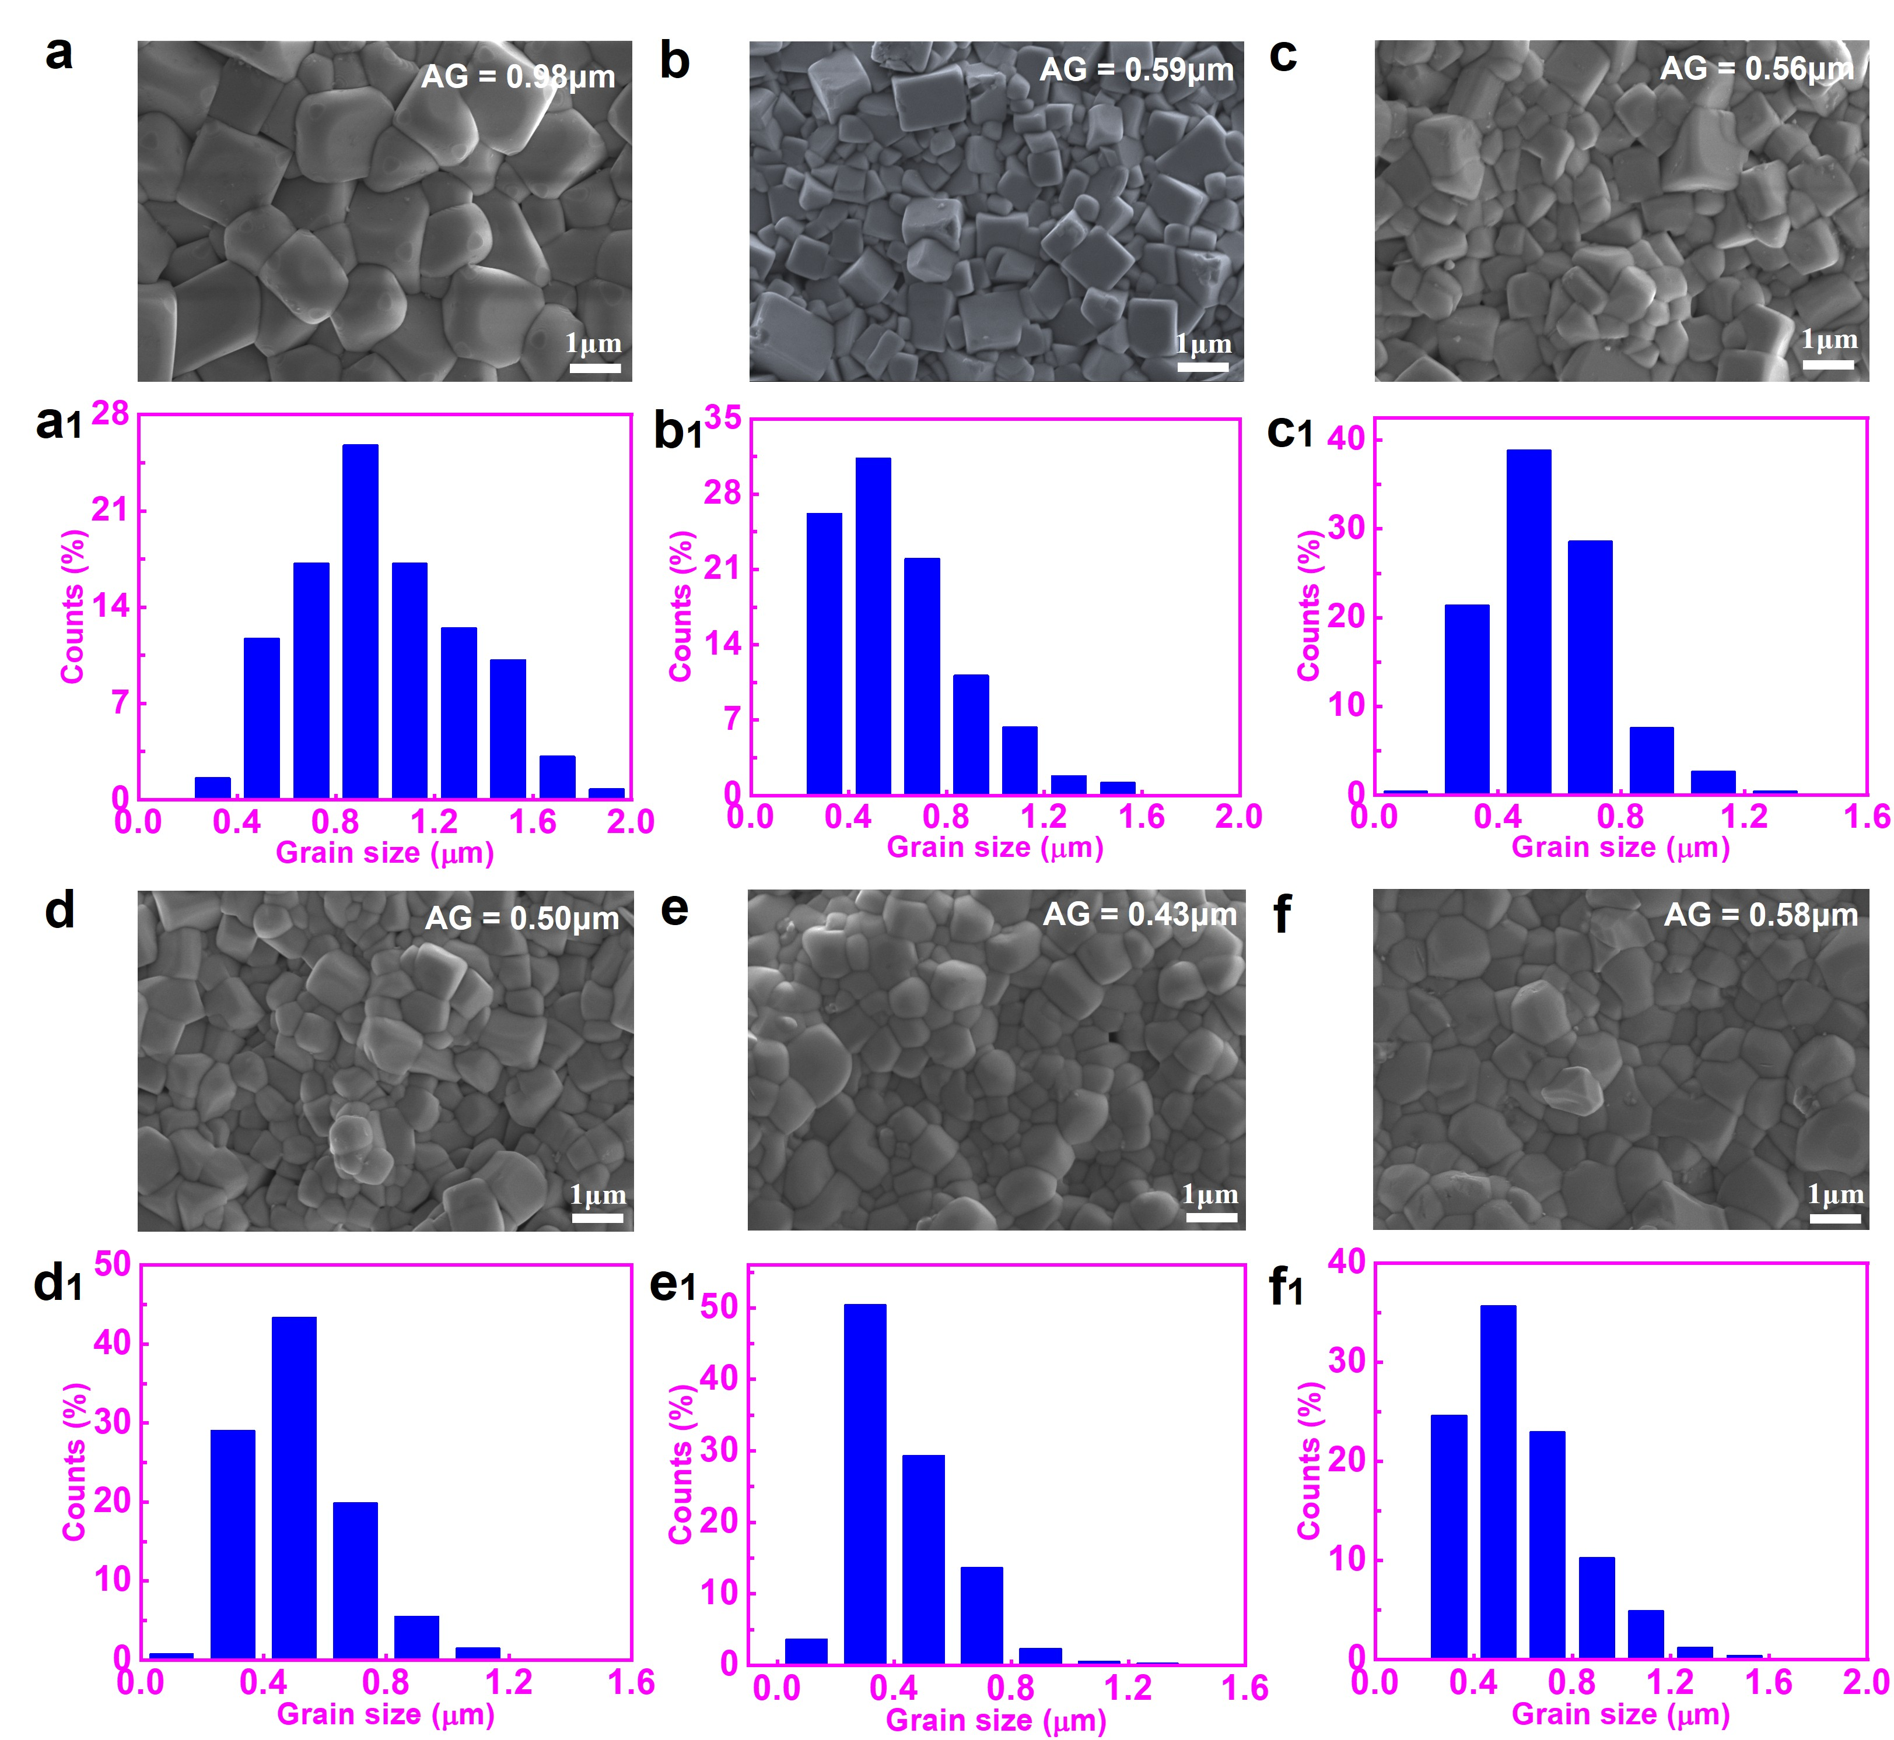
Fig. S5 SEM images and corresponding grain size distribution histograms for a BNT and BNSLT-xBMT ceramics with b x = 0, c x = 0.06, d x = 0.08, e x = 0.10, and f x = 0.15. Average grain size (AG) generally decreases with increasing entropy.

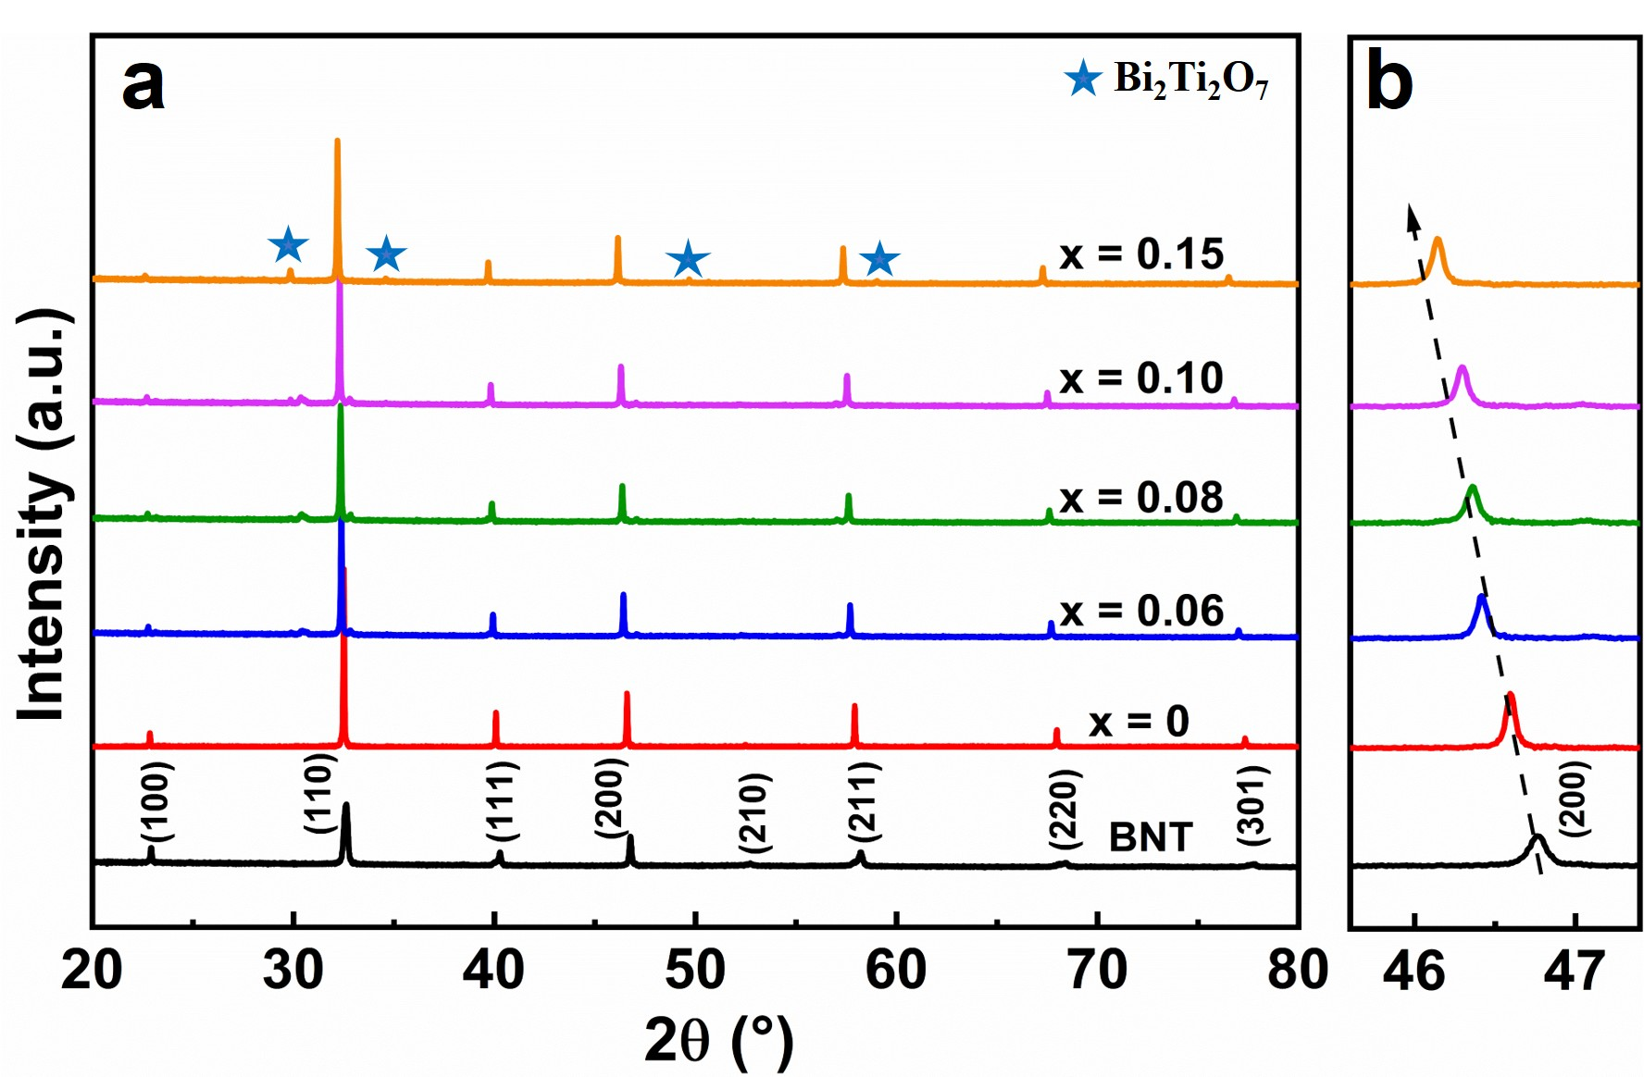
Fig. S6 Structural characterization by XRD. a XRD patterns of BNSLT-xBMT ceramics in the 2θ range of 20-80º. b Enlarged view of the (200)_{pc} diffraction peak region.
Diffraction peaks correspond to a perovskite structure. Asterisks (★) indicate minor secondary phase identified as Bi₂Ti₂O₇ (PDF#-97-018-0395). In addition, it can be seen that the (200) diffraction peaks gradually shift to lower angles with increasing entropy, indicating lattice expansion due to heterovalent ion substitution.

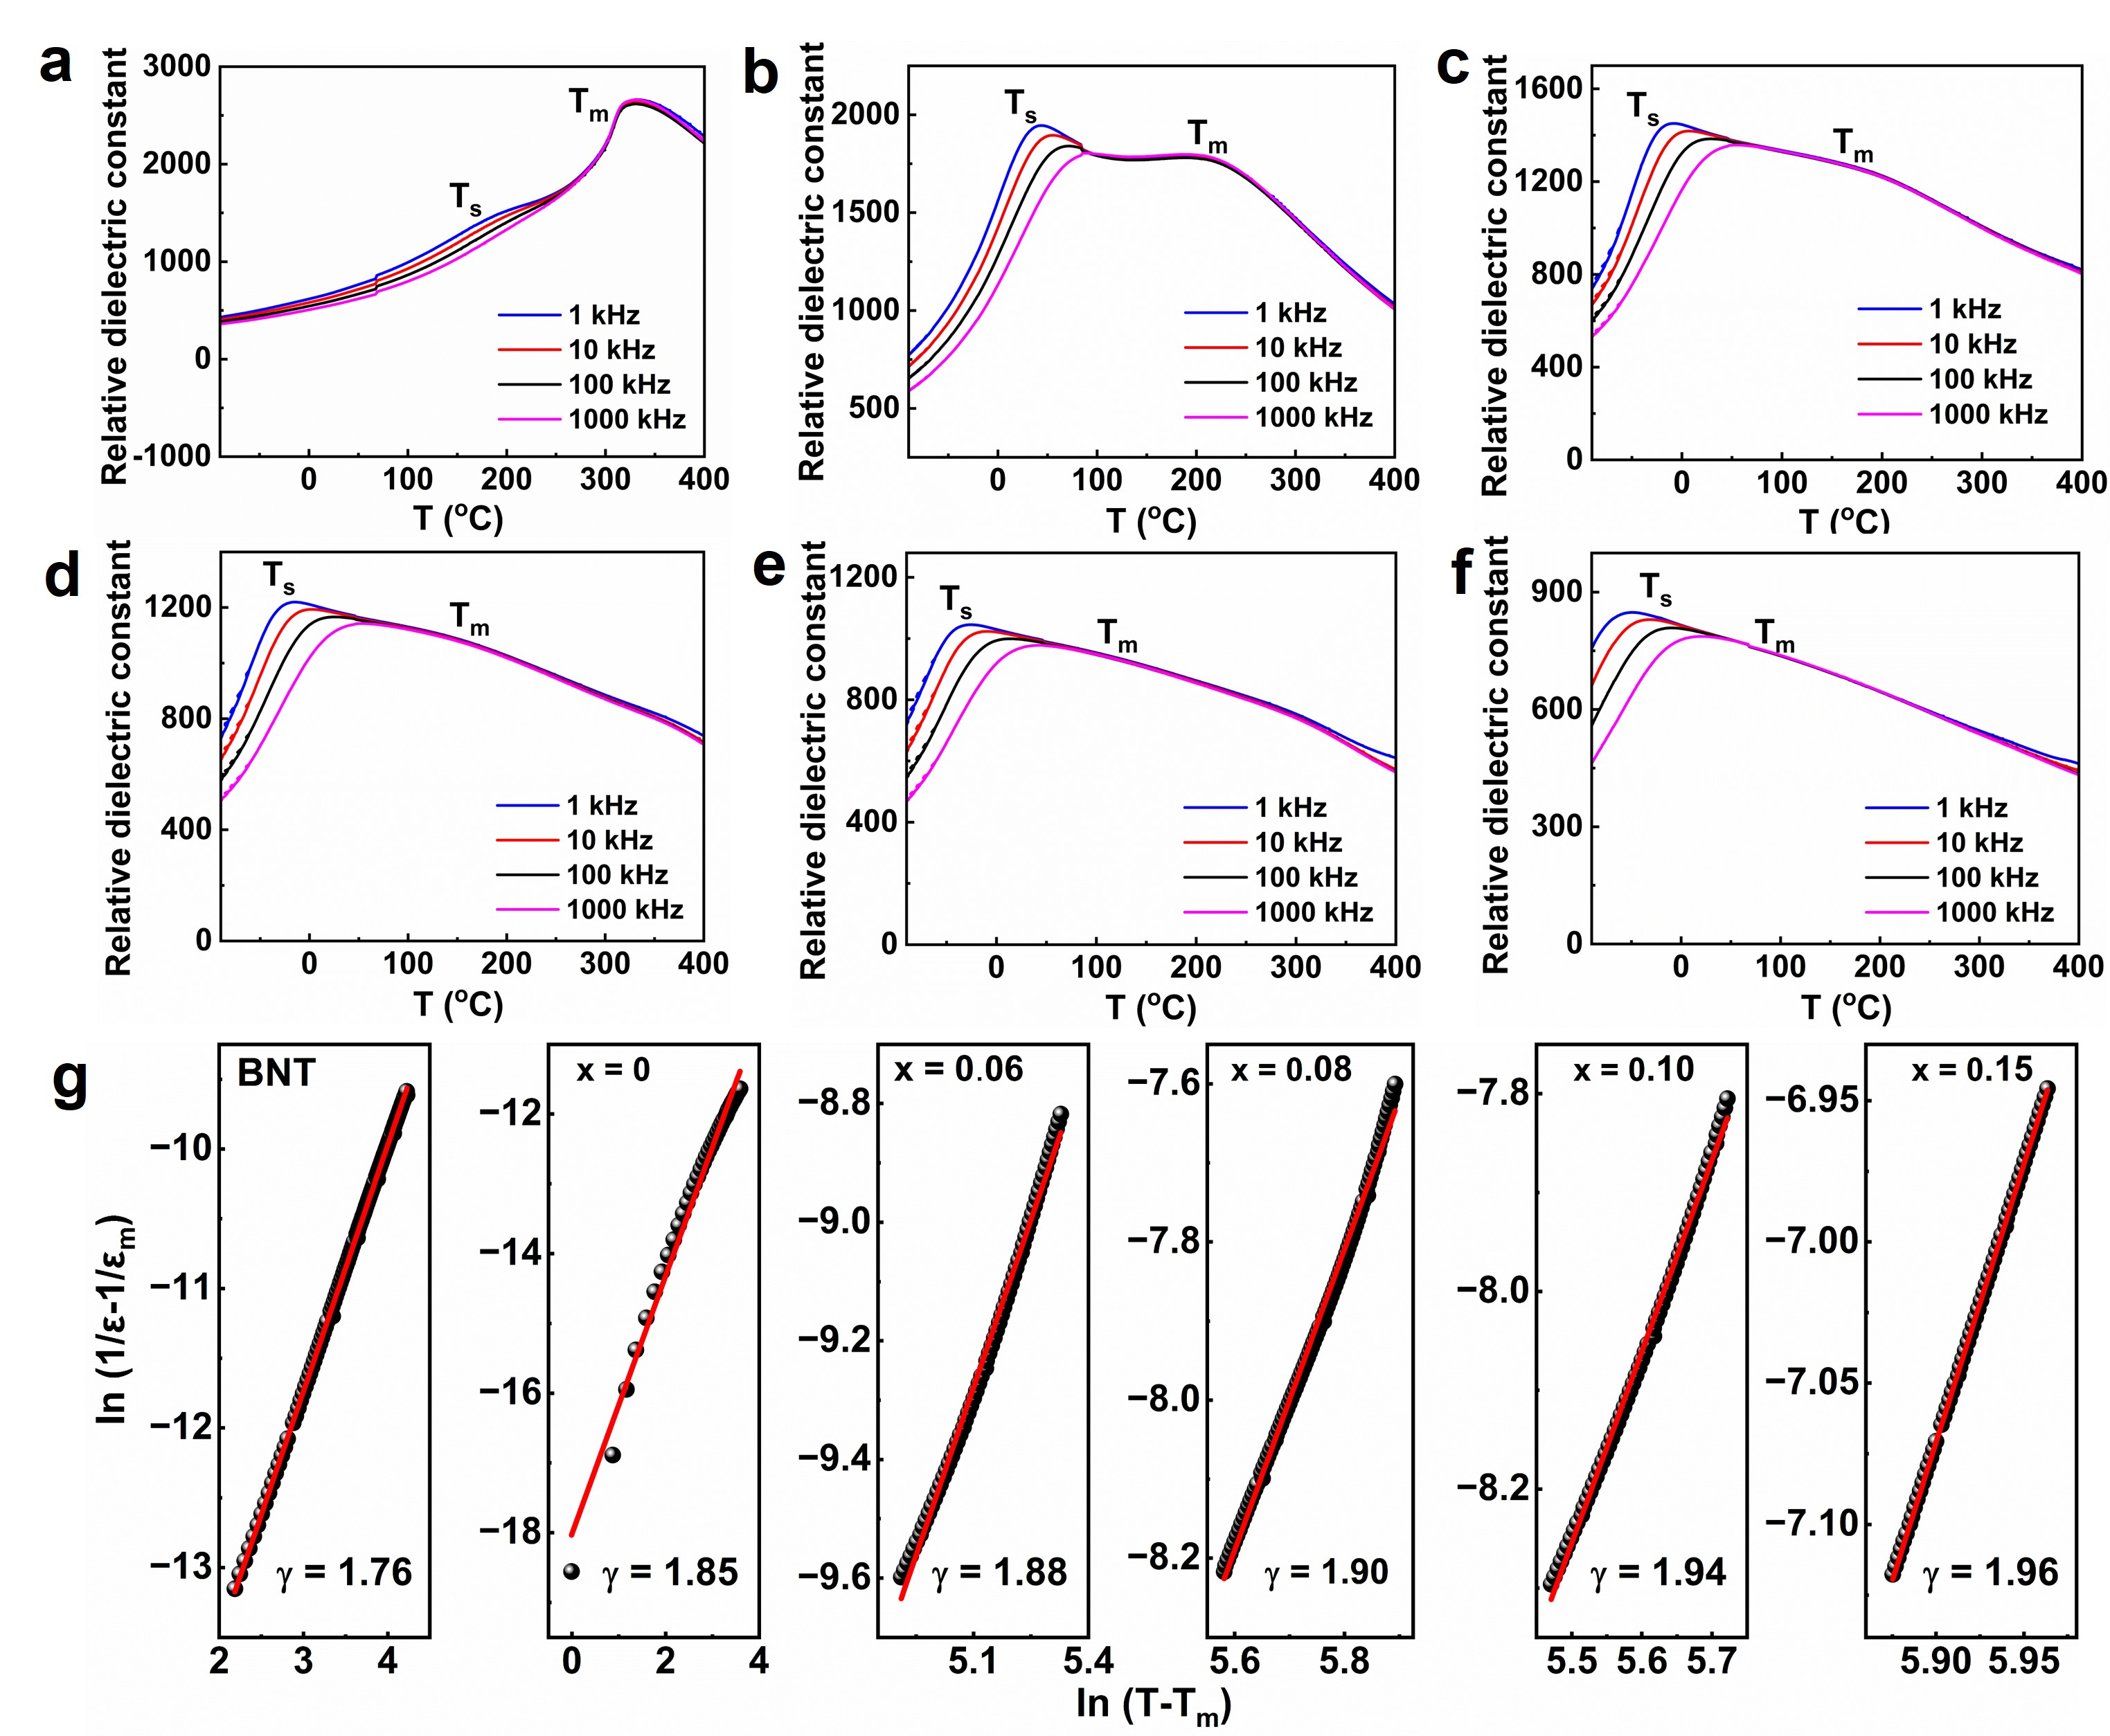
Fig. S7 Temperature-dependent dielectric properties. Relative dielectric constant (ε_{r}) as a function of temperature (ε_{r} - T) at various frequencies (1 kHz-1000 kHz) for a BNT, and BNSLT-xBMT ceramics with b x = 0, c x = 0.06, d x = 0.08, e x = 0.10 and f x = 0.15. g Modified Curie-Weiss law fitting for the diffuseness coefficient (γ).
The dielectric anomaly peak T_{s} may be associated with the thermal relaxation of tetragonal and rhombohedral PNRs¹. The dielectric anomaly peak T_{m} arises from the transition from the ferroelectric to paraelectric phase, which is commonly defined as Curie temperature (T_{c}). To quantitatively evaluate the relaxor behavior, the diffuseness coefficient (γ) was determined using the modified Curie-Weiss law as expressed in Eq. 1²:
$\frac{\text{1}}{\text{ε}}\text{-}\frac{\text{1}}{{\text{ε}}_{\text{m}}}\text{= }\frac{{\text{(}\text{T}\text{-}{\text{T}}_{\text{m}}\text{)}}^{\text{γ}}}{\text{C}}$ (1)
where ε is the dielectric constant, ε_{m} is the maximum value of ε at T_{m}, and C presents the Curie constant. Fig. S7g shows that as entropy increases, the γ values increase from 1.76 to 1.96, indicating significantly enhanced relaxor behavior, since a larger γ corresponds to a higher degree of relaxor characteristic. The enhanced relaxor level with increasing entropy arises from cation disorder and domain evolution, which is beneficial to improve W_{rec} and η.
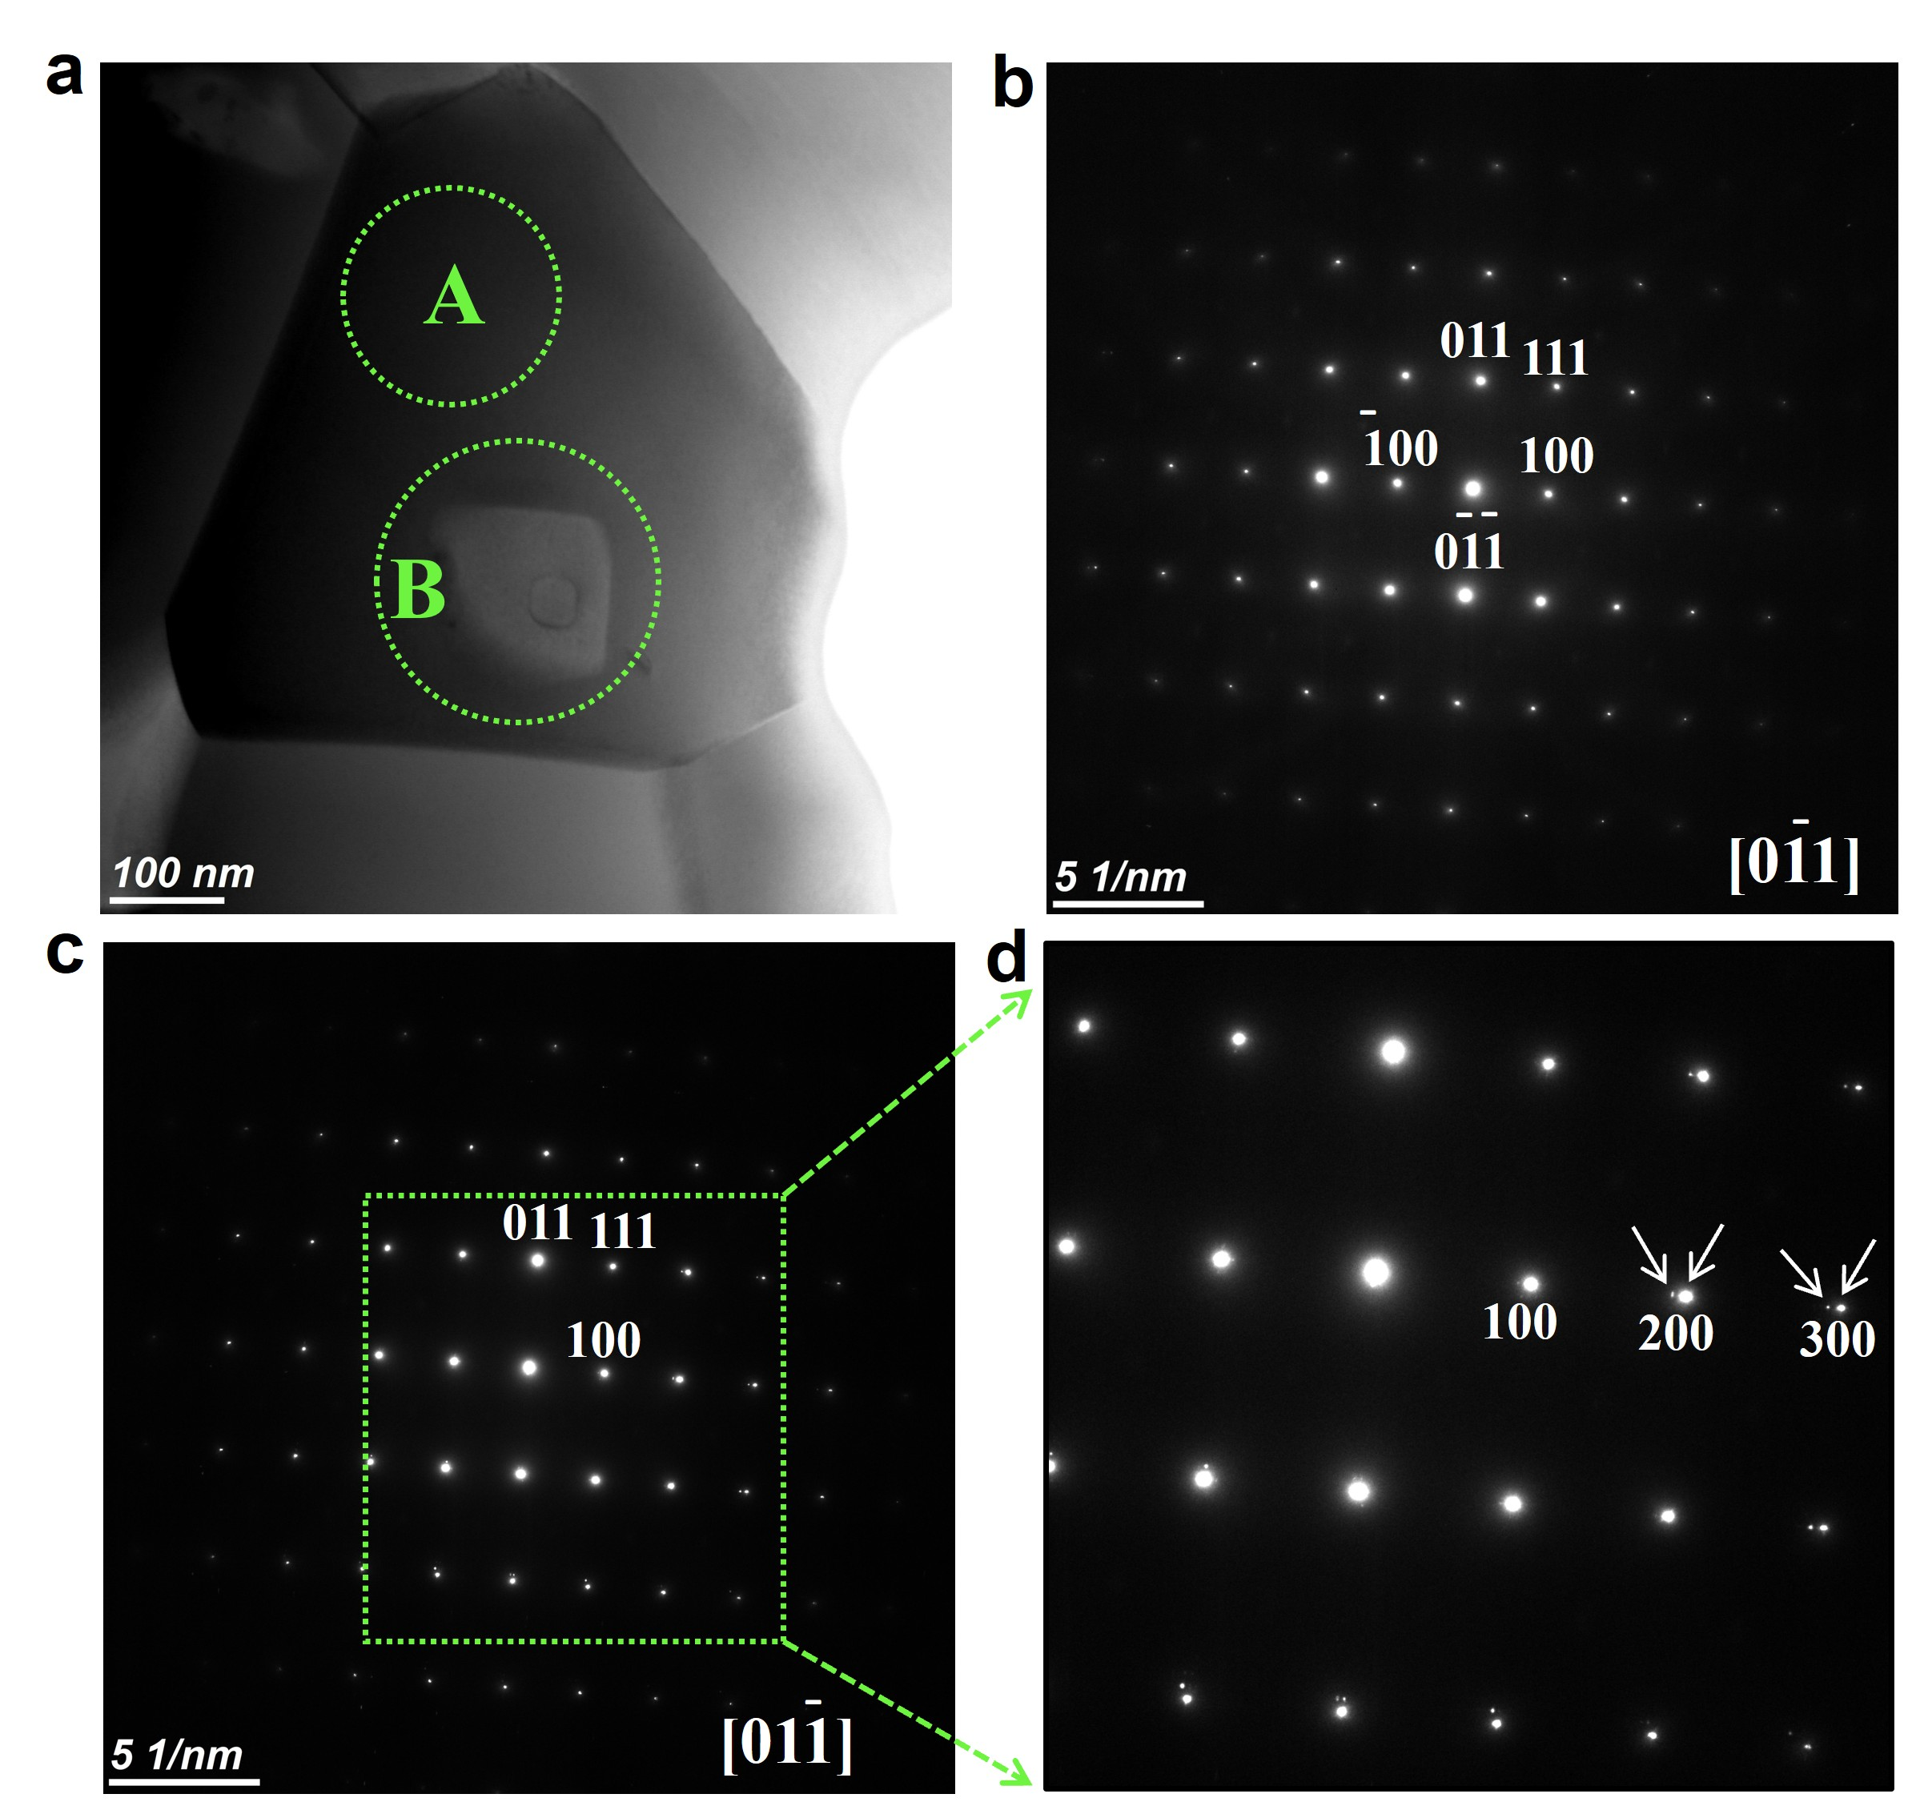
Fig. S8 Selected area electron diffraction (SAED) analysis. a Bright-field STEM image showing the location for SAED. b SAED pattern from the shell region, consistent with an average pseudocubic structure. c SAED pattern acquired across a core-shell interface. d Enlarged view of the boxed area in c, showing slight splitting of diffraction spots, indicative of lattice strain/distortion due to compositional heterogeneity.

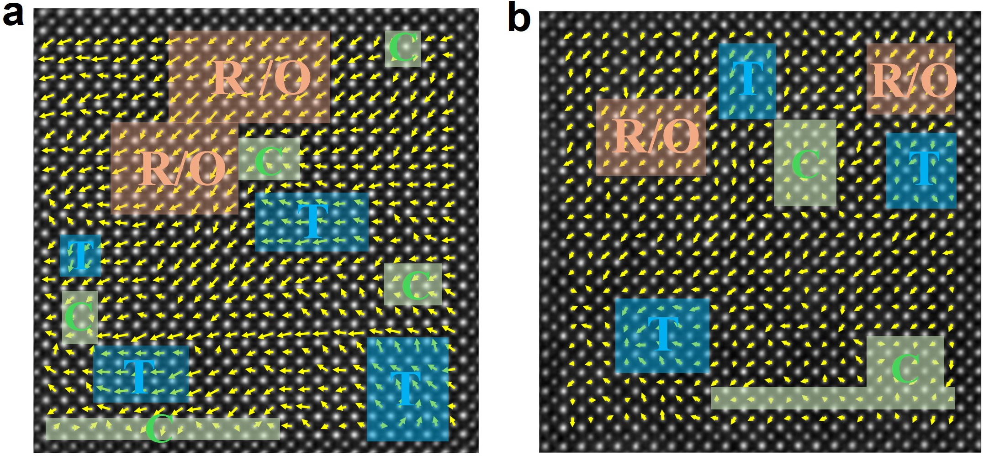
Fig. S9 Atomic-resolution polarization vector mapping along [001]_{c}. HAADF-STEM images with overlaid polarization vector for the core a and shell b regions viewed along [001]_{c}. This projection allows identification of T, R/O, and C phases.
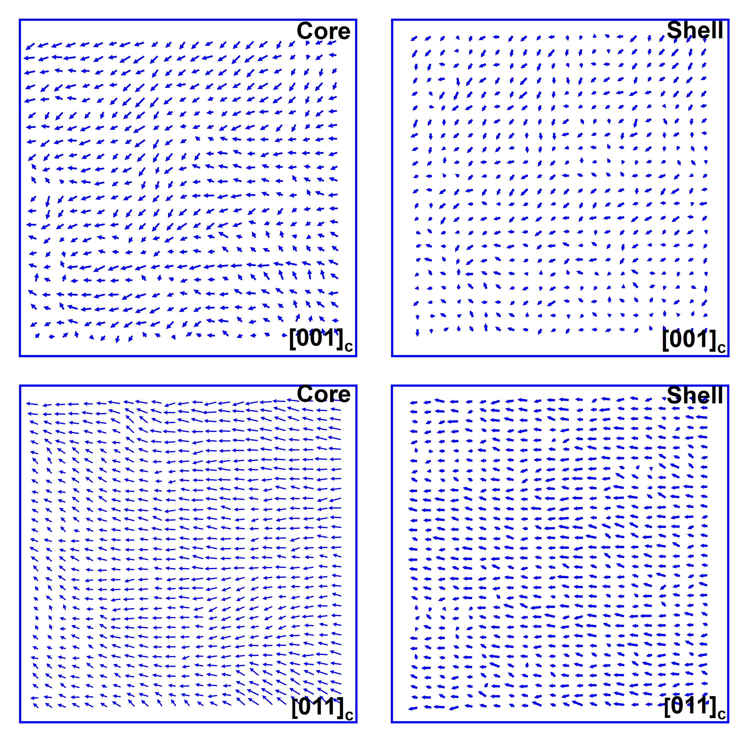
Fig. S10 Polarization vector maps without atomic overlays. Polarization vector maps derived from HAADF-STEM data for the core a, c and shell b, d regions along both [001]_{c} and [011]_{c} zone axes, providing a clear view of the polarization direction distribution.

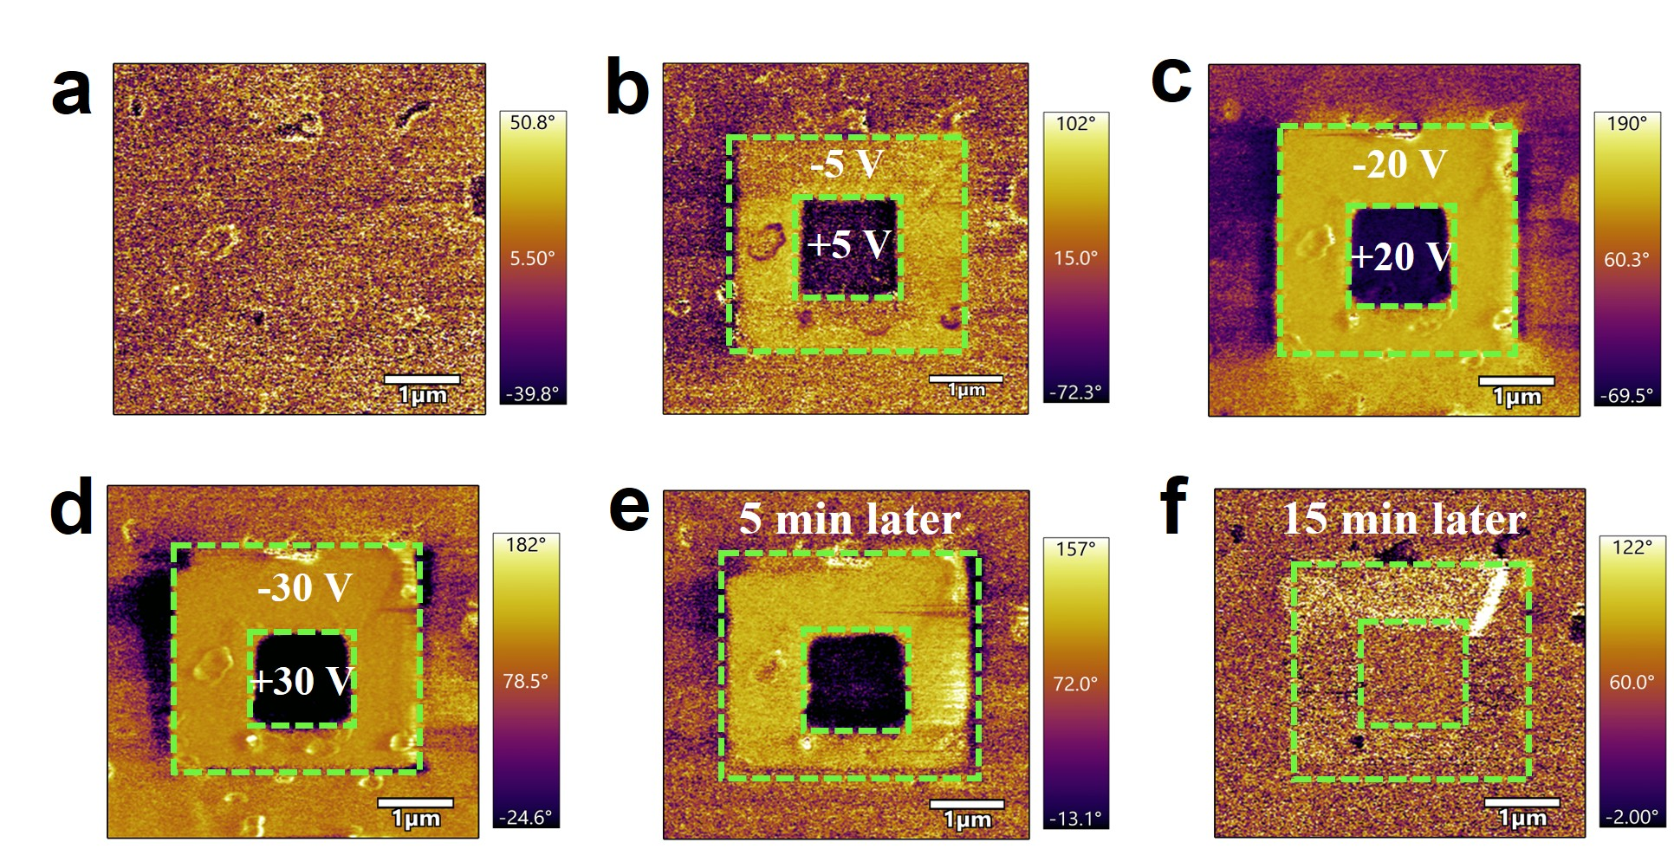
Fig. S11 Piezoresponse force microscopy (PFM ) analysis of domain dynamics. a Out-of-plane PFM phase image of the x = 0.10 ceramic. Out-of-plane PFM phase images after poling with voltages of b ±5 V, c ±20 V, and d ±30 V. Out-of-plane PFM phase images after subsequent relaxation for e 5 and f 15 minutes. Obviously, the written domains are metastable and revert to their initial state, confirming the high dynamics and low energy barrier for reorientation of the polar nanoregions (PNRs).
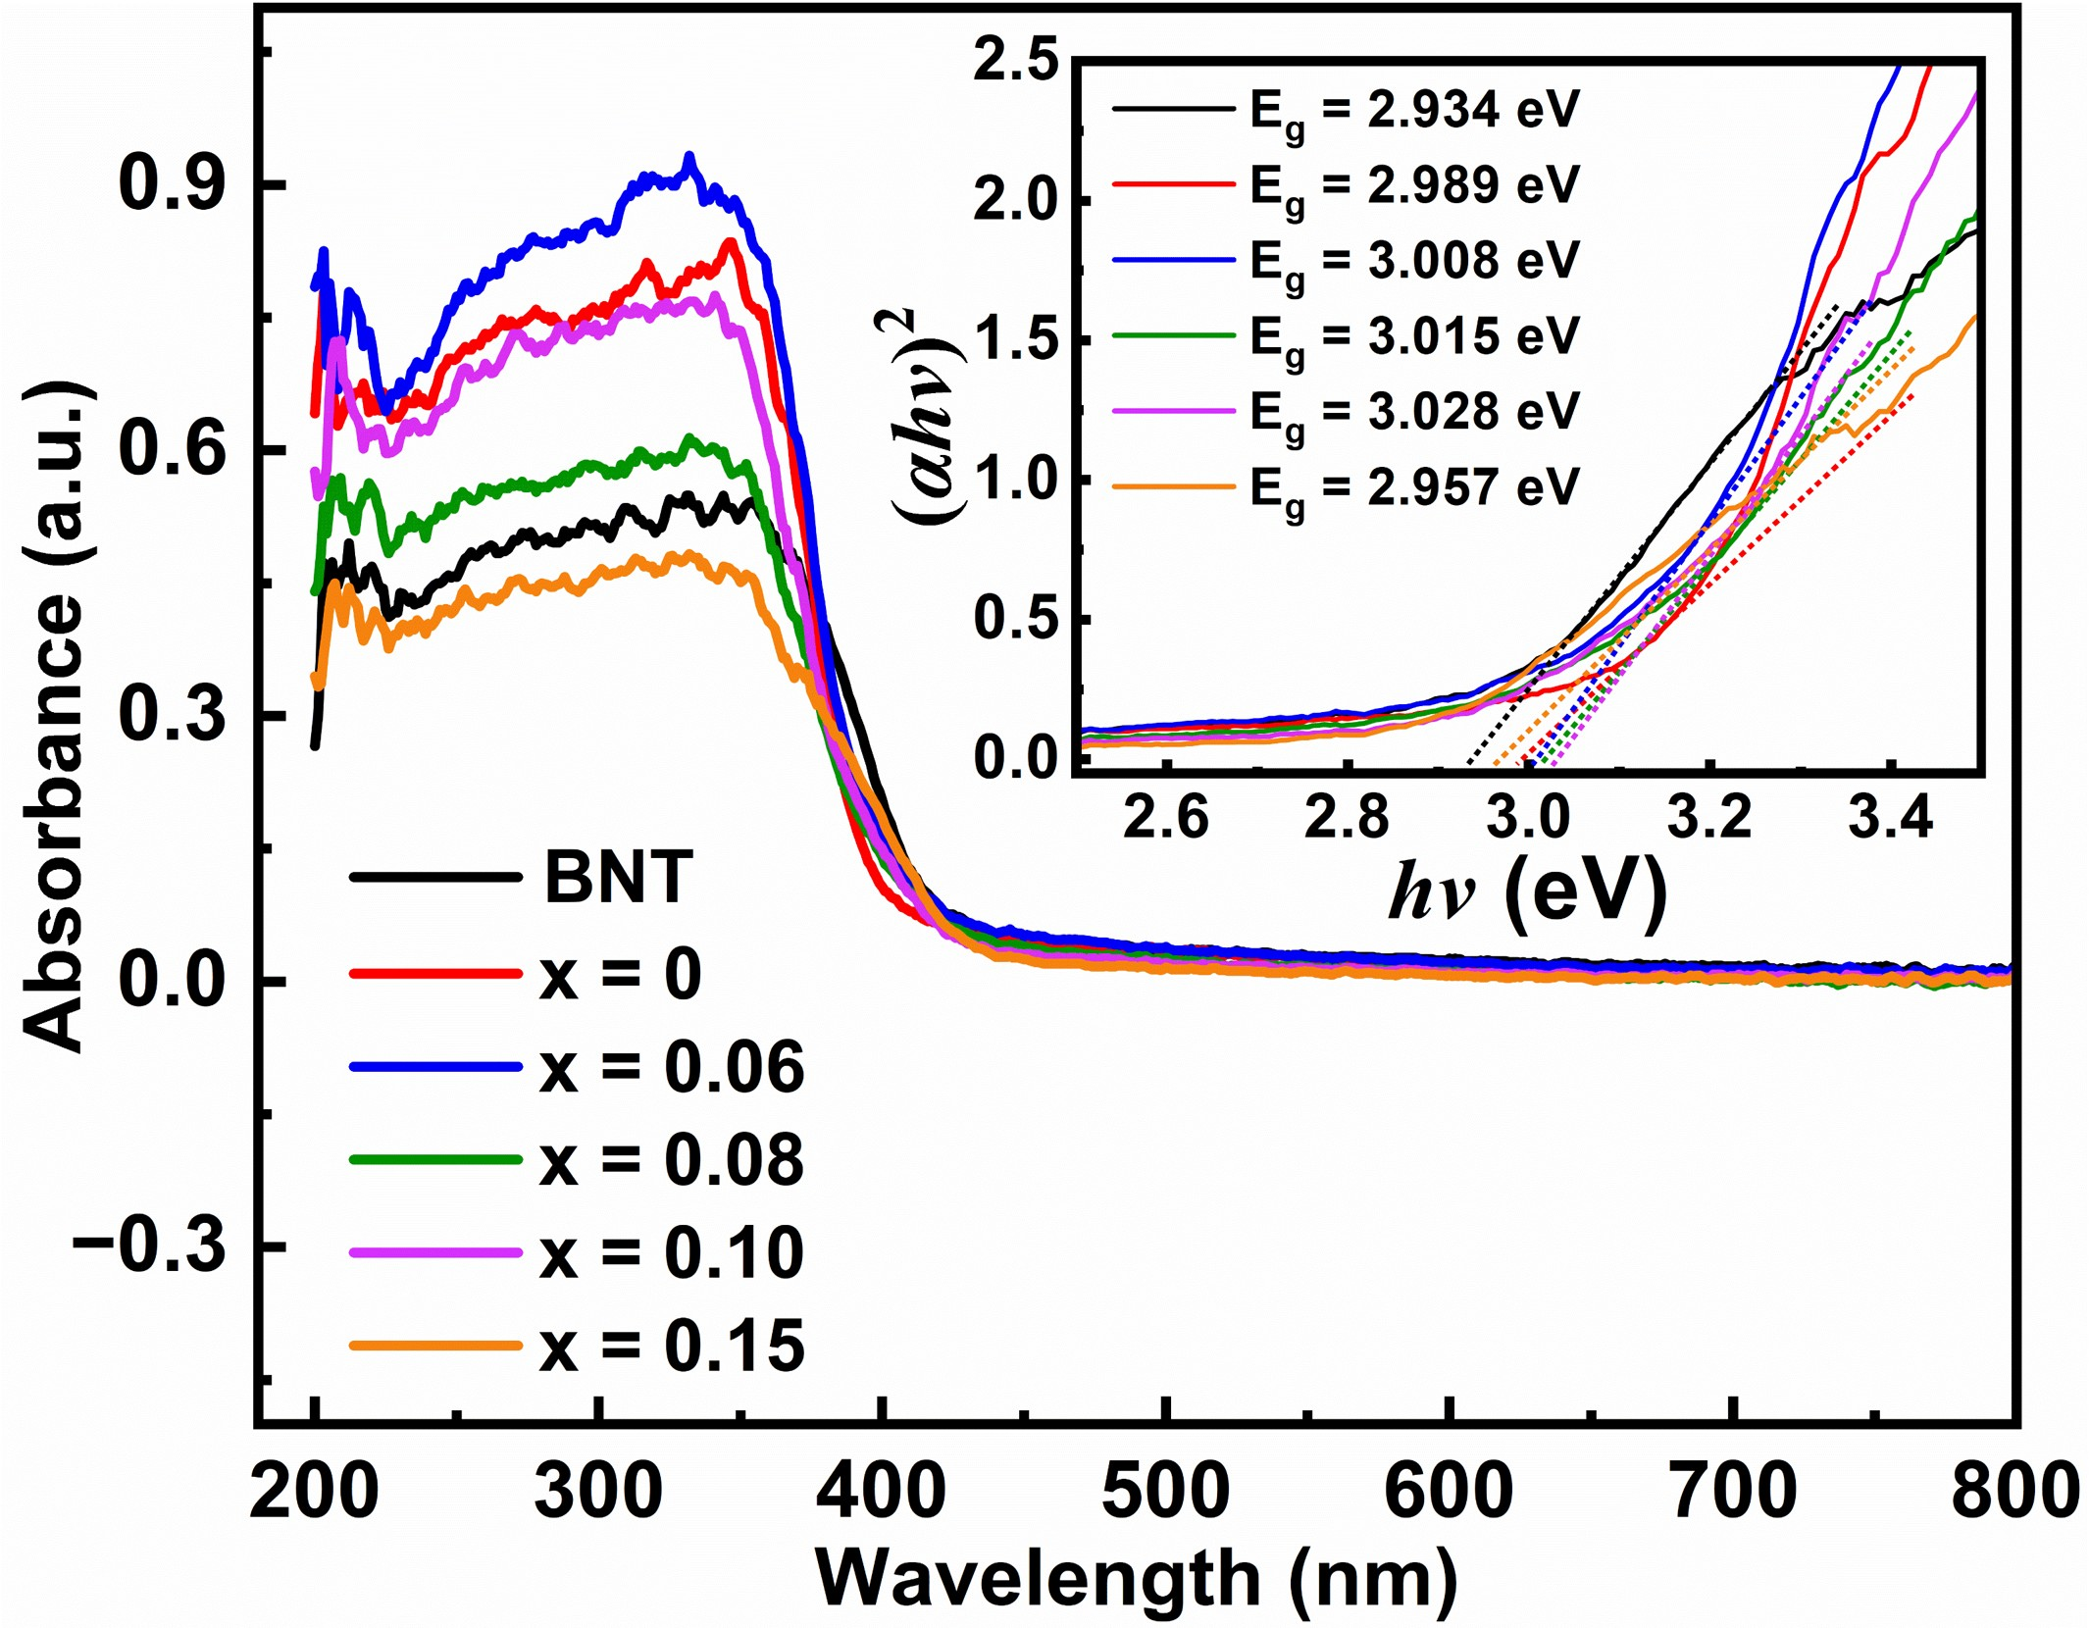
Fig. S12 Optical band gap determination. UV-Vis absorption spectra and corresponding (αhν)² vs hν plots (inset) for BNT and BNSLT-xBMT ceramics.

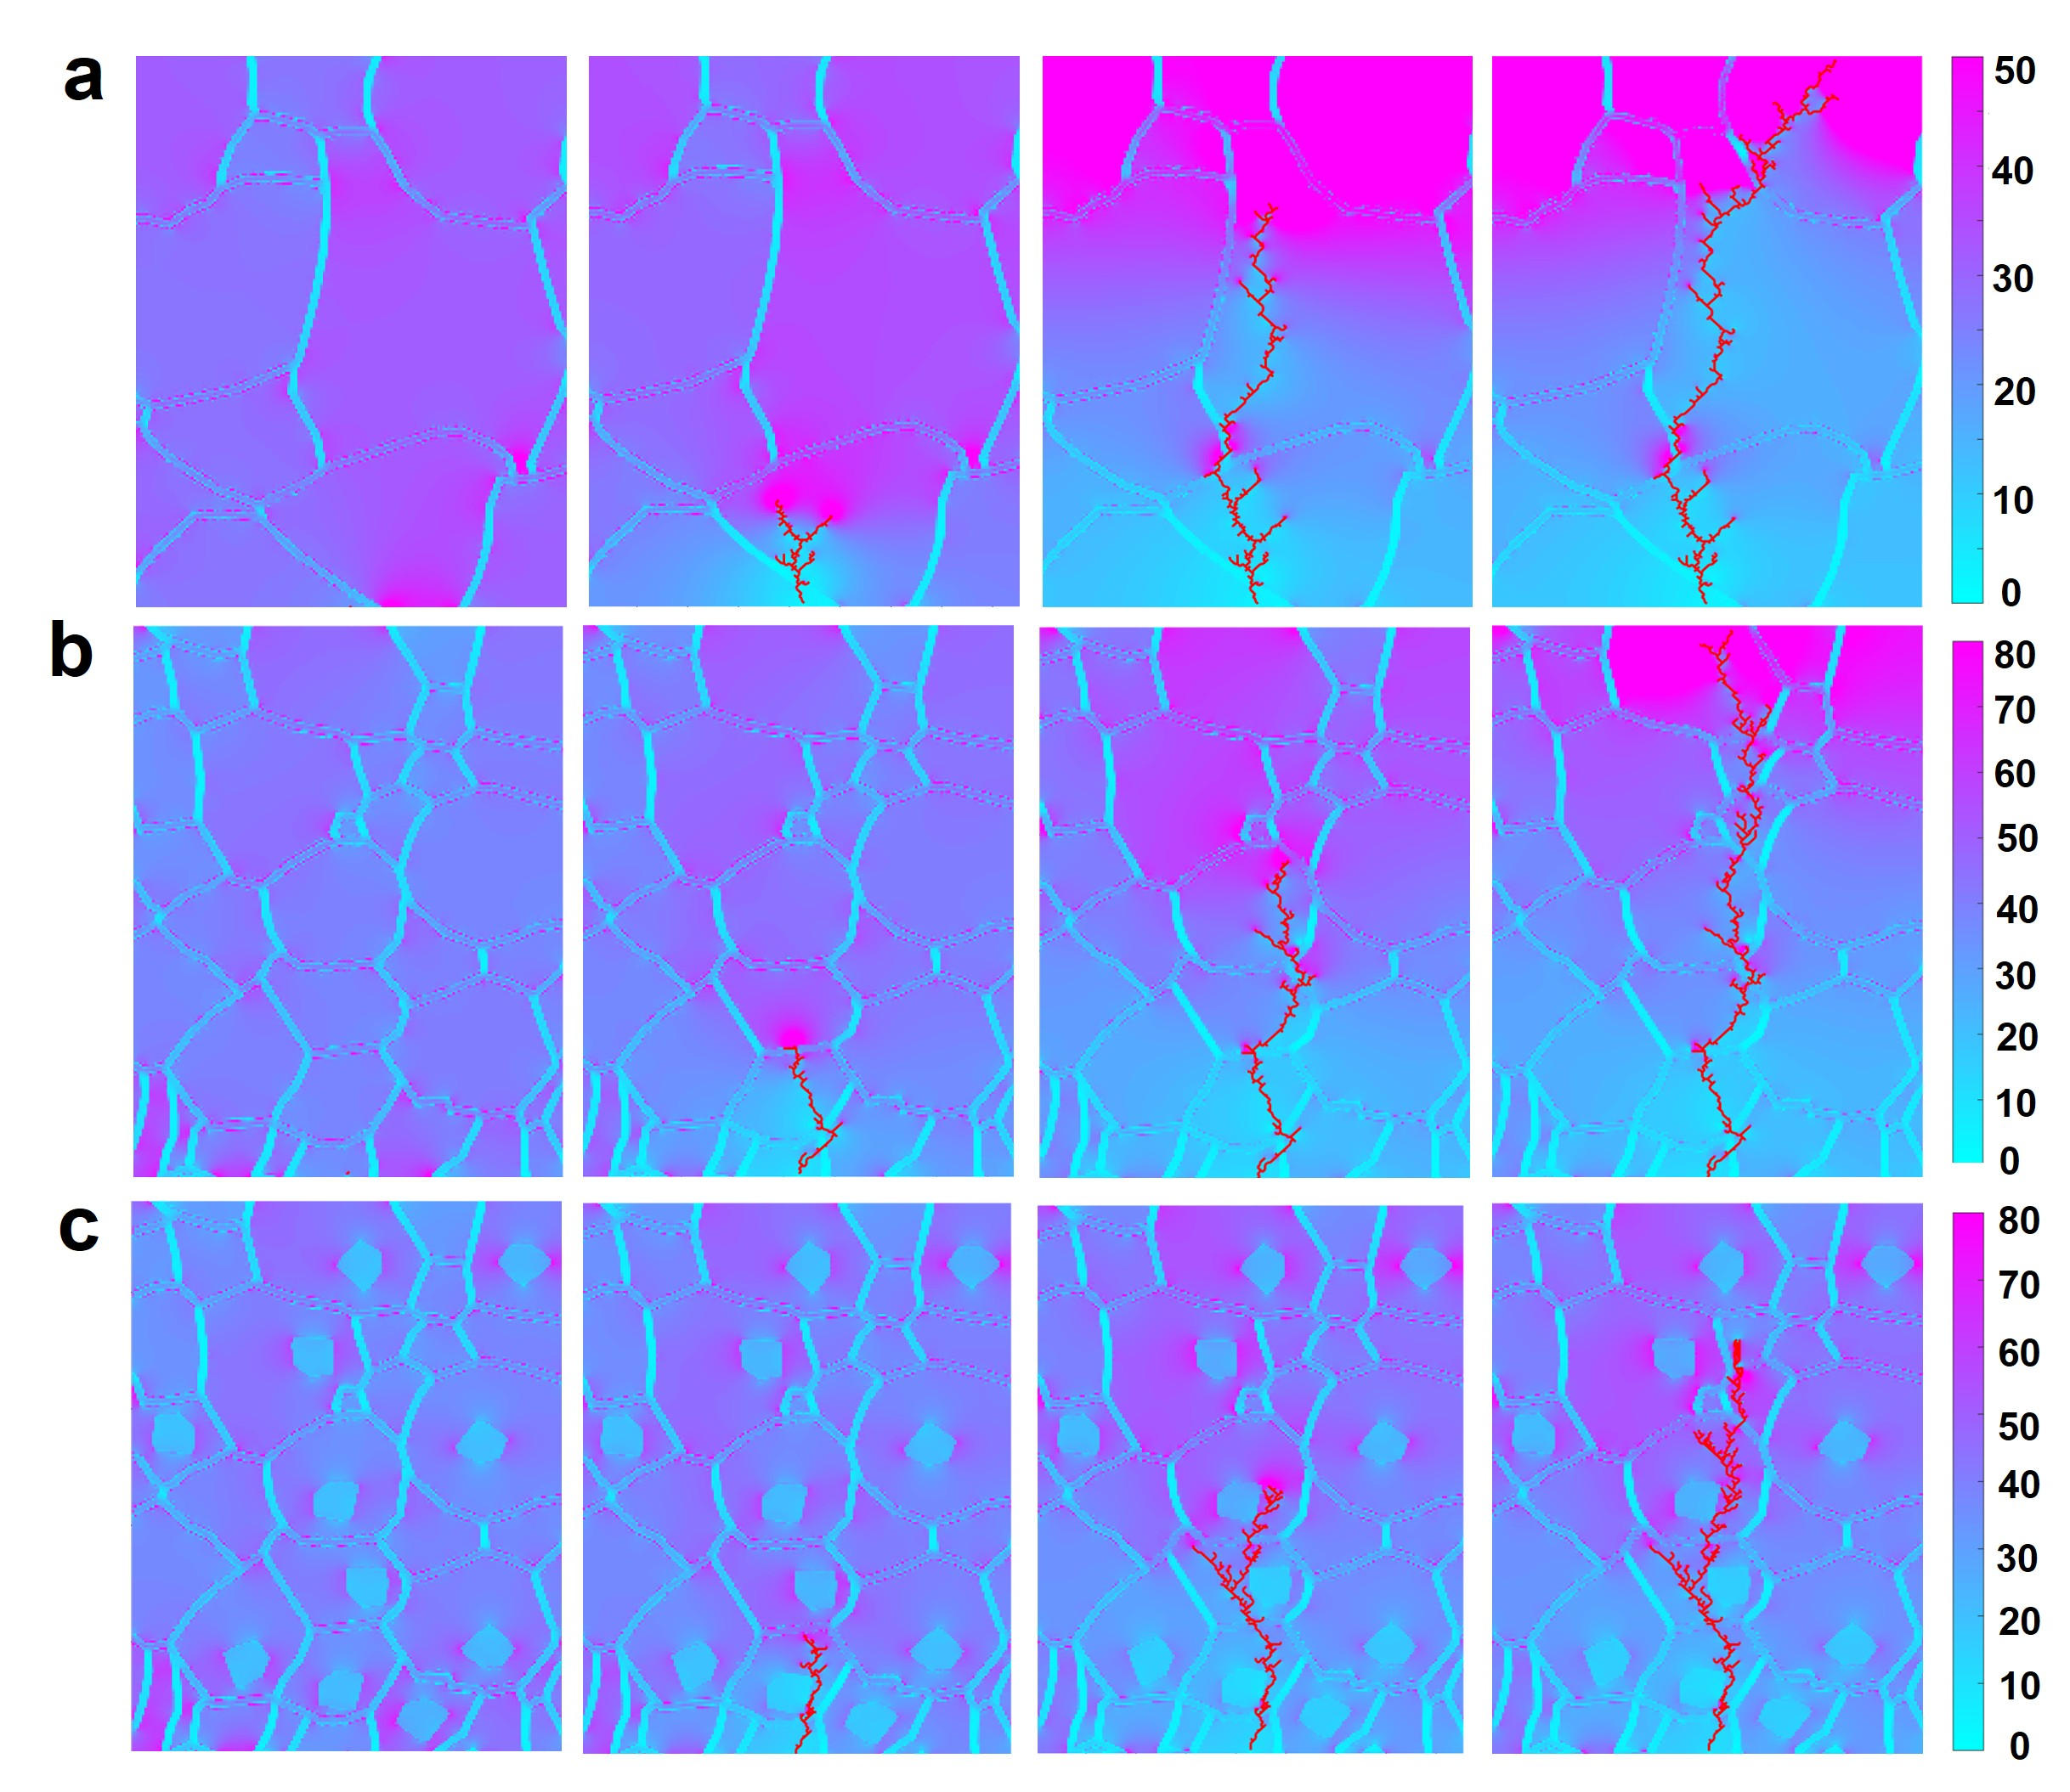
Fig. S13 Finite element simulations of polarization distribution. Simulated polarization distribution under an electric field of 680 kV/cm for: a Model A (BNT, low entropy, large grains); b Model B (x = 0.10, high entropy, fine grains, no core-shell); c Model C (x = 0.10, high entropy, fine grains, with core-shell). The combination of fine grains and core-shell structure leads to a more uniform polarization distribution.

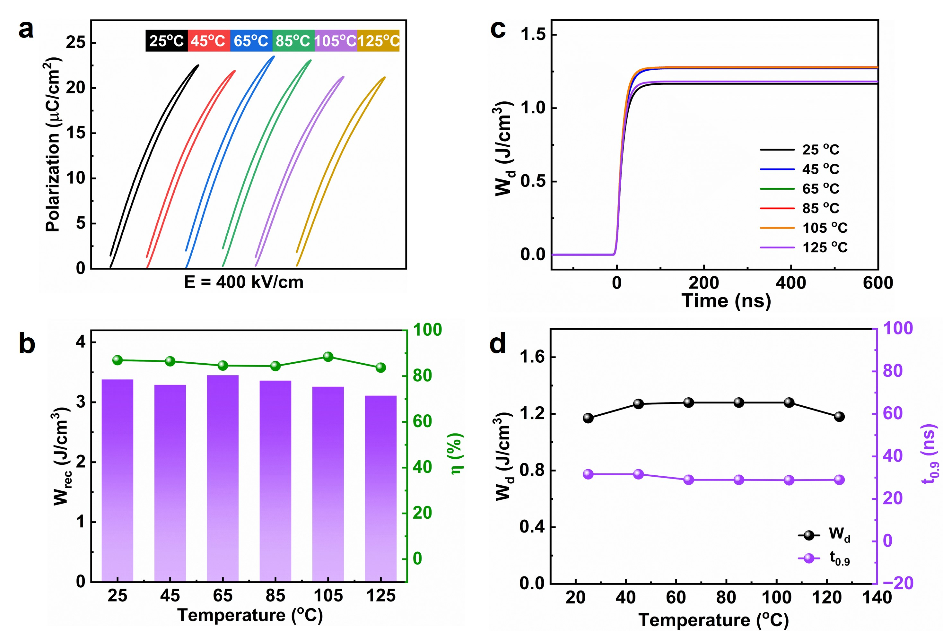
Fig. S14 Thermal stability of energy storage and discharge properties (x = 0.10). a Unipolar P - E loops measured at 400 kV/cm across a temperature range of 25-125 ºC. b Corresponding W_{rec} and η as a function of temperature. c Discharged energy density (W_{d}) versus time at 220 kV/cm under different temperatures. d W_{d} and discharge time (t_{0.9}) at 220 kV/cm as a function of temperature, demonstrating excellent thermal stability.

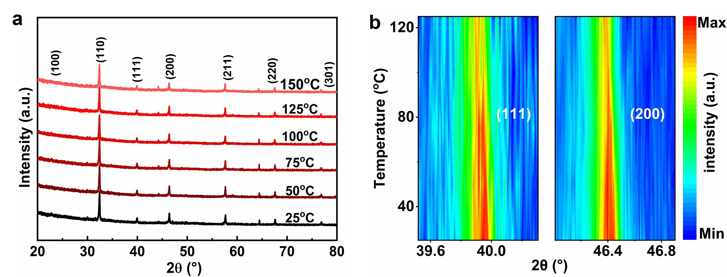
Fig. S15 In-situ temperature-dependent XRD analysis (x = 0.10). a In-situ XRD patterns collected from 25 ºC to 125 ºC. b Thermal evolution of the (111) and (200) diffraction peaks, showing stable peak positions and shapes, indicating robust structural stability over the measured temperature range.
Table S1 Relevant references for the Fig. 2h.

Figure | Ref
Fig. 2h | [3-47]

References
1. Wang, M. et al. Ultrahigh energy storage density and efficiency in Bi_{0.5}Na_{0.5}TiO₃-based ceramics via the domain and bandgap engineering. ACS Appl. Mater. Interfaces 13, 51218-51229 (2021).
2. Uchino, K. et al. Critical exponents of the dielectric constants in diffused-phase-transition crystals. Ferroelectrics 44, 55-61 (1982).
3. Huang, J. et al. Greatly enhanced energy storage and discharge properties of AgNbO₃ ceramics with a stable antiferroelectric phase and high breakdown strength using hydrothermally synthesized powders. J. Mater. Chem. A 10, 16337-16350 (2022).
4. Li, B. et al. Achieving ultrahigh energy storage density of La and Ta codoped AgNbO₃ ceramics by optimizing the field-induced phase transitions. ACS Appl. Mater. Interfaces 15, 4246-4256 (2023).
5. Lu, Z. et al. Mechanism of enhanced energy storage density in AgNbO₃-based lead-free antiferroelectrics. Nano Energy 79, 105423 (2021).
6. Luo, N. et al. Constructing phase boundary in AgNbO₃ antiferroelectrics: pathway simultaneously achieving high energy density and efficiency. Nat. Commun. 11, 4824 (2020).
7. Luo, N. et al. Aliovalent A-site engineered AgNbO₃ lead-free antiferroelectric ceramics toward superior energy storage density. J. Mater. Chem. A 7, 14118-14128 (2019).
8. Yang, Y. et al. Phase modulation leads to ultrahigh energy storage performance in AgNbO₃-based ceramics and multilayer capacitors. ACS Appl. Mater. Interfaces 16, 69608-69616 (2024).
9. Bai, X. et al. High recoverable energy storage density in nominal (0.67-x)BiFeO₃-0.33BaTiO₃-xBaBi₂Nb₂O₉ lead-free composite ceramics. Ceram. Int. 47, 23116-23123 (2021).
10. Chen, Z. et al. Simultaneously achieving high energy storage density and efficiency under low electric field in BiFeO₃-based lead-free relaxor ferroelectric ceramics. J. Eur. Ceram. Soc. 40, 5450-5457 (2020).
11. Li, F. et al. Multifunctionality of lead-free BiFeO₃-based ergodic relaxor ferroelectric ceramics: High energy storage performance and electrocaloric effect. J. Alloy. Compd. 803, 185-192 (2019).
12. Wang, M. et al. Energy storage properties under moderate electric fields in BiFeO₃-based lead-free relaxor ferroelectric ceramics. Chem. Eng. J. 440, 135789 (2022).
13. Yang, H. et al. Enhanced breakdown strength and energy storage density in a new BiFeO₃-based ternary lead-free relaxor ferroelectric ceramic. J. Eur. Ceram. Soc. 39, 2673-2679 (2019).
14. Yang, Q. et al. Excellent energy storage performance of K_{0.5}Bi_{0.5}TiO₃-based ferroelectric ceramics under low electric field. Chem. Eng. J. 414, 128769 (2021).
15. Zhang, Y. et al. Multiphase coexistence and high energy storage performance in BKT-based lead-free relaxor ferroelectric ceramics. Appl. Mater. Today 37, 102097 (2024).
16. Zheng, L. et al. Simultaneously achieving high energy storage performance and remarkable thermal stability in Bi_{0.5}K_{0.5}TiO₃-based ceramics. Mater. Today Energy 28, 101078 (2022).
17. Che, Z. et al. Phase structure and defect engineering in (Bi_{0.5}Na_{0.5})TiO₃-based relaxor antiferroelectrics toward excellent energy storage performance. Nano Energy 100, 107484 (2022).
18. Chen, P. et al. Outstanding energy-storage and charge-discharge performances in Na_{0.5}Bi_{0.5}TiO₃ lead-free ceramics via linear additive of Ca_{0.85}Bi_{0.1}TiO₃. Chem. Eng. J. 435, 135065 (2022).
19. Chen, Y. et al. Enhanced energy storage properties and dielectric stabilities in BNT-based ceramics via multiphase and dielectric peak broadening engineering. Mater. Chem. Phys. 290, 126542 (2022).
20. Co, N. D. et al. Effect of crystallization temperature on energy-storage density and efficiency of lead-free Bi_{0.5}(Na_{0.8}K_{0.2})_{0.5}TiO₃ thin films prepared by sol-gel method. J. Sci-Adv. Mater. Dev. 4, 370-375 (2019).
21. Ji, H. et al. Ultrahigh energy density in short-range tilted NBT-based lead-free multilayer ceramic capacitors by nanodomain percolation. Energy Storage Mater. 38, 113-120 (2021).
22. Kang, R. et al. Energy storage performance of Bi_{0.5}Na_{0.5}TiO₃-based relaxor ferroelectric ceramics with superior temperature stability under low electric fields. Chem. Eng. J. 410, 128376 (2021).
23. Liu, Z. et al. Mediating the confliction of polarizability and breakdown electric-field strength in BNST relaxor ferroelectric for energy storage applications. J. Alloy. Compd. 823, 153772 (2020).
24. Shang, K. et al. Medium electric field-induced ultrahigh polarization response and boosted energy-storage characteristics in BNT-based relaxor ferroelectric polycrystalline ceramics. Ceram. Int. 48, 37223-37231 (2022).
25. Yan, F. et al. Superior energy storage properties and excellent stability achieved in environment-friendly ferroelectrics via composition design strategy. Nano Energy 75, 105012 (2020).
26. Yang, L. et al. Ultra-high energy storage performance with mitigated polarization saturation in lead-free relaxors. J. Mater. Chem. A 7, 8573-8580 (2019).
27. Zeng, F. et al. Enhanced energy-storage performance in BNT-LST-based ceramics via polarization optimization and breakdown strength regulation. Sustain. Mater. Techno. 38, e00741 (2023).
28. Zhang, L. et al. Novel Na_{0.5}Bi_{0.5}TiO₃ based, lead-free energy storage ceramics with high power and energy density and excellent high-temperature stability. Chem. Eng. J. 383, 123154 (2020).
29. Zhang, Y. et al. Advanced energy storage properties and multi-scale regulation mechanism in (1-x)(Bi_{0.5}Na_{0.5})_{0.7}Sr_{0.3}TiO₃-xCa(Nb_{0.5}Al_{0.5})O₃ relaxor ferroelectric ceramics. Acta Mater. 276, 120109 (2024).
30. Chen, L. et al. Excellent energy storage and mechanical performance in hetero-structure BaTiO₃-based relaxors. Chem. Eng. J. 452, 139222 (2023).
31. Liu, G. et al. An investigation of the dielectric energy storage performance of Bi(Mg_{2/3}Nb_{1/3})O₃-modifed BaTiO₃ Pb-free bulk ceramics with improved temperature/frequency stability. Ceram. Int. 45, 19189-19196 (2019).
32. Long, C. et al. Simultaneously realizing ultrahigh energy storage density and efficiency in BaTiO₃-based dielectric ceramics by creating highly dynamic polar nanoregions and intrinsic conduction. Acta Mater. 256, 119135 (2023).
33. Yang, S. et al. Enhancement of energy storage performances in BaTiO₃-based ceramics via introducing Bi(Mg_{2/3}Sb_{1/3})O₃. J. Energy Storage 78, 110102 (2024).
34. Zeng, D. et al. Relaxor ferroelectric ceramics with excellent energy storage density obtained from BT-based ceramics. J. Power Sources 580, 233454 (2023).
35. Gao, T. et al. Enhanced comprehensive energy storage properties of lead-free KNN based ceramics through composition optimization strategy. Chem. Eng. J. 500, 157560 (2024).
36. Li, D. et al. Improved energy storage properties achieved in (K,Na)NbO₃‑based relaxor ferroelectric ceramics via a combinatorial optimization strategy. Adv. Funct. Mater. 32, 2111776 (2022).
37. Yang, Z. et al. Grain size engineered lead-free ceramics with both large energy storage density and ultrahigh mechanical properties. Nano Energy 58, 768-777 (2019).
38. Zhang, M. et al. Significant increase in comprehensive energy storage performance of potassium sodium niobate-based ceramics via synergistic optimization strategy. Energy Storage Mater. 45, 861-868 (2022).
39. Zhang, M. et al. Energy storage performance of K_{0.5}Na_{0.5}NbO₃-based ceramics modified by Bi(Zn_{2/3}(Nb_{0.85}Ta_{0.15})_{1/3})O₃. Chem. Eng. J. 425, 131465 (2021).
40. Dong, X. et al. High energy storage density and power density achieved simultaneously in NaNbO₃-based lead-free ceramics via antiferroelectricity enhancement. J. Materiomics 7, 629-639 (2021).
41. Dong, X. et al. (1-x)[0.90NN-0.10Bi(Mg_{2/3}Nb_{1/3})O₃]-x(Bi_{0.5}Na_{0.5})_{0.7}Sr_{0.3}TiO₃ ceramics with core-shell structures: a pathway for simultaneously achieving high polarization and breakdown strength. Nano Energy 101, 107577 (2022).
42. Pan, T. et al. Enhanced energy density and efficiency in lead‐free sodium niobate‐based relaxor antiferroelectric ceramics for electrostatic energy storage application. Adv. Electron. Mater. 8, 2200793 (2022).
43. Qi, H. et al. Ultrahigh energy‐storage density in NaNbO₃‐based lead‐free relaxor antiferroelectric ceramics with nanoscale domains. Adv. Funct. Mater. 29, 1903877 (2019).
44. Xie, A. et al. NaNbO₃‐(Bi_{0.5}Li_{0.5})TiO₃ lead‐free relaxor ferroelectric capacitors with superior energy‐storage performances via multiple synergistic design. Adv. Energy Mater. 11, 2101378 (2021).
45. Liu, L. et al. Achieving high energy storage performance and ultrafast discharge speed in SrTiO₃-based ceramics via a synergistic effect of chemical modification and defect chemistry. Chem. Eng. J. 429, 132548 (2022).
46. Liu, L. et al. Multi-scale collaborative optimization of SrTiO₃-based energy storage ceramics with high performance and excellent stability. Nano Energy 109, 108275 (2023).
47. Zhu, X. et al. Enhanced energy storage density of Sr_{0.7}Bi_{x}TiO₃ lead-free relaxor ceramics via A-site defect and grain size tuning. Chem. Eng. J. 420, 129808 (2021).

