Supplementary Information

Spin-Canted Mn–Mn Coupling in Symmetry-Broken Chloride Dimer with Dual-Responsive Luminescence and Sensing
Guojun Zhou^{1, #, *}, Pei Wang^{1, #}, Qiqiong Ren^{1, #}, Nan Zhang¹, Jin Lv¹, Yilin Mao¹, Jianwei Qiao^{2, *}, Xian-Ming Zhang^{1, 3, *}
¹Key Laboratory of Magnetic Molecules and Magnetic Information Material, Ministry of Education, School of Chemistry and Chemistry Engineering, Shanxi Normal University, Taiyuan 030031, China
²College of Physics and Optoelectronics, Taiyuan University of Technology, Taiyuan 030024, China
³College of Chemistry & Chemical Engineering, Key Laboratory of Interface Science and Engineering in Advanced Material, Taiyuan University of Technology, Taiyuan, 030024, China

#These three authors as co-first authors contributed equally to this work.
*E-mail: zhougj@sxnu.edu.cn (G. J. Z.); qiaojianwei@tyut.edu.cn (Q. J. W.); zhangxianming@tyut.edu.cn (X. M. Z.)

Fig. S1 Centimeter-scale single crystals of (C₁₀H₂₀O₅Mn)(CH₃CN)MnCl₄ under natural light and UV lamp.

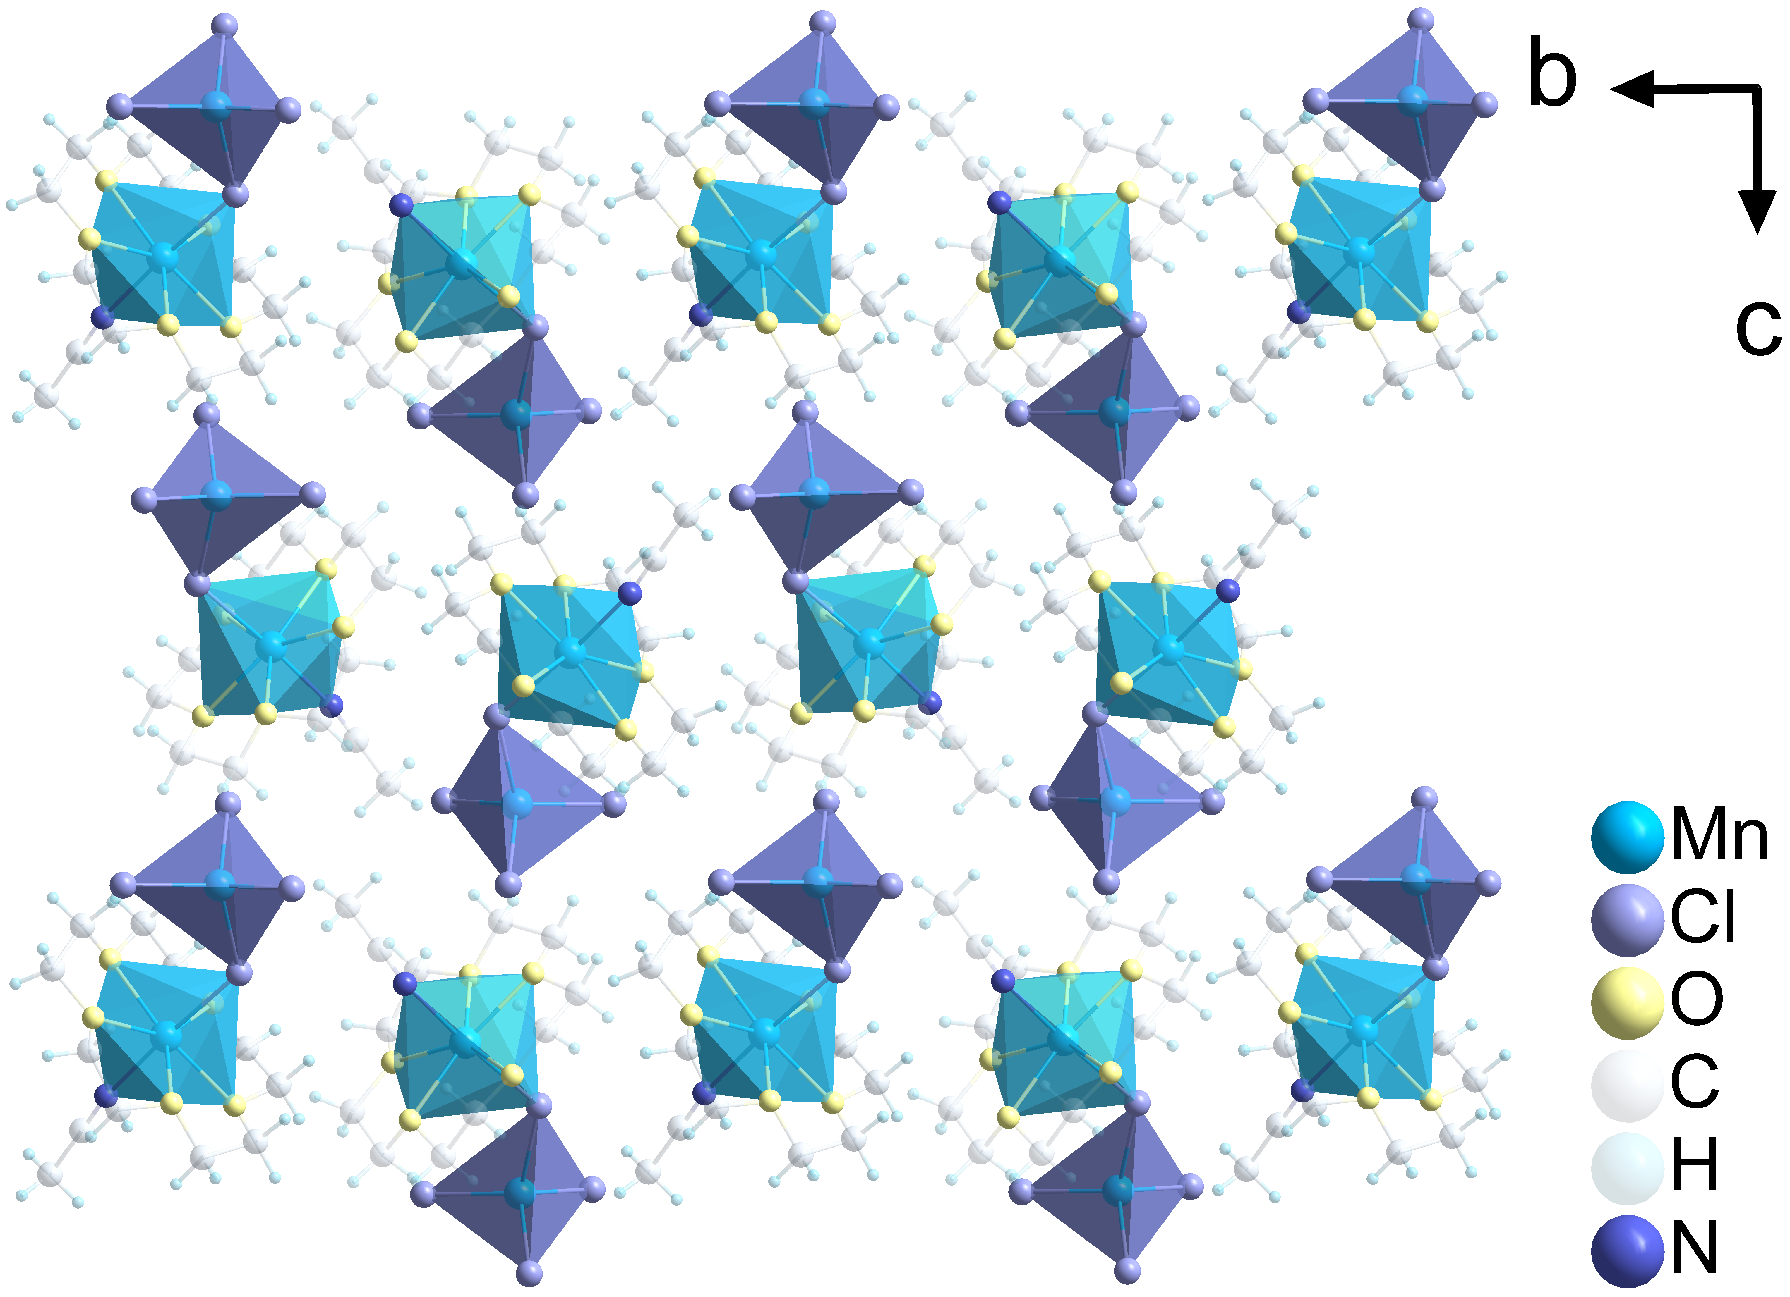
Fig. S2 Packing views of (C₁₀H₂₀O₅Mn)(CH₃CN)MnCl₄ unit cell along a axis.

Fig. S3 a) Scanning electron microscopy (SEM) and elemental mappings of Mn, O, Cl b) Energy dispersive spectrometer EDS elemental mappings of (C₁₀H₂₀O₅Mn)(CH₃CN)MnCl₄.

Fig. S4 XPS spectra for a) survey scan and high-resolution XPS spectra of b) Mn 2p; c) Cl 2p; d) O 1s; e) C 1s; f) N 1s in (C₁₀H₂₀O₅Mn)(CH₃CN)MnCl₄ crystals.

Fig. S5 Magnetic structures including three different AFM magnetic models (Mode1, 3, 4) and one FM magnetic model (Mode 2).

Fig. S6. The Mn···Mn distances between different dimers.

Fig. S7 The plot depicting the charge density distribution of (C₁₀H₂₀O₅Mn)(CH₃CN)MnCl₄. The yellow and cyan areas signify the charge accumulation and depletion.

Fig. S8 Temperature-dependent PL spectra of (C₁₀H₂₀O₅Mn)(CH₃CN)MnCl₄ from 5-305 K. a) Temperature-induced blue-shift from 668 nm to 638 nm in spin-canted Mn²⁺ dimer. b) Emission spectra from 5 K to 305 K with a broadening of the FWHM.

Fig. S9 The pressures-dependent CIE plots in the range of 0 – 20 MPa.

Table S1 Main parameters of processing and refinement of the (C₁₀H₂₀O₅Mn)(CH₃CN)MnCl₄ at room temperature (RT).
Chemical formula | C₁₂H₂₃O₅Cl₄Mn₂N
Molecular weight | 512.99
Temperature (K) | 293(2)
Space Group, Z | P2₁/n, 4
a (Å) | 9.2163(18)
b (Å) | 13.278(3)
c (Å) | 17.365(4)
α(°) | 90
β (°) | 95.41(3)
γ (°) | 90
V (Å³) | 2115.6(7)
ρ_{calc}(g/cm³) | 1.611
μ (mm⁻¹) | 1.718
Reflections measured | 31580
Reflections independent | 4337
Reflections with F > 4σ(F) | 3585
2θ_{max} (°) | 52.896
h, k, l - limits | -11 ≤ h ≤ 11; -16 ≤ k ≤ 16; -21 ≤ l ≤ 21
R_{int} | 0.0585
Refinement results
The weighed refinement of F² | w = 1/[σ²(F_{o}²)+(0.0532P)²+0.0369P]  where P = max(F_{o}²+2F_{c}²)/3
Number of refinement parameters | 218
R₁[F_{o} > 4σ(F_{o})] | 0.0324
wR2 | 0.0811
Goof | 1.130
∆ρ_{max}(e/Å³) | 0.729
∆ρ_{min}(e/Å³) | -0.765
(∆/σ)_{max} | <0.001
Extinction coefficient (SHELXL 2014/7) | 0.0150(8)

Table S2 Fractional atomic coordinates and isotropic or equivalent isotropic displacement parameters (Å²)
Atom | x | y | z | U_{iso}*/U_{eq} | Occ.
Mn1 | 0.46654(3) | 0.66066(2) | 0.74523(2) | 0.03225(12) | 1
Mn2 | 0.72944(4) | 0.75117(2) | 0.55115(2) | 0.03502(12) | 1
Cl1 | 0.59700(7) | 0.78352(5) | 0.66373(3) | 0.04804(18) | 1
Cl2 | 0.83632(7) | 0.59013(5) | 0.55041(4) | 0.04768(17) | 1
Cl3 | 0.91484(7) | 0.87180(5) | 0.55608(4) | 0.05249(18) | 1
Cl4 | 0.54649(8) | 0.76611(6) | 0.44780(4) | 0.0600(2) | 1
O1 | 0.35917(17) | 0.56807(12) | 0.64603(8) | 0.0405(4) | 1
O2 | 0.26032(18) | 0.73918(12) | 0.70301(9) | 0.0432(4) | 1
O3 | 0.42099(18) | 0.77479(12) | 0.83388(9) | 0.0461(4) | 1
O4 | 0.66303(19) | 0.66979(15) | 0.83129(9) | 0.0528(5) | 1
O5 | 0.61244(19) | 0.53916(14) | 0.72042(10) | 0.0559(5) | 1
C1 | 0.2489(3) | 0.6235(2) | 0.59997(14) | 0.0553(7) | 1
C2 | 0.1604(3) | 0.6768(2) | 0.65459(16) | 0.0556(7) | 1
C3 | 0.1945(3) | 0.7950(2) | 0.76103(15) | 0.0540(7) | 1
C4 | 0.3156(3) | 0.8487(2) | 0.80817(16) | 0.0596(8) | 1
C5 | 0.5464(3) | 0.8098(3) | 0.88059(16) | 0.0651(8) | 1
C6 | 0.6395(3) | 0.7209(3) | 0.90093(15) | 0.0686(9) | 1
C7 | 0.7454(3) | 0.5803(3) | 0.83854(18) | 0.0743(9) | 1
C8 | 0.7499(3) | 0.5329(2) | 0.76267(18) | 0.0704(8) | 1
C9 | 0.5757(3) | 0.47153(18) | 0.65751(15) | 0.0515(6) | 1
C10 | 0.4650(3) | 0.52177(19) | 0.60211(14) | 0.0484(6) | 1
C11 | 0.2810(3) | 0.51932(18) | 0.86542(13) | 0.0425(5) | 1
C12 | 0.2040(3) | 0.4657(2) | 0.92163(14) | 0.0583(7) | 1
N1 | 0.3402(2) | 0.56047(16) | 0.82105(11) | 0.0500(5) | 1
H2A | 0.187985 | 0.578032 | 0.567283 | 0.066* | 1
H2B | 0.293269 | 0.671480 | 0.567236 | 0.066* | 1
H3A | 0.086419 | 0.718038 | 0.626408 | 0.067* | 1
H3B | 0.112637 | 0.628752 | 0.685854 | 0.067* | 1
H5A | 0.144064 | 0.750022 | 0.793505 | 0.065* | 1
H5B | 0.124840 | 0.843107 | 0.737210 | 0.065* | 1
H6A | 0.358856 | 0.899136 | 0.776979 | 0.072* | 1
H6B | 0.278676 | 0.881965 | 0.852075 | 0.072* | 1
H8A | 0.517799 | 0.841757 | 0.927067 | 0.078* | 1
H8B | 0.599020 | 0.858576 | 0.852286 | 0.078* | 1
H9A | 0.731844 | 0.742130 | 0.927358 | 0.082* | 1
H9B | 0.591730 | 0.676518 | 0.935027 | 0.082* | 1
H11A | 0.702123 | 0.534355 | 0.873249 | 0.089* | 1
H11B | 0.843781 | 0.595472 | 0.860369 | 0.089* | 1
H12A | 0.822048 | 0.566296 | 0.734448 | 0.084* | 1
H12B | 0.777943 | 0.462750 | 0.769294 | 0.084* | 1
H14A | 0.536395 | 0.409485 | 0.676442 | 0.062* | 1
H14B | 0.661957 | 0.455392 | 0.631946 | 0.062* | 1
H15A | 0.511391 | 0.572222 | 0.572301 | 0.058* | 1
H15B | 0.418414 | 0.472620 | 0.566598 | 0.058* | 1
H18A | 0.268599 | 0.418139 | 0.948745 | 0.070* | 1
H18B | 0.122476 | 0.430566 | 0.895617 | 0.070* | 1
H18C | 0.169803 | 0.512703 | 0.957819 | 0.070* | 1

Table S3 The main bond lengths (Å) of compound (C₁₀H₂₀O₅Mn)(CH₃CN)MnCl₄.
Atom‒Atom | Length/Å | Atom‒Atom | Length/Å
Mn1‒O1 | 2.2664(16) | C3‒C4 | 1.501(4)
Mn1‒O2 | 2.2301(17) | C3‒O2 | 1.432(3)
Mn1‒O3 | 2.2283(15) | C4‒O3 | 1.423(3)
Mn1‒O4 | 2.2399(18) | C5‒C6 | 1.482(5)
Mn1‒O5 | 2.1690(17) | C5‒O3 | 1.426(3)
Mn1‒N1 | 2.2690(2) | C6‒O4 | 1.421(3)
Mn1‒Cl1 | 2.5359(8) | C7‒C8 | 1.465(4)
Mn2‒Cl1 | 2.4386(9) | C7‒O4 | 1.409(4)
Mn2‒Cl2 | 2.3548(8) | C8‒O5 | 1.405(3)
Mn2‒Cl3 | 2.3378(8) | C9‒C10 | 1.492(4)
Mn2‒Cl4 | 2.3519(10) | C9‒O5 | 1.430(3)
C1‒C2 | 1.487(4) | C10‒O1 | 1.432(3)
C1‒O1 | 1.435(3) | C11‒N1 | 1.126(3)
C2‒O2 | 1.448(3) | C11‒C12 | 1.447(3)

Table S4 Bond Angles for (C₁₀H₂₀O₅Mn)(CH₃CN)MnCl₄.
Atom‒Atom‒Atom | Angle/° | Atom‒Atom‒Atom | Angle/°
O1‒Mn1‒Cl1 | 96.94(4) | C1‒O1‒Mn1 | 112.42(14)
O1‒Mn1‒N1 | 84.93(7) | C10‒O1‒Mn1 | 111.53(13)
O2‒Mn1‒Cl1 | 87.14(5) | C10‒O1‒C1 | 113.90(18)
O2‒Mn1‒O1 | 72.91(6) | O1‒C1‒C2 | 106.88(19)
O2‒Mn1‒O4 | 143.54(7) | O2‒C2‒C1 | 106.6(2)
O2‒Mn1‒N1 | 89.81(7) | C2‒O2‒Mn1 | 113.52(14)
O3‒Mn1‒Cl1 | 94.48(5) | C3‒O2‒Mn1 | 114.55(14)
O3‒Mn1‒O1 | 142.83(6) | C3‒O2‒C2 | 114.6(2)
O3‒Mn1‒O2 | 72.48(6) | O2‒C3‒C4 | 106.7(2)
O3‒Mn1‒O4 | 72.26(7) | O3‒C4‒C3 | 107.1(2)
O3‒Mn1‒N1 | 81.81(7) | C4‒O3‒Mn1 | 114.84(14)
O4‒Mn1‒Cl1 | 86.64(5) | C4‒O3‒C5 | 116.5(2)
O4‒Mn1‒O1 | 143.53(6) | C5‒O3‒Mn1 | 114.79(15)
O4‒Mn1‒N1 | 94.11(7) | O3‒C5‒C6 | 107.2(2)
O5‒Mn1‒Cl1 | 91.85(6) | O4‒C6‒C5 | 108.0(2)
O5‒Mn1‒O1 | 71.34(6) | C6‒O4‒Mn1 | 114.53(15)
O5‒Mn1‒O2 | 143.84(6) | C7‒O4‒Mn1 | 114.15(16)
O5‒Mn1‒O3 | 143.49(7) | C7‒O4‒C6 | 116.8(2)
O5‒Mn1‒O4 | 72.28(7) | O4‒C7‒C8 | 110.1(2)
O5‒Mn1‒N1 | 92.34(8) | O5‒C8‒C7 | 110.1(2)
N1‒Mn1‒Cl1 | 175.78(6) | C8‒O5‒Mn1 | 119.07(16)
Cl2‒Mn2‒Cl1 | 113.93(3) | C8‒O5‒C9 | 119.9(2)
Cl3‒Mn2‒Cl1 | 105.62(3) | C9‒O5‒Mn1 | 120.83(15)
Cl3‒Mn2‒Cl2 | 108.52(3) | O5‒C9‒C10 | 108.03(19)
Cl3‒Mn2‒Cl4 | 116.04(3) | O1‒C10‒C9 | 107.90(19)
Cl4‒Mn2‒Cl1 | 102.70(3) | C11‒N1‒Mn1 | 171.6(2)
Cl4‒Mn2‒Cl2 | 110.03(3) | N1‒C11‒C12 | 179.3(3)
Mn2‒Cl1‒Mn1 | 129.32(3)

Table S5 Hydrogen-bond geometry in the (C₁₀H₂₀O₅Mn)(CH₃CN)MnCl₄ structure (Å, °).
D‒H···A | D‒H | H···A | D···A | D‒H···A
C2‒H2A···Cl3^{i} | 0.97 | 2.79 | 3.745 (3) | 167.2
C3‒H3A···Cl4^{ii} | 0.97 | 2.91 | 3.725 (3) | 141.9
C5‒H5A···Cl2^{ii} | 0.97 | 2.98 | 3.910 (3) | 161.0
C6‒H6A···Cl4^{iii} | 0.97 | 2.89 | 3.766 (3) | 150.8
C6‒H6B···Cl3^{ii} | 0.97 | 2.85 | 3.757 (3) | 155.6
C7‒H7A···Cl3^{iv} | 0.97 | 2.75 | 3.703 (4) | 166.4
C7‒H7B···Cl4^{iii} | 0.97 | 2.94 | 3.802 (3) | 148.9
C8‒H8B···Cl1^{iv} | 0.97 | 2.84 | 3.774 (3) | 160.8
C9‒H9B···Cl2 | 0.97 | 2.87 | 3.543 (3) | 127.5
C12‒H12B···Cl1^{v} | 0.96 | 2.93 | 3.869 (3) | 166.8
Symmetry codes: (i) x-1, y, z; (ii) x-1/2, -y+3/2, z+1/2; (iii) x+1/2, -y+3/2, z+1/2; (iv) -x+3/2, y-1/2, -z+3/2; (v) -x+1/2, y-1/2, -z+3/2.

Table S6 Total energy for various hypothetic models.
Mode | Total Energy (eV)
1 | -1066.01607
2 | -1065.96361
3 | -1066.01616
4 | -1066.01605

Table S7 Comparison of fluorescent lifetime parameters of 0D hybrid Mn(II) chloride.
 | Single crystal | Fluorescence lifetime | References
1 | TAMn₂Cl₅⋅2H₂O | 1.14 ms | 1
2 | (S‑C₃H₁₀ON)MnCl₃ | 1.02 ms | 2
3 | (C₄NOH₁₀)₅Mn₂Cl₉·C₂H₅OH | 4.83 ms | 3
 | (ABI)₄MnCl₆ | 13.19 ms | 4
4 | Mn-2DMAP | 1.21 ms | 5
5 | Mn-4DMAP | 1.79 ms | 5
6 | (C₄NOH₁₀)₂MnCl4 | 3.36 ms | 3
7 | (C₁₃H₂₆N)₂MnCl₄ | 3.829 ms | 6
8 | (C₇H₁₈N)₂MnCl₄ | 4.206 ms | 6
9 | (C₈H₂₀N)₂MnCl₄ | 3.42 ms | 7
10 | (Ph4P)₂MnCl₄ | 3.9 ms | 8
11 | (C₉H₁₂N₂)₂MnCl₄ | 2.094 ms | 9
12 | (C₅H₁₃N₃)₂MnCl₄ | 3.54 ms | 10
13 | (C₂₄H₂₀P)₂MnCl₄ | 2.46 ms | 11
14 | [DMAEMP]MnCl₄ | 3.26 ms | 12
15 | [MMPrIm]MnCl₄ | 3.527 ms | 12
16 | [EP]MnCl₄ | 1.40 ms | 12
17 | (KC)₂MnCl₄ | 2.79 ms | 13

Table S8 Relationship between line width (ΔH) and pressure variation.
Pressure (MPa) | ΔH (G)
0 | 406.17
2 | 411.76
3 | 442.09
4 | 450.07
5 | 456.46
10 | 459.64
15 | 460.45
20 | 458.84

References
1. Cong, et al. Manganese halides with timely and delayed reversible thermal fluorescence quenching for dual-secure information encryption and anti-counterfeiting. Chem. Eng. J. 505, 159672 (2025).

2. Panda, Swain, Raghunathan, Sundaresan. Negative thermal quenching and self-trapped exciton emission in (R/S-C₃H₁₀ON)MnCl₃. Chem. Mater. 36, 5698-5708 (2024).

3. Sun, Li, Dong, Zang. Thermoinduced structural-transformation and thermochromic luminescence in organic manganese chloride crystals. Chem. Sci. 10, 3836-3839 (2019).

4. Wang, et al. Flexible 3D printed fibers of novel manganese halides with superior acid/alkali resistance for X-ray imaging and radiation warning. Chem. Eng. J. 515, 163495 (2025).

5. Zhou, Li, Dai, Han, Yan. Dynamic magneto-optical response and reversible humidity-sensitive luminescence tuned by intermolecular interactions in manganese halides. Adv. Funct. Mater. n/a, 2503326 (2025).

6. Wang, et al. Efficient narrow-band green light-emitting hybrid halides for wide color gamut display. ACS Appl. Electron. Mater. 4, 4068-4076 (2022).

7. Chang, et al. Temperature-dependent reversible optical properties of Mn-based organic–inorganic hybrid (C₈H₂₀N)₂MnCl₄ metal halides. ACS Appl. Mater. Interfaces 15, 5487-5494 (2023).

8. Ben‐Akacha, et al. Mechanochemical synthesis of zero dimensional organic‐inorganic metal halide hybrids. ChemPhotoChem 4, 1–5 (2020).

9. Cong, et al. Reversible thermodynamic phase-transition in zero-dimensional manganese halides enables dual-secure optical information anti-counterfeiting and encryption. Laser Photonics Rev., e00761 (2025).

10. Cheng, et al. Centimeter‐sized single crystals of tetrahedral manganese (Ⅱ) halide hybrids for wide‐color gamut backlighting displays. Small, 2307216 (2023).

11. Zhou, Liu, Molokeev, Xiao, Xia, Zhang. Manipulation of Cl/Br transmutation in zero-dimensional Mn²⁺-based metal halides toward tunable photoluminescence and thermal quenching behaviors. J. Mater. Chem. C 9, 2047-2053 (2021).

12. Pan, et al. Enhancement of the photoluminescence efficiency of hybrid manganese halides through rational structural design. Chem. Commun. 57, 6907-6910 (2021).

13. Zhao, et al. Circularly polarized luminescence from achiral single crystals of hybrid manganese halides. J. Am. Chem. Soc. 141, 15755-15760 (2019).

