Supplementary information

Bedoya-Durán M. J., H. H. Jones, K. M. Malone, and L. C. Branch. Reference site influences perceived species loss in shade coffee, but assemblages in fact depend on landscape context.

Appendix A, Table S1. Species of ground-dwelling birds¹ captured on cameras, IUCN status², published altitudinal range³, and number of independent records⁴ in shade coffee plantations, forest fragments, and continuous forest in the Serranía de Los Paraguas region in the Western Andes of Colombia from July 2016 to July 2018.

Scientific name | English name | IUCN status | Altitudinal range | Independent records
 |  |  |  | Shade coffee | Forest fragments | Continuous forest
Tinamidae
Crypturellus soui | Little Tinamou | LC | 0-2000 | 5 | 15 | 7
Nothocercus bonapartei | Highland Tinamou | LC | 1500-2200 | 0 | 0 | 34
Nothocercus julius | Tawny-breasted Tinamou | LC | 1800-3500 | 0 | 0 | 13
Cracidae
Chamaepetes goudotii | Sickle-winged Guan | LC | 1100-2500 | 4 | 42 | 81
Ortalis columbiana* | Colombian Chachalaca | LC | 100-2500 | 0 | 1 | 0
Odontophoridae
Odontophorus hyperythrus | Chestnut Wood-quail | NT | 1600-2800 | 1 | 14 | 65
Columbidae
Patagioenas cayennensis* | Pale-vented Pigeon | LC | 0-1300 | 1 | 0 | 0
Leptotila plumbeiceps | Grey-headed Dove | LC | 1000-1800 | 17 | 24 | 1
Leptotila verreauxi | White-tipped Dove | LC | 0-2000 | 16 | 11 | 1
Zentrygon frenata | White-throated Quail-dove | LC | 900-3000 | 5 | 47 | 81
Grallaridae
Grallaria guatimalensis | Scaled Antpitta | LC | 500-2500 | 2 | 16 | 7
Grallaria ruficapilla | Chestnut-crowned Antpitta | LC | 1200-3600 | 0 | 0 | 19
Grallaria flavotincta | Yellow-breasted Antpitta | LC | 1300-2350 | 1 | 0 | 44
Grallaria [rufula] alvarezi | Rufous (Chamí) Antpitta | LC | 2300-3800 | 0 | 0 | 2
Grallaricula cucullate* | Hooded Antpitta | LC | 1800-2200 | 0 | 0 | 1
Grallaricula flavirostris* | Ochre-breasted Antpitta | LC | 900-2200 | 0 | 0 | 1
Grallaricula nana | Slate-crowned Antpitta | LC | 1900-3300 | 0 | 0 | 3
Rhinocryptidae
Scytalopus spp. | Tapaculo spp. | LC | Unknown | 0 | 1 | 11
Formicariidae
Formicarius rufipectus | Rufous-breasted Antthrush | LC | 850-2400 | 0 | 0 | 7
Chamaeza turdina | Schwartz's Antthrush | LC | 1400-2600 | 0 | 1 | 16
Furnariidae
Sclerurus mexicanus | Tawny-throated Leaftosser | LC | 0-2000 | 0 | 2 | 1
Lochmias nematura | Sharp-tailed Streamcreeper | LC | 750-2800 | 0 | 2 | 1
Troglodytidae
Cyphorhinus thoracicus | Chestnut-breasted Wren | LC | 1200-2700 | 0 | 0 | 17
Turdidae
Catharus aurantiirostris | Orange-billed Nightingale-thrush | LC | 600-2200 | 2 | 4 | 3
Catharus ustulatus | Swainson's Thrush | LC | 0-2500 | 4 | 12 | 14
Turdus leucops* | Yellow-legged Thrush | LC | 900-2000 | 0 | 0 | 1
Turdus serranus | Glossy-black Thrush | LC | 1400-2800 | 0 | 0 | 14
Turdus fuscater | Great Thrush | LC | 2000-4100 | 3 | 0 | 18
Turdus ignobilis | Black-billed Thrush | LC | 0-2000 | 12 | 4 | 2
Passerellidae
Oreothraupis arremonops | Tanager Finch | LC | 1200-2700 | 0 | 0 | 60
Arremon brunneinucha | Chestnut-capped Brush-finch | LC | 800-2600 | 15 | 45 | 64
* Species that were registered on cameras only once and excluded from the data analysis.
¹ Total number of species recorded were as follows: Shade coffee plantations: 14, forest fragments: 16, and continuous forest: 29.
² IUCN status (IUCN 2020): LC = Least Concern, DD = Data Deficient, NT = Near Threatened, VU = Vulnerable.
³ Altitudinal ranges were taken from: IUCN, 2020; Myers et al. 2000.
⁴ Consecutive records of a species were considered independent if they were separated by at least 24 hours.

Appendix A, Table S2. Species of mammals¹ captured on cameras, IUCN status², published altitudinal range³, and number of independent records⁴ in shade coffee plantations, forest fragments, and continuous forest in the Serranía de Los Paraguas region of the Western Andes of Colombia from July 2016 to July 2018.

Scientific name⁵ | English name | IUCN status | Altitudinal range | Independent records
 |  |  |  | Shade coffee | Forest fragments | Continuous forest
Agoutidae
Cuniculus paca | Spotted paca | LC | 0-2300 | 14 | 17 | 6
Cuniculus taczanowskii | Mountain paca | NT | 2000-4000 | 0 | 0 | 7
Dinomys branickii* | Pacarana | LC | 250-3200 | 0 | 0 | 1
Canidae
Cerdocyon thous | Crab-eating fox | LC | 0-3000 | 14 | 17 | 6
Cervidae
Mazama americana | Red-brocket deer | DD | 0-5000 | 0 | 2 | 1
Chlamyphoridae
Cabassous centralis | Naked-tailed armadillo | DD | 0-3000 | 2 | 5 | 3
Dasypodidae
Dasypus novemcinctus | Nine-banded armadillo | LC | 0-2000 | 13 | 42 | 38
Dasyproctidae
Dasyprocta punctata | Central American agouti | LC | 0-2400 | 34 | 54 | 24
Didelphidae
Didelphis marsupialis | Lowland opossum | LC | 0-2000 | 36 | 29 | 3
Didelphis pernigra | Andean white-eared opossum | LC | 2000-3700 | 2 | 7 | 42
Erethizontidae
Coendou rufescens | Stump-tailed porcupine | LC | 800-3500 | 0 | 0 | 3
Felidae
Leopardus pardalis | Ocelot | LC | 0-3000 | 1 | 6 | 9
Leopardus tigrinus | Oncilla | VU | 0-3626 | 7 | 15 | 40
Leopardus wiedii | Margay | NT | 0-3000 | 2 | 8 | 23
Panthera onca* | Jaguar | NT | 0-3000 | 0 | 0 | 1
Puma concolor | Puma | LC | 0-5800 | 0 | 0 | 29
Puma yagouaroundi | Jaguarundi | LC | 0-3200 | 0 | 7 | 2
Mustelidae
Eira barbara | Tayra | LC | 0-2400 | 10 | 58 | 46
Mustela felipei | Colombian weasel | VU | 1525-2700 | 0 | 0 | 2
Mustela frenata | Long-tailed weasel | LC | 863-4220 | 1 | 7 | 17
Myrmecophagidae
Tamandua mexicana | Northern tamandua | LC | 0-2000 | 1 | 1 | 3
Procyonidae
Bassaricyon neblina | Olinguito | NT | 1500-2800 | 0 | 0 | 3
Nasua nasua | South American coati | LC | 0-2500 | 0 | 4 | 62
Nasuella olivacea | Western mountain coati | NT | 1300-4260 | 0 | 0 | 15
Potos flavus | Kinkajou | LC | 0-2500 | 0 | 4 | 9
Procyon cancrivorous | Crab-eating raccoon | LC | 0-2350 | 3 | 15 | 2
Sciuridae
Sciurus granatensis | Red-tailed squirrel | LC | 0-3000 | 27 | 72 | 82
Tayassuidae
Pecari tajacu | Collared peccary | LC | 0-3000 | 0 | 0 | 6
Ursidae
Tremarctos ornatus | Andean bear | VU | 200-4750 | 0 | 0 | 7
* Species that were registered on cameras only once and excluded from the data analysis.
¹ Number of species recorded were as follows: Shade coffee plantations: 15, forest fragments: 19, and continuous forest: 29.
² IUCN status (IUCN 2020): LC = Least Concern, DD = Data Deficient, NT = Near Threatened, VU = Vulnerable.
³Altitudinal ranges were taken from IUCN, 2020
⁴ Consecutive records of a species were considered independent if they were separated by at least 24 hours.
⁵Species names and taxonomy was based on Wilson and Reeder 1993.
Appendix B: Approach used to produce a land use map of the study landscape using the Google Earth Engine cloud computing platform.

Method for land use map

After an exhaustive search of images of our study landscape, which is characterized by high cloudiness and steep slopes that make it difficult to obtain clear images, we were able to obtain a relatively cloud free Sentinel image from the Copernicus/S2 satellite ('COPERNICUS/S2/20180810T153621_20180810T153618_T18NUL') using the Google Earth Engine cloud computing platform (Gorelick et al. 2017). This image had a 10-meter spatial resolution. We performed a supervised classification with 100 training points collected in the field for each of the three dominant land-use types: crops (mainly shade coffee), pastures, and forest (primary and secondary).

We used a Random Forest classifier for image analysis. Random forest is a machine learning technique that consists of tree-structured classifiers built by bootstrapping randomly selected predictors. Randomization of the predictors means that thousands of tree-structured classifiers are produced without overfitting the model. We derived a combination of widely used vegetation indices from the Sentinel image, including the Normalized Difference Vegetation Index (NDVI), Solid Adjusted Vegetation Index (SAVI), VIs123 -Vegetation Indices, four image transformations: MID57, TCT 1, TCT 2, TCT 3, and band combinations (Green, Red, Red_edge1-2-3, NIR-Near Infrared, NarrowNIR-Narrow Near Infrared and SWIR1-2-Short-wave infrared). These indices combined with image transformation have been shown to be good predictors to classify forest types in tropical environments (Sesnie et al. 2010; Fagan et al. 2015; Haro-Carrión and Southworth 2018).

We classified our landscape into three main classes: forest, pasture, and crops, which were primarily shade-grown coffee. Also, we combined clouds and buildings into a fourth class because they exhibited a similar spectrum; clouds-buildings were easier to classify than to mask out; and this class represented less than five percent of the image. Classification accuracy was assessed using the Kappa index. The overall class accuracy was high (Kappa coefficient > 0.75, overall accuracy = 0.83), considering the difficulties of remote image classification in this type of environment. Shade-grown coffee plantations can be confounded with forest and sometimes regrowth areas on satellite images because these plantations have areas with trees and other dense vegetation. Thus, the shade-grown coffee class had the lowest producer and user accuracy; coffee -71 %, forest - 78%, pasture - 84 %; See confusion matrix in Table S1).

Based on our classification, we constructed a land use map (Fig. 2A) and use ArcGIS 10.6 (ESRI, Redlands, California, USA) to manipulate the image produced by the Google Earth Engine platform and to obtain landscape metrics. Then, we built a continuous forest polygon to calculate the variable “distance to continuous forest” for the hierarchical multi-species occupancy model. The continuous forest polygon was defined by merging adjacent pixels of the forest class in the land use map located at the top of the mountains where the continuous mass of forest is connected until the Chocó lowlands to the west. Strips of forest less than 200 m wide connected to this forest were not included as continuous forest.

Table S3: Overall producer’s and user’s accuracies and confusion matrix for the model used to build the land use map

 | Reference data |  |  |  | Total | User Acc.
Predicted | Clouds | Crops | Pasture | Forest | Total | User Acc.
Clouds/building | 49 | 0 | 3 | 0 | 52 | 94.23
Crops | 0 | 30 | 6 | 9 | 45 | 66.67
Pasture | 4 | 5 | 48 | 3 | 60 | 80.00
Forest | 0 | 7 | 0 | 42 | 49 | 85.71
Total | 53 | 42 | 57 | 54 |  | Overall:
Producer Acc. | 92.5 | 71.4 | 84.2 | 77.8 |  | 81.65

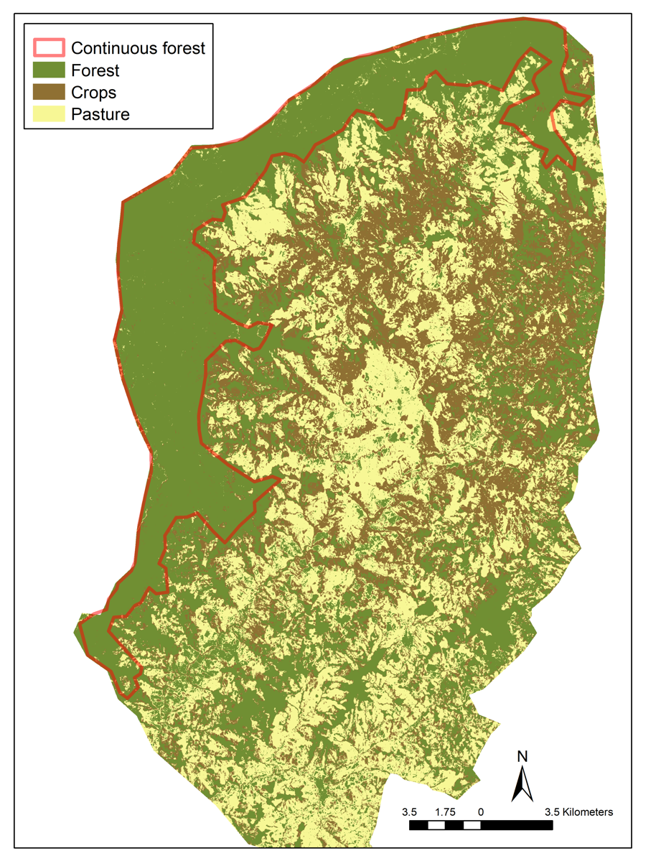

Figure S1. Land use map and forest polygon built to calculate landscape level variables for the multi-species occupancy model

Appendix C. Method used to build a cost-distance layer for human disturbance

Human land-use change, including settlements and roads, and human activities associated with greater access to natural habitats, significantly impacts species persistence in natural environments in many regions of the world (Rytwinski and Fahrig 2012; Nagy-Reis et al. 2017; Cavada et al. 2019) The Summed Point Influence (SPI) tool compiles data about these factors into one GIS layer (Fisher and Didier, 2012, Summed Point influence 1.0 beta; https://doi.org/10.5281/zenodo.887367). We used this tool to produce a GIS layer for our study site and then extracted disturbance values for each camera location. This index of human disturbance was used as a covariate in our occupancy model.

The SPI tool uses ArcGIS’s cost-distance model to represent the potential influence of humans on cells in the landscape by combining human population data represented by point localities (i.e., towns and cities) and a raster-based travel-cost layer. The travel cost layer is produced by combining land cover information with road and river data and assigning each cell in the raster a value for how long it takes to travel through the cell. For example, cells with forests and no roads and/or rivers might take longer to travel through than cells with open land cover types and cells with roads or rivers. The model then iteratively estimates an influence layer for each human settlement on the landscape and sums the influence layers for all settlements, weighting the individual layers by the population size of the settlement (i.e., larger settlements have more influence). Three advantages of the SPI tool over other similar approaches are that (1) human influence in any part of the landscape is influenced by proximity to all settlements in the landscapes, as opposed to just the nearest settlement, (2) the influence of towns is weighted by their population size, and (3) proximity to settlements is estimated via cost-distance (e.g., time to travel from a settlement to a place in the landscape) rather than Euclidean distance.

Settlement locality data that we used with the SPI tool came from reports published on the internet by local municipalities. Approximate population size for settlements was assigned based on public records from Colombia’s National Administrative Department of Statistics (Departamento Administrativo Nacional de Estadística) and web pages of the municipalities (https://geoportal.dane.gov.co/). We also verified the proportion of the population living in urban areas for each municipality with municipality web pages. Urban population estimates used for the model are as follows: 1) Versalles, 4300; 2) El Cairo, 3300; 3) Argelia, 3100; 4) El Balsal, 566; 5) Alban, 1025; 6) El Dovio, 6300. We produced the travel cost layer required by the SPI Tool by combining raster-based land-cover data from our land use map (10-m resolution) with vector-based road data. The road database was obtained from Serraniagua, the local NGO working with the private reserve owners. The table below summarizes the travel cost values we assigned to different cell types. The SPI tool allows the user to assign a maximum influence value in person*minute units. Based on various SPI model outputs, we set the maximum value for the model as 100,000 person * minutes.

Table S4: Table showing the travel cost assigned for each class

Cell type | Assumed means of travel | Travel cost *
Forest without a road | Foot | 60
Crops and pasture with a road | Foot | 30
Forests, crops, or pasture with a paved road | Vehicle | 1
Forests, crops, or pasture with an unpaved road | Vehicle | 2
* Minutes to travel through a 1-km cell)

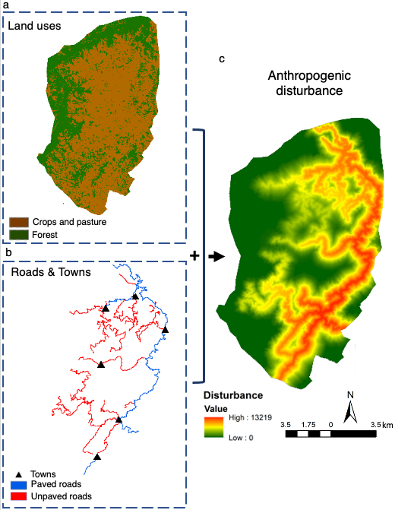
Figure S2. GIS layers (a and b) built to produce a final human disturbance map (c).

Appendix D. Multi-species occupancy model.

Model specifications and code:

Our data were in the form y_{ik} representing the number of detections at camera location i of species k. We modeled the sampling process as:
y_{ik} ~ Binomial (z_{ik} * p_{ik ,} nrep_{i} )
where p_{ik} is detection probability, nrep_{i} is the number of trapping occasions at each camera location, and z_{ik} is the true unobserved occupancy state, which we modeled as:
z_{ik} ~ Bernoulli (w_{k}*ψ_{ik})
where ψ_{ik} is occurrence probability and w_{k} indicates if a species is present in the community, and is governed by
w_{k} ~ Bernoulli (𝛀)
where 𝛀 is the probability that species k is a member of the community. To estimate species richness, we used a parameter-expanded data augmentation approach (Dorazio and Royle 2005; Kéry and Schaub 2012), where we added 15 all-zero trap frequencies to estimate richness in our landscape while accounting for the number of unobserved species (Dorazio et al. 2006). This data augmentation approach ensured that the number of all-zero detection histories was larger than the number of species that could have been missed in our sampling.
To model differences in species-specific occupancy between continuous forest and both forest fragments and shade coffee plantations, we used a logit link function that included land-use type as a covariate and used an effects parameterization with continuous forest as the intercept category. We also included the three continuous landscape-context variables described above as covariates to examine how the landscape surrounding camera locations affected species richness and occupancy. Elevation was not analyzed as a covariate but was incorporated in the model to account for differences in elevation among camera sites. Correlation among all variables was < 0.7, except for elevation and continuous forest (-0.72; See table S5 and S6 for means and correlations of variables). In this landscape, continuous forest is located at high elevations. All variables included in the model were standardized (mean set equal to zero and variance equal to one), and thus beta coefficients should be interpreted as such. We modeled landscape effects on occupancy probability as:
$$logit\left(ψ_{ik}\right) \sim α_{k}+ {β1}_{k}*{coffee}_{i}+ {β2}_{k}*{fragment}_{i}$$
$$+ {β3}_{k}*{disturbance}_{i}+ {β4}_{k}*{dist. forest}_{i}$$
$$+ {β5}_{k}*{forest 1km}_{i}$$
$$+ {β6}_{k}*{elevation}_{i}$$
$$+ γ_{site_{i}}$$
where 𝛂_{k} ~ Normal (𝛍, 𝛔²) is a random effect for species, coffee and fragment represent two of three land-use types with continuous forest as the reference level, $γ_{site_{i}}$ ~ Normal (0, 𝛔²) is a random effect for cameras at the same site, and additional terms represent the covariates described above. We modeled detection probability as:
logit (p_{ik}) ~ 𝛂_{k} + 𝛃1_{k} * understory_{i} + 𝛃2_{k} * canopy_{i}
where 𝛂_{k} ~ Normal (𝛍, 𝛔²) is a random effect for species, and the additional terms represent effects of vegetation on the detection process.
We used vague prior distributions for all parameters. We initiated three simulation chains to estimate the posterior distribution based on 100,000 iterations and a burn-in period of 70,000. We assessed convergence based on R-hat values <1.1 (Brooks and Gelman 1998).

Table S5: Covariates (mean ± SD) by land-use type used to model species detectability and
occupancy and to control for the altitudinal gradient in the landscape.

 | Variable | Continuous forest | Forest fragments |  |  | Coffee
 | Detectability
Canopy cover (%) |  | 82.41 (7.88) |  | 81.8 (12.89) | 50.8 (24.17)
Understory density (m) |  | 1.45 (0.47) |  | 1.28 (12.89) | 1.05 (0.64)
 | Occupancy
 | Dist. to continuous forest (km) | 0 | 2.52 (1.59) |  |  | 3.4 (1.52)
 | Human disturbance index | 2590.4 (2550.3) | 6072.5 (2789.0) |  |  | 6647.1 (2550.3)
 | Forest in 1-km buffer¹ (%) | 0.58 (0.38) | 0.55 (0.33) |  |  | 0.56 (0.32)
 | Elevation (m.a.s.l)² | 2128 (216.8) | 1746 (170.3) |  |  | 1576 (186.1)
¹We also calculated the amount of forest in a 500-m buffer, but this was highly correlated with 1-km buffer (0.98) so we only used the 1-km buffer.
² Covariate used to control for the elevational gradient

Table S6: Correlation coefficients among vegetation and landscape variables used to model species detectability and occupancy and control for the elevational gradient.

 | Elevation | Canopy | Understory | Distance to continuous forest | Human disturbance | Forest amount (1-km buffer)
Elevation (m.a.s.l) | 1 | 0.32 | 0.24 | -0.72 | -0.66 | 0.26
Canopy cover | 0.32 | 1 | 0.31 | -0.31 | -0.23 | -0.03
Understory density | 0.24 | 0.31 | 1 | -0.15 | -0.16 | 0.04
Distance to continuous forest | -0.72 | -0.31 | -0.15 | 1 | 0.33 | 0.07
Human disturbance | -0.66 | -0.23 | -0.16 | 0.33 | 1 | -0.41
Forest amount (1-km buffer) | 0.26 | -0.03 | 0.04 | 0.07 | -0.41 | 1

Code used for the hierarchical multi-species occupancy model:

model {

# Priors
omega ~ dunif(0,1)

#Priors to describe heterogeneity among species in the community
for(k in 1:M){
lpsi[k] ~ dnorm(mu.lpsi, tau.lpsi) # Hyperparameters making species random effects
lp[k] ~ dnorm(mu.lp, tau.lp)
betalpsi1[k] ~ dnorm(mu.betalpsi1, tau.betalpsi1)
betalpsi2[k] ~ dnorm(mu.betalpsi2, tau.betalpsi2)
betalpsi3[k] ~ dnorm(mu.betalpsi3, tau.betalpsi3)
betalpsi4[k] ~ dnorm(mu.betalpsi4, tau.betalpsi4)
betalpsi5[k] ~ dnorm(mu.betalpsi5, tau.betalpsi5)
betalpsi6[k] ~ dnorm(mu.betalpsi6, tau.betalpsi6)
betalp1[k] ~ dnorm(mu.betalp1, tau.betalp1)
betalp2[k] ~ dnorm(mu.betalp2, tau.betalp2)
}

for (i in 1:nmeta_site){
gamma[i] ~ dnorm(0, tau.gamma) # random effect for sites
}

# Hyperpriors for psi
mu.lpsi ~ dnorm(0,0.001)
tau.lpsi <- pow(sd.lpsi, -2)
sd.lpsi ~ dunif(0,5)
mu.betalpsi1 ~ dnorm(0,0.1)
tau.betalpsi1 <- pow(sd.betalpsi1, -2)
sd.betalpsi1 ~ dunif(0,5)
mu.betalpsi2 ~ dnorm(0,0.1)
tau.betalpsi2 <- pow(sd.betalpsi2, -2)
sd.betalpsi2 ~ dunif(0,5)
mu.betalpsi3 ~ dnorm(0,0.1)
tau.betalpsi3 <- pow(sd.betalpsi3, -2)
sd.betalpsi3 ~ dunif(0,5)
mu.betalpsi4 ~ dnorm(0,0.1)
tau.betalpsi4 <- pow(sd.betalpsi4, -2)
sd.betalpsi4 ~ dunif(0,5)
mu.betalpsi5 ~ dnorm(0,0.1)
tau.betalpsi5 <- pow(sd.betalpsi5, -2)
sd.betalpsi5 ~ dunif(0,5)
mu.betalpsi6 ~ dnorm(0,0.1)
tau.betalpsi6 <- pow(sd.betalpsi6, -2)
sd.betalpsi6 ~ dunif(0,5)
tau.gamma <- pow(sd.gamma, -2)
sd.gamma ~ dunif(0,5)

# Hyperpriors for p
mu.lp ~ dnorm(0,0.001)
tau.lp <- pow(sd.lp, -2)
sd.lp ~ dunif(0,2)
mu.betalp1 ~ dnorm(0,0.1)
tau.betalp1 <- pow(sd.betalp1, -2)
sd.betalp1 ~ dunif(0,2)
mu.betalp2 ~ dnorm(0,0.1)
tau.betalp2 <- pow(sd.betalp2, -2)
sd.betalp2 ~ dunif(0,2)

# Superpopulation process
for(k in 1:M){
w[k] ~ dbern(omega)
}

# Ecological model for true occurrence z
for (k in 1:M){
for (i in 1:nsite){
logit(psi[i,k]) <- lpsi[k]
+ (betalpsi1[k] * cof[i]) + (betalpsi2[k] * frag[i]) # land use type as predictors
+ (betalpsi4[k] * disturbance[i]) # human disturbance
+ (betalpsi5[k] * dist_cont_for[i]) # distance to continuous forest
+ (betalpsi6[k] * forest1000m[i]) # Forest in 1km-buffer (%)
+ (betalpsi3[k] * elev[i]) # elevation as nuisance variable
+ gamma[meta_site[i]] # random effect of site
mu.psi[i,k] <- w[k] * psi[i,k]
z[i,k] ~ dbern(mu.psi[i,k])
}
}

# Observation model for observed data
for (k in 1:M){
for (i in 1:nsite){
logit(p[i,k]) <- lp[k] + (betalp1[k] * undstor[i]) + (betalp2[k] * canopy[i])
mu.p[i,k] <- z[i,k] * p[i,k]
y[i,k] ~ dbin(mu.p[i,k], nrep[i]) # binomial model for detection - surveys are collapsed
}
}

# Derived quantities
for(k in 1:M){
Nocc.fs[k] <- sum(z[,k]) # Number of occupied sites
}
for (i in 1:nsite){
Nsite[i] <- sum(z[i,]) # Number of occurring species at each site
}

N.site.coffee <- mean(Nsite[1:56]) # mean N across sites in shade coffee
N.site.fragments <- mean(Nsite[204:302]) # mean N across sites in forest fragments
N.site.continuous <- mean(Nsite[57:203]) # mean N across cont. forest sites

n0 <- sum(w[(nspec+1):(nspec+nz)]) # Number of unseen species

Ntotal <- sum(w[]) # Total metacommunity size
Literature cited

Cavada N, Havmøller RW, Scharff N, Rovero F (2019) A landscape-scale assessment of tropical mammals reveals the effects of habitat and anthropogenic disturbance on community occupancy. PLoS One 14:1–15. https://doi.org/10.1371/journal.pone.0215682
Del Hoyo J (2020) All the birds of the world. Lynx Edicions, Barcelona

Dorazio RM, Royle JA (2005) Estimating size and composition of biological communities by modeling the occurrence of species. J Am Stat Assoc 100:389–398.

Dorazio RM, Royle JA, Söderström B, Glimskär A (2006) Estimating species richness and accumulation by modeling species occurrence and detectability. Ecology 87:842–854.

Fagan ME, DeFries RS, Sesnie SE, et al (2015) Mapping species composition of forests and tree plantations in northeastern Costa Rica with an integration of hyperspectral and multitemporal landsat imagery. Remote Sens 7:5660–5696. https://doi.org/10.3390/rs70505660

Fisher K, Didier K (2012) Summed Point Influence (SPI) Tool v.1.0 beta
Gorelick N, Hancher M, Dixon M, et al (2017) Google Earth Engine: Planetary-scale geospatial analysis for everyone. Remote Sens Environ 202:18–27. https://doi.org/10.1016/j.rse.2017.06.031

Haro-Carrión X, Southworth J (2018) Understanding land cover change in a fragmented forest landscape in a biodiversity hotspot of coastal Ecuador. Remote Sens 10:1–21. https://doi.org/10.3390/rs10121980

IUCN (2020) The IUCN Red List of Threatened Species. Version 2020-1
Schaub M, Kéry M (2012) Combining information in hierarchical models improves inferences in population ecology and demographic population analyses. Anim Conserv 15:125–126. https://doi.org/10.1111/j.1469-1795.2012.00531.x
Kissling WD, Dalby L, Fløjgaard C, et al (2014) Establishing macroecological trait datasets: digitalization, extrapolation, and validation of diet preferences in terrestrial mammals worldwide. Ecol Evol 4:2913–2930. https://doi.org/10.1002/ece3.1136
Myers N, Mittermeier RA, Mittermeier CG, et al (2000) Biodiversity hotspots for conservation priorities. Nature 403:853–8

Nagy-Reis MB, Nichols JD, Chiarello AG, et al (2017) Landscape use and co-occurrence patterns of Neotropical spotted cats. PLoS One 12:1–22. https://doi.org/10.1371/journal.pone.0168441

Rytwinski T, Fahrig L (2012) Do species life history traits explain population responses to roads? A meta-analysis. Biol Conserv 147:87–98. https://doi.org/10.1016/j.biocon.2011.11.023

Sesnie S., Finegan B, Gessler P., et al (2010) The multispectral separability of Costa Rican rainforest types with support vector machines and Random Forest decision trees. Int J Remote Sens 31:2885–2909

Wilman H, Belmaker J, Jennifer S, et al (2014) EltonTraits 1.0: Species-level foraging attributes of the world’s birds and mammals. Ecology 95:2027

Wilson DE, Reeder DM (1993) Mammal species of the world: a taxonomic and geographic reference, second edi. Smithsonian Institution Press, Washington, D.C

