Tableau S1: possible model of the anomalies
N° | Forms of anomaly | Comment
1 | 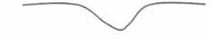 | Well marked and constricted fault. Precise hydrogeological node or single fault cut perpendicularly
2 | 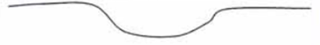 | Well-marked but wide fault. Wide hydrogeological node or single fault intersected not perpendicularly, hydrogeological node border
3 | 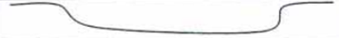 | Very wide or intersected fault with a small angle and/or faults intersected before the node
4 | 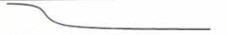 | Collapsed compartment?
5 | 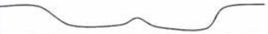 | Fault intersected before the node
6 | 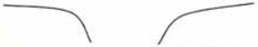 | Very marked fault
7 |  | other anomalies
Tableau S2: morphological model of the formations covering the anomaly
N° | Shapes superimposed on the anomaly | Comments
A | 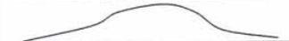 | Medium-strength partial area above the fault, temporary reservoir above the fractured fault?
B | 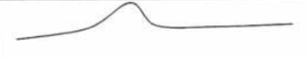 | Moderately resistant zone above the fault, temporary reservoir above the fractured fault? Possibility of a lateral dyke
C | 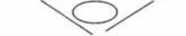 | Two inclined faults possibly individuating a ball alteration
D | 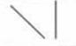 | Junction of two vertical and inclined faults
E |  | Inclined fault
F |  | other anomalies

