A.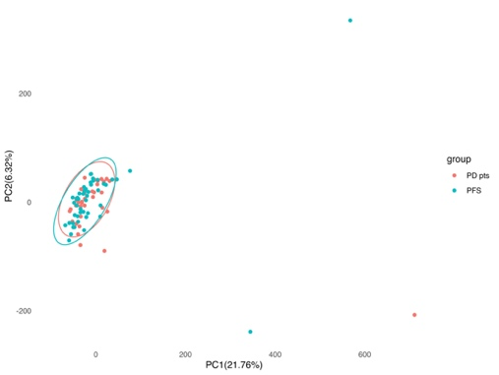 B.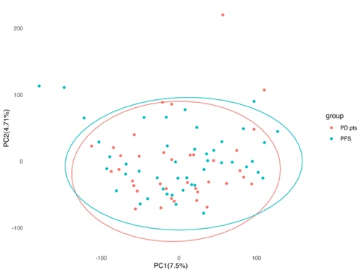
C.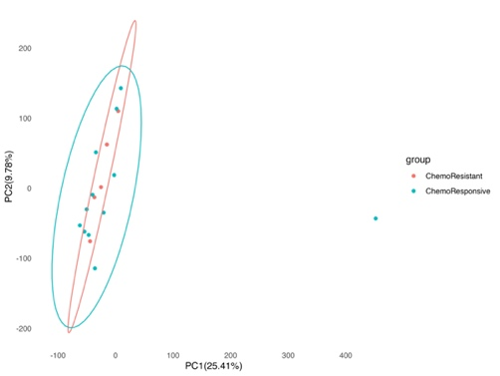 D.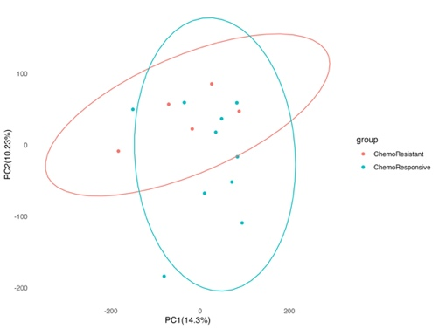
Figure S1. Principal Component Analysis (PCA) for outlier detection in osteosarcoma datasets. (A) PCA of 88 osteosarcoma patients based on global gene expression profiles. (B) PCA of 82 patients after outlier removal. (C) PCA of 17 post-chemotherapy patients with available drug response data. (D) PCA of 15 patients after outlier removal. Ellipses represent 95% confidence intervals of sample clustering within each group.

Figure S2. Dose-response curves for cisplatin treatment in U2OS cells transiently transfected with miRNA mimics. Cell survival (%) was assessed following cisplatin treatment at various concentrations (log [M]) using SRB assay. IC50 values are displayed in the table below the graph, indicating the differential sensitivity of each group. U2OS cells transfected with hsa-miR-16-1-3p mimic (orange) or hsa-miR-16-2-3p mimic (black) showed significantly decreased IC50 compared with the negative control group transfected with scrambled miRNA (blue), suggesting enhanced cisplatin sensitivity.

Supplementary Table 1. List of oligonucleotides used in the article.
Oligonucleotide Name | Oligonucleotide Sequence
miR-16-F | aCCGGTTAGCAGCACGTAAATATTGGCGCTCGAGCGCCAATATTTACGTGCTGCTATTTTTG
miR-16-R | AATTCAAAAATAGCAGCACGTAAATATTGGCGCTCGAGCGCCAATATTTACGTGCTGCTAAc
hsa-miR-16-1*-F | accggCCAGTATTAACTGTGCTGCTGActcgagTCAGCAGCACAGTTAATACTGGtttttg
hsa-miR-16-1*-R | aattcaaaaaCCAGTATTAACTGTGCTGCTGActcgagTCAGCAGCACAGTTAATACTGGc
hsa-miR-16-2*-F | accggCCAATATTACTGTGCTGCTTTActcgagTAAAGCAGCACAGTAATATTGGtttttg
hsa-miR-16-2*-R | aattcaaaaaCCAATATTACTGTGCTGCTTTActcgagTAAAGCAGCACAGTAATATTGGc
shScrambled-F | aCCGGTCCTAAGGTTAAGTCGCCCTCGCTCGAGCGAGGGCGACTTAACCTTAGGTTTTTG
shScrambled-R | AATTCAAAAACCTAAGGTTAAGTCGCCCTCGCTCGAGCGAGGGCGACTTAACCTTAGGAc
PLKO-Dir | tgtggaaaggacgaaacacc
PLKO-Rev | tctttcccctgcactgtacc

Supplementary Table 2. Predicted target genes of miR-16, miR-16-1-3p, and miR-16-2-3p with significantly upregulated expression exceeding the GSEA enrichment threshold.
Genes with log₂ fold change (log₂FC) values exceeding the GSEA enrichment threshold—defined as the log₂FC corresponding to the maximum enrichment score (ES) in the ranked gene list—were selected as the most relevant contributors to the enrichment of predicted target gene sets. These genes are expected to play critical roles in the biological functions regulated by each individual microRNA and were used for downstream functional enrichment analyses.
Table 2A presents upregulated predicted target genes of miR-16 in chemotherapy-resistant osteosarcoma patients;
Table 2B contains upregulated predicted target genes of miR-16-1-3p in chemotherapy-resistant patients;
Table 2C lists upregulated predicted target genes of miR-16-1-3p in patients with progressive disease;
Table 2D includes upregulated predicted target genes of miR-16-2-3p in chemotherapy-resistant patients.

Supplementary Table 3. Expression values of differentially upregulated predicted target genes of miR-16, miR-16-1-3p, and miR-16-2-3p in osteosarcoma patient subgroups.
Supplementary Table 3 presents the expression profiles of predicted target genes of miR-16, miR-16-1-3p, and miR-16-2-3p that are significantly upregulated (log₂FC > 0, p < 0.05) in specific osteosarcoma patient subgroups.
Table 3A includes expression values of upregulated miR-16 target genes in chemotherapy-resistant patients.
Table 3B contains expression values of upregulated miR-16-1-3p target genes in chemotherapy-resistant patients.
Table 3C lists expression values of upregulated miR-16-1-3p target genes in progressive patients.
Table 3D presents expression values of upregulated miR-16-2-3p target genes in chemotherapy-resistant patients.

