SCHISTOCYTES EVALUATION IN IRON DEFICIENCY: AN ASSESSMENT ADOPTED FROM ICSH NOMENCLATURE GUIDELINE

Additional File 2

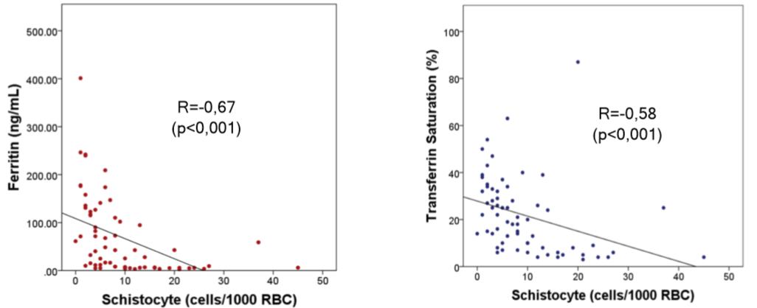
Figure S1. Schistocyte count and iron parameters correlation in the microcytic population

