Supplementary Figures

Telomere-to-telomere cattle genome assembly reveals novel introgressions and selection signatures associated with adaptation and energy metabolism

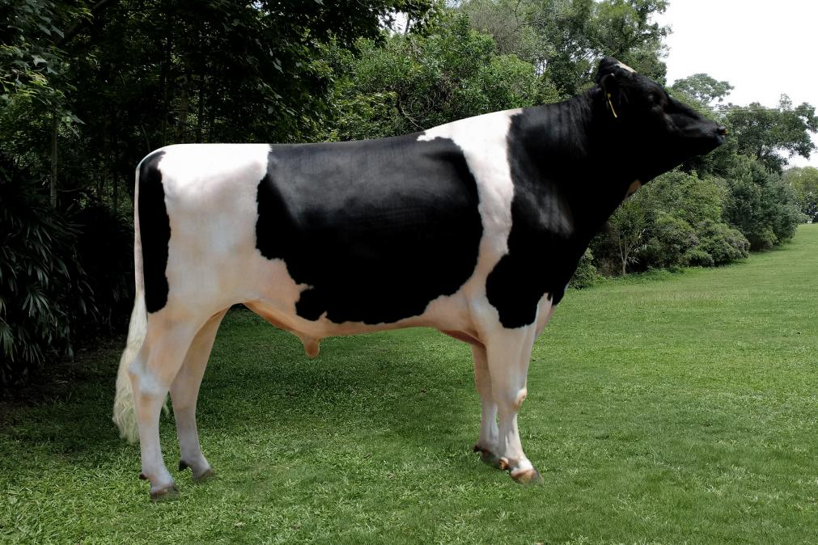
Supplementary Fig. 1 The Holstein bull for the assembly of the T2T-cattle1.0-SAAS genome.

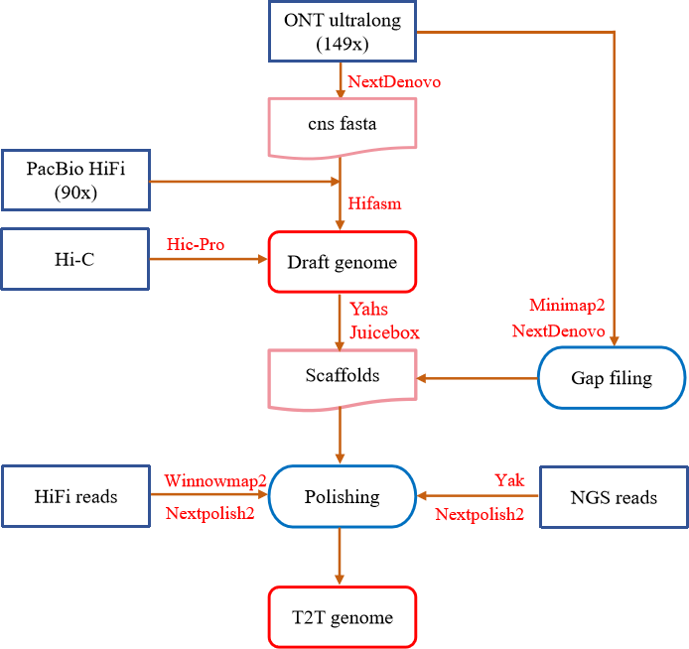
Supplementary Fig. 2 The pipeline for the assembly of the T2T-cattle1.0-SAAS genome. Genome assembly was conducted using a pipeline that combines multiple computational tools. Hifiasm integrated HiFi and CNS (from corrected ONT) data to assemble genomic sequences into contigs. Hi-C data was quality-controlled by fastp, then Hicpr0 aligned reads to the preliminarily assembled genome. Yahs sorted contigs into Scaffolds, and Juicebox optimized them, resulting in 29 scaffolds anchored to 29 pseudochromosomes. Long ONT reads were aligned to gap-containing genomes, and reads at gap termini were iteratively assembled by NextDenovo to fill gaps, with manual curation for completion. Yak divided the second-generation sequencing reads into count files for 21-mer and 31-mer sequences. Winnomap2 aligned HiFi reads to form BAM, and NextPolish2 polished using count files and BAM to polishing genome.

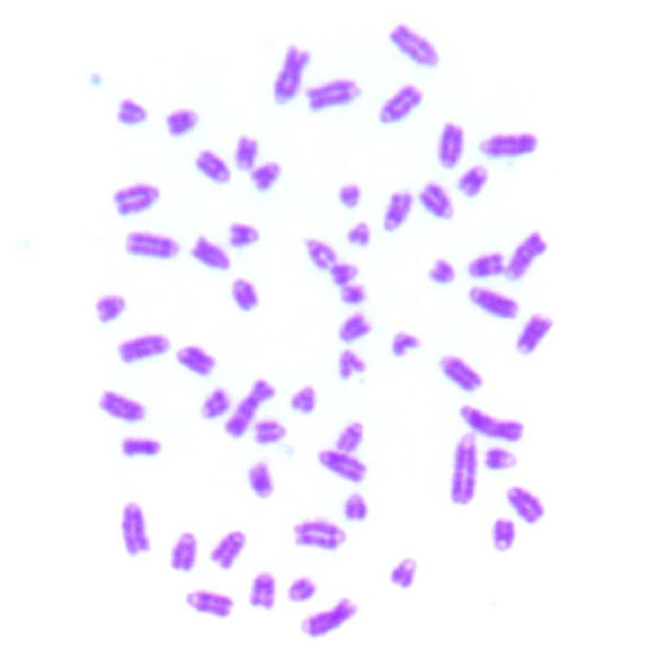
Supplementary Fig. 3 Karyotyping of Holstein bull. The karyotyping of the Holstein bull was conducted utilizing mitotic spreads in conjunction with Giemsa staining. The representative image illustrates the haploid complement, consisting of 60 chromosomes (58 autosomes, and the X and Y chromosomes).

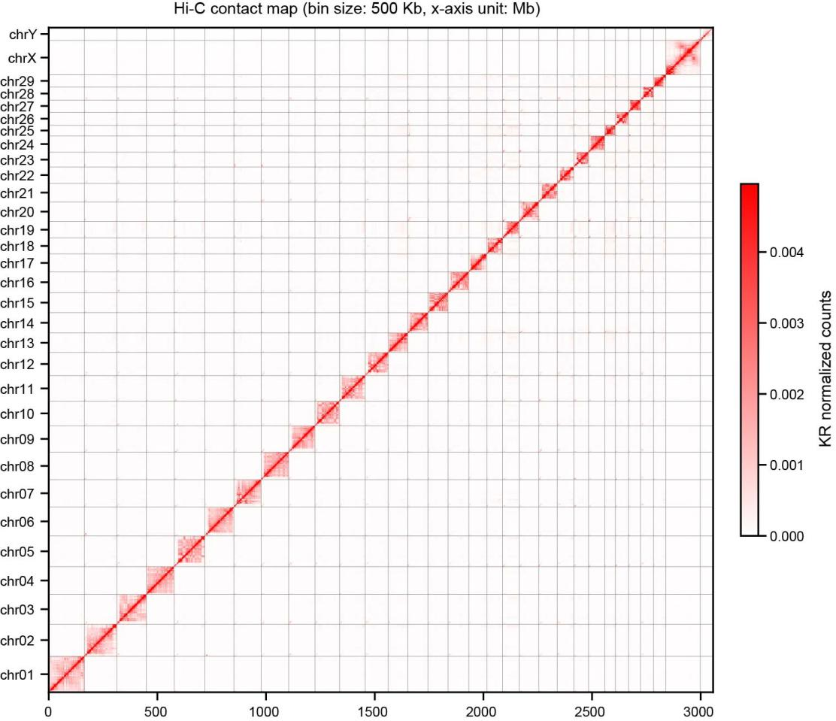
Supplementary Fig. 4 Hi-C heatmap for the evaluation of T2T-cattle1.0-SAAS. The diagonal pattern of the red-shaded regions suggests a higher frequency of interactions between genomic regions that are closer in linear distance.
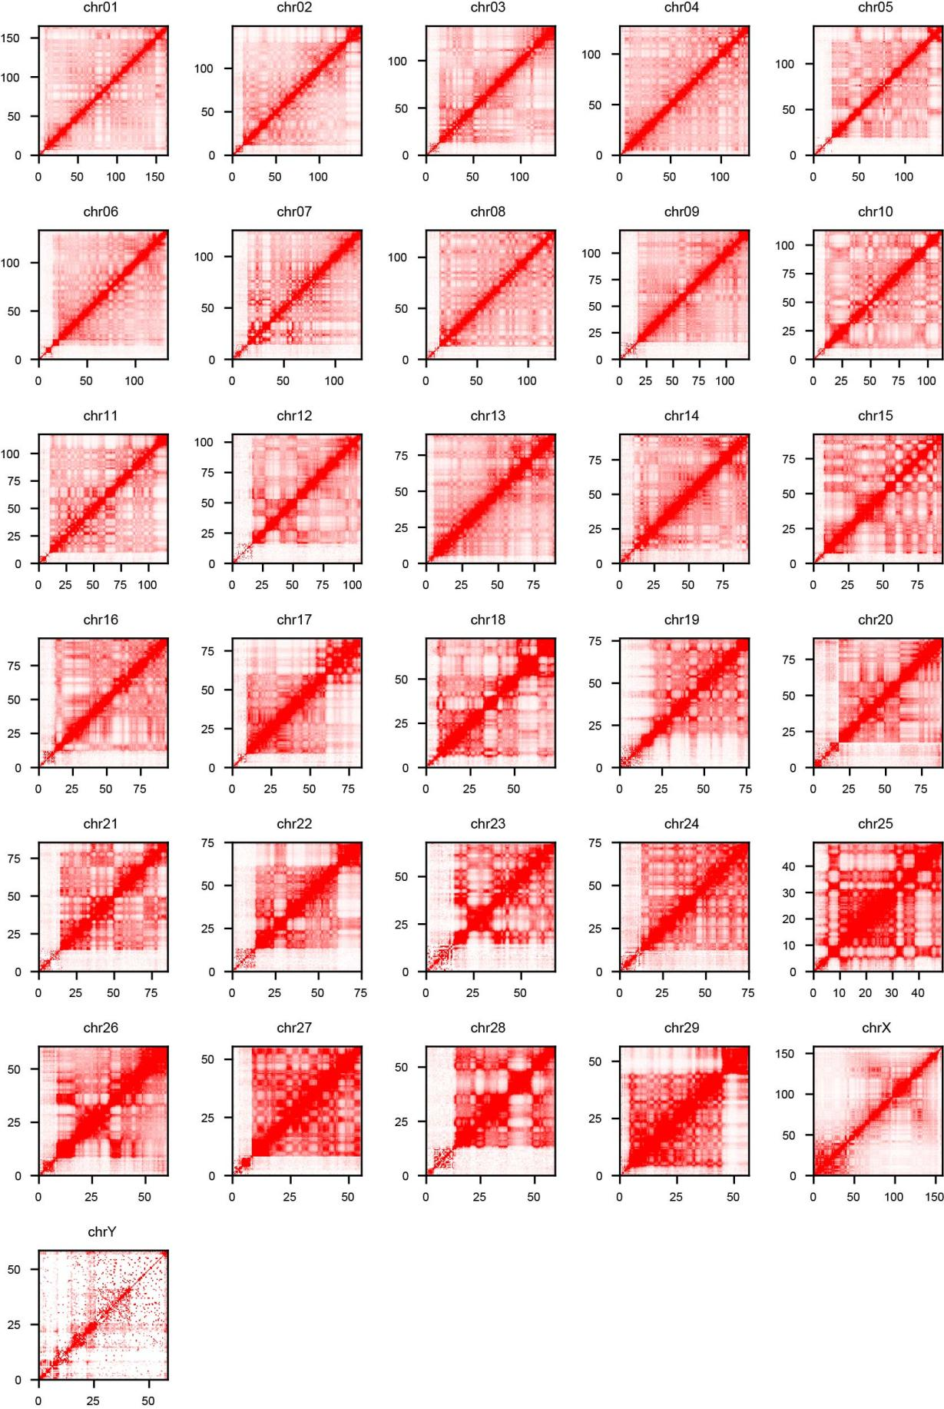
Supplementary Fig. 5 Hi-C heatmap for the evaluation on each chromosome of T2T-cattle1.0-SAAS. The diagonal pattern of the red-shaded regions suggests a higher frequency of interactions between regions of the same chromosome that are closer in linear distance.

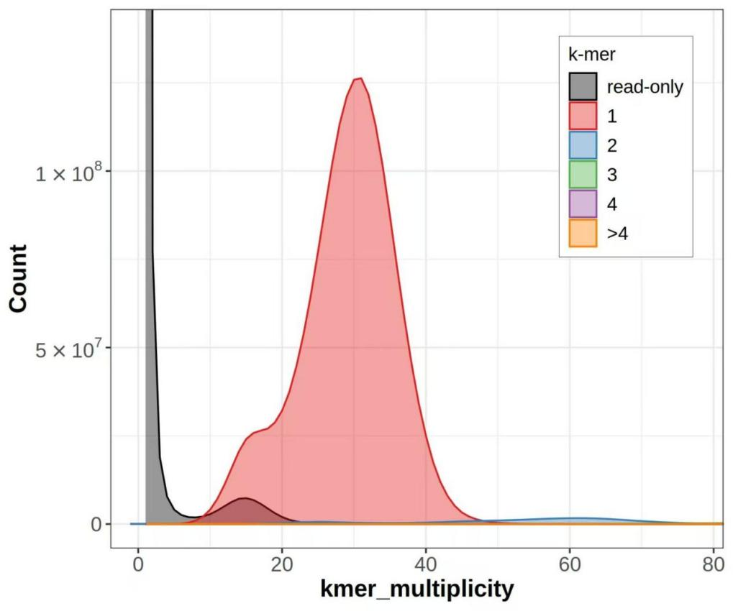
Supplementary Fig. 6 The k-mer multiplicity (x-axis) and k-mer counts (y-axis) to assess the completeness of the T2T-cattle1.0-SAAS. The x-axis is plotted against y-axis to examine the assembly completeness.

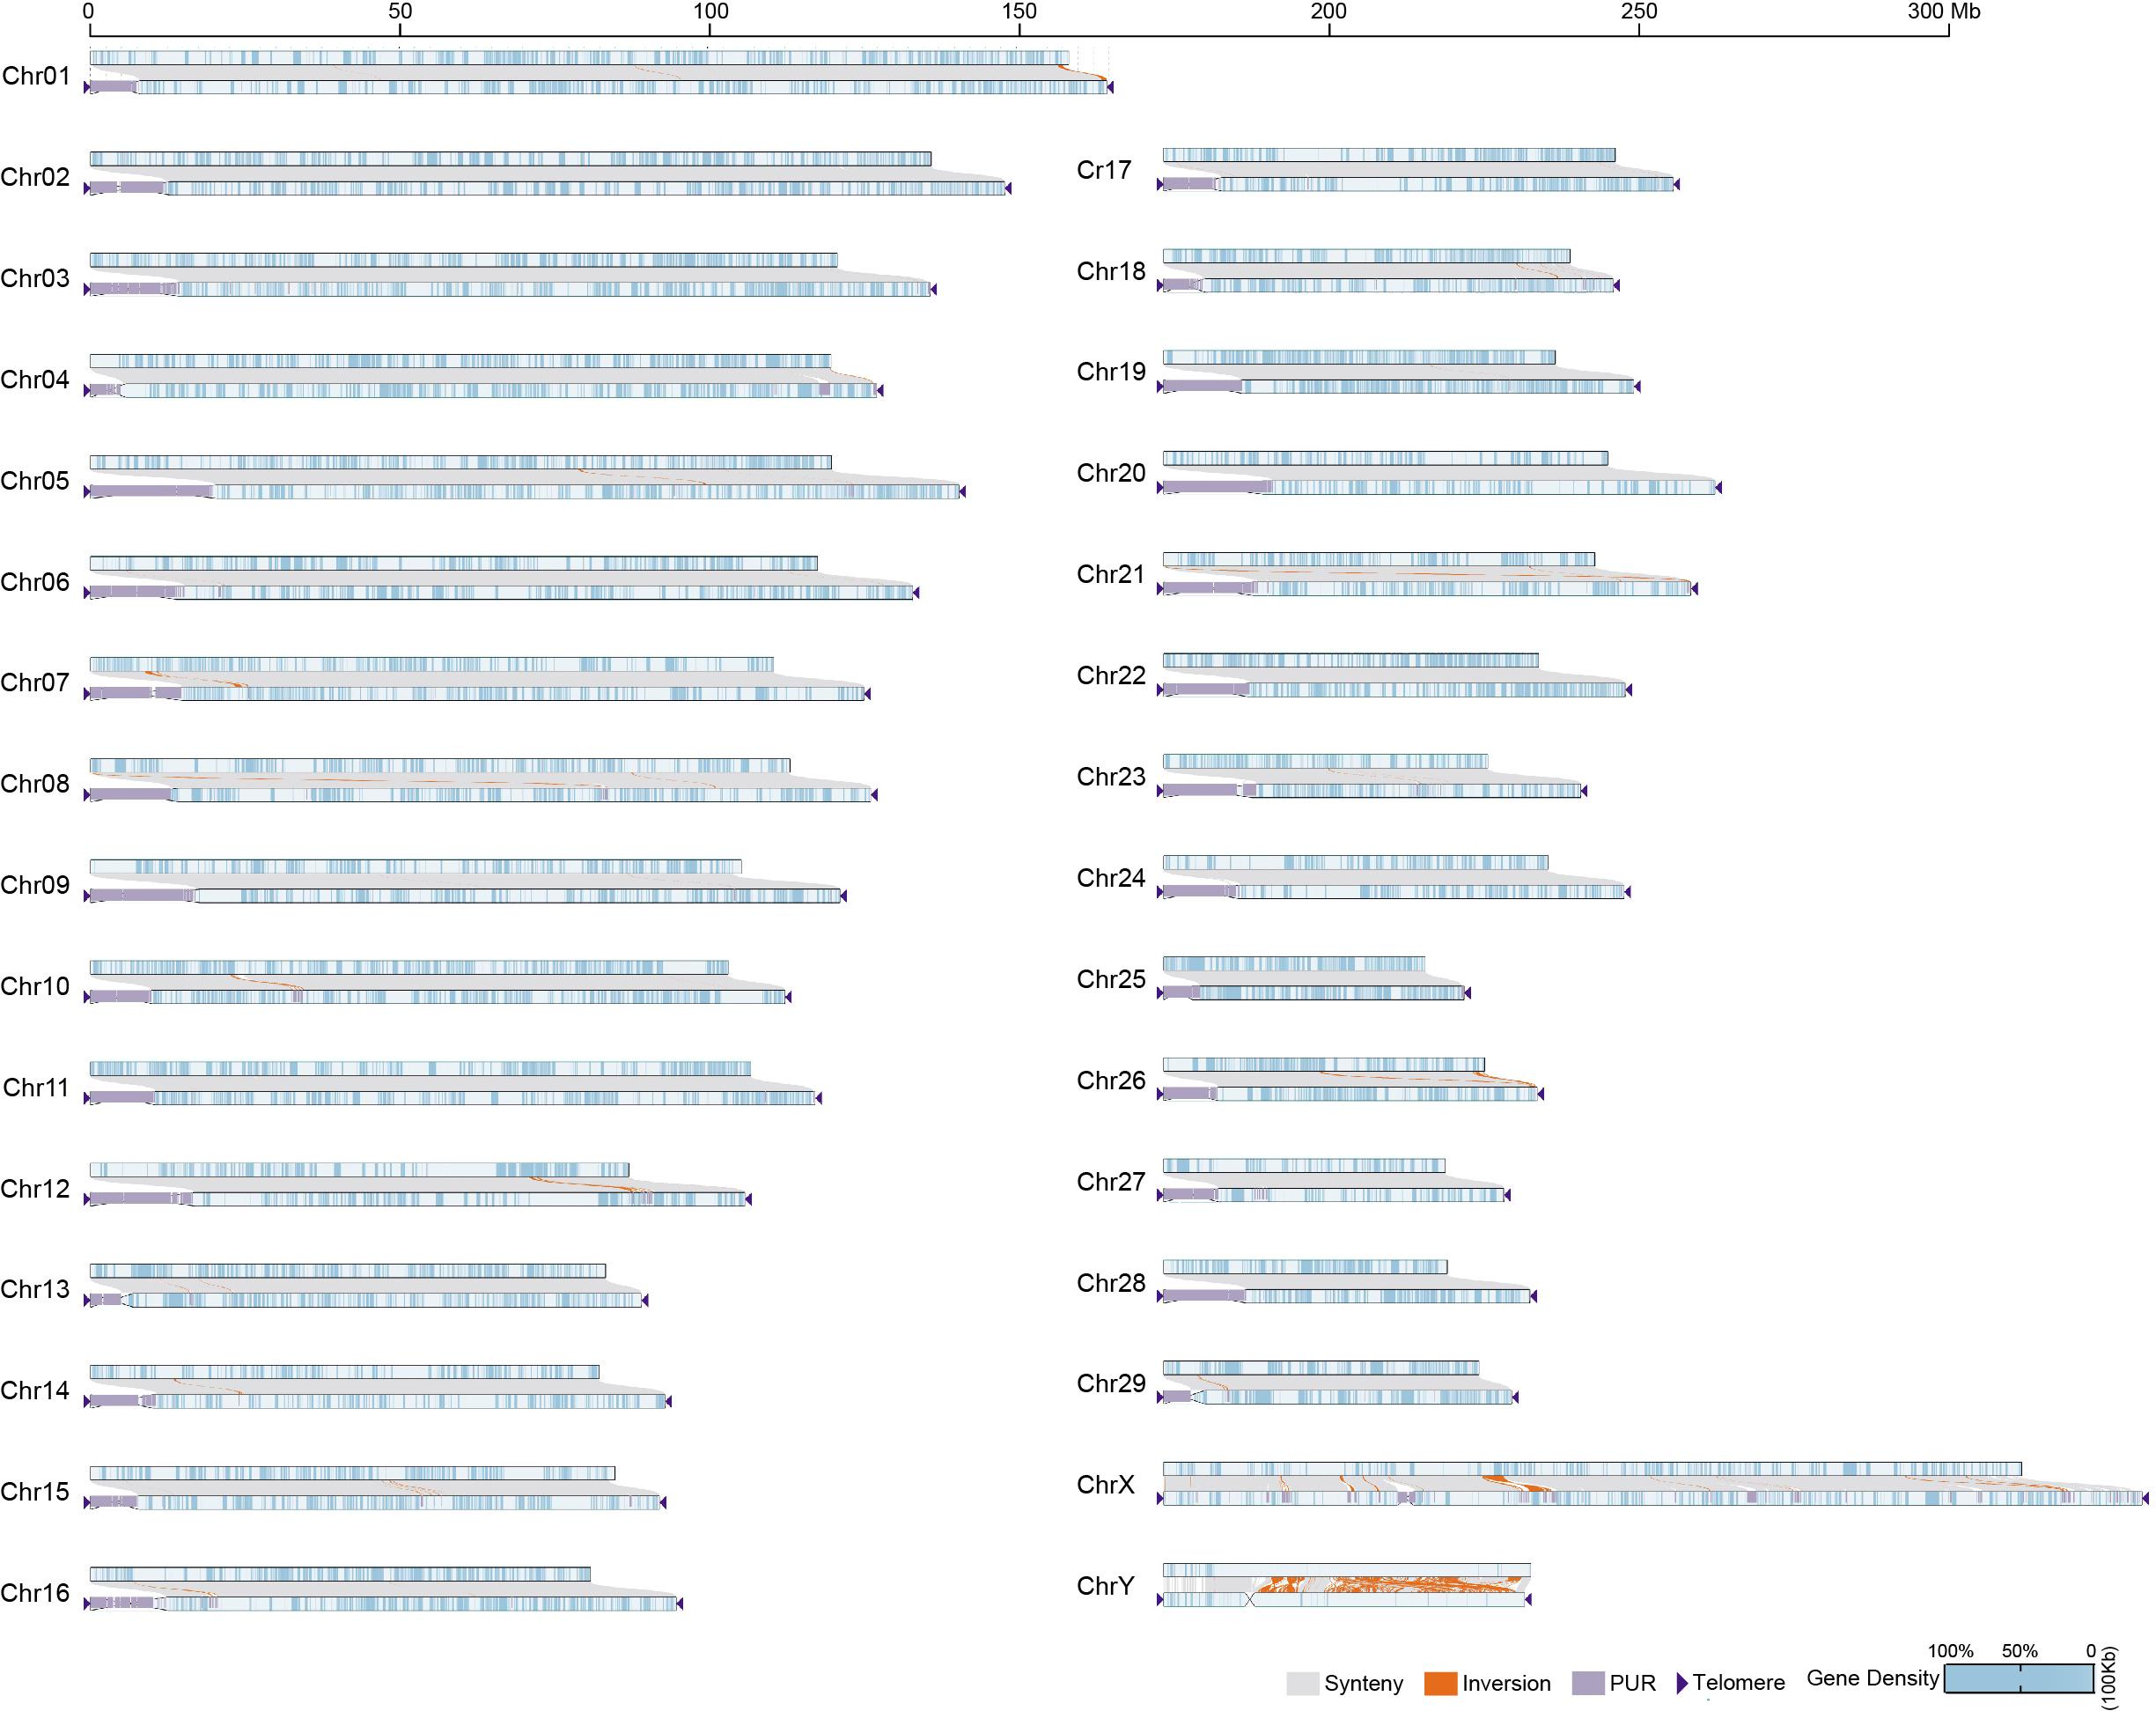
Supplementary Fig. 7 The synteny analysis between the T2T-cattle-SAAS and ARS-UCD2.0. The comparative analyses of the T2T-cattle-SAAS and ARS-UCD2.0 genomes encompass an examination of synteny (light gray), inversion (pink), previously unassembled region (PUR) (dark grey), telomere (triangle arrow), and gene density (gradient of blue).

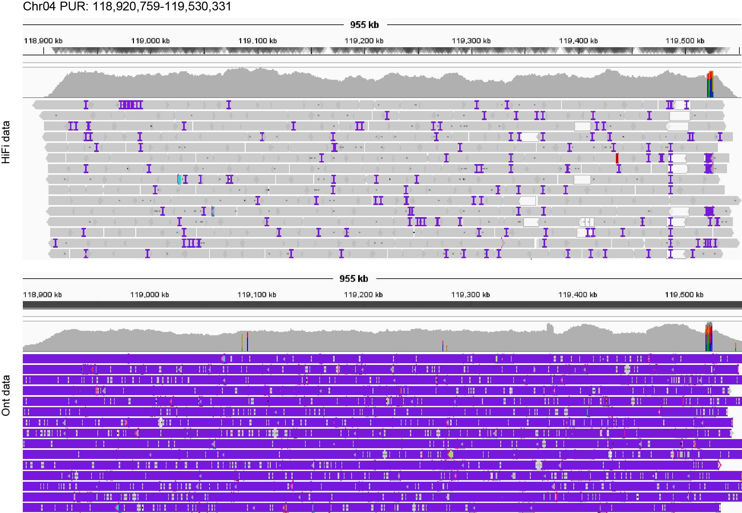
Supplementary Fig. 8 Mapping of HiFi and ONT reads in PUR of Chr04. HiFi and Ont reads were aligned to the T2T-cattle1.0-SAAS genome, showing the mapped region within a PUR (118,920,759-119,530,331 bp) on Chr04.

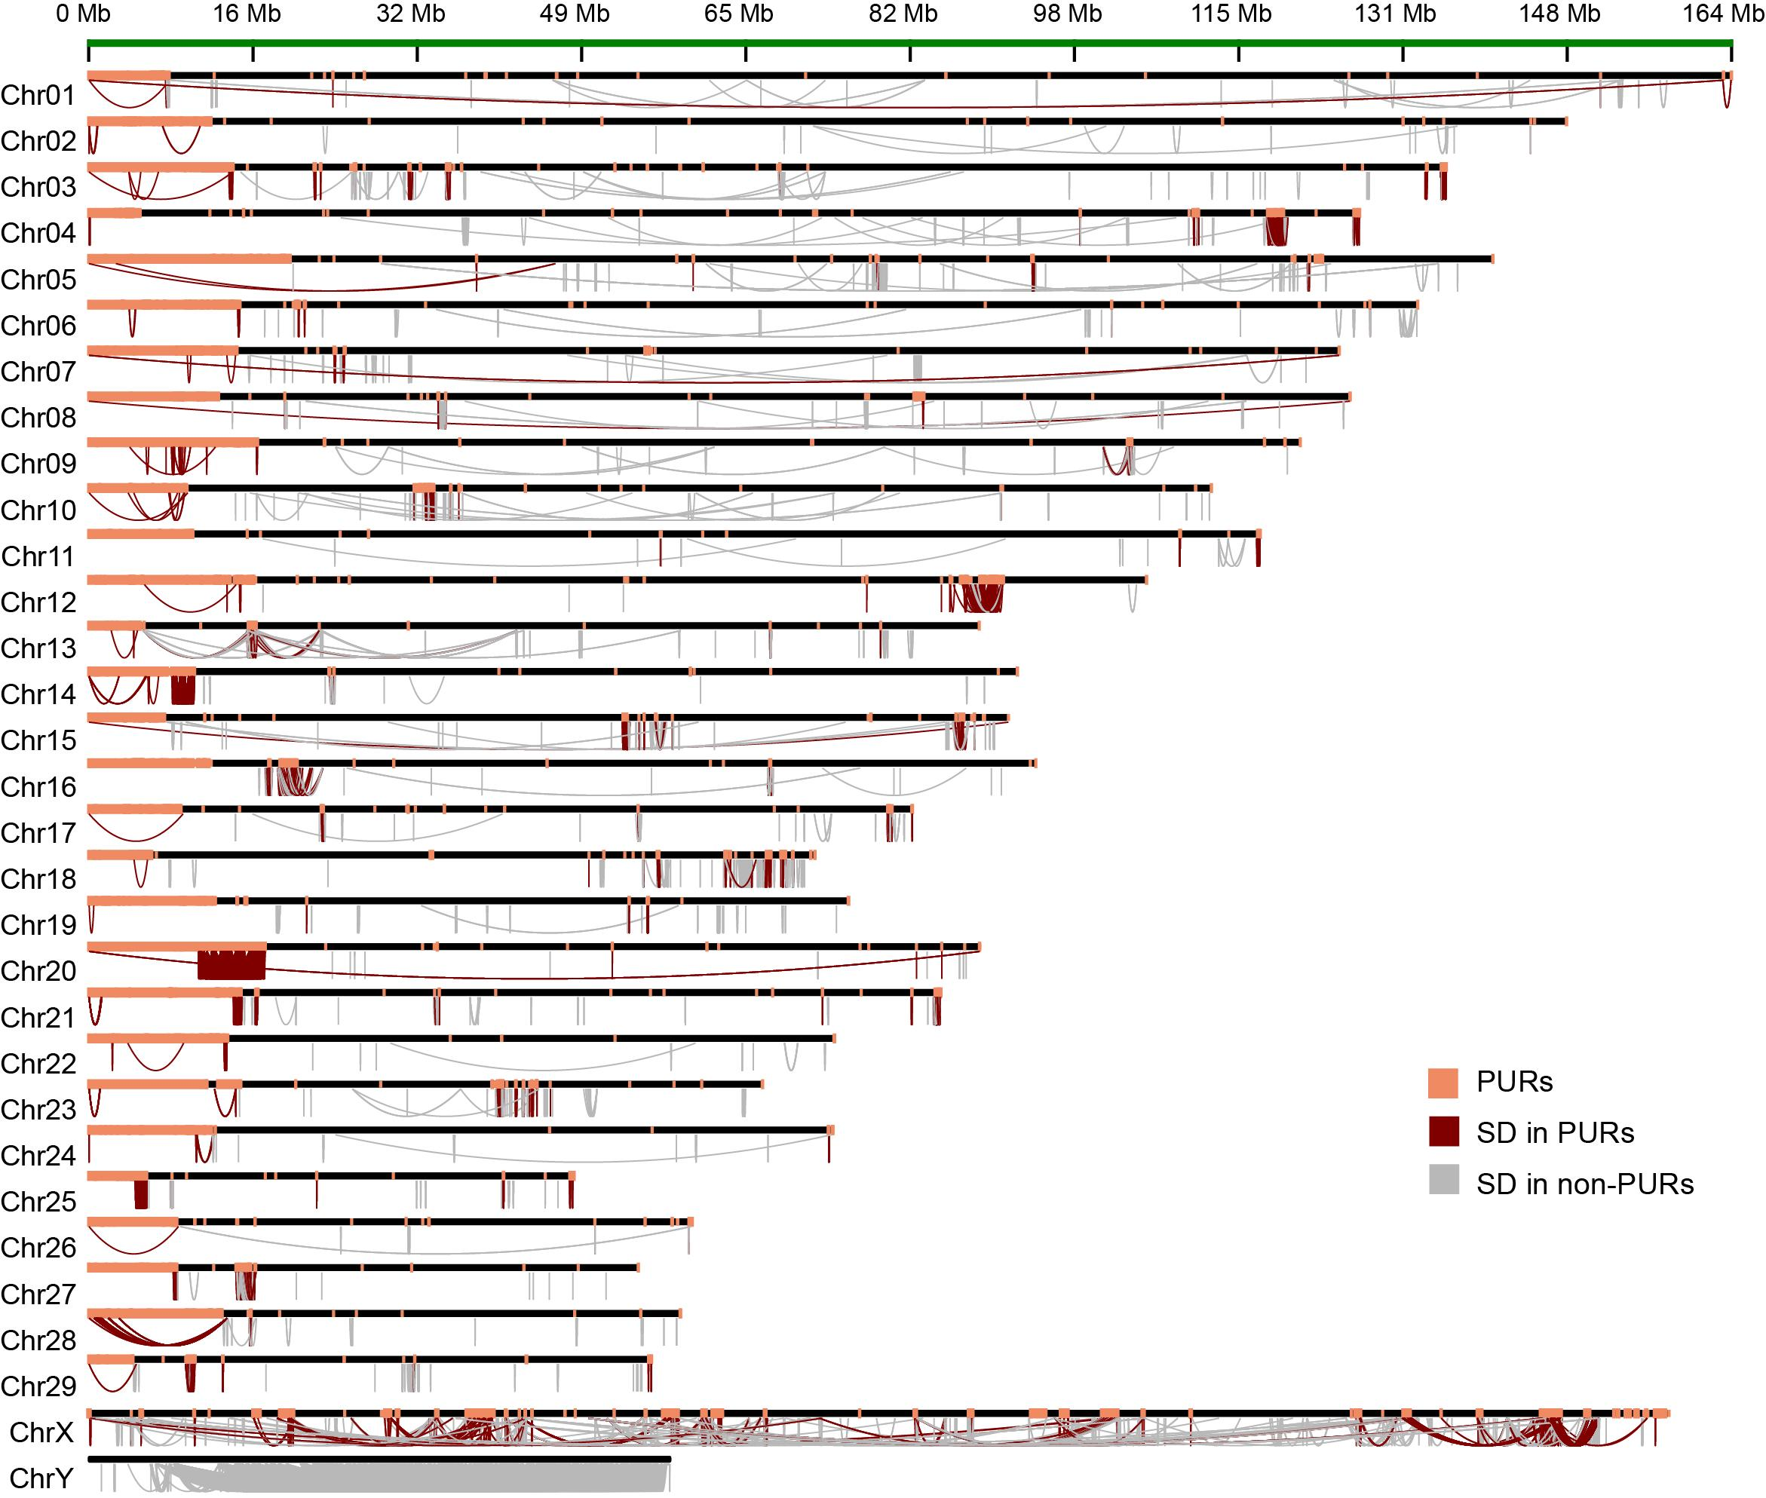
Supplementary Fig. 9 Distribution of SDs on the T2T-cattle1.0-SAAS. The genoimic PURs are shown in pink. The SDs in PURs (dark red) and in non-PURs (grey) are indicated in each chromosome.

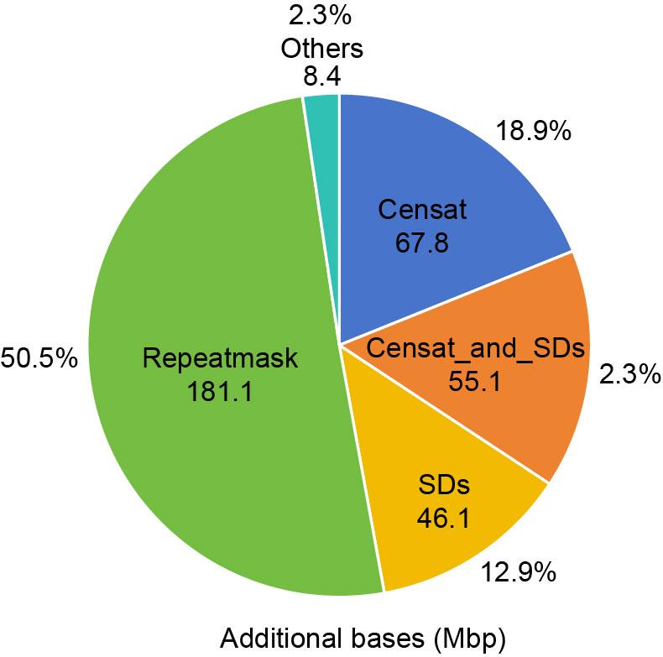
Supplementary Fig. 10 The total length of each type repeat sequences in PURs. The repeat sequences in PURs include CenSat, SDs, overlapping CenSat and SDs, RepMask and other repeats.

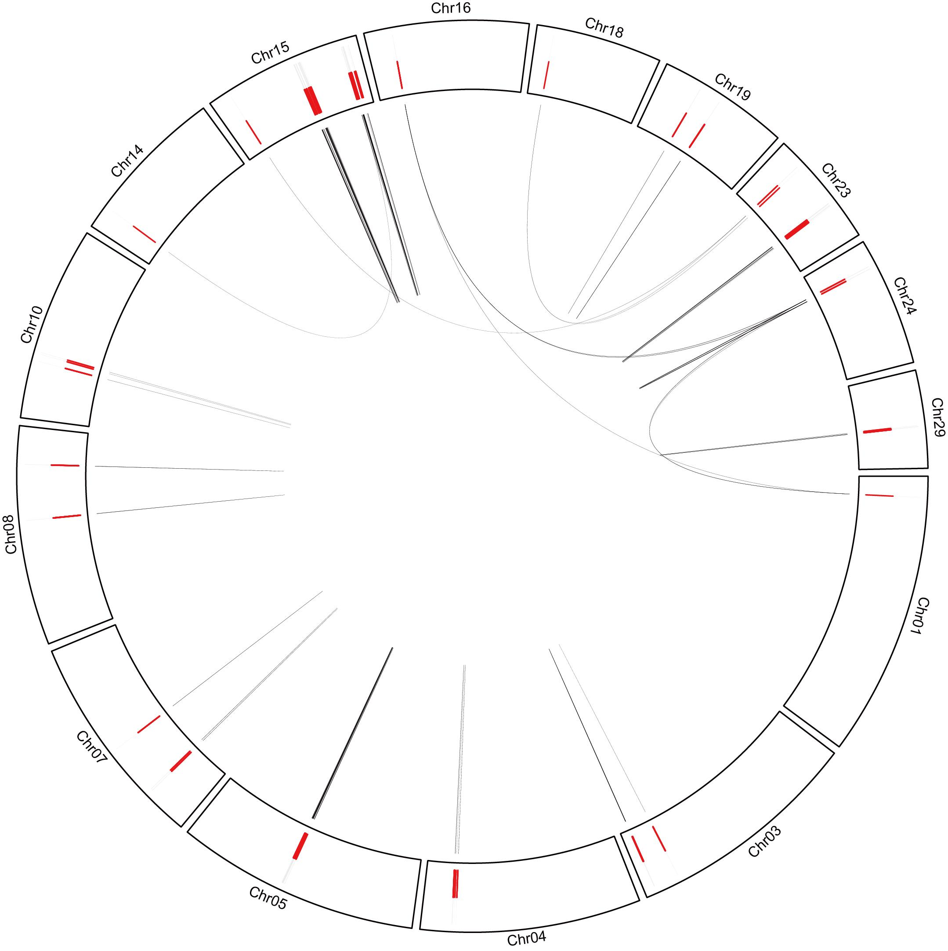
Supplementary Fig. 11 Identification of SDs related with copies of olfactory receptor genes on chromosomes. The SDs, represented by dark or grey curves, are illustrated on the chromosomes of T2T-cattle1.0-SAAS. The olfactory receptor genes (red lines) located within the SD regions are depicted.

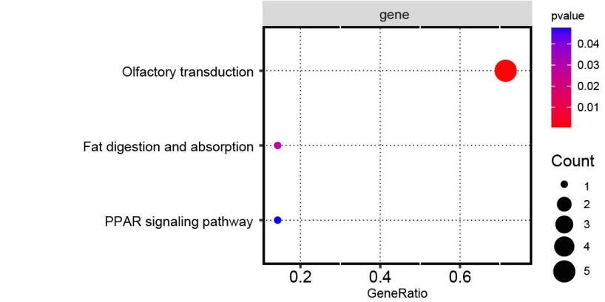
Supplementary Fig. 12 The enriched analysis of SDs in T2T-cattle1.0-SAAS. The enriched analysis of SDs in the cattle T2T genome are conducted using KEGG pathways. The circle size indicates the number of transcripts enriched in each pathway or term, while the color gradient represents the p-value.

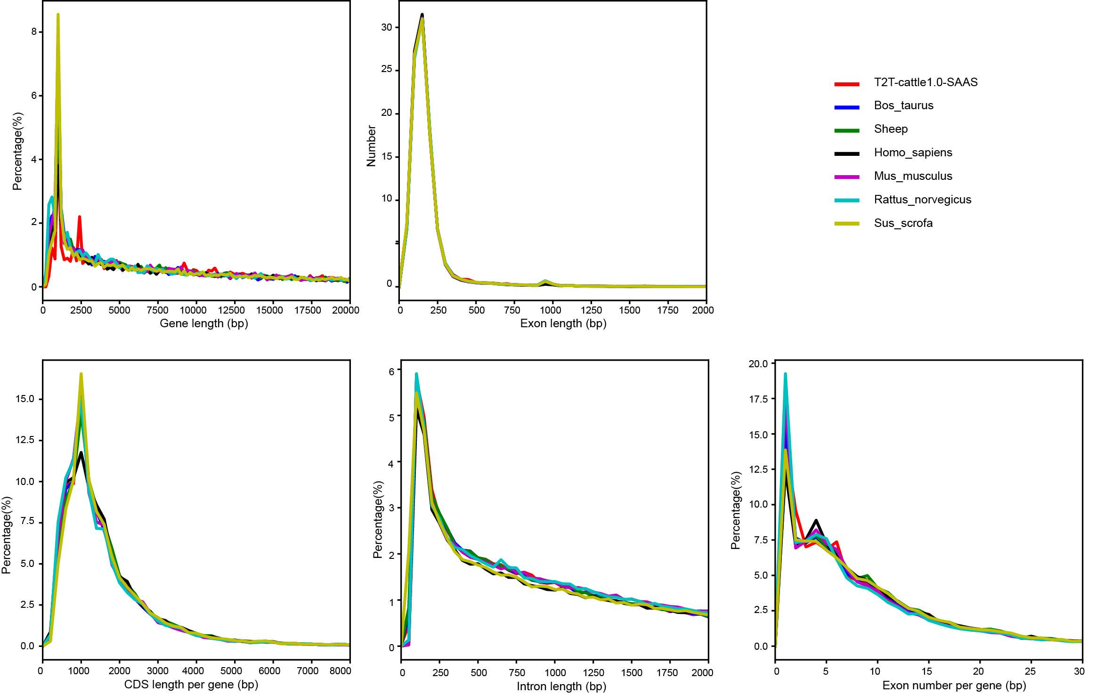
Supplementary Fig. 13 Comparisons of gene structures among the assembled T2T-cattle1.0-SAAS genome, the cattle reference genome, and other species genomes. The newly assembled T2T-cattle-SAAS genome showed the terms of gene length, exon length, CDS length per gene, intron length, and exon number per gene across different species' genomes.

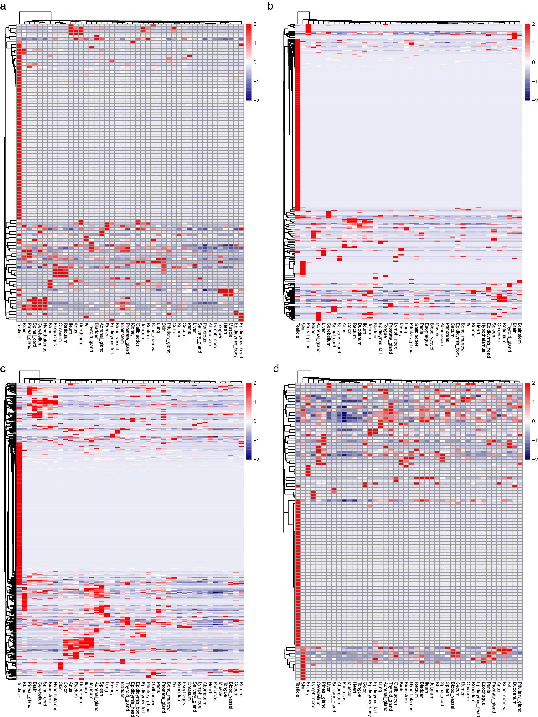
Supplementary Fig. 14 Heatmap depicting the expression of four type genes accross 44 cattle tissues. a-d, NAGs (newly anchored genes), DUPs (duplicate genes), genes in PURs, Y chromosome genes are seperately depicted by heatmap. Color legends refer to gene cluster.

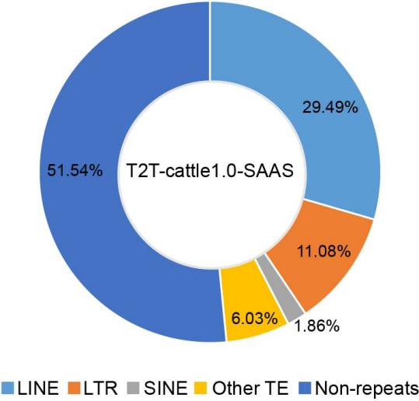
Supplementary Fig. 15 Circos plot displaying the percentage of transposable elements in the T2T-cattle1.0-SAAS. These repeat elements include the long interspersed nuclear element (LINE), long terminal repeats (LTR), short interspersed nuclear element (SINE), other transposable element (TE) and non-repeats.

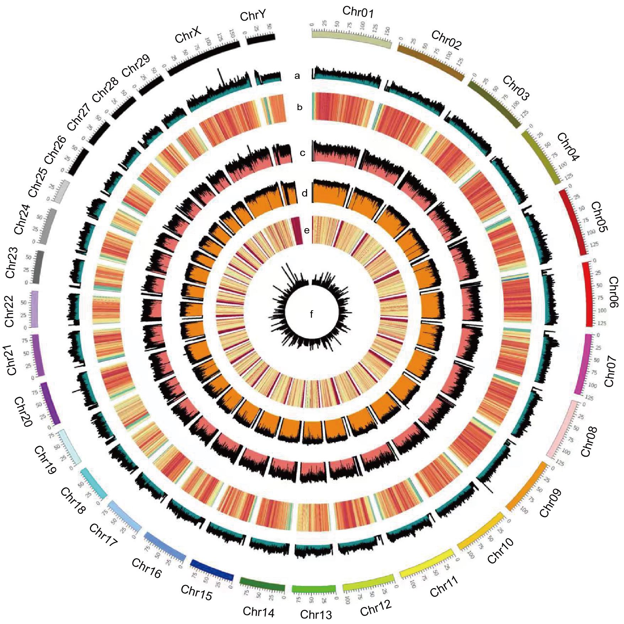
Supplementary Fig. 16 Circos plot showing the landscape of the T2T-cattle1.0-SAAS. This circular plot displays genome features for cattle specie. The outermost layer comprises colored blocks representing the 31 chromosomes, marked with thick lines at 25 Mb intervals. Outermost to innermost tracks indicate the a) TE, b) GC content, c) LTR, d) LINE, e) SINE, and f) DNA transposon.

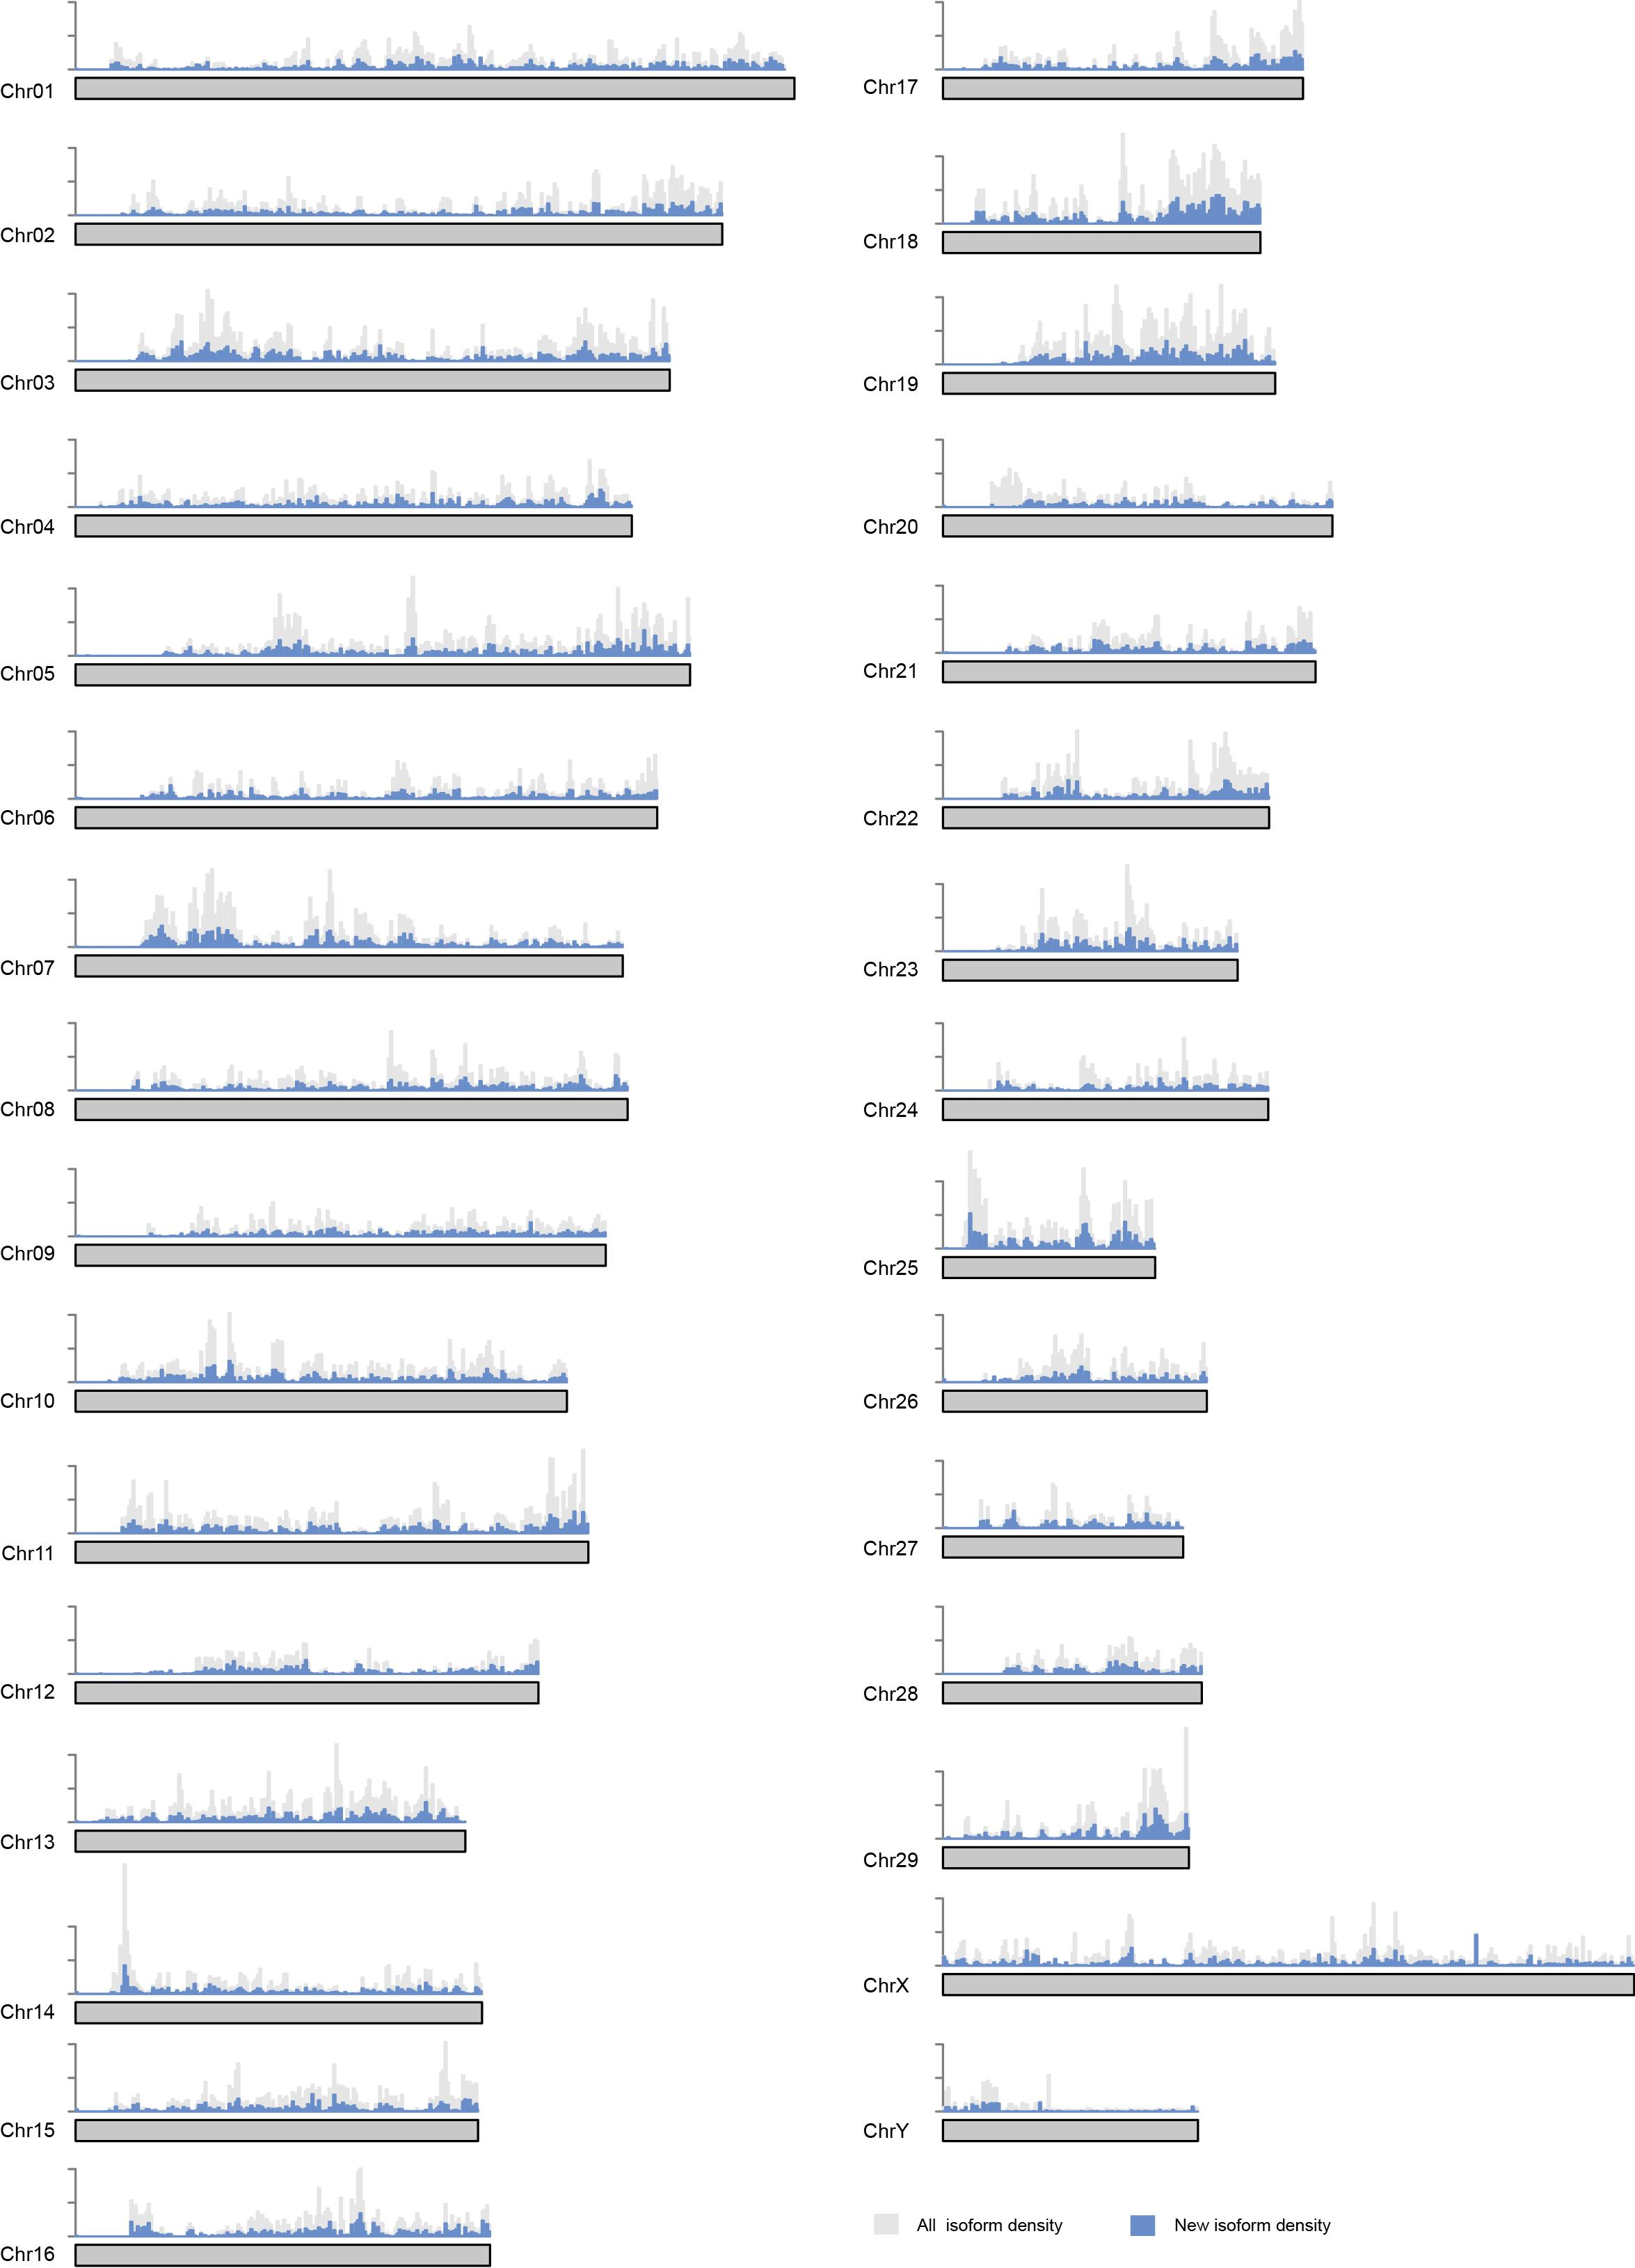
Supplementary Fig. 17 Idetification of gene isoforms in T2T-cattle1.0-SAAS. All isoform density is highlighted in grey. The new isoform density is highlighted in light blue.

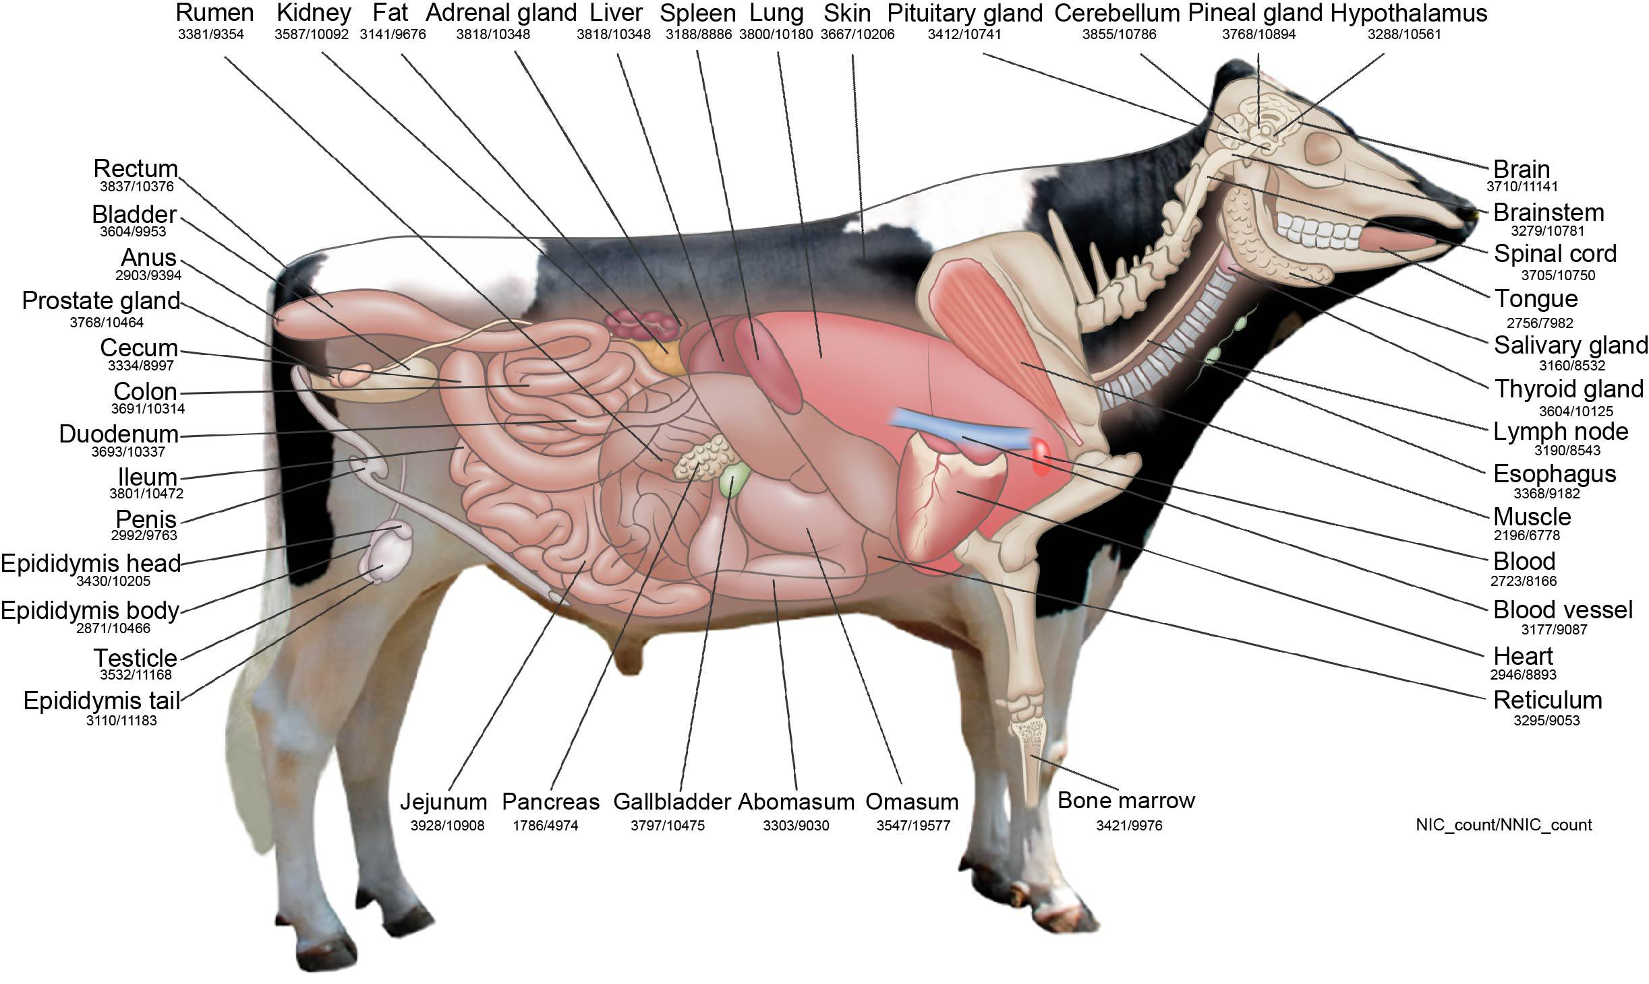
Supplementary Fig. 18 Reconstruction of newly isoforms in T2T-cattle1.0-SAAS. Two categories of newly identified isoforms, namely novel_not_in_catalog (nnic) and novel_in_catalog (nic), were shown across 44 cattle tissues.

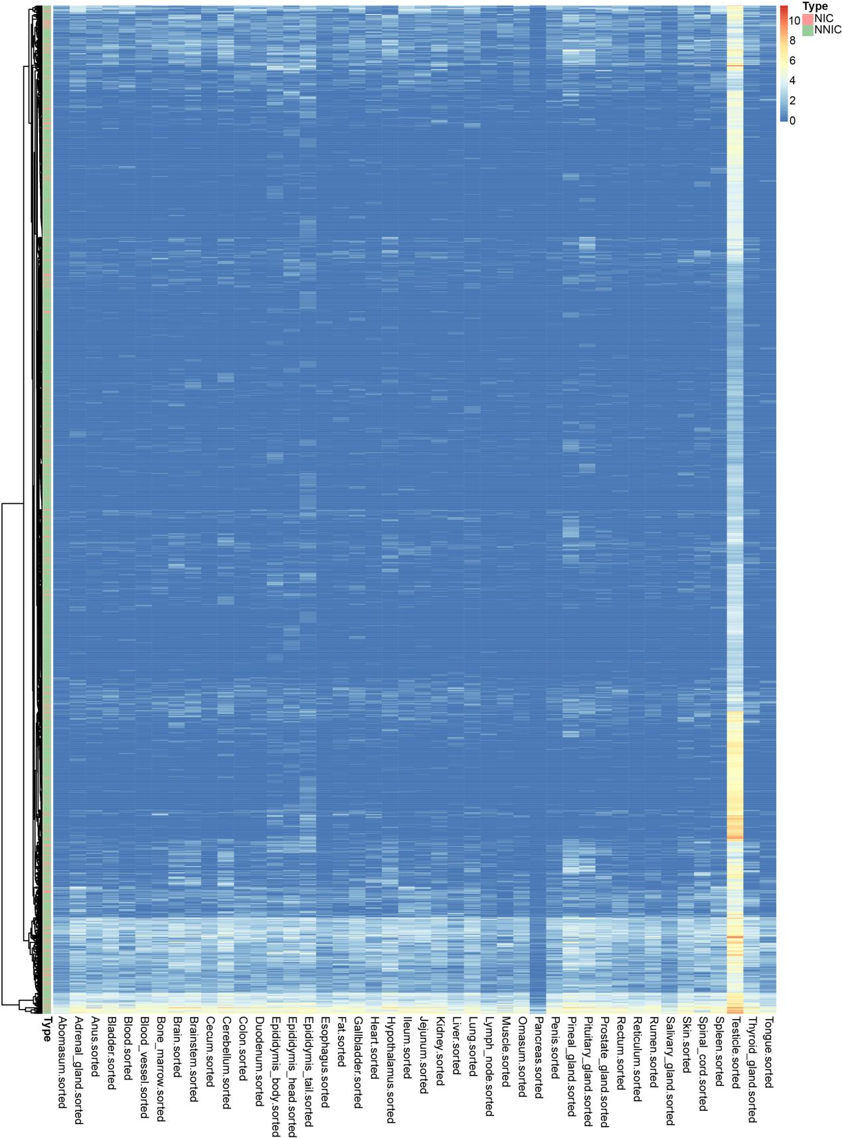
Supplementary Fig. 19 Expression heatmap of newly isoforms in T2T-cattle-SAAS. Novel transcripts including common and unique transcripts accross 44 tissues were enriched by heatmap analysis. Color legends refer to gene cluster.

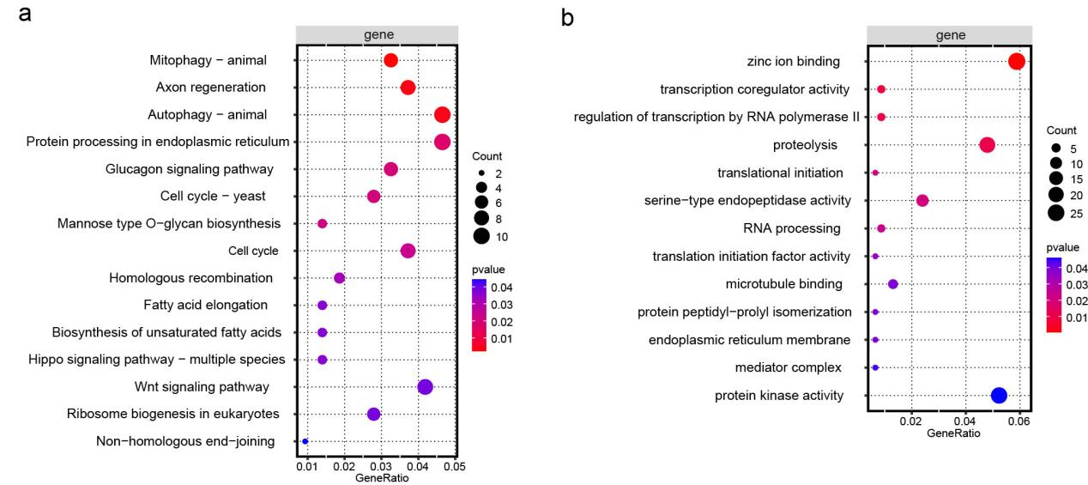
Supplementary Fig. 20 The enriched analysis of new testis transcripts. a-b, The enriched analysis are performed using KEGG pathways and GO terms, focusing on novel transcripts in the testis. The circle size indicates the number of transcripts enriched in each pathway or term, while the color gradient represents the p-value.

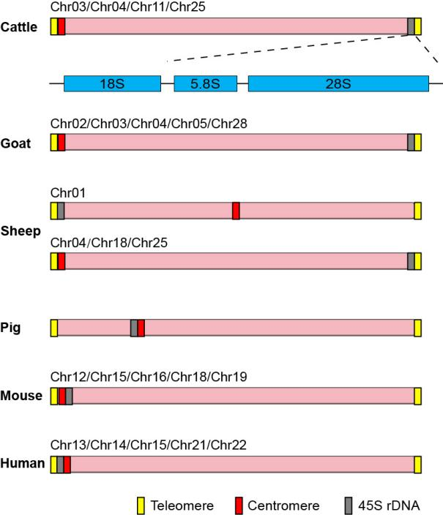
Supplementary Fig. 21 Comparative analysis of rDNA chromosomal positions across various species. The positional relationships among the 45S ribosomal DNA (rDNA) (grey), the centromere (red), and the telomere (yellow) are annotated. Except for cattle, the 45S rDNA data of other species were obtained from published literature (Vollger et al., 2022; Liu et al., 2024; Wu et al., 2024).

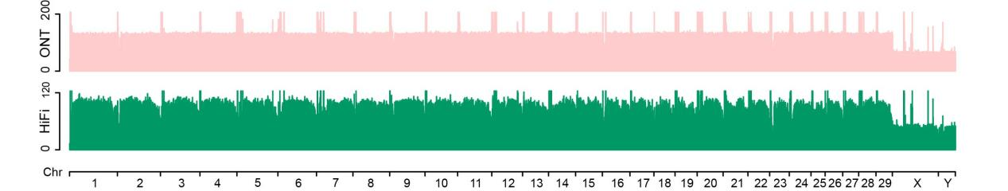Supplementary Fig. 22 Sequencing coverage mapped to 31 chromosomes of the T2T- cattle1.0-SAAS. Sequencing reads obtained from ONT and HiFi platforms were aligned to each assembled chromosome.

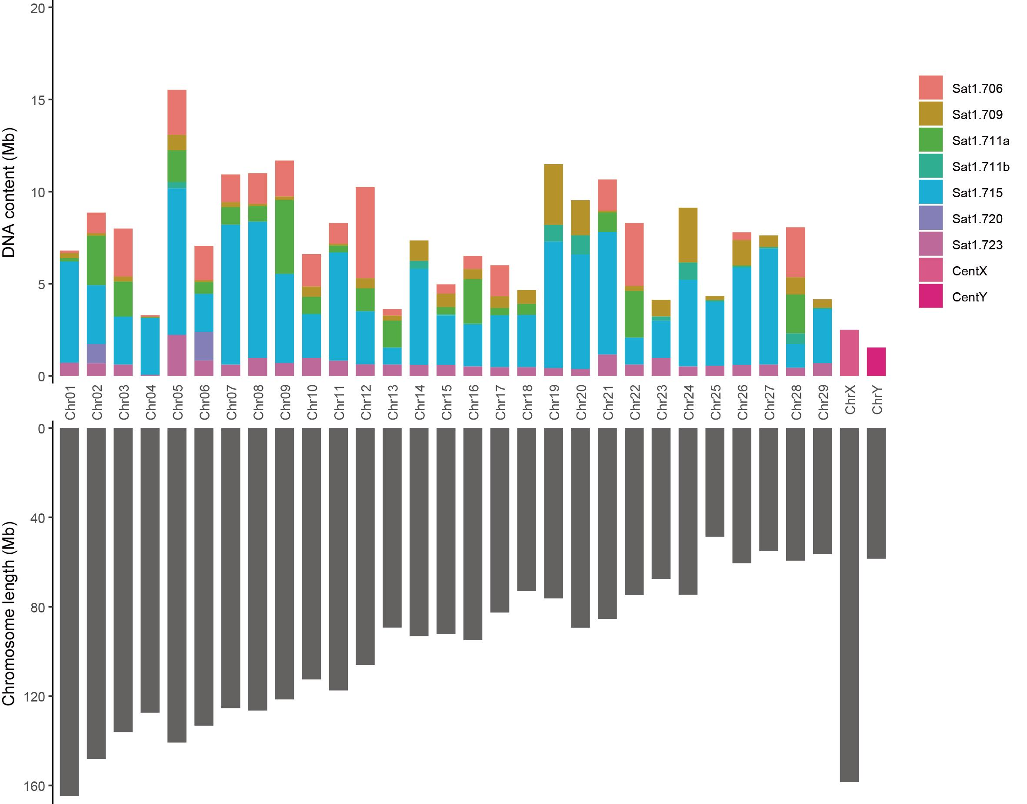
Supplementary Fig. 23 The lengths of satellite units in centromeric regions in all chromosomes of T2T-cattle1.0-SAAS. The color-coded stacked columns above represent the lengths of various satellite units within the centromeric regions of the chromosomes, while the lower columns illustrate the length of each chromosome in cattle.

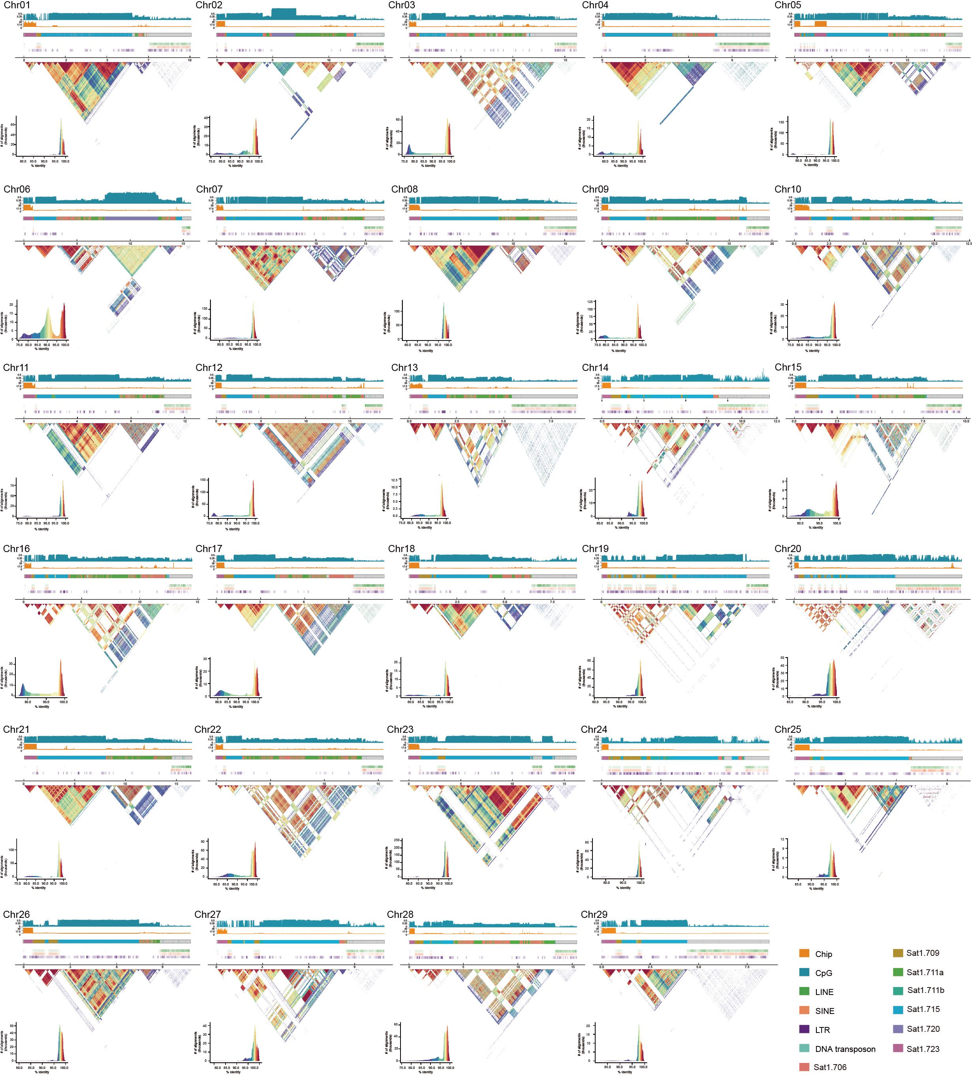
Supplementary Fig. 24 Genomic characteristics of cattle chromosomes. The following are displayed from top to bottom: CpG, Chip, Centromere (Sat1.706, Sat1.709, Sat1.7lla, Sat1.711b, Sat1.715, Sat1.720, and Sat1.723), LINE, SINE, LTR, and DNA transposon. A detailed paired 10 kb sequence identity heatmap shows the identity (%) of the repetitive sequences in the chromosome's centromere region.
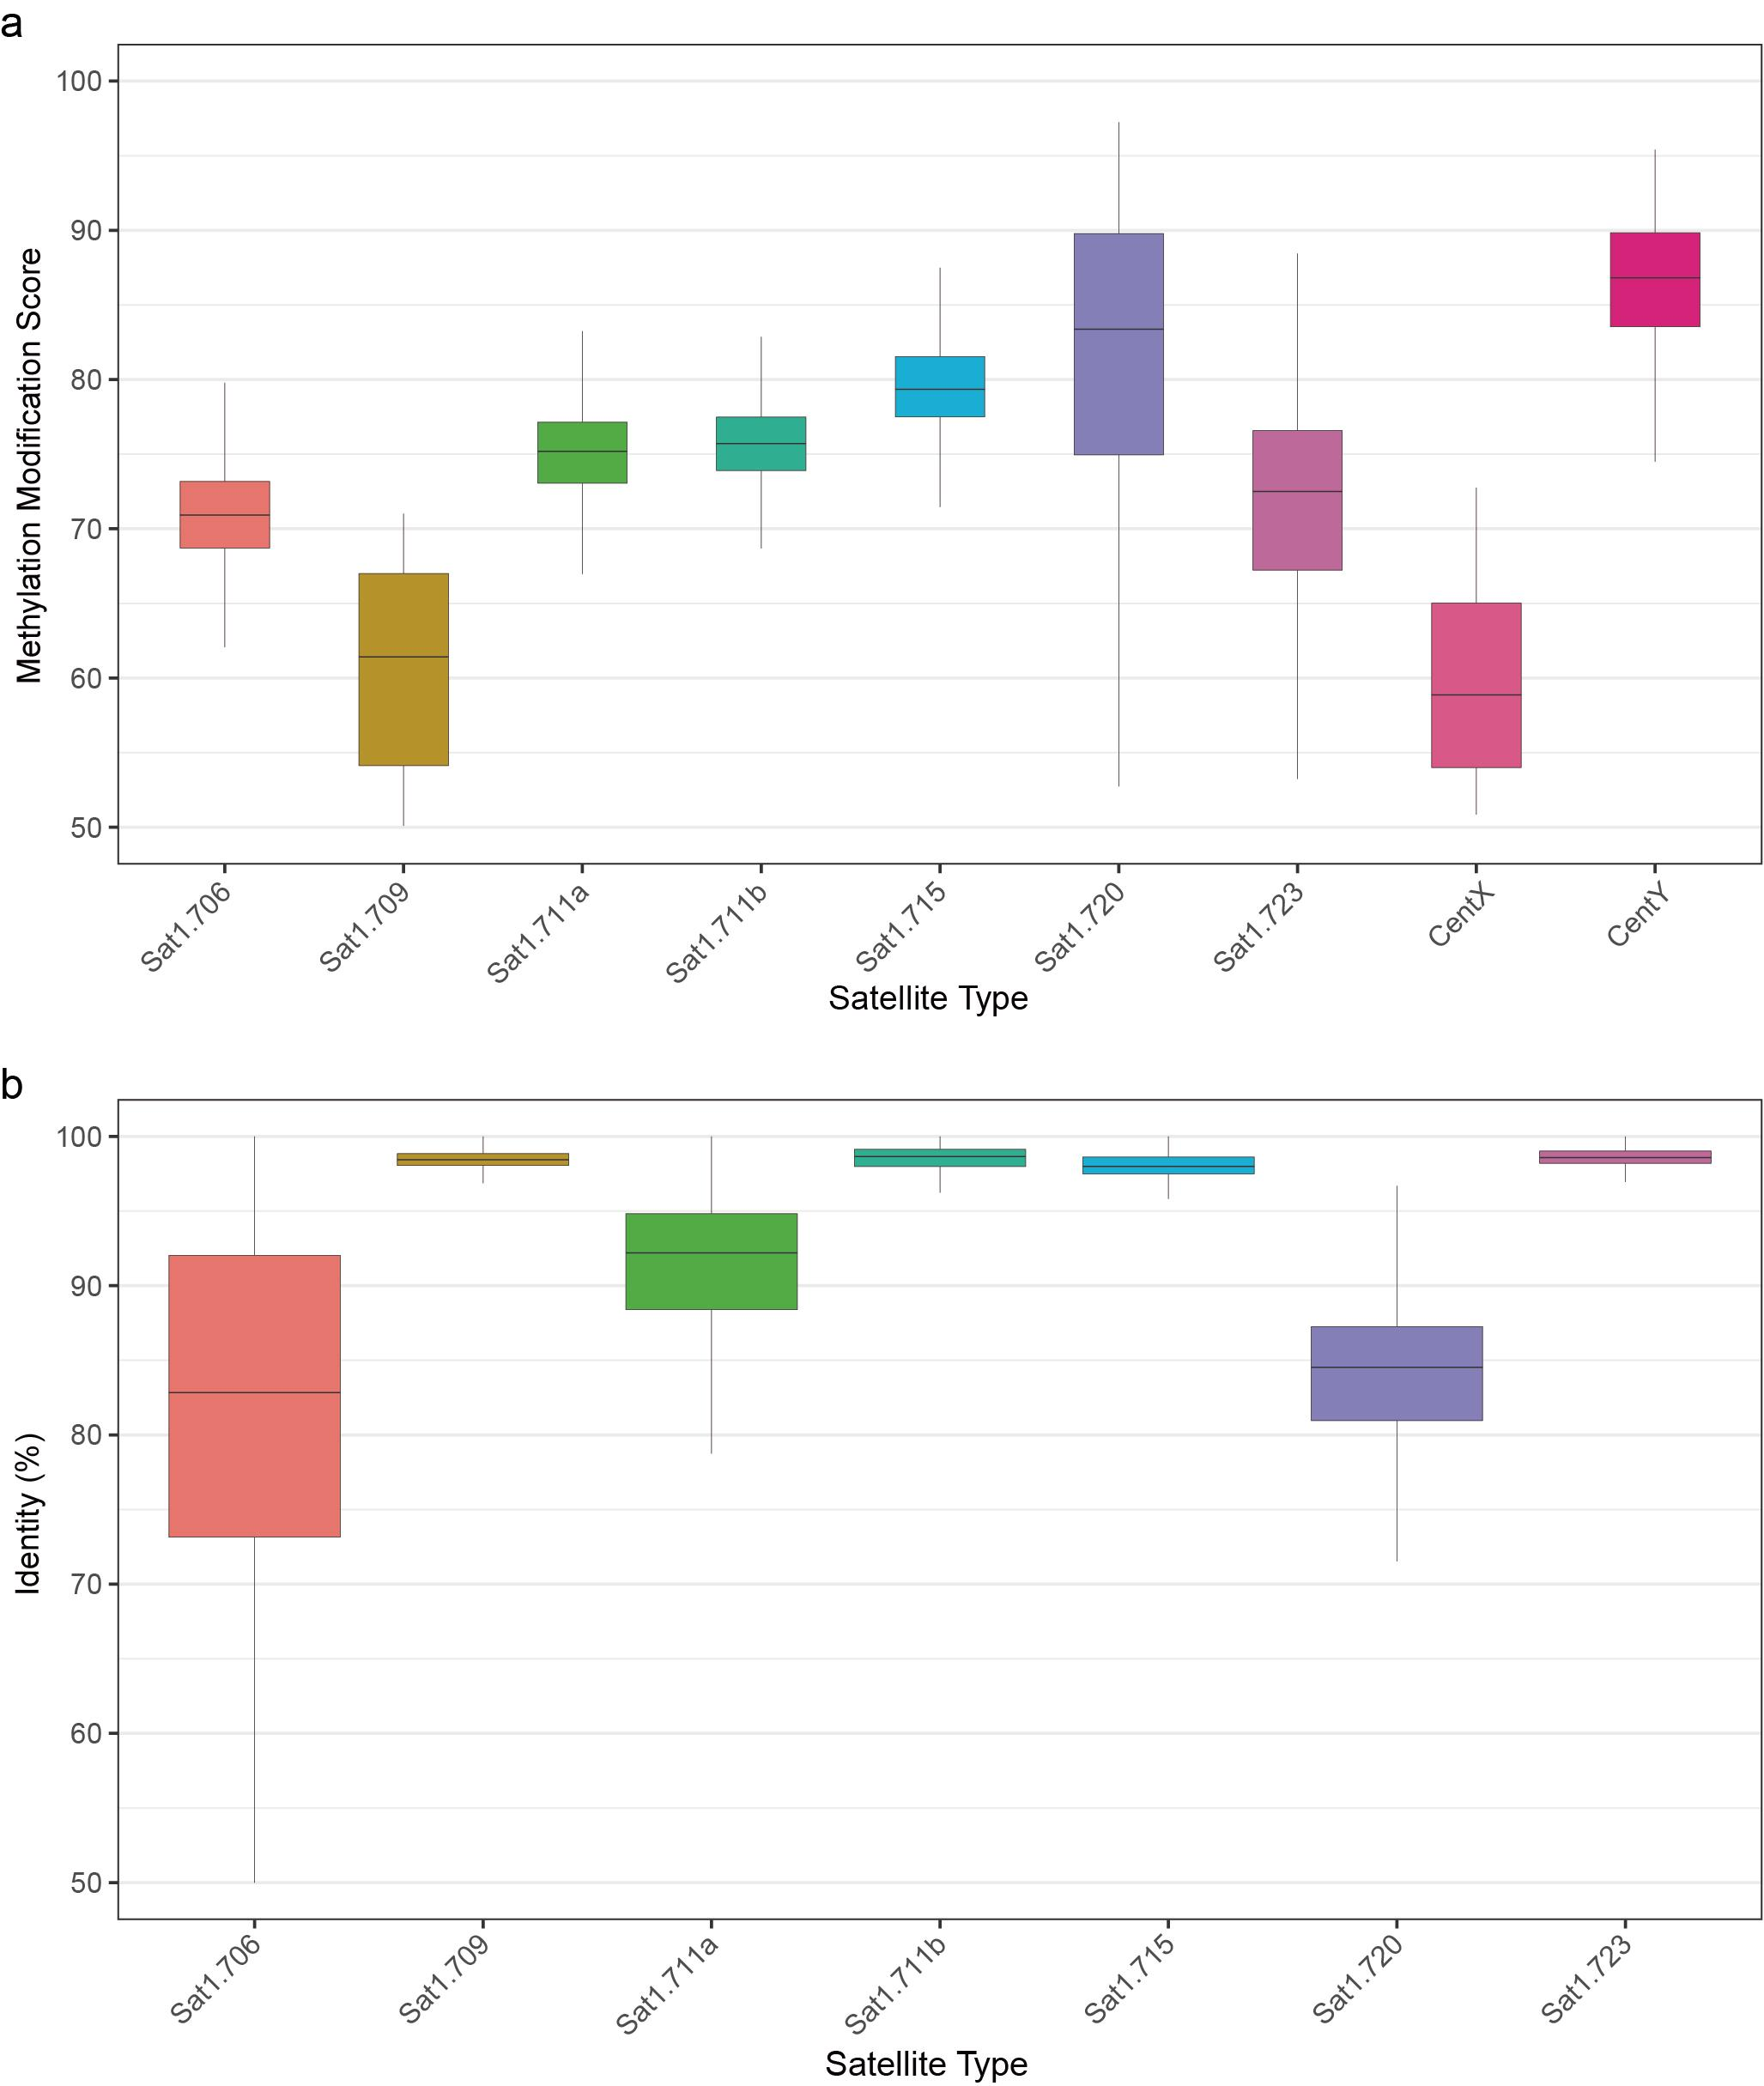
Supplementary Fig. 25 The methylation modification score and sequence identity of centromeric satellites. a, Methylation modification score. b, Sequence variation (measured by sequence identity) of satellites in the centromeres.
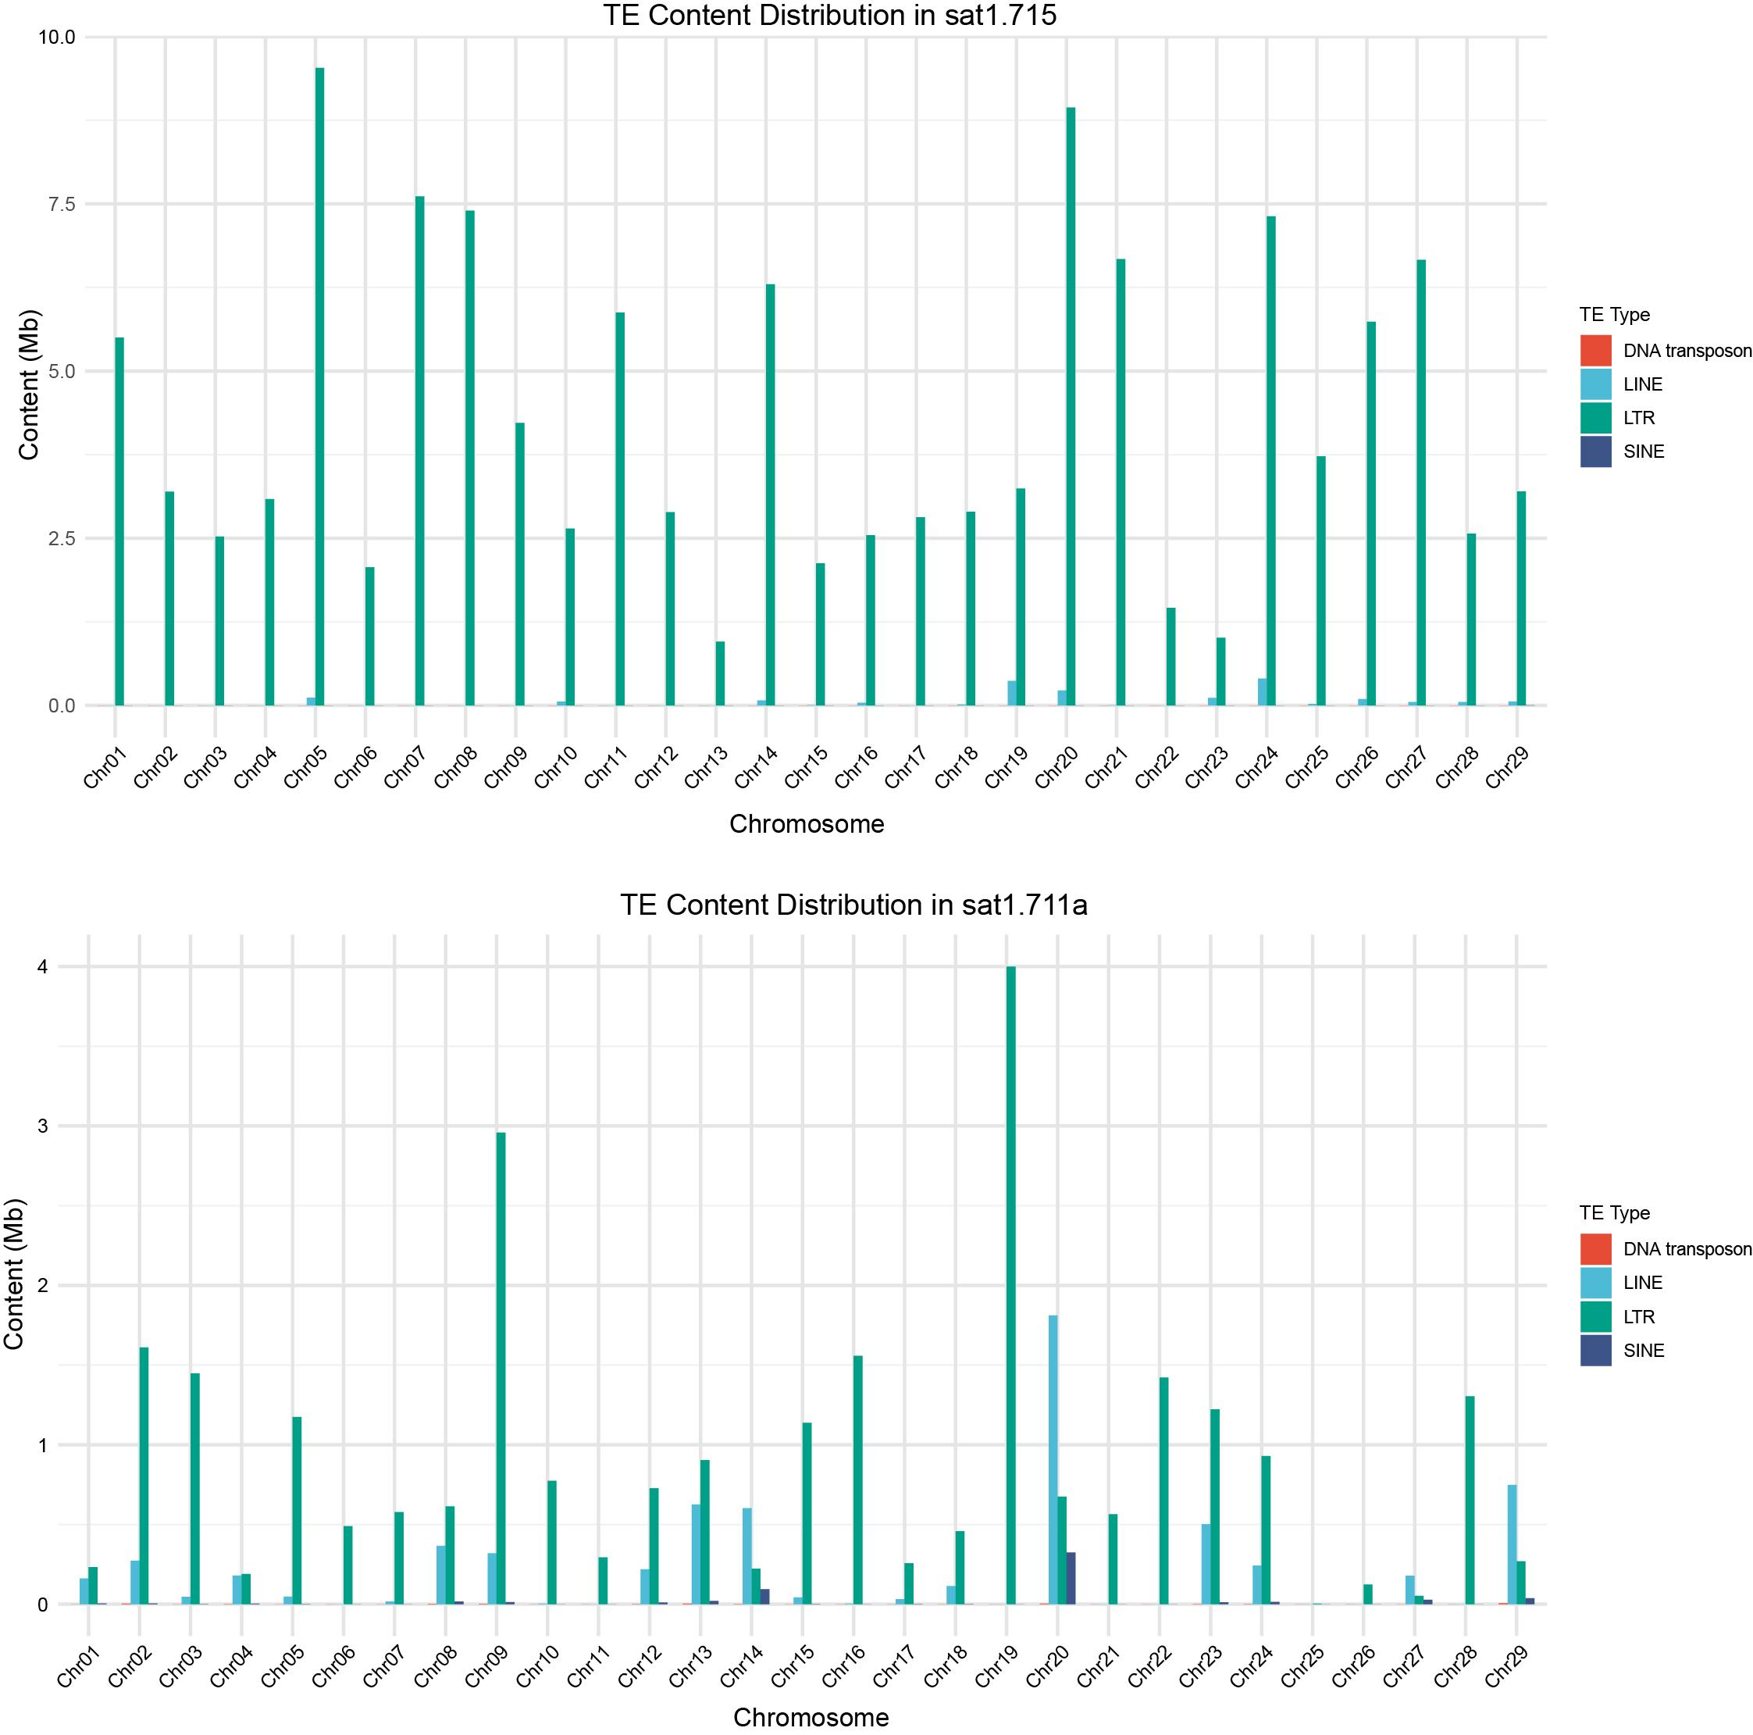
Supplementary Fig. 26 Transposable Element (TE) content distribution in centromeric Sat1.715 and Sat1.711a for autosomes. The content of TE types including DNA transposon, LINE, LTR, and SINE, are individually counted and labeled on each autosome.

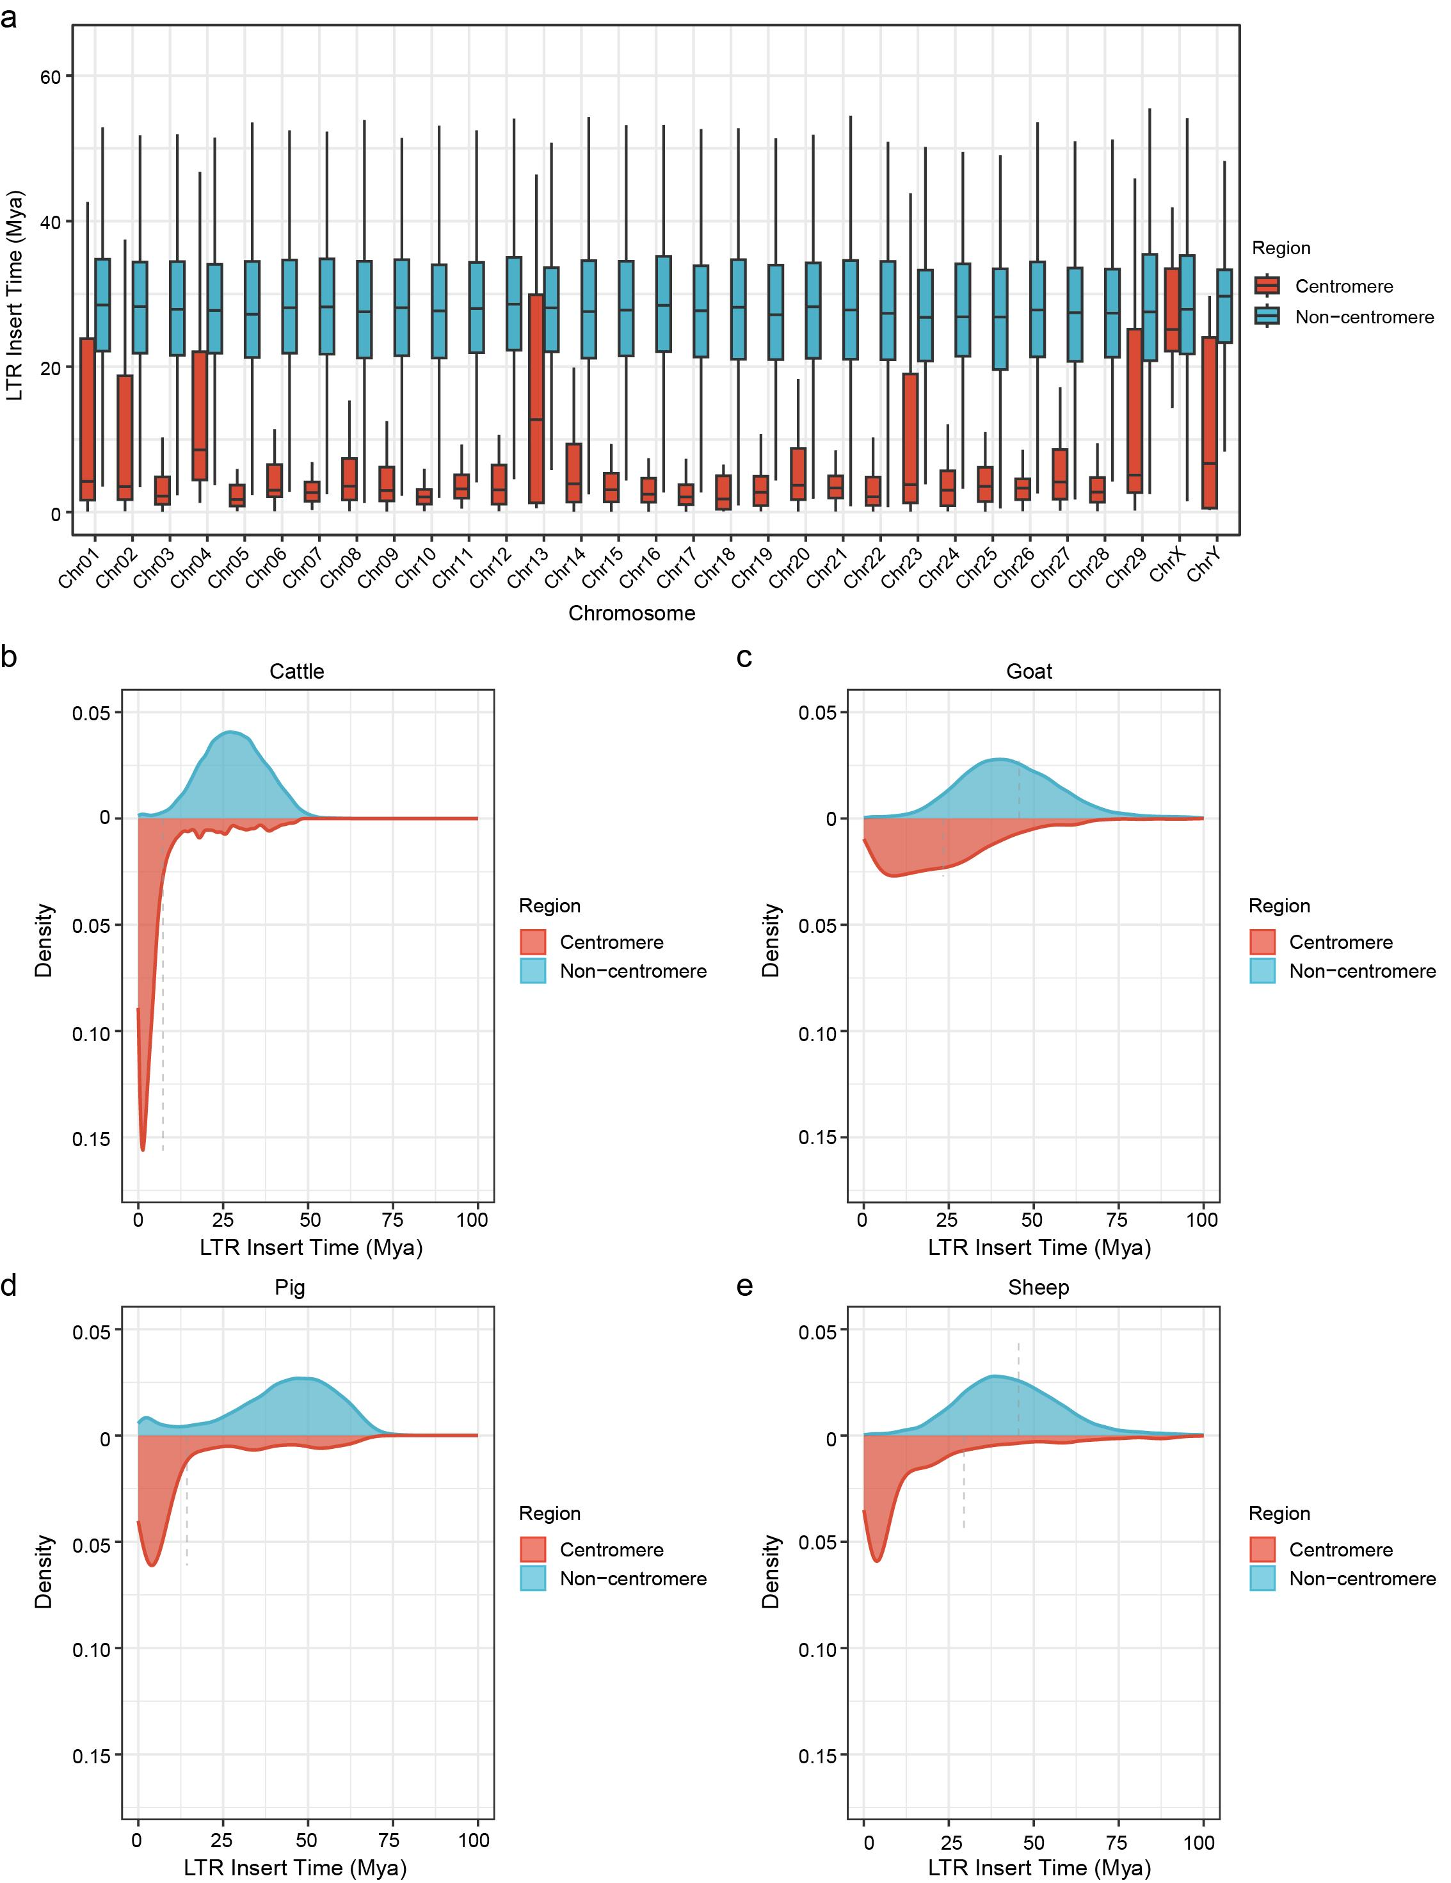
Supplementary Fig. 27 Differences in LTR insertion time and distribution between centromeric and non-centromeric regions across four species. a, The chromosomal distribution of LTR insertion time in the centromeric and non-centromeric regions in T2T-cattle1.0-SAAS. b-e, Differences of LTR insert time between the centromeric and non-centromeric regions in T2T-cattle1.0-SAAS, T2T-goat1.0, T2T-pig1.0 and T2T-sheep1.0.
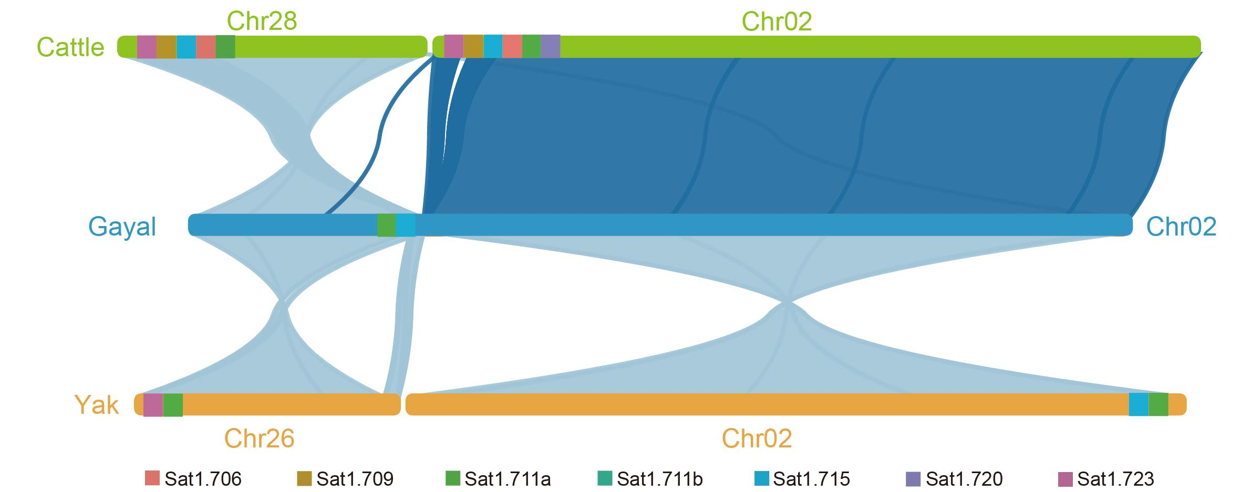
Supplementary Fig. 28 Collinearity relationship between gayal, cattle, and yak chromosomes. Chromosome collinearity exists among T2T-cattle1.0-SAAS (Chr28 and Chr02), gayal (Chr02), and yak (Chr26 and Chr02). The presence or absence of Sat1.706, Sat1.709, Sat1.7lla, Sat1.711b, Sat1.715, Sat1.720, and Sat1.723 in the centromeres is indicated by color.
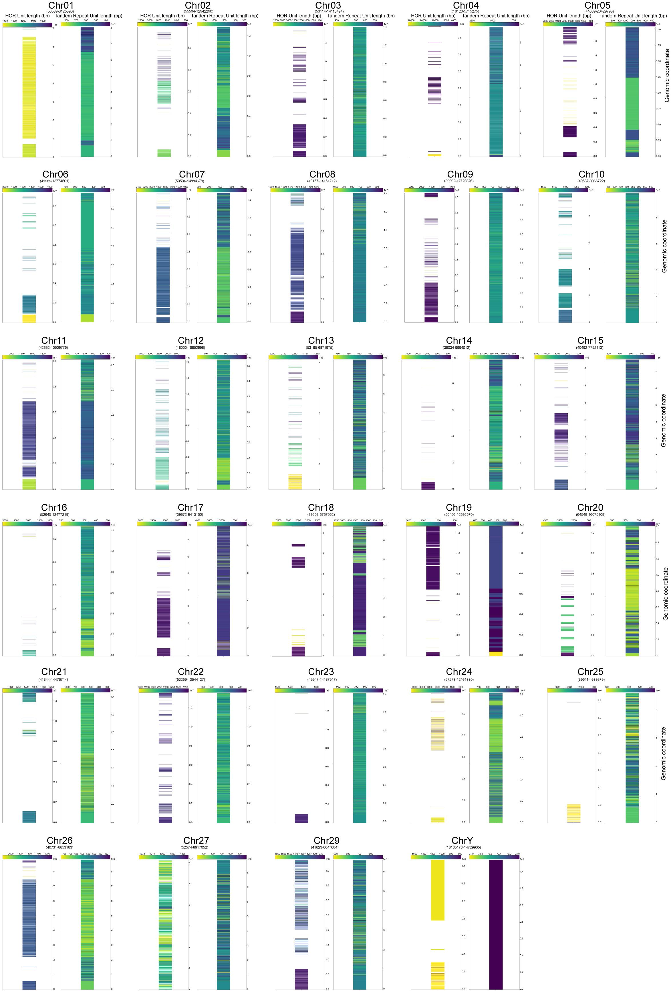
Supplementary Fig. 29 Structural features of the higher-order repeat (HOR). The lengths of the HOR units within the centromeric regions, as well as the lengths of each tandem repeat unit contained within these HOR units, have been elucidated for all chromosomes of T2T-cattle1.0-SAAS.

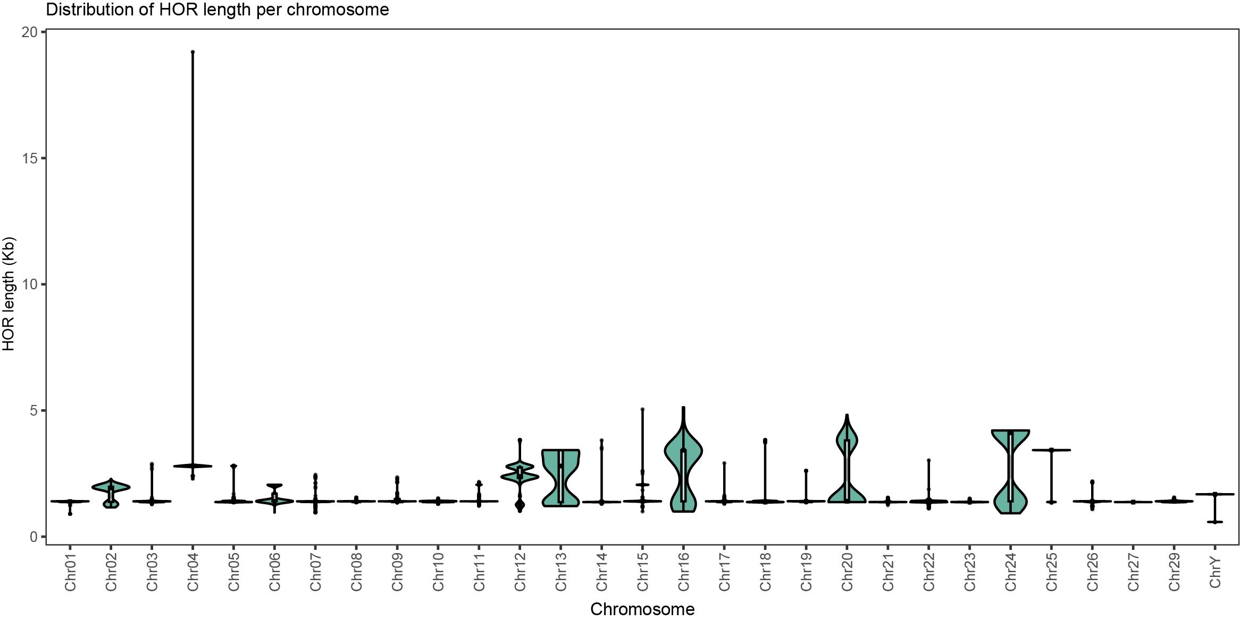
Supplementary Fig. 30 Chromosomal distribution of HOR lengths in cattle. Violin plots illustrate the distribution of HOR lengths identified across individual chromosomes. Each violin’s width represents the density of HORs at a given length, with the internal line indicating the median. The analysis was based on genome-wide annotation of HORs from assembled cattle chromosomes, revealing both conserved length patterns and chromosome-specific variation. Notably, several chromosomes harbor distinct clusters of longer HORs, suggesting potential differences in centromeric organization and evolutionary dynamics.

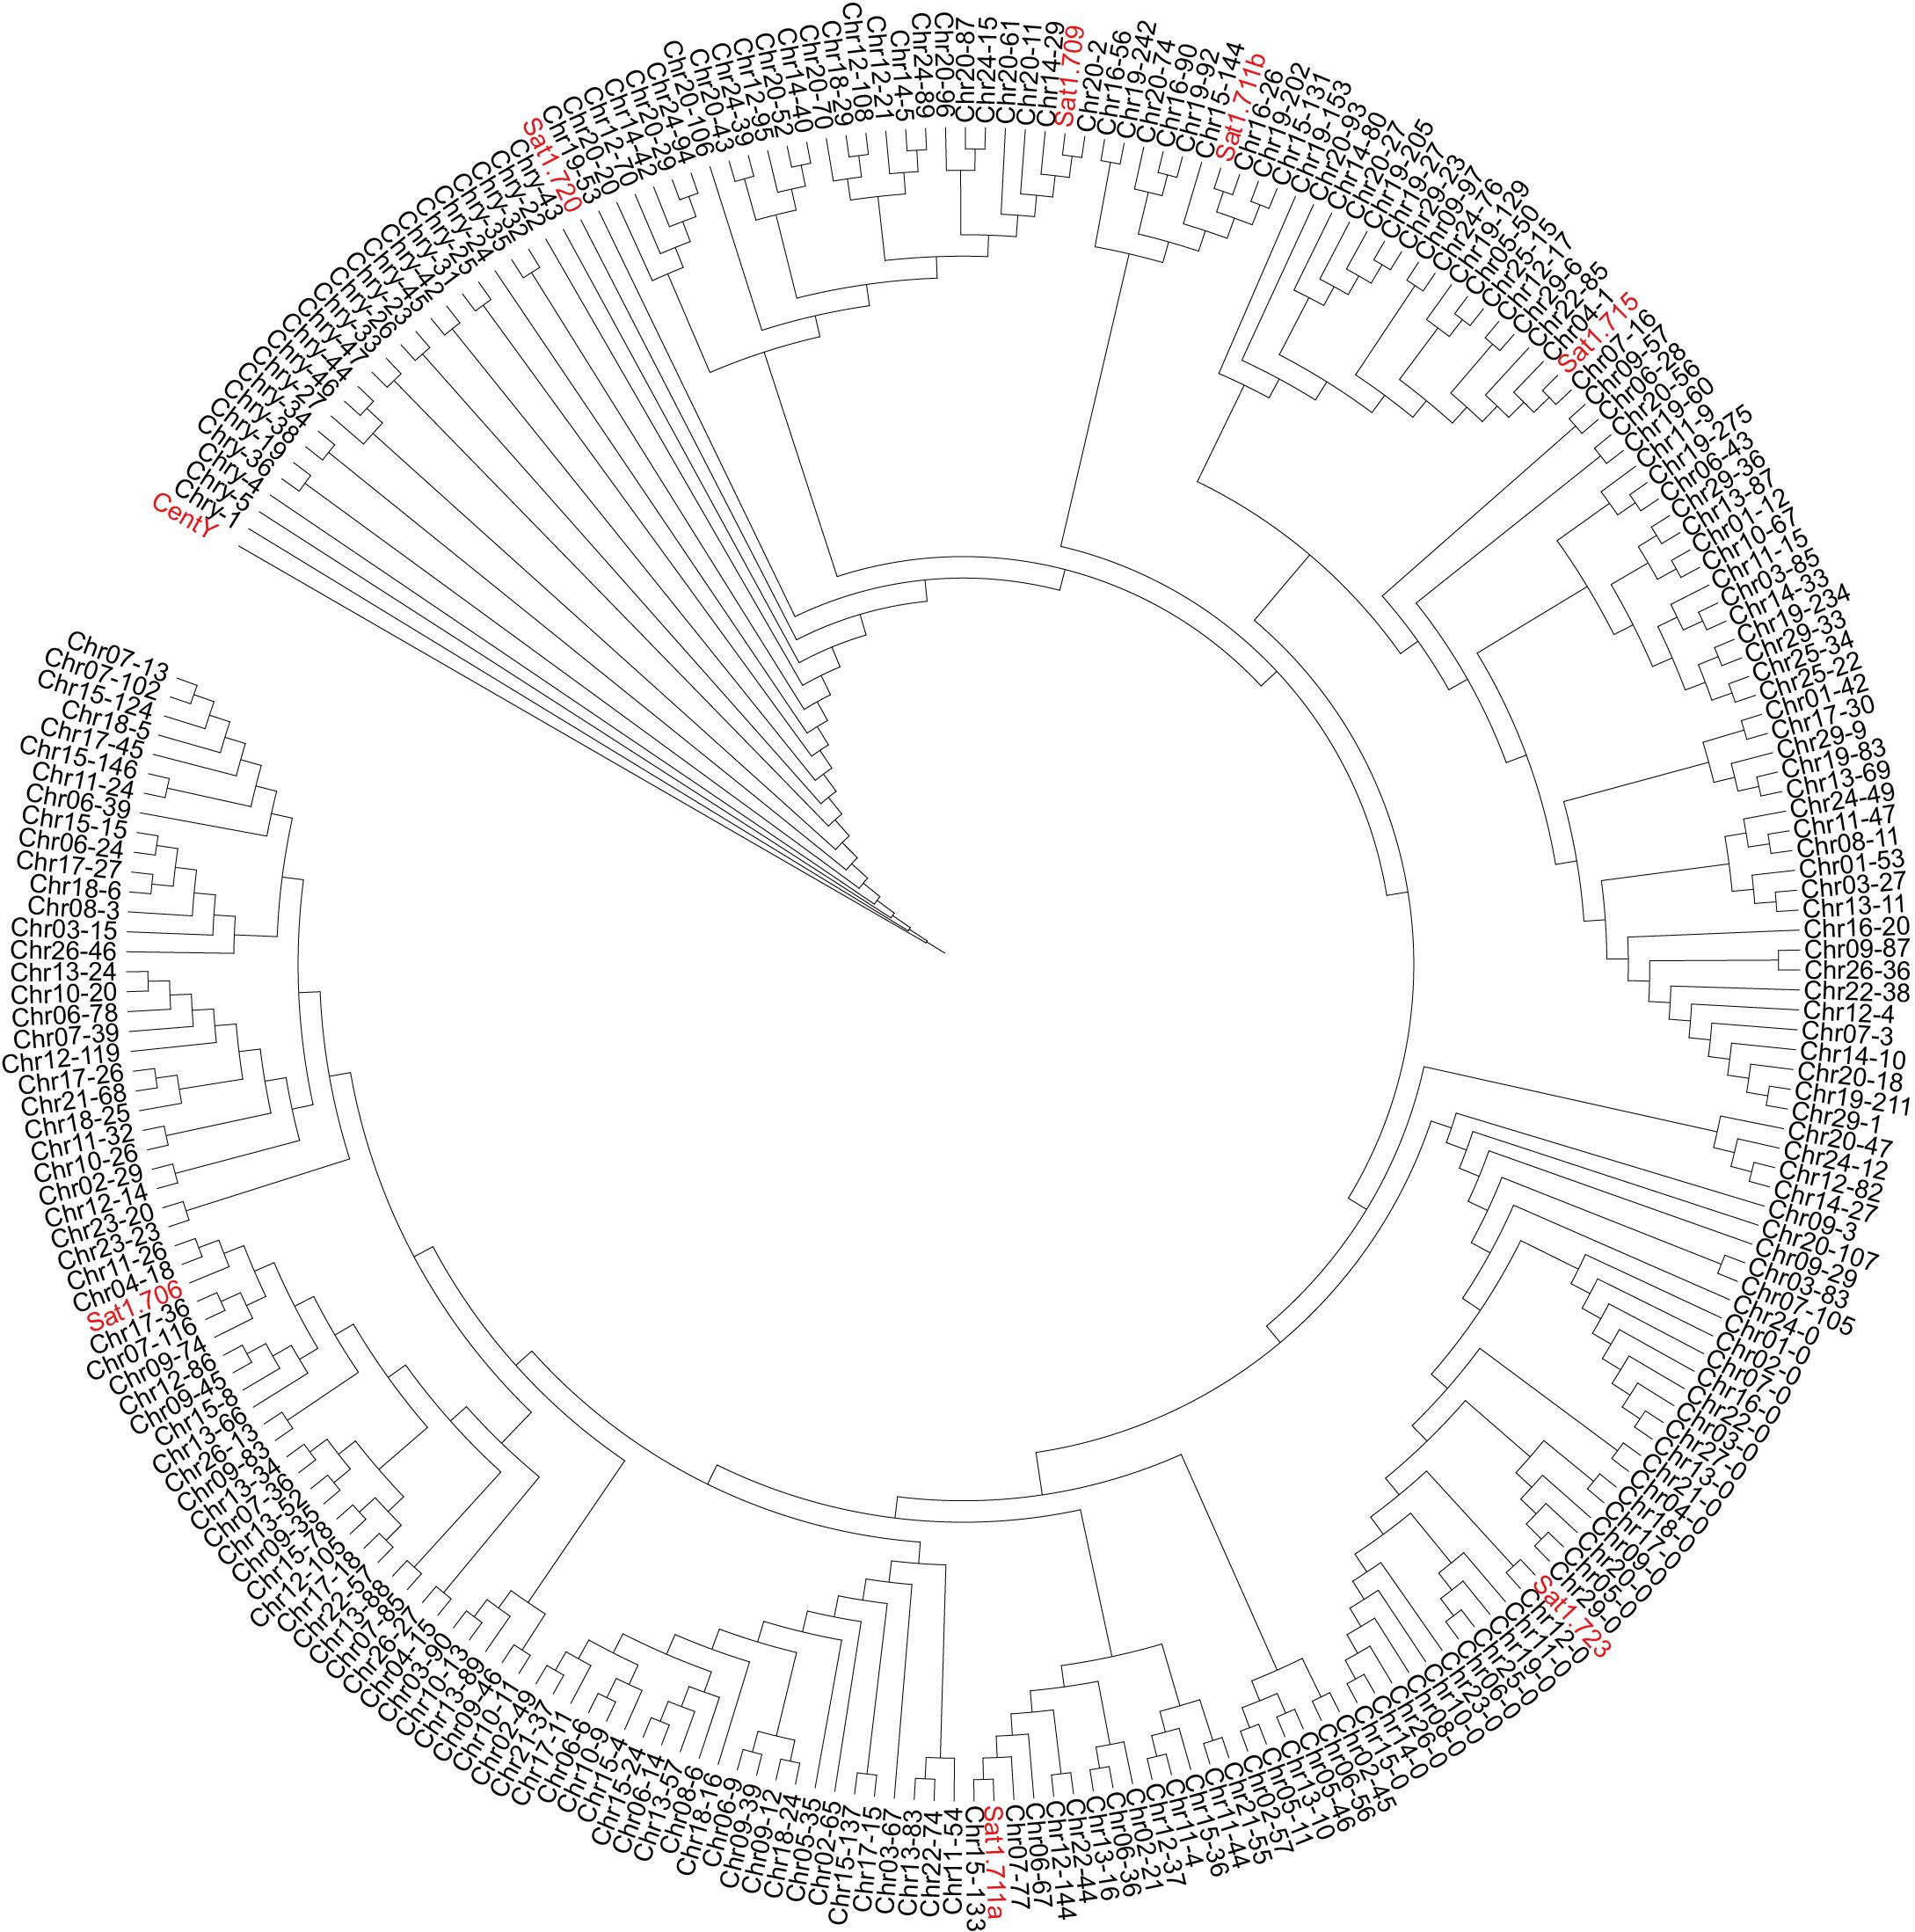
Supplementary Fig. 31 Phylogenetic relationships between bovine HOR monomers and known satellite DNA families. Monomer sequences constituting HORs identified across cattle chromosomes were globally aligned to canonical satellite families (Sat1.706, Sat1.709, Sat1.711a, Sat1.711b, Sat1.715, Sat1.720, Sat1.723, and CentY) using the Biostrings package (Needleman–Wunsch algorithm). Pairwise alignment scores were converted into sequence similarities and subsequently into distance matrices, which were used to construct phylogenetic trees. The resulting topology highlights the clustering of HOR monomers with specific satellite families and reveals chromosome-specific organization patterns, providing insights into the evolutionary dynamics of centromeric repeats in cattle.

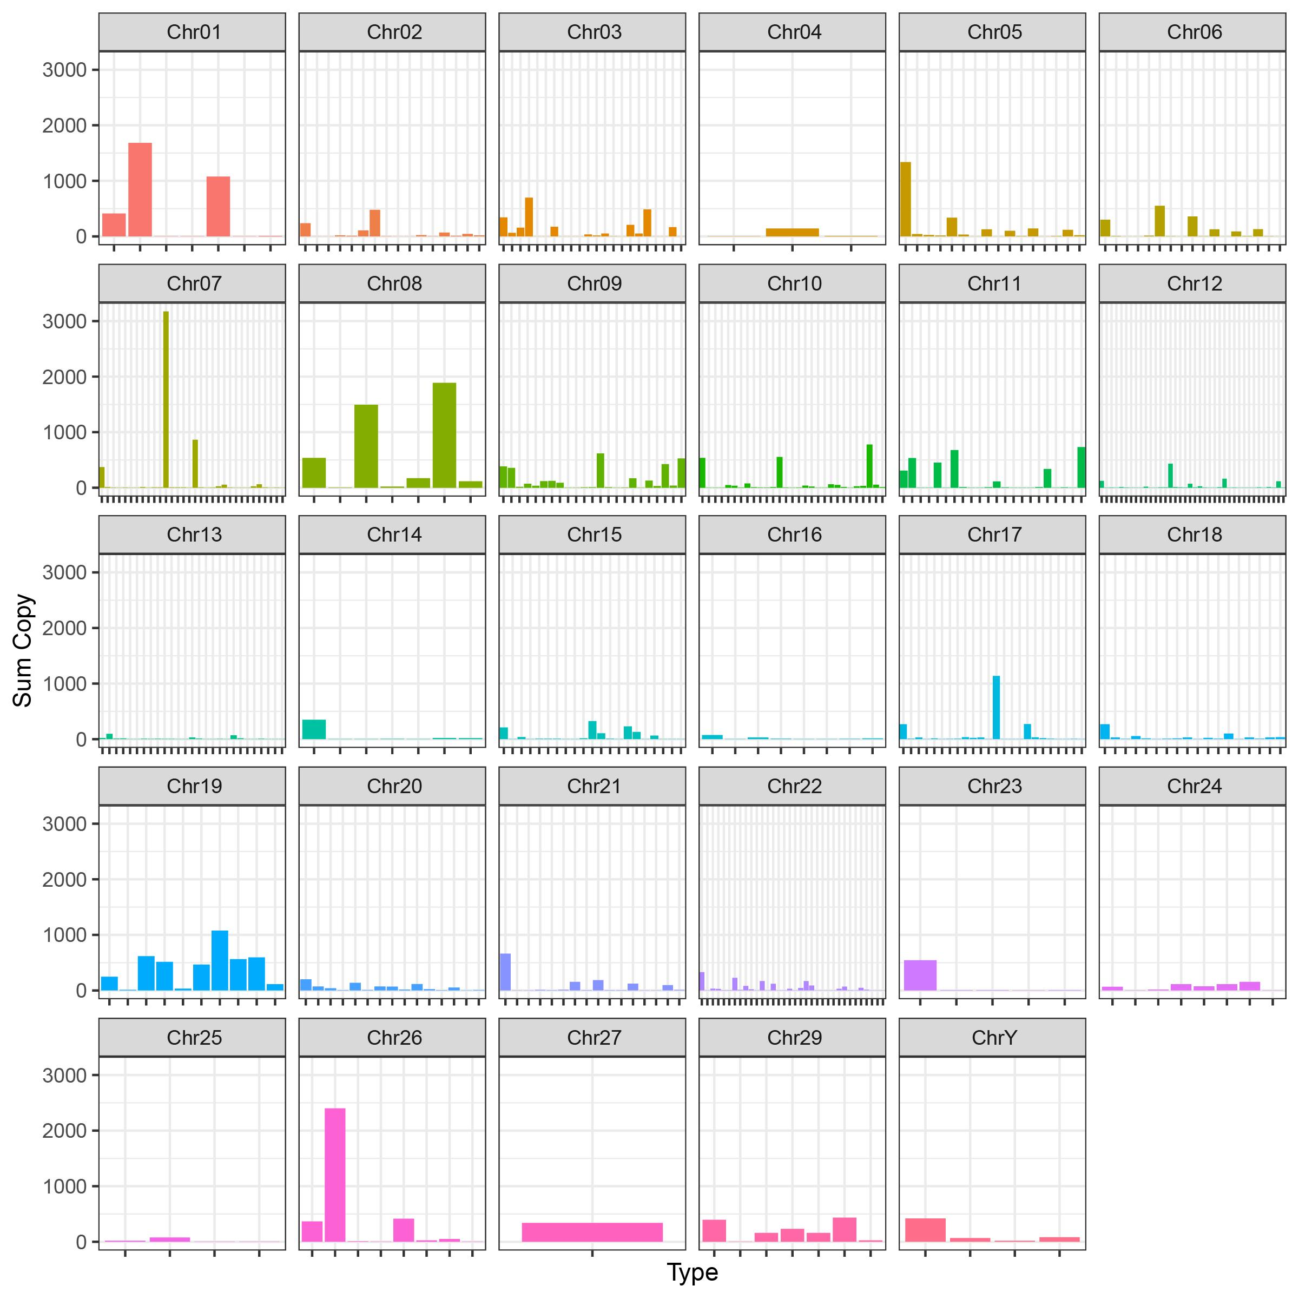
Supplementary Fig. 32 Chromosomal distribution of HOR copy numbers in cattle. Bar plots depict the copy number variation of distinct HOR types identified across individual chromosomes. Each panel corresponds to one chromosome, with multiple bars representing different HOR families present on that chromosome. The relative abundance of HORs highlights chromosome-specific repeat organization and reveals both common and unique expansion patterns among cattle centromeric regions.

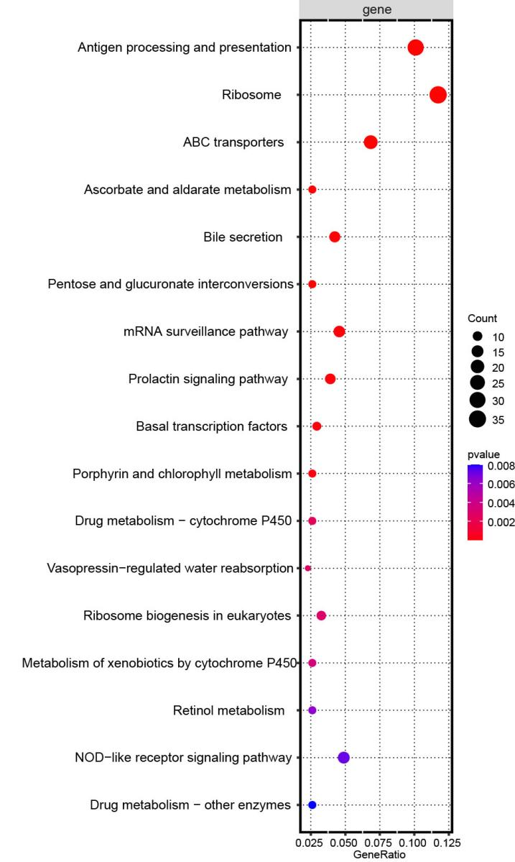
Supplementary Fig. 33 The enriched analysis of expanded gene families in T2T-cattle1.0-SAAS. The enriched analysis of expanded gene families in the cattle T2T genome are conducted using KEGG pathways. The circle size indicates the number of transcripts enriched in each pathway or term, while the color gradient represents the p-value.

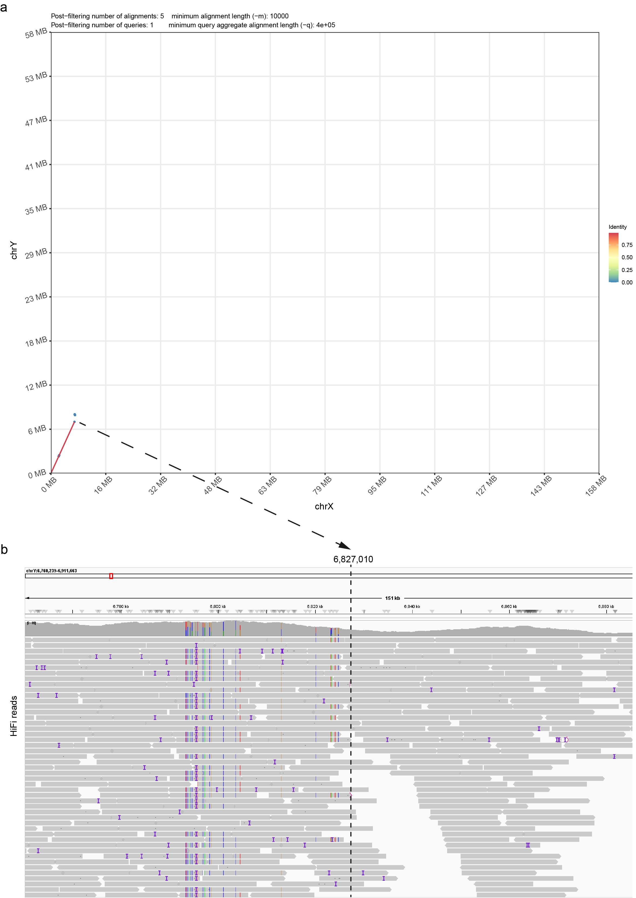
Supplementary Fig. 34 Identification of PAR in X and Y chromosomes of T2T-cattle1.0-SAAS. a, X and Y chromosome collinearity diagrams. The color of the line denotes the sequence identity of the X and Y chromosomes and indicates the PAR boundary at approximately 6.8 Mb in the cattle T2T genome. b, The HiFi reads mapped to PAR on chromosome Y. The black dashed line delineates the theoretical boundary of the PAR, representing the truncated HiFi reads, which likely originate from the maternal X chromosome's PAR, with their right termini failing to align with the PAR on the Y chromosome.

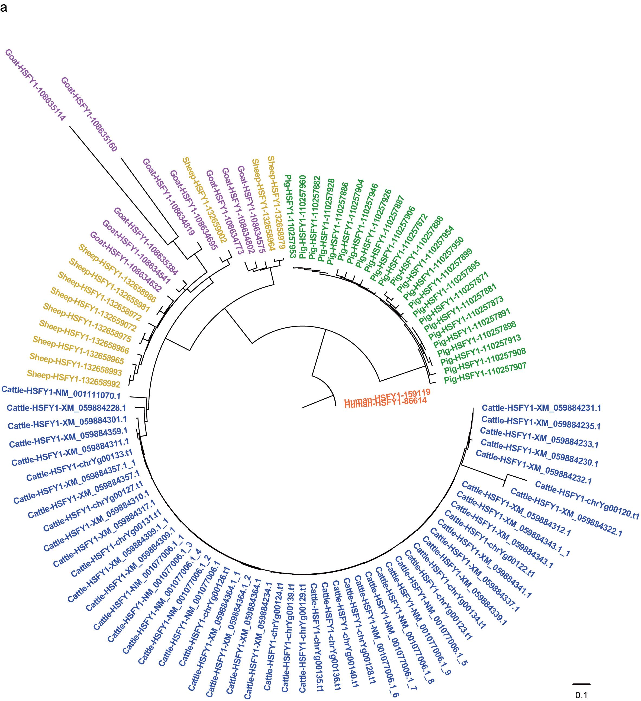

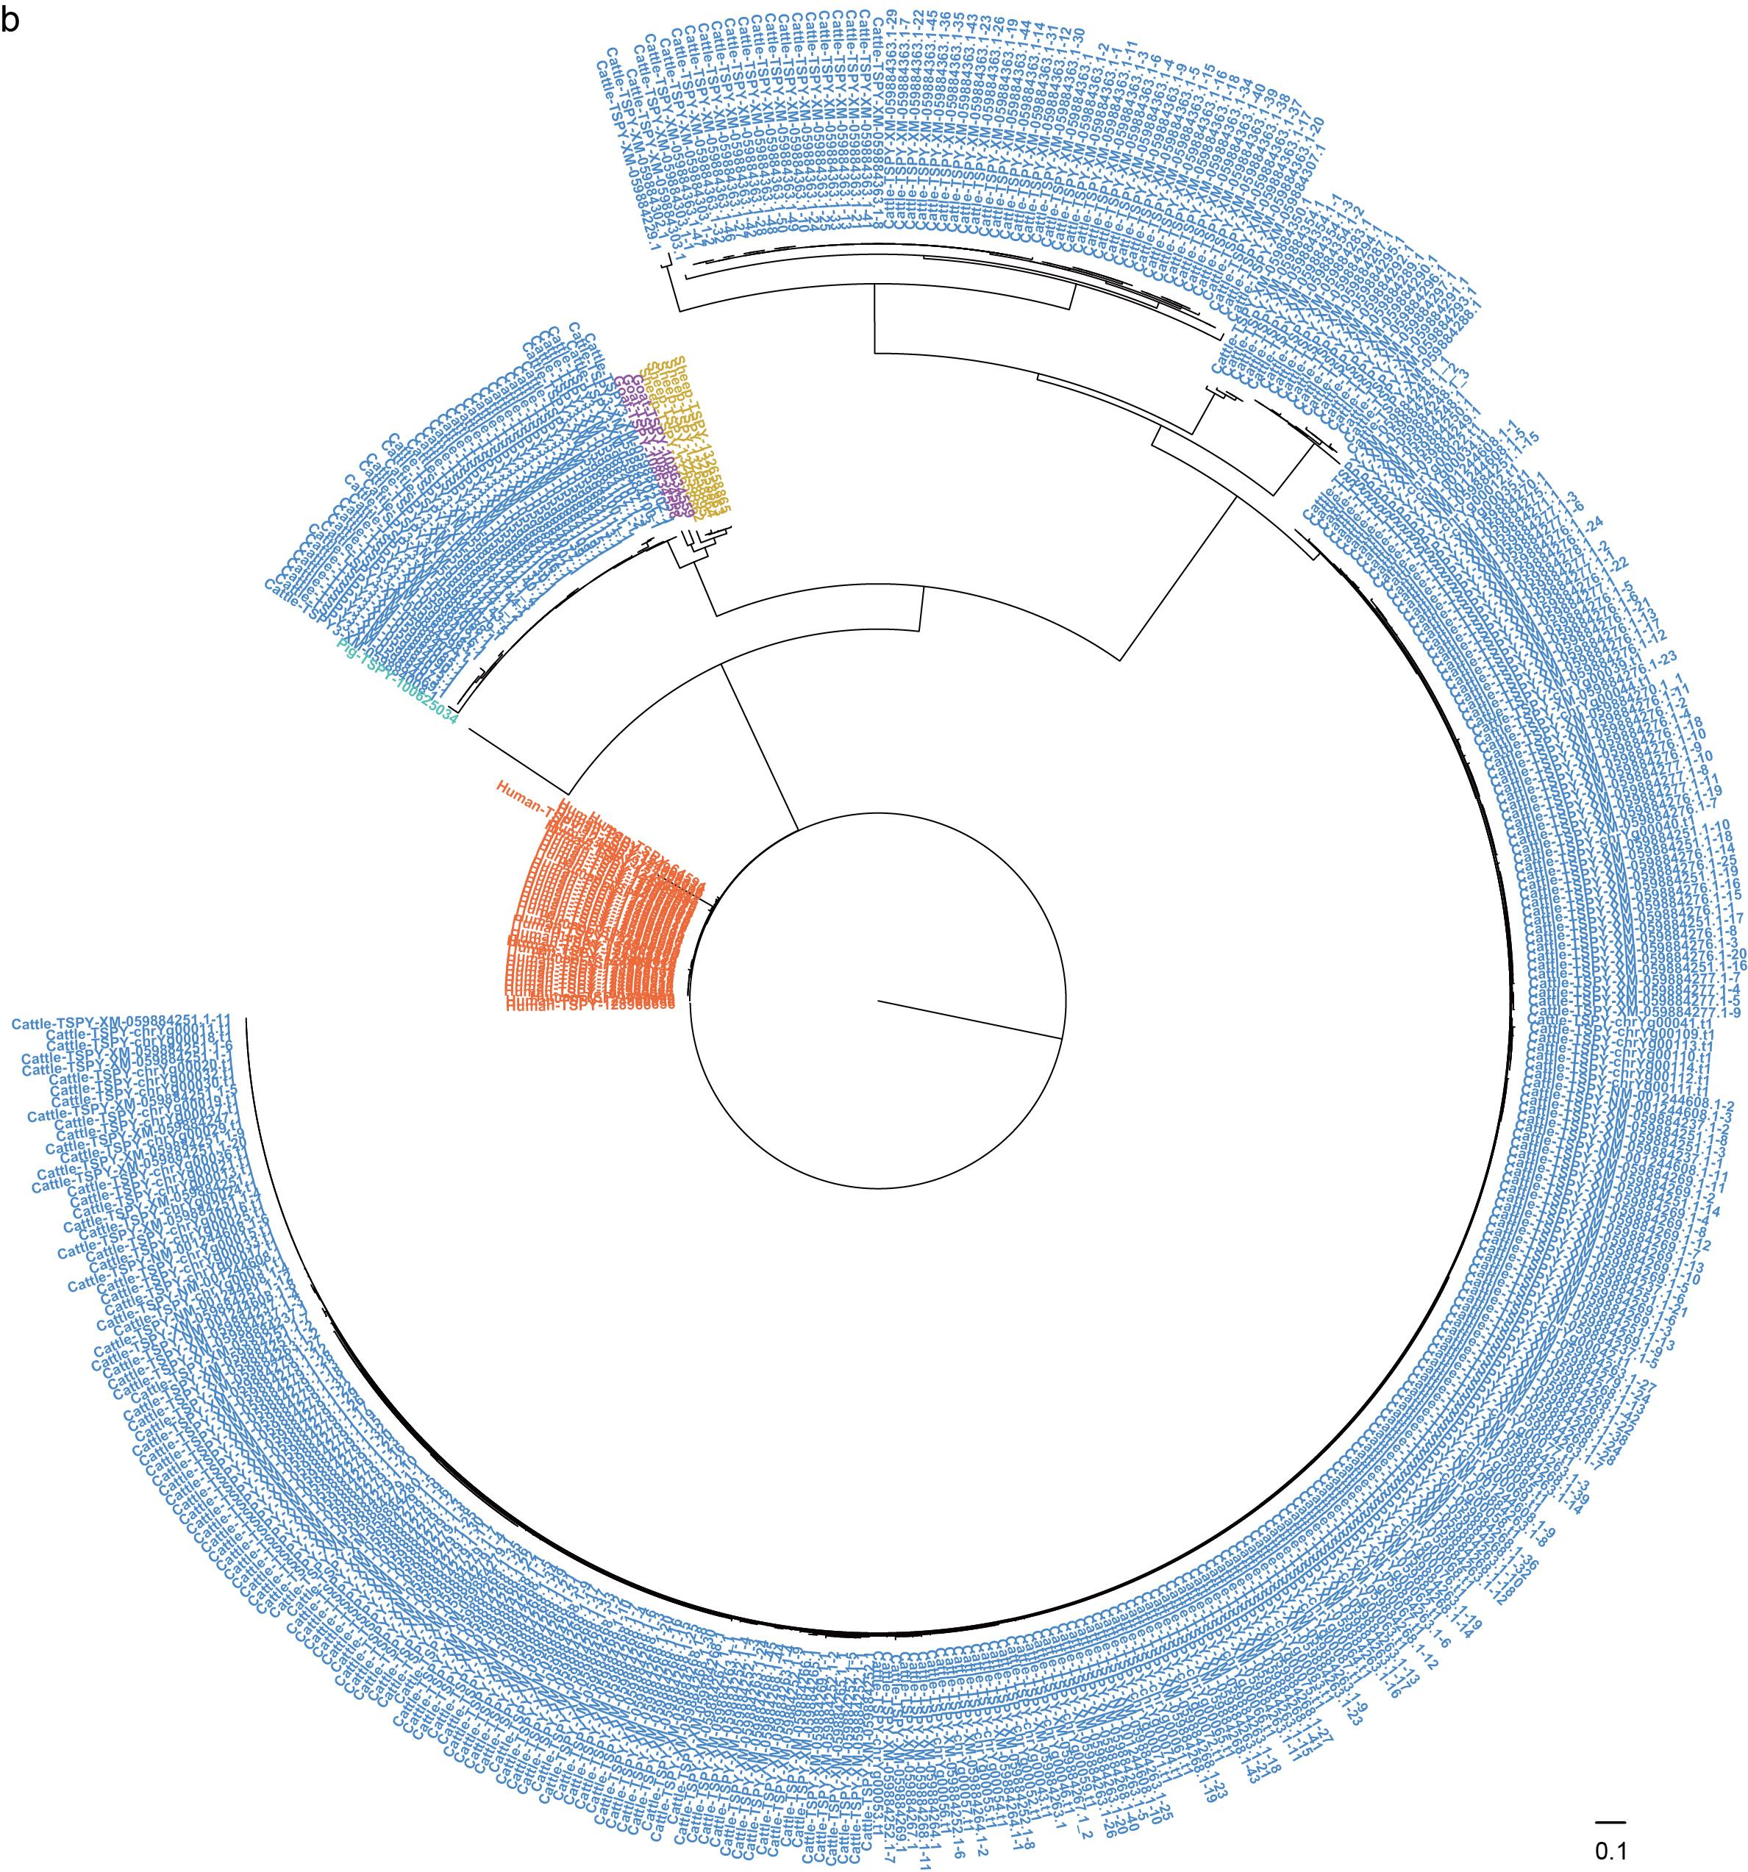

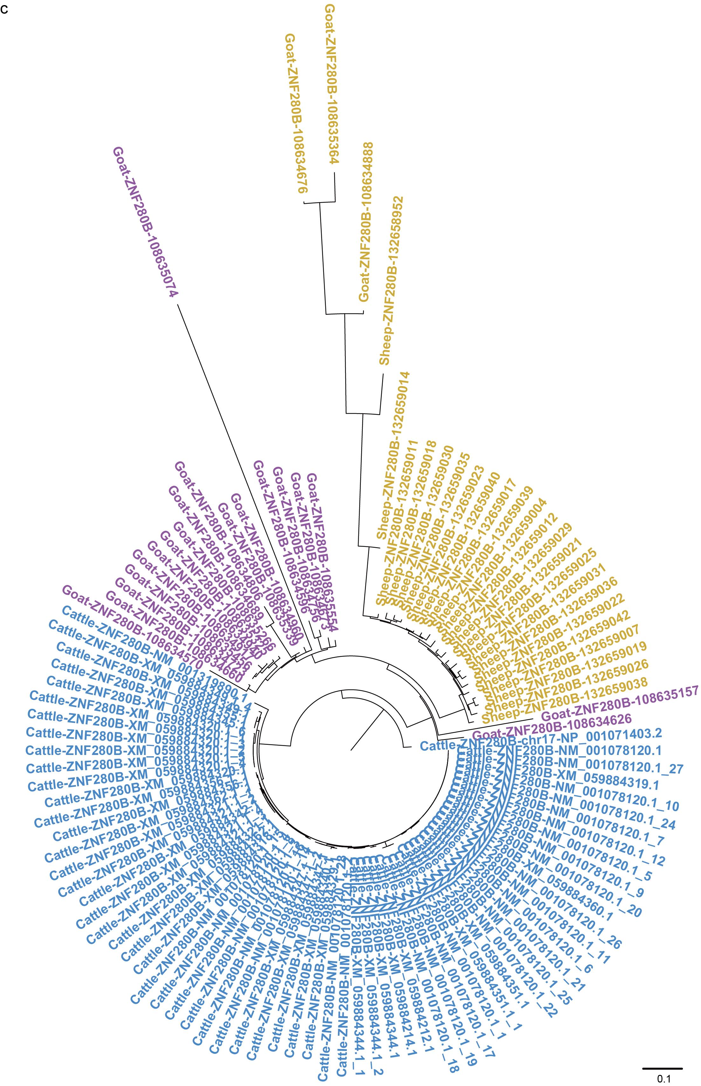
Supplementary Fig. 35 Clustering of Y chromosome protein-coding genes HSFY1, TSPY, and ZNF280B across species. a-c, HSFY1, TSPY, and ZNF280B. The genes HSFY1, TSPY, and ZNF280B are presented, with each gene copy being identified by the species name, gene name, and gene ID number. Gene copies displayed in pink font are derived from humans and serve as outgroups in the construction of the phylogenetic tree. Gene copies are color-coded as follows: green for porcine amplicon genes, purple for goat, yellow for sheep, and blue for cattle.

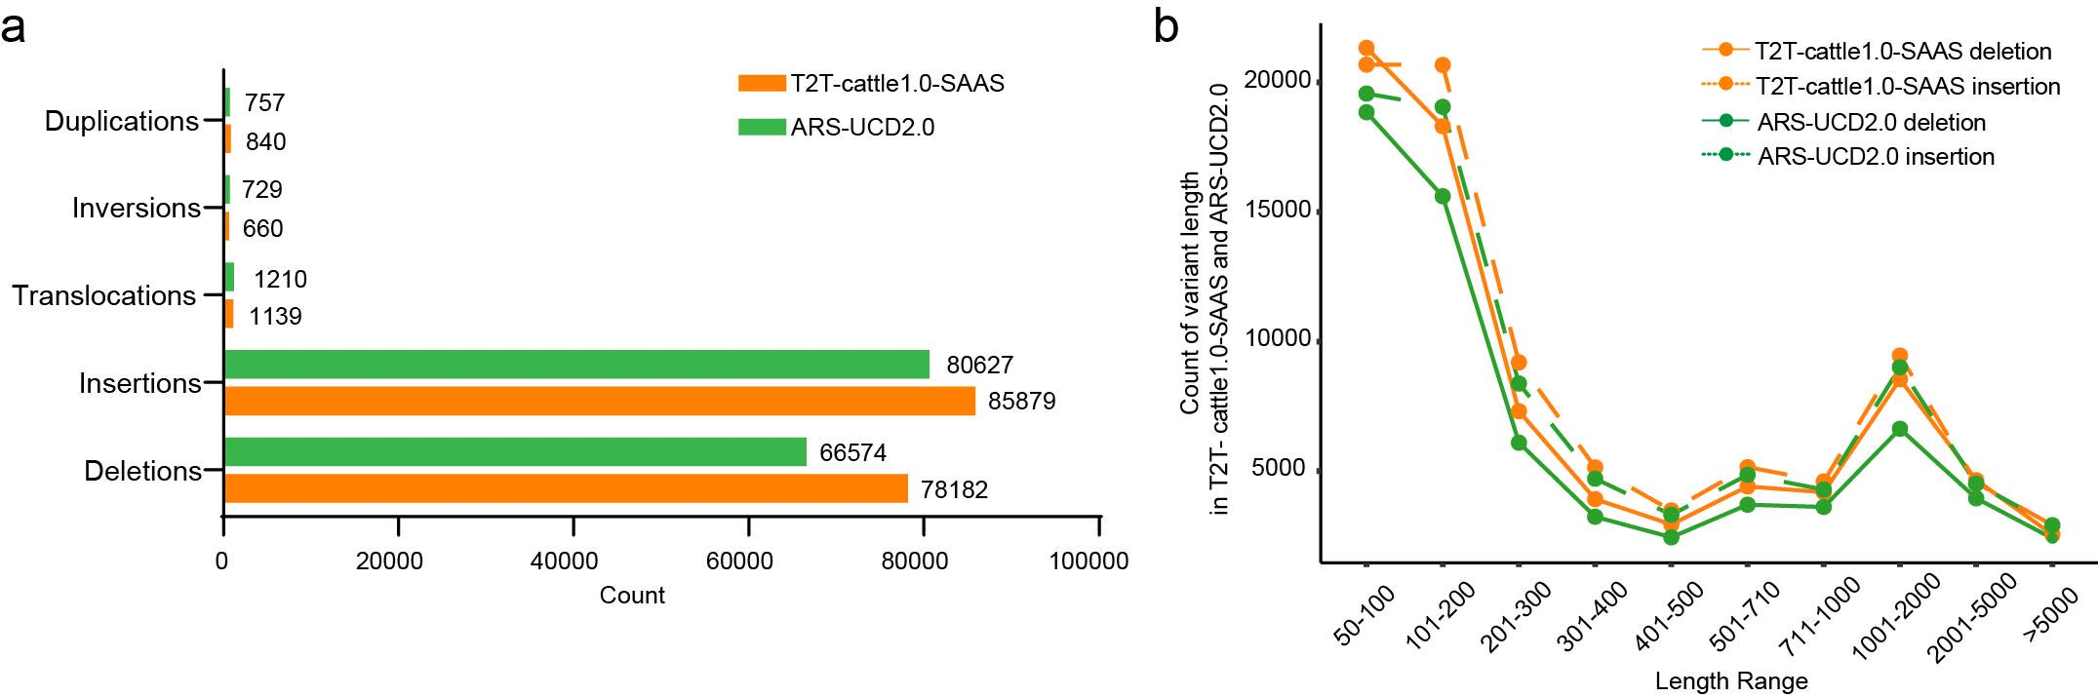
Supplementary Fig. 36 Comparison of counts of structural variation (SV) (a) and different SV length range (b) detected using T2T-cattle1.0-SAAS versus ARS-UCD2.0 as references. The SV types include duplication, inversion, translocation, insertion, and deletion.

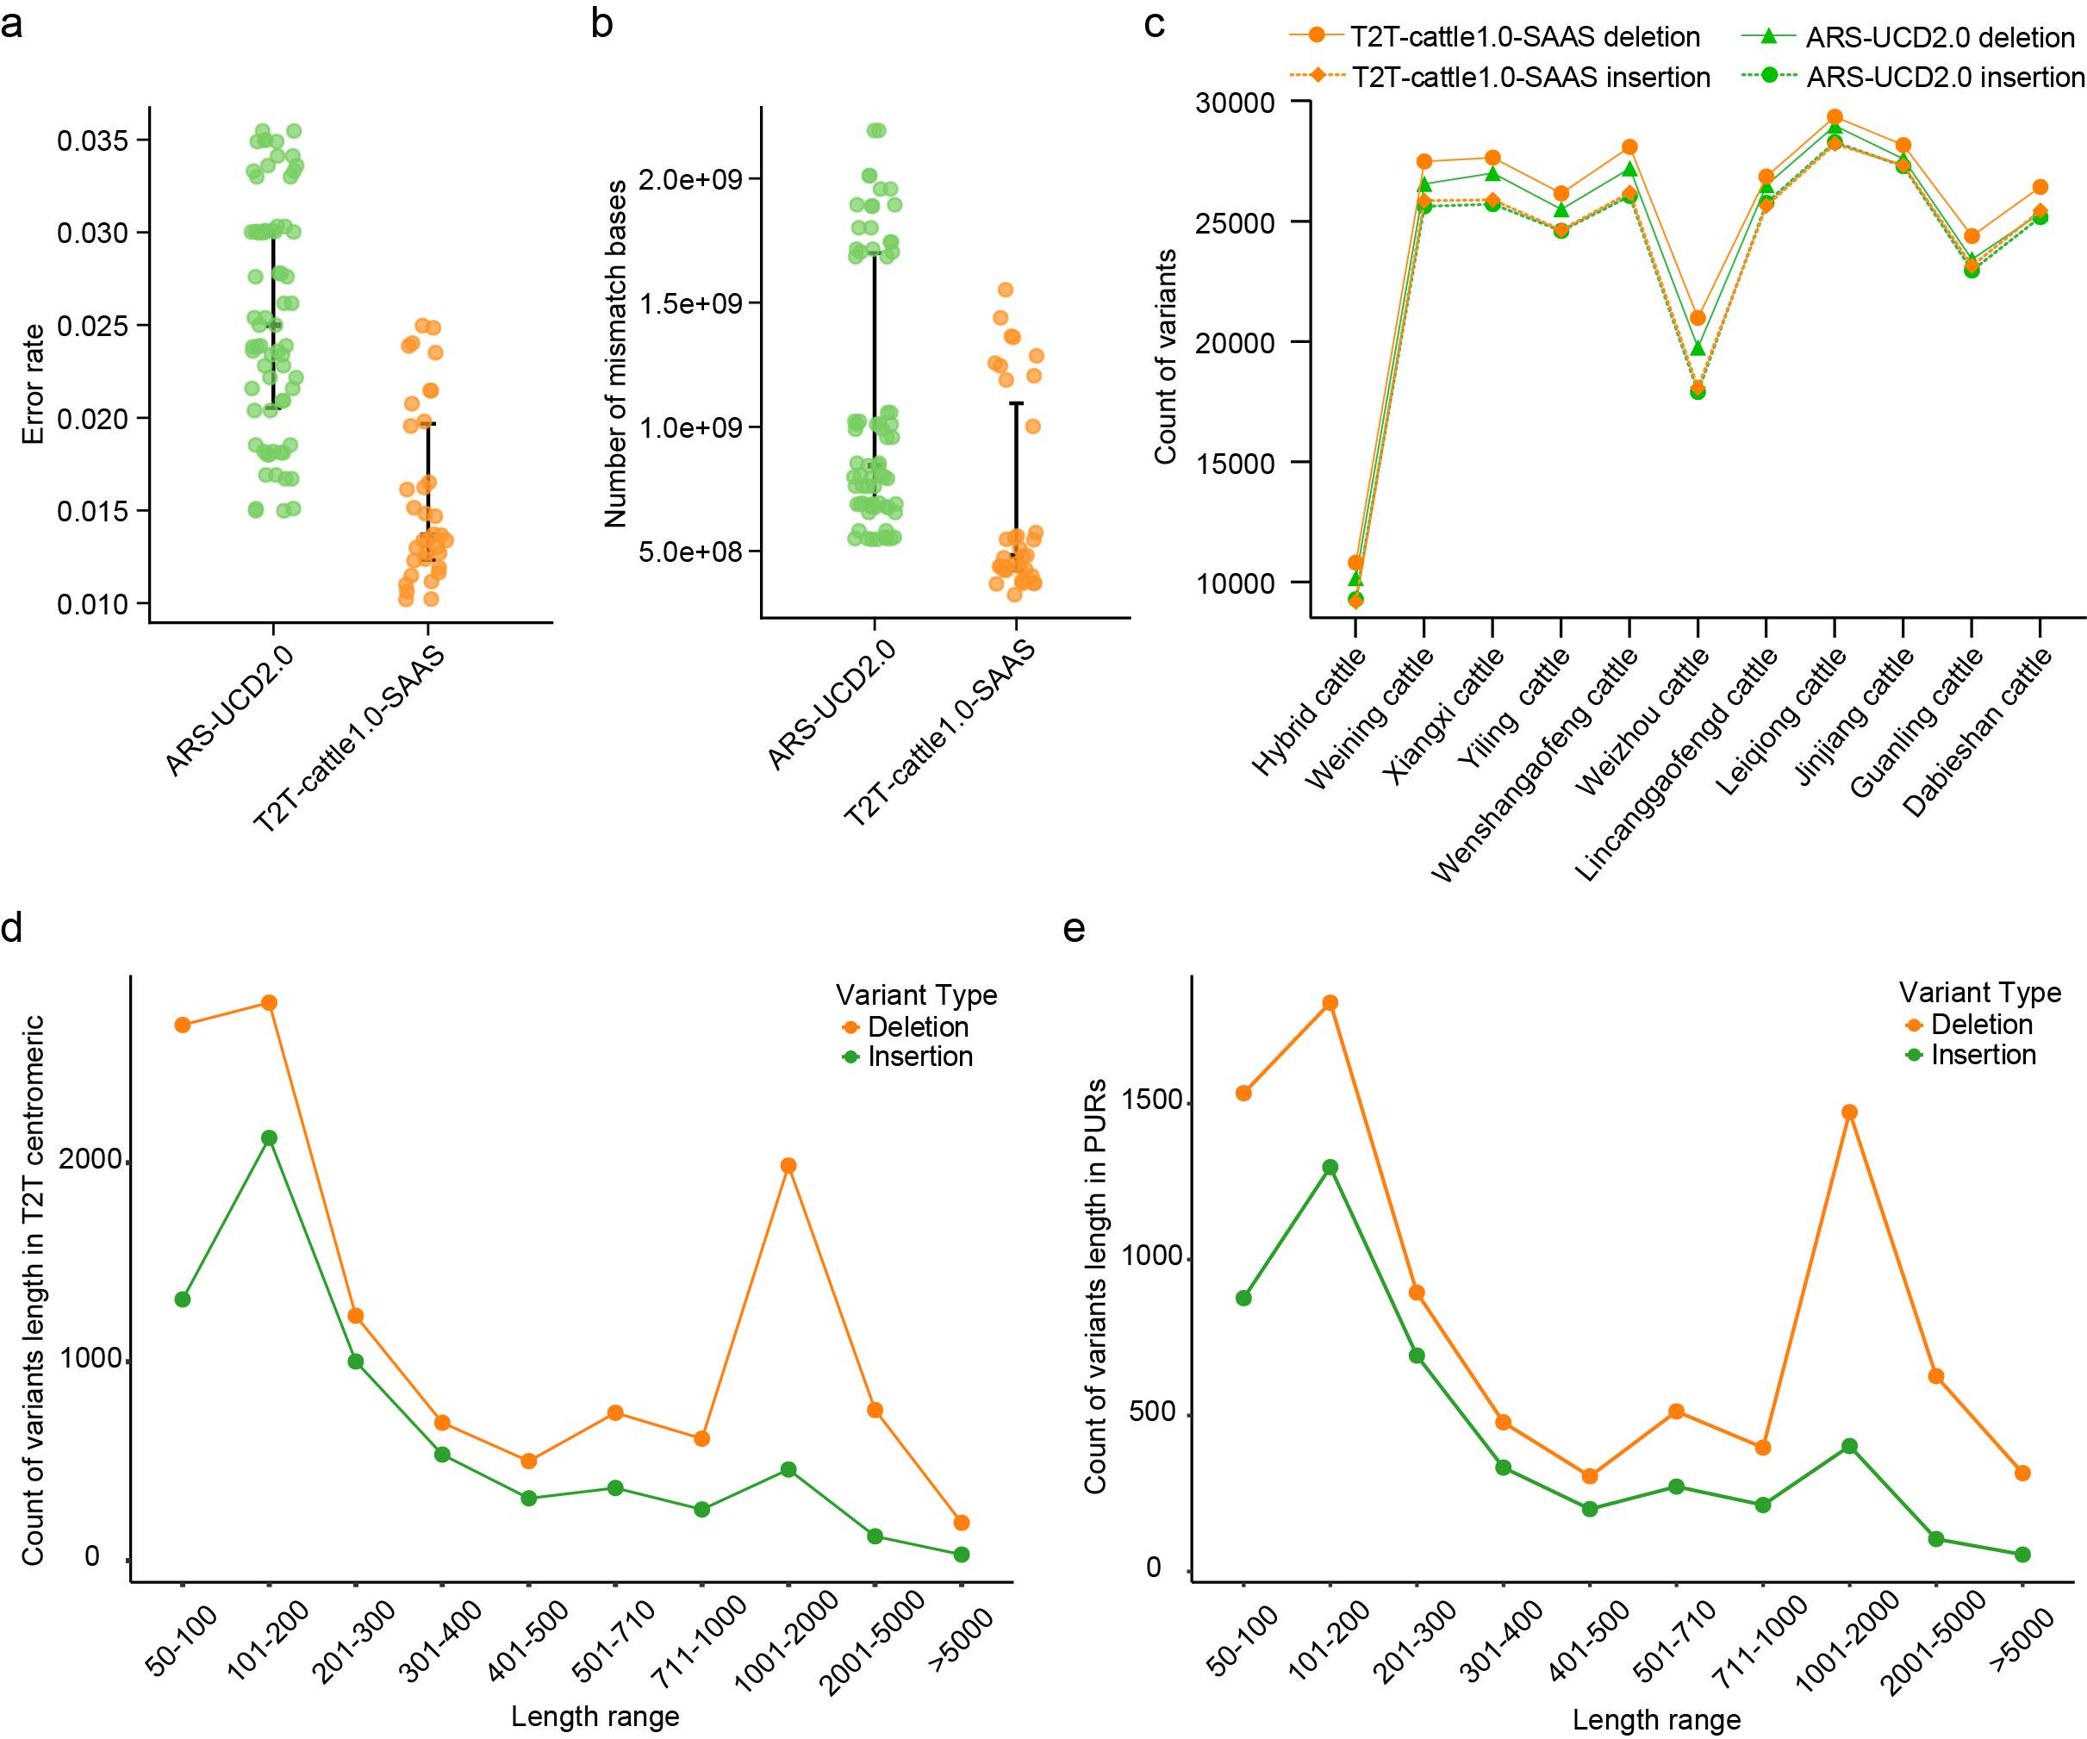
Supplementary Fig. 37 Comparison of SV callings using T2T-cattle1.0-SAAS and ARS-UCD2.0. a-b, Alignment error rate and number of mismatch bases on detecting SVs using T2T-cattle1.0-SAAS versus ARS-UCD2.0 as references. c, Comparison of counts of deletion and insertion in bovine species detected using T2T-cattle1.0-SAAS versus ARS-UCD2.0 as references. d, Counts of deletion and insertion in different length range detected using T2T-cattle1.0-SAAS versus ARS-UCD2.0 as references. e, Counts of deletion and insertion of different length range in PUR regions detected using the T2T-cattle1.0-SAAS as reference.

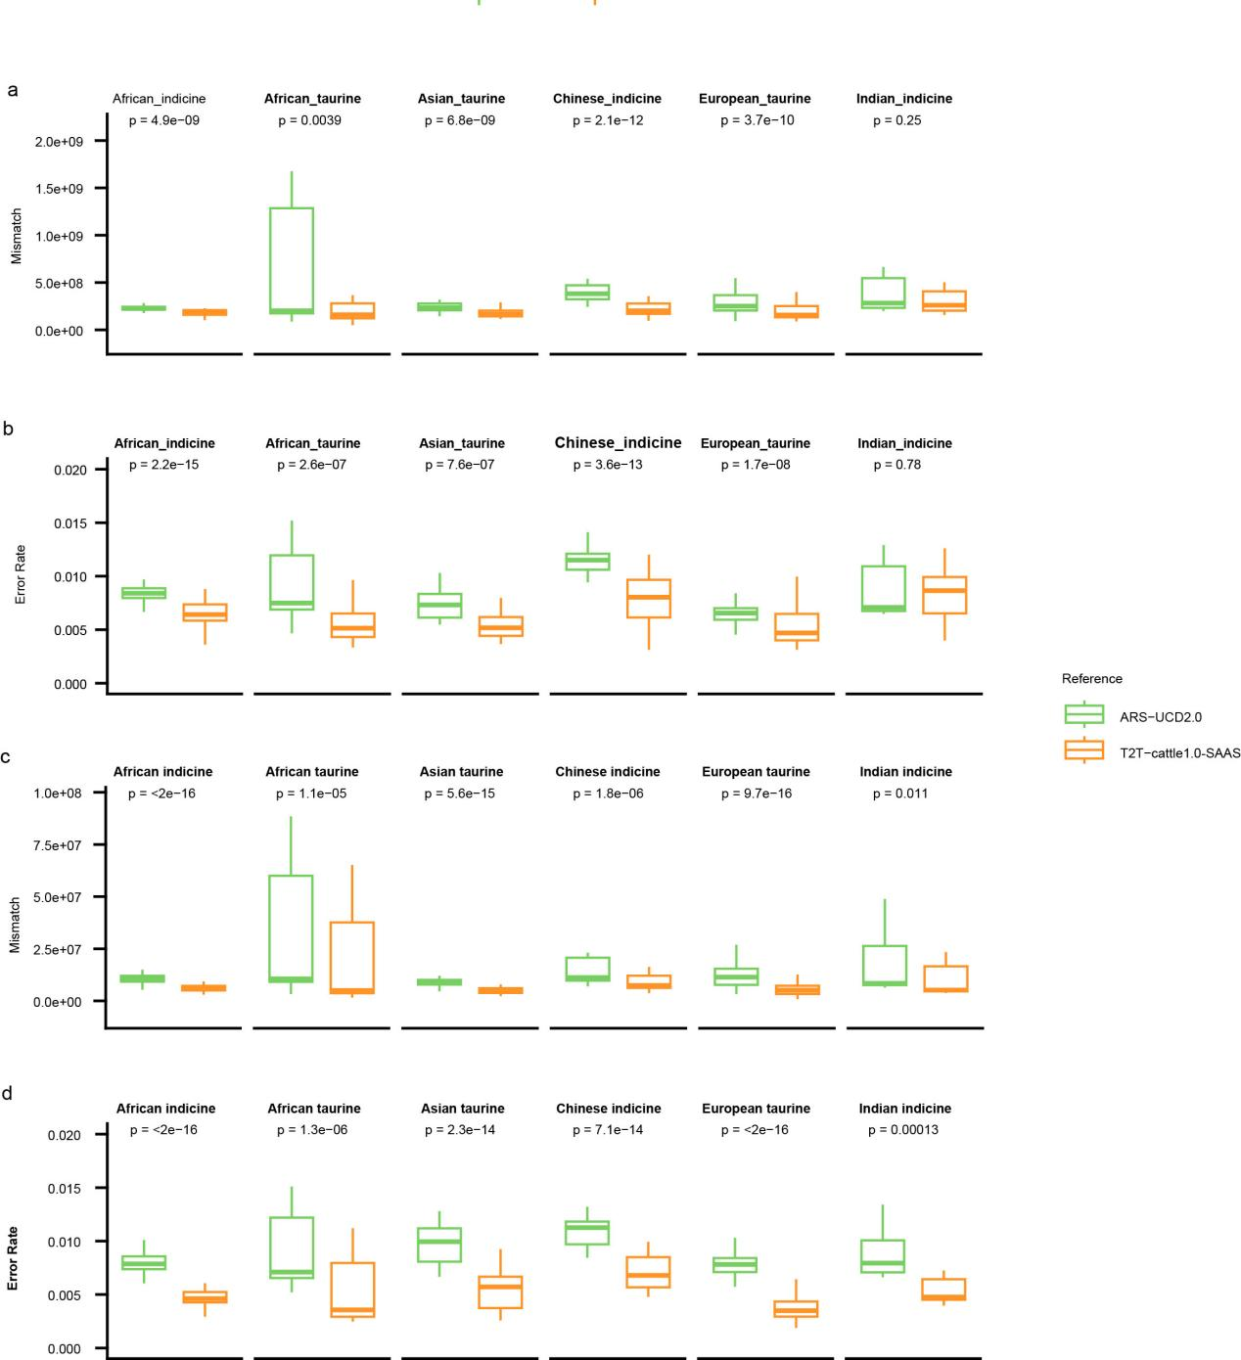
Supplementary Fig. 38 Comparative of mismatch count and alignment error rate of detecting SNPs using T2T-cattle1.0-SAAS versus ARS-UCD2.0 as references in six bovine populations. a-b, Comparison of all chromosomes. c-d, Comparision of the X chromosome. The student's t test was used to perform the comparisions of mismatch count and alignment error rate.

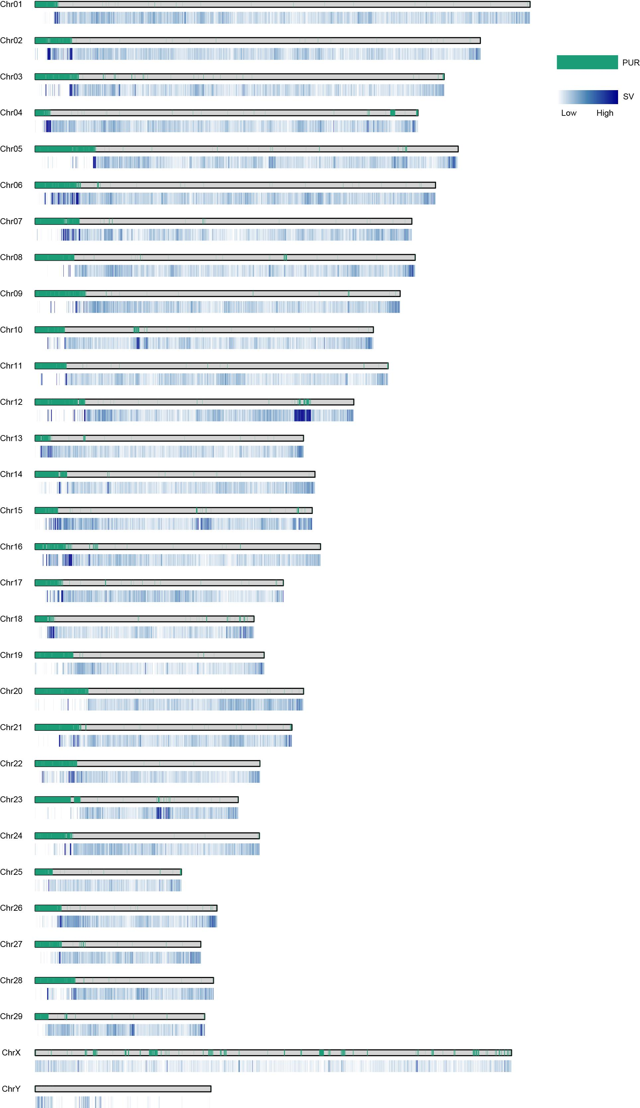
Supplementary Fig. 39 Distribution of SVs in PURs on the T2T-cattle1.0-SAAS. The SVs (gradient blue) in PURs (green) are indicated in each chromosome.
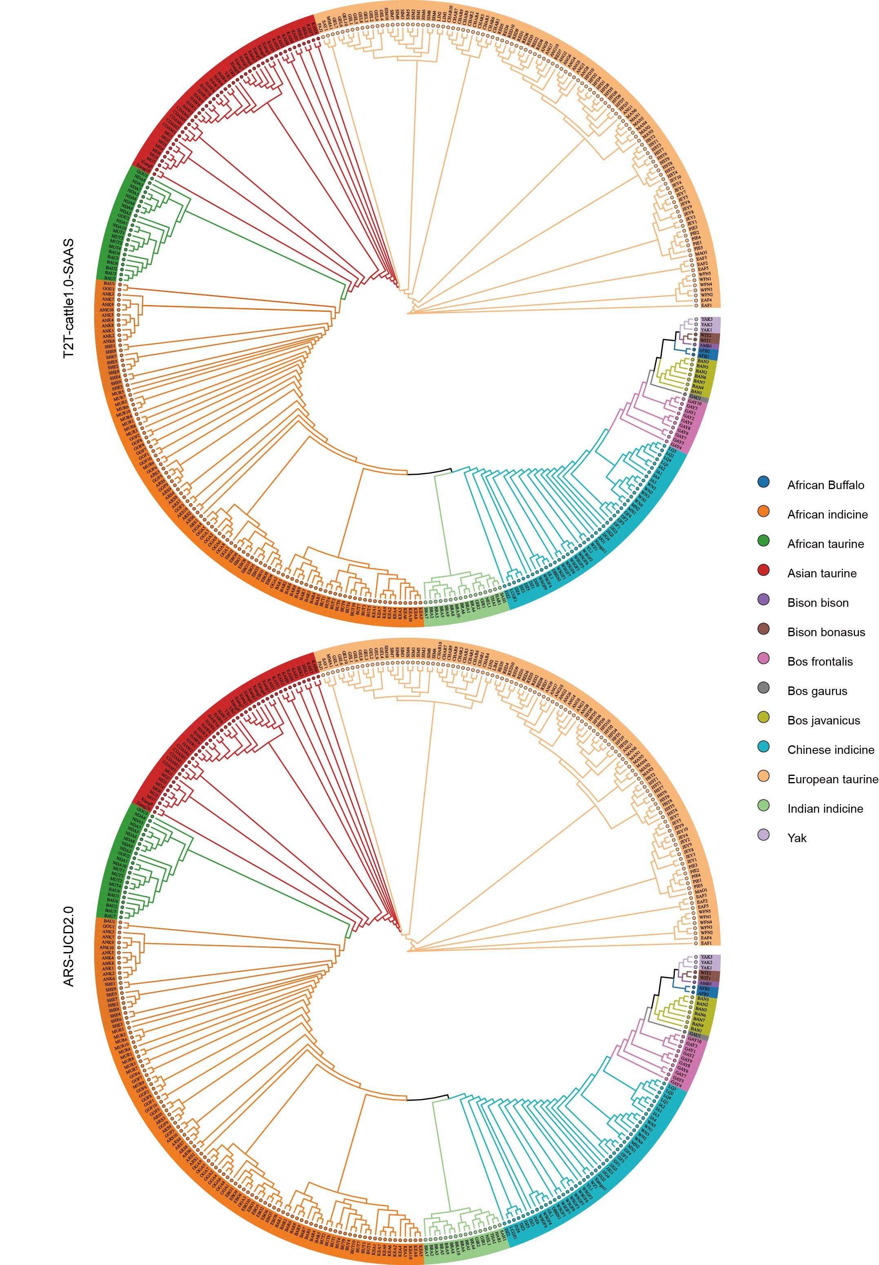
Supplementary Fig. 40 Phylogenetic trees constructed with autosomal SNPs identified using T2T-cattle1.0 and ARS-UCD2.0, respectively. The two constructed trees using different genome as references are identical. Phylogenetic trees were constructed using the Neighbor-Joining method.
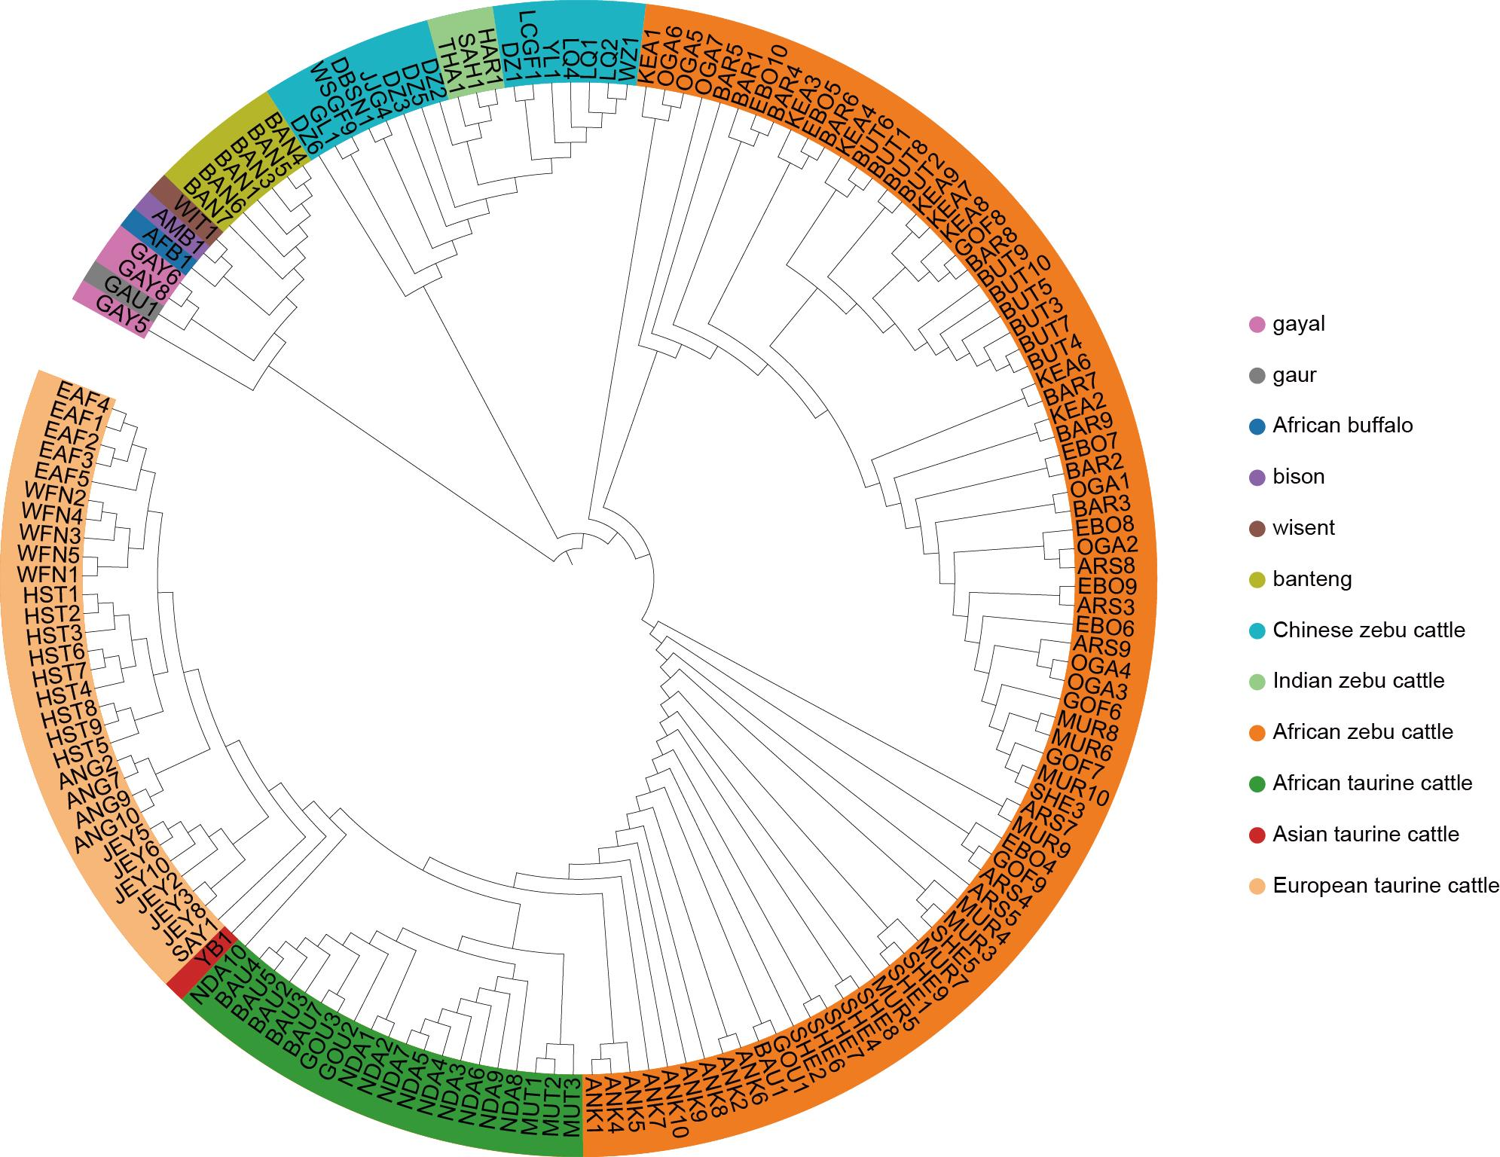
Supplementary Fig. 41 Phylogenetic tree constructed with SNPs of X chromosome identified in ARS-UCD2.0. Phylogenetic tree was constructed using the Neighbor-Joining method.

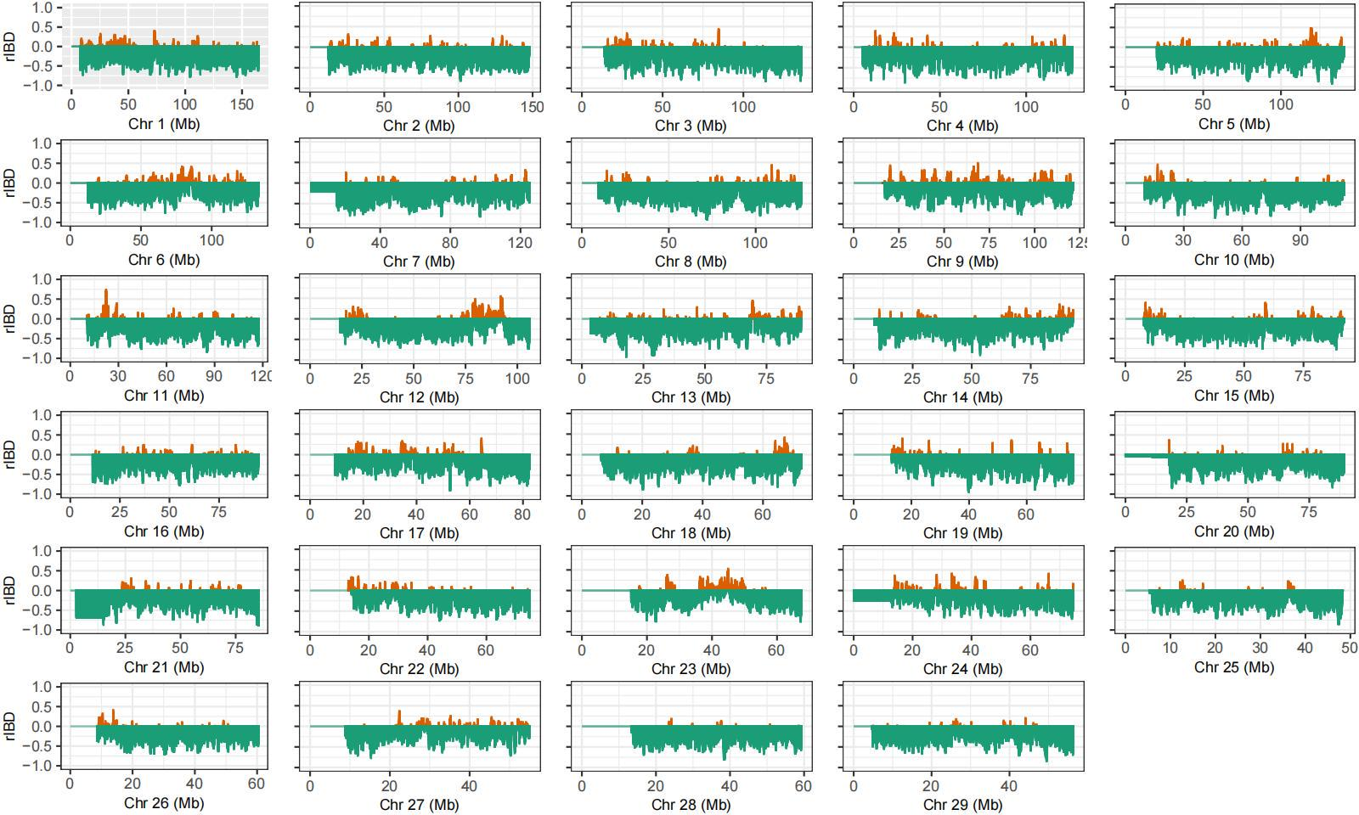
Supplementary Fig. 42 Introgression anlysis between banteng and Chinese zebu cattle on all autosomes. The positive relative IBDs indicate introgression from banteng to Chinese zebu cattle with the Indian zebu as the reference population.

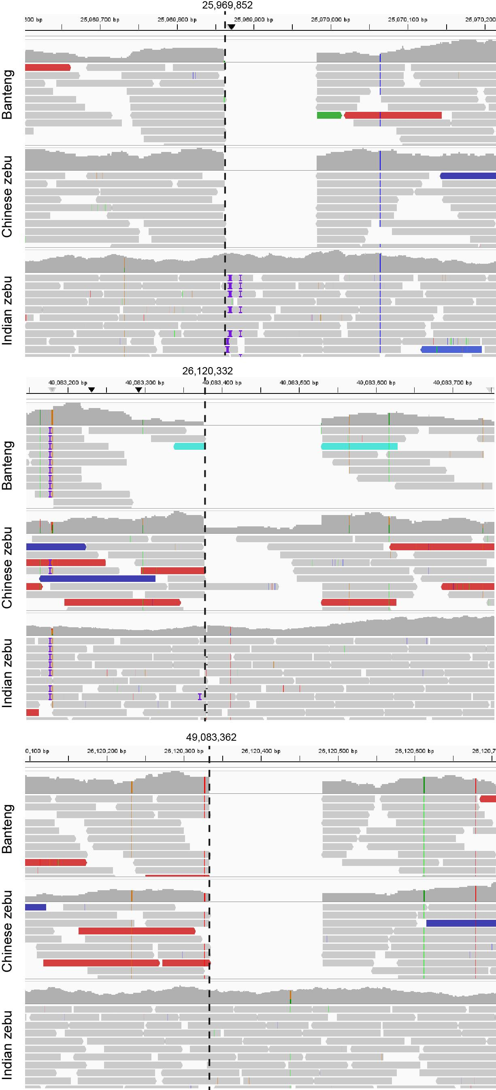

Supplementary Fig. 43 The 3 SVs confirmed by the introgression from banteng to Chinese zebu cattle. The three SV regions on Chr23 were were individually depicted using sequencing read coverage data from banteng, Chinese Zebu, and Indian Zebu. The initiation point of each SV region is indicated by a dashed line.

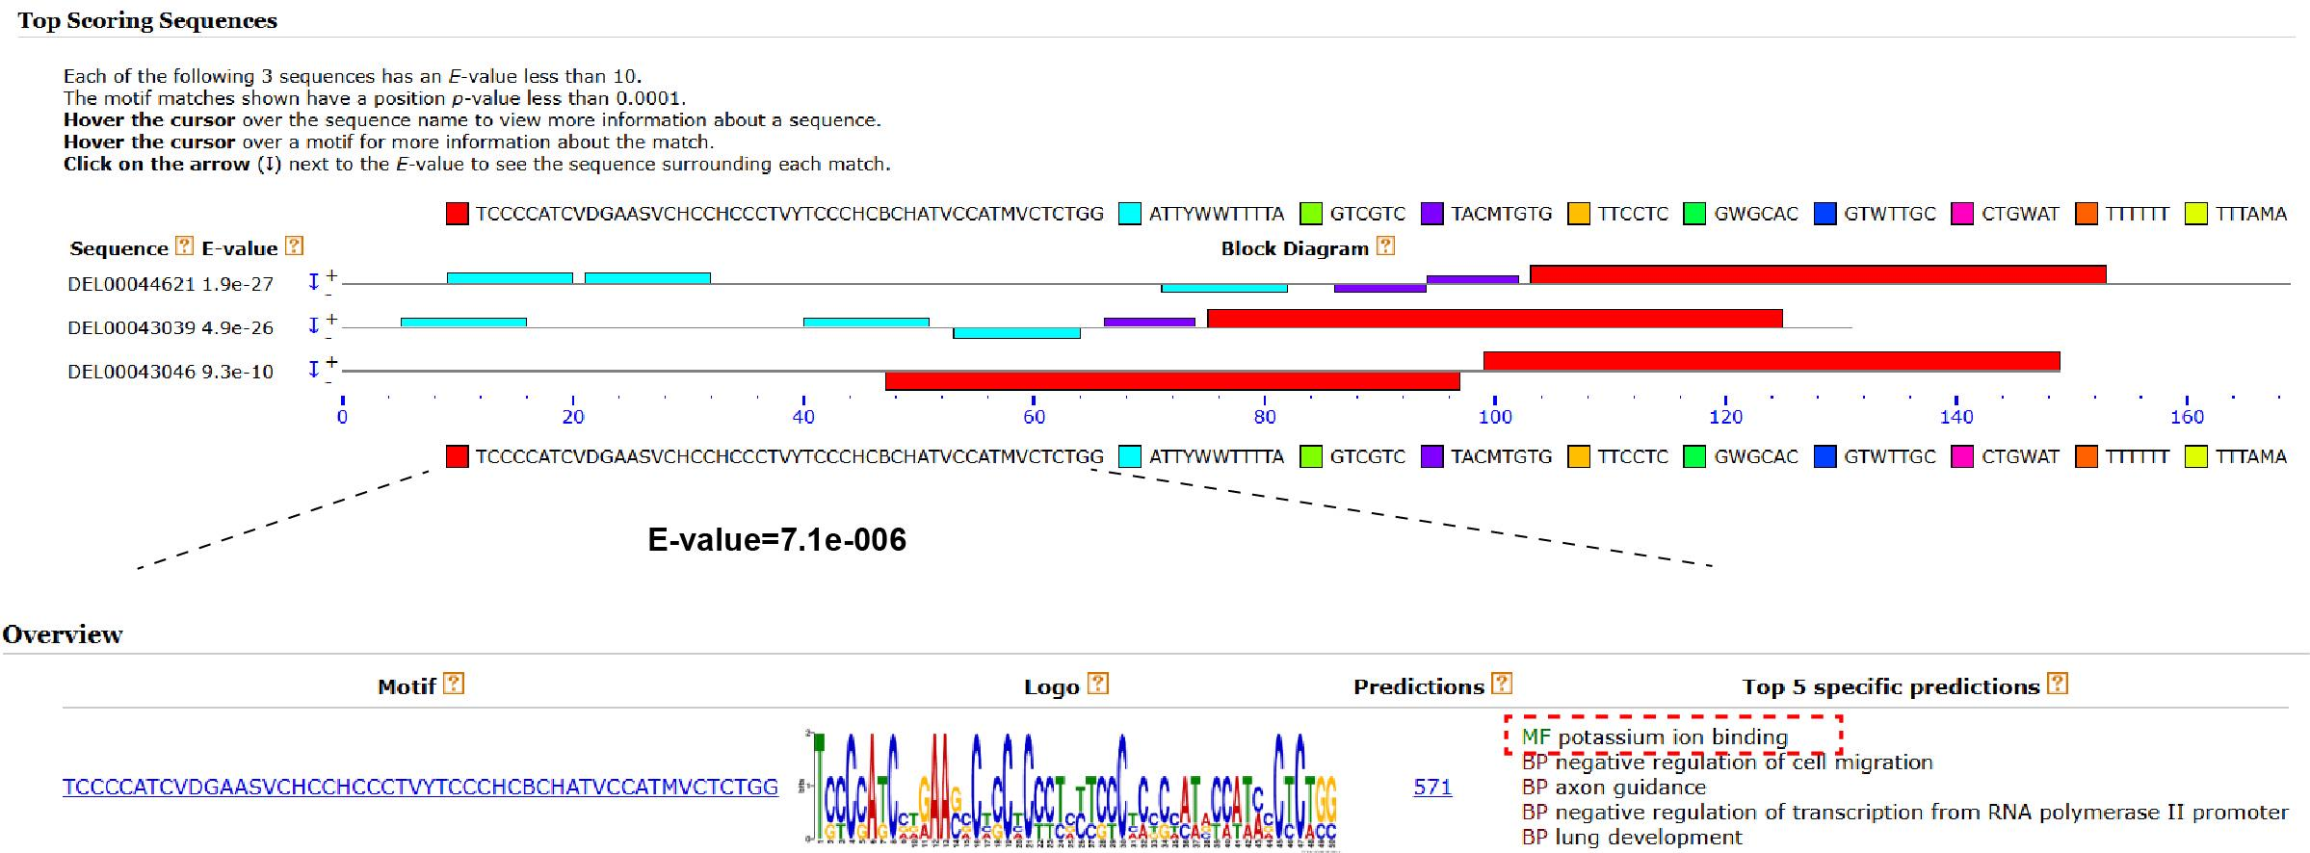

Supplementary Fig. 44 Motif analysis conducted on 3 SVs in the banteng-to-Chinese zebu introgression region on Chr23. The 3 SV sequences was analyzed with MEME software, and multiple motifs were identified. The motif (TCCCCATCVDGAASVCHCCHCCCTVYTCCCHCBCHATVCCATMVCTCTGG) is significant enrichment, with an E-value of 7.1e-006. This particular motif was further examined using GO terms, of which "potassium ion binding" is the top-ranked term, highlighted by a red dashed box.

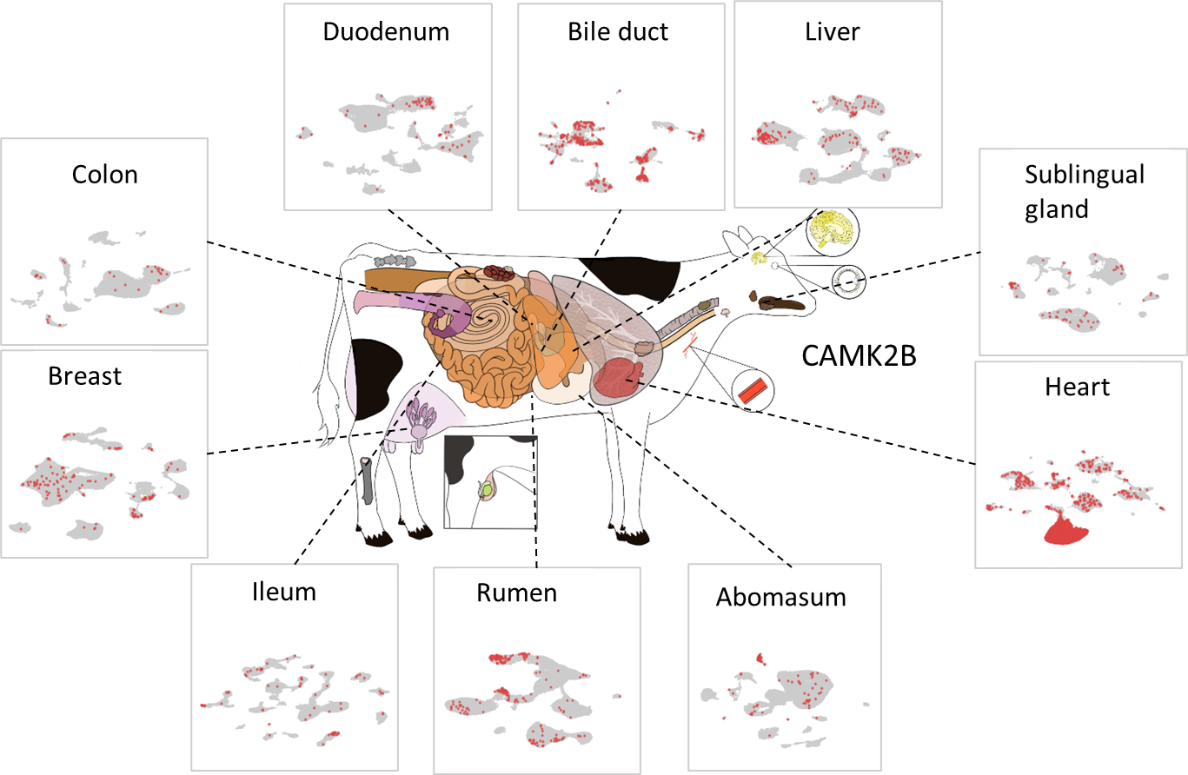
Supplementary Fig. 45 Expression of CAMK2B across bovine tissues. Illustration of bovine tissues indicates the expression of CAMK2B in liver, bile duct, duodenum, colon, breast, ileum, rumen, abomasum, heart, and sublingual gland, based on single-cell transcriptomic data from the multi-tissue cattle atlas (Han, B., Li, H., Zheng, W. et al. Nat Genet, 2025, https://doi.org/10.1038/s41588-025-02329-5).

