Supplementary Information

Quantifying crowding-ventilation effect on respiratory infections

Wei Jia¹, Pan Cheng¹, Jian Hang², Hua Qian³ and Yuguo Li^{1,4*}

¹Department of Mechanical Engineering, The University of Hong Kong, Pokfulam Road, Hong Kong SAR, China
²School of Atmospheric Sciences, Sun Yat-sen University, and Southern Marine Science and Engineering Guangdong Laboratory (Zhuhai), Zhuhai, China
³School of Energy and Environment, Southeast University, Nanjing, China
⁴Faculty of Architecture, The University of Hong Kong, Pokfulam Road, Hong Kong SAR, China

*Corresponding author: liyg@hku.hk

List of figures and tables
Supplementary Fig. 1–4
Supplementary Table 1–4
Supplementary Material 1–5

Supplementary Materials S1.
Transient correction factor and spaciousness dilution factor

To quantify how spaciousness and ventilation reduce respiratory infection risk, our framework relies on the effective clean flow rate ($q_{e}$, L/s per person), which integrates clean air equivalent ($q_{c}$) with volume-time air clearance (VTAC), the dilution effect of spaciousness (air volume per person, $V_{p}$, m³/person, divided by exposure time, $∆t$, hours). The transient correction factor $C_{T}$ and spaciousness dilution factor $γ$ are critical to deriving VTAC’s contribution. Here, we detail their formulation and behavior, ensuring clarity for applying our model to diverse indoor settings.

The transient correction factor accounts for non-steady-state aerosol concentration dynamics in a well-mixed room with volume ($V$) (m³) and clean air equivalent ($q_{C}$) (L/s). It is defined as:

$C_{T}=\frac{1-e^{-n∆t}}{n∆t}$ (S1.1)
where $n=\frac{3.6q_{C}}{V}$ is the air change rate (ACH, h⁻¹), with $q_{C}$ in L/s and $V$ in m³ (1 m³ = 1,000 liters, 1 hour = 3,600 seconds). $C_{T}$ ranges from 0 (high ventilation or long exposure) to 1 (low ventilation or short exposure), adjusting the effective clean flow rate for transient conditions.

The spaciousness dilution factor ($γ$) quantifies VTAC’s contribution to dilution. For co-exposure (Scenario S2, infectors and susceptibles together for $∆t$):
$γ_{0}=\frac{C_{T}}{1-C_{T}}$ (S1.2)

For the general case (Scenario S2, co-exposure $∆t$ plus post-exposure for $∆t_{0}$):
$γ_{\frac{∆t_{0}}{∆t}}=\frac{C_{T}e^{-n∆t_{0}}}{1-C_{T}e^{-n∆t_{0}}}$ (S1.3)

When $∆t_{0}=0$, $γ_{\frac{∆t_{0}}{∆t}}=γ_{0}$, making S1 a special case of S2. The VTAC component is $q_{a}=γ_{0}q_{c}$ for Scenario S1 or $q_{a}=γ_{\frac{∆t_{0}}{∆t}}q_{c}$ for Scenario S2, where $q_{c}=q_{C}/N_{σ}$ is clean air equivalent per person. Figure S1 illustrates $C_{T}$ and $γ$ for $\frac{∆t_{0}}{∆t}$ = 0, 0.5, and 1, showing how $γ$ increases with lower ventilation or shorter exposure, amplifying VTAC’s role in crowded settings.

This formulation enables precise modeling of VTAC’s dilution effect, critical for understanding infection risk in settings like jails or shelters with low ventilation (e.g., 1 L/s per person), where modest spaciousness (10-30 m³/person) significantly boosts effective clean flow rate (Jia et al., 2022).

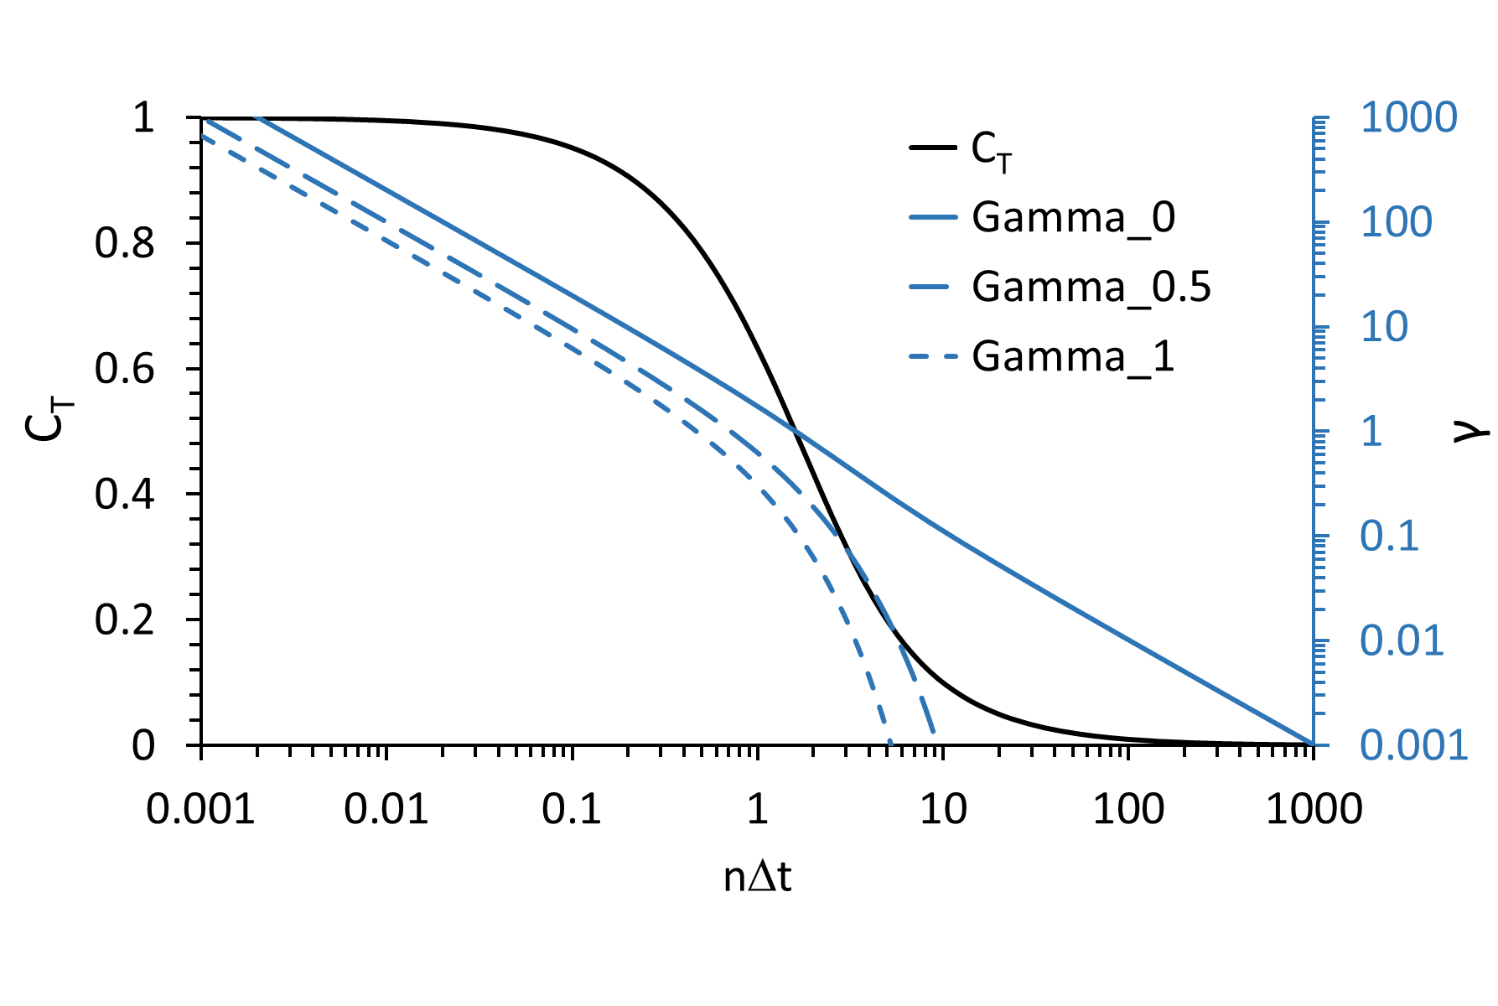
Figure S1. Variation of the transient correction factor $C_{T}$ and spaciousness dilution factor $γ$ for three values of $\frac{∆t_{0}}{∆t}$= 0, 0.5, and 1.

Supplementary Materials S2.
Deriving the VTAC formula

The volume-time air clearance (VTAC) metric, $q_{vt}$, represents the dilution effect of spaciousness (air volume per person, $V_{p}$, m³/person, divided by exposure time, $∆t$, hours) within the effective clean flow rate ($q_{e}$, L/s per person). Here, we derive the VTAC formula, showing how it emerges as an asymptote of $q_{e}$, highlighting spaciousness’s role in reducing aerosol exposure in poorly ventilated settings.

The effective clean flow rate $q_{e}$ and VATC contribution $q_{a}$ for co-exposure (Scenario S1):
$q_{e}=\frac{1}{1-C_{T}}q_{c}$ (S2.1)
$q_{a}=γ_{0}q_{d}=\frac{C_{T}}{1-C_{T}}q_{c}$ (S2.2)
where $q_{c}$ is clean air equivalent per person (L/s per person), and $C_{T}=\frac{1-e^{-n∆t}}{n∆t}$, with $n=\frac{3.6q_{C}}{V}=\frac{3.6q_{c}}{V_{p}}$ (ACH), $γ_{0}=\frac{C_{T}}{1-C_{T}}$ is spaciousness dilution factor.

The effective clean flow rate $q_{e}$ and VATC contribution $q_{a}$ for co-exposure and post-exposure (Scenario S2) are:
$q_{e}=\frac{1}{1-C_{T}e^{-n∆t_{0}}}q_{c}$ (S2.3)
$q_{a}=γ_{\frac{∆t_{0}}{∆t}}q_{d}=\frac{C_{T}e^{-n∆t_{0}}}{1-C_{T}e^{-n∆t_{0}}}q_{c}$ (S2.4)
where co-exposure time is $∆t$ and post-exposure time is $∆t_{0}$.

The effective clean flow rate $q_{e}$ has two asymptotes:
- Ventilation asymptote: As $n∆t→∞$,$C_{T}→0$, so for both S1 and S2:
$\lim_{n∆t→∞}{q_{e}}=\lim_{n∆t→∞}\frac{q_{c}}{\left(1-C_{T}\right)}≈q_{c}$ (S2.5)
$\lim_{n∆t→∞}{q_{e}}=\lim_{n∆t→∞}\frac{1}{1-C_{T}e^{-n∆t_{0}}}q_{c}≈q_{c}$ (S2.6)
- VTAC asymptote: For low $n∆t$ (<0.2), we use the quadratic approximation for the exponential term, $e^{-n∆t}≈1-n∆t+{\frac{1}{2}\left(n∆t\right)}^{2}$:
$\lim_{n∆t→0}{q_{e}}=\lim_{n∆t→0}\frac{q_{c}}{1+\frac{e^{-n∆t}-1}{n∆t}}≈\frac{q_{c}}{1+\frac{1-n∆t+{\frac{1}{2}\left(n∆t\right)}^{2}-1}{n∆t}}=\frac{{2V}_{p}}{∆t}$ (S2.7)
$\lim_{n∆t→0}{q_{e}}=\lim_{n∆t→0}\frac{q_{c}}{1-C_{T}e^{-n∆t_{0}}}≈\frac{q_{c}}{1-e^{-n∆t_{0}}+\frac{n∆t}{2}e^{-n∆t_{0}}}=\frac{{2V}_{p}}{∆t+∆t_{0}}$ (S2.8)

We write $q_{vt}=\frac{2V_{p}}{∆t∙3.6}$ for S1, $q_{vt}=\frac{2V_{p}}{\left(∆t+∆t_{0}\right)∙3.6}$ for S2, where $V_{p}$ is in m³/person, $∆t$ in hours, and $q_{vt}$ in L/s per person (1 m³ = 1,000 liters, 1 hour = 3,600 seconds). For example, in a shelter with 30 m³/person and 4-hour co-exposure, $q_{vt}=\frac{2∙30}{4∙3.6}≈4.17$ L/s per person, significantly boosting $q_{e}$ in low-ventilation settings (e.g., 1 L/s per person). Further for a 4-hour co-exposure and 1-hour post-exposure, $q_{vt}$ decreases to $\frac{2∙30}{\left(4+1\right)∙3.6}≈3.33$ L/s per person.

When spaciousness is high (e.g., 1,000 m³/person), making $n∆t$ low for typical exposure times, $q_{e}≈q_{vt}$, meaning inhalation exposure primarily depends on air volume, not clean air equivalent $q_{c}$. This underscores VTAC’s critical role in settings like earthquake shelters (Kawano et al., 2016), where modest spaciousness (30-40 m³/person) reduced infection rates despite poor ventilation. At high air change rates or long exposures, $q_{e}≈q_{c}$, as clean air equivalent dominates.

Supplementary Materials S3.
Approximate formula for effective clean flow rate

To simplify the effective clean flow rate for engineering applications, we derived an empirical approximation:
$q_{e}^{\frac{5}{4}}=q_{c}^{\frac{5}{4}}+q_{vt}^{\frac{5}{4}}$ (S3.1)
where $q_{e}$ is the effective clean flow rate, $q_{c}$ is the clean air equivalent, and $q_{vt}=\frac{2V_{p}}{∆t∙3.6}$ is VTAC, all in L/s per person. This formula was tested across all 84 ASHRAE 62.1 (2019) occupancy categories, achieving accuracy within 3% error, suitable for practical use in building design and infection control. For example, in a classroom with 2 L/s per person and VTAC of 4.17 L/s (30 m³/person, 4 hours exposure), the formula approximates $q_{e}≈5.5$ L/s, aligning with our model’s predictions for low-ventilation settings.

This equation is derived by assuming $q_{e}^{p}=q_{c}^{p}+q_{vt}^{p}$. This form is inspired by generalized means or Hölder means (also called p-norms in vector contexts). Let $x=q_{c}/q_{vt}$, we have $q_{e}/q_{vt}={\left(x^{p}+1\right)}^{1/p}$. To find the best $p$, minimize an error metric (max or relative errors) between the exact and approximate functions over a relevant range of $x$ (e.g., x∈ [0.001,50], covering practical scenarios from very short to long exposure times. We obtained a value of 1.22-1.24, and using exactly $p=1.25$ results in negligible additional error. The approximate formula captures well the complex interactions between ventilation and VTAC empirically.

Supplementary Materials S4.
Analysing the ASHRAE 62.1 and 241 standard data

It may be difficult to justify the specification of very high intake fraction time in some spaces. A higher intake fraction time means more secondary infections in the space.

ASHRAE 62.1 (2022) does not account for infection control. For ASHRAE 62.1 occupancy/space categories, we first match the met values and likely exposure time (ASHRAE 62.1, 2022; Ainsworth et al., 2011). 84 occupancy categories are divided into six exposure time groups of 0.1, 0.5, 1, 2, 4 and 8 hours. In ASHRAE 62.1, each space category is specified with a minimum outdoor ventilation rate and occupant density (#/100 m²). The occupant density data is converted to spaciousness by assuming a ceiling height of 3 m. The clean air equivalent ($q_{c}$) incorporates outdoor ventilation rate ($q_{v}$) and contributions from surface deposition (0.3 h⁻¹) and natural virus deactivation (0.63 h⁻¹). Note our defined clean air equivalent $q_{c}=q_{v}+q_{setting}+q_{deactivation}$, for estimation with the standard.

Table S1. Assigned typical exposure hours and corresponding indoor spaces.
Exposure time (h) | Space type
0.1 | Main entry lobby, lobby, occupiable storage room, telephone/data entry, animal surgery scrub
0.5 | Mall common area, reception area, coffee station, booking/waiting area, bank vaults or safe deposit, animal exam/preparation/procedure rooms, large animal holding room
1.0 | Lecture hall, multi-use assembly, bar, cocktail lounge, cafeteria, fast food dining, transportation waiting, restaurant, lecture classroom, break rooms, bowling alley, health club, theatre, media center, laboratories, wood/metal/pharmacy/pet shop, kitchen, laundry rooms, supermarket, gym, library (public assembly spaces), shipping/receiving, animal imaging/necropsy/postoperative recovery rooms, small-animal-cage room
2.0 | Auditorium seating area, spectator area, places of religious worship, multi-purpose assembly, disco/dance floor, courtrooms, stages/studios, conference room, museum, dayroom, daycare sickroom, barbershop, beauty, nail salon, sorting/packing/light assembly, computer (not printing), animal operating rooms
4.0 | Gambling/casino, legislative chamber, correctional cell, game arcades, guard station, sales, library (educational facilities), manufacturing where hazardous materials are used
8.0 | Office, bedroom/living room, barrack (sleeping area), manufacturing where hazardous materials are not used

The ASHRAE-specified minimum clean air equivalent ($q_{c}$) is represented by empty circles, and its corresponding effective clean flow rate ($q_{e}$) is shown as a solid circle (Figure S2a, b and c). In general, the intake fraction times for the short exposure time are 2–3 orders-of-magnitude lower than those for the long exposure times (Figure 4a).

In the ASHRAE 62.1 (2022) data, spaces with smaller air volumes have lower minimum required ventilation rates and slightly larger air change rates (Figure 4c; detailed data in Table S2). Most spaces with smaller air volumes are public spaces, which is in contradiction with infection control requirements. The exposure time varies greatly across spaces, with no clear correlation with the air volumes.

In theory, one would expect a constant intake fraction time, however, the ASHRAE 62.1 data suggest a significant four order of magnitude (0.00002 hr to 0.2 hr) difference in the possible intake fraction time. Such a wide range of intake fraction time suggests different infection risks in different occupancy category by design. Obviously, the ASHRAE 62.1 ventilation standard is for general indoor air quality, not specifically for control of respiratory infection.

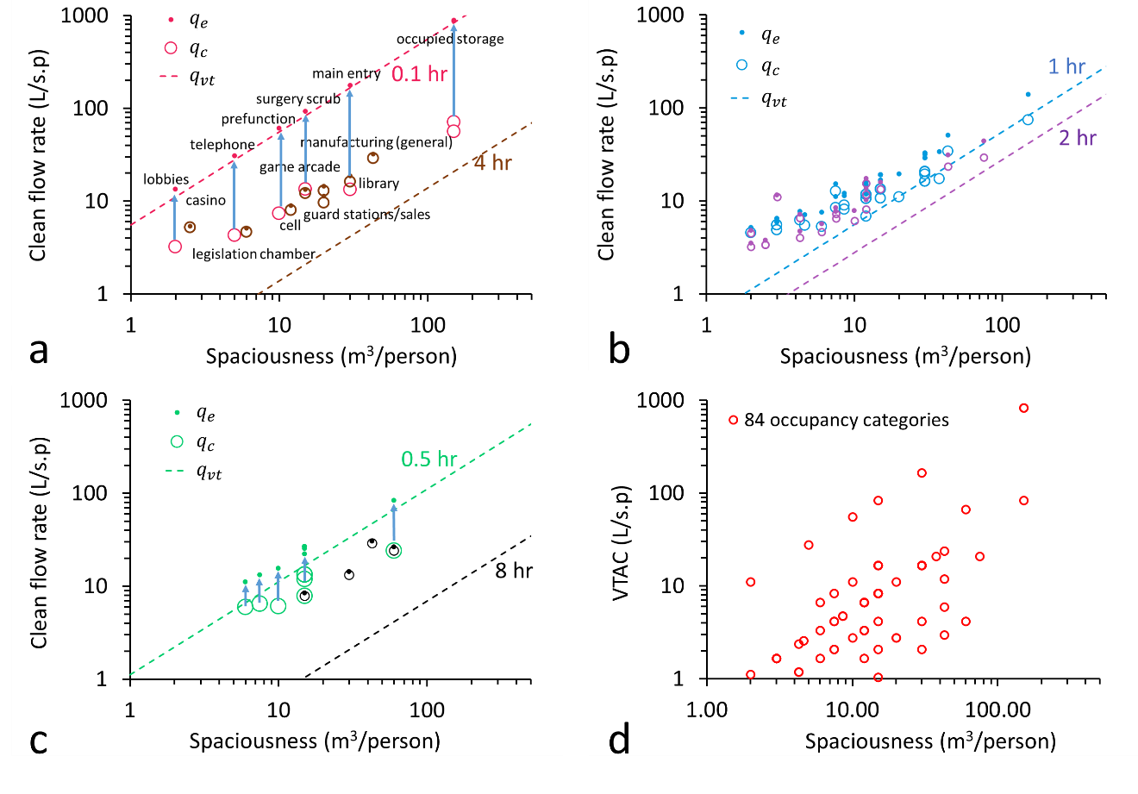
Figure S2. Effective clean flow rate, clean air equivalent, and VATC in realistic spaces from ASHRAE 62.1-2022. (a) Spaces with typical occupying period of 0.1 hr and 4 hr; (b) spaces with typical occupying period of 1 hr and 2 hr; (c) spaces with typical occupying period of 0.5 hr and 8 hr and (d) all spaces presented with their VTAC and spaciousness. Detailed data are shown in Table S2.

Similar data preparation was done for ASHRAE 241 (2023), i.e., specify metabolic rate, exposure times, equivalent clean airflow ($q_{ECAi}$), and occupant density to each space category, and then further obtain clean air equivalent $q_{c}=q_{ECAi}+q_{setting}+q_{deactivation}$. In Table S3, Figures S3 and S4, occupant density follows ASHRAE 62.1 (2022), a 3 m ceiling height is assumed, and offices, classrooms, and food and beverage facilities are further classified to yield 29 space categories. Conversely, Table S4 assigns 25 space categories using ASHRAE development team data (Benjamin et al., 2025) for occupant density and ceiling height.

For most of the 29 ASHRAE occupancy categories, the estimated effective clean flow rate is not a function of the spaciousness, but the air change rate does (Figure S3a and Figure 4d). This observation is in contrast from our main conclusion here that spaciousness and ventilation are coupled, particularly at low ventilation setting. A low spaciousness should be associated with a larger ventilation rate, following the very small size ventilation at low spaciousness (less than 15 m³/person), and the ASHRAE 241 does slightly better than 62.1. The four order of magnitude variation in ASHRAE 62.1 is reduced to a two-order range (0.003 to 0.1 hr) in ASHRAE 241 (Figure 4b). This is a significant improvement in consistency. However, a relatively large range of variation still exists. Assume that an intake fraction time of 0.02 hr is needed corresponding to an infectious quanta generation rate of 50 quanta/h, a too low value than 0.02 hr implies the waste of dilution, while a too high value than 0.02 hr signifies insufficiency.

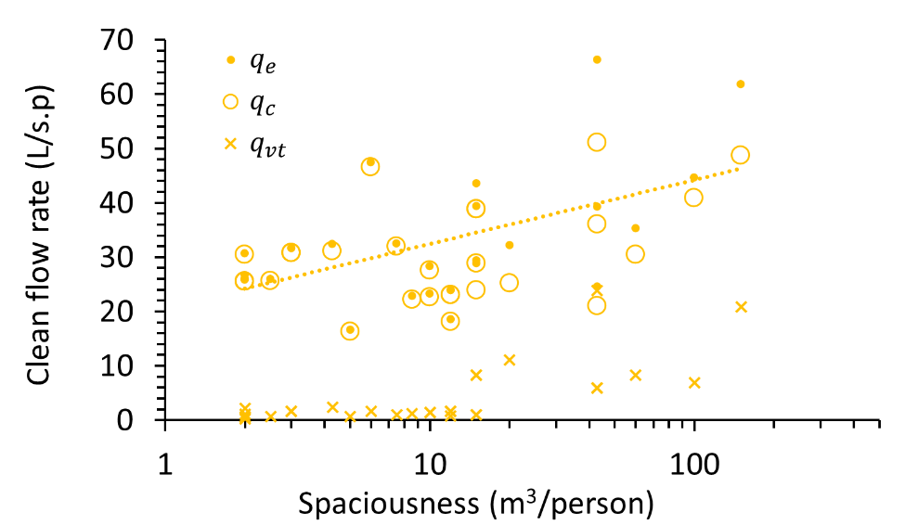
Figure S3. Effective clean flow rate, clean air equivalent and VTAC of 29 occupancy categories in ASHRAE 241 ventilation standard. Detailed data are shown in Table S3.

Supplementary Materials S5.
An example consistent standard of minimum clean airflow equivalent for ASHRAE 62.1 and 241 with a constant intake fraction

If a constant intake fraction time of 0.02 hr is specified, the resulted minimum threshold clean air equivalent rates with the identical spaciousness are shown in Table S2 for ASHRAE 62.1 and Table S3 for ASHRAE 241.

If the ${iF}_{t}$ threshold approach is adopted, the relationship between clean air equivalent and VTAC would follow an opposing trend (Figure S4b and S4d). However, the relationship between clean air equivalent and spaciousness does not show a completely opposing trend (Figure S4a and S4c), since VTAC is determined by both spaciousness and exposure time.

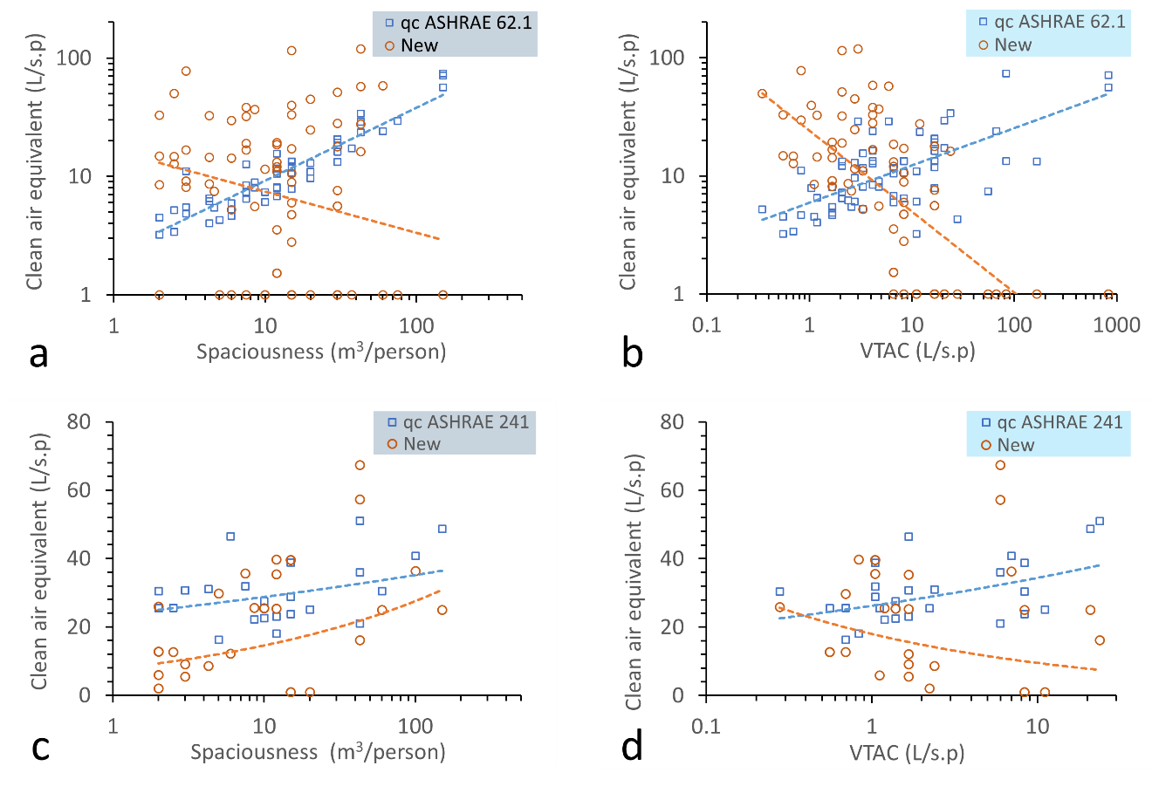
Figure S4. The minimum clean air equivalent for 84 space categories in ASHRAE 62.1 and 29 space categories in ASHEAE 241, and the corresponding new derived flow rates based on a threshold intake fraction time of 0.02 hr. Occupant density and exposure times remain unchanged.

Table S2. Ventilation and exposure parameters for 84 occupancy categories from ASHRAE 62.1-2022. Primary parameters are occupant density, assigned exposure times (0.1, 0.5, 1, 2, 4, 8 hours), physical activity levels, and metabolic rates (ASHRAE 62.1, 2022; Ainsworth et al., 2011). A standard ceiling height of 3 m is assumed. The clean air equivalent (q_{c}) incorporates outdoor air rate (q_{v}) and contributions from surface deposition (0.3 h⁻¹) and natural virus deactivation (0.63 h⁻¹). Note our defined clean air equivalent here $q_{c}=q_{v}+q_{setting}+q_{deactivation}$.
No | Occupancy category | Occupant density (#/100 m²) | Physical activity | Exposure time (h) | Met value | q_{v} (L/s.p) | Spaciousness V_{p} (m³/p) | q_{c} (L/s.p) | ACH (h⁻¹) | C_{T} | q_{e} accurate (L/s.p) | q_{a} = q_{e} -q_{c} (L/s.p) | q_{vt} (L/s.p) | q_{e} approx (L/s.p) | Diff in qe (%)* | q_{in} (L/s) | iF_{t} (h)* | New q_{c} (iFt=0.02 h)#
1 | Animal exam room | 20 | light/moderate | 0.5 | 2.8 | 8.0 | 15.0 | 11.9 | 2.85 | 0.53 | 25.4 | 13.6 | 16.7 | 24.9 | 1.94 | 0.298 | 0.005506 | 1.0
2 | Animal imaging (MRI/CT/PET) | 20 | light/moderate | 1 | 3 | 9.5 | 15.0 | 13.4 | 3.21 | 0.30 | 19.1 | 5.7 | 8.3 | 19.0 | 0.27 | 0.319 | 0.015724 | 8.9
3 | Animal necropsy | 20 | moderate/heavy | 1 | 4.5 | 9.5 | 15.0 | 13.4 | 3.21 | 0.30 | 19.1 | 5.7 | 8.3 | 19.0 | 0.27 | 0.479 | 0.023587 | 17.1
4 | Animal operating rooms | 20 | moderate exercise | 2 | 3.5 | 9.5 | 15.0 | 13.4 | 3.21 | 0.16 | 15.8 | 2.5 | 4.2 | 15.8 | 0.16 | 0.373 | 0.044198 | 33.0
5 | Animal postoperative recovery room | 20 | light exercise | 1 | 2.5 | 9.5 | 15.0 | 13.4 | 3.21 | 0.30 | 19.1 | 5.7 | 8.3 | 19.0 | 0.27 | 0.266 | 0.013104 | 6.0
6 | Animal preparation rooms | 20 | moderate exercise | 0.5 | 3.5 | 9.5 | 15.0 | 13.4 | 3.21 | 0.50 | 26.6 | 13.3 | 16.7 | 26.2 | 1.67 | 0.373 | 0.006570 | 1.0
7 | Animal procedure room | 20 | light/moderate | 0.5 | 3 | 9.5 | 15.0 | 13.4 | 3.21 | 0.50 | 26.6 | 13.3 | 16.7 | 26.2 | 1.67 | 0.319 | 0.005631 | 1.0
8 | Animal surgery scrub | 20 | light exercise | 0.1 | 2.3 | 9.5 | 15.0 | 13.4 | 3.21 | 0.86 | 92.5 | 79.1 | 83.3 | 90.0 | 2.64 | 0.208 | 0.000249 | 1.0
9 | Art classroom | 20 | moderate exercise | 1 | 3.3 | 9.5 | 15.0 | 13.4 | 3.21 | 0.30 | 19.1 | 5.7 | 8.3 | 19.0 | 0.27 | 0.364 | 0.017297 | 10.6
10 | Auditorium seating area | 150 | Sedentary/Passive | 2 | 1.5 | 2.7 | 2.0 | 3.2 | 5.79 | 0.09 | 3.5 | 0.3 | 0.6 | 3.5 | 0.58 | 0.076 | 0.085210 | 14.8
11 | Bank vaults or safe deposit | 5 | light exercise | 0.5 | 2.3 | 8.5 | 60.0 | 24.0 | 1.44 | 0.71 | 83.6 | 59.6 | 66.7 | 81.2 | 2.89 | 0.208 | 0.001376 | 1.0
12 | Banks or bank lobbies | 15 | light exercise | 1 | 2 | 5.8 | 20.0 | 11.0 | 1.97 | 0.44 | 19.5 | 8.5 | 11.1 | 19.2 | 1.19 | 0.208 | 0.010282 | 1.0
13 | Barbershop | 25 | Sedentary/Passive | 2 | 1.3 | 5.0 | 12.0 | 8.1 | 2.43 | 0.20 | 10.2 | 2.1 | 3.3 | 10.2 | 0.05 | 0.076 | 0.025545 | 11.1
14 | Barracks, sleeping areas | 20 | Sleep or Nap | 8 | 1 | 4.0 | 15.0 | 7.9 | 1.89 | 0.07 | 8.4 | 0.6 | 1.0 | 8.4 | 0.70 | 0.079 | 0.094869 | 39.7
15 | Bars, cocktail lounges | 100 | moderate exercise | 1 | 2 | 4.7 | 3.0 | 5.5 | 6.57 | 0.15 | 6.5 | 1.0 | 1.7 | 6.4 | 0.18 | 0.458 | 0.030977 | 9.1
16 | Beauty and nail salons | 25 | Sedentary/Passive | 2 | 1.3 | 12.4 | 12.0 | 15.5 | 4.65 | 0.11 | 17.4 | 1.9 | 3.3 | 17.3 | 0.44 | 0.076 | 0.014971 | 11.1
17 | Bedroom/living room | 10 | Sedentary/Passive | 8 | 1.3 | 5.5 | 30.0 | 13.3 | 1.59 | 0.08 | 14.4 | 1.1 | 2.1 | 14.3 | 0.63 | 0.076 | 0.072320 | 51.3
18 | Booking/waiting | 50 | Sedentary/Passive | 0.5 | 1.5 | 4.4 | 6.0 | 6.0 | 3.57 | 0.47 | 11.1 | 5.2 | 6.7 | 11.0 | 1.43 | 0.076 | 0.006728 | 1.0
19 | Bowling Alley | 40 | moderate exercise | 1 | 3.8 | 6.5 | 7.5 | 8.4 | 4.05 | 0.24 | 11.1 | 2.7 | 4.2 | 11.1 | 0.08 | 0.458 | 0.034111 | 16.7
20 | Break rooms (crowded) | 50 | Sedentary/Passive | 1 | 1.5 | 3.7 | 6.0 | 5.3 | 3.15 | 0.30 | 7.5 | 2.3 | 3.3 | 7.5 | 0.30 | 0.076 | 0.019890 | 5.2
21 | Break rooms (spatious) | 25 | Sedentary/Passive | 1 | 1.5 | 3.7 | 12.0 | 6.8 | 2.04 | 0.43 | 11.9 | 5.1 | 6.7 | 11.7 | 1.12 | 0.076 | 0.012652 | 1.5
22 | Cafeteria/fast-food dining | 100 | moderate exercise | 1 | 2 | 4.7 | 3.0 | 5.5 | 6.57 | 0.15 | 6.5 | 1.0 | 1.7 | 6.4 | 0.18 | 0.458 | 0.030977 | 9.1
23 | Cell | 25 | Sleep or Nap | 4 | 1 | 4.9 | 12.0 | 8.0 | 2.40 | 0.10 | 8.9 | 0.9 | 1.7 | 8.9 | 0.46 | 0.079 | 0.044792 | 19.3
24 | Classroom (age 9 plus) | 35 | Sedentary/Passive | 1 | 1.8 | 6.7 | 8.6 | 8.9 | 3.75 | 0.26 | 12.1 | 3.1 | 4.8 | 12.1 | 0.12 | 0.080 | 0.014910 | 5.6
25 | Classroom (ages 5-8) | 25 | Sedentary/Passive | 1 | 1.8 | 7.4 | 12.0 | 10.5 | 3.15 | 0.30 | 15.1 | 4.6 | 6.7 | 15.0 | 0.30 | 0.078 | 0.011934 | 3.6
26 | Coffee stations | 20 | Sedentary/Passive | 0.5 | 1.5 | 4.0 | 15.0 | 7.9 | 1.89 | 0.65 | 22.3 | 14.4 | 16.7 | 21.7 | 2.65 | 0.076 | 0.003363 | 1.0
27 | Coin-operated laundries | 20 | light exercise | 1 | 2 | 6.8 | 15.0 | 10.7 | 2.56 | 0.36 | 16.7 | 6.0 | 8.3 | 16.6 | 0.63 | 0.208 | 0.011987 | 2.8
28 | Computer (not printing) | 4 | Sedentary/Passive | 2 | 1.5 | 10.0 | 75.0 | 29.4 | 1.41 | 0.33 | 44.1 | 14.7 | 20.8 | 43.9 | 0.46 | 0.076 | 0.006807 | 1.0
29 | Computer lab | 25 | Sedentary/Passive | 1 | 1.5 | 7.4 | 12.0 | 10.5 | 3.15 | 0.30 | 15.1 | 4.6 | 6.7 | 15.0 | 0.30 | 0.071 | 0.009945 | 1.5
30 | Conference/meeting | 50 | Sedentary/Passive | 2 | 1.5 | 3.1 | 6.0 | 4.7 | 2.79 | 0.18 | 5.7 | 1.0 | 1.7 | 5.7 | 0.08 | 0.076 | 0.052998 | 14.2
31 | Courtrooms | 70 | Sedentary/Passive | 2 | 1.5 | 2.9 | 4.3 | 4.0 | 3.39 | 0.15 | 4.7 | 0.7 | 1.2 | 4.7 | 0.20 | 0.076 | 0.063385 | 14.5
32 | Daycare (through age 4) | 25 | moderate exercise | 1 | 3.3 | 8.6 | 12.0 | 11.7 | 3.51 | 0.28 | 16.2 | 4.5 | 6.7 | 16.1 | 0.18 | 0.321 | 0.020410 | 12.1
33 | Daycare sickroom | 25 | Sedentary/Passive | 2 | 1.3 | 8.6 | 12.0 | 11.7 | 3.51 | 0.14 | 13.6 | 1.9 | 3.3 | 13.6 | 0.23 | 0.076 | 0.019059 | 11.1
34 | Dayroom | 30 | Sedentary/Passive | 2 | 1.3 | 3.5 | 10.0 | 6.1 | 2.19 | 0.23 | 7.9 | 1.8 | 2.8 | 7.9 | 0.05 | 0.076 | 0.033104 | 11.5
35 | Disco/Dance floors | 100 | heavy exercise | 2 | 7.8 | 10.3 | 3.0 | 11.1 | 13.29 | 0.04 | 11.5 | 0.4 | 0.8 | 11.4 | 0.74 | 0.849 | 0.135558 | 77.8
36 | Gambling Casinos | 120 | moderate exercise | 4 | 2.5 | 4.6 | 2.5 | 5.2 | 7.48 | 0.03 | 5.4 | 0.2 | 0.3 | 5.3 | 0.72 | 0.458 | 0.186031 | 49.9
37 | Game arcades | 20 | moderate exercise | 4 | 5.8 | 8.3 | 15.0 | 12.2 | 2.92 | 0.09 | 13.3 | 1.1 | 2.1 | 13.2 | 0.59 | 0.458 | 0.174251 | 115.4
38 | Guard stations | 15 | Sedentary/Passive | 4 | 1.3 | 4.5 | 20.0 | 9.7 | 1.74 | 0.14 | 11.3 | 1.6 | 2.8 | 11.3 | 0.22 | 0.076 | 0.046072 | 24.7
39 | Gym, sports arena (play area) | 7 | heavy exercise | 1 | 7 | 22.9 | 42.9 | 33.9 | 2.85 | 0.33 | 50.7 | 16.8 | 23.8 | 50.5 | 0.45 | 0.849 | 0.013811 | 16.2
40 | Health club (aerobic rooms) | 40 | heavy exercise | 1 | 8 | 10.8 | 7.5 | 12.7 | 6.09 | 0.16 | 15.2 | 2.5 | 4.2 | 15.2 | 0.13 | 0.849 | 0.052724 | 38.1
41 | Health club (weight rooms) | 10 | heavy exercise | 1 | 6 | 13.0 | 30.0 | 20.8 | 2.49 | 0.37 | 32.8 | 12.1 | 16.7 | 32.6 | 0.69 | 0.849 | 0.018266 | 17.8
42 | Kitchen (cooking) | 20 | moderate exercise | 1 | 3.3 | 6.8 | 15.0 | 10.7 | 2.56 | 0.36 | 16.7 | 6.0 | 8.3 | 16.6 | 0.63 | 0.458 | 0.019778 | 10.6
43 | Large-animal holding room | 20 | moderate exercise | 0.5 | 3.5 | 9.5 | 15.0 | 13.4 | 3.21 | 0.50 | 26.6 | 13.3 | 16.7 | 26.2 | 1.67 | 0.373 | 0.006570 | 1.0
44 | Laundry rooms within dwelling units | 10 | moderate exercise | 1 | 4 | 8.5 | 30.0 | 16.3 | 1.95 | 0.44 | 29.0 | 12.8 | 16.7 | 28.7 | 1.22 | 0.458 | 0.013788 | 5.6
45 | Laundry rooms, central | 10 | moderate exercise | 1 | 4 | 8.5 | 30.0 | 16.3 | 1.95 | 0.44 | 29.0 | 12.8 | 16.7 | 28.7 | 1.22 | 0.458 | 0.013788 | 5.6
46 | Lecture classroom | 65 | Sedentary/Passive | 1 | 1.8 | 4.3 | 4.6 | 5.5 | 4.25 | 0.23 | 7.1 | 1.6 | 2.6 | 7.1 | 0.06 | 0.088 | 0.025356 | 7.5
47 | Lecture hall (fixed seats) | 150 | Sedentary/Passive | 1 | 1.8 | 4.0 | 2.0 | 4.5 | 8.13 | 0.12 | 5.1 | 0.6 | 1.1 | 5.1 | 0.34 | 0.088 | 0.034952 | 8.5
48 | Legislative chambers | 50 | Sedentary/Passive | 4 | 1.5 | 3.1 | 6.0 | 4.7 | 2.79 | 0.09 | 5.1 | 0.5 | 0.8 | 5.1 | 0.56 | 0.076 | 0.117470 | 29.7
49 | Libraries (educational facilities) | 10 | Sedentary/Passive | 4 | 1.5 | 8.5 | 30.0 | 16.3 | 1.95 | 0.13 | 18.6 | 2.4 | 4.2 | 18.6 | 0.31 | 0.088 | 0.032191 | 27.9
50 | Libraries (public assembly spaces) | 10 | Sedentary/Passive | 1 | 1.5 | 8.5 | 30.0 | 16.3 | 1.95 | 0.44 | 29.0 | 12.8 | 16.7 | 28.7 | 1.22 | 0.088 | 0.005171 | 1.0
51 | Lobbies (public assembly spaces) | 150 | Sedentary/Passive | 0.1 | 1.5 | 2.7 | 2.0 | 3.2 | 5.79 | 0.76 | 13.4 | 10.1 | 11.1 | 13.0 | 2.94 | 0.076 | 0.001123 | 1.0
52 | Lobbies/prefunction | 30 | light exercise | 0.1 | 2 | 4.8 | 10.0 | 7.4 | 2.66 | 0.88 | 60.6 | 53.2 | 55.6 | 59.1 | 2.46 | 0.208 | 0.000330 | 1.0
53 | Main entry lobbies (office buildings) | 10 | light exercise | 0.1 | 2 | 5.5 | 30.0 | 13.3 | 1.59 | 0.92 | 175.6 | 162.4 | 166.7 | 172.3 | 1.90 | 0.208 | 0.000114 | 1.0
54 | Mall common areas | 40 | light exercise | 0.5 | 2.3 | 4.6 | 7.5 | 6.5 | 3.11 | 0.51 | 13.2 | 6.7 | 8.3 | 12.9 | 1.74 | 0.208 | 0.008741 | 1.0
55 | Manufacturing (excludes heavy industrial and process using chemicals ) | 7 | moderate exercise | 4 | 3 | 17.9 | 42.9 | 28.9 | 2.43 | 0.10 | 32.2 | 3.3 | 6.0 | 32.1 | 0.47 | 0.458 | 0.037214 | 57.3
56 | Manufacturing where hazardous materials are not used | 7 | moderate exercise | 8 | 3 | 17.9 | 42.9 | 28.9 | 2.43 | 0.05 | 30.5 | 1.6 | 3.0 | 30.3 | 0.75 | 0.458 | 0.078695 | 119.1
57 | Media center | 25 | Sedentary/Passive | 1 | 1.5 | 7.4 | 12.0 | 10.5 | 3.15 | 0.30 | 15.1 | 4.6 | 6.7 | 15.0 | 0.30 | 0.071 | 0.009945 | 1.5
58 | Multi-purpose assembly | 120 | Sedentary/Passive | 2 | 1.5 | 2.8 | 2.5 | 3.4 | 4.89 | 0.10 | 3.8 | 0.4 | 0.7 | 3.8 | 0.48 | 0.076 | 0.079311 | 14.7
59 | Multi-use assembly | 100 | Sedentary/Passive | 1 | 1.8 | 4.1 | 3.0 | 4.9 | 5.85 | 0.17 | 5.9 | 1.0 | 1.7 | 5.9 | 0.11 | 0.088 | 0.030630 | 8.1
60 | Museums (children's) | 40 | moderate exercise | 2 | 3.3 | 5.3 | 7.5 | 7.2 | 3.47 | 0.14 | 8.5 | 1.2 | 2.1 | 8.4 | 0.22 | 0.364 | 0.078079 | 32.2
61 | Museums (galleries) | 40 | light exercise | 2 | 2 | 4.6 | 7.5 | 6.5 | 3.11 | 0.16 | 7.7 | 1.2 | 2.1 | 7.7 | 0.14 | 0.208 | 0.051777 | 19.0
62 | Music/theater/dance | 35 | heavy exercise | 1 | 7.8 | 5.9 | 8.6 | 8.1 | 3.39 | 0.29 | 11.3 | 3.2 | 4.8 | 11.3 | 0.21 | 0.817 | 0.069092 | 36.7
63 | Occupiable storage rooms for dry materials | 2 | Sedentary/Passive | 0.1 | 1.5 | 17.5 | 150.0 | 56.3 | 1.35 | 0.94 | 871.3 | 815.0 | 833.3 | 856.2 | 1.73 | 0.076 | 0.0000172 | 1.0
64 | Occupiable storage rooms for liquids and gels | 2 | Sedentary/Passive | 0.1 | 1.5 | 32.5 | 150.0 | 71.3 | 1.71 | 0.92 | 881.5 | 810.3 | 833.3 | 864.0 | 1.98 | 0.076 | 0.0000170 | 1.0
65 | Office space | 5 | Sedentary/Passive | 8 | 1.5 | 8.5 | 60.0 | 24.0 | 1.44 | 0.09 | 26.3 | 2.3 | 4.2 | 26.1 | 0.58 | 0.076 | 0.045660 | 58.3
66 | Pet shops (animal areas) | 10 | moderate exercise | 1 | 4.3 | 12.8 | 30.0 | 20.6 | 2.47 | 0.37 | 32.7 | 12.1 | 16.7 | 32.4 | 0.71 | 0.458 | 0.013160 | 7.6
67 | Pharmacy (prep. area) | 10 | light exercise | 1 | 1.8 | 11.5 | 30.0 | 19.3 | 2.31 | 0.39 | 31.6 | 12.3 | 16.7 | 31.3 | 0.84 | 0.208 | 0.005705 | 1.0
68 | Photo studios | 10 | light exercise | 1 | 1.8 | 8.5 | 30.0 | 16.3 | 1.95 | 0.44 | 29.0 | 12.8 | 16.7 | 28.7 | 1.22 | 0.208 | 0.006205 | 1.0
69 | Places of religious worship | 120 | Sedentary/Passive | 2 | 1.3 | 2.8 | 2.5 | 3.4 | 4.89 | 0.10 | 3.8 | 0.4 | 0.7 | 3.8 | 0.48 | 0.076 | 0.068736 | 12.7
70 | Reception areas | 30 | Sedentary/Passive | 0.5 | 1.5 | 3.5 | 10.0 | 6.1 | 2.19 | 0.61 | 15.5 | 9.4 | 11.1 | 15.1 | 2.44 | 0.076 | 0.004836 | 1.0
71 | Restaurant dining rooms | 70 | moderate exercise | 1 | 2 | 5.1 | 4.3 | 6.2 | 5.20 | 0.19 | 7.7 | 1.5 | 2.4 | 7.7 | 0.06 | 0.458 | 0.026121 | 8.6
72 | Sales (except as below) | 15 | moderate exercise | 4 | 2.3 | 7.8 | 20.0 | 13.0 | 2.33 | 0.11 | 14.5 | 1.6 | 2.8 | 14.5 | 0.44 | 0.458 | 0.063352 | 44.9
73 | Science laboratories | 25 | moderate exercise | 1 | 4.5 | 8.6 | 12.0 | 11.7 | 3.51 | 0.28 | 16.2 | 4.5 | 6.7 | 16.1 | 0.18 | 0.364 | 0.027831 | 18.5
74 | Shipping/receiving | 2 | heavy exercise | 1 | 8 | 35.0 | 150.0 | 73.8 | 1.77 | 0.47 | 138.8 | 65.1 | 83.3 | 136.8 | 1.45 | 0.849 | 0.005763 | 1.0
75 | Small-animal-cage room (static cages) | 20 | light exercise | 1 | 2.3 | 9.5 | 15.0 | 13.4 | 3.21 | 0.30 | 19.1 | 5.7 | 8.3 | 19.0 | 0.27 | 0.208 | 0.012055 | 4.8
76 | Small-animal-cage room (ventilated cages) | 20 | light exercise | 1 | 2.3 | 9.5 | 15.0 | 13.4 | 3.21 | 0.30 | 19.1 | 5.7 | 8.3 | 19.0 | 0.27 | 0.208 | 0.012055 | 4.8
77 | Sorting, packing, light assembly | 7 | moderate exercise | 2 | 3.5 | 12.4 | 42.9 | 23.4 | 1.97 | 0.25 | 31.2 | 7.8 | 11.9 | 31.2 | 0.09 | 0.458 | 0.022426 | 27.5
78 | Spectator areas | 150 | moderate exercise | 2 | 3.3 | 4.0 | 2.0 | 4.5 | 8.13 | 0.06 | 4.8 | 0.3 | 0.6 | 4.8 | 0.72 | 0.458 | 0.137139 | 32.8
79 | Stages, studios | 70 | moderate exercise | 2 | 3.3 | 5.4 | 4.3 | 6.5 | 5.49 | 0.09 | 7.2 | 0.7 | 1.2 | 7.2 | 0.55 | 0.458 | 0.091787 | 32.6
80 | Supermarket | 8 | light exercise | 1 | 2.3 | 7.6 | 37.5 | 17.2 | 1.65 | 0.49 | 33.7 | 16.5 | 20.8 | 33.2 | 1.60 | 0.208 | 0.006821 | 1.0
81 | Telephone/data entry | 60 | Sedentary/Passive | 0.1 | 1.5 | 3.0 | 5.0 | 4.3 | 3.09 | 0.86 | 30.7 | 26.4 | 27.8 | 29.9 | 2.61 | 0.076 | 0.000488 | 1.0
82 | Transportation waiting | 100 | light exercise | 1 | 3.5 | 4.1 | 3.0 | 4.9 | 5.85 | 0.17 | 5.9 | 1.0 | 1.7 | 5.9 | 0.11 | 0.208 | 0.059558 | 16.8
83 | University/college laboratories | 25 | moderate exercise | 1 | 3.5 | 8.6 | 12.0 | 11.7 | 3.51 | 0.28 | 16.2 | 4.5 | 6.7 | 16.1 | 0.18 | 0.433 | 0.021647 | 13.2
84 | Wood/metal shop | 20 | moderate exercise | 1 | 3.3 | 9.5 | 15.0 | 13.4 | 3.21 | 0.30 | 19.1 | 5.7 | 8.3 | 19.0 | 0.27 | 0.441 | 0.017297 | 10.6
# These red 1.0 values represent that the VTAC exceeds the required effective clean flow rate.
* The numbers highlighted by yellow are the maximum or minimum values.

Table S3. Ventilation and exposure parameters for 29 occupancy categories from ASHRAE 241-2023. This table details occupancy density (ASHRAE 62.1, 2022), exposure times (0.1, 0.5, 1, 2, 4, 8 hours), physical activity levels, and metabolic rates (Ainsworth et al., 2011) for 29 categories, with refined classifications for offices, classrooms, and food and beverage facilities. A standard ceiling height of 3 m is assumed. The clean air equivalent (q_{c}) incorporates equivalent clean airflow (q_{ECAi}) and contributions from surface deposition (0.3 h⁻¹) and natural virus deactivation (0.63 h⁻¹). Note our defined clean air equivalent here $q_{c}=q_{ECAi}+q_{setting}+q_{deactivation}$.
no | Occupancy category | Occupant density (#/100 m²) | Physical activity | Exposure time (h) | Met value | q_{ECAi} (L/s.p) | Spaciousness V_{p} (m³/p) | q_{c} (L/s.p) | ACH (h⁻¹) | C_{T} | q_{e} accurate (L/s.p) | q_{a} = q_{e} -q_{c} (L/s.p) | q_{vt} (L/s.p) | q_{e} approx (L/s.p) | Diff in q_{e} (%) | q_{in} (L/s)* | iF_{t} (h)* | New q_{c} (iFt=0.02 h)#
1 | Audotorium | 150 | Sedentary/Passive | 2 | 1.3 | 25 | 2.0 | 25.5 | 45.9 | 0.011 | 25.8 | 0.3 | 0.6 | 25.7 | 0.43 | 0.076 | 0.0101 | 12.8
2 | Classroom: daycare | 25 | Light/Moderate | 4 | 1.8 | 20 | 12.0 | 23.1 | 6.9 | 0.036 | 24.0 | 0.9 | 1.7 | 23.8 | 0.73 | 0.076 | 0.0300 | 35.4
3 | Classroom: elementary school | 25 | Sedentary/Passive | 4 | 1.3 | 20 | 12.0 | 23.1 | 6.9 | 0.036 | 24.0 | 0.9 | 1.7 | 23.8 | 0.73 | 0.458 | 0.0217 | 25.3
4 | Classroom: high school | 35 | Sedentary/Passive | 4 | 1.3 | 20 | 8.6 | 22.2 | 9.3 | 0.027 | 22.8 | 0.6 | 1.2 | 22.7 | 0.68 | 0.1 | 0.0228 | 25.6
5 | Convention | 150 | Sedentary/Passive | 4 | 1.3 | 30 | 2.0 | 30.5 | 54.9 | 0.005 | 30.7 | 0.1 | 0.3 | 30.6 | 0.23 | 0.076 | 0.0170 | 25.9
6 | Corectional cell | 25 | Sleep or Nap | 8 | 1 | 15 | 12.0 | 18.1 | 5.4 | 0.023 | 18.5 | 0.4 | 0.8 | 18.4 | 0.64 | 0.078 | 0.0432 | 39.7
7 | Correctional dayroom | 30 | Sedentary/Passive | 4 | 1.3 | 20 | 10.0 | 22.6 | 8.1 | 0.031 | 23.3 | 0.7 | 1.4 | 23.1 | 0.71 | 0.076 | 0.0223 | 25.5
8 | Food & beverage facilities: cafeteria | 100 | Moderate exercise | 1 | 2 | 30 | 3.0 | 30.8 | 36.9 | 0.027 | 31.6 | 0.9 | 1.7 | 31.4 | 0.68 | 0.071 | 0.0063 | 9.1
9 | Food & beverage facilities: restaurant | 70 | Moderate exercise | 1 | 2 | 30 | 4.3 | 31.1 | 26.1 | 0.038 | 32.3 | 1.2 | 2.4 | 32.1 | 0.74 | 0.208 | 0.0062 | 8.6
10 | Gym | 7 | Heavy exercise | 1 | 7 | 40 | 42.9 | 51.1 | 4.3 | 0.230 | 66.3 | 15.2 | 23.8 | 66.3 | 0.06 | 0.849 | 0.0106 | 16.2
11 | Health care exam room | 20 | Sedentary/Passive | 1 | 1.3 | 20 | 15.0 | 23.9 | 5.7 | 0.174 | 28.9 | 5.0 | 8.3 | 28.9 | 0.10 | 0.1 | 0.0045 | 1.0
12 | Health care group treament area | 20 | Sedentary/Passive | 1 | 1.3 | 35 | 15.0 | 38.9 | 9.3 | 0.107 | 43.5 | 4.7 | 8.3 | 43.3 | 0.44 | 0.1 | 0.0030 | 1.0
13 | Health care patient room | 20 | Sleep or Nap | 8 | 1 | 35 | 15.0 | 38.9 | 9.3 | 0.013 | 39.4 | 0.5 | 1.0 | 39.2 | 0.49 | 0.076 | 0.0203 | 39.7
14 | Health care resident room | 20 | Sleep or Nap | 8 | 1 | 25 | 15.0 | 28.9 | 6.9 | 0.018 | 29.4 | 0.5 | 1.0 | 29.2 | 0.57 | 0.076 | 0.0272 | 39.7
15 | Health care waiting room | 50 | Sedentary/Passive | 2 | 1.3 | 45 | 6.0 | 46.6 | 27.9 | 0.018 | 47.4 | 0.8 | 1.7 | 47.1 | 0.57 | 0.1 | 0.0055 | 12.2
16 | Lecture hall | 150 | Sedentary/Passive | 1 | 1.3 | 25 | 2.0 | 25.5 | 45.9 | 0.022 | 26.1 | 0.6 | 1.1 | 25.9 | 0.62 | 0.088 | 0.0050 | 5.9
17 | Lobbies | 150 | Sedentary/Passive | 0.5 | 1.5 | 25 | 2.0 | 25.5 | 45.9 | 0.044 | 26.7 | 1.2 | 2.2 | 26.5 | 0.75 | 0.076 | 0.0028 | 2.1
18 | Manufacturing | 7 | Moderate exercise | 4 | 3 | 25 | 42.9 | 36.1 | 3.0 | 0.083 | 39.3 | 3.2 | 6.0 | 39.1 | 0.61 | 0.441 | 0.0305 | 57.3
19 | Museum | 40 | Light exercise | 4 | 1.8 | 30 | 7.5 | 31.9 | 15.3 | 0.016 | 32.5 | 0.5 | 1.0 | 32.3 | 0.54 | 0.208 | 0.0222 | 35.7
20 | Office: call center | 60 | Sedentary/Passive | 4 | 1.5 | 15 | 5.0 | 16.3 | 11.7 | 0.021 | 16.6 | 0.4 | 0.7 | 16.5 | 0.62 | 0.1 | 0.0360 | 29.8
21 | Office: general | 5 | Sedentary/Passive | 4 | 1.5 | 15 | 60.0 | 30.5 | 1.8 | 0.137 | 35.3 | 4.8 | 8.3 | 35.2 | 0.26 | 0.458 | 0.0170 | 25.1
22 | Place of religious workship | 120 | Sedentary/Passive | 2 | 1.3 | 25 | 2.5 | 25.6 | 36.9 | 0.014 | 26.0 | 0.4 | 0.7 | 25.9 | 0.49 | 0.076 | 0.0100 | 12.7
23 | Residential common space | 30 | Sedentary/Passive | 4 | 1.3 | 25 | 10.0 | 27.6 | 9.9 | 0.025 | 28.3 | 0.7 | 1.4 | 28.1 | 0.66 | 0.076 | 0.0184 | 25.5
24 | Residential dwelling unit | 3 | Sleep or Nap | 8 | 1 | 15 | 100.0 | 40.8 | 1.5 | 0.085 | 44.6 | 3.8 | 6.9 | 44.4 | 0.59 | 0.076 | 0.0179 | 36.4
25 | Retail | 15 | Light exercise | 1 | 1.8 | 20 | 20.0 | 25.2 | 4.5 | 0.218 | 32.2 | 7.0 | 11.1 | 32.2 | 0.05 | 0.458 | 0.0056 | 1.0
26 | Sorting, packagin, light assembly | 7 | Moderate exercise | 4 | 3.5 | 10 | 42.9 | 21.1 | 1.8 | 0.141 | 24.5 | 3.5 | 6.0 | 24.5 | 0.23 | 0.458 | 0.0571 | 67.4
27 | Spectator area | 150 | Sedentary/Passive | 2 | 1.3 | 25 | 2.0 | 25.5 | 45.9 | 0.011 | 25.8 | 0.3 | 0.6 | 25.7 | 0.43 | 0.458 | 0.0101 | 12.8
28 | Transportation waiting | 100 | Sedentary/Passive | 1 | 1.3 | 30 | 3.0 | 30.8 | 36.9 | 0.027 | 31.6 | 0.9 | 1.7 | 31.4 | 0.68 | 0.1 | 0.0041 | 5.5
29 | Warehouse | 2 | Moderate exercise | 4 | 2 | 10 | 150.0 | 48.8 | 1.2 | 0.212 | 61.8 | 13.1 | 20.8 | 61.8 | 0.04 | 0.458 | 0.0129 | 25.1
# These red 1.0 values represent that the VTAC exceeds the required effective clean flow rate.
* The numbers highlighted by yellow are the maximum or minimum values.

Table S4. Ventilation and exposure parameters for 25 occupancy categories from ASHRAE 241-2023. In this table, exposure time, physical activity levels and metabolic rates were same as Table S2, occupant density and ceiling height were adopted from the values of ASHRAE 241 development team (Benjamin et al., 2025). The clean air equivalent (q_{c}) incorporates equivalent clean airflow (q_{ECAi}) and contributions from surface deposition (0.3 h⁻¹) and natural virus deactivation (0.63 h⁻¹). Note our defined clean air equivalent here $q_{c}=q_{ECAi}+q_{setting}+q_{deactivation}$.
no | Occupancy category | Occupant density (#/100 m²) | Ceiling height (m) | Physical activity | Exposure time (h) | Met value | q_{ECAi} (L/s.p) | Spaciousness V_{p} (m³/p) | q_{c} (L/s.p) | ACH (h⁻¹) | C_{T} | q_{e} accurate (L/s.p) | q_{a} = q_{e} -q_{c} (L/s.p) | q_{vt} (L/s.p) | q_{e} approx (L/s.p) | Diff in qe (%)* | q_{in} (L/s) | iF_{t} (h)* | New q_{c} (iFt=0.02 h)#
1 | Audotorium | 30 | 9.2 | Sedentary/Passive | 2 | 1.3 | 25 | 30.7 | 32.9 | 3.9 | 0.129 | 37.8 | 4.9 | 8.5 | 37.7 | 0.30 | 0.076 | 0.00688 | 6.4
2 | Classroom | 25 | 2.7 | Sedentary/Passive | 4 | 1.3 | 20 | 10.8 | 22.8 | 7.6 | 0.033 | 23.6 | 0.8 | 1.5 | 23.4 | 0.72 | 0.1 | 0.02207 | 25.4
3 | Convention | 40 | 10 | Sedentary/Passive | 4 | 1.3 | 30 | 25.0 | 36.5 | 5.3 | 0.048 | 38.3 | 1.8 | 3.5 | 38.0 | 0.75 | 0.076 | 0.01358 | 24.3
4 | Corectional cell | 25 | 2.7 | Sleep or Nap | 8 | 1 | 15 | 10.8 | 17.8 | 5.9 | 0.021 | 18.2 | 0.4 | 0.8 | 18.1 | 0.61 | 0.078 | 0.04402 | 39.8
5 | Correctional dayroom | 30 | 6 | Sedentary/Passive | 4 | 1.3 | 20 | 20.0 | 25.2 | 4.5 | 0.055 | 26.6 | 1.5 | 2.8 | 26.4 | 0.74 | 0.076 | 0.01952 | 24.7
6 | Food & beverage facilities | 50 | 3.6 | Moderate exercise | 1 | 2 | 30 | 7.2 | 31.9 | 15.9 | 0.063 | 34.0 | 2.1 | 4.0 | 33.8 | 0.71 | 0.071 | 0.00588 | 7.4
7 | Gym | 36 | 3.8 | Heavy exercise | 1 | 7 | 40 | 10.6 | 42.7 | 14.6 | 0.069 | 45.9 | 3.1 | 5.9 | 45.6 | 0.69 | 0.849 | 0.01526 | 32.0
8 | Health care exam room | 20 | 2.7 | Sedentary/Passive | 1 | 1.3 | 20 | 13.5 | 23.5 | 6.3 | 0.159 | 27.9 | 4.5 | 7.5 | 27.9 | 0.15 | 0.1 | 0.00465 | 1.0
9 | Health care group treament area | 20 | 2.7 | Sedentary/Passive | 1 | 1.3 | 35 | 13.5 | 38.5 | 10.3 | 0.097 | 42.6 | 4.2 | 7.5 | 42.4 | 0.51 | 0.1 | 0.00305 | 1.0
10 | Health care patient room | 10 | 2.7 | Sleep or Nap | 8 | 1 | 35 | 27.0 | 42.0 | 5.6 | 0.022 | 42.9 | 1.0 | 1.9 | 42.7 | 0.63 | 0.076 | 0.01863 | 39.3
11 | Health care resident room | 10 | 2.7 | Sleep or Nap | 8 | 1 | 25 | 27.0 | 32.0 | 4.3 | 0.029 | 32.9 | 1.0 | 1.9 | 32.7 | 0.70 | 0.076 | 0.02429 | 39.3
12 | Health care waiting room | 30 | 2.7 | Sedentary/Passive | 2 | 1.3 | 45 | 9.0 | 47.3 | 18.9 | 0.026 | 48.6 | 1.3 | 2.5 | 48.3 | 0.67 | 0.1 | 0.00535 | 11.7
13 | Lecture hall | 75 | 9 | Sedentary/Passive | 1 | 1.3 | 25 | 12.0 | 28.1 | 8.4 | 0.119 | 31.9 | 3.8 | 6.7 | 31.8 | 0.37 | 0.088 | 0.00408 | 1.0
14 | Lobbies | 30 | 9.2 | Sedentary/Passive | 0.5 | 1.5 | 25 | 30.7 | 32.9 | 3.9 | 0.443 | 59.1 | 26.1 | 34.1 | 58.3 | 1.24 | 0.076 | 0.00127 | 1.0
15 | Manufacturing | 7 | 12 | Moderate exercise | 4 | 3 | 25 | 171.4 | 69.3 | 1.5 | 0.171 | 83.6 | 14.3 | 23.8 | 83.5 | 0.11 | 0.441 | 0.01435 | 44.3
16 | Museum | 40 | 10 | Light exercise | 4 | 1.8 | 30 | 25.0 | 36.5 | 5.3 | 0.048 | 38.3 | 1.8 | 3.5 | 38.0 | 0.75 | 0.208 | 0.01881 | 34.4
17 | Office | 5 | 2.7 | Sedentary/Passive | 4 | 1.5 | 15 | 54.0 | 29.0 | 1.9 | 0.129 | 33.3 | 4.3 | 7.5 | 33.2 | 0.30 | 0.458 | 0.01804 | 25.7
18 | Place of religious workship | 90 | 12 | Sedentary/Passive | 2 | 1.3 | 25 | 13.3 | 28.4 | 7.7 | 0.065 | 30.4 | 2.0 | 3.7 | 30.2 | 0.70 | 0.076 | 0.00855 | 10.8
19 | Residential common space | 30 | 9.2 | Sedentary/Passive | 4 | 1.3 | 25 | 30.7 | 32.9 | 3.9 | 0.065 | 35.2 | 2.3 | 4.3 | 35.0 | 0.71 | 0.076 | 0.01477 | 23.8
20 | Residential dwelling unit | 3 | 2.7 | Sleep or Nap | 8 | 1 | 15 | 90.0 | 38.3 | 1.5 | 0.082 | 41.7 | 3.4 | 6.3 | 41.4 | 0.61 | 0.076 | 0.01921 | 36.8
21 | Retail | 15 | 6 | Light exercise | 1 | 1.8 | 20 | 40.0 | 30.3 | 2.7 | 0.342 | 46.1 | 15.8 | 22.2 | 45.9 | 0.52 | 0.458 | 0.00390 | 1.0
22 | Sorting, packagin, light assembly | 5 | 12 | Moderate exercise | 4 | 3.5 | 10 | 240.0 | 72.0 | 1.1 | 0.228 | 93.3 | 21.3 | 33.3 | 93.3 | 0.05 | 0.458 | 0.01500 | 46.8
23 | Spectator area | 33 | 21 | Sedentary/Passive | 2 | 1.3 | 25 | 63.6 | 41.4 | 2.3 | 0.211 | 52.5 | 11.1 | 17.7 | 52.5 | 0.04 | 0.458 | 0.00495 | 1.0
24 | Transportation waiting | 10 | 10 | Sedentary/Passive | 1 | 1.3 | 30 | 100.0 | 55.8 | 2.0 | 0.431 | 98.1 | 42.3 | 55.6 | 97.0 | 1.15 | 0.1 | 0.00133 | 1.0
25 | Warehouse | 20 | 12 | Moderate exercise | 4 | 2 | 10 | 60.0 | 25.5 | 1.5 | 0.163 | 30.5 | 5.0 | 8.3 | 30.4 | 0.13 | 0.458 | 0.02626 | 35.4
# These red 1.0 values represent that the VTAC exceeds the required effective clean flow rate.
* The numbers highlighted by yellow are the maximum or minimum values.

Supplementary References
- Ainsworth, B.E., Haskell, W.L., Herrmann, S.D., Meckes, N., Bassett, D.R., Tudor-Locke, C., Greer, J.L., Vezina, J., Whitt-Glover, M.C. and Leon, A.S., 2011. 2011 Compendium of Physical Activities: a second update of codes and MET values. Medicine & Science in Sports & Exercise, 43(8), 1575–1581.
- ASHRAE 62.1, 2022. ANSI/ASHRAE Standard 62.1-2022, Ventilation for Acceptable Indoor Air Quality. Atlanta, GA: American Society of Heating, Refrigerating and Air-Conditioning Engineers, Inc.
- ASHRAE 241, 2023. ANSI/ASHRAE Standard 241, Control of Infectious Aerosols. Atlanta, GA: American Society of Heating, Refrigerating and Air-Conditioning Engineers, Inc.
- Jia, W., Cheng, P., Ma, L., Wang, S., Qian, H. and Li, Y., 2022. Individual heterogeneity and airborne infection: Effect of non-uniform air distribution. Building and Environment, 226, 109674.
- Jones, B., Iddon, C., Zaatari, M., Wargocki, P. and Bruns, R., 2025. Risk modeling for ASHRAE Standard 241-2023–Control of infectious aerosols. Building and Environment, 283, 113318.
- Kawano, T., Tsugawa, Y., Nishiyama, K., Morita, H., Yamamura, O. and Hasegawa, K., 2016. Shelter crowding and increased incidence of acute respiratory infection in evacuees following the Great Eastern Japan Earthquake and tsunami. Epidemiology & Infection, 144(4), 787–795.
- Li, Y., Qian, H., Hang, J., Chen, X., Cheng, P., Ling, H., Wang, S., Liang, P., Li, J., Xiao, S. and Wei, J., 2021. Probable airborne transmission of SARS-CoV-2 in a poorly ventilated restaurant. Building and Environment, 196, 107788.

