Supplementary Materials
Dual-Mode Photothermal and Colorimetric Immunosensor Based on Polydopamine@Prussian Blue Nanocomposite for Sensitive Detection of Benzocaine
Bao-Zhu Jiaª, Wen-Feng Zhang^{c}, Qin-Chun Yin^{d}, Xue-Ying Rui^{b}, Lin Luo^{b,} *, Zhen-Lin Xu^{b}
ª College of Biology and Food Engineering, Guangdong University of Education, Guangzhou 510303, China
^{b} Guangdong Provincial Key Laboratory of Food Quality and Safety, College of Food Science, South China Agricultural University, Guangzhou 510642, China
^{c} Guangdong Provincial Key Laboratory of Chemical Measurement and Emergency Test Technology, Guangdong Provincial Engineering Research Center of Rapid Testing Instrument for Food Nutrition and Safety, Institute of Analysis, Guangdong Academy of Sciences (China National Analytical Center, Guangzhou), Guangzhou 510070, China
^{d} Key Laboratory of Tropical Fruits and Vegetables Quality and Safety for State Market Regulation, Hainan Institute for Food Control, Haikou 570314, China

*Corresponding author. E-mail: lin.luo@scau.edu.cn (L. Luo)

Liquid chromatography-tandem mass spectrometry/mass spectrometry (LC-MS/MS) for BZC detection
The dual-mode immunosensor was validated by LC-MS/MS, as described in Industry Standards for Entry-Exit Inspection and Quarantine of the People's Republic of China for determination of BZC in aquatic products SN/T 5441-2022. Briefly, 2 μL portion of the prepared sample was injected into the QTRAP™ 4500 system equipped with an C18 chromatographic column (100 mm×2.1mm, 1.7 μm particle size, column temperature 30 °C) and separated at a flow rate of 300 μL min⁻¹ (mobile phase A, 0.2% formic acid; mobile phase B, acetonitrile). The MS parameters were as follows: desolation temperature at 550 °C; desolvation gas (N₂), flow rate at 10 L min⁻¹; ion spray voltage at 5500 V. The analytes were identified by parent/daughter ions as well as peak retention times in comparison to the standards. The [M + H]⁺ at m/z 166.1 was the parent ion of BZC. The daughter ion at m/z 138.1 was used for quantitation, and the daughter ion at m/z 94.0 was selected as a qualitative ion. Fig. S2 shows the calibration curve for BZC quantification by LC-MS/MS.

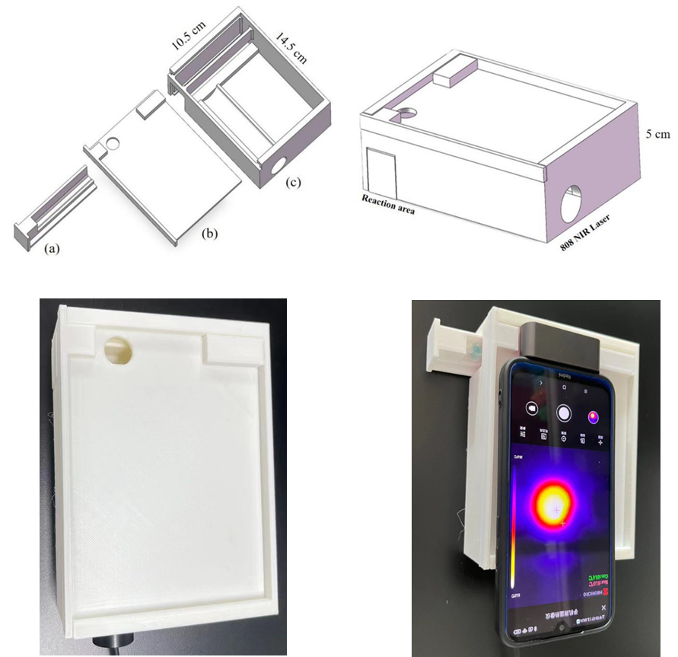
Fig. S1. 3D-printed portable readout device for photothermal analysis of the dual-mode immunosassay. The device includes a movable microplate holder (a), which allows secure fixation of microplates and flexible adjustment according to detection requirements. The top section (b) is designed to accommodate an infrared thermal imager and a smartphone, enabling convenient reading of photothermal signals. The main body (c) features a precisely designed slot for integrating an infrared laser module, ensuring accurate irradiation of the microplate reaction area and enhancing portability during detection.

Regression Equation: y = 1.93226e5 x + 3.33411e4 (r = 0.99929) (weighting: 1 / x)
Expected Concentration | Number of Values | Mean Calculated Concentration | % Accuracy | Std. Deviation | %CV
1.000 | 1 of 1 | 0.95 | 95.5 | N/A | N/A
2.000 | 1 of 1 | 1.82 | 90.8 | N/A | N/A
5.000 | 1 of 1 | 5.00 | 99.9 | N/A | N/A
10.000 | 1 of 1 | 10.58 | 105.8 | N/A | N/A
20.000 | 1 of 1 | 21.86 | 109.3 | N/A | N/A
50.000 | 1 of 1 | 50.99 | 102.0 | N/A | N/A
80.000 | 1 of 1 | 79.69 | 99.6 | N/A | N/A
100.000 | 1 of 1 | 97.10 | 97.1 | N/A | N/A

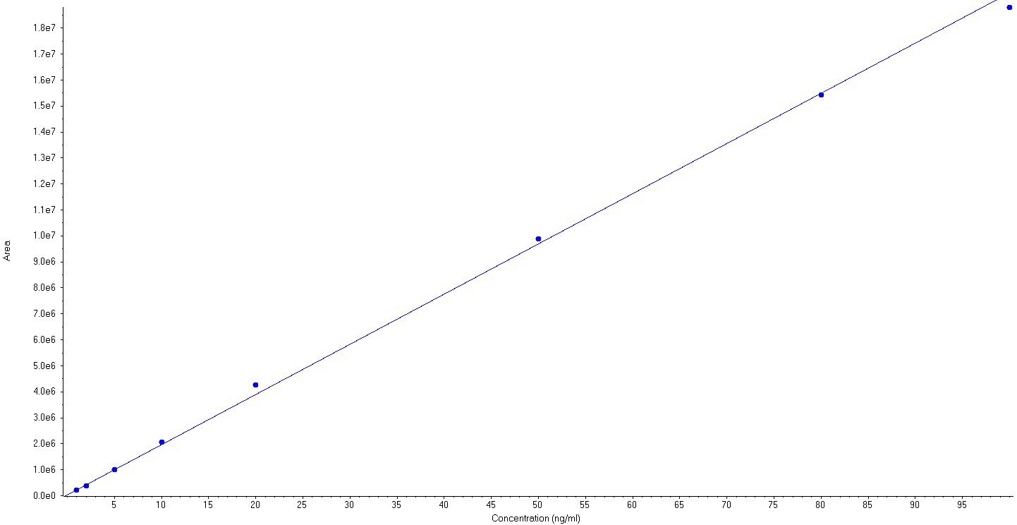

Fig. S2. Calibration curve for BZC detection by LC-MS/MS

Fig. S3. The TEM image of PDA-Fe NPs

Fig. S4. Optimization of synthesis conditions of PDA@PB NPs: (A, B) Optimization of potassium ferrocyanide concentration (C, D) Optimization of hydrochloric acid concentration.

Fig. S5. EDS spectrum of PDA@PB NP

Fig. S6. The relative peroxidase-mimicking activity of PDA@PB NPs under different pH

Table S1. Comparison of the Km and Vmax with different catalysts.
Catalysts | substrate | Km | Reference
HRP | TMB | 0.434 | [1]
HRP | H₂O₂ | 3.70 | [1]
Fe₃O₄ NPs | TMB | 0.098 | [1]
Fe₃O₄ NPs | H₂O₂ | 154 | [1]
Fe-N-C | TMB | 3.6 | [2]
Fe-N-C | H₂O₂ | 12.2 | [2]
Cu NCs | TMB | 0.648 | [3]
Cu NCs | H₂O₂ | 29.16 | [3]
Hemin-Au@MOF | TMB | 2.67 | [4]
Hemin-Au@MOF | H₂O₂ | 2.58 | [4]
Zn-N-C | TMB | 0.224 | [5]
Zn-N-C | H₂O₂ | 40.16 | [5]
FGN | TMB | 0.154 | [6]
FGN | H₂O₂ | 7.51 | [6]
BP/Au | TMB | 0.417 | [7]
BP/Au | H₂O₂ | 20.69 | [7]
PDA@PB NPs | TMB | 0.41 | This work
PDA@PB NPs | H₂O₂ | 2.29 | This work

Table S2. Recovery study of BZC in samples by the developed photothermal-colorimetric immunoassay and LC-MS/MS.

Samples |  | colorimetric mode |  |  | Photothermal mode |  |  | LC-MS/MS
 | Added(ng mL⁻¹) | Detected(ng/mL) | Recovery(%) | CVs(%) | Detected(ng mL⁻¹) | Recovery(%) | CVs(%) | Detected(ng mL⁻¹) | Recovery(%)
water | 5 | 4.5±0.5 | 89.6 | 11.5 | 4.9±0.2 | 98.5 | 5.0 | 5.2±0.1 | 104.5
water | 50 | 45.6±2.5 | 91.1 | 5.5 | 48.5±1.6 | 97.1 | 3.2 | 47.1±2.6 | 94.1
water | 100 | 89.0±8.1 | 89.0 | 9.1 | 108.7±2.0 | 108.7 | 1.9 | 84.9±0.7 | 84.9
fish | 5 | 4.5±0.3 | 89.1 | 7.5 | 4.9±0.4 | 97.5 | 8.8 | 4.9±0.2 | 98.6
fish | 50 | 43.2±4.1 | 86.3 | 9.5 | 47.3±2.4 | 94.6 | 5.0 | 54.7±0.7 | 109.5
fish | 100 | 89.6±2.6 | 89.6 | 2.9 | 81.3±2.6 | 81.3 | 3.2 | 82.0±2.1 | 82.0
shrimp | 5 | 4.1±0.2 | 82.2 | 0.1 | 4.2±0.5 | 84.5 | 11.5 | 5.3±0.2 | 106.4
shrimp | 50 | 39.1±1.6 | 78.2 | 4.1 | 39.8±1.3 | 79.6 | 3.2 | 62.1±0.9 | 124.2
shrimp | 100 | 83.0±6.1 | 83.0 | 7.3 | 96.5±1.8 | 96.5 | 1.9 | 85.6±1.9 | 85.6

References
- Gao, L, Zhuang, J, Nie, L, Zhang, J, Zhang, Y, Gu, N, Wang, T, Feng, J, Yang, D, Perrett, S, Yan, X, (2007). Intrinsic peroxidase-like activity of ferromagnetic nanoparticles. Nature Nanotechnology 2, 577-583. https://doi.org/10.1038/nnano.2007.260
- Jiao, L, Xu, W, Yan, H, Wu, Y, Liu, C, Du, D, Lin, Y, Zhu, C, (2019). Fe–N–C Single-Atom Nanozymes for the Intracellular Hydrogen Peroxide Detection. Analytical Chemistry 91, 11994-11999. https://doi.org/10.1021/acs.analchem.9b02901
- Hu, L, Yuan, Y, Zhang, L, Zhao, J, Majeed, S, Xu, G, (2013). Copper nanoclusters as peroxidase mimetics and their applications to H2O2 and glucose detection. Analytica Chimica Acta 762, 83-86. https://doi.org/10.1016/j.aca.2012.11.056
- Zhang, L, Fan, C, Liu, M, Liu, F, Bian, S, Du, S, Zhu, S, Wang, H, (2018). Biominerized gold-Hemin@MOF composites with peroxidase-like and gold catalysis activities: A high-throughput colorimetric immunoassay for alpha-fetoprotein in blood by ELISA and gold-catalytic silver staining. Sensors and Actuators B: Chemical 266, 543-552. https://doi.org/10.1016/j.snb.2018.03.153
- Xu, B, Wang, H, Wang, W, Gao, L, Li, S, Pan, X, Wang, H, Yang, H, Meng, X, Wu, Q, Zheng, L, Chen, S, Shi, X, Fan, K, Yan, X, Liu, H, (2019). A Single‐Atom Nanozyme for Wound Disinfection Applications. Angewandte Chemie International Edition 58, 4911-4916. https://doi.org/10.1002/anie.201813994
- Li, Y, Liu, S, Yin, X, Wang, S, Tian, Y, Shu, R, Jia, C, Chen, Y, Sun, J, Zhang, D, Zhu, M, Wang, J, (2022). Nature-inspired nanozymes as signal markers for in-situ signal amplification strategy: A portable dual-colorimetric immunochromatographic analysis based on smartphone. Biosensors and Bioelectronics 210. https://doi.org/10.1016/j.bios.2022.114289
- Ding, L, Shao, X, Wang, M, Zhang, H, Lu, L, (2021). Dual-mode immunoassay for diethylstilbestrol based on peroxidase activity and photothermal effect of black phosphorus-gold nanoparticle nanohybrids. Analytica Chimica Acta 1187. https://doi.org/10.1016/j.aca.2021.339171

