Additional File 1

Supplementary Figures

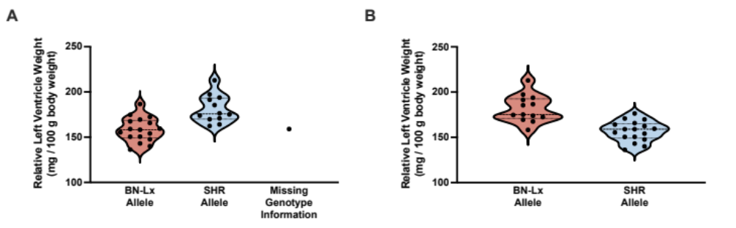Supplementary Figure 1. Relative left ventricle weight by genotype at significant or suggestive QTL peaks. Relative left ventricle weight is separated by genotype/allele of the SNP with the maximum LOD score in the region of each physiological QTL peak. Each circle represents a strain mean from the HXB/BXH panel. A) Relative left ventricle weight QTL on Chromosome 8. The peak for this genome-wide suggestive QTL is at 129.06 Mb and the 1.5 LOD drop interval is from 113.6 to 129.5 Mb. B) Relative left ventricle weight QTL on Chromosome 17. The peak for this genome-wide significant QTL is at 10.97 Mb and the 1.5 LOD drop interval is from 5.4 to 15.3 Mb.

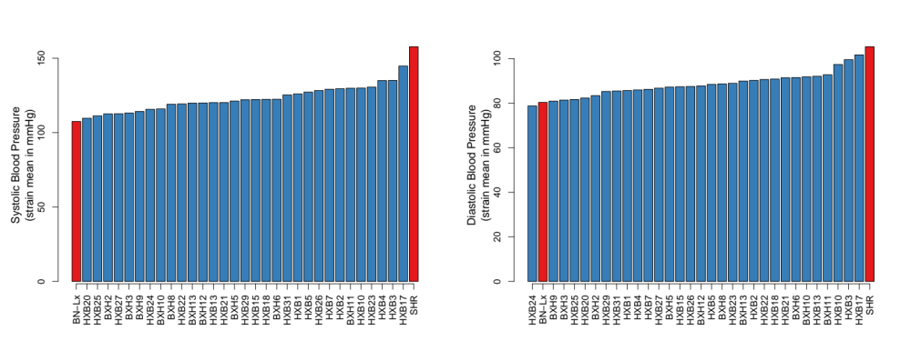
Supplementary Figure 2. Distribution of systolic and diastolic blood pressure among HXB/BXH strains. Strains are in ascending order for each blood pressure trait. The BN-Lx and SHR (progenitor) strains are colored red, and RI strains are blue. A) Systolic Blood Pressure and B) Diastolic Blood Pressure

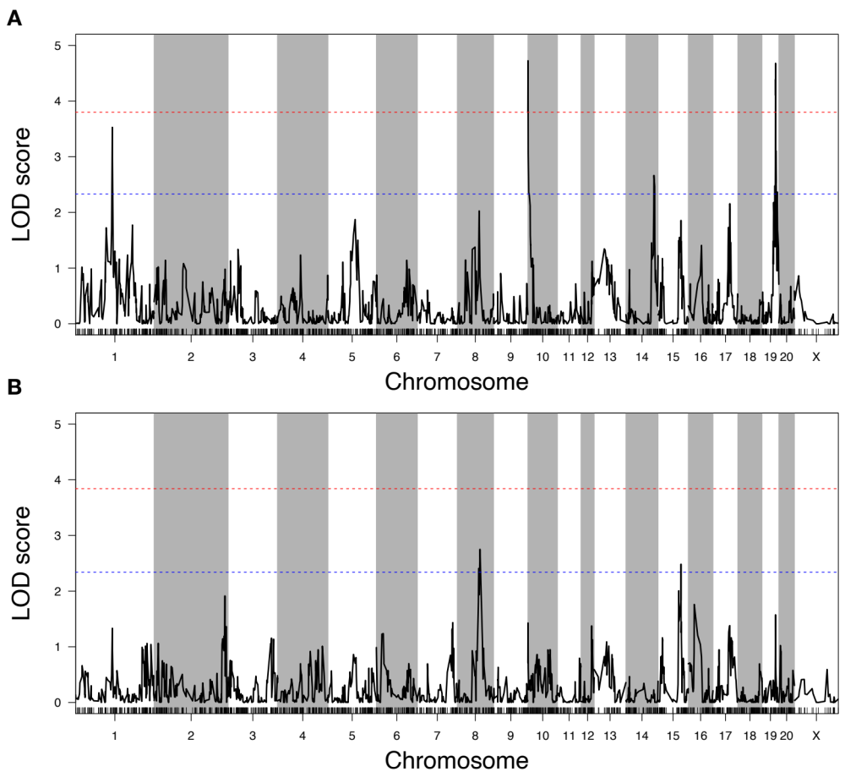

Blood Pressure Type | Chr: Mb | LOD (p-value) | Peak Interval: +/- 1.5 LOD Drop
Systolic Blood Pressure | Chr 1: 132.03 Mb | 3.53 (0.081) | Chr1: (129.4, 135.5) Mb
Systolic Blood Pressure | Chr 10: 6.25 Mb | 4.73 (0.012) | Chr 10: (5.7, 6.9) Mb
Systolic Blood Pressure | Chr 14: 100.63 Mb | 2.66 (0.406) | Chr 14: (89.4, 115.3) Mb
Systolic Blood Pressure | Chr 19: 48.73 Mb | 4.68 (0.013) | Chr 19: (48.2, 49.3) Mb
Diastolic Blood Pressure | Chr 8: 81.25 Mb | 2.75 (0.303) | Chr 8: (70.9, 89.9) Mb
Diastolic Blood Pressure | Chr 15: 84.89 Mb | 2.48 (0.469) | Chr 15: (18.3, 87.6) Mb

Supplementary Figure 3. Blood pressure QTLs in HXB/BXH recombinant inbred panel. The LOD plot for the QTL marker regression is shown for A) Systolic Blood Pressure (SBP) and B) Diastolic Blood Pressure (DBP). The red dotted line represents a significant threshold (genome-wide p-value < 0.05) and the blue dotted line represents a suggestive threshold (genome-wide p-value < 0.63) based on 1,000 permutations.

Supplementary Figure 4. Predicted miRNA binding sites in circH2afy differentially expressed between SHR and BN-Lx strains and physically located in a QTL for relative left ventricle weight. The first track ‘Ensembl Gene Predictions – archive 95 – jan2019’ includes a portion of two Ensembl transcripts (i.e., splice variants) of H2afy transcribed from this region. The horizontal bars represent exons that are connected by a thin horizontal line that covers intronic regions. The arrows in the intronic region indicate the direction of transcription. The second track ‘circH2afy’ in black indicates the region of the genome that codes for the circRNA, circH2afy. The next track in blue below the circRNA indicates predicted miRNA binding sites for each miRNA that is predicted to bind the circRNA and that is differentially expressed between BN-Lx and SHR strains. Image generated using the UCSC Genome Browser (https://genome.ucsc.edu; Kent et al 2002).

Supplementary Figure 5. Tnfrsf21 3’ UTR binding site of miR-210-5p. The top track in red indicates the 3’ Untranslated Region (UTR) of the Ensembl transcript for Tnfrsf21. The thicker rectangular portion indicates the final portion of the coding region of the transcript while the narrower section represents the 3’ UTR. The second track in green represents the binding site for miR-210-5p in the annotated 3’ UTR. Image generated using the UCSC Genome Browser (https://genome.ucsc.edu; Kent et al 2002).

A
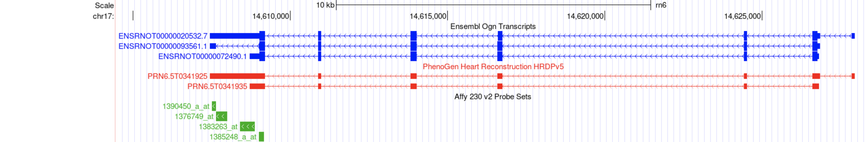

B
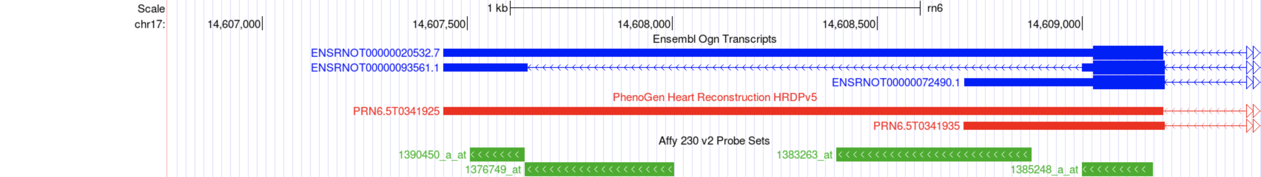

C
 | baseMean | log2FoldChange | lfcSE | stat | pvalue | padj
ENSRNOG00000047786 | 968.0 | -0.80 | 0.09 | -8.47 | 2.39E-17 | 1.48E-15 | BNLx is higher
ENSRNOG00000029792 | 2615.6 | 0.59 | 0.10 | 5.70 | 1.21E-08 | 2.69E-07 | SHR is higher

Supplementary Figure 6. Updating the annotation and quantitation of Ogn expression in the left ventricle of BN-Lx and SHR/Ola rat heart.
The DNA location and isoform expression of Ogn in rat has undergone a problematic evolution. For instance, in the Rn6 version of the rat genome, identical sequences for Ogn appeared at two sites, one with a start site at 14.6 Mb and the other at 15.5 Mb on Ch 17. In the latest version of the rat genome being compiled by IROC (mRatBN7.2/rn7 (Nov 2020) - currently available from NCBI, UCSC Genome Browser, RGD, and soon Ensembl ), there is only one Ogn gene and it is located on the minus strand of Ch 17: 15.02 to 15.03 Mb. Reconstruction of our transcriptome data (see Panel A above) indicates the presence of two isoforms of Ogn in the left ventricle of rat, PRN6.5T0341925 (long 3’ UTR) and PRN6.5T0341935 (short 3’ UTR form). The current version of Ensembl indicates the possible presence of three isoforms of Ogn (Panel A). Panel A also includes the position of the probes for Ogn present on Affymetrix RAE230.2.0 array used by Petretto, et al. (2008) for quantitating the expression of Ogn in their work. Panel B is an expansion of the genomic area Ch 17: 14606773-14609436 providing a more detailed view of the position of the probes in relationship to the identified isoforms. Given the sequences of the isoforms we identified only one probe on the Affymetrix array used by the Petretto, et al. (2008) that would hybridize to both the long and short forms of Ogn transcripts. The expression levels measured by probe 1390450_a_at did not correlate with the extent of LV hypertrophy across the HXB/BXH RI panel in the work of Petretto, et al. (2008) and they interpreted this result to mean that the short 3’ UTR isoform of Ogn was not associated with the extent of LV hypertrophy and yet was determinant of the higher Ogn protein levels that they proposed to contribute to the extent of hypertrophy.
Our results (Panel C) indicate a higher expression of the short 3’ UTR form of Ogn (PRN6.5T0341935) in the BN-Lx strain which has the smaller LV weight while in the SHR/Ola, the long form (PRN6.5T0341925), is most prominent. On the surface, the results of Petretto, et al. (2008) and our results agree as to the negative relationship between the amount of the short 3’ UTR form and LV weight at least in the parental strains of the HXB/BXH RI panel. What is not clear is the reason for the lack of correlation in the work of Petretto, et al. (2008) of the short 3’ UTR isoform with the extent of hypertrophy in the RI rat panel. However, the issue may be resolved by considering jointly the overall effect of several genes within the Ch 17 QTL locus for hypertrophy.
Our work thus complements the results of Petretto, et al. (2008) in that Ogn and the protein derived from that gene contributes to LV hypertrophy, but we provide another viable candidate from a nearby region of the rat genome as a further contributor for LV hypertrophy. The sum effect of the identified candidates may be a more valid determinant of the overall measure of LV hypertrophy.

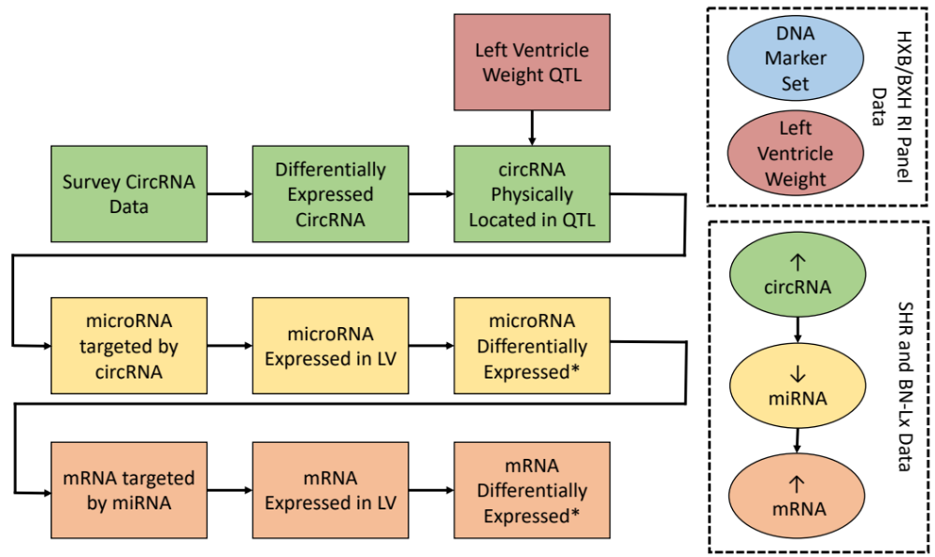

Supplementary Figure 7. Identification of candidate circRNAs, miRNAs, and mRNAs that predispose to high or low relative left ventricle weight. An oval depicts a specific type of data set and which strains it was gathered from (either SHR and BN-Lx strains (progenitors) only, or full HXB/BXH RI panel), while the rectangles depict an analysis or filtering step. Specific information is shown in each rectangle on how each type of RNA candidate was identified in the process. * indicates a differential expression in the expected direction based on the direction of the difference observed in the relevant circRNA. The arrows within the ovals in the dashed box on the right represent the relative directions expected based on the hypothesis that circRNAs ‘sponge’ miRNAs and miRNAs degrade mRNAs. If the circRNA is up-regulated in the SHR, then we would expect the subsequent miRNA to be down-regulated and mRNA to be up-regulated. However, if the circRNA is down-regulated in the SHR, then we would expect the subsequent miRNA to be up-regulated and mRNA to be down-regulated.

Supplementary Tables

Supplementary Table 1. Correlation of relative left ventricle weight and blood pressure. Pearson correlations were performed across all pairwise combinations of physiological traits. The correlation coefficients and (p-values) are reported.
 | Relative Left Ventricle Weight | Systolic Blood Pressure | Diastolic Blood Pressure
Relative Left Ventricle Weight |  | 0.058  (0.762) | -0.237  (0.207)
Systolic Blood Pressure | 0.058  (0.762) |  | 0.71  (1.35e-05)
Diastolic Blood Pressure | -0.237  (0.207) | 0.71  (1.35e-05)

Supplementary Table 2. Differential expression results for the 30 miRNA expressed above background and targeted by a candidate circRNA. Each row represents a unique miRNA-circRNA pair, so there are some miRNAs targeted by more than one circRNA.
miRNA | Chr | Start | log2 Fold Difference (SHR - BN-Lx) | pvalue | circRNA | Database to predict as target | Score (miRDB only) | circRNA Expression (SHR vs BN-Lx)
miR-139-5p | chr1 | 166,589,550 | -0.65 | 0.012 | rno_circRNA_015936 | miRDB | 52 | down
miR-196c-5p | chr10 | 84,113,587 | 3.04 | 0.019 | rno_circRNA_015936 | miRDB | 95 | down
miR-497-5p | chr10 | 56,844,978 | 0.51 | 0.070 | rno_circRNA_015936 | miRDB | 57 | down
miR-497-5p | chr10 | 56,844,978 | 0.51 | 0.070 | rno_circRNA_004563 | miRDB | 60 | up
miR-708-3p | chr1 | 161,221,259 | 0.45 | 0.137 | rno_circRNA_015936 | miRDB | 62 | down
miR-708-5p | chr1 | 161,221,255 | 0.45 | 0.137 | rno_circRNA_015936 | miRDB | 74 | down
miR-301a-5p | chr10 | 74,417,751 | 0.49 | 0.158 | rno_circRNA_005713 | TargetScan7.0 | not applicable | up
miR-466b-2-3p | chr17 | 71,776,561 | -0.89 | 0.210 | rno_circRNA_015936 | miRDB | 83 | down
miR-185-3p | chr11 | 86,812,709 | 0.59 | 0.273 | rno_circRNA_015936 | miRDB | 85 | down
miR-185-3p | chr11 | 86,812,709 | 0.59 | 0.273 | rno_circRNA_004535 | miRDB | 70 | down
miR-185-5p | chr11 | 86,812,715 | 0.59 | 0.273 | rno_circRNA_015936 | miRDB | 94 | down
miR-195-3p | chr10 | 56,845,308 | 0.16 | 0.347 | rno_circRNA_015936 | miRDB | 62 | down
miR-195-5p | chr10 | 56,845,315 | 0.16 | 0.347 | rno_circRNA_004563 | miRDB | 60 | up
miR-195-5p | chr10 | 56,845,315 | 0.16 | 0.347 | rno_circRNA_015936 | miRDB | 53 | down
miR-146b-5p | chr1 | 266,089,502 | 0.66 | 0.366 | rno_circRNA_015936 | miRDB | 67 | down
miR-216a-5p | chr14 | 113,112,146 | -0.60 | 0.379 | rno_circRNA_004563 | miRDB | 56 | up
miR-18a-3p | chr15 | 100,180,023 | 0.26 | 0.386 | rno_circRNA_004563 | miRDB | 55 | up
miR-133a-3p | chr18 | 2,052,486 | -0.24 | 0.434 | rno_circRNA_015936 | miRDB | 84 | down
miR-133a-5p | chr18 | 2,052,493 | -0.24 | 0.434 | rno_circRNA_004563 | TargetScan7.0 | not applicable | up
miR-103-1-5p | chr10 | 20,606,728 | -1.09 | 0.459 | rno_circRNA_015936 | miRDB | 66 | down
miR-28-5p | chr11 | 79,380,536 | 0.11 | 0.462 | rno_circRNA_015936 | miRDB | 82 | down
miR-339-5p | chr12 | 17,369,016 | -0.13 | 0.476 | rno_circRNA_015936 | miRDB | 56 | down
miR-211-5p | chr1 | 125,042,143 | 1.03 | 0.483 | rno_circRNA_015936 | miRDB | 55 | down
miR-664-2-5p | chr13 | 103,192,580 | -0.19 | 0.519 | rno_circRNA_004535 | TargetScan7.0 | not applicable | down
miR-664-2-5p | chr13 | 103,192,580 | -0.19 | 0.519 | rno_circRNA_004563 | miRDB | 84 | up
miR-511-3p | chr17 | 81,382,974 | 0.21 | 0.604 | rno_circRNA_015936 | miRDB | 62 | down
miR-25-3p | chr12 | 19,307,349 | 0.32 | 0.712 | rno_circRNA_015936 | miRDB | 75 | down
miR-25-3p | chr12 | 19,307,349 | 0.32 | 0.712 | rno_circRNA_006400 | TargetScan7.0 | not applicable | up
miR-21-3p | chr10 | 73,902,219 | 0.38 | 0.750 | rno_circRNA_015936 | miRDB | 80 | down
miR-210-5p | chr1 | 214,208,381 | 0.36 | 0.764 | rno_circRNA_006400 | miRDB | 51 | up
miR-142-5p | chr10 | 75,050,854 | 0.30 | 0.798 | rno_circRNA_004563 | miRDB | 52 | up
miR-324-5p | chr10 | 56,621,140 | 0.07 | 0.814 | rno_circRNA_004563 | miRDB | 65 | up
miR-324-5p | chr10 | 56,621,140 | 0.07 | 0.814 | rno_circRNA_015936 | miRDB | 54 | down
miR-874-3p | chr17 | 7,025,019 | -0.20 | 0.855 | rno_circRNA_015936 | miRDB | 65 | down
miR-874-3p | chr17 | 7,025,019 | -0.20 | 0.855 | rno_circRNA_005713 | TargetScan7.0 | not applicable | up
miR-214-5p | chr13 | 80,130,933 | -0.02 | 0.904 | rno_circRNA_015936 | miRDB | 61 | down
miR-144-5p | chr10 | 65,291,378 | -0.01 | 0.978 | rno_circRNA_015936 | miRDB | 67 | down

Supplementary Table 3. Protein-coding mRNAs that have binding sites for at least one of the three candidate miRNAs. The physical location of the gene is indicated by the chromosome (Chr) and starting megabase (Mb). The log2 difference, p-value and FDR are reported for the differential expression between the SHR strain and the BN-Lx/Cub strain. A positive difference indicates SHR up-regulation, and a negative difference indicates SHR down-regulation. The candidate tier reflects the concordance of direction of differential expression, based on the theory that the circRNA will “sponge” the miRNA and reduce its nascent expression.
Ensembl Gene ID | Gene Symbol | Physical Location: Chr (Mb) | Log2 Difference (SHR– BN-Lx) | p-value | FDR | miRNA | mRNA regulation | Candidate Tier
ENSRNOG00000011517 | Tnfrsf21 | Chr 9: 20.5 Mb | 0.40 | 3.42E-03 | 1.64E-02 | miR-210-5p | SHR-up | 1
ENSRNOG00000003338 | Pmp22 | Chr 10: 49.5 Mb | -0.27 | 2.04E-06 | 1.69E-05 | miR-139-5p | BNLx-up | 2
ENSRNOG00000003741 | Nptx1 | Chr 10: 108.7 Mb | -2.02 | 4.74E-09 | 2.27E-07 | miR-139-5p | BNLx-up | 2
ENSRNOG00000004162 | Pfkfb2 | Chr 13: 47.4 Mb | 0.49 | 6.97E-08 | 8.36E-07 | miR-139-5p | SHR-up | 2
ENSRNOG00000004730 | Meis2 | Chr 3: 107.6 Mb | -0.39 | 5.98E-06 | 3.59E-05 | miR-139-5p | BNLx-up | 2
ENSRNOG00000005333 | Azin1 | Chr 7: 77.3 Mb | 0.38 | 1.67E-08 | 2.68E-07 | miR-139-5p | SHR-up | 2
ENSRNOG00000005345 | Vsnl1 | Chr 6: 37.0 Mb | 2.07 | 3.07E-06 | 2.11E-05 | miR-196c-5p | SHR-up | 2
ENSRNOG00000008289 | Slc25a3 | Chr 7: 34.8 Mb | -0.26 | 2.11E-06 | 1.69E-05 | miR-139-5p | BNLx-up | 2
ENSRNOG00000012482 | Ndrg4 | Chr 19: 9.8 Mb | -0.43 | 1.00E-08 | 2.40E-07 | miR-139-5p | BNLx-up | 2
ENSRNOG00000016998 | Atxn1 | Chr 17: 19.2 Mb | -0.31 | 8.46E-04 | 4.51E-03 | miR-139-5p | BNLx-up | 2

References

Kent WJ, Sugnet CW, Furey TS, Roskin KM, Pringle TH, Zahler AM, Haussler D. The human genome browser at UCSC. Genome Res. 2002 Jun;12(6):996-1006.

Petretto E, Sarwar R, Grieve I, Lu H, Kumaran MK, Muckett PJ, et al. Integrated genomic approaches implicate osteoglycin (Ogn) in the regulation of left ventricular mass. Nat Genet. 2008;40(5):546-52.

