Supplementary Table 1 Mean and range of yield and plant architecture traits of 24 cotton genotypes at three environments in kharif-2024
Genotypes |  | PH | NMB | FSB | NSB | SBL | MIL | BP | BW | SCY
Anjali |  | 100.74 | 0.57 | 22.44 | 21.22 | 19.13 | 6.42 | 21.11 | 5.08 | 107.42
ARBC 1601 |  | 95.83 | 0.81 | 22.90 | 21.42 | 20.38 | 6.11 | 20.51 | 5.02 | 106.34
ARBC 1651 |  | 96.94 | 0.91 | 22.19 | 20.58 | 20.14 | 6.03 | 20.90 | 4.91 | 106.28
ARBC 19 |  | 97.47 | 0.66 | 23.52 | 20.12 | 17.20 | 6.14 | 22.39 | 4.91 | 115.12
Bt C-61 |  | 90.41 | 0.98 | 22.27 | 19.33 | 20.18 | 5.77 | 21.50 | 5.01 | 118.29
Bt C-62 |  | 86.11 | 0.78 | 20.04 | 21.35 | 18.01 | 5.50 | 22.13 | 5.30 | 114.93
Bt C-63 |  | 94.57 | 1.08 | 23.29 | 20.56 | 21.11 | 6.03 | 22.00 | 4.59 | 103.29
CO 15 |  | 87.34 | 0.67 | 21.57 | 20.65 | 18.16 | 5.52 | 21.81 | 4.96 | 113.30
CO 17 |  | 79.76 | 0.64 | 19.58 | 22.14 | 17.74 | 5.03 | 22.51 | 5.12 | 122.88
CSH 3075 |  | 91.83 | 0.68 | 22.59 | 20.47 | 20.46 | 5.79 | 23.03 | 4.67 | 109.45
DSC 1651 |  | 89.22 | 0.68 | 22.16 | 20.70 | 20.08 | 5.70 | 21.29 | 4.86 | 112.73
F 2381 |  | 93.94 | 1.04 | 23.06 | 19.76 | 19.18 | 5.91 | 21.98 | 4.63 | 106.67
F 2383 |  | 86.46 | 0.72 | 21.22 | 20.79 | 19.04 | 5.45 | 21.00 | 5.33 | 120.07
H C-54 |  | 90.45 | 0.75 | 21.88 | 21.17 | 19.11 | 5.65 | 22.79 | 4.92 | 121.19
Nano |  | 84.34 | 0.32 | 19.93 | 18.60 | 16.60 | 5.32 | 22.16 | 4.99 | 121.16
PKV-081 Bt |  | 96.29 | 1.14 | 22.65 | 19.44 | 21.12 | 6.14 | 19.16 | 4.45 | 105.74
Rajat Bt |  | 81.78 | 0.52 | 20.14 | 21.11 | 18.26 | 5.23 | 21.80 | 4.41 | 111.12
Roja |  | 91.51 | 0.83 | 22.35 | 21.97 | 20.15 | 5.84 | 23.20 | 5.31 | 119.69
RS 2818 |  | 77.87 | 0.35 | 19.37 | 18.09 | 16.56 | 4.99 | 22.18 | 5.18 | 112.83
Subiksha |  | 93.09 | 0.87 | 22.88 | 21.38 | 16.15 | 5.90 | 21.16 | 5.22 | 126.56
Suraj |  | 84.73 | 0.84 | 20.87 | 21.88 | 17.11 | 5.41 | 21.89 | 5.29 | 126.92
Suraksha |  | 83.24 | 0.39 | 21.16 | 21.02 | 18.98 | 5.75 | 22.88 | 5.31 | 133.41
TCHB 213 |  | 94.11 | 0.65 | 21.44 | 19.56 | 19.59 | 5.94 | 21.18 | 4.82 | 119.67
TVH 002 |  | 86.38 | 0.41 | 21.20 | 20.17 | 17.02 | 5.44 | 21.07 | 5.22 | 118.60
Min |  | 77.87 | 0.32 | 19.37 | 18.09 | 16.15 | 4.99 | 19.16 | 4.41 | 103.29
Max |  | 100.74 | 1.14 | 23.52 | 22.14 | 21.12 | 6.42 | 23.20 | 5.33 | 133.41
Mean |  | 89.77 | 0.72 | 21.70 | 20.56 | 18.81 | 5.71 | 21.73 | 4.98 | 115.57
Environments
E1-Coimbatore | Mean | 89.02 | 0.76 | 21.68 | 20.44 | 18.49 | 5.72 | 21.84 | 5.03 | 114.90
E1-Coimbatore | Min | 74.33 | 0.20 | 18.62 | 17.40 | 14.23 | 4.83 | 18.60 | 4.19 | 100.40
E1-Coimbatore | Max | 101.77 | 1.31 | 24.03 | 23.31 | 21.29 | 6.42 | 25.03 | 5.59 | 132.33
E2-Veppanthattai | Mean | 87.99 | 0.61 | 21.37 | 20.13 | 18.27 | 5.51 | 21.47 | 4.88 | 115.51
E2-Veppanthattai | Min | 75.33 | 0.00 | 18.50 | 17.28 | 14.03 | 4.71 | 18.48 | 4.07 | 101.11
E2-Veppanthattai | Max | 99.73 | 1.19 | 23.83 | 23.11 | 21.17 | 6.23 | 24.08 | 5.49 | 134.28
E3-Srivilliputhur | Mean | 92.29 | 0.79 | 22.04 | 21.11 | 19.67 | 5.90 | 21.89 | 5.02 | 116.30
E3-Srivilliputhur | Min | 77.61 | 0.18 | 18.83 | 17.80 | 15.78 | 4.85 | 19.71 | 4.62 | 103.65
E3-Srivilliputhur | Max | 105.22 | 1.07 | 23.48 | 23.31 | 22.17 | 6.76 | 25.77 | 5.53 | 133.63
For all other parameters, lower values (red), intermediate vales (yellow), and higher values (green)

Supplementary Table 2 Ranking of cotton genotypes based on MTSI score
Ranking | Genotype | MTSI score | Ranking | Genotype | MTSI score
1 | Suraj | 2.16 | 13 | Bt C-62 | 4.35
2 | Subiksha | 2.53 | 14 | CO 17 | 4.45
3 | F 2383 | 2.54 | 15 | F 2381 | 4.69
4 | RS 2818 | 3.08 | 16 | CSH 3075* | 4.73
5 | Roja | 3.26 | 17 | ARBC 1651* | 4.81
6 | TVH 002 | 3.47 | 18 | ARBC 1601 | 4.96
7 | Suraksha | 3.78 | 19 | Bt C-63 | 4.99
8 | CO 15 | 3.81 | 20 | TCHB 213 | 5.09
9 | Bt C-61 | 3.86 | 21 | ARBC 19 | 5.17
10 | DSC 1651 | 4.01 | 22 | PKV-081 Bt | 5.22
11 | Anjali | 4.05 | 23 | Nano | 5.88
12 | H C-54 | 4.35 | 24 | Rajat Bt | 6.22

(A)  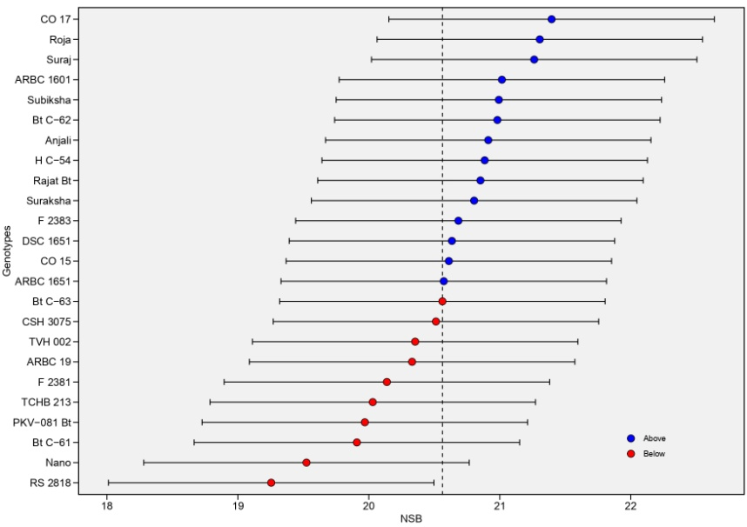 | (B)  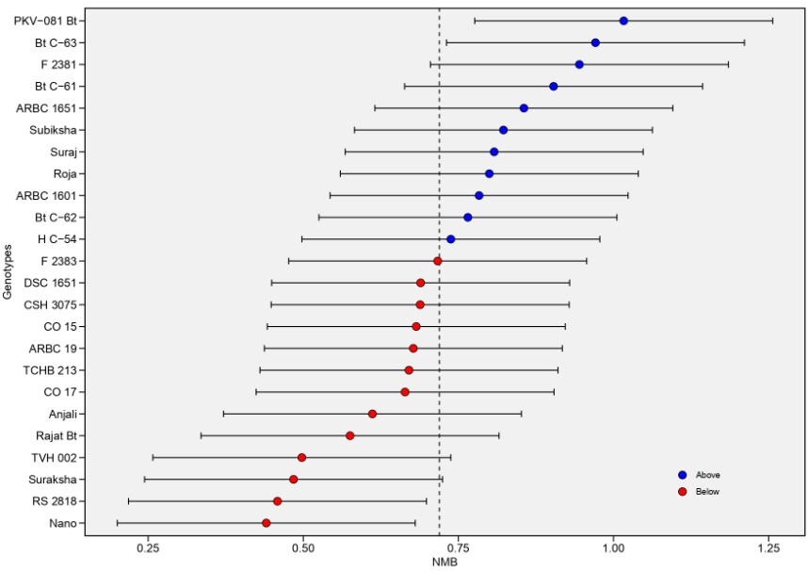
(C)  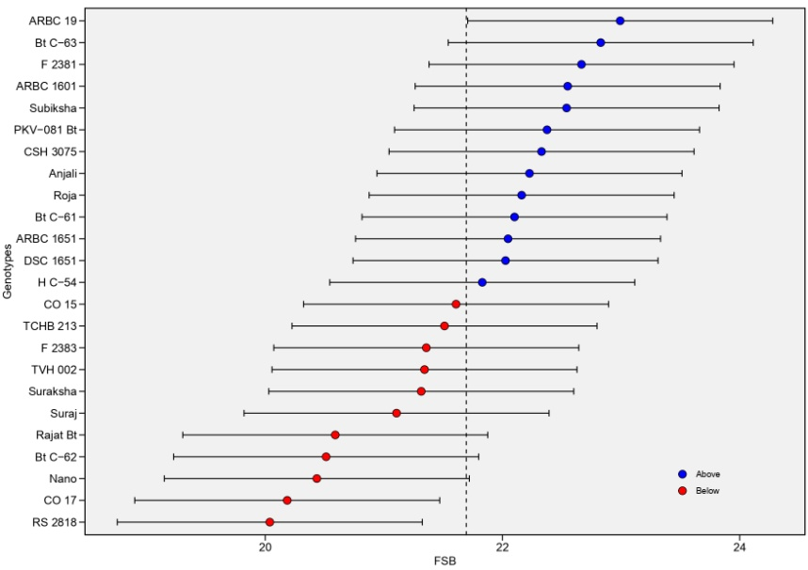 | (D)  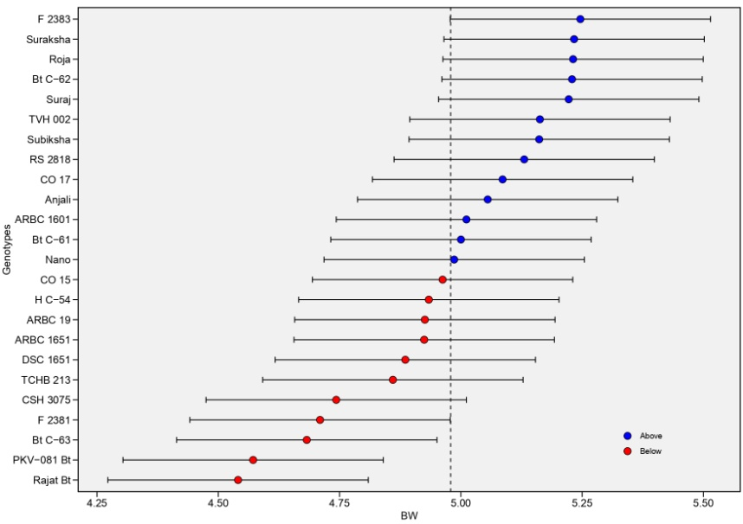

Supplementary Fig. 1 BLUP mean values for (A) number of sympodial branches, (B) number of monopodial branches, (C) height of first sympodial-branch origin from ground, and (D) boll weight in 24 cotton genotypes evaluated across three environments

