Appendices

Appendix A: PRISMA Flow Diagram

Figure A1: PRISMA Flow Diagram for Systematic Review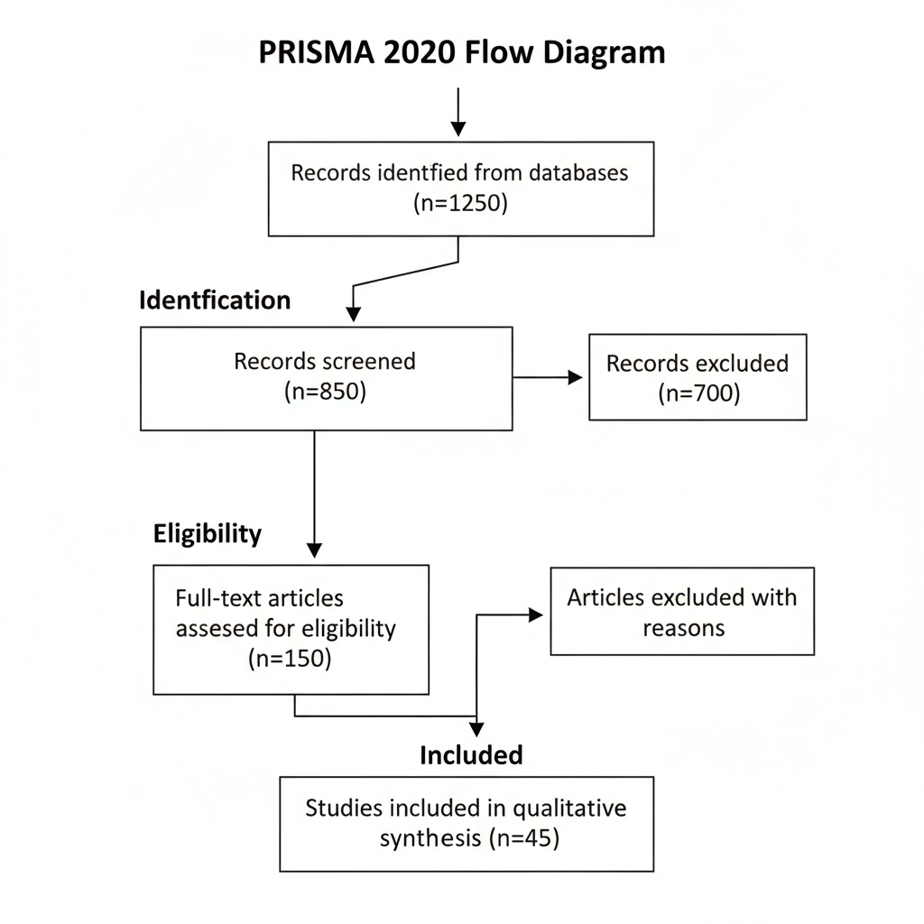

Identification of studies via databases and registers

Records identified from:
- PubMed (n = 520)
- Scopus (n = 430)
- Google Scholar (n = 300)

Total records identified (n = 1250)

Records removed before screening:
- Duplicate records (n = 400)
- Records marked as ineligible (n = 0)

Records screened (n = 850)

Records excluded (n = 700)

Reports sought for retrieval (n = 150)

Reports not retrieved (n = 0)

Reports assessed for eligibility (n = 150)

Reports excluded:
- Not relevant to CHD (n = 60)
- No full text available (n = 25)
- Wrong population/setting (n = 20)

Studies included in review (n = 45)

Appendix B: Search Strategy

PubMed search strategy: ("congenital heart disease"[MeSH]) AND ("undiagnosed" OR "missed diagnosis") AND ("resource-limited" OR "low-income") AND ("diagnostic challenge*" OR "barrier*")

