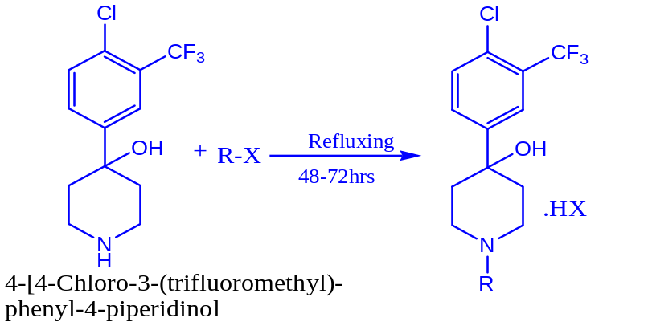
Scheme-1

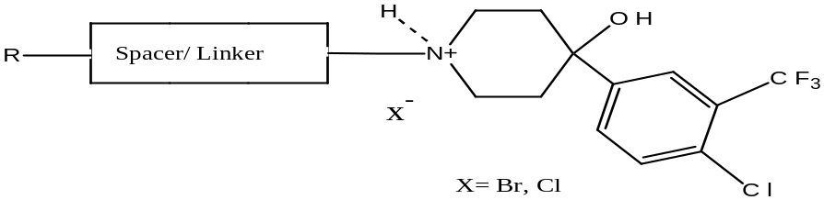
Scheme-2

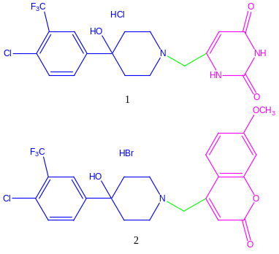 | 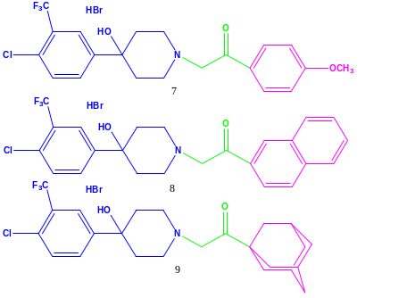
GROUP A₁ | GROUP A₃
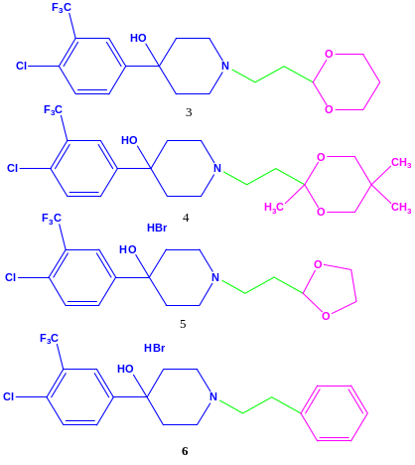 | 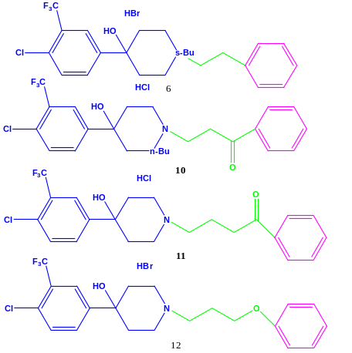
GROUP A₂ | GROUP B

Scheme-3: Group A (A₁-A₃) and Group B of TFMP Derivatives

