Supplementary Materials
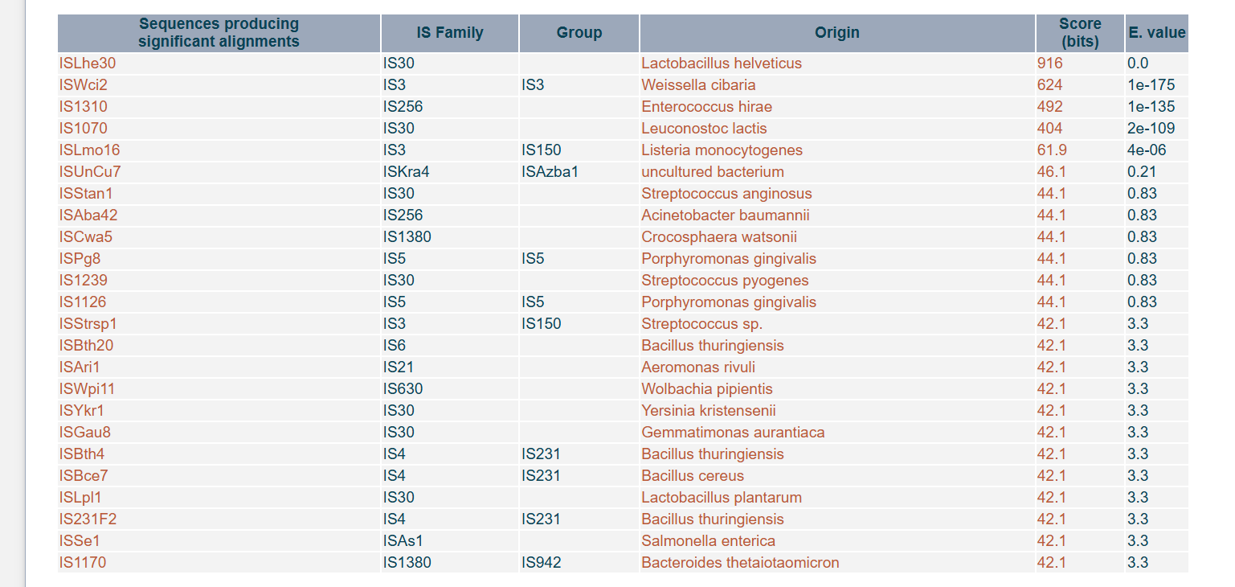
Figure S1. Insertion sequences (IS) elements in L. falkenbergense BSMRAU-M1L5 genome identified via ISfinder, including names, families, groups, origins, bit scores, and E-values.

Table S1. Assembly ID, isolation source, and country of origin of 22 L. falkenbergense strains.
SL. No | Assembly | Strain | Source | Country
 | GCA_045801155.1 | SAEED 24451 | Camel milk | Egypt
 | GCA_016939455.1 | FDAARGOS_1201 | Human | Germany
 | GCF_039871445.1 | OSY-112 | Cheese | USA
 | GCF_036670195.1 | P3A1 | Commercial probiotic | Denmark
 | GCF_036670225.1 | P3A3 | Commercial probiotic | Denmark
 | GCF_033195155.1 | UCMA20153 | Cider | France
 | GCF_032911705.1 | RO-1 | Cheese | Greece
 | GCF_030361025.1 | TOM.81 | Ayran | Russia
 | GCF_030017075.1 | LASM36 | Sugarcane | USA
 | GCF_030017175.1 | LASM18 | Sugarcane | USA
 | GCF_032061125.1 | CTOTU48847 | Urban | USA
 | GCA_031987845.1 | CTOTU47883 | Urban | USA
 | GCF_026486025.1 | 156 | Sweet potato leaves | Australia
 | GCF_025211315.1 | CIRM-BIA 876 | Kefir | Russia
 | GCF_025211365.1 | CIRM-BIA 1191 | Cheese | France
 | GCF_025211425.1 | CIRM-BIA 1261 | Plant | Italy
 | GCF_025211415.1 | CIRM-BIA 1240 | Cheese | Spain
 | GCF_025211065.1 | LBAE K30 | Wheat sourdough | France
 | GCF_014634865.1 | LMG 18969 | Fermenting string beans | China
 | GCF_014634785.1 | C | Yogurt | China
 | GCF_014634805.1 | LMG 10779 | Lactic culture | Sweden-1
 | GCA_034120155.1 | BSMRAU-M1L5 | Card | Bangladesh

Table S2. Stain-specific genes of L. falkenbergense BSMRAU-M1L5.
SL no. | Gene | Annotation
 | xylB_3 | Xylulose kinase
 | group_1286 | hypothetical protein
 | melA_1 | Alpha-galactosidase Mel36A
 | group_1341 | Alpha-galactosidase AgaA
 | group_165 | hypothetical protein
 | galK_3 | Galactokinase
 | group_1718 | Galactokinase
 | group_1767 | hypothetical protein
 | group_2462 | hypothetical protein
 | group_2463 | hypothetical protein
 | group_305 | hypothetical protein
 | group_3337 | hypothetical protein
 | group_3343 | Tyrosine recombinase XerC
 | group_3344 | hypothetical protein
 | group_3345 | hypothetical protein
 | group_3346 | hypothetical protein
 | group_3347 | hypothetical protein
 | group_3348 | hypothetical protein
 | group_3349 | hypothetical protein
 | group_3350 | hypothetical protein
 | group_3351 | hypothetical protein
 | group_3352 | hypothetical protein
 | group_3353 | hypothetical protein
 | group_3354 | hypothetical protein
 | group_3355 | Single-stranded DNA-binding protein
 | group_3356 | hypothetical protein
 | group_3357 | hypothetical protein
 | group_3358 | hypothetical protein
 | group_3359 | hypothetical protein
 | group_3360 | hypothetical protein
 | group_3361 | hypothetical protein
 | group_3362 | hypothetical protein
 | group_3363 | hypothetical protein
 | group_3364 | hypothetical protein
 | group_3369 | hypothetical protein
 | group_3370 | hypothetical protein
 | group_3372 | hypothetical protein
 | group_3373 | hypothetical protein
 | group_3374 | hypothetical protein
 | group_3375 | hypothetical protein
 | group_3376 | hypothetical protein
 | group_3377 | hypothetical protein
 | group_3378 | hypothetical protein
 | group_3379 | hypothetical protein
 | group_3380 | hypothetical protein
 | group_3381 | hypothetical protein
 | group_3382 | hypothetical protein
 | group_3383 | hypothetical protein
 | group_3384 | hypothetical protein
 | group_3385 | hypothetical protein
 | group_3386 | hypothetical protein
 | group_3387 | hypothetical protein
 | group_3388 | hypothetical protein
 | aldh_1 | Aldehyde dehydrogenase
 | recG_2 | ATP-dependent DNA helicase RecG
 | mutS_2 | DNA mismatch repair protein MutS
 | mutL_2 | DNA mismatch repair protein MutL
 | group_3393 | hypothetical protein
 | ndkA_2 | Nucleoside diphosphate kinase
 | murB_2 | UDP-N-acetylenolpyruvoylglucosamine reductase
 | nhaK_3 | Sodium, potassium, lithium and rubidium/H(+) antiporter
 | cdaA_2 | Cyclic di-AMP synthase CdaA
 | cdaR_2 | CdaA regulatory protein CdaR
 | glmM_2 | Phosphoglucosamine mutase
 | rnc_2 | Ribonuclease 3
 | group_3401 | Chromosome partition protein Smc
 | group_3403 | hypothetical protein
 | group_3404 | hypothetical protein
 | group_3405 | hypothetical protein
 | group_3406 | hypothetical protein
 | group_3407 | hypothetical protein
 | group_3408 | hypothetical protein
 | group_3409 | hypothetical protein
 | group_3410 | hypothetical protein
 | group_3411 | hypothetical protein
 | group_3413 | hypothetical protein
 | group_3414 | hypothetical protein
 | clpP_3 | ATP-dependent Clp protease proteolytic subunit
 | group_3417 | hypothetical protein
 | group_3418 | hypothetical protein
 | group_3419 | hypothetical protein
 | group_3420 | hypothetical protein
 | group_3421 | hypothetical protein
 | group_3422 | hypothetical protein
 | group_3423 | hypothetical protein
 | group_3424 | hypothetical protein
 | group_3425 | hypothetical protein
 | group_3426 | hypothetical protein
 | group_3427 | hypothetical protein
 | group_3428 | hypothetical protein
 | group_3429 | hypothetical protein
 | group_3430 | hypothetical protein
 | group_3431 | hypothetical protein
 | group_3432 | hypothetical protein
 | group_3433 | hypothetical protein
 | group_3434 | hypothetical protein
 | group_3435 | hypothetical protein
 | group_3436 | hypothetical protein
 | group_3437 | hypothetical protein
 | group_3440 | hypothetical protein
 | group_3441 | hypothetical protein
 | group_3442 | hypothetical protein
 | group_3443 | hypothetical protein
 | group_3444 | hypothetical protein
 | group_3445 | hypothetical protein
 | group_3446 | Putative prophage phiRv2 integrase
 | group_3447 | hypothetical protein
 | group_3448 | hypothetical protein
 | group_3449 | hypothetical protein
 | group_3450 | hypothetical protein
 | group_3451 | hypothetical protein
 | group_3452 | hypothetical protein
 | group_3453 | Vancomycin B-type resistance protein VanW
 | group_3473 | hypothetical protein
 | engB_2 | putative GTP-binding protein EngB
 | group_3475 | hypothetical protein
 | group_3477 | hypothetical protein
 | group_3478 | hypothetical protein
 | group_3479 | hypothetical protein
 | group_446 | hypothetical protein
 | group_568 | Lichenan permease IIC component
 | group_595 | hypothetical protein
 | group_710 | Lactose permease
 | xerC_8 | Tyrosine recombinase XerC

Table S3. Complete pathway modules of L. falkenbergense BSMRAU-M1L5.
Category | Complete pathway modules | Module ID
Glycolysis / Gluconeogenesis | Pyruvate oxidation | M00307
 | Glycolysis, core module involving three-carbon compounds | M00002
Pentose phosphate pathway | PRPP biosynthesis | M00005
 | Pentose phosphate pathway, oxidative phase | M00006
Other carbohydrate metabolism | Ascorbate degradation, ascorbate | M00550
Amino sugar and nucleotide sugar metabolism | Nucleotide sugar biosynthesis | M00549
 | UDP-N-acetyl-D-glucosamine biosynthesis, prokaryotes | M00909
Pyruvate metabolism | Phosphate acetyltransferase-acetate kinase pathway | M00579
Oxidative phosphorylation | F-type ATPase, prokaryotes and chloroplasts | M00157
Fatty acid biosynthesis | Fatty acid biosynthesis, initiation | M00082
 | Fatty acid biosynthesis, elongation | M00083
Purine metabolism | De novo purine biosynthesis | M00048
 | Guanine ribonucleotide biosynthesis | M00050
 | Deoxyribonucleotide biosynthesis | M00053
Pyrimidine metabolism | Pyrimidine ribonucleotide biosynthesis | M00052
 | Pyrimidine deoxyribonucleotide biosynthesis | M00938
Serine and threonine metabolism | Threonine biosynthesis | M00018
Cysteine and methionine metabolism | Cysteine biosynthesis | M00021
Branched-chain amino acid metabolism | Leucine biosynthesis | M00432
Arginine and proline metabolism | Ornithine biosynthesis | M00028
 | Proline biosynthesis | M00015
Aromatic amino acid metabolism | Shikimate pathway | M00022
Cofactor and vitamin metabolism | Thiamine salvage pathway | M00899
 | Coenzyme A biosynthesis | M00120
 | C1-unit interconversion | M00140
 | Menaquinone biosynthesis | M00116
Terpenoid backbone biosynthesis | C10-C20 isoprenoid biosynthesis | M00364

Table S4. CRISPR-Cas elements identified in the genome of L. falkenbergense BSMRAU-M1L5.
Element | Type / ID | Start | End | Spacers / Genes | Repeat consensus / Cas genes | Evidence Level
Cas cluster | CAS | 47732 | 53948 | 4 | cas2_TypeI-II-III, cas1_TypeII, cas9_TypeII, csn2_TypeIIA | –
Cas cluster | CAS-TypeIIA | 53283 | 53948 | 1 | csn2_TypeIIA | –
CRISPR | NZ_JAVUPV010000002_1 | 53969 | 54400 | 6 | GCTTCAGATGTATGTCAGATCAATGGGGCTTTATAC | 4
Cas cluster | CAS | 29498 | 31087 | 2 | cas3_TypeI, cas3_TypeI | –
Cas cluster | CAS | 16387 | 17754 | 2 | cas3_TypeI, cas3_TypeI | –
Cas cluster | CAS | 35240 | 36514 | 2 | cas3_TypeI, cas3_TypeI | –
Cas cluster | CAS | 26899 | 28194 | 2 | cas3_TypeI, cas3_TypeI | –
Cas cluster | CAS | 4098 | 4856 | 1 | cas4_TypeI-II | –

Table S5. Prohages identified in the genome of L. falkenbergense BSMRAU-M1L5.

Prophage Region | Length (Kb) | Completeness | Most Common Phage Homology
NZ_JAVUPV010000002.1 | 137.6 | Intact | PHAGE_Lactob_Sha1
NZ_JAVUPV010000029.1 | 217.4 | Incomplete | PHAGE_Strept_phi3396

