Supplementary Figure 1. Tissue and pathway enrichment results based on MAGMA gene-level associations
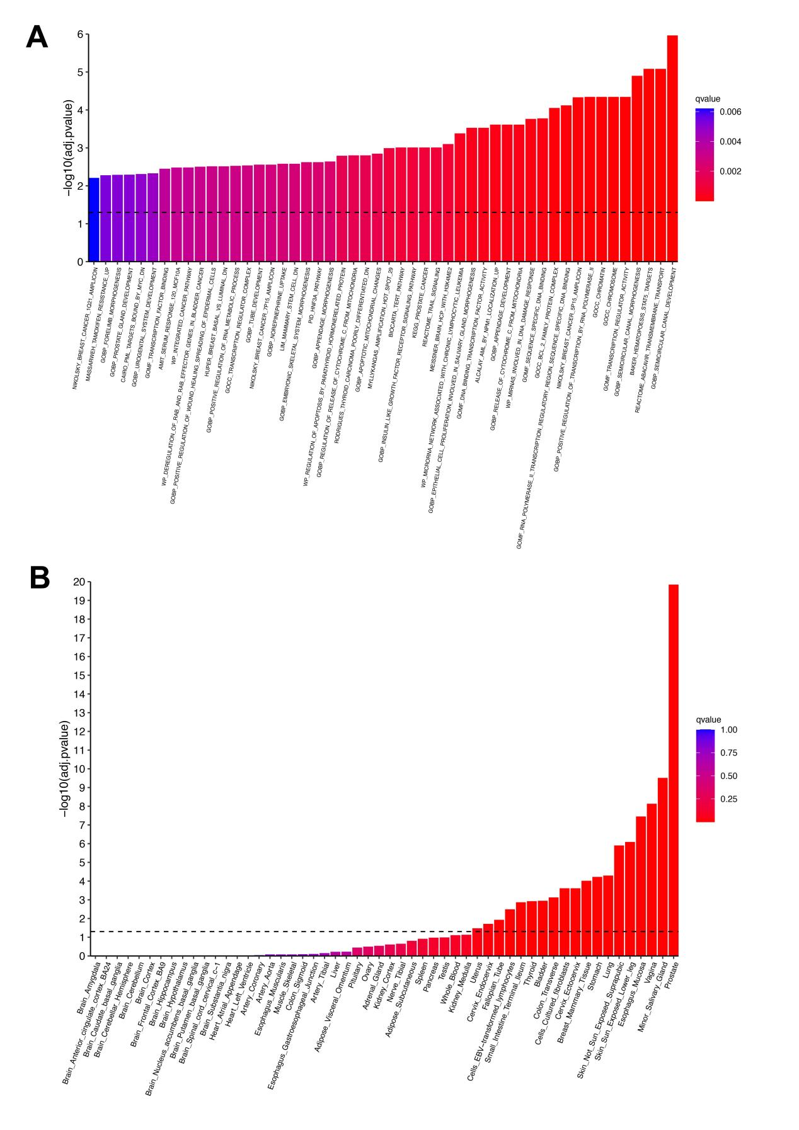
Abbreviations: MAGMA, Multi-marker Analysis of Genomic Annotation.

Supplementary Figure 2. Colocalization plots for SMR-significant genes without evidence of colocalization
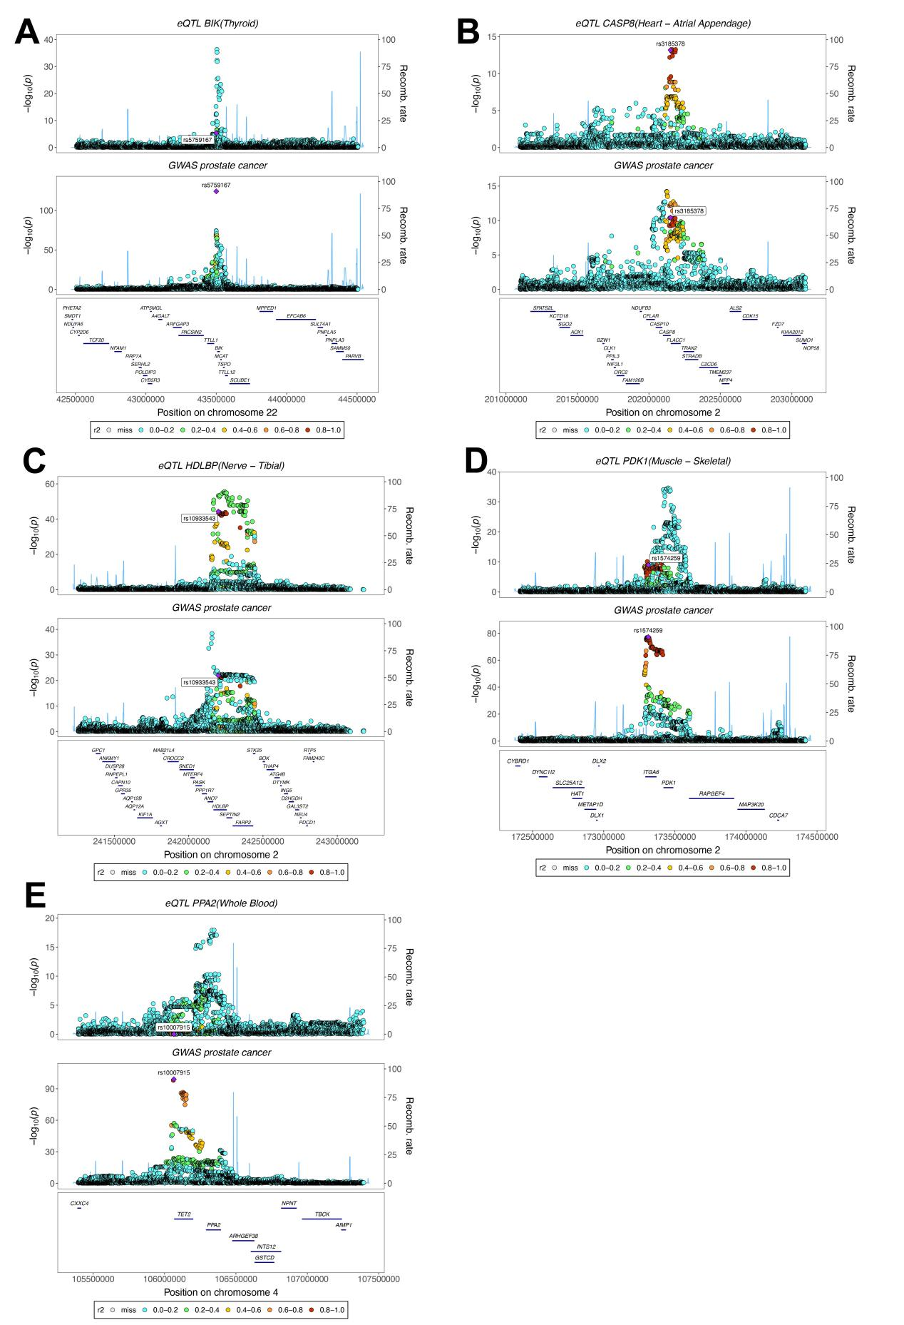

Abbreviations: GWAS, genome-wide association studies; eQTL, expression quantitative trait loci.

