Appendix Section 2. Additional Analyses
- Overall hospital mortality
  - Among RCTs
- Based on patient group:
Neither among patients in sepsis/septic shock (OR, 0.98; 95% CI, 0.76-1.26; n= 1297; I² = 0%; p=0.86) nor among surgical patients (OR, 1.08; 95% CI, 0.63- 1.86; n= 860; I² = 4%) significant differences for hospital mortality was observed comparing vitamin C and placebo or SOC groups (E-Supplement Figure 1).
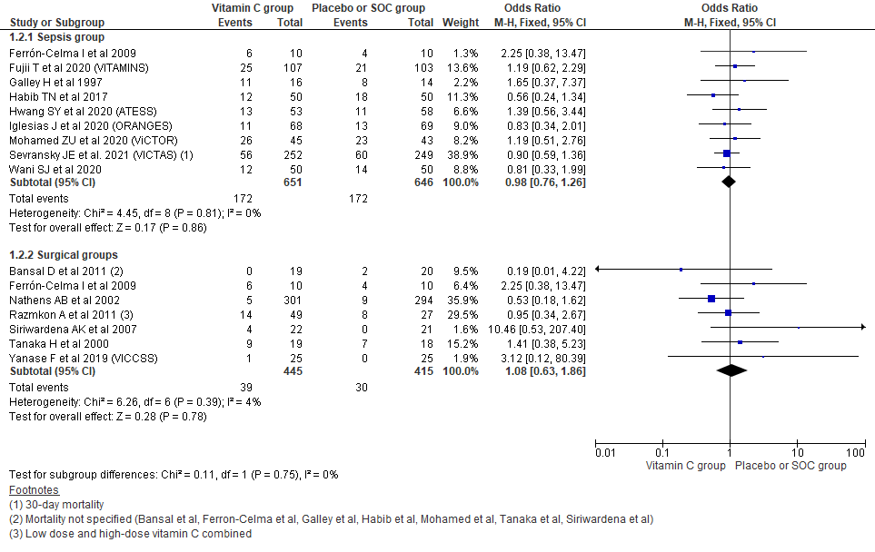
E-Supplement Figure 1. Forest plot showing hospital mortality outcome across surgical and sepsis group among RCTs
- Based on blinding
Running analysis for hospital mortality taking RCTs based on blinding of trials also could not show significant differences between two groups. For double blinded trials, odds for mortality was showed to be slightly higher among vitamin C group (OR, 1.04; 95% CI, 0.76-1.43; n= 938; I² = 0%; p=0.80) while for single blinded/open odds was slightly reduced (OR 0.92, 95% CI 0.65 to 1.29; n= 1199; I² = 0%; p=0.61) comparing with placebo or SOC group; but it could not reach statistical significance (E-Supplement Figure 2).
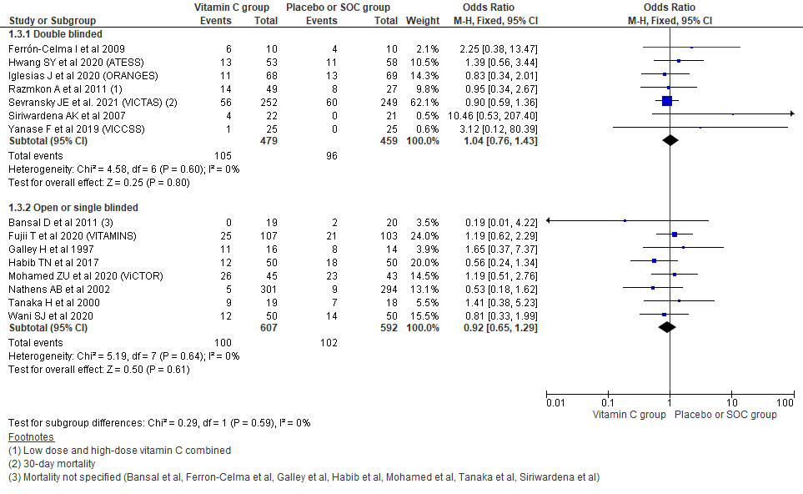
E-Supplement Figure 2. Forest plot showing hospital mortality outcome across double blinded and single blinded/open RCTs
- Based on concomitant other anti-oxidants use
Analysis comparing placebo/ SOC with vitamin C only (OR, 0.93; 95% CI, 0.49-1.76; n= 207; I² = 5%; p=0.82) and placebo/ SOC with other concomitant anti-oxidants use with vitamin C (OR, 0.99; 95% CI, 0.77- 1.27; n= 1930; I² = 0%; p=0.94) also could not show significant differences in hospital mortality (E-Supplement Figure 3).
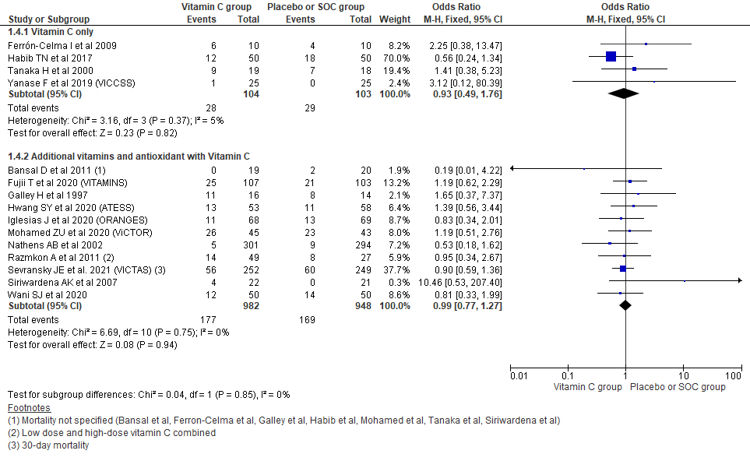
E-Supplement Figure 3. Forest plot showing hospital mortality outcome across use of vitamin C only or other anti-oxidants with vitamin C as treatment group across RCTs
  - Among observational studies
- Based on patient group:
In sepsis/septic shock group mortality could not reach significant differences (OR, 0.73; 95% CI, 0.46-1.15; n= 340351; I² = 86%; p=0.17) while among surgical patients (OR, 0.69; 95% CI, 0.56-0.85; n= 5143; I² = 4%; p=0.0005) significant reduction in hospital mortality was observed comparing vitamin C and placebo/ SOC groups (E-Supplement Figure 4).
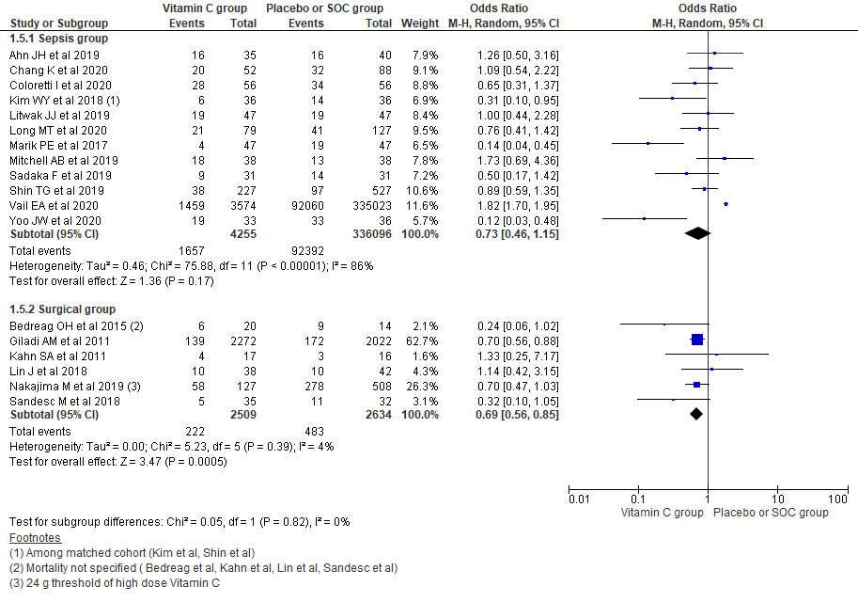
E-Supplement Figure 4. Forest plot showing hospital mortality outcome across surgical and sepsis group among observational studies
- Based on concomitant other anti-oxidants use
Analysis comparing placebo/ SOC with vitamin C only could not reach significant differences in mortality (OR, 0.86; 95% CI, 0.64-1.16; n= 963; I² = 0%; p=0.32); while comparing placebo/ SOC with other concomitant anti-oxidants use with vitamin C showed significant reduction in hospital mortality (OR, 0.60; 95% CI, 0.38-0.95; n= 344531; I² = 91%; p<0.0001) (E-Supplement Figure 5).
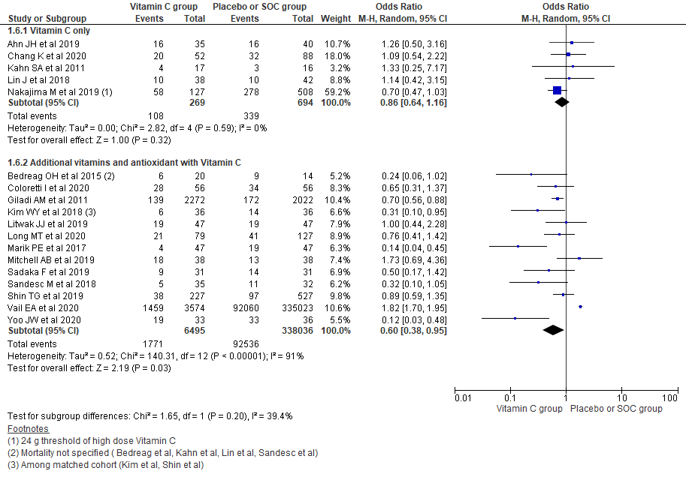
E-Supplement Figure 5. Forest plot showing hospital mortality outcome across use of vitamin C only or other antioxidants with vitamin C as treatment group across observational studies
- 28/30-day mortality
Pooling data for 28/30-days mortality using random effect model also showed similar findings as in fixed effect model with no significant group differences in overall 28/30-days mortality (OR, 0.86; 95% CI, 0.69-1.07; n= 3405; I² = 28%; p=0.18); among RCTs (OR, 0.77; 95% CI, 0.57-1.05; n= 2131; I² = 37%; p=0.10); observational studies (OR, 1.00; 95% CI, 0.75-1.33; n= 1274; I² = 4%; p=0.98) (E-Supplement Figure 6).
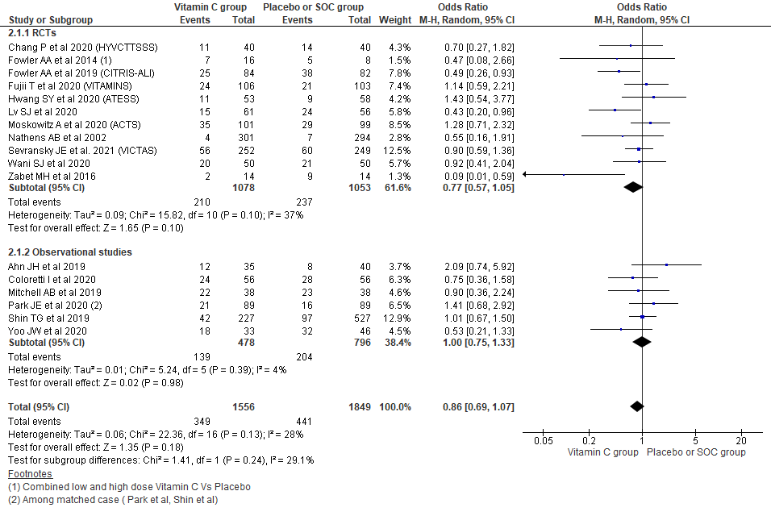
E-Supplement Figure 6. Forest plot showing 28/30-days mortality outcome using random effect model
- ICU mortality
Pooling data from 14 studies reporting ICU mortality showed OR of 0.83 for overall ICU mortality (95% CI, 0.61-1.13; n= 2448; I² = 38%; p=0.24), though it could not reach statistical significance. Similarly, further subgroup analysis taking type of study under consideration showed similar result with RCTs (OR, 1.02; 95% CI, 0.75-1.38; n= 1716; I² = 0%; p=0.91) and observational studies (OR, 0.69; 95% CI, 0.41-1.17; n= 732; I² = 55%; p=0.17) (E-Supplement Figure 7).
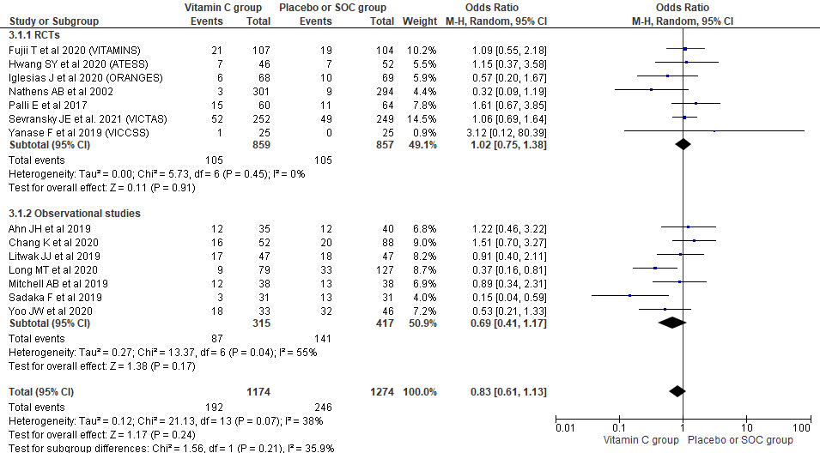
E-Supplement Figure 7. Forest plot showing ICU mortality outcome using random effect model
- Overall length of hospital stay (LoHS)
  - Among RCTs
- Based on patient group:
Among patients in sepsis/septic shock there was no significant differences in length of hospital stay between two groups (MD, 0.63; 95% CI, -0.41 to 1.68; n= 1141; I² = 0%; p=0.23) however among critically ill surgical patients average 1.7 days reduction in LoHS was observed among vitamin C group comparing with placebo/SOC (MD, -1.70; 95% CI, -2.89 to -0.51; n= 663; I² = 52%; p=0.005) (E-Supplement Figure 8).
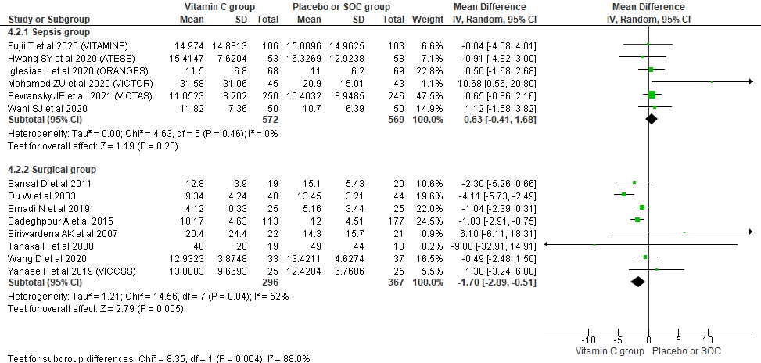
E-Supplement Figure 8. Forest plot showing LoHS outcome across surgical and sepsis group among RCTs
- Based on blinding
Running analysis for LoHS taking RCTs based on blinding of trials showed some reduction in length of hospital stay of vitamin C group among both double blinded trials (MD, -0.54; 95% CI, -1.43 to 0.36; n= 1247; I² = 34%; p=0.24) and single blinded/open RCTs reduction in LoHS among vitamin C group (MD, -0.78; 95% CI, -3.77 to 2.20; n= 557; I² = 73%; p=0.61) comparing with placebo or SOC group but could not reach statistical significance (E-Supplement Figure 9).
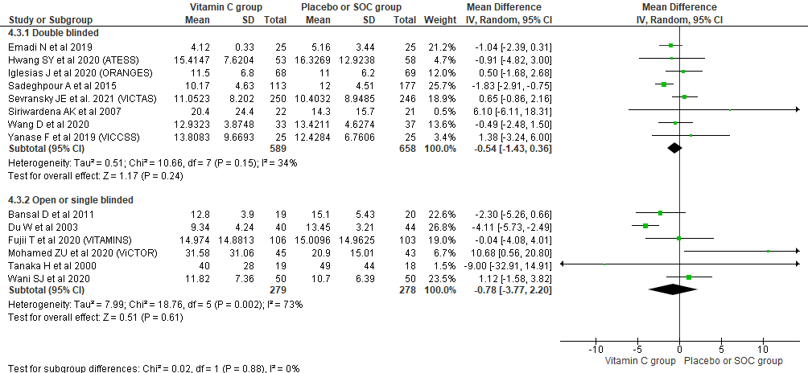
E-Supplement Figure 9. Forest plot showing LoHS outcome across double blinded and single blinded/open RCTs
- Based on concomitant other anti-oxidants use
Analysis comparing vitamin C only with placebo/ SOC showed on an average 1.7 days reduction in LoHS among vitamin C group (MD, -1.70; 95% CI, -3.02 to -0.37; n= 581; I² = 61%; p=0.01) while such reduction is not seen in other concomitant anti-oxidants use with vitamin C (MD, 0.31; 95% CI, -0.91 to 1.53; n= 1223; I² = 21%; p=0.62) also could not show significant differences in hospital mortality (E-Supplement Figure 10).
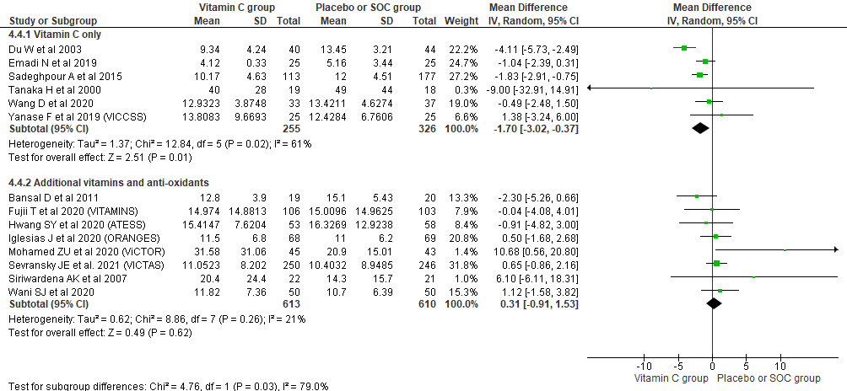
E-Supplement Figure 10. Forest plot showing hospital mortality outcome across use of vitamin C only or other anti-oxidants with vitamin C as treatment group across RCTs
  - Among observational studies
- Based on patient group:
In both sepsis/septic shock group (MD, 1.34; 95% CI, -0.43 to 3.10; n = 246631; I2 = 64%; p=0.14) and surgical group (MD, -5.25; 95% CI, -14.19 to 3.69; n = 4526; I² = 97%; p=0.25) reduction in LoHS could not reach statistical significance comparing vitamin C with placebo/ SOC groups (E-Supplement Figure 11).
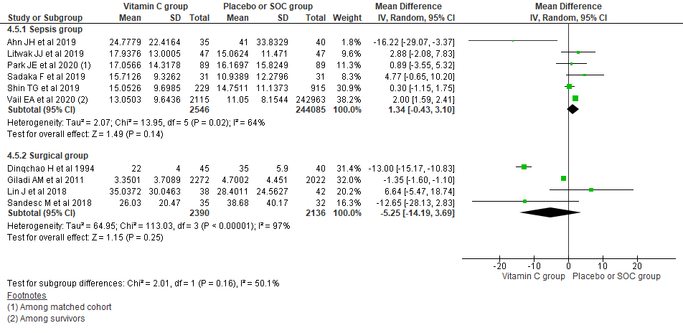
E-Supplement Figure 11. Forest plot showing hospital mortality outcome across surgical and sepsis group among observational studies
- Based on concomitant other anti-oxidants use
Running analysis considering concomitant use of other anti-oxidants with vitamin C among observational studies also could not show significant differences in length of hospital stay comparing placebo/ SOC with vitamin C only (MD, -8.12; 95% CI, -19.97 to 3.74; n = 240; I² = 80%; p=0.18) or concomitant use of other anti-oxidants with vitamin C (MD, 0.83; 95% CI, -1.31 to 2.97; n= 250917; I² = 97%; p=0.45) (E-Supplement Figure 12).
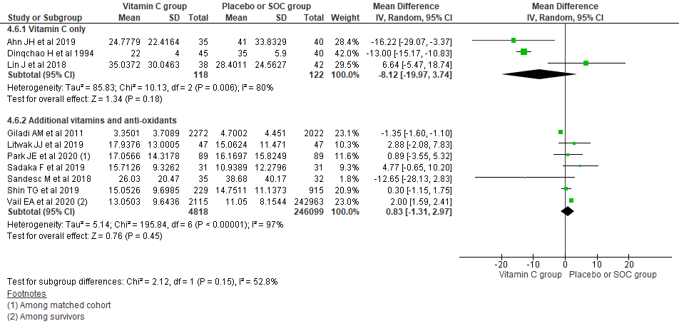
E-Supplement Figure 12. Forest plot showing hospital mortality outcome across use of vitamin C only or other anti-oxidants with vitamin C as treatment group across observational studies
- New AKI
Pooling new onset AKI outcome using random effect model also showed no significant difference in new AKI outcome (OR, 1.22; 95% CI, 0.94 to 1.58; n= 5330; I² = 0%; p=0.14). Similarly, based on type of study also could not show significant changes with fixed effect model result among observational studies (OR, 1.66; 95% CI, 0.78 to 3.54; n= 4482; I² = 37%; p=0.35) and RCTs (OR, 1.17; 95% CI, 0.85 to 1.61; n= 848; I² = 0%; p=0.35) (E-Supplement Figure 13).

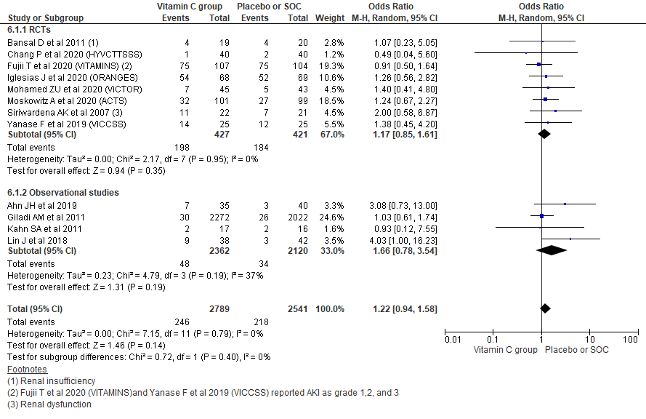
E-Supplement Figure 13. Forest plot showing new AKI outcome using random effect model.

