APPENDIX A
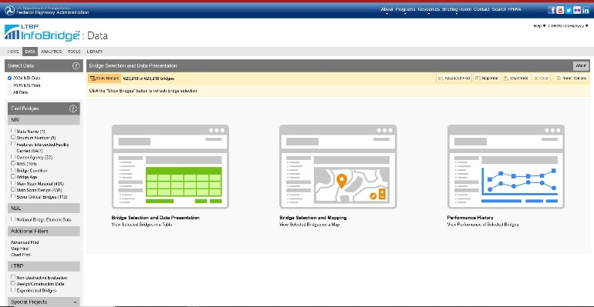
Figure A: Data webpage for LTBP program (Courtesy LTBP)

