Appendix A. Participant inclusion criteria flowchart
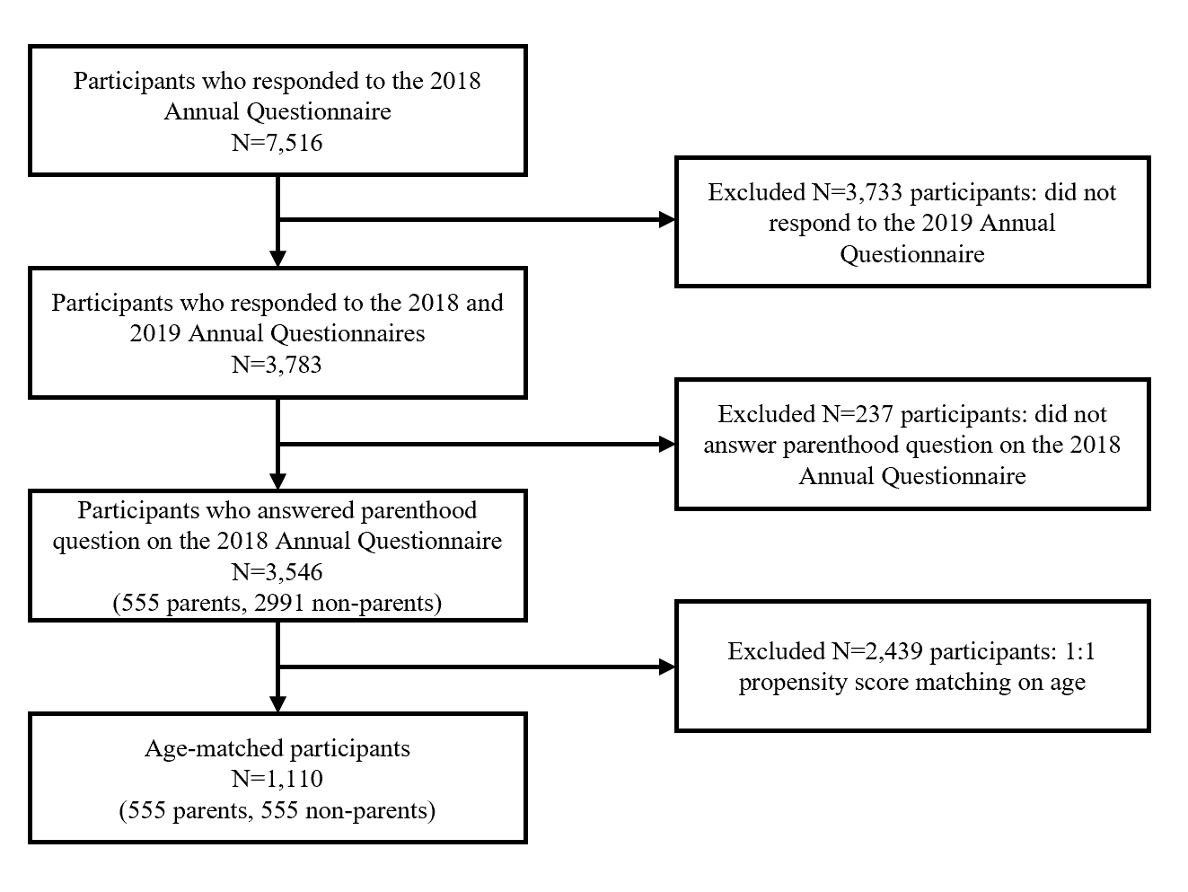

Appendix B. Causal diagrams for confounder selection
