Supplementary materials
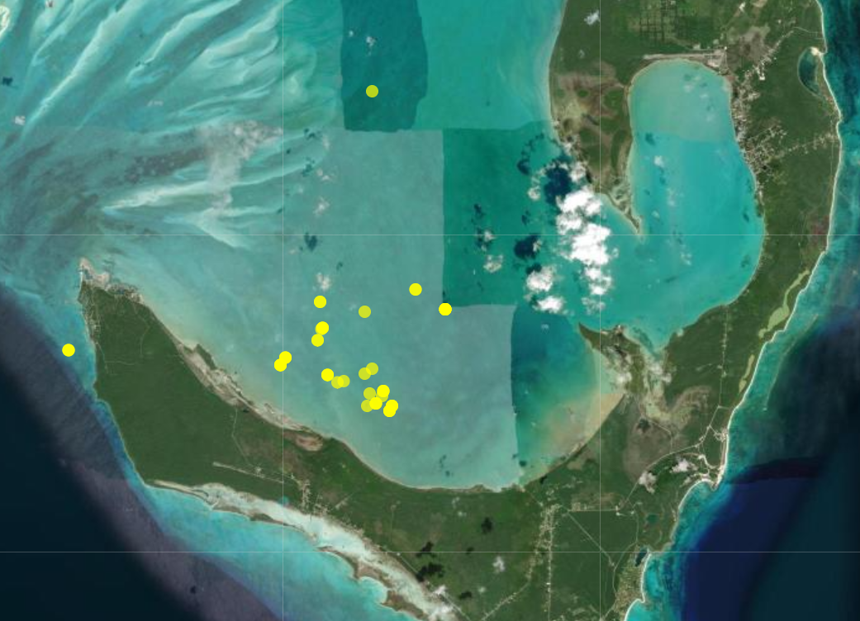
Figure S1. Map of lionfish and parrotfish capture sites off Cape Eleuthera, Eleuthera Island, The Bahamas. Yellow points represent the sites of successful fish capture.
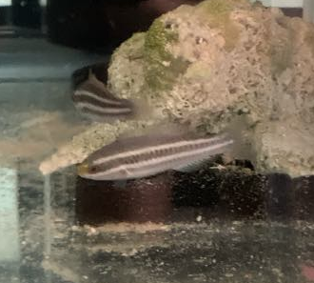
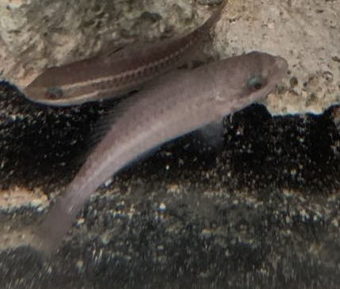
a)
b)

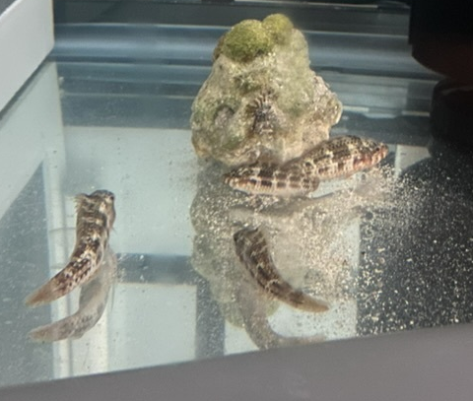
c)

Figure S2. Three colourations of princess (Scarus taeniopterus) and striped (S. iseri) parrotfish. Figure S2a shows the striped colouration (black with two white stripes, sometimes with a yellow splotch on the nose). b) Pale colouration (all silvery). c) Mottled colouration (brown speckles, camouflage). Juvenile princess and striped parrotfish change colour as a response to predators or other threats (Crook 1999; Wisenden 2003; Berchtold and Côté 2020). They often appear striped while unstressed, pale while moderately stressed, or mottled colouration while extremely stressed.

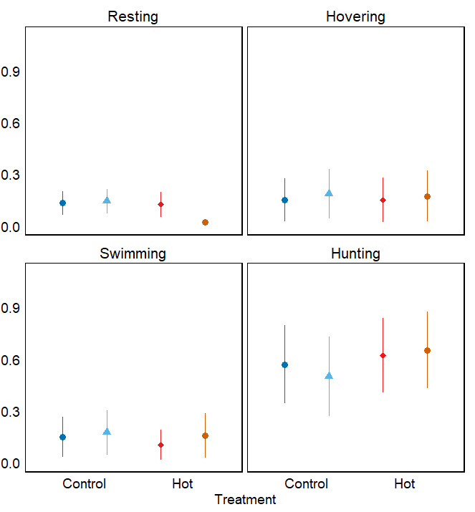
Predicted probabilities
b)
d)
c)
a)

**
*


Dawn Control
Midday Control
Midday Hot
Dawn Hot

Figure S3. Predicted probabilities of lionfish (Pterois spp.) behaviours under two different treatment conditions (control, 29 °C versus hot, 32 °C) and time of day (dawn versus midday). Figure 3a shows resting, defined as being immobile at the bottom of the tank or against a form of cover. b) Hovering; immobile in the water column. c) Swimming; actively moving in any direction. d) Hunting; angled towards the prey fish with pectoral fins fully splayed. Points represent the estimated mean probability of each behaviour based on generalized additive model (GAM) predictions, with error bars showing standard error. *p <0.05, **p < 0.01, ***p < 0.001.

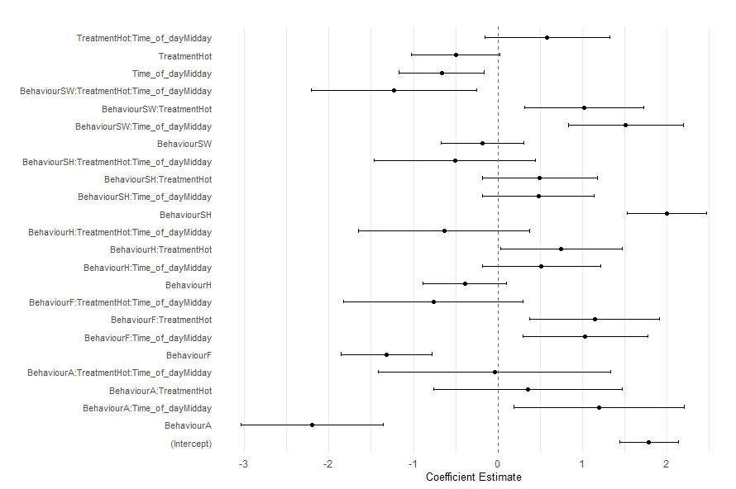

Figure S4. Standardized effect sizes ± 95% confidence intervals for pairwise contrasts from a generalized linear mixed effects model (GLMM) with a negative binomial distribution examining the effects of treatment conditions (control, 29 °C versus hot, 32 °C) and time of day (dawn versus midday) on the behaviour of striped (Scarus iseri) and princess (S. taeniopterus) parrotfish, measured per fish. Behaviours include aggression, feeding, hovering, resting, sheltering, and swimming. Resting behaviour, control treatment, and dawn trials were used as the baseline conditions for the GLMM. Positive values indicate greater expression of the behaviour per fish in the first condition listed in each contrast. Significant effects are indicated by non-overlapping confidence intervals with zero.
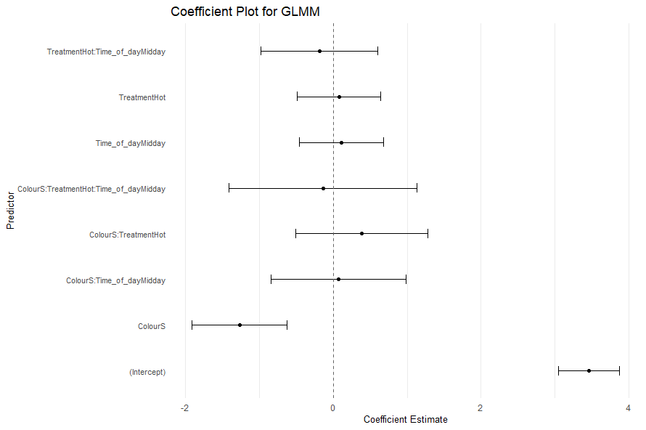

Figure S5. Standardized effect sizes ± 95% confidence intervals for pairwise contrasts from a generalized linear mixed effects model (GLMM) with a negative binomial distribution examining the effects of treatment conditions (control, 29 °C versus hot, 32 °C) and time of day (dawn versus midday) on the colouration in striped (Scarus iseri) and princess (S. taeniopterus) parrotfish, measured per fish. Colourations include pale and striped. Pale colouration, control treatment, and dawn trials were used as the baseline conditions for the GLMM. Positive values indicate greater expression of the colouration per fish in the first condition listed in each contrast. Significant effects are indicated by non-overlapping confidence intervals with zero.
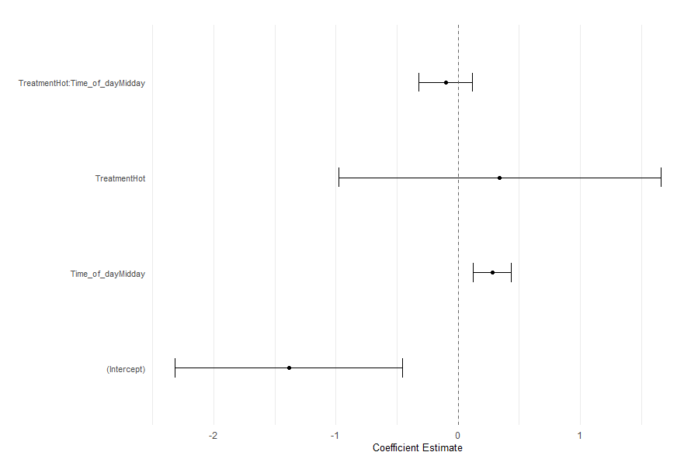
Figure S6. Standardized effect sizes ± 95% confidence intervals for pairwise contrasts from a generalized linear mixed effects model (GLMM) with a binomial distribution examining the effects of treatment conditions (control, 29 °C versus hot, 32 °C) and time of day (dawn versus midday) on the position of striped (Scarus iseri) and princess (S. taeniopterus) parrotfish in relation to lionfish (Pterois spp.).
Table S1. Start and end weights (g) and total lengths (cm) of lionfish in the study. Lionfish were weighed and measured at the start of the experiment and after the experiment finished.

Tank | Treatment | Start weight (g) | Start length (cm) | End weight (g) | End length (cm)
1 | Hot | 123.38 | 21.2 | NA | NA
1b | Control | 229.75 | 25.3 | 215.89 | 25.5
2 | Hot | 206.67 | 26.0 | 191.5 | 26.0
3 | Control | 103.60 | 17.0 | 59.06 | 17.2
4 | Control | 172.40 | 26.5 | NA | NA
4b | Hot | 231.31 | 24.8 | 201.55 | 24.9
5 | Hot | 17.99 | 12.6 | 17.74 | 12.9
6 | Control | 21.10 | 12.7 | 18.08 | 12.8
7 | Hot | 88.35 | 18.7 | 75.71 | 18.9
8 | Hot | 78.66 | 18.5 | 70.79 | 18.5
9 | Control | 165.98 | 23.6 | 152.59 | 23.7
10 | Control | 29.99 | 17.6 | 59.99 | 17.6

Table S2. Mean start and end weights (g) and total lengths (cm) ± standard error (SE) for striped (Scarus iseri) and princess parrotfish (S. taeniopterus) used in this project. Parrotfishes were weighed and measured at the start of the experiment and after the experiment finished. Control tanks were set to 29 °C, while hot tanks were set to 32 °C.

Tank | Treatment | Mean start weight (g) ± SE | Mean end weight (g) ± SE | Mean start length (cm) ± SE | Mean end length (cm) ± SE
1 | Hot | 4.76 ± 0.80 | 3.81 ± 0.88 | 6.5 ± 0.4 | 6.5 ± 0.5
1b | Control | 4.13 ± 1.24 | 4.20 ± 1.23 | 6.5 ± 0.8 | 6.5 ± 0.7
2 | Hot | 3.03 ± 0.74 | 2.76 ± 0.45 | 5.3 ± 0.4 | 5.4 ± 0.4
3 | Control | 6.32 ± 0.74 | 6.19 ± 1.81 | 7.4 ± 0.8 | 7.4 ± 0.7
4 | Control | 3.18 ± 0.84 | 2.75 ± 0.65 | 5.8 ± 0.5 | 6.0 ± 0.5
4b | Hot | 4.38 ± 1.10 | 4.45 ± 0.82 | 6.6 ± 0.6 | 6.7 ± 0.6
5 | Hot | 1.82 ± 0.19 | 1.73 ± 0.61 | 4.9 ± 0.3 | 5.0 ± 0.3
6 | Control | 3.43 ± 1.01 | 3.24 ± 1.03 | 5.9 ± 0.7 | 6.0 ± 0.6
7 | Hot | 2.41 ± 0.62 | 2.60 ± 0.67 | 5.3 ± 0.6 | 5.4 ± 0.6
8 | Hot | 4.09 ± 0.91 | 5.17 ± 0.16 | 6.4 ± 0.4 | 6.6 ± 0.5
9 | Control | 5.77 ± 1.08 | 6.45 ± 1.00 | 7.2 ± 0.5 | 7.3 ± 0.5
10 | Control | 3.57 ± 0.90 | 3.74 ± 1.08 | 6.1 ± 0.6 | 6.1 ± 0.6

Table S3. Predicted probabilities from a multinomial generalized additive model (GAM), with estimates, standard errors (SE), z-statistics, p-values, and 95% confidence intervals (conf. low, conf. high). Random effects for tank were excluded. Each row corresponds to a specific combination of the observed behaviours (resting, hovering, swimming, and hunting), treatment (control, 29 °C and hot, 32 °C), and time of day (dawn or midday). Significant p-values are in bold and represent the probability that a given behaviour under a specific combination of treatment and time of day is statistically different from zero.
Behaviour | Treatment | Time of day | Estimate | SE | Z-statistic | p-value | Conf. Low | Conf. High
Resting | Control | Dawn | 0.132 | 0.070 | 1.885 | 0.059 | -0.005 | 0.269
 |  | Midday | 0.142 | 0.070 | 2.047 | 0.041 | 0.006 | 0.279
 | Hot | Dawn | 0.123 | 0.071 | 1.738 | 0.082 | -0.0157 | 0.262
 |  | Midday | 0.022 | 0.016 | 1.367 | 0.172 | -0.009 | 0.053
Hovering | Control | Dawn | 0.151 | 0.125 | 1.208 | 0.227 | -0.094 | 0.395
 |  | Midday | 0.184 | 0.143 | 1.291 | 0.197 | -0.096 | 0.464
 | Hot | Dawn | 0.152 | 0.129 | 1.178 | 0.239 | -0.101 | 0.404
 |  | Midday | 0.172 | 0.147 | 1.171 | 0.242 | -0.116 | 0.461
Swimming | Control | Dawn | 0.149 | 0.117 | 1.273 | 0.203 | -0.081 | 0.379
 |  | Midday | 0.174 | 0.129 | 1.351 | 0.177 | -0.077 | 0.427
 | Hot | Dawn | 0.102 | 0.086 | 1.191 | 0.234 | -0.066 | 0.270
 |  | Midday | 0.156 | 0.129 | 1.211 | 0.226 | -0.096 | 0.408
Hunting | Control | Dawn | 0.569 | 0.225 | 2.524 | 0.012 | 0.127 | 1.010
 |  | Midday | 0.499 | 0.231 | 2.163 | 0.031 | 0.047 | 0.951
 | Hot | Dawn | 0.623 | 0.216 | 2.887 | 0.004 | 0.200 | 1.046
 |  | Midday | 0.650 | 0.222 | 2.930 | 0.003 | 0.215 | 1.086

Table S4. Confusion matrix showing the proportion of predicted versus observed lionfish behaviours (resting, hovering, swimming, and hunting) based on a multinomial generalized additive model (GAM). Values represent the percentage of predictions (rows) that matched each observed behaviour (columns). The bold diagonal values indicate correct classifications, with an overall classification accuracy of 66.2%.
 | Actual
Predicted | Resting | Hovering | Swimming | Hunting
Resting | 0.69 | 0.12 | 0.06 | 0.13
Hovering | 0.00 | 0.46 | 0.10 | 0.43
Swimming | 0.04 | 0.12 | 0.51 | 0.32
Hunting | 0.05 | 0.15 | 0.10 | 0.70

