Supplemental Material
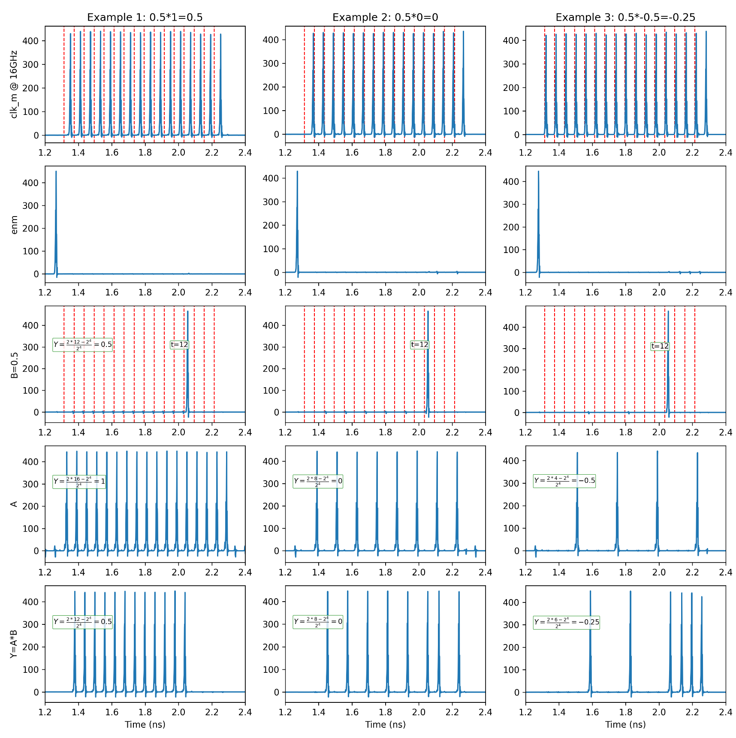
Figure S1. Three examples of multiplication for 4 bits of resolution. Signal A is a pulse stream. Signal B is encoded in the time domain. The output of the multipliers (Synapses) are encoded as pulse streams. The neuron will merge the streams and depending and fire if the accumulation crosses its threshold. The figure shows one time-epoch with 16 time slots, while each red line represents a time-slot.

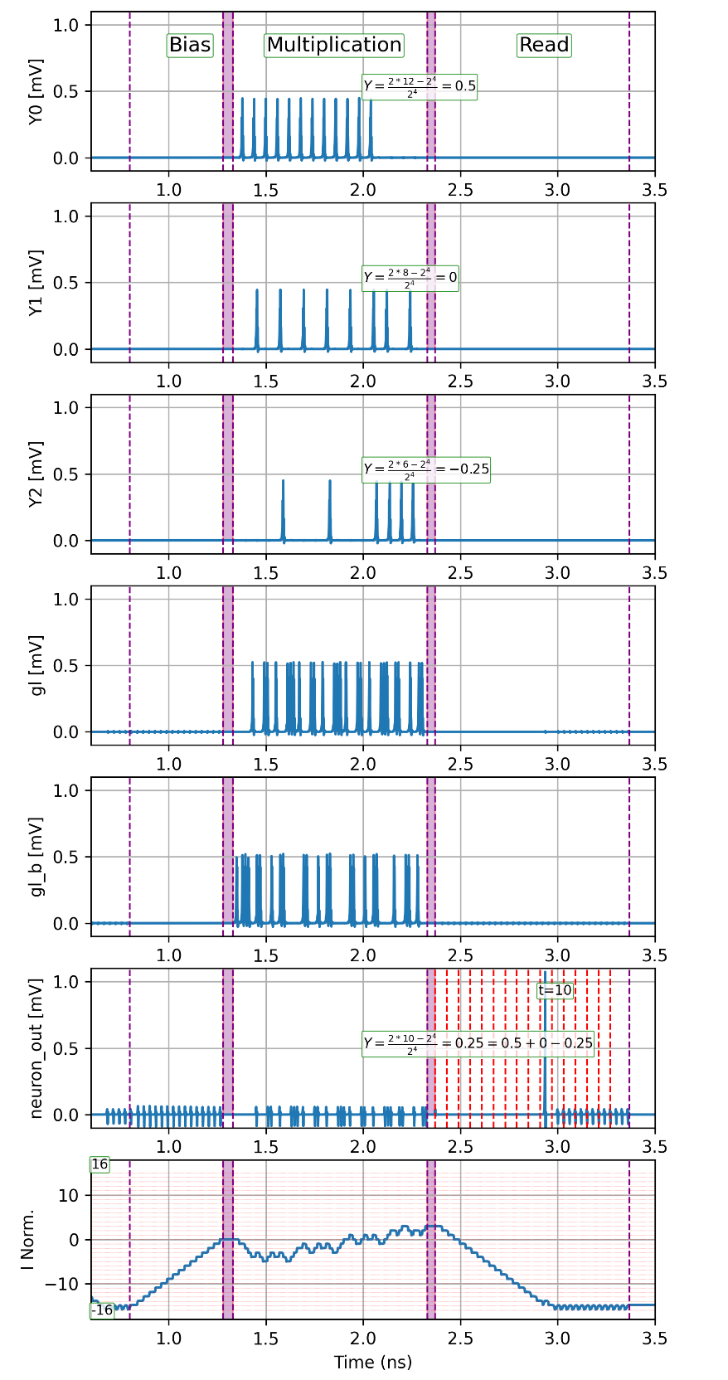
Figure S2. Example of neuron operation with three input synapses Y0=0.5, Y1=0, Y2=-0.25. The last row “I Norm” shows the normalized current in the analog buffer’s inductor with capacity for 32 pulses. The current in the inductor increases(decreases) with gl(gl_b). Signals gl(gl_b) are the synaptic and inverted synaptic outputs merged on a single stream.

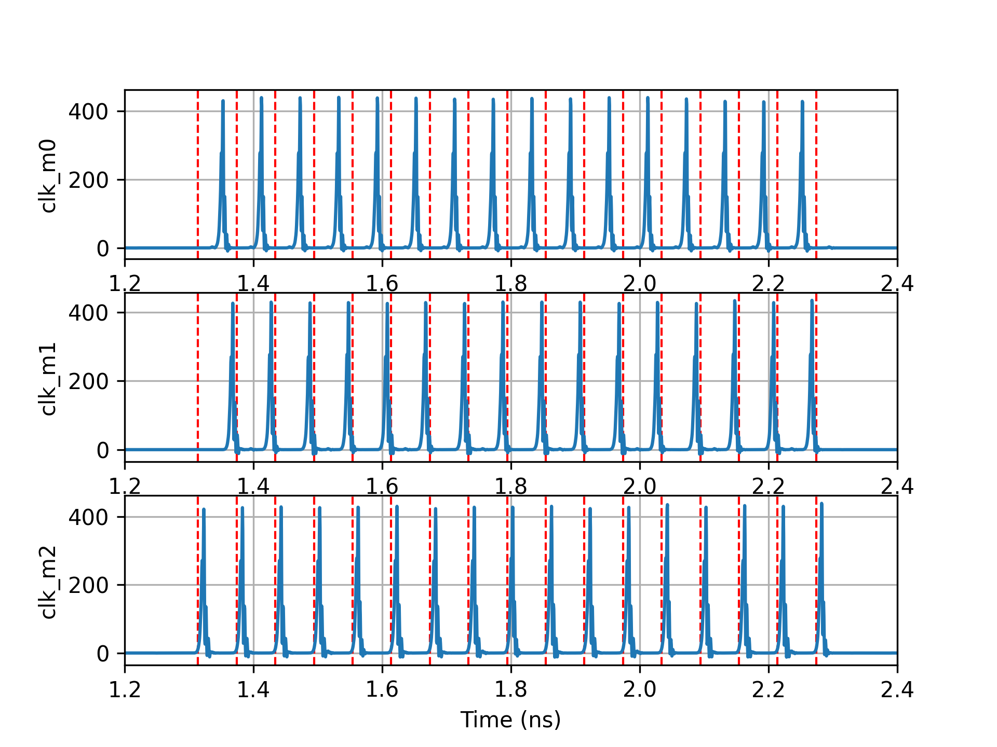
Figure S3. Example of clock phases used for driving three different synapses. Each output stream from the synapse operates on its own phase and won’t collide with the others at the input of the N:1 merger in the neuron.

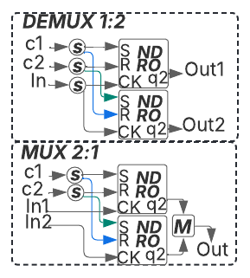
Figure S4. 2:1 Multiplexer (MUX 2:1) and 1:2 Demultiplexer (DEMUX 1:2) used for the analog double buffer scheme.

