Supplementary Information for

Social Media Reveals Gaps Between Climate Action and Public Perception from National to City Scales

Part 1. Supplementary Figures

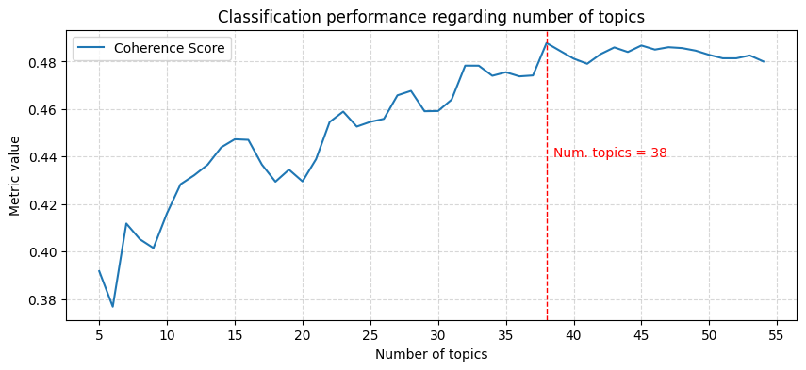
Figure S1. Coherence score of topic modeling on NDC

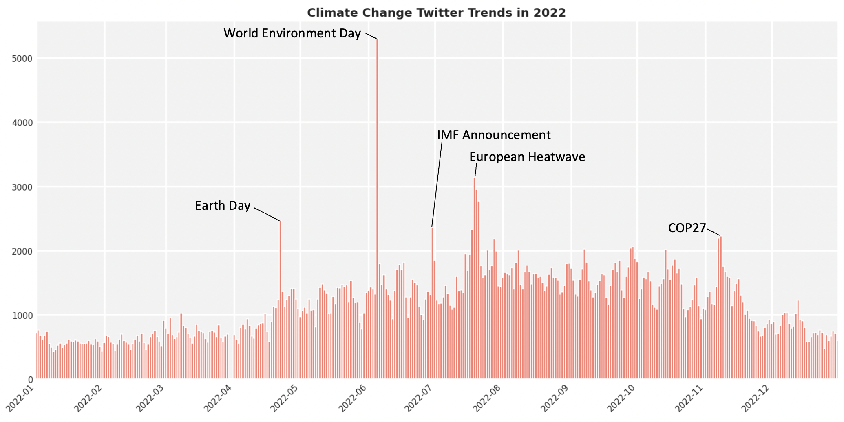
Figure S2. Number of climate-related tweets in 2022

T1: Emission accounting  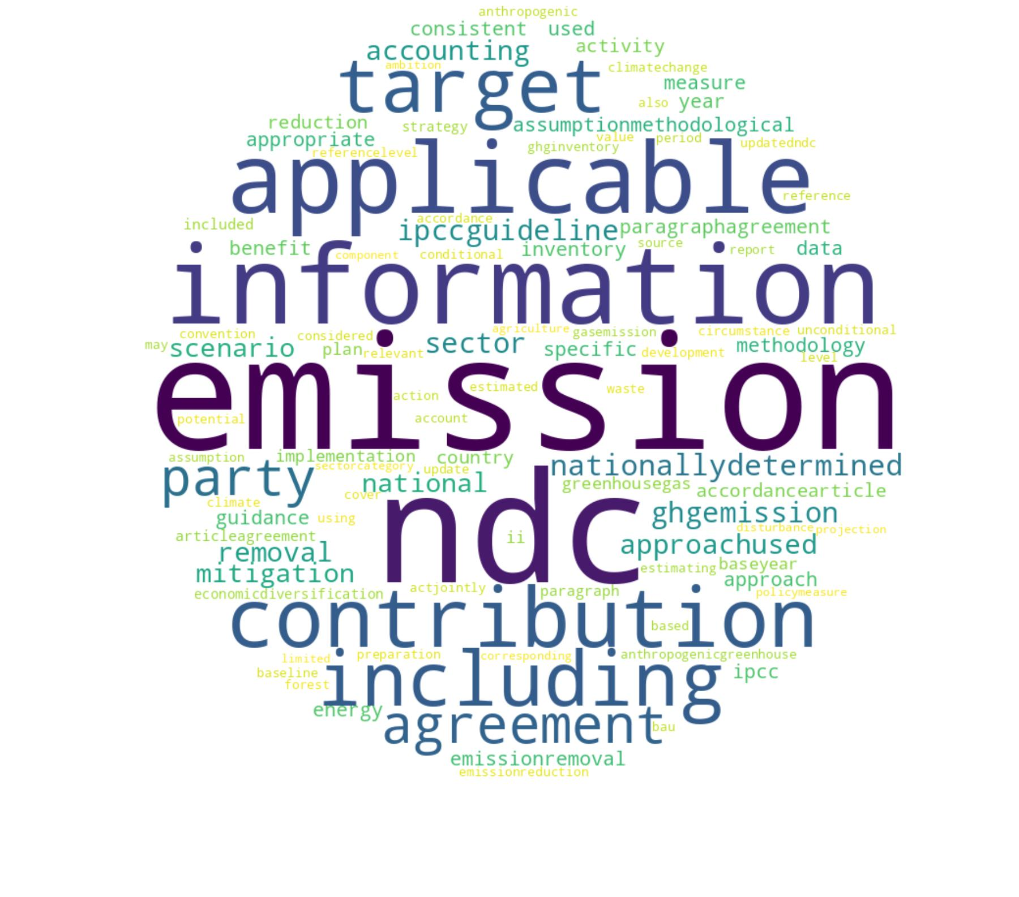 | T2: Renewable energy  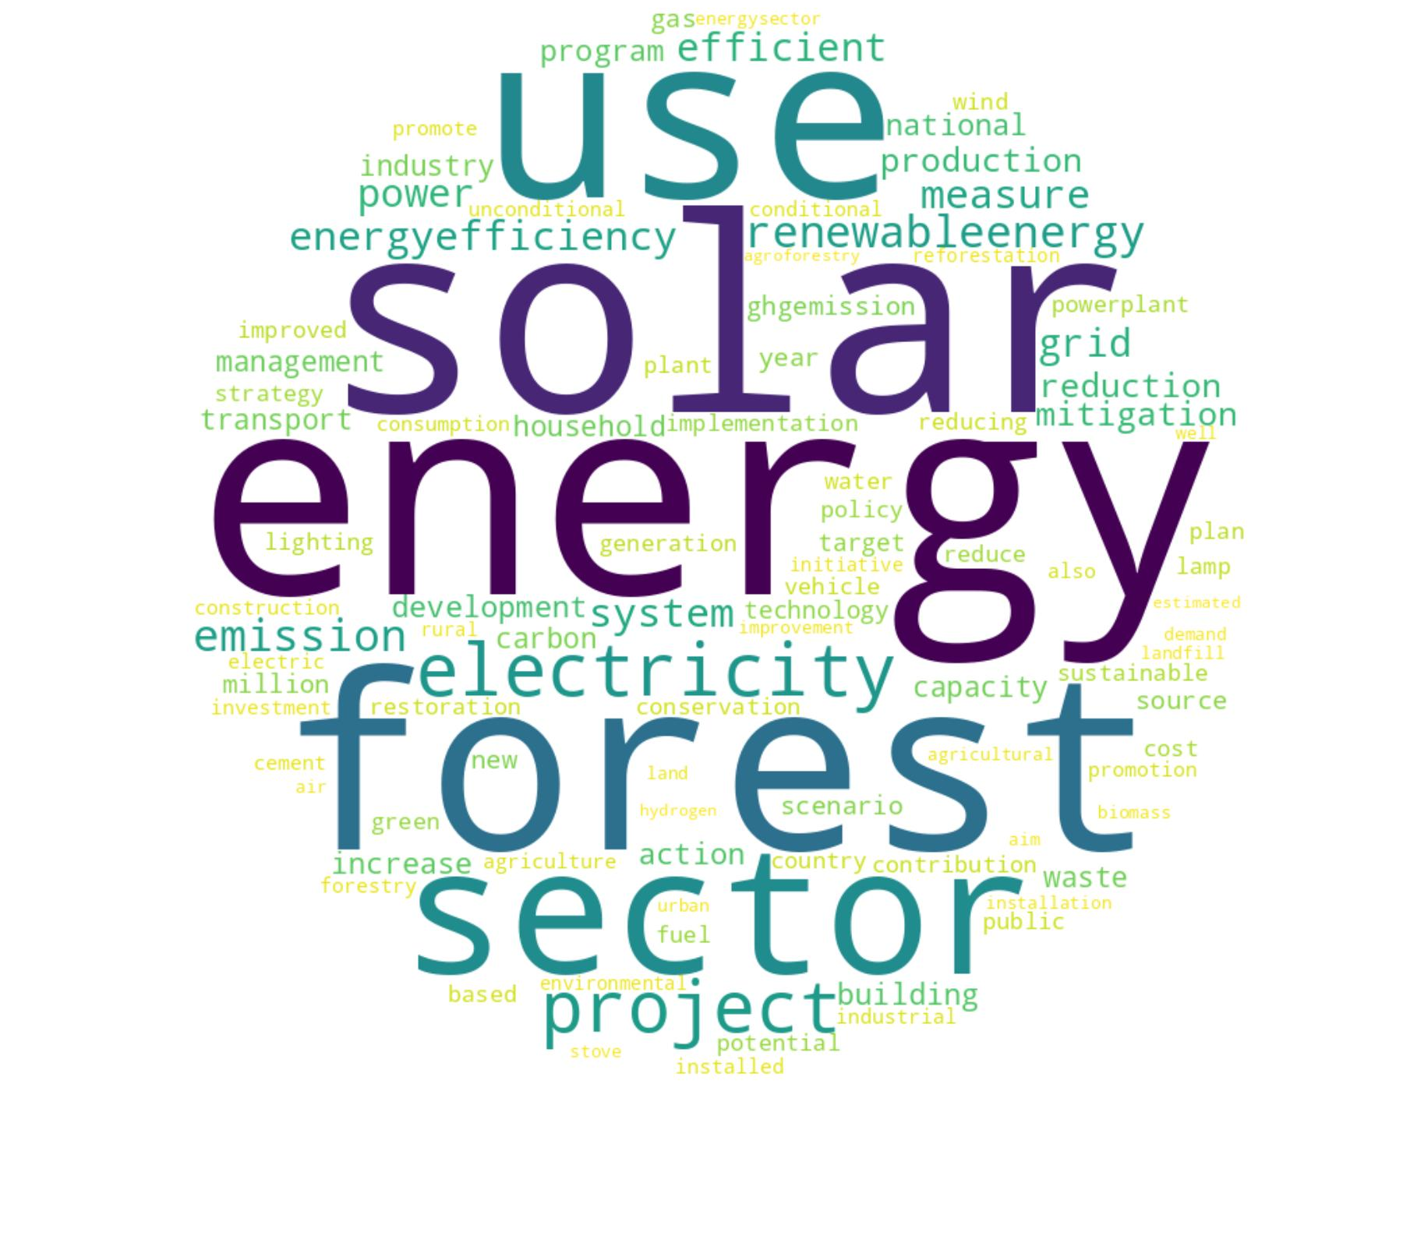 | T3: Resilience strategies  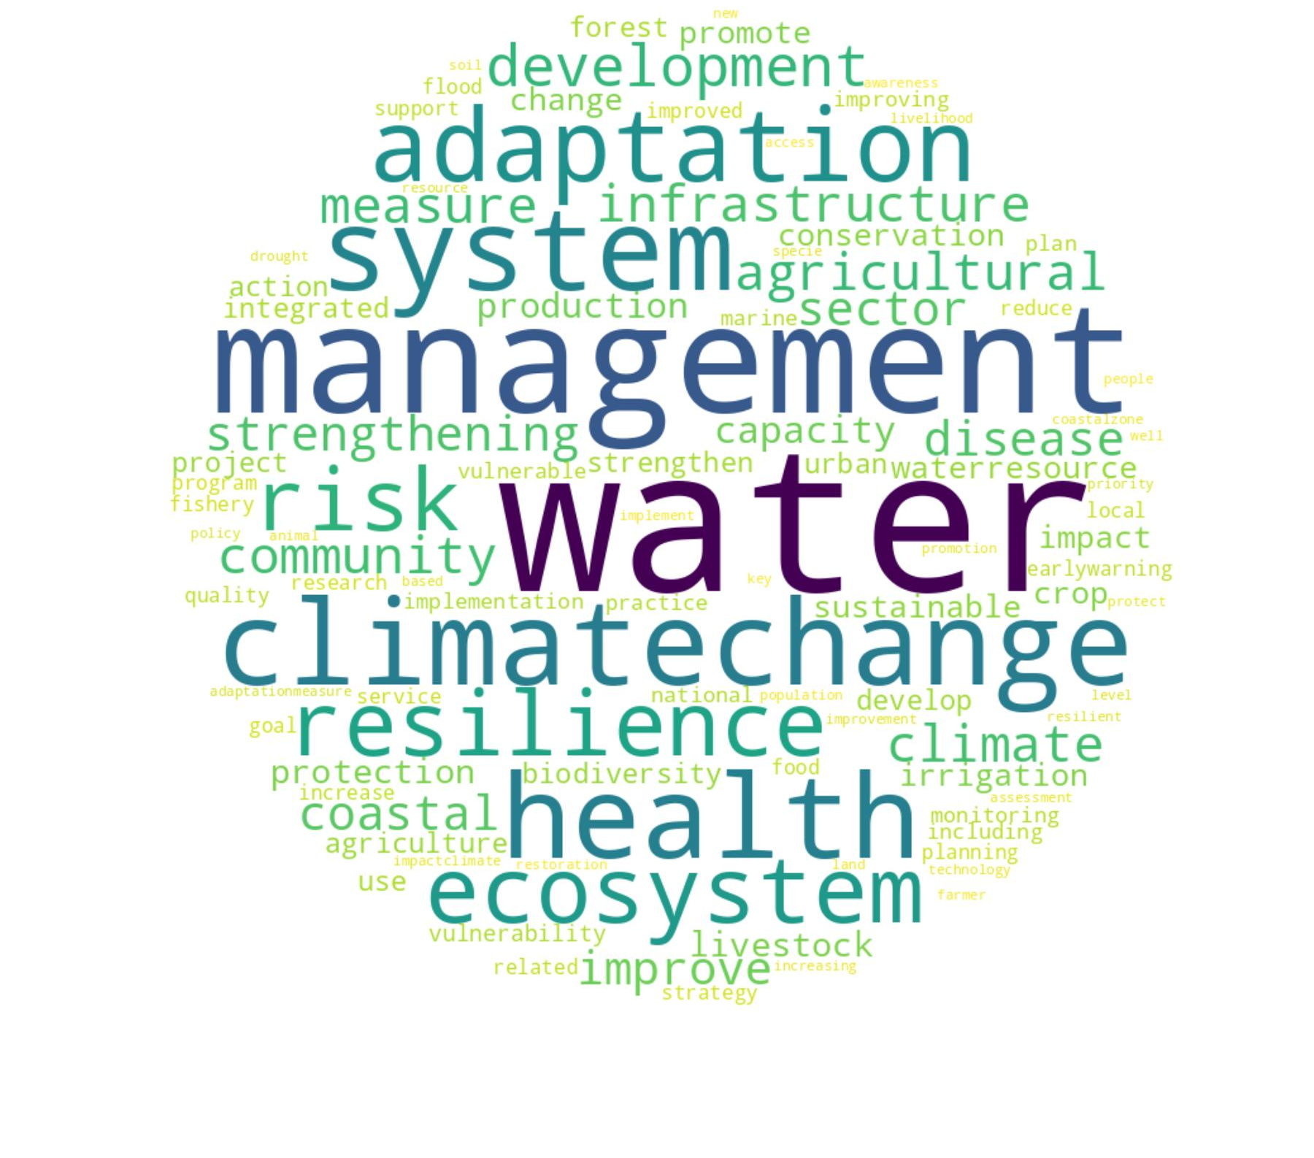 | T4: Adaptation processes  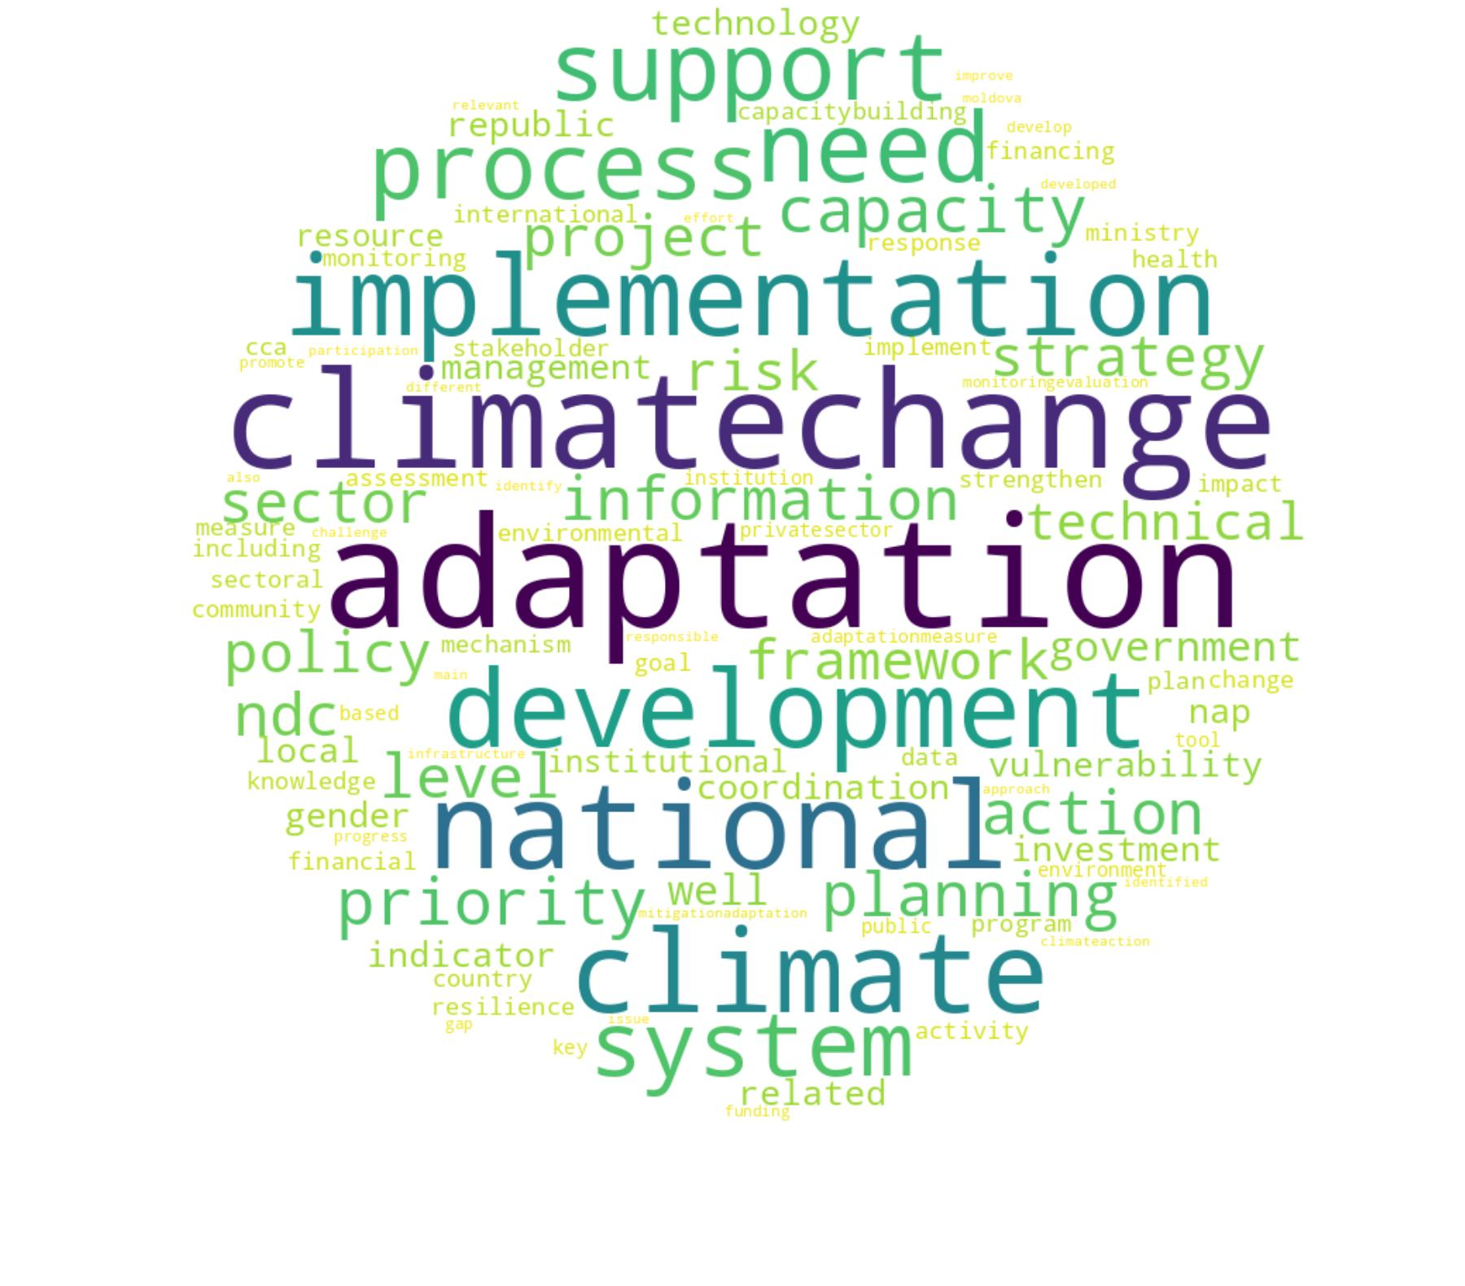 | T5: Targets and ambition  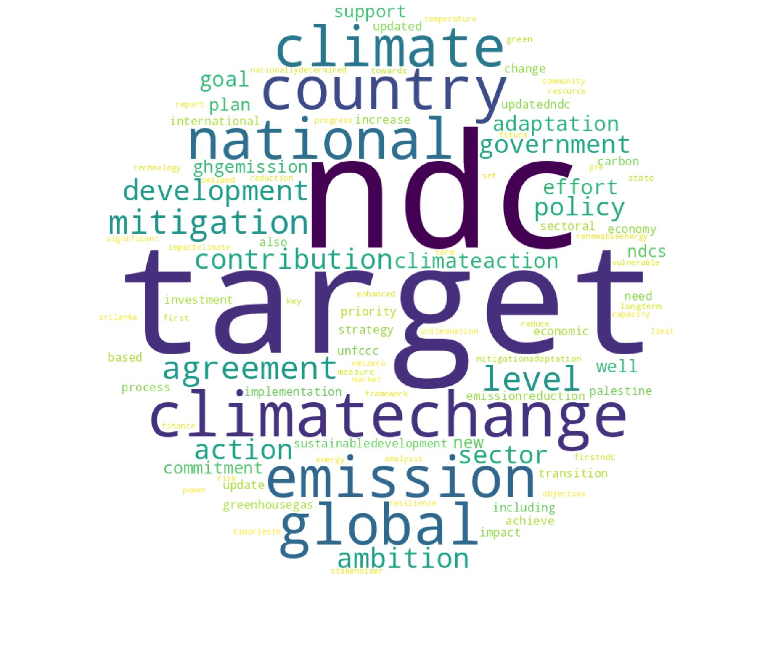 | T6: Climate impact  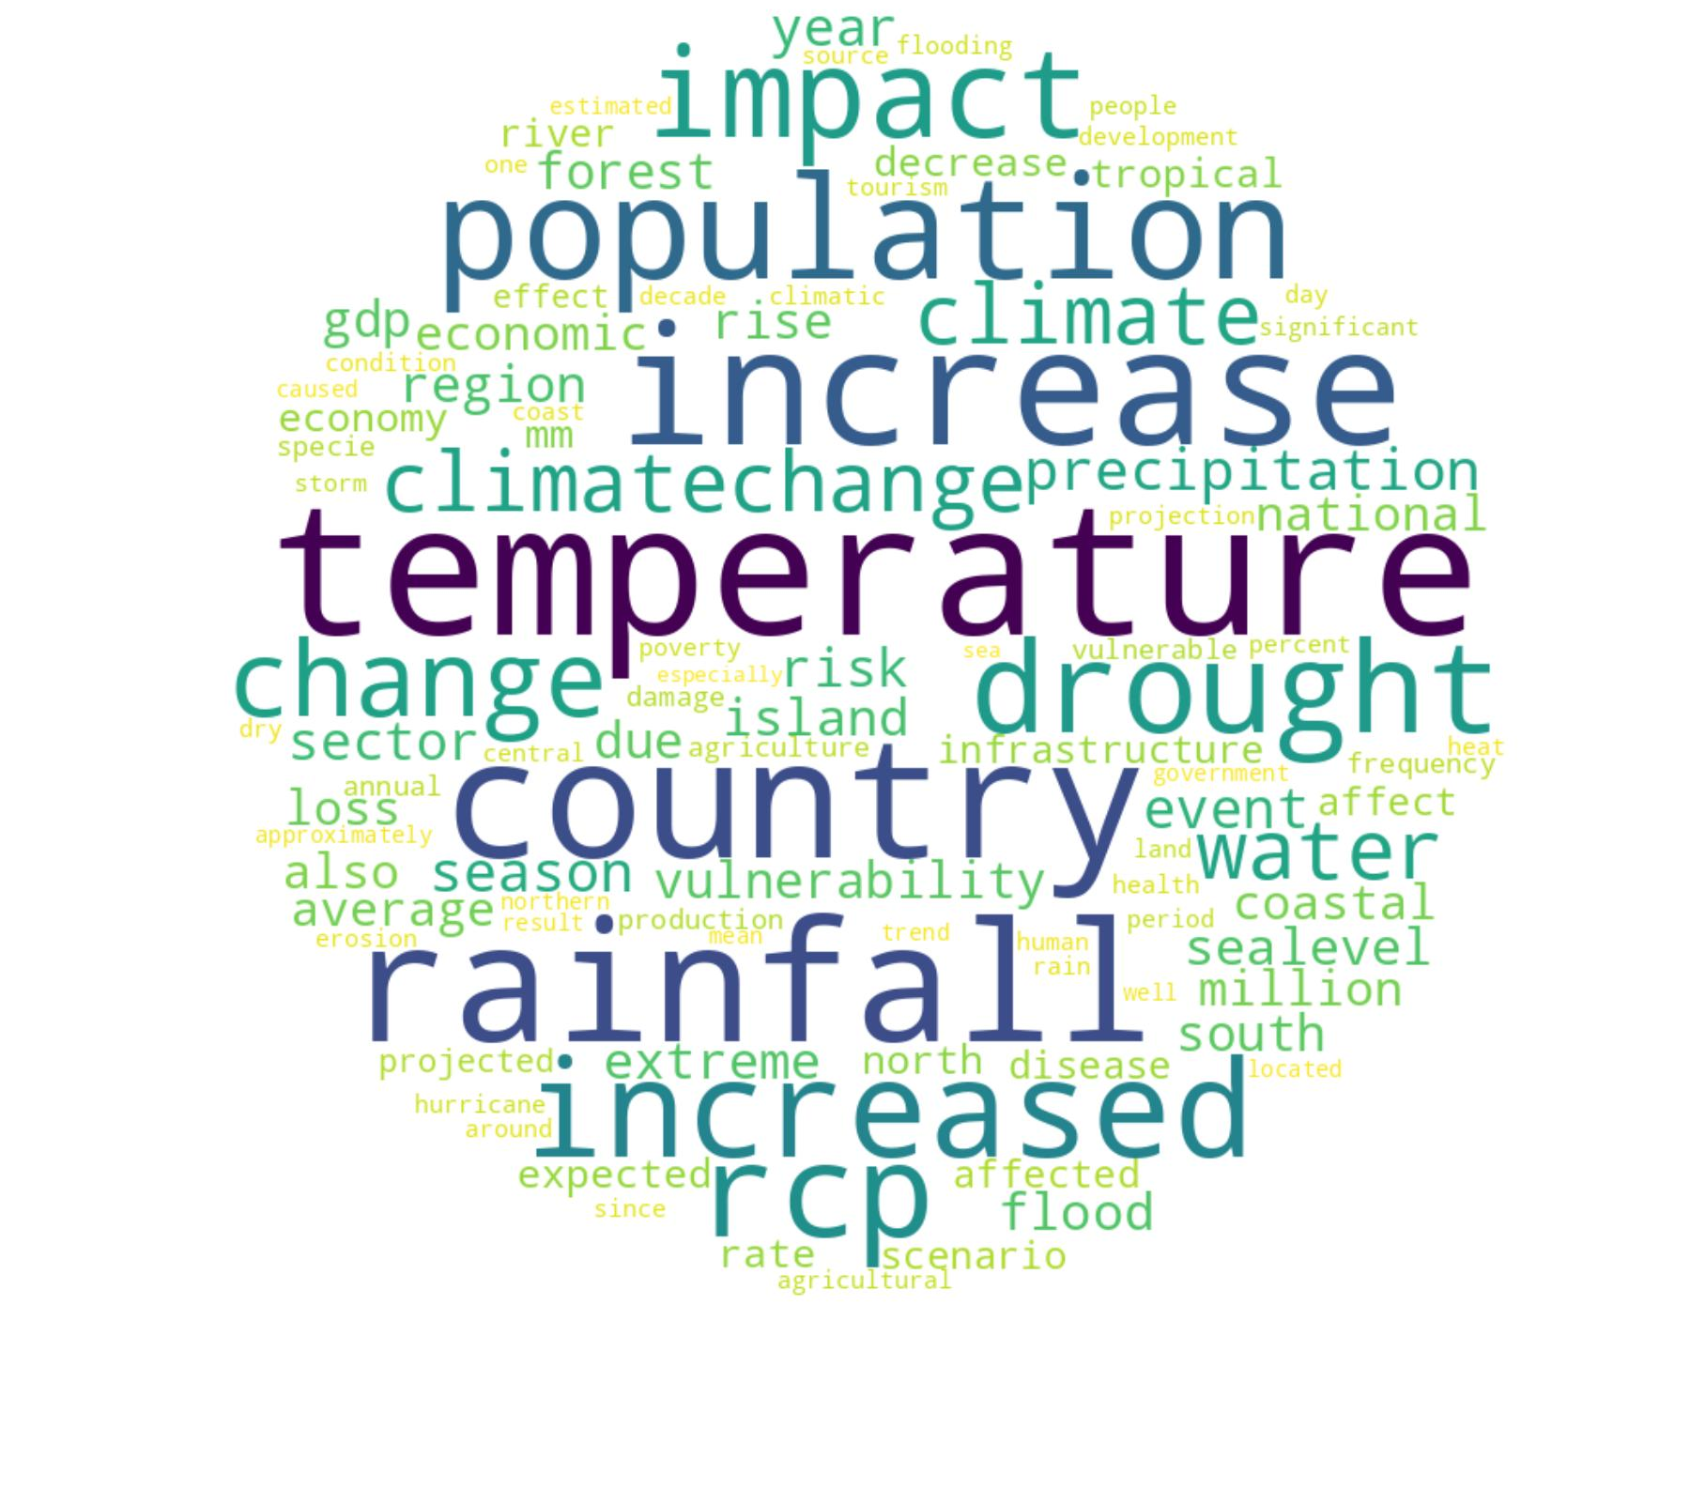 | T7: Governance and direction  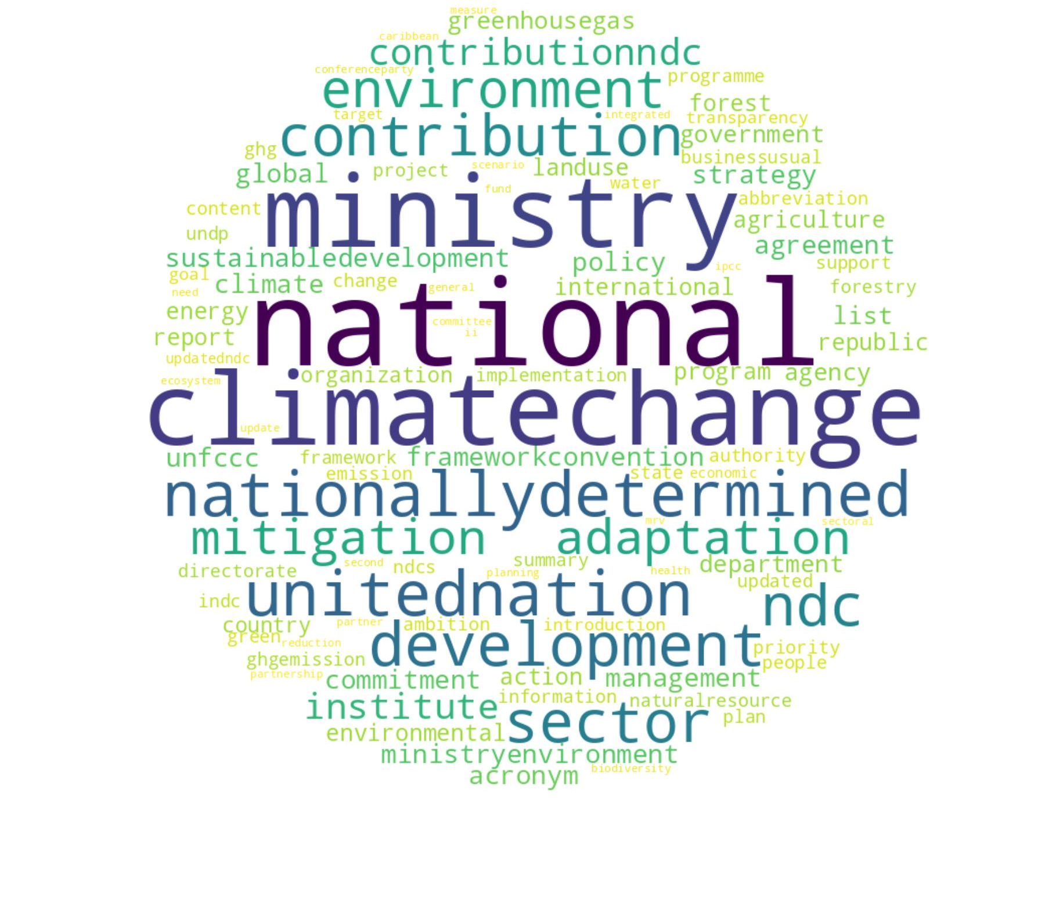 | T8: Regulatory frameworks  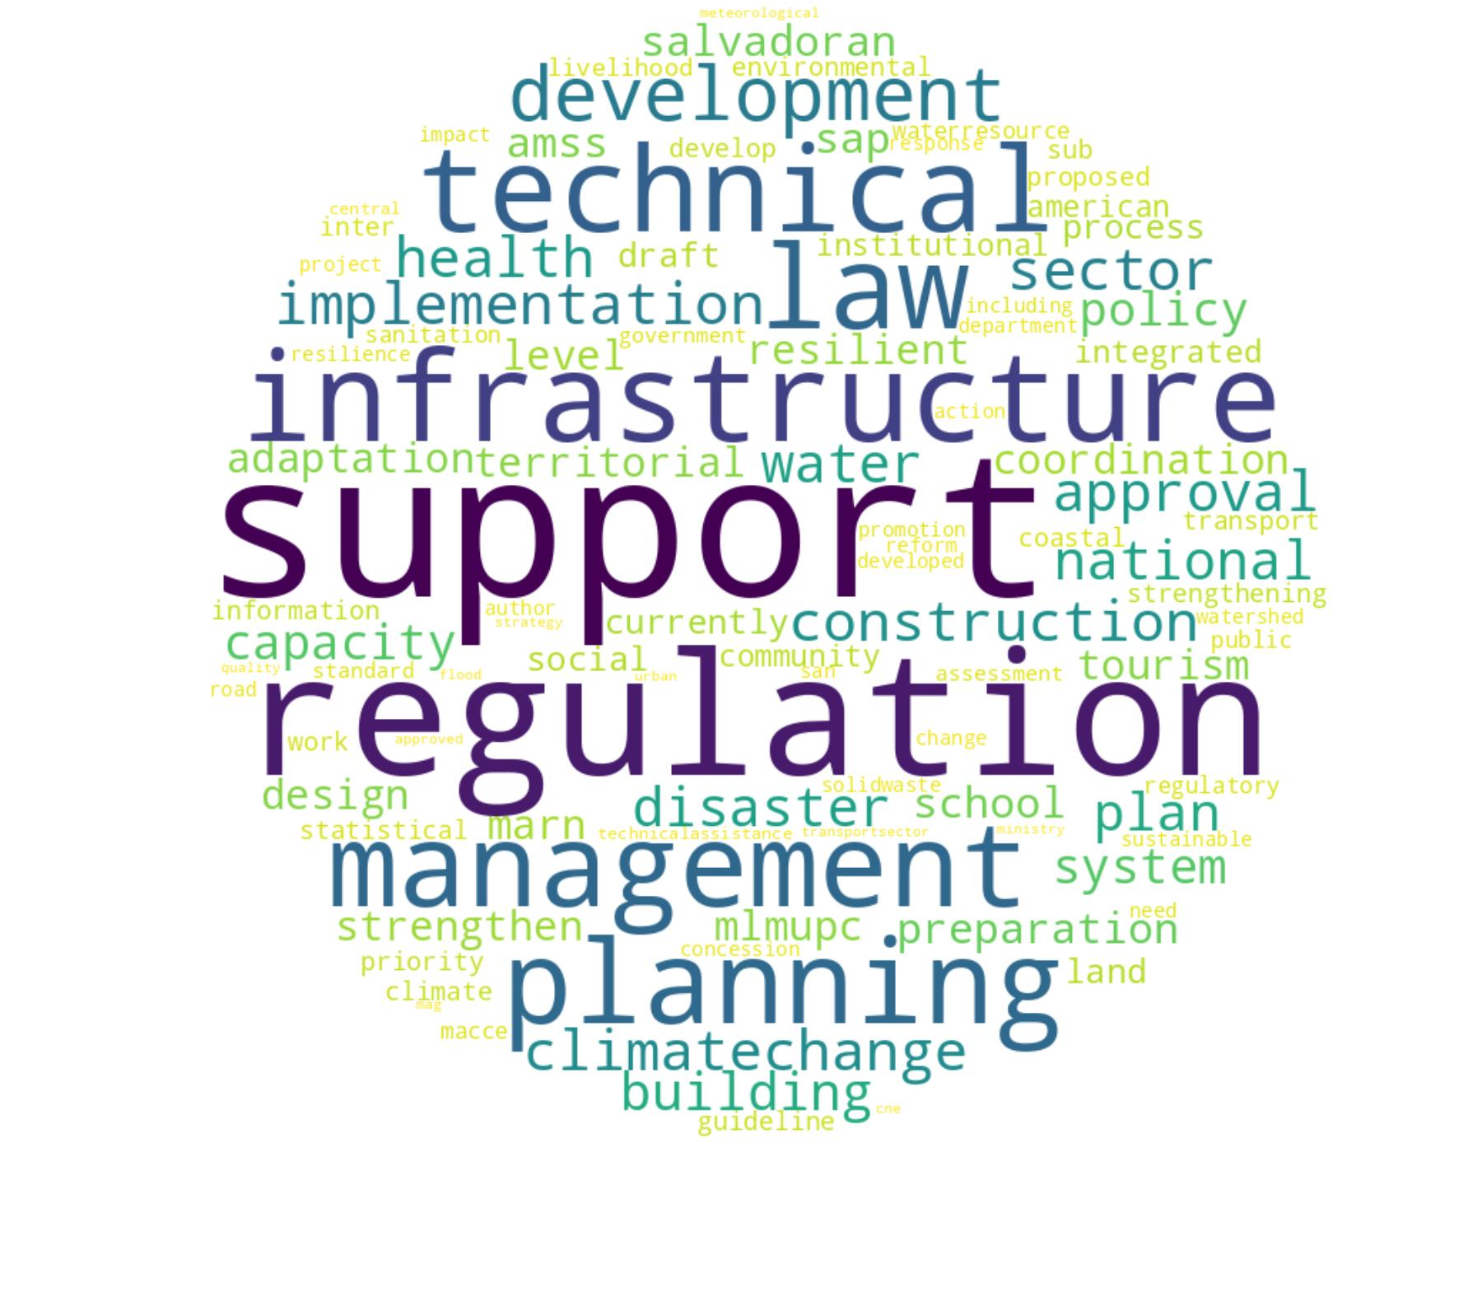
T9: Sustainable resource use  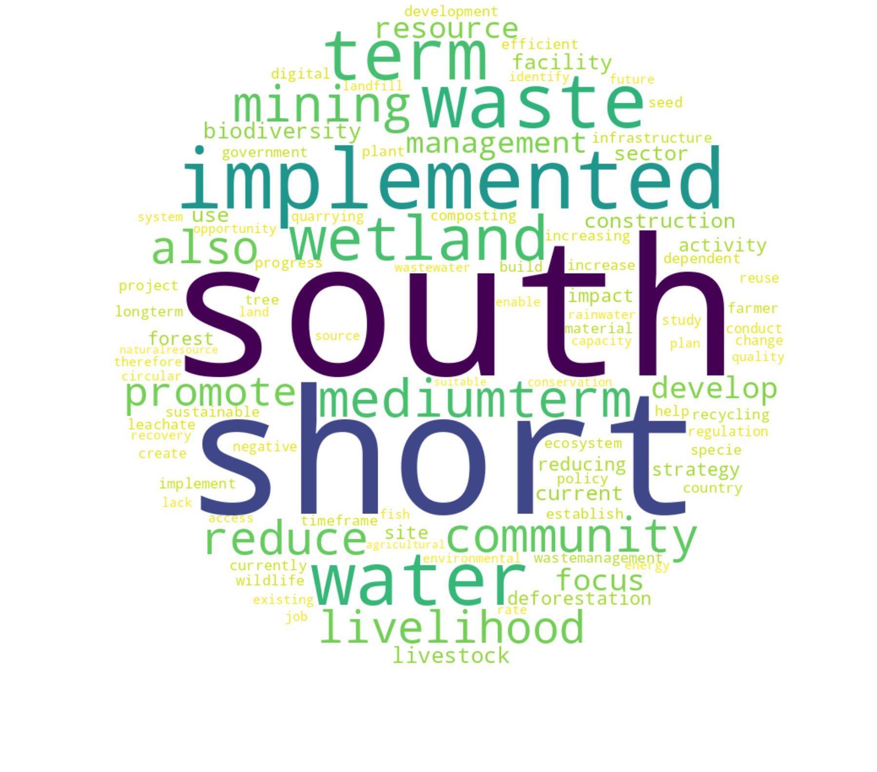 | T10: Waste and emission  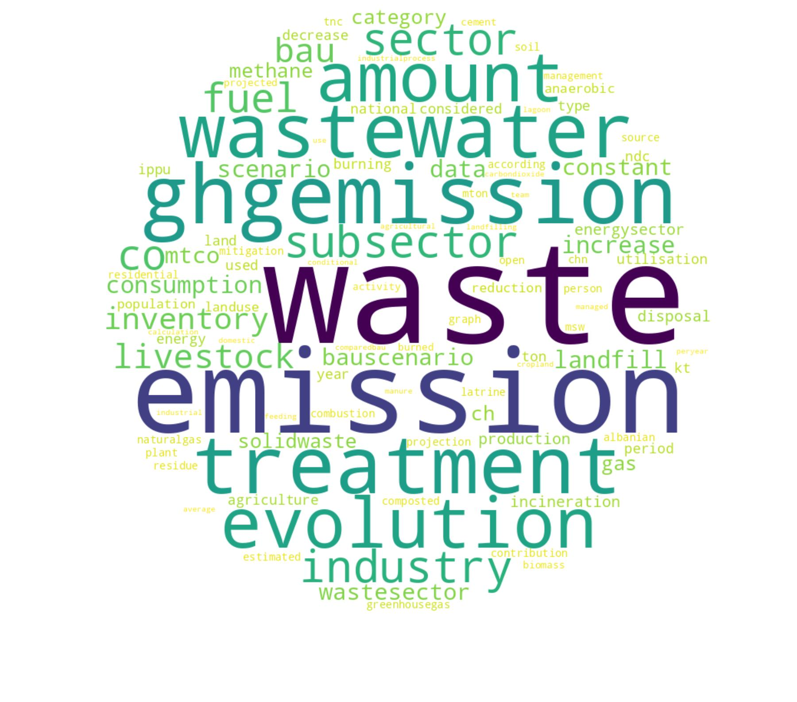 | T11: Environmental ministries   | T12: Projects and management  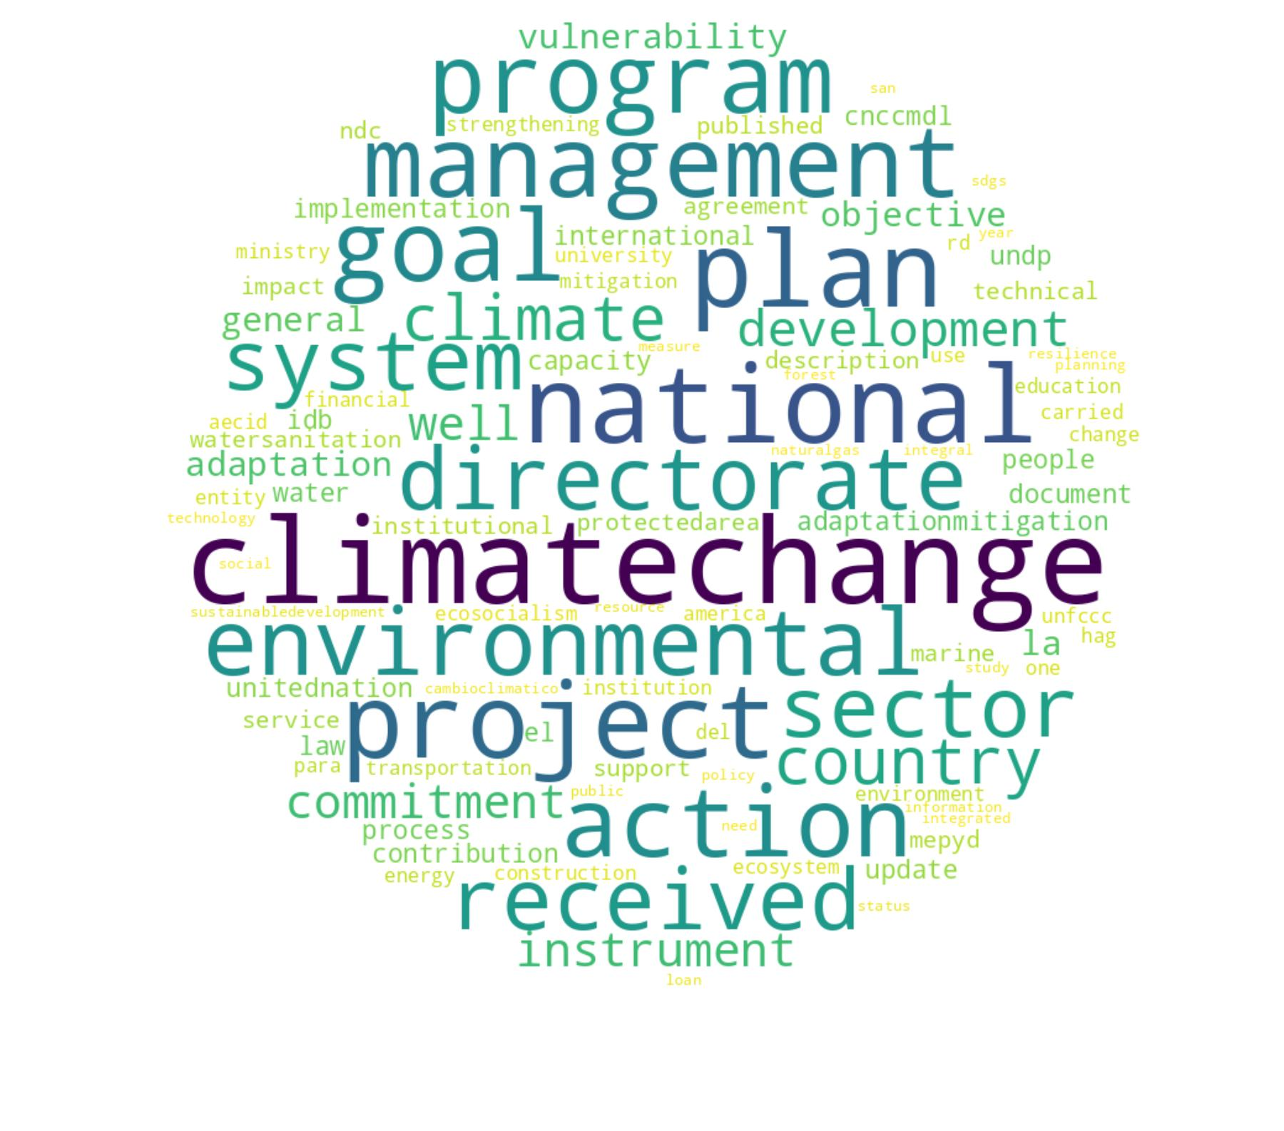 | T13: Gender and community   | T14: Carbon and forest economy  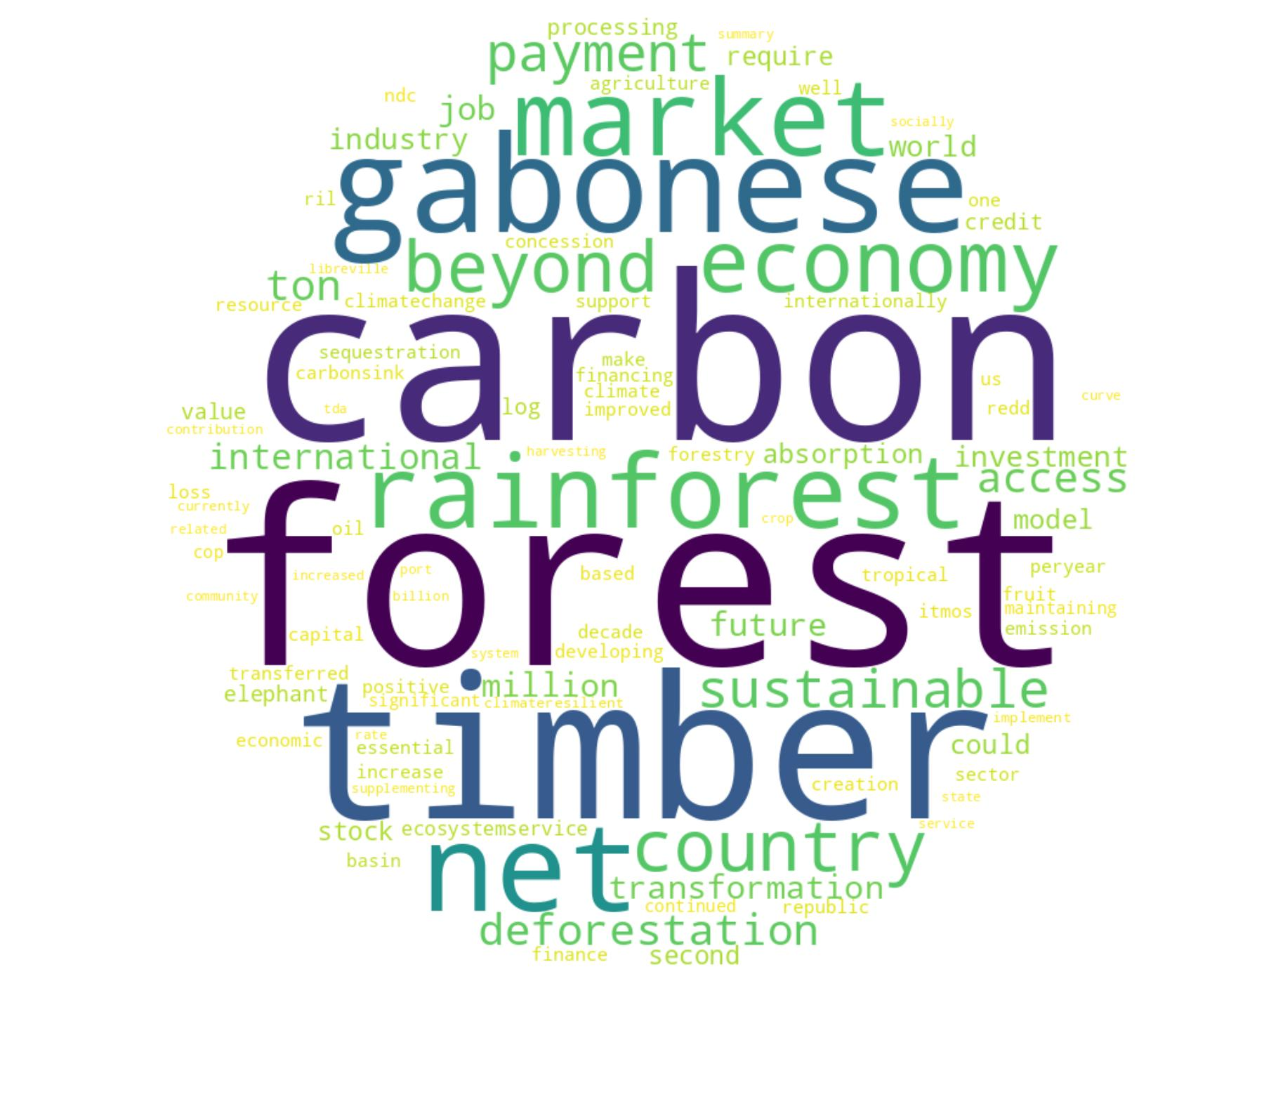 | T15: Climate finance  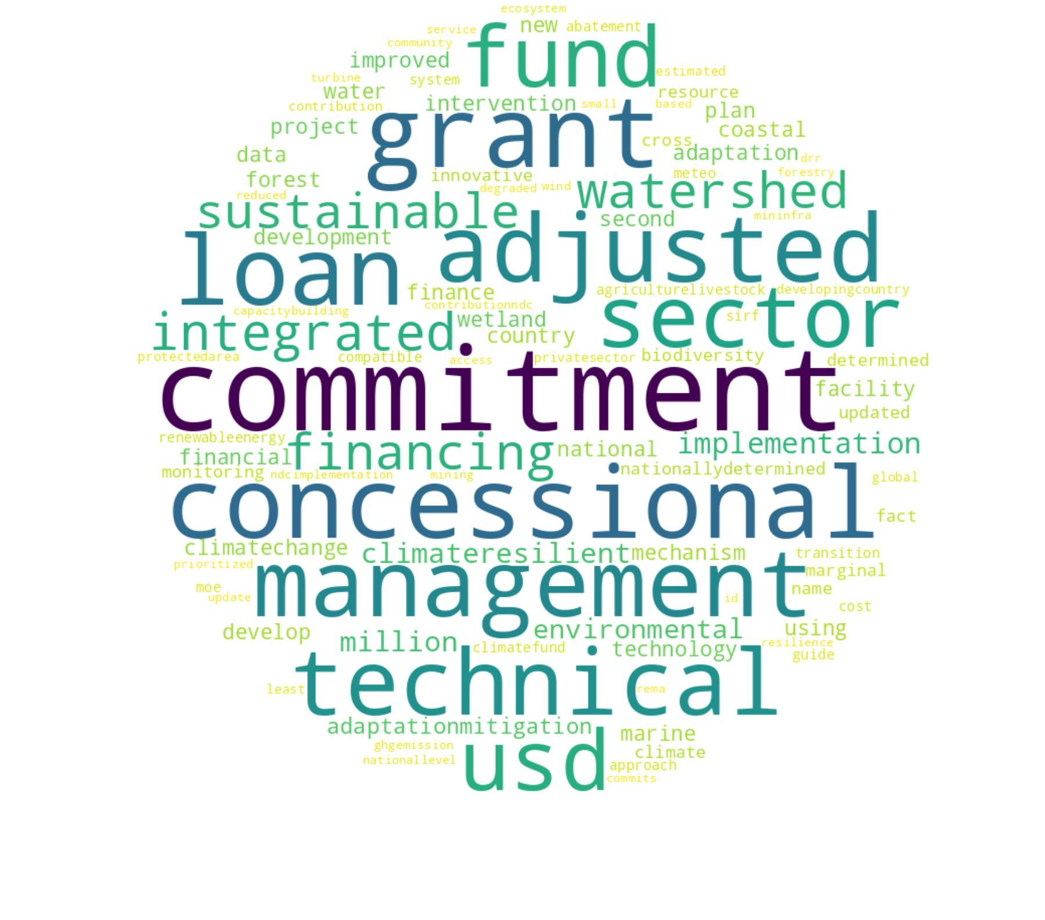 | T16: Government official sources  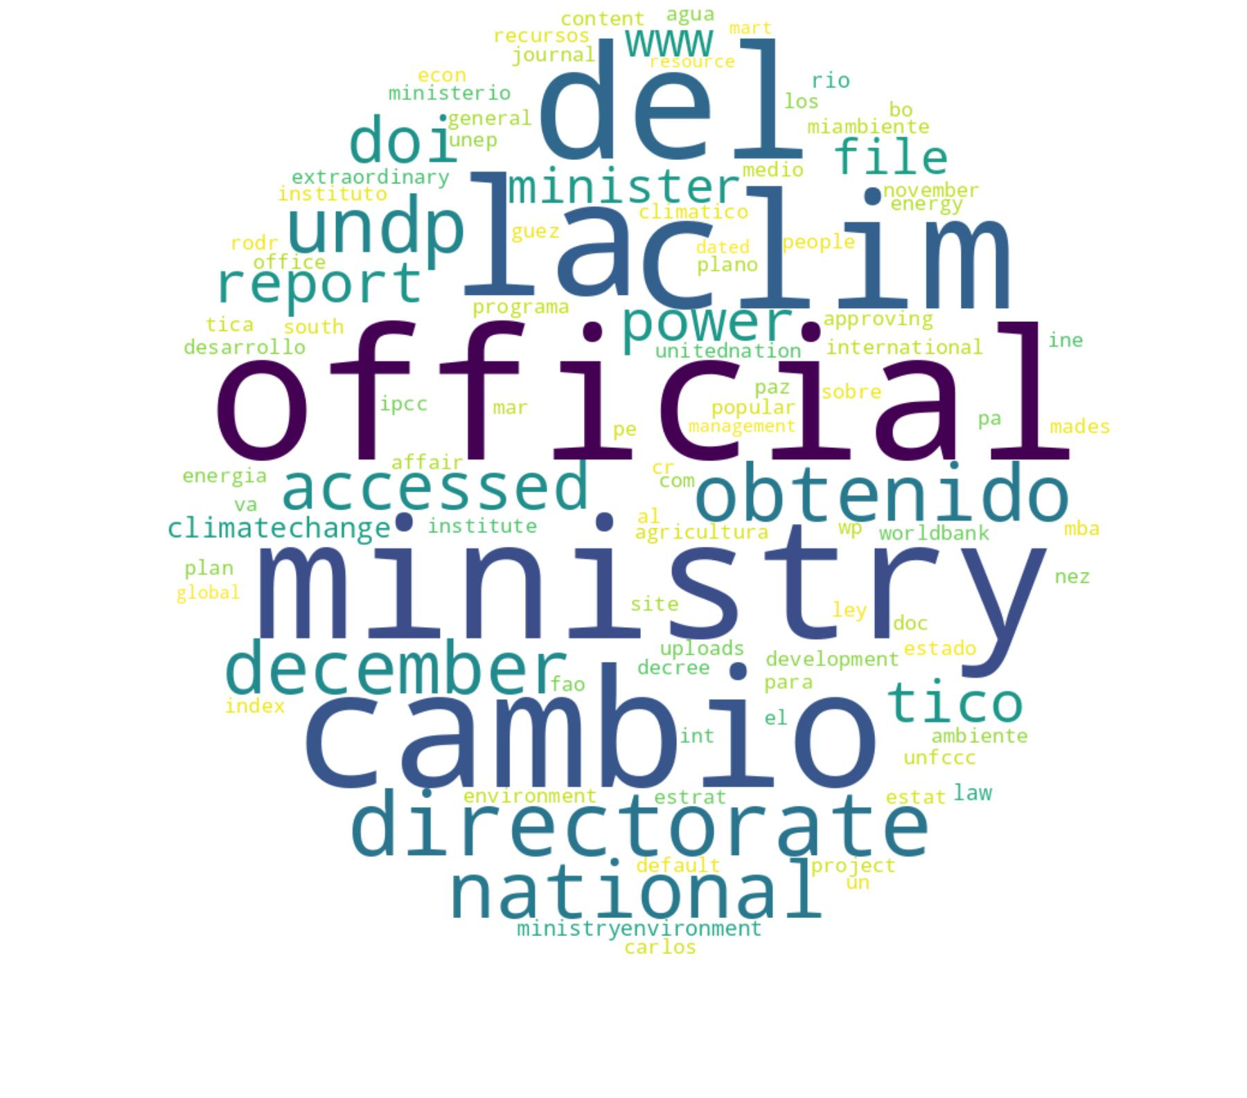
T17: Resource extraction  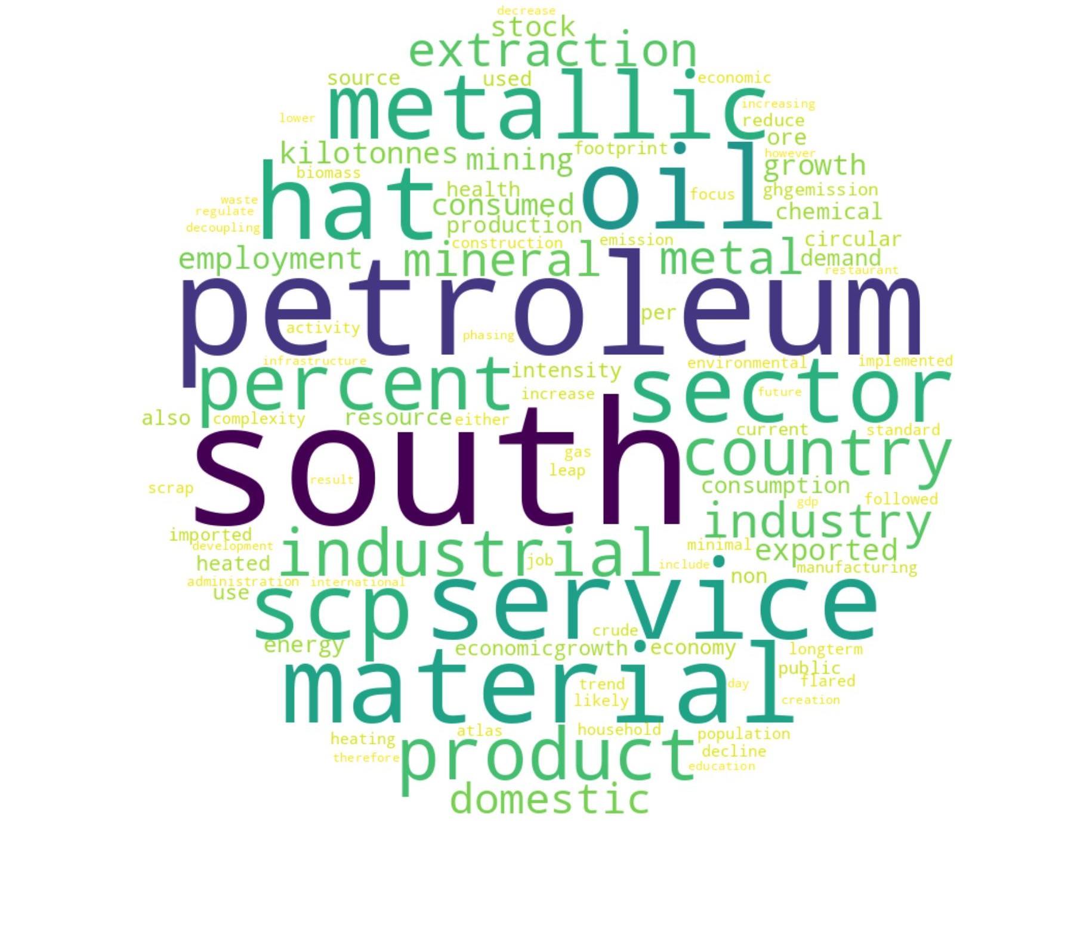 | T18: Public transport systems  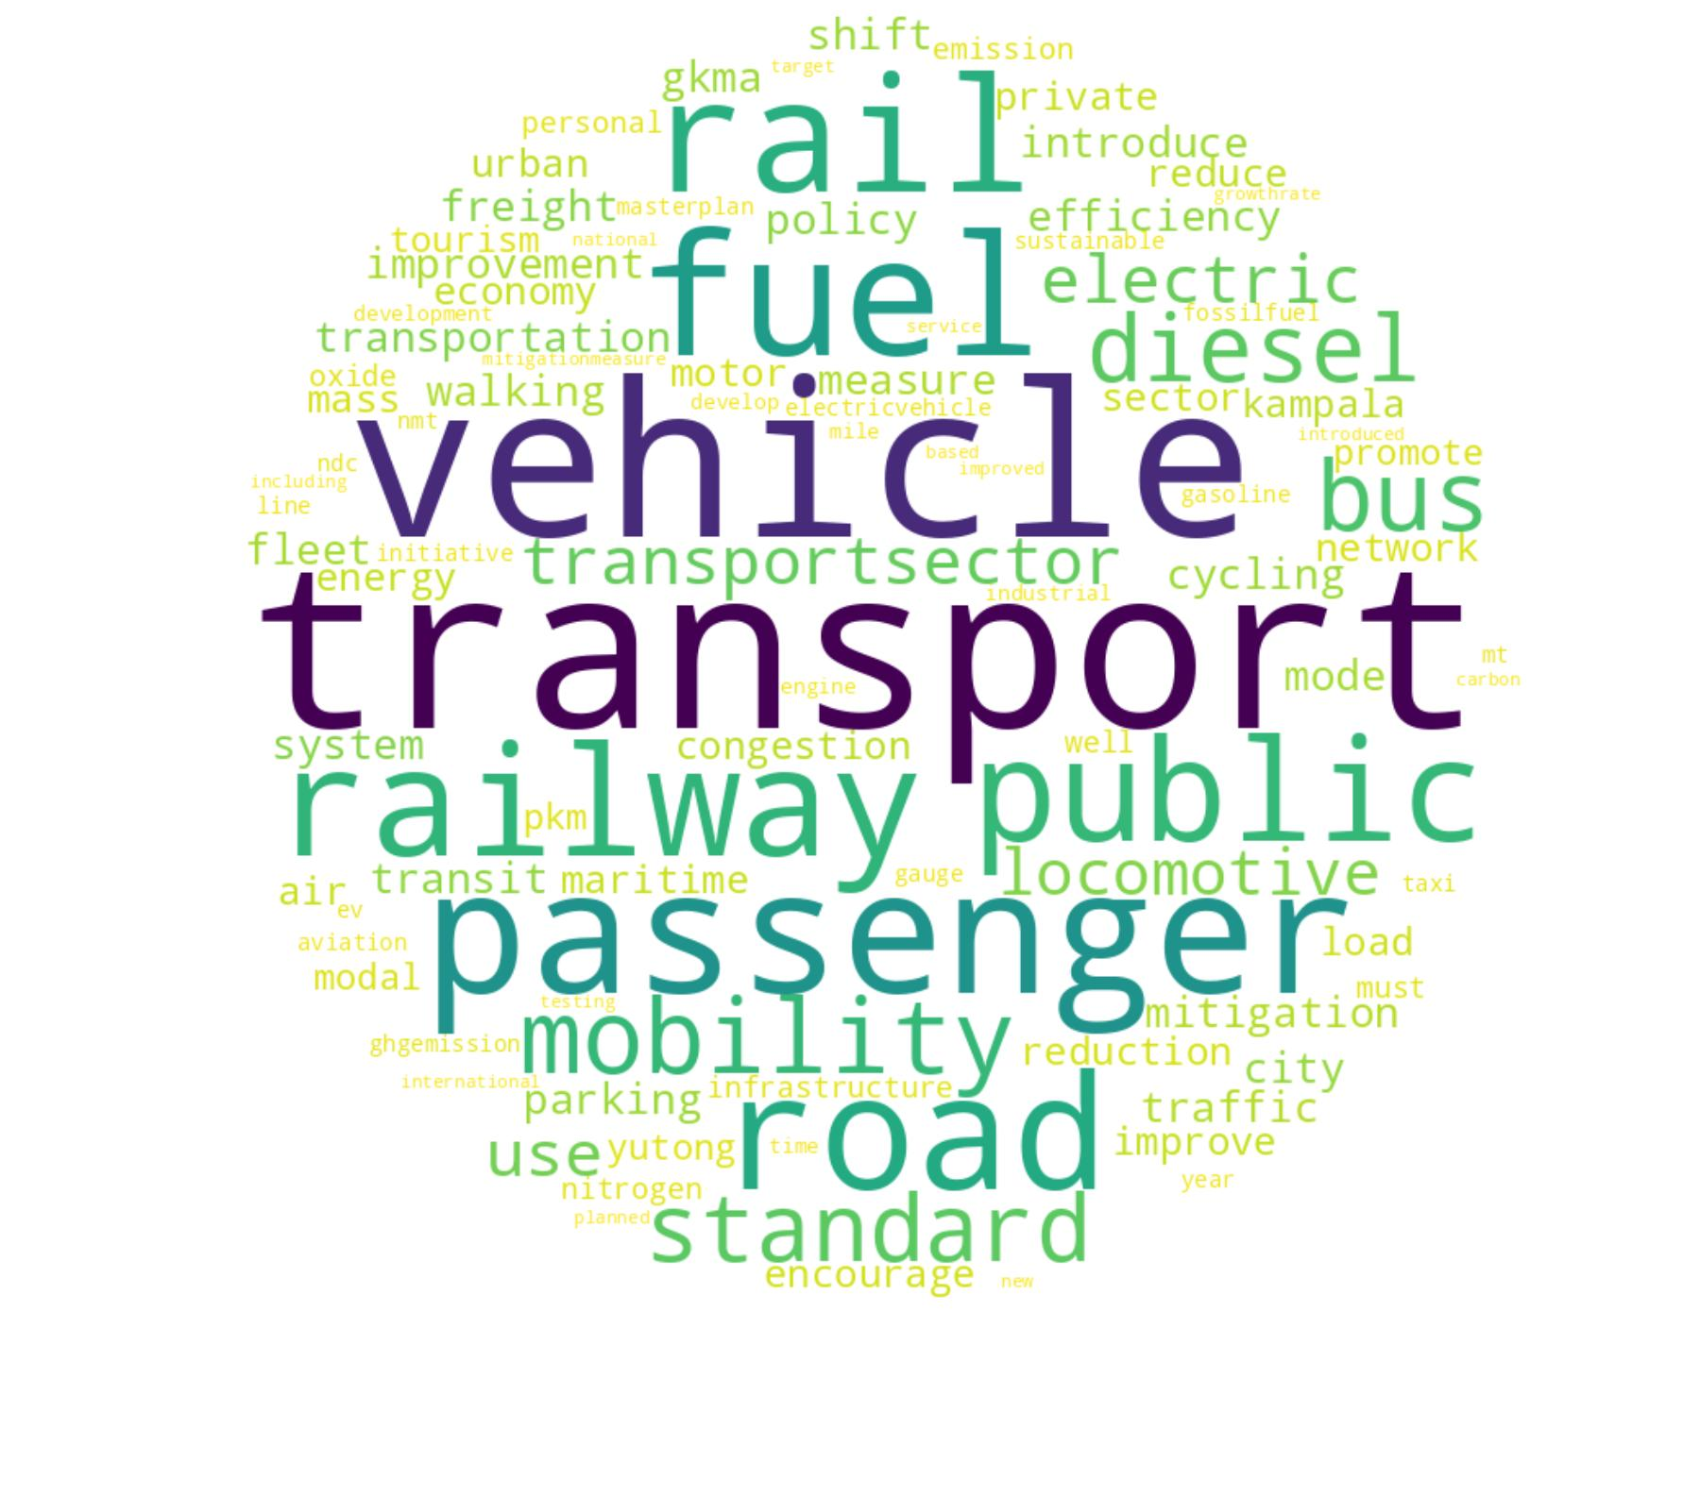 | T19: Sectoral emission mitigation  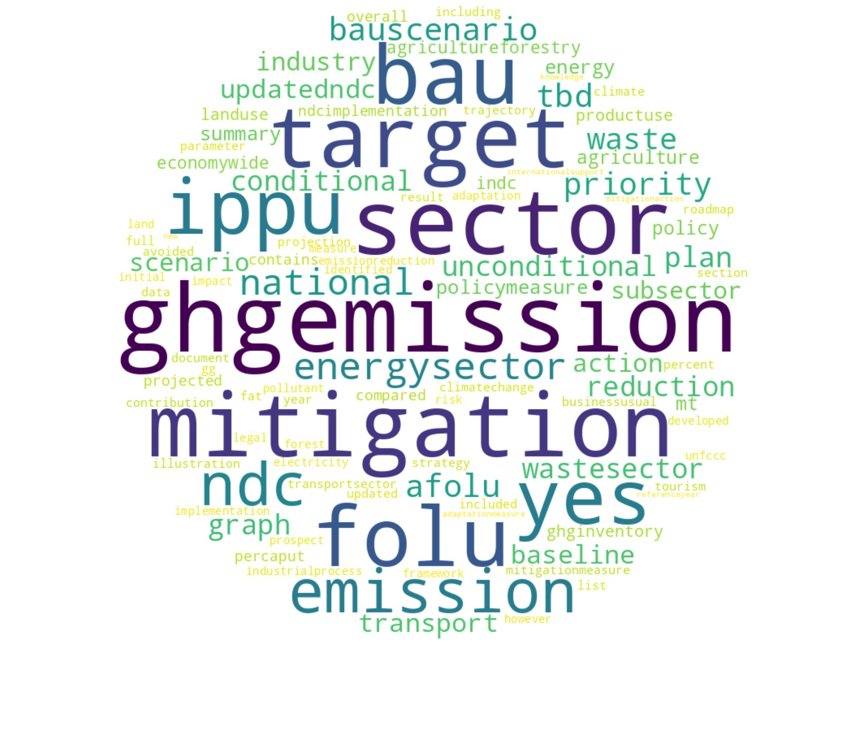 | T20: Freight and transportation  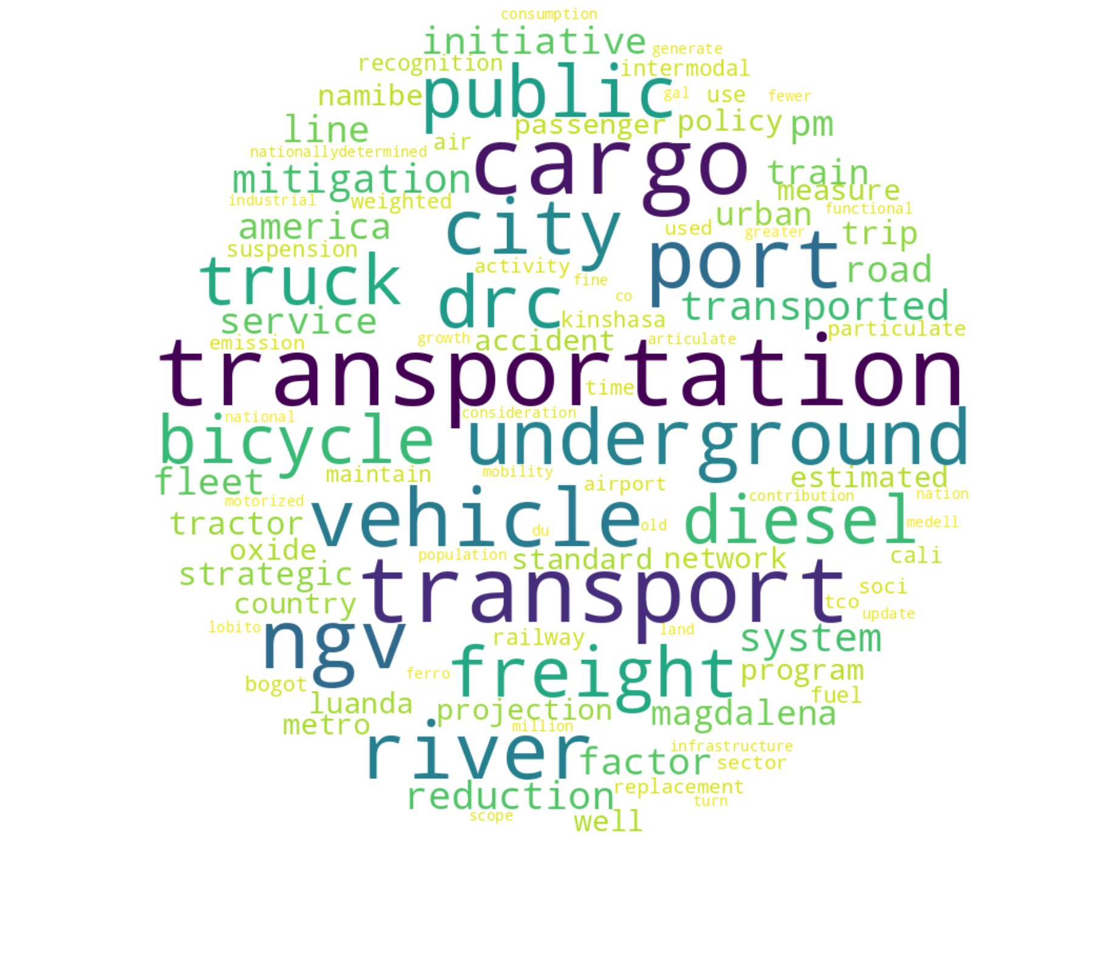 | T21: MRV systems   | T22: Youth and sustainability  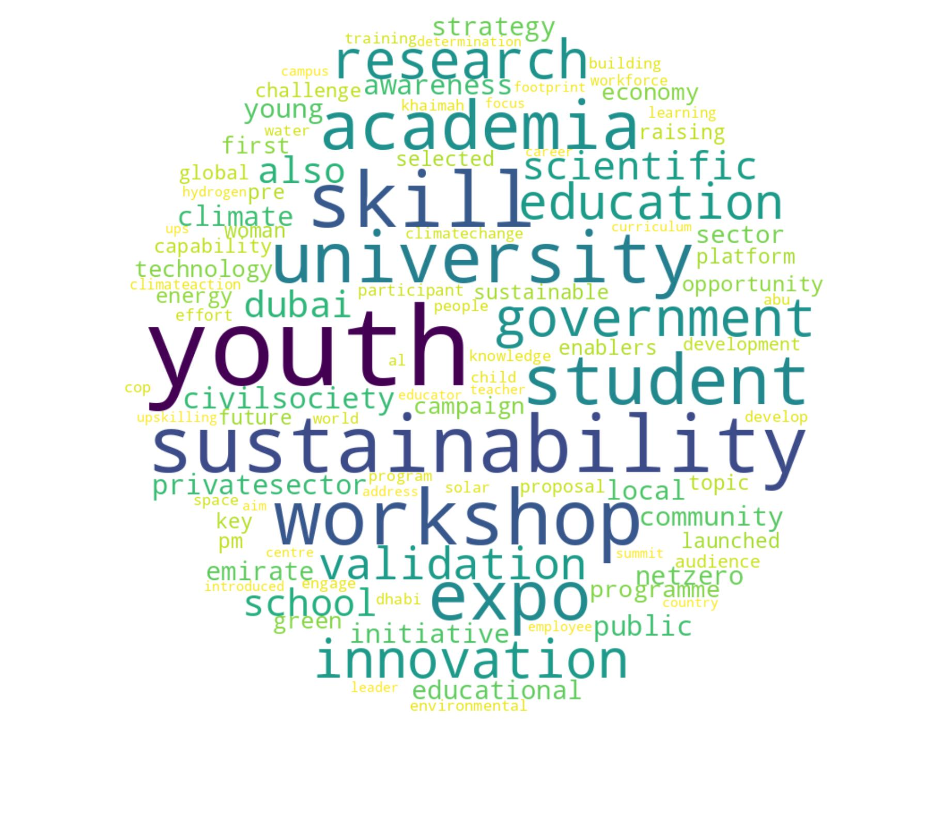 | T23: GHG emissions commitments  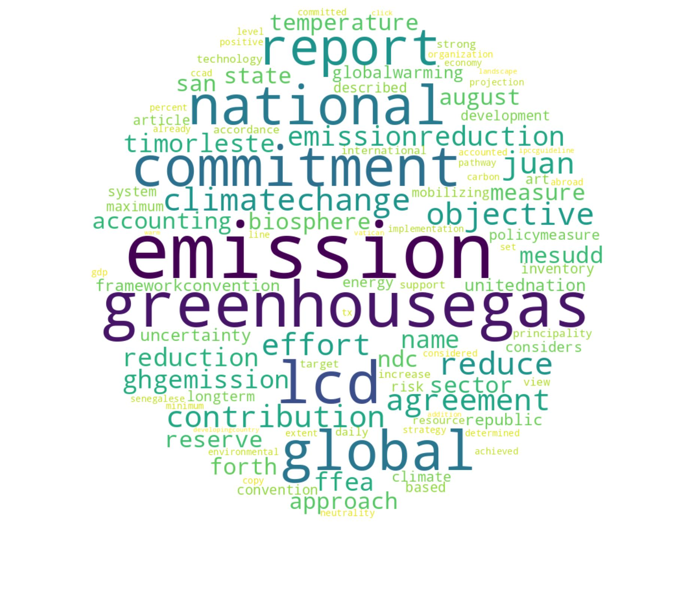 | T24: Public consultation  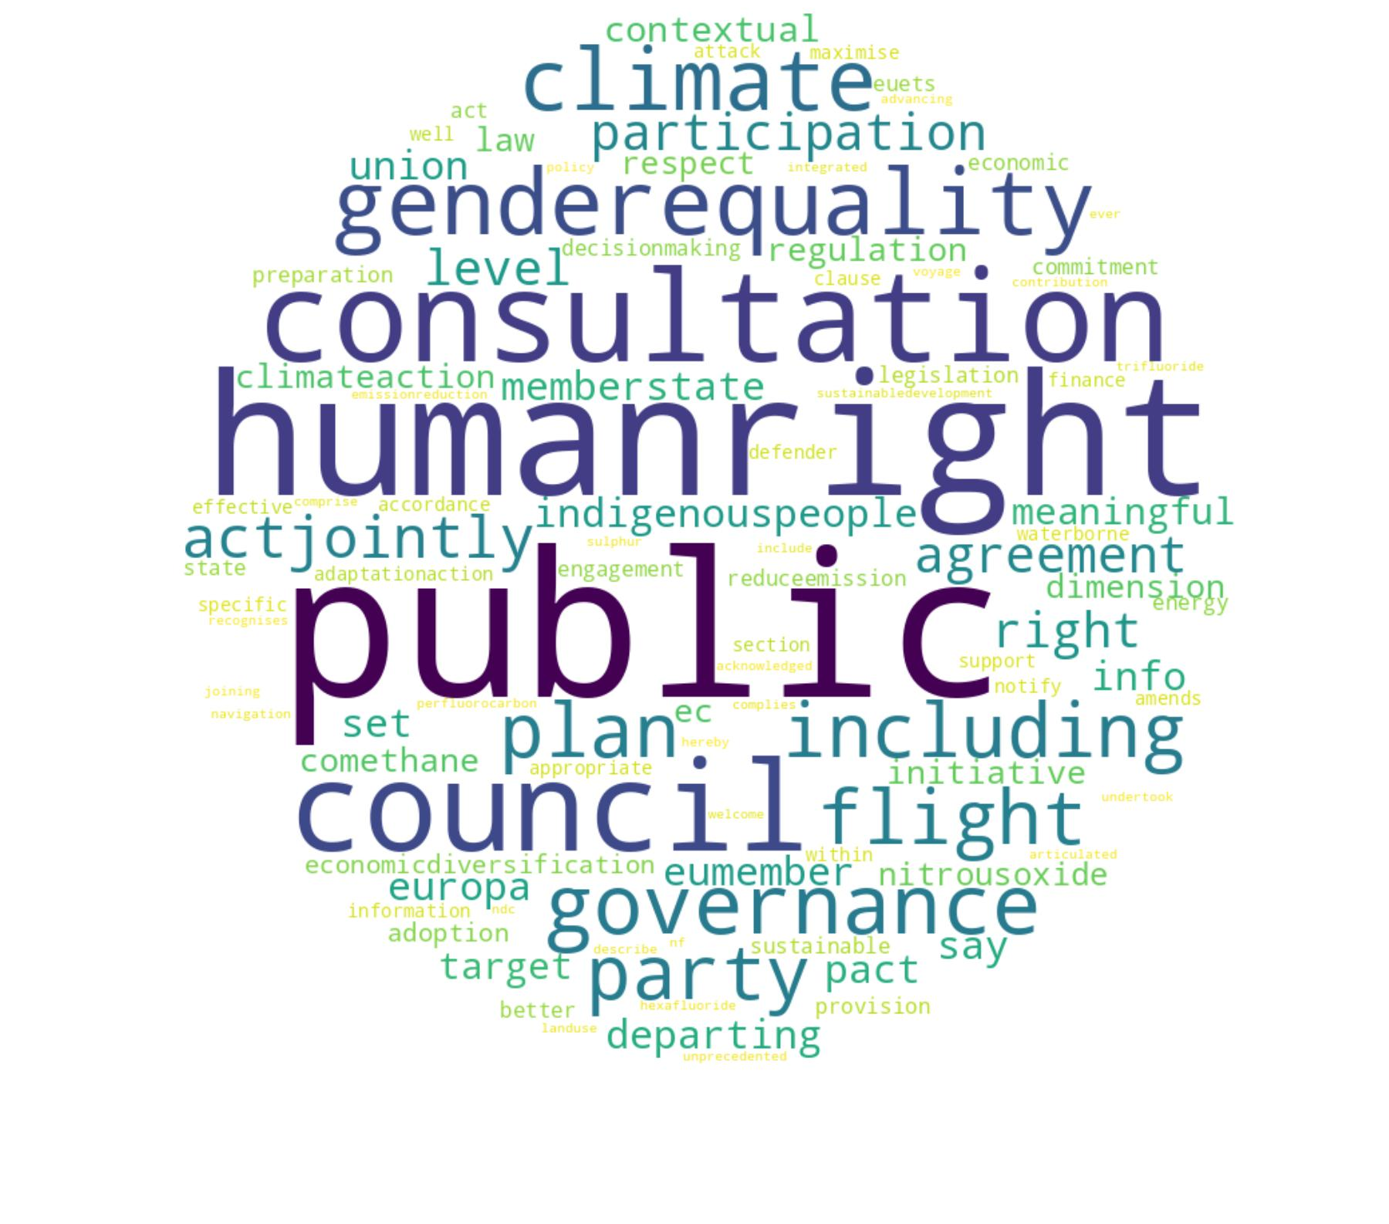
T25: Carbon pricing and targets  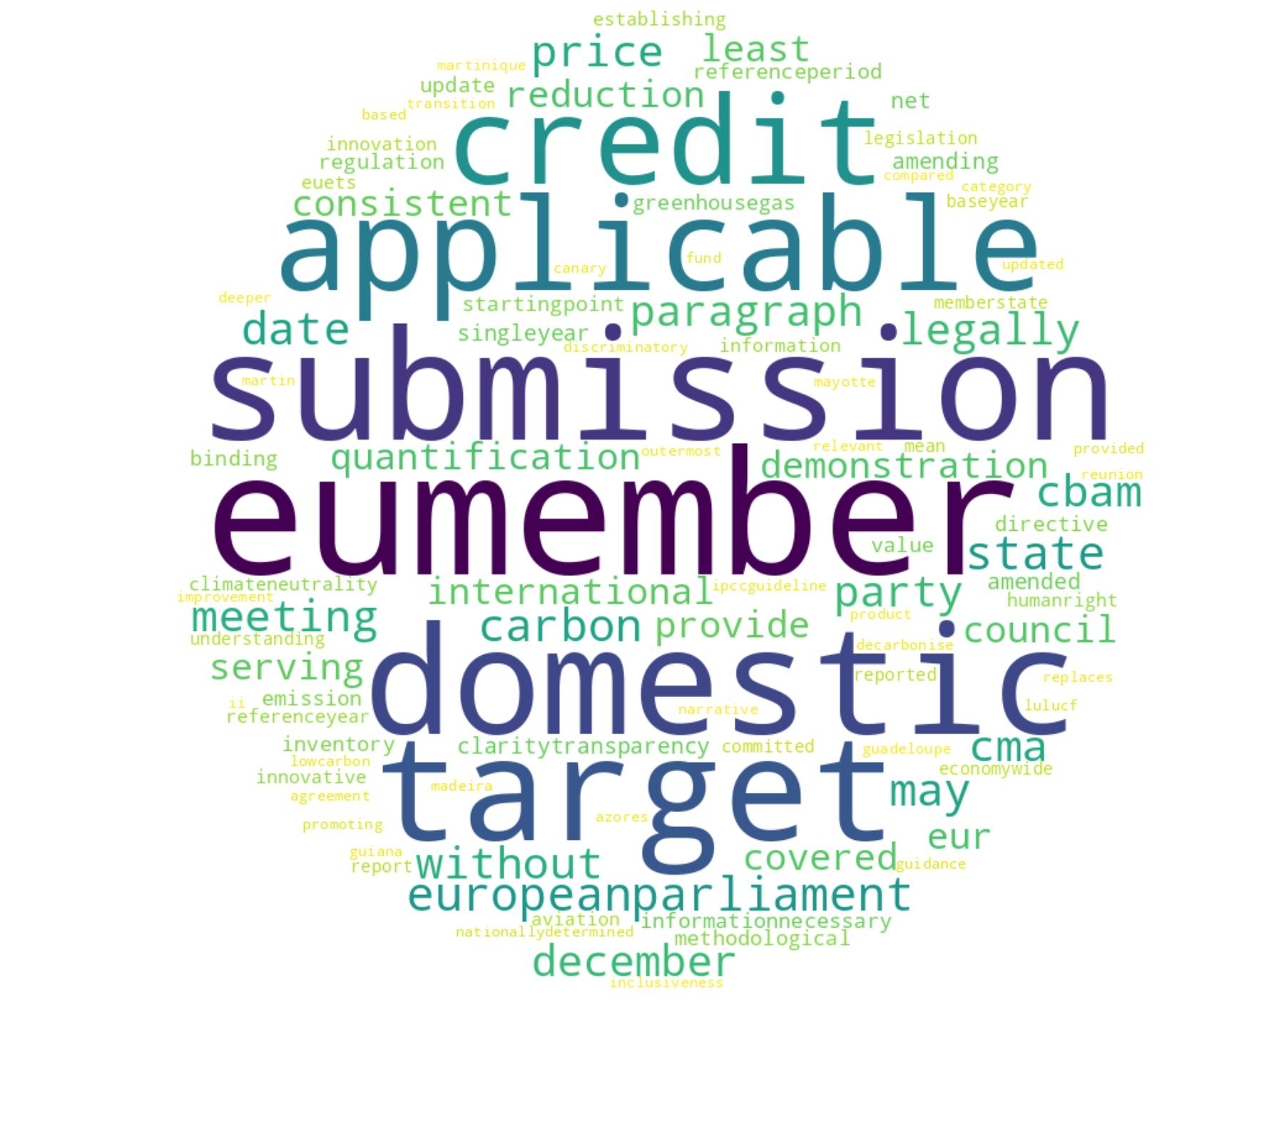 | T26: Ozone and refrigerants  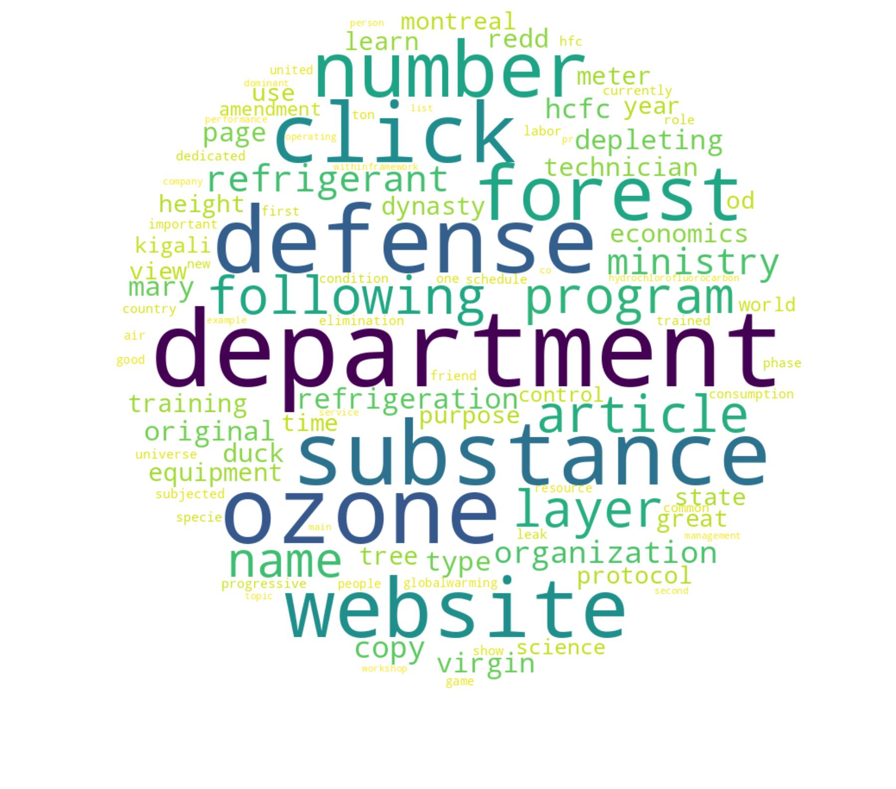 | T27: Emission trading  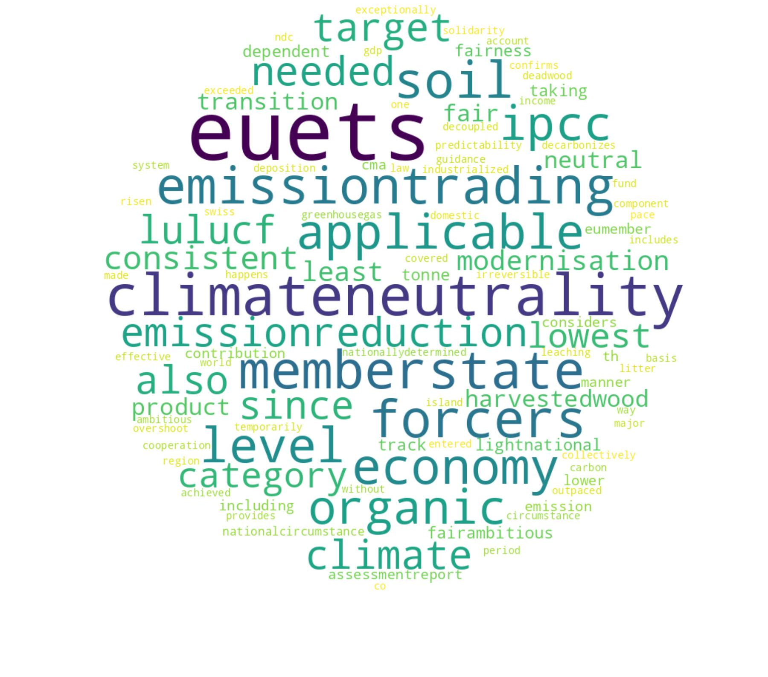 | T28: Legislation and directives  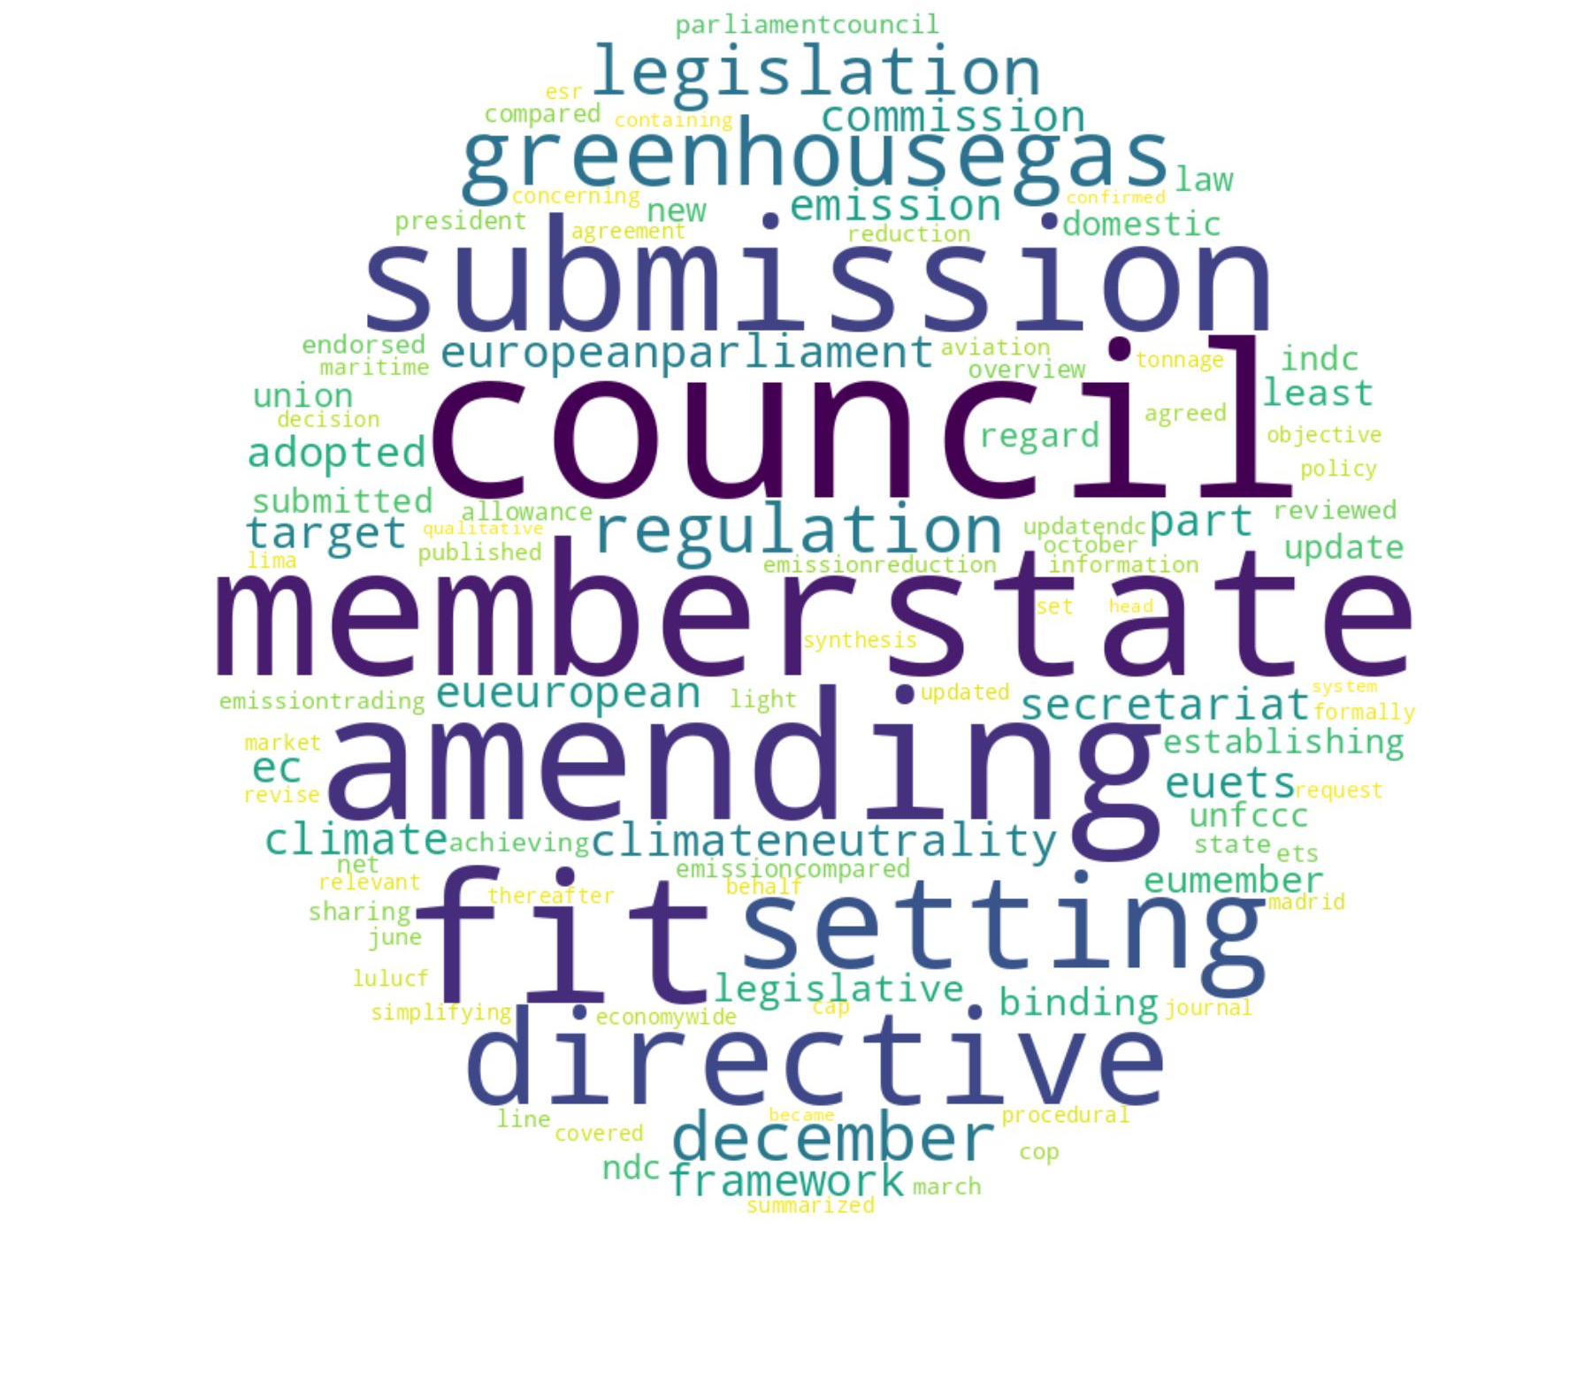 | T29: Net zero strategies  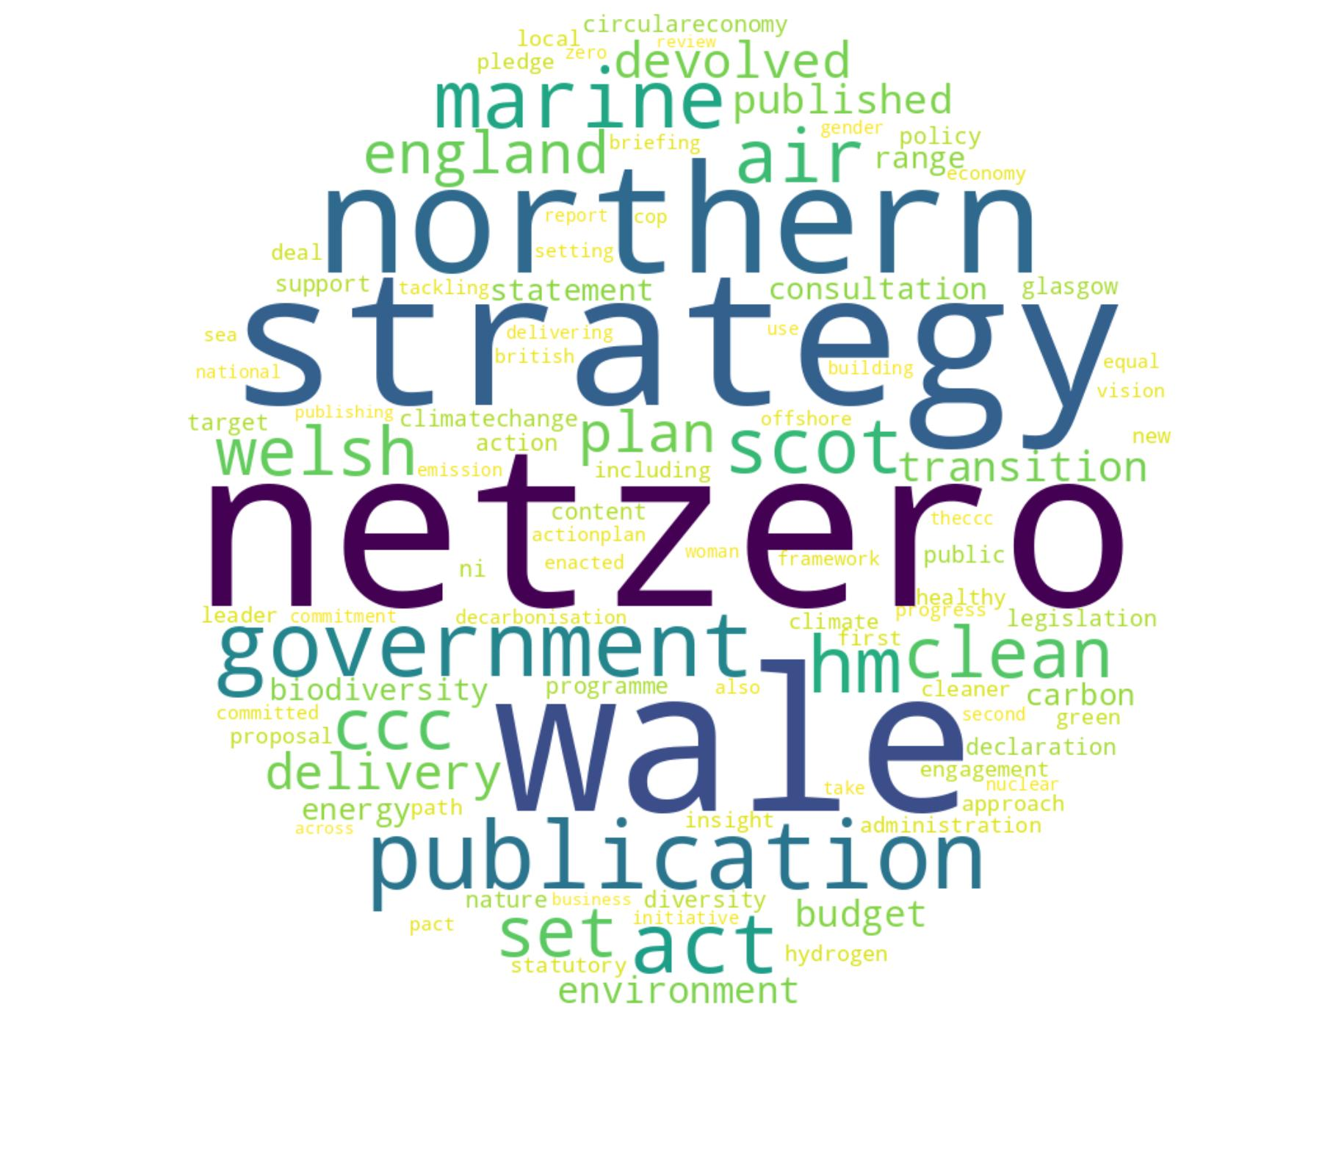 | T30: Agreement compliance  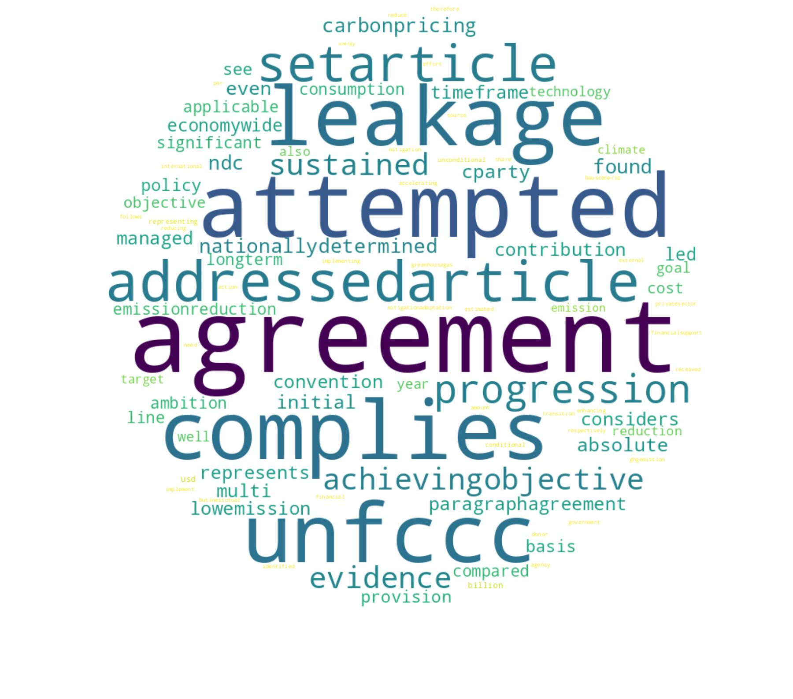 | T31: Aviation and shipping  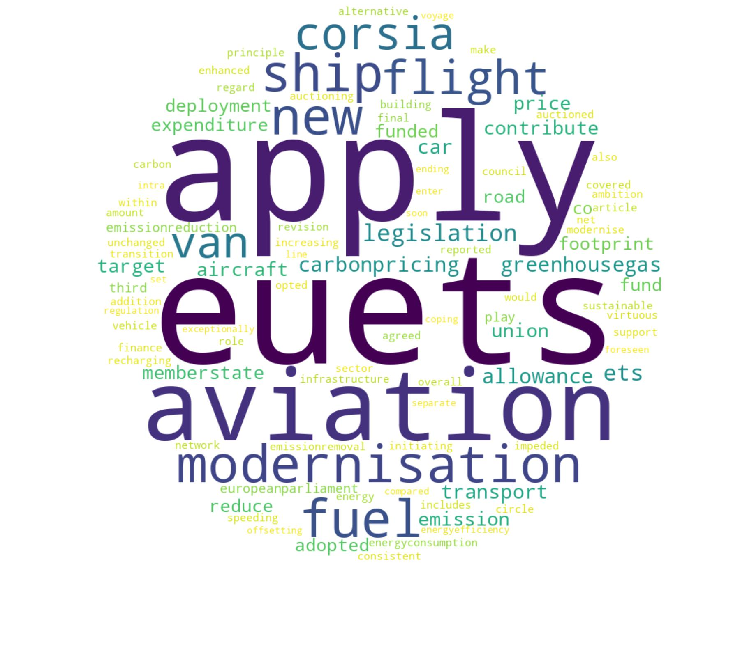 | T32: Carbon removals strategies  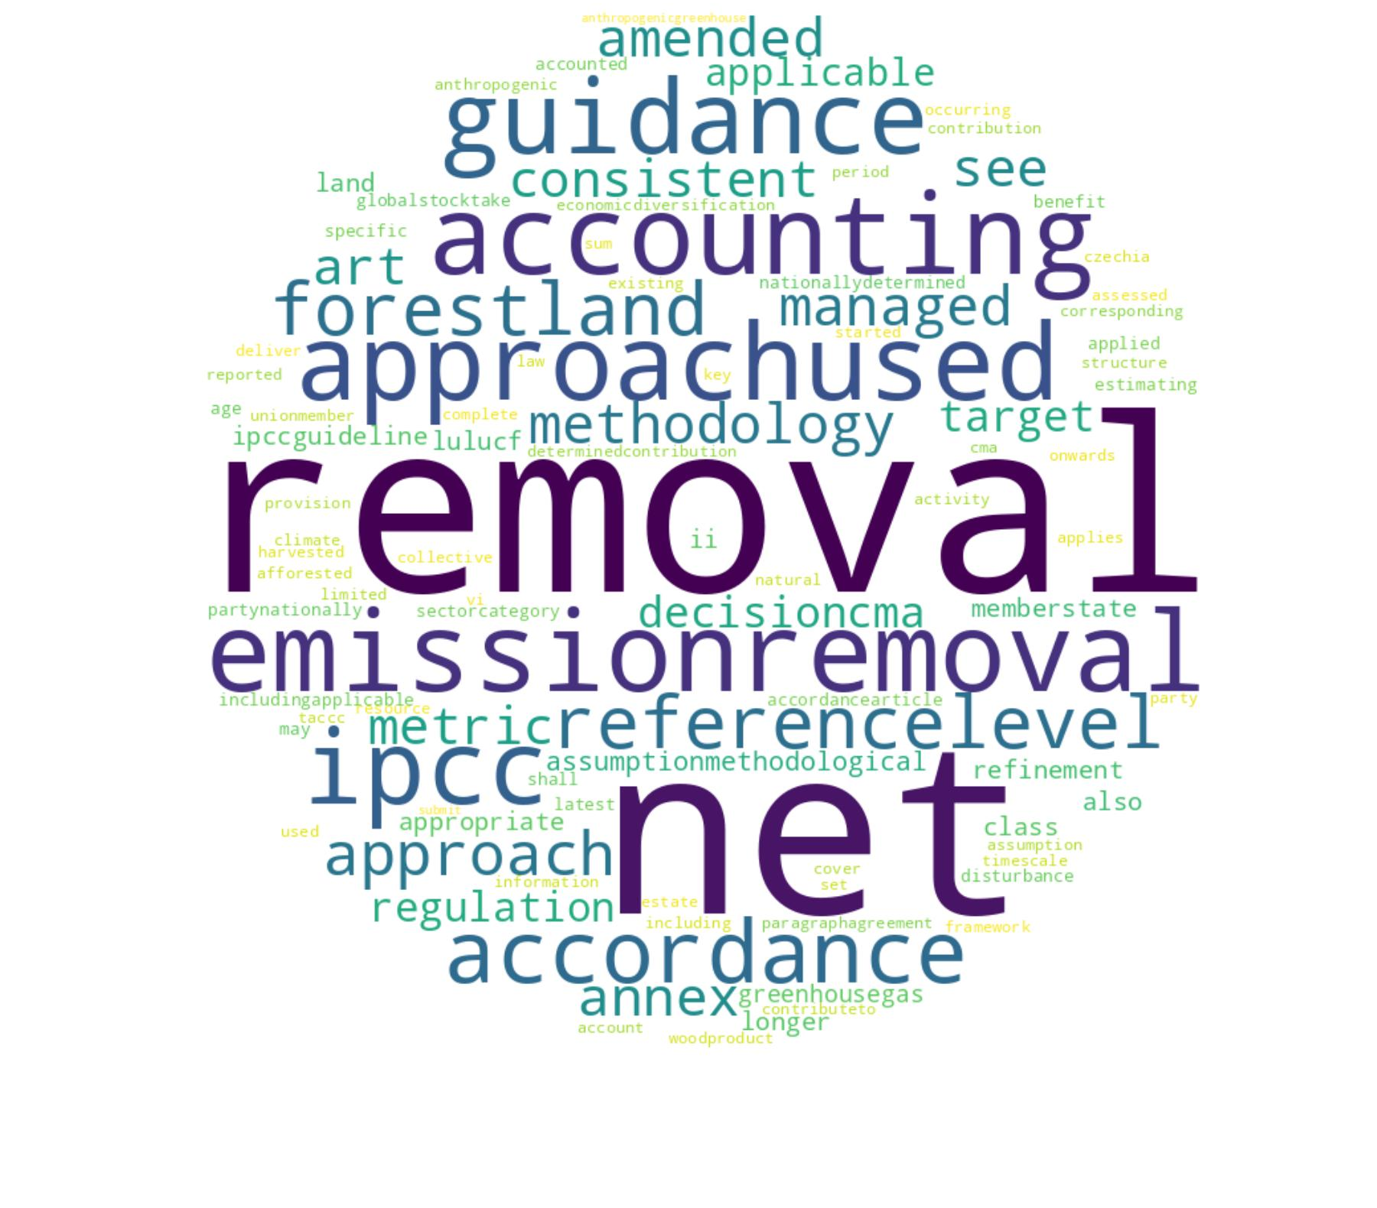
T33: Mitigation instruments  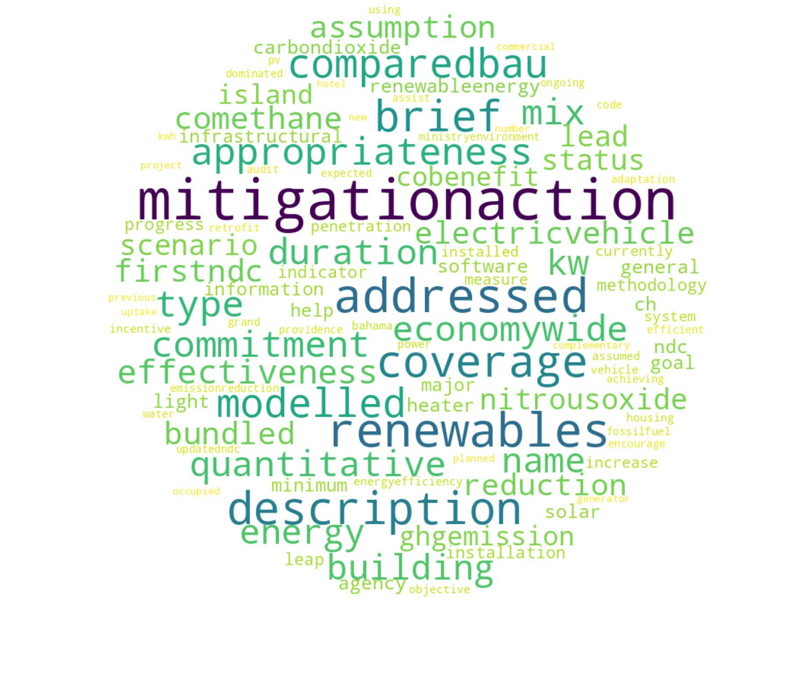 | T34: Loss and damage  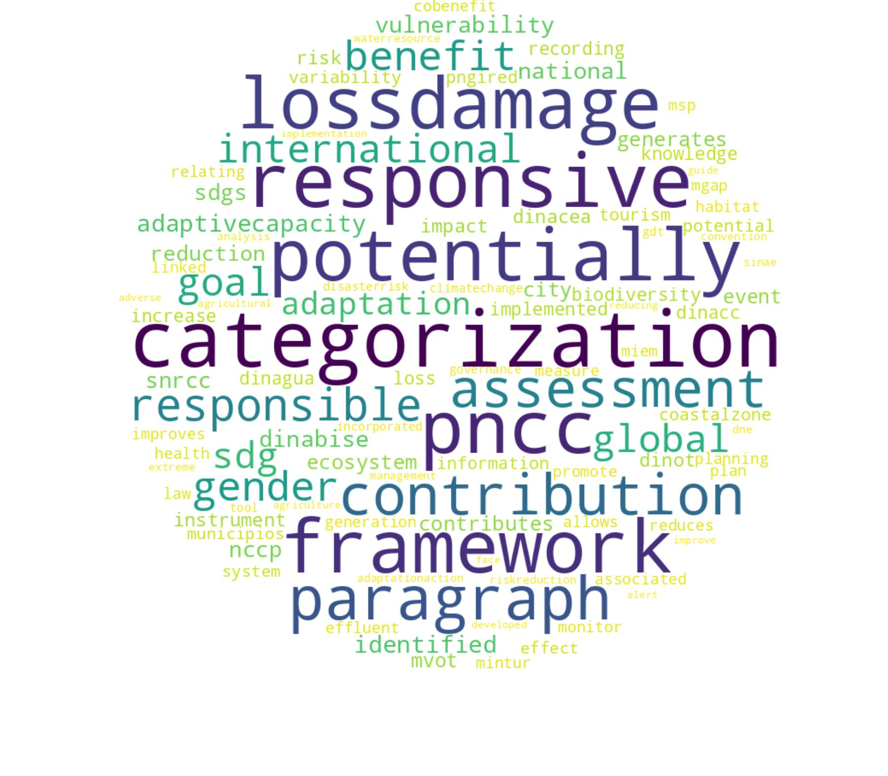 | T35: Energy regulation standards  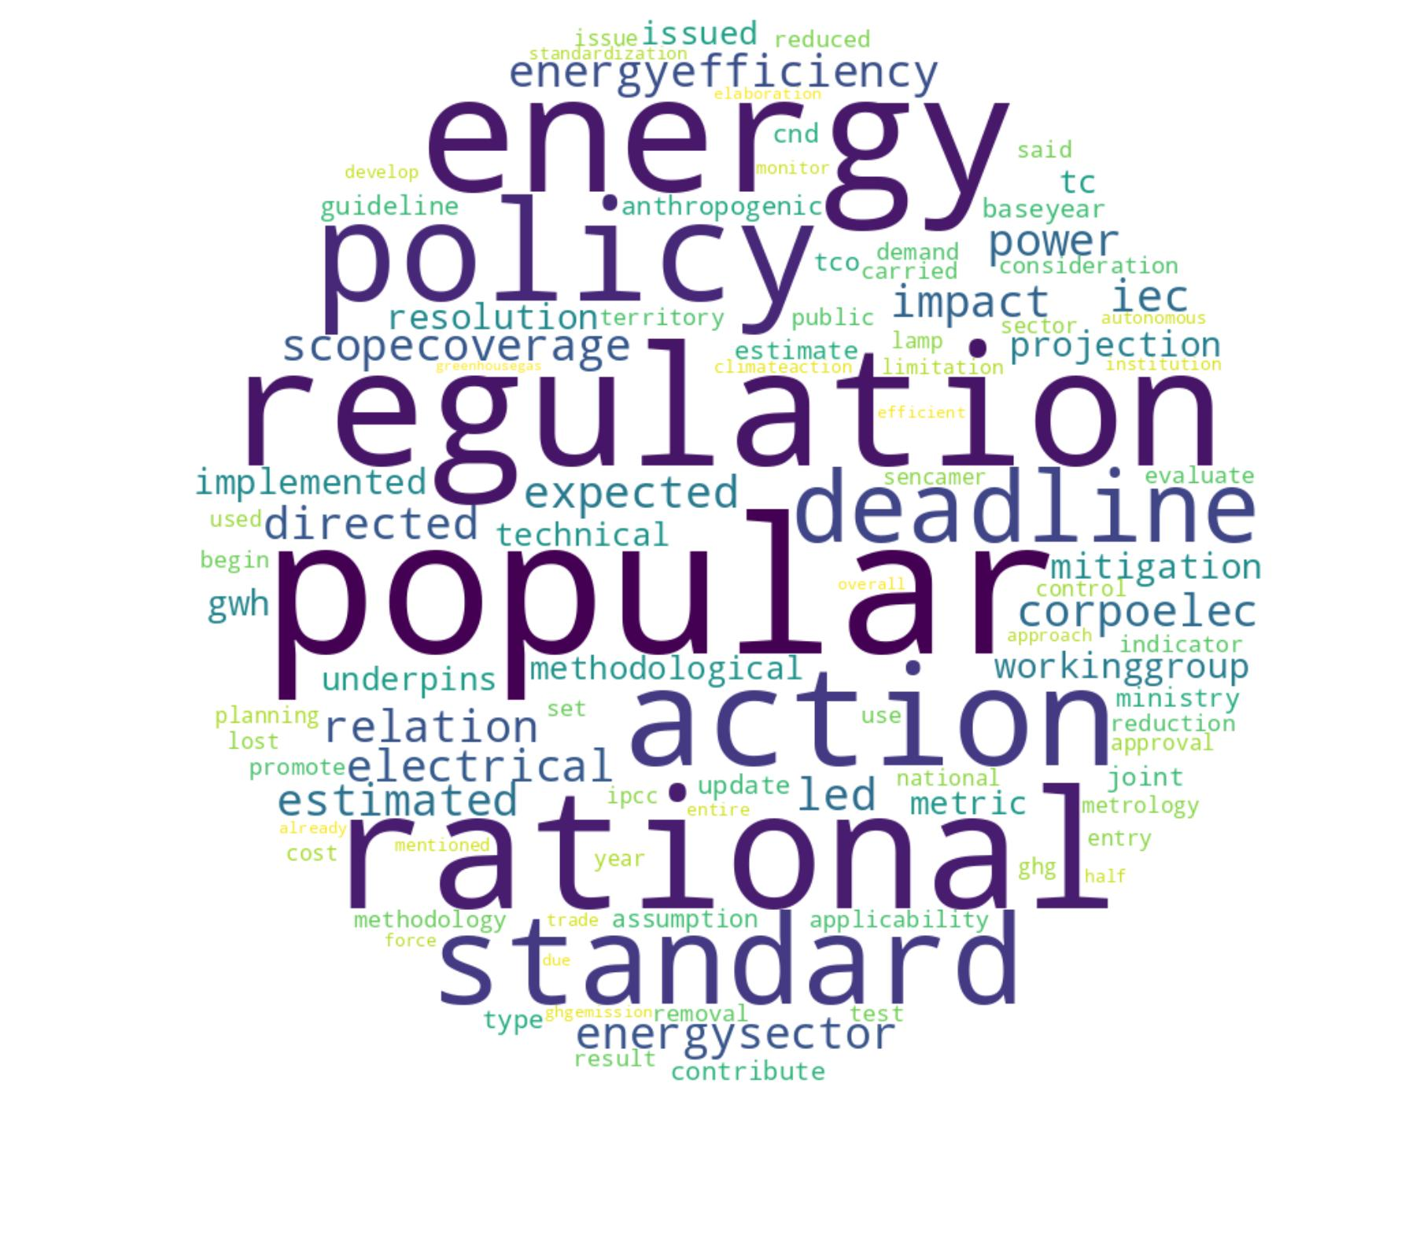 | T36: System transparency  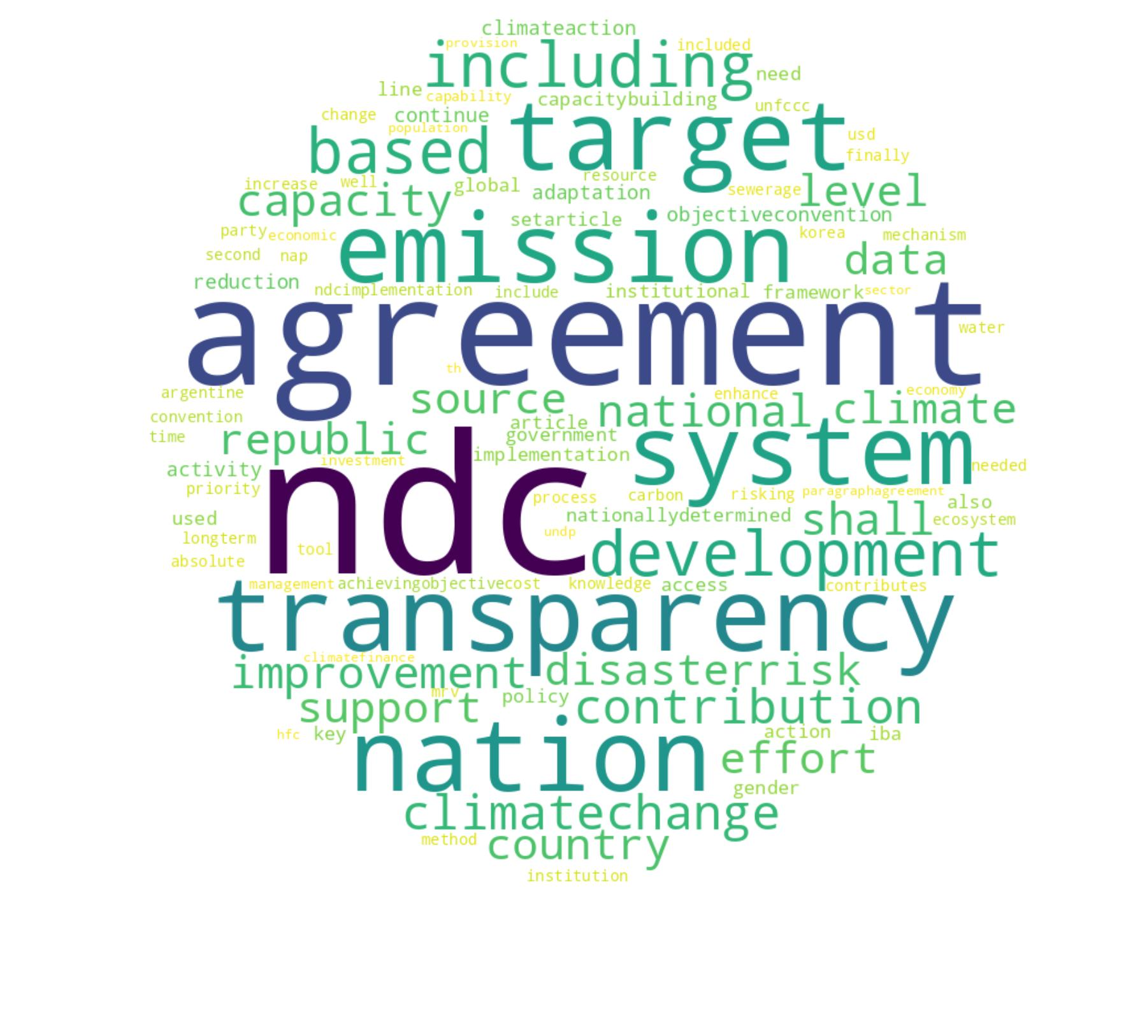 | T37: GHG policy instruments  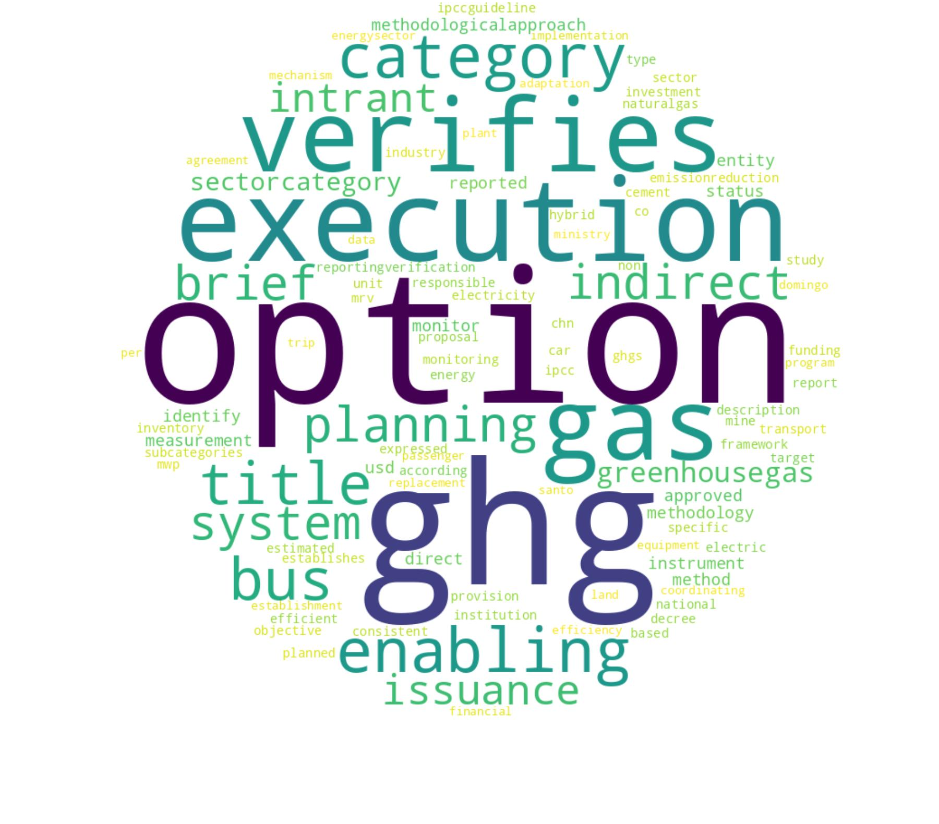 | T38: Climate compatibility  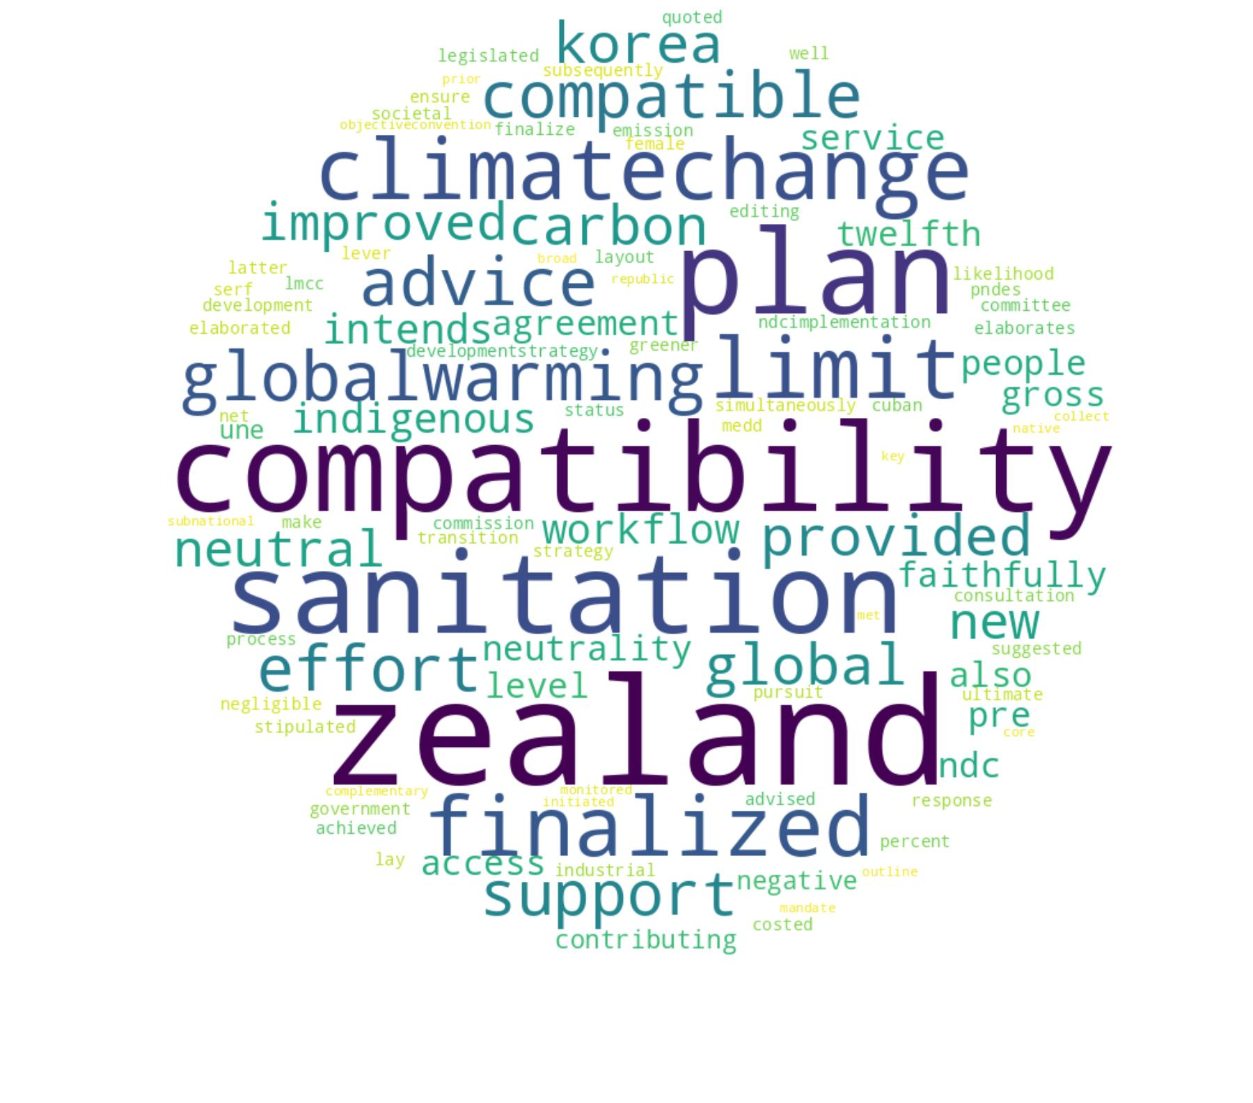
Figure S3. Word clouds of 38 topics generated based on NDCs

Sentence 1: “@BelowZeroGames @scottdellinger The Carbon Tax spin was a real conservative tactic win. They pushed it as a burden.”
Sentence 2: “What in the world, Iowa. 70 degrees and 70mph wind in December? #ClimateCrisis”
Sentence 3: “Water Resource is Important!”
Sentence 4: “My manuscript is accepted.”

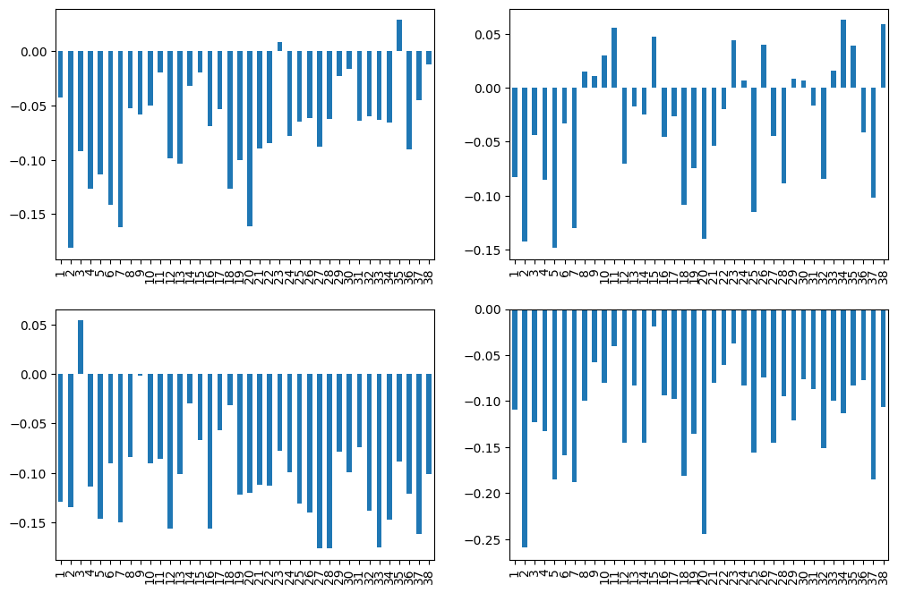
(a) Sentence 1 | (b) Sentence 2
(c) Sentence 3 | (d) Sentence 4

Figure S4. Topic recall scores of sentence examples. The recall scores have been standardized. We consider a topic to be mentioned in a tweet if the corresponding score is greater than 0. Sentences 1 and 2 are real tweets from our dataset. Sentence 3 and 4 are pseudo samples for comparison.

Part 2. Supplementary Tables

Table S1. Six topic groups, 38 topics, and their descriptions
Topic group | Sub-topic | Description
G1: Emission accounting and target | T1: Emission accounting | Greenhouse gas measurement, IPCC guidelines, and alignment with NDC targets
G1: Emission accounting and target | T5: Targets and ambition | Emission reduction commitments, global climate goals, and pursuit of higher ambition.
G1: Emission accounting and target | T19: Sectoral emission mitigation | Sectoral emissions, BAU scenarios, and policy measures.
G1: Emission accounting and target | T23: GHG emissions commitments | National reporting, accounting methods, and global climate objectives.
G1: Emission accounting and target | T30: Agreement compliance | Carbon leakage concerns, article requirements, and ambition under international frameworks.
G2: Sector mitigation strategies | T2: Renewable energy | Solar energy, renewable energy projects, electricity generation, energy efficiency, and forest sector initiatives
G2: Sector mitigation strategies | T10: Waste and emission | GHG inventories, wastewater treatment, and sectoral evolution.
G2: Sector mitigation strategies | T12: Projects and management | National plans, environmental management systems, and sector‐specific strategies.
G2: Sector mitigation strategies | T17: Resource extraction | Industrial production, extraction intensity, and economic impact.
G2: Sector mitigation strategies | T18: Public transport systems | Public mobility, rail infrastructure, and fuel efficiency standards.
G2: Sector mitigation strategies | T20: Freight and transportation | Public transit, freight logistics, and urban mobility solutions.
G2: Sector mitigation strategies | T26: Ozone and refrigerants | Substance regulation, website references, and forest programs.
G2: Sector mitigation strategies | T29: Net zero strategies | Government policies, air quality, and clean energy transition.
G2: Sector mitigation strategies | T31: Aviation and shipping | Legislation, carbon pricing, and modernization of transport fuels.
G2: Sector mitigation strategies | T32: Carbon removals strategies | Forest land methodology, IPCC guidance, and approaches for emission removals.
G2: Sector mitigation strategies | T33: Mitigation instruments | Economywide scenarios, renewables, and co‐benefit modeling.
G2: Sector mitigation strategies | T35: Energy regulation standards | Efficiency policies, mitigation deadlines, and rational action.
G3: Adaptation | T3: Resilience strategies | Water resource management, ecosystem protection, and resilience strategies.
G3: Adaptation | T4: Adaptation processes | Policy frameworks, technical support, and capacity building for climate adaptation.
G3: Adaptation | T6: Climate impact | Rising temperatures, changing rainfall, and population exposure to extreme events.
G3: Adaptation | T11: Environmental ministries | National objectives, forestry efforts, and health research.
G3: Adaptation | T34: Loss and damage | Risk assessment, global adaptation, and gender inclusion.
G3: Adaptation | T38: Climate compatibility | Climate neutrality, global warming limits, and indigenous advice.
G4: Governance and regulation | T7: Governance and direction | Government ministries, institutional arrangements, and overarching policy direction.
G4: Governance and regulation | T8: Regulatory frameworks | Technical guidance, law frameworks, and capacity for climate management.
G4: Governance and regulation | T16: Government official sources | Ministry directives, official decrees, and national references for climate measures.
G4: Governance and regulation | T21: MRV systems | Data collection, national coordination, and reporting platforms.
G4: Governance and regulation | T28: Legislation and directives | Greenhouse‐gas regulations, amendments, and submission processes for member states.
G4: Governance and regulation | T36: System transparency | Target setting, capacity development, and transparent reporting under climate agreements.
G4: Governance and regulation | T37: GHG policy instruments | Verification systems, indirect emissions, and planning methods.
G5: Social inclusion | T9: Sustainable resource use | Wetland conservation, waste management, and community livelihoods.
G5: Social inclusion | T13: Gender and community | Women’s empowerment, youth engagement, and social inclusion in climate initiatives.
G5: Social inclusion | T22: Youth and sustainability | University research, education programs, and innovation workshops.
G5: Social inclusion | T24: Public consultation | Human rights, gender equality, and public participation in climate governance.
G6: Finance and Carbon market | T14: Carbon and forest economy | Rainforest conservation, carbon markets, and sustainable timber.
G6: Finance and Carbon market | T15: Climate finance | Concessional loans, funds, and financial commitments
G6: Finance and Carbon market | T25: Carbon pricing and targets | Domestic target setting, carbon credits, and legally binding obligations for member states.
G6: Finance and Carbon market | T27: Emission trading | Emission trading, LULUCF, and soil pathways toward climate neutrality.

Table S2. Tweet examples and their stances
Sub-topic | Tweet examples
Stance Training Dataset
Believer | RT @Mick_Fanning: Just watched this amazing documentary by leonardodicaprio on climate change.
Believer | We must combat climate change. Indigenous ppl are protesting for our earth, our water. Yet this happens: https://t.co/EUDmjbgbkx
Denier | @ClimateReality Sorry. I don't believe in climate change. I think it's a big sham to get more tax dollars that should be going elsewhere.
Denier | In my opinion, climate change is nothing more than a way 2 remove our money from our pockets 4 their greeny projects.
Neutral | RT @CatalyticRxn: Trend is toward increased acceptance of climate change, but acceptance that it's human-caused is flat.
Neutral | How do ghosts cool their environment and could we use that to combat global warming? #funny
Our Twitter Dataset
Believer | A remarkable man and his work on climate change is so impressive more people need to see it... https://t.co/JtpuX9QYFv
Believer | We are excited to learn at this event on Thursday 12/16. A discussion of solutions to maritime-related climate change.
Denier | Yep. Let's keep the air and water as clean as we can but hard stop with the climate change nonsense.
Denier | @pfdoran @think_or_swim @SadhbhO @WeallIreland Environmentalism has been synonymous with sacrifice. That needs to change.
Neutral | Was the deadly Kentucky tornado due to climate change? It’s complicated.
Neutral | With Global Warming imminent, I hope 2022 ushers in tank tops and shorts as appropriate office attire.

